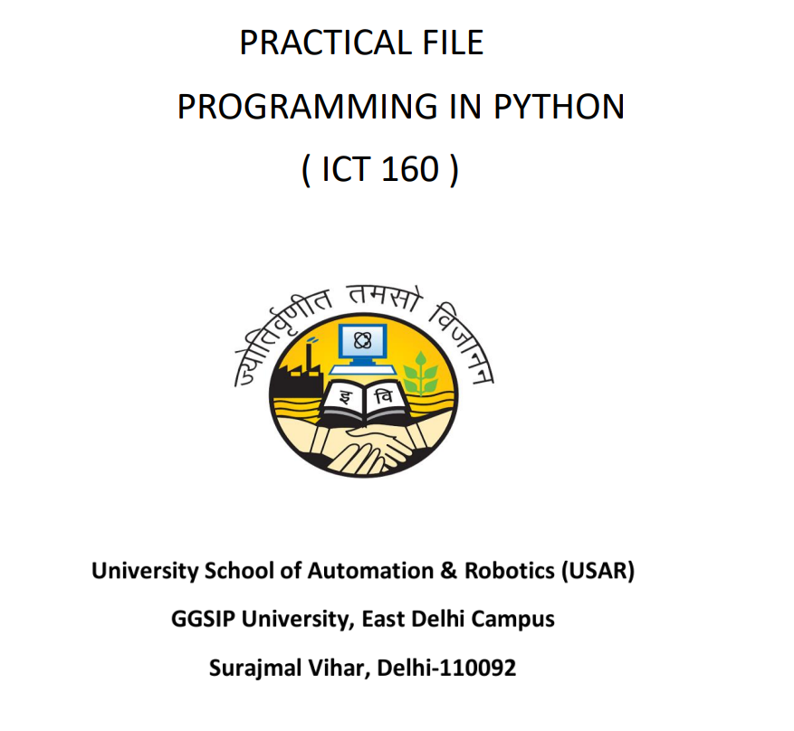

Name: Harsh Kumar
Roll no: 03719051723
Branch: IIOT
Batch: B1
Submitted to: Dr. Amit Choudhary

Q1) Write a Program to perform string manipulation operations using set of pre-defined functions such as: a) Find()
b) Upper()
c) Len()
d) Max() and Min()
e) Fetching a specific content from the String

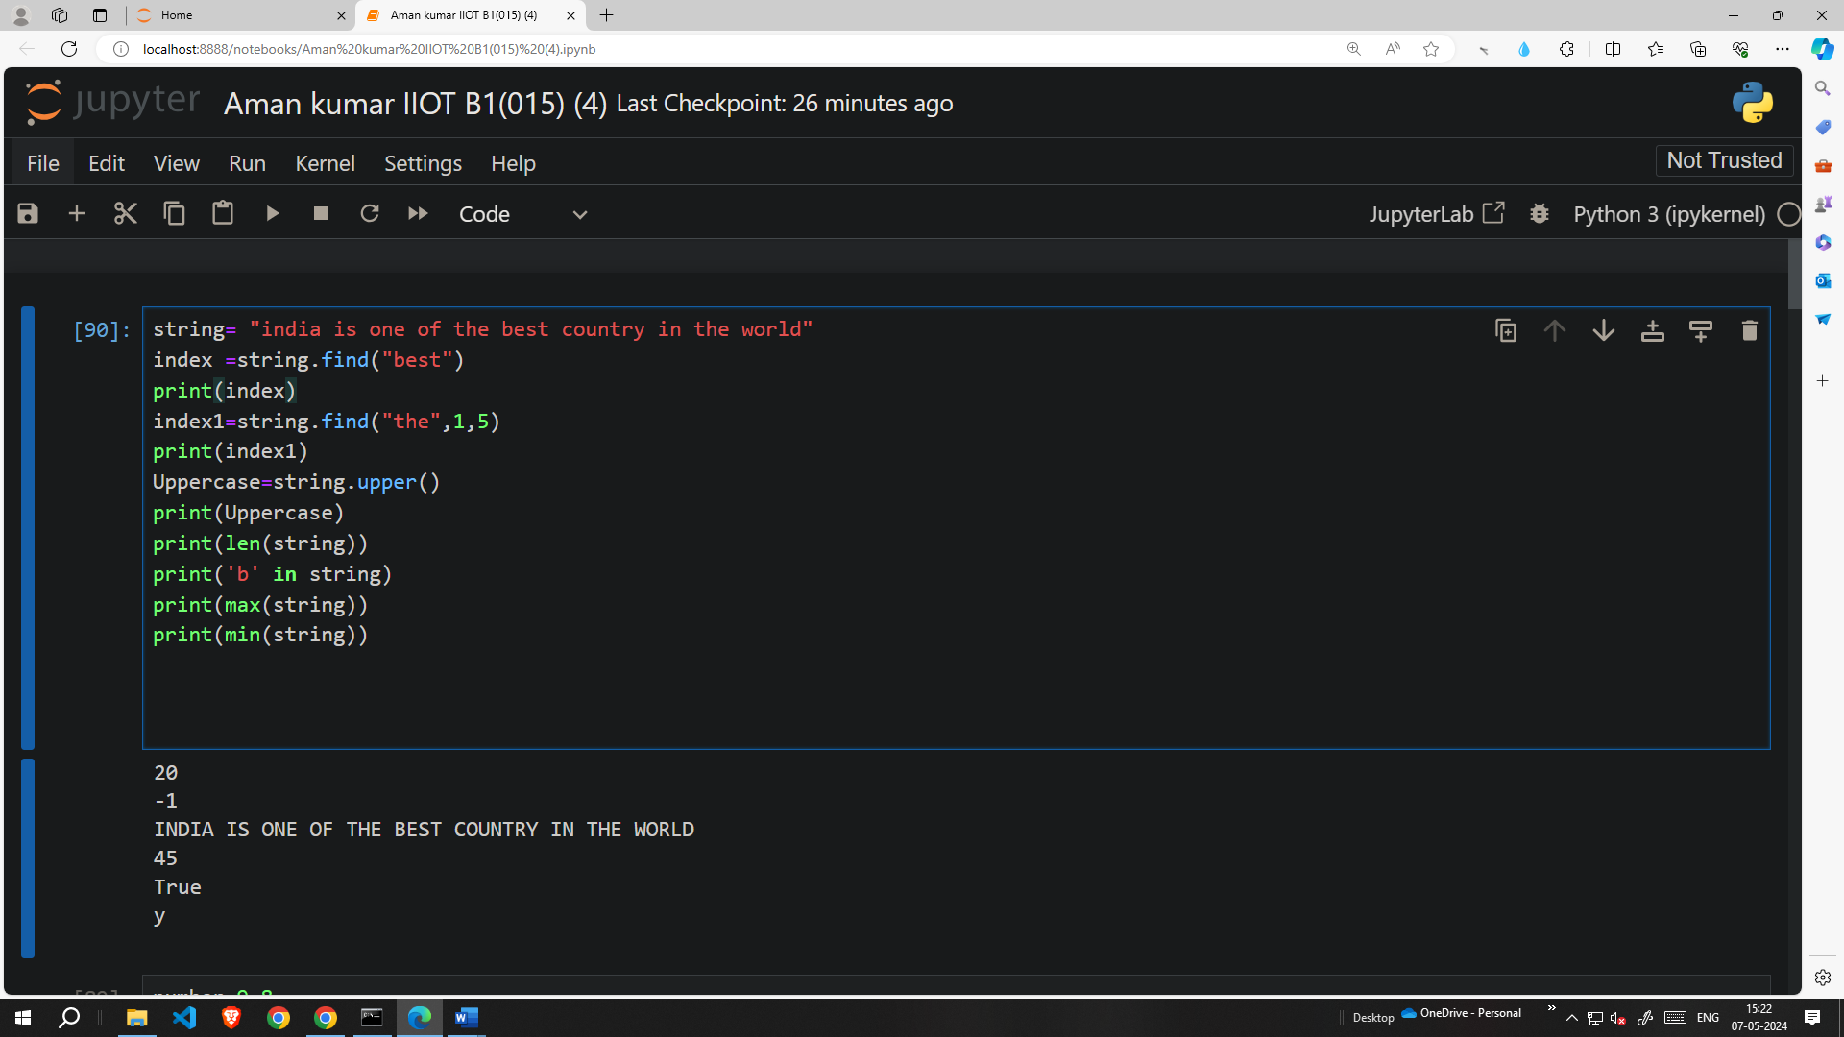
Q2) Write a Program to perform to test and check the mathematical functions such as:
a) Ceil()
b) Sqrt()
c) Pow()
d) Factorial()

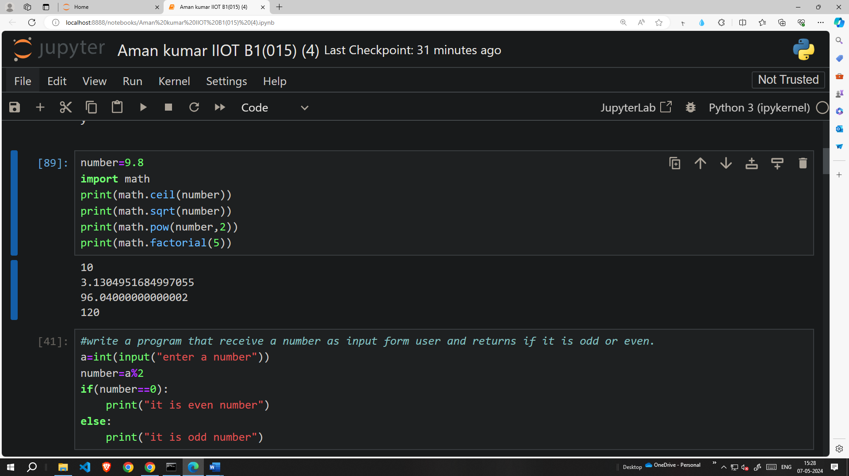

Q3) Write a Program that receive a number as input from user and returns if it odd or even number.

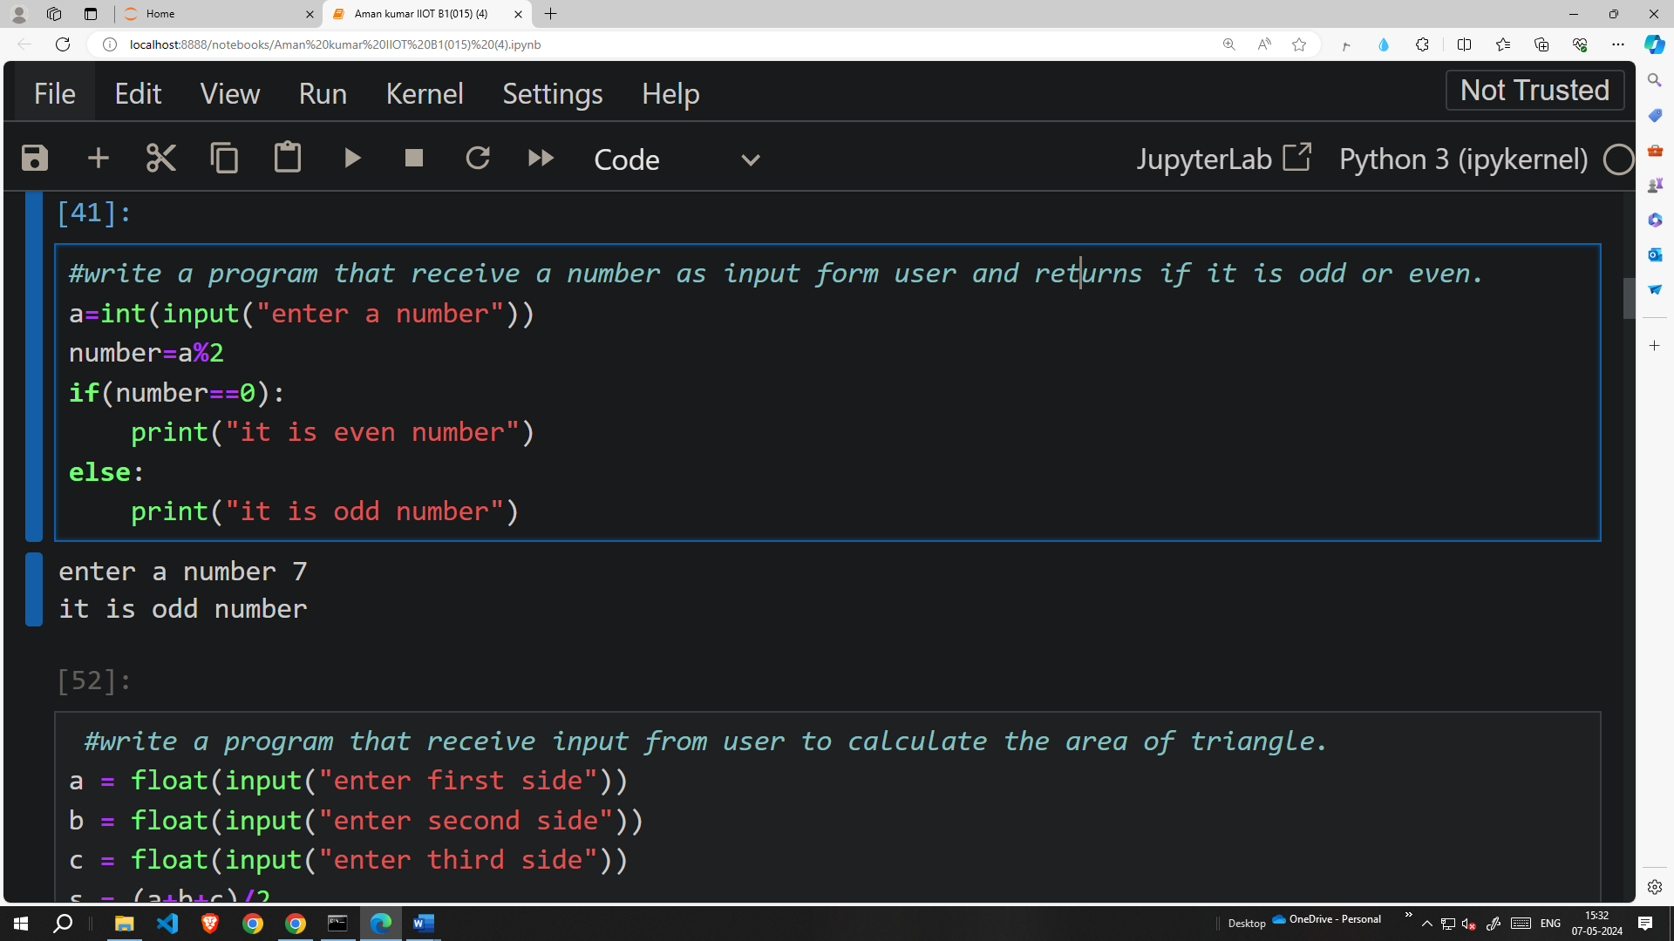

Q4) Write a Program that receive input from the user to calculate the Area of Triangle.

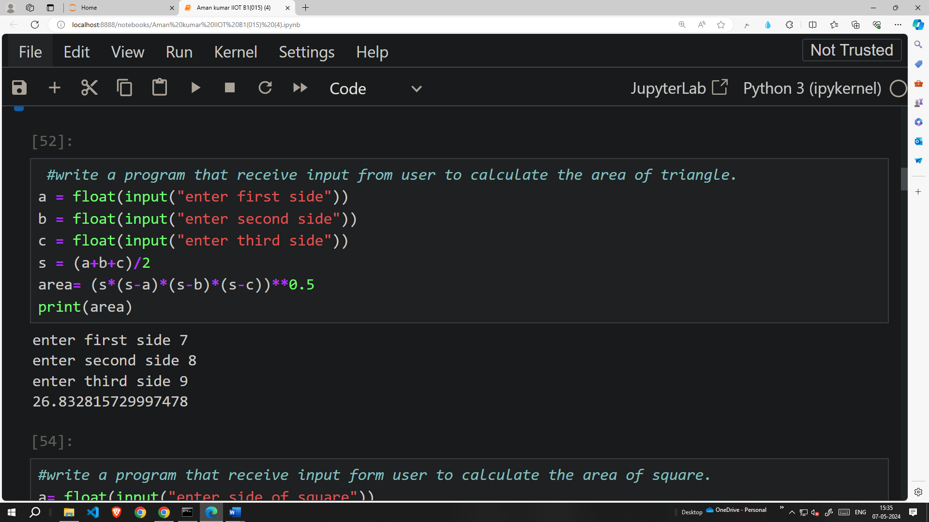

Q5) Write a Program that receive input from the user to calculate the Area of Square

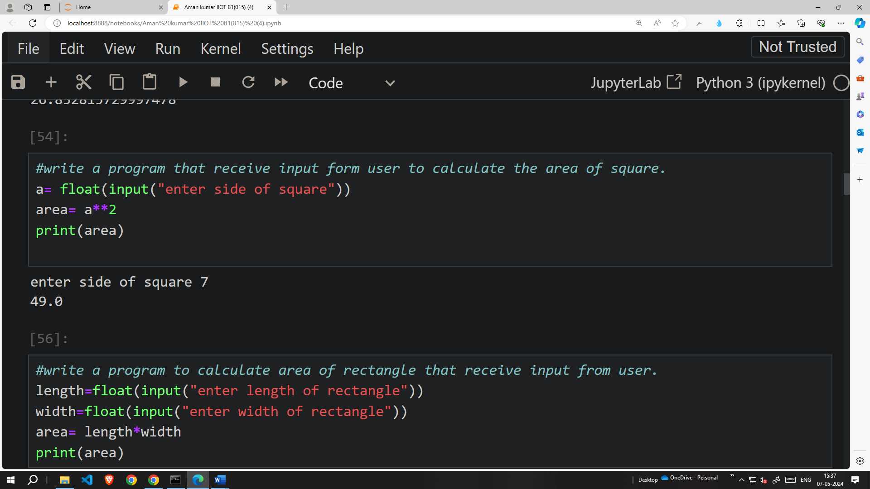

Q6) Write a Program that receive input from the user to calculate the Area of Rectangle

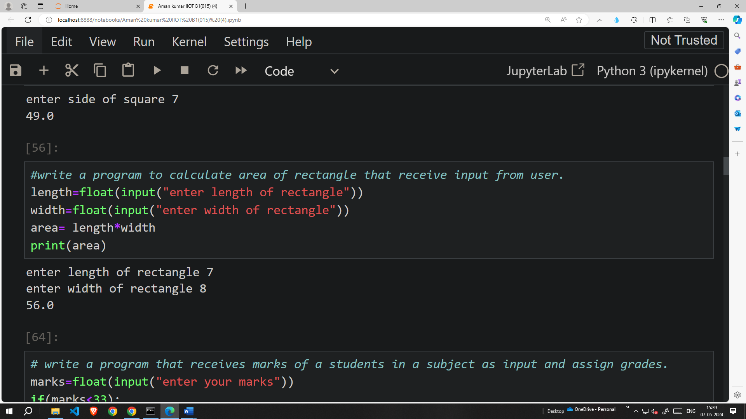

Q8) Write a Program that receives marks of a students for a subject as input and assign the grades A||B||C||D||E||F

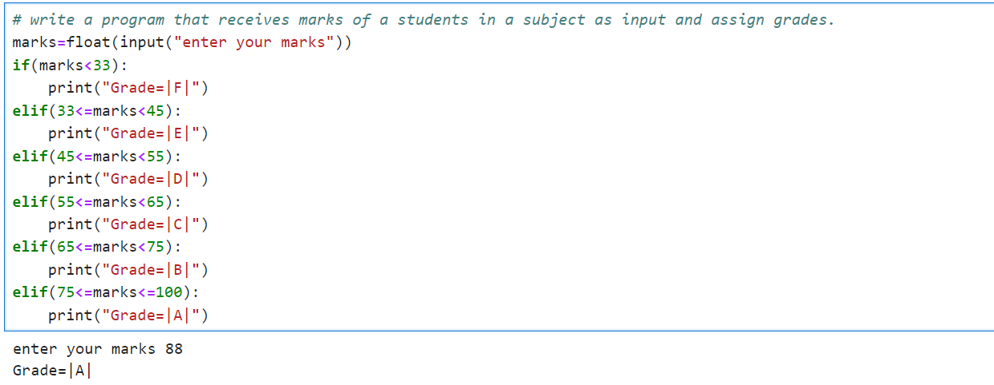

Q7) Write a Program to check if the input string is Palindrome or not

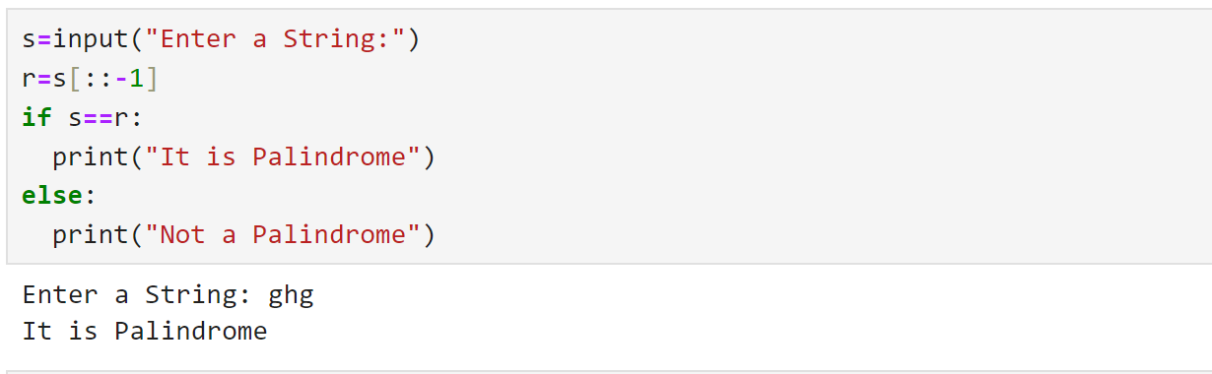

Q9) Write a Program to compute the GCD of the two numbers.

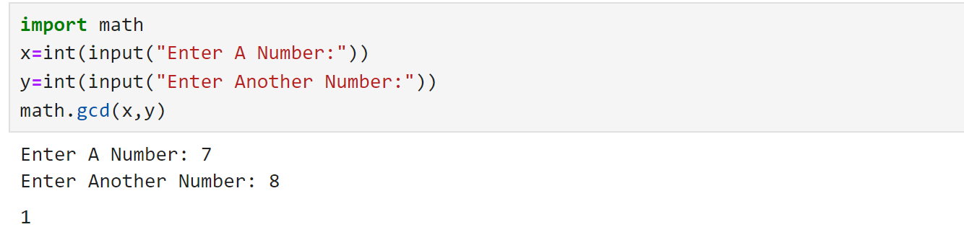

Q10) Write a Program to check if the given number is Armstrong number or not. Example of Armstrong number are:- 153, 370, 371 etc.

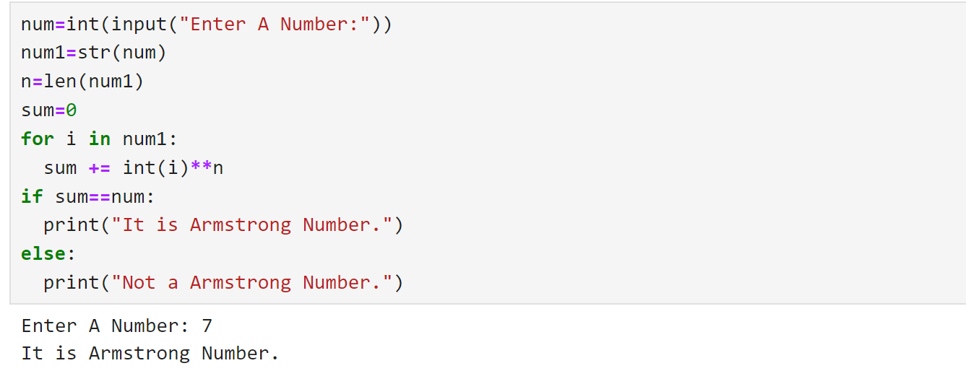

Q11) Write a Program to check if the input year is a leap year or not

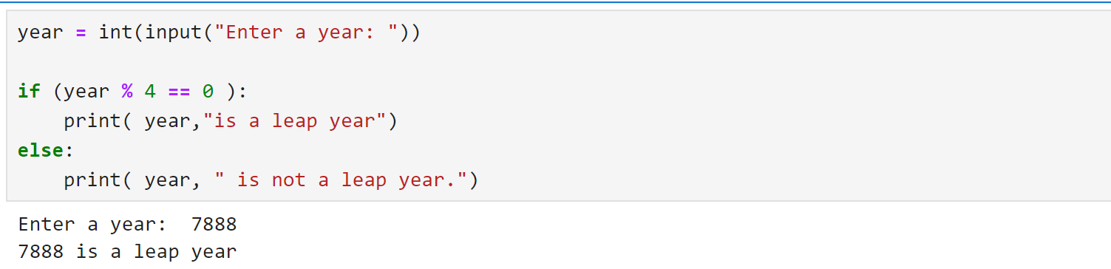

Q12) Write a Program to computer factorial of a given number

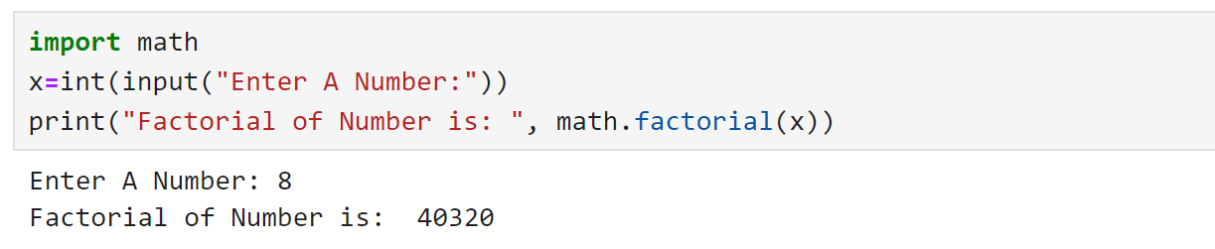

Q13) Write a Program to generate Fibonacci series till 100.

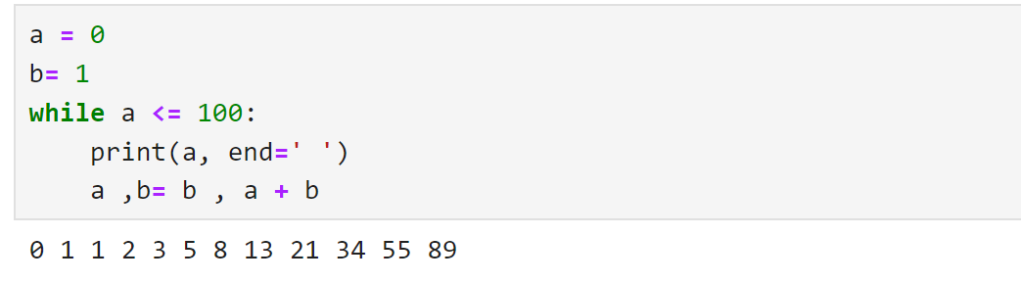

Q14) Write a Program to print a multiplication table of a given number

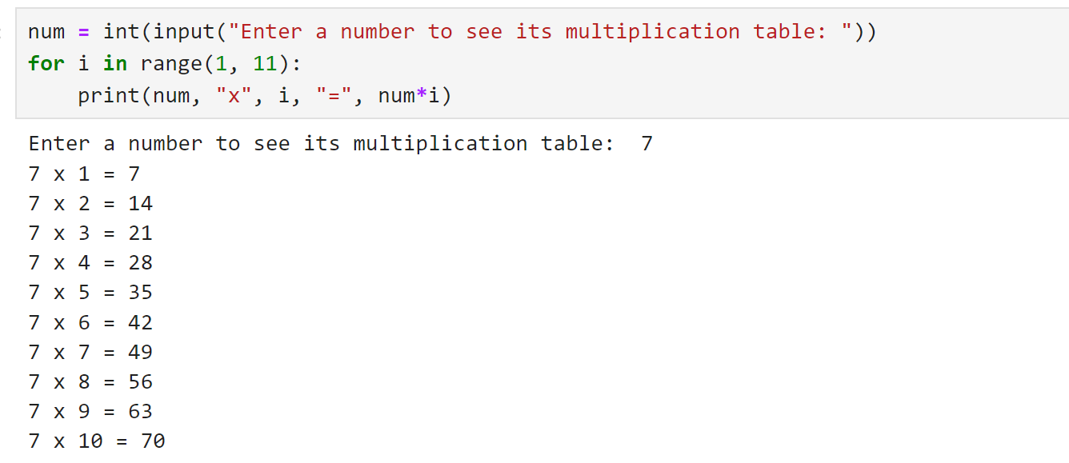

Q15) Write a Program to create a two list and perform the following operation’s:
1) Add the Elements of the two list.
2) Compare the contents of the two list.
3) to find the number of the elements in the list.
4) Sort the elements of the list.
5) Reverse the contents of the List

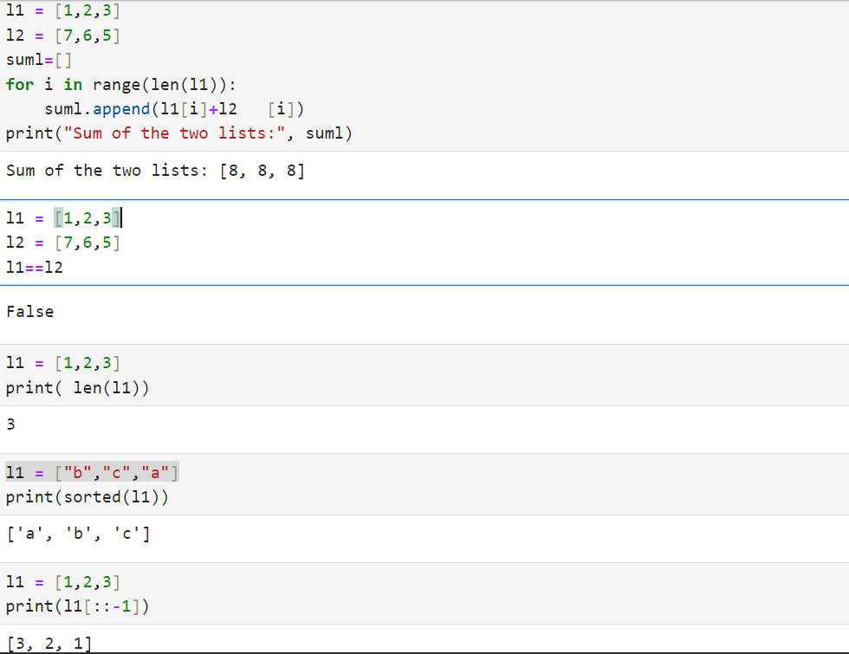

Q16) Using NumPy, write a program to create 1 Dim Array, load it with numbers, and perform the operation of Iteration and Slicing on it.

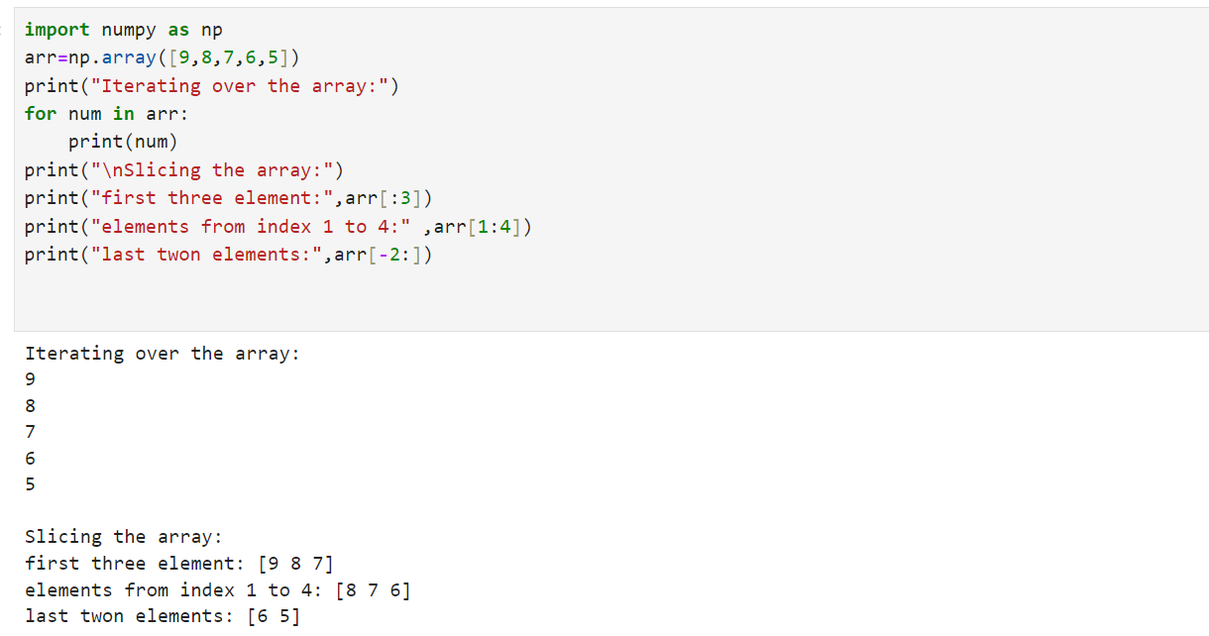

Q17) Using NumPy, write a program to create Multi-Dim Array, load it with the numbers and display the content of it.

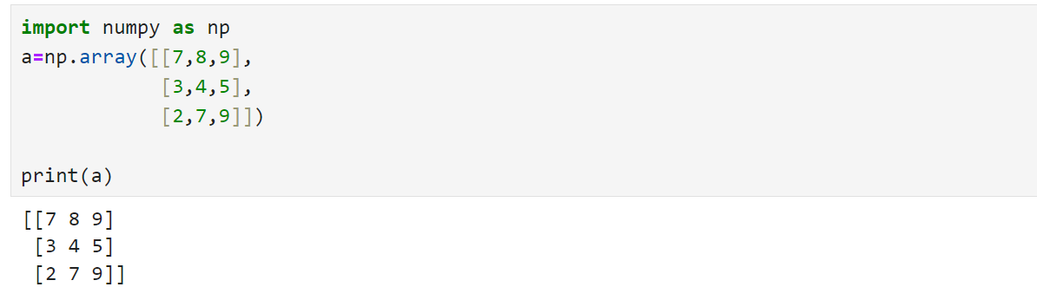

Q18) Using NumPy, write a program to create two 1 Dim Array and perform the operation of Iteration, Sorting the contents of array and concatenating the contents of the array.

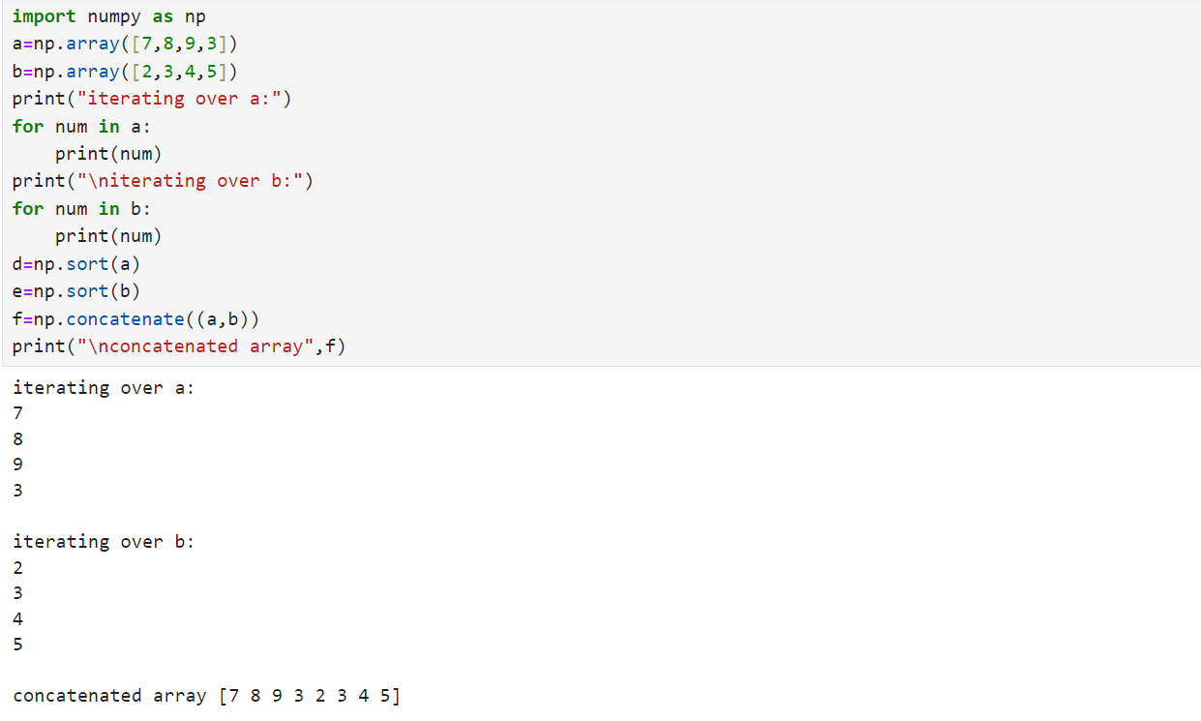

Q19) Using NumPy, initialize the array and display their dimensionality.

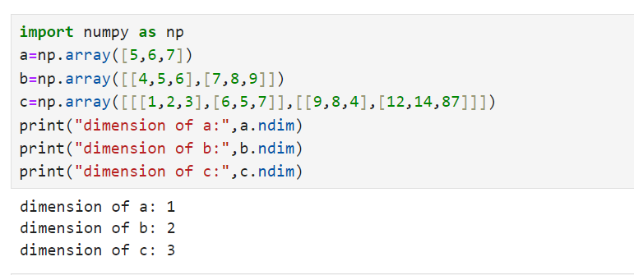

Q20) Define Employee Class with fields such as Employee ID and Employee Name. Instantiate the class, invoke the constructor and make a call to user defined function to display the information about employee.

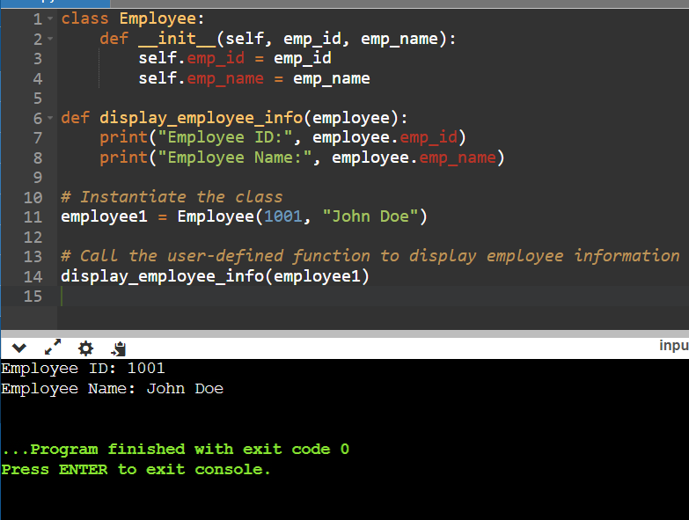
Q21) Write a Program to create a class called ‘Student’ with fields such as: Enrolment Number, USS Name, Branch Name, Student Name etc. Instantiate a class and make a call to user defined function to display the details of students.

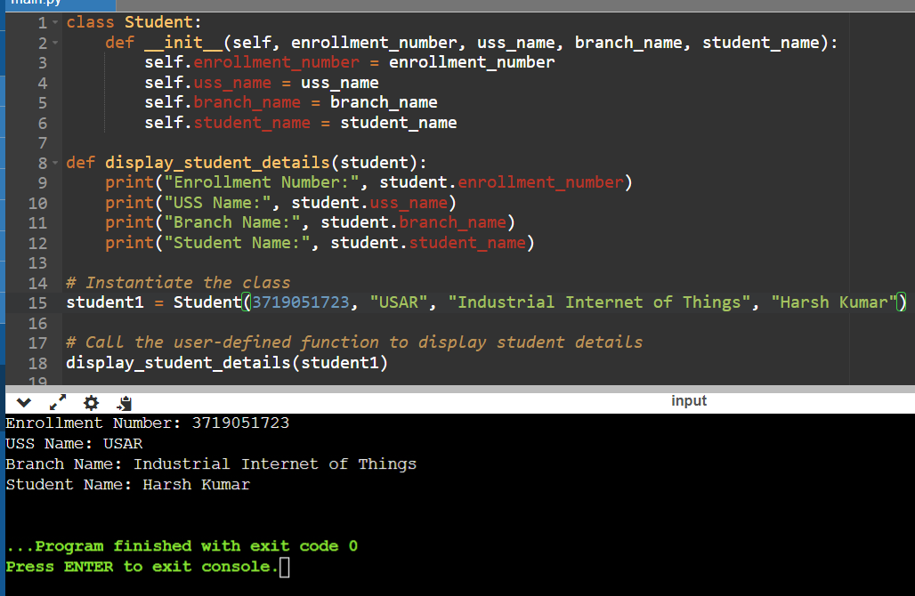

Q22) Write a Program to create and display the content of the tuple. Initialize the tuple with the name of the cities. Display content of the tuple along with name/index positions of the cities.

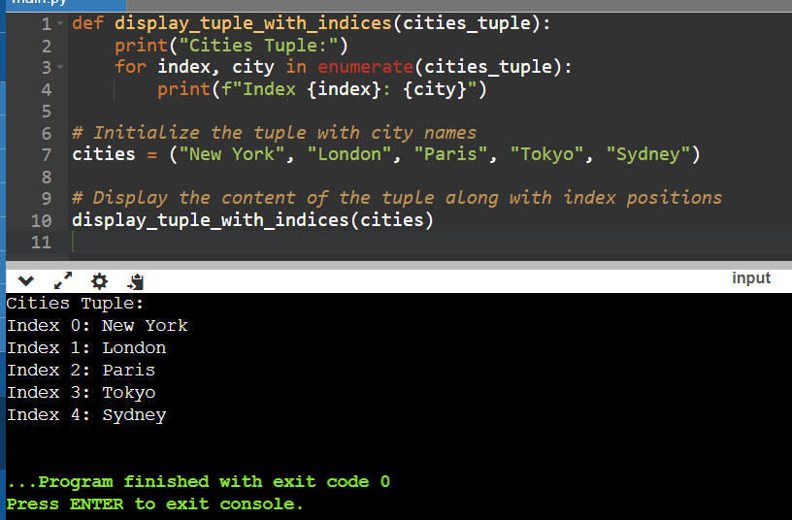

Q23) Write a program to create an Array of Even numbers till 14. Display the contents of array, compute the length of array and also show how to delete a element from the desired position from the array.

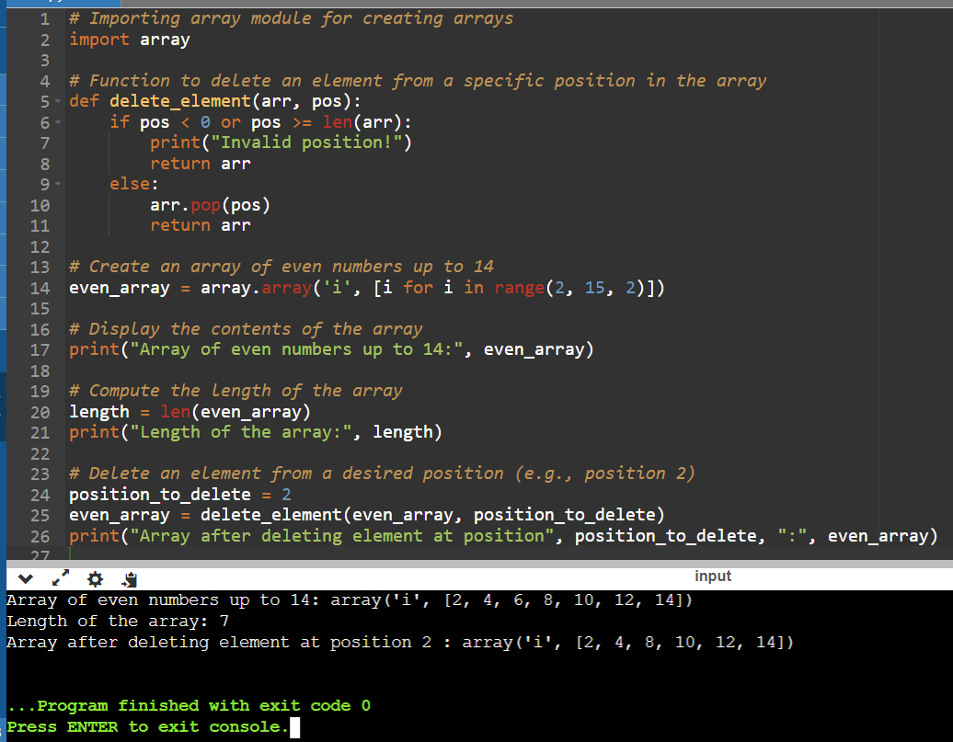
Q25) Using Filter function, write a program to filter the elements which are greater than 9.

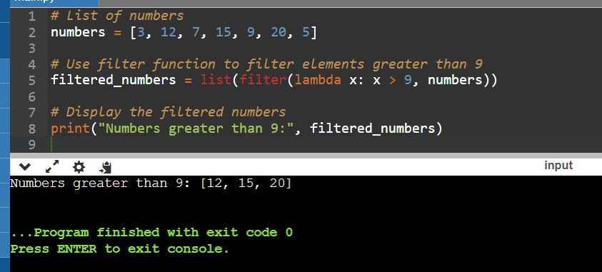

Q26) Using Filter function, write a program to display multiple of 5 from a given array.

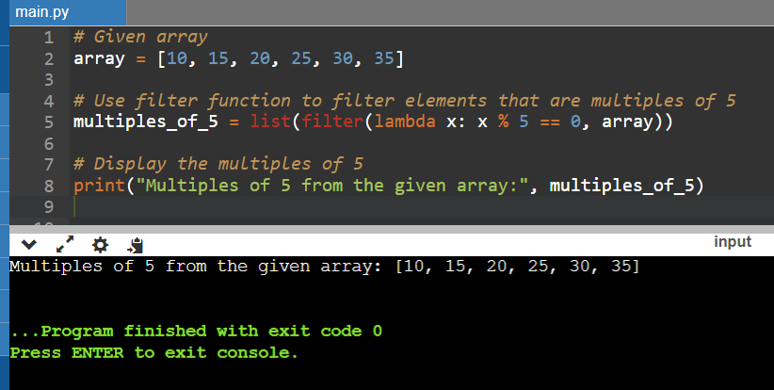

Q27) Write a Program to create a file called “Input.txt”, perform the write/read operation in it with a string “Computer Science”.

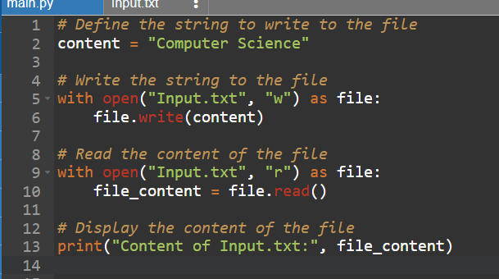

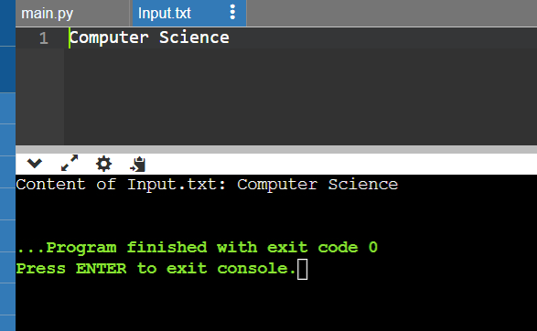
Q28) Write a Program to create a file called “Input.txt”, initialize it with a string of your choice and perform the read operation to read only the first 3 characters from the file.

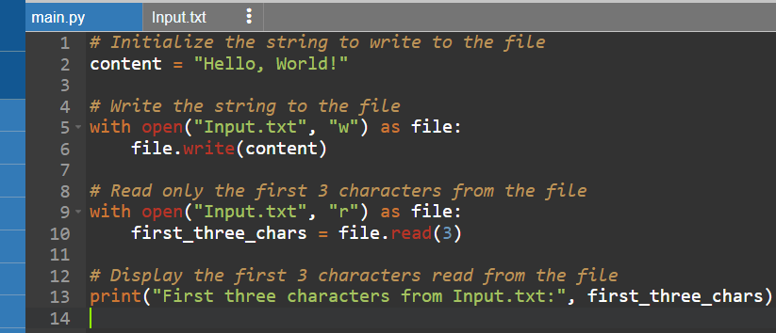

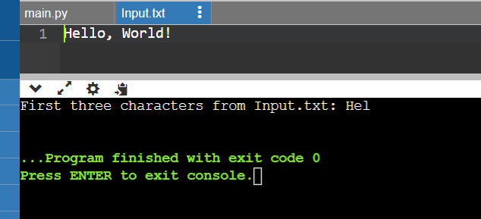
Q29) Using Panda, create a Data Frame, initialize it with the contents such as: your Enrolment Number and Name and display them.

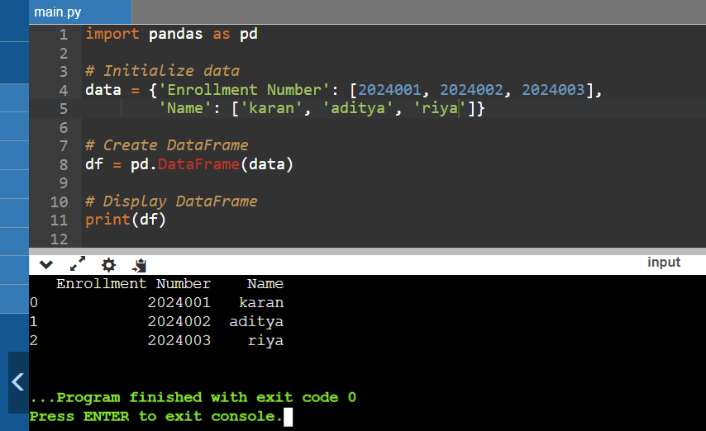

Q30) Create 2 array, using the MatPlotLib, plot the graph with the content of the two array, with coordinates plotting on X axis and Y axis.
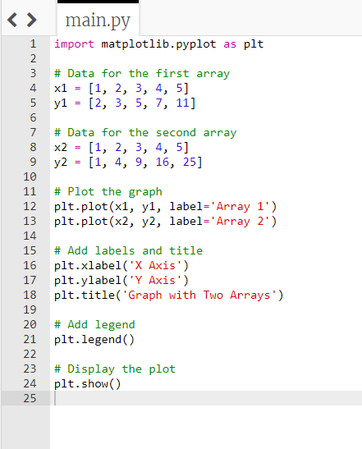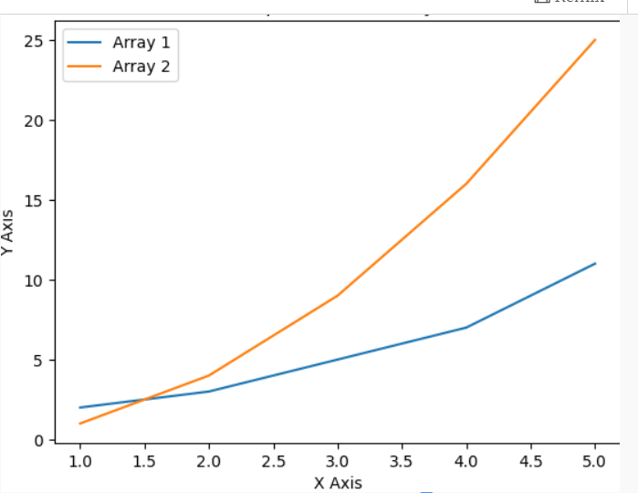
Q31) Create a .csv file (with contents like: Age, Weight and BMI). Read the content of the file and using Panda and MatPlotLib, plot the graph.
