**Report**

Team Hax (Harshvardhan & Hrishikesh Deshpande)

Game Name -- Buhido Showdown

**About:**

The Game is a Multiplayer TPP Deathmatch format-based shooter game set in a Japanese era where the Bushidos (Japanese people who spend their life as samurai) divided into 2 teams, fight to establish their dominance over the Japanese floating city called Buhido.The game is played in the colosseum of the floating city ‘Buhido ‘. Up to 10 player can join at once and the game is published on the CORE store and is played by more than 20 people from the game community till now. The game is developed using CORE Games engine which is a kind of 3D construction kit on top of UNREAL game engine which makes it easy to develop games using their free assets and UI based development. ‘LUA’ is used as the programming language for writing the scripts

**Controls:**

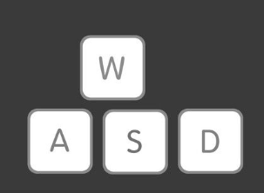**Movement**

**(Normal Jog)**

W – Forward

A – Left

S – Backward

D - Right

**Sprint - ‘SHIFT’ + W/A/S/D**

**Jump - Spacebar**

**Double Jump - Hit the Spacebar twice in a row**

**Crouch – Press C**

**To reload the weapon press R**

**To change the weapon from the inventory -- use numeric keys (1 , 2 , 3 , 4 , 5 , 6)**

**Use Left Mouse Button (LHB) to shoot and Right Mouse button (RHB) to scope in/out**

**USE F to interact like To Drive/Exit Tank, open/close doors etc.**

**Other Information: -**

Since the CORE still does not have a build support for .exe files etc. to play the game you will have to

STEP 1 – Install CORE Game from the link on the Epic game store

<https://www.coregames.com/download>

STEP 2 – After Installation, Launch the App and Search for Buhido Showdown on the CORE store and click on Play. Or use the link - “<https://www.coregames.com/games/feac3f/buhido-showdown?utm_source=copy&utm_medium=client>”

