**Main Modules (Name, Purpose, Interfaces)**



**Databases (Name, Purpose)**







**External Components (Name, Purpose)**



**Frameworks (Name, Purpose)**



**Dependencies diagram**

Example**:**

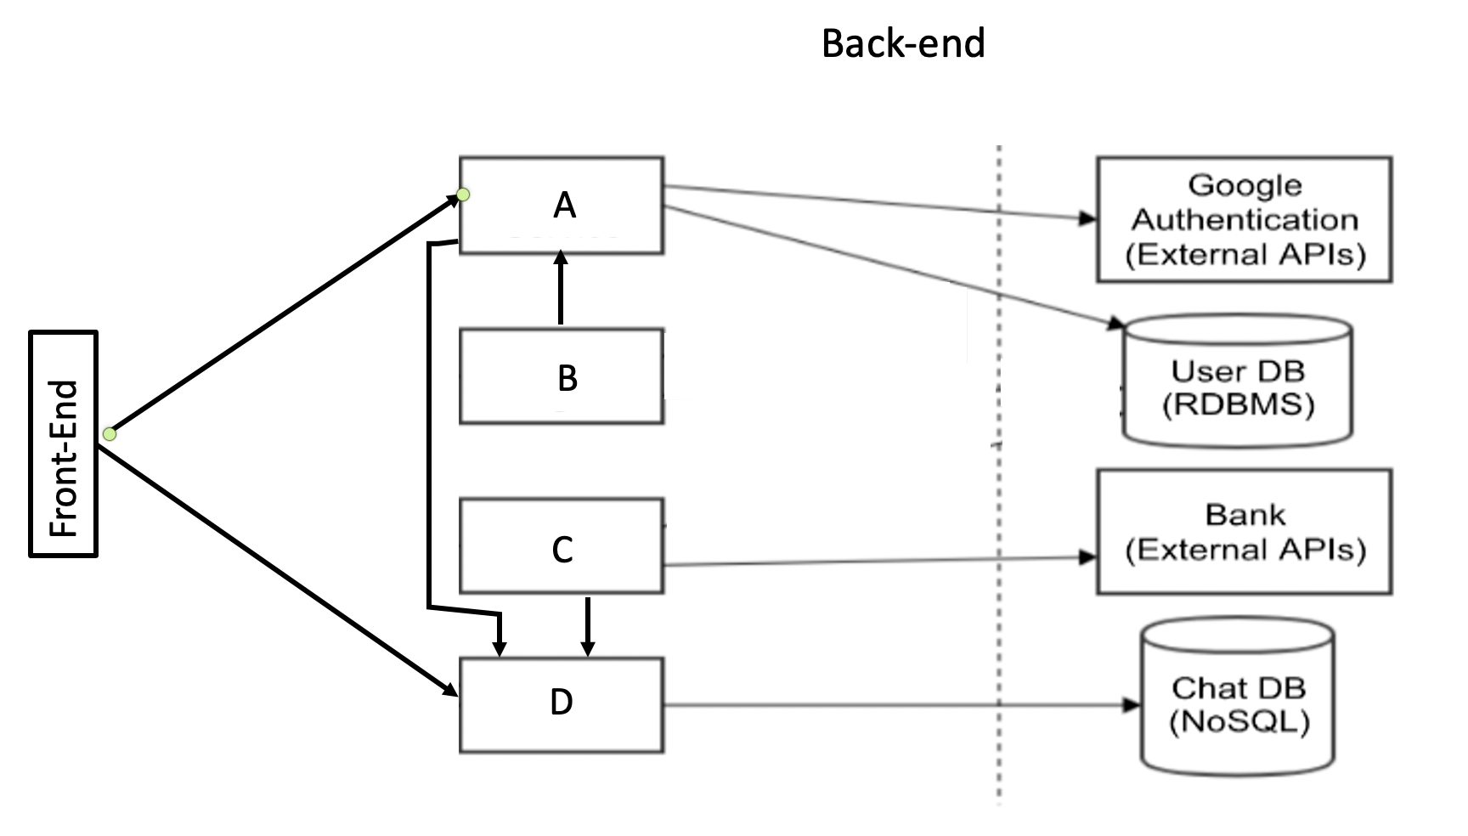

**Design of non-functional requirements**



**Design of the main project complexity**