**Regis University CC&IS**

**CS465 Unix**

**Lab Homework #1**

Student: Matt Hartigan

(all answers given below in red text)

Read through the following 26 steps and then complete them on a Unix system. Fill in your answers on this document.

When using **Word** to turn in your homework, you must TURN OFF the automatic features that cause words to be automatically uppercased. Check your settings! Case matters in Unix, so the case must be correct in the answers you give.

Each correct answer will be worth 3 points

(33 answers x 3 = 99 + 1 point for naming the file you turn in correctly).

See the end of the document for submission instructions.

NOTES:

a) When asked to "**explain**" the output, explain it in your own words – do **not** just submit the command output!

b) When asked "**what command you used**", list the **entire** command, including any arguments and options you used.

STEPS:

1. Log on to your new Unix account. You will be required to change your password immediately. Choose a mix of letters, numbers, and special characters for a secure password. Remember that Unix is case-sensitive.

Complete.

1. Type **date** and press Enter. Explain the output that is displayed.

This command outputs the date, time (accurate down to the second), time zone (Mountain), and year in the location where the linux machine is located. Since I am accessing it from Houston, Texas (Central Time Zone), the time is different here.

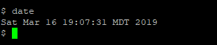

1. Type **who** and press Enter. Explain the output that is displayed.

The who command outputs all the current users that are logged into the machine, as well as which pseudo terminal they are assigned (i.e. pts/4 in my case). The date, time of login, and IP address is also included. It is worth noting that my (user harti149) IP includes the state that I am logging in from (tx). The first two user IP’s look more typical, perhaps because they are logging on either not via ssh, or from a Regis computer (or because they are the professor).

Since I was assigned pts/4 instead of pts/3, it looks like another user logged out of the system between the time that I first logged on and the time that I issued the ‘who’ command.

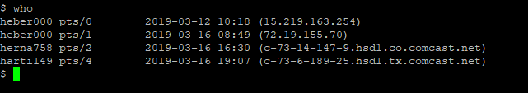

1. Type **w** and press Enter.

Explain the output that is displayed and how it differs from the **who** listing.

The ‘w’ command first displays a line stating the time, how long the system has been up, and the number of users logged on, followed by three values for loads on the overall system.

Below the first line, individual user information is displayed. It contains all the information displayed by the ‘who’ command, but with descriptive column headings, time idle, time spent on background processes, time spent on current processes, and the last command that was typed into the shell by the user.

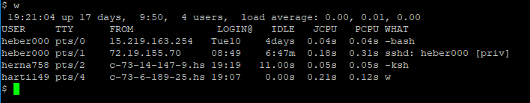

1. Type **echo hello** and press Enter.

Explain what is displayed (i.e. explain HOW the **echo** command works).

The echo command outputs the value of the argument it is given. In the case of the string ‘hello’, the string is output to stdout (i.e. the terminal screen). If we echo a variable (i.e. echo $PATH), then the value of the variable is output to stdout.



1. Display your current (working) directory pathname.   
   1. What command did you use?

pwd

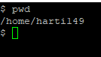

* 1. What directory was displayed?

/home/harti149

This is the user directory for my specific username.

1. Display the manual page for the **ls** command.   
   1. What command did you use?

man ls

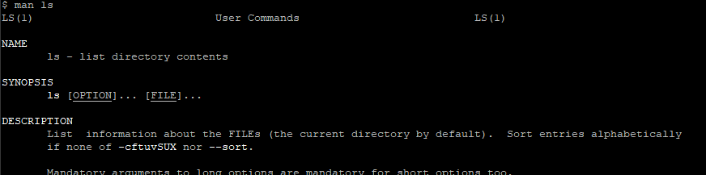

* 1. What do you need to do to exit the manual page for the **ls** command and return to the command prompt ($)?

q

Type ‘q’ for quit to return to the command prompt.

1. Type **touch lab1file** and press Enter. Then type **ls**, without any arguments, to display this directory's contents.   
   1. What is displayed by this command?

Nothing is displayed after entering the ‘touch lab1file’ command.

The name of all files in the current working directory (which is still the user directory) is displayed by the ‘ls’ command. In our case, the only visible file is the one that we created with touch.

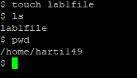

* 1. How many files do you see?   
     One.

1. Use **ls** with the **-l** option (the letter 'l', not the number 1).

Explain how the **ls -l** command is different than just an **ls** command.

The ‘ls -l’ command lists the long format of every file in the current working directory. Although there is still only one file in our working directory, we can now see the permissions, number of links, creator, date / time in addition to the filename.

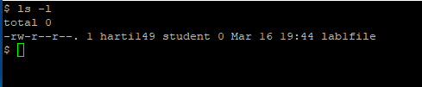

1. Use **ls** with the **-a** option.

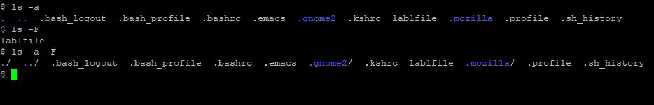

* 1. How many files do you see this time?

There are twelve total files. Four of them (‘.’, ‘..’, ‘.gnome2’, and ‘.mozilla’) are directory files. Eleven of the twelve files are ‘dot’ files, meaning that they are hidden until the ‘-a’ options is given to the ls command.

* 1. List the names of each **new** file that showed up, including directory files.

.

..

.bash_logout

.bash_profile

.bashrc

.emacs

.gnome2

.kshrc

lab1file

.mozilla

.profile

.sh_history

* 1. Where did these new files come from? Why didn't they show up using **ls** alone?

They did not technically ‘come from’ anywhere since they were always in the user directory. They are; however, hidden files so they did not show up with just an ‘ls’ command. The option ‘-a’ had to be given with the ls command to get them to appear.

1. Use **ls** with the **-aF** option.  
   Explain how a **ls -aF** command is different than just an **ls -a** command (use the **man** pages if necessary).

When using the ls command, adding the -a option displays all files (including those that are hidden) in the current working directory. Adding the ‘F’ to make the option ‘-aF’, causes the shell to display all files (including those that are hidden) in the current working directly, along with their file types. In our case, we see the ‘/’ symbol appended to four of the files, indicating that they are directory files.

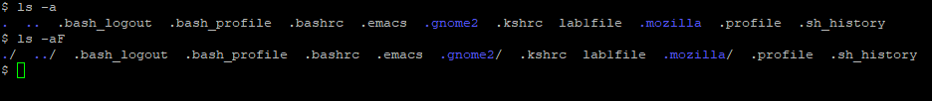

1. What is the name of the root directory on a Unix system?

/

Root is represented by a forward slash ‘/’

1. Display the contents of the **.profile** file in your home directory. (NOTE: You may need to create the **.profile** file by RENAMING the **profile** file to be **.profile**) What command did you use?

cat .profile

1. Type **whatis man**   
   Then type **whatis date**   
   Then type **whatis ls**   
   Now explain what the **whatis** command does.

The whatis command searches through the unix manual pages for each given argument. For every argument that matches, it then extracts the brief description listed for it in the manual. The matching arguments and brief descriptions are then displayed to screen.

1. Type **cal** to display the calendar for the current month.  
   Then use the **man** pages for the **cal** command to figure out how to display a calendar for an entire year.   
   1. What command would you use to display the calendar for the entire current year?

cal -y

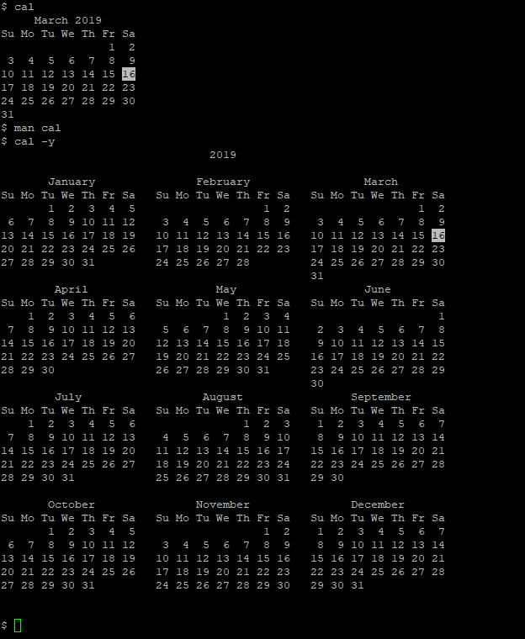

* 1. Use the **man** pages for **cal** to find out and explain what is unusual about the year 1752, and why it was done.  
     Paraphrasing from the manual: the Gregorian Reformation is assumed to have occurred in 1752 on September 3rd. Most countries in the world recognized the reformation, and the fact that 10 days were removed from the calendar after September 3rd of that year because of it. Therefore, unix captures this when it displays the 1752 calendar too.

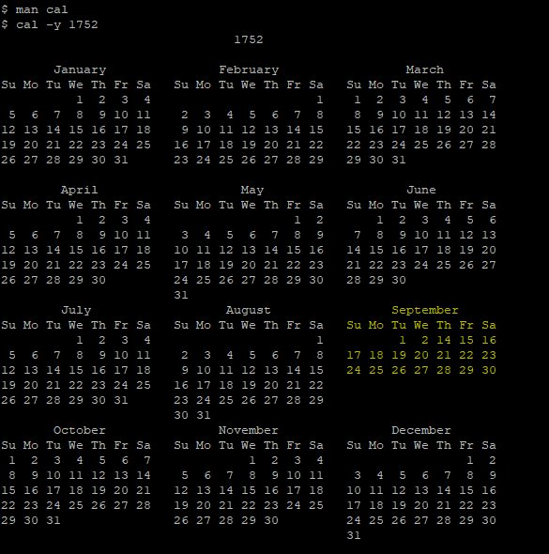

1. Use the **man** pages for the **cal** command to figure out how to display just the month in which you were born.
   1. What command did you use?

cal 6 1992

* 1. What day of the week were you born on?

Tuesday (June 16th, 1992)

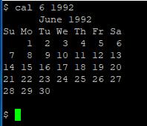

1. Use the **hostname** command to display your machine's name. What is it?

acadunixhost01.regis.local

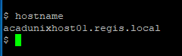

1. Send an e-mail to yourself, using the **mailx** utility. What command did you use?

mailx [harti149](mailto:mhartigan@regis.edu)

1. Enter the **mailx** utility and type: **?**  
   What does this command do?

Typing the command ‘mailx’ command by itself causes you to enter the mail utility if there are any messages. Typing ‘?’ brings up the help menu, which is a list of commands that can be used in the utility.

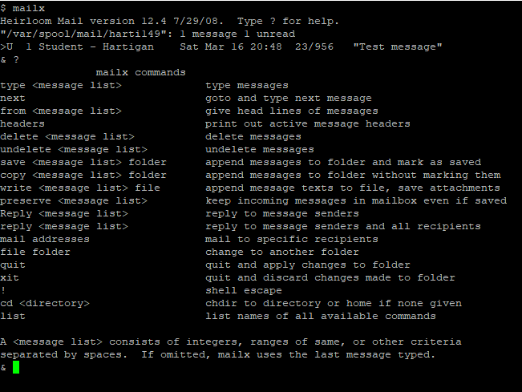

1. From within **mailx**, type: **h**  
   What does this command do?

Once in the mailx utility, typing the ‘h’ command lists the headers of all the messages in your inbox on the screen.

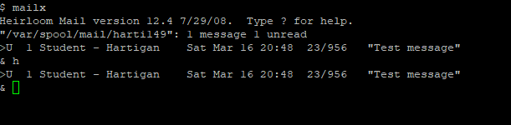

1. From within **mailx**, type: **1** (the number 1)  
   What does this command do?

It brings up the first message listed in your mailbox (i.e. the message that corresponds to the number of the argument that you give the command prompt, which in this case is a 1).

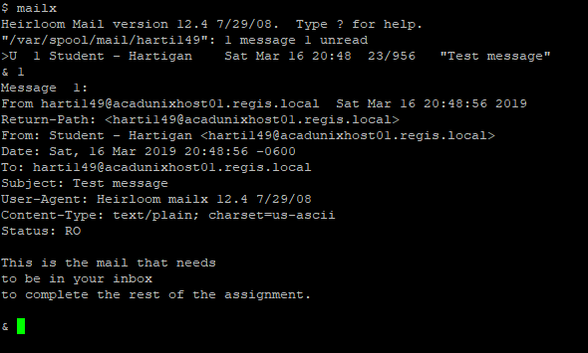

1. From within **mailx**, type: **s mymessage**What does this command do?

Since we did not specify a message number, the ‘s mymessage’ command took the current message (i.e. the one that I sent to myself earlier) and saved it into a file named mymessage in the current working directory. By going back into the mailx utility after executing this command, we see that the message is no longer there. Instead, when we open the “mymessage” file using the “cat mymessage” command in the regular terminal, we see that the message contents are all stored in that file instead.

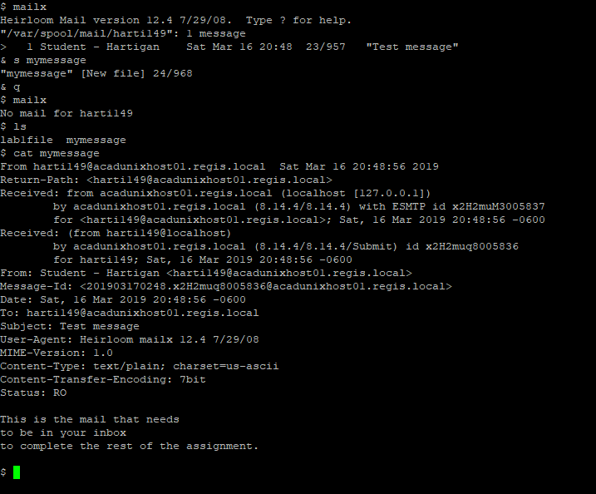

1. From within **mailx**, type: **d 1**  
   What does this command do?

It deletes the message in the mailx utility that corresponds to the argument “1”.

1. Exit the **mailx** utility.  
   What command did you use?

quit

1. There are three ways to logout of Unix.   
   Try logging out and back in using all three methods to determine which ones work on your system. Which ones worked?

Ones that worked:

exit

Ctrl-d

Ones that didn’t work:

logout

1. Send an e-mail **from your Unix account** to your facilitator's Unix account, before **midnight Sunday**.

Complete.

**Submission**

This homework assignment is due by midnight Sunday (last day of Week 1).

Submit a filled in copy of this Word document to the **Homework Assn 1** drop box (located under the Dropbox tab in the online course).

Before submitting the Word file with your answers, you MUST rename it as follows:

### Lastname-hwk1.docx

For example:

### Smith-hwk1.docx