Hannah Jensen
ITEC 3170 Section 1
HW 2 Documentation
Problem Statement: Traffic accidents are an everyday occurrence, but changes in traffic patterns may lead to an increase in accidents. I am to determine if holidays, or certain days of the week may increase the likelihood of accidents, and if so, what other factors may play an important role.

HW 1 Hypothesis: There is a significant difference in number of car crashes on holidays or specific days of the week.

HW 2 Hypothesis: Crashes are more likely to occur on weekdays, particularly during commuting periods.

Dataset: Chicago Car Crashes: https://catalog.data.gov/dataset/traffic-crashes-crashes/resource/858674f2-8acc-4803-ba50-91c7faf54030

GitHub: https://github.com/hartjensen/chicago_crashes

Process:
After determining that holidays didn’t play a huge part in car crashes, I decided to look at days of the week and weather conditions.
First, I used the same dataset as before, with the columns I found the most usefull:
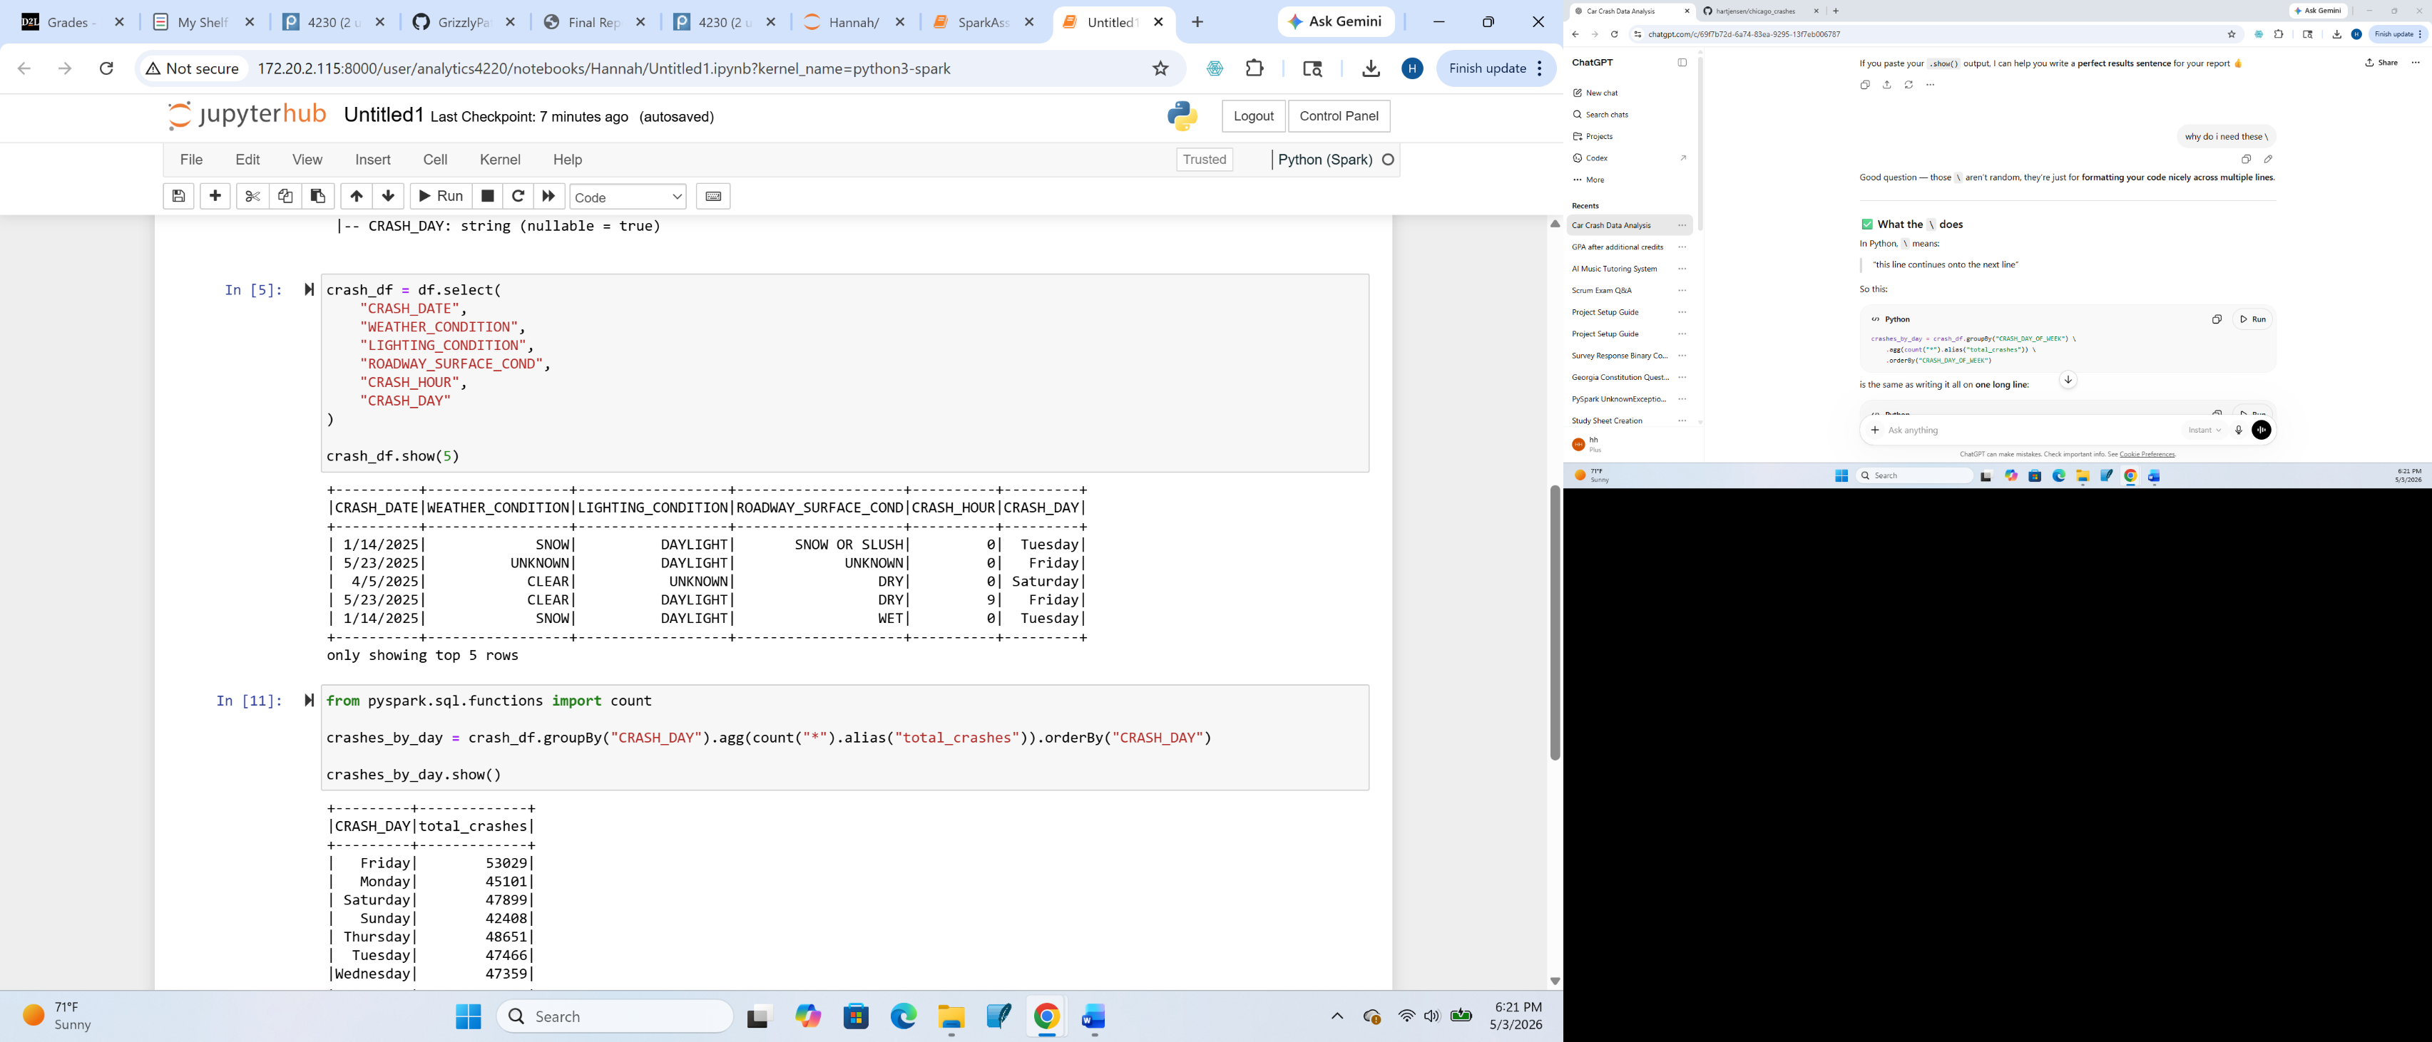
Next, I grouped and sorted the total amount of crashes per day of the week to find that Friday has the most amount of crashes.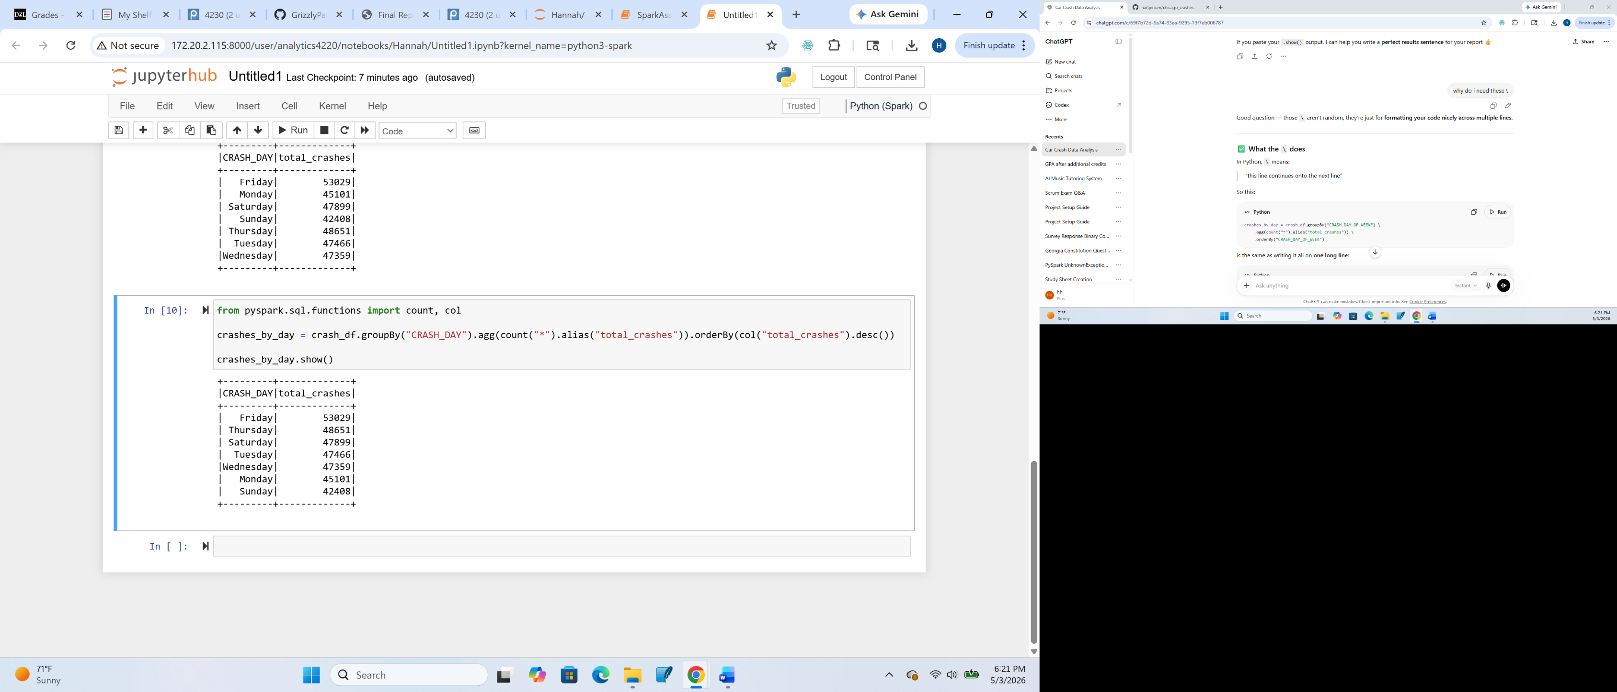
I then did the same to determine which weather conditions had the most crashes.
Conclusion: My hypothesis was that there would be an increased number of crashes on weekends due to drinking. I counted each day of the week and these were the days with the most crashes. The top 3 does contain weekend days. I also wanted to see if weather played a role, but most crashes occurred when the weather is clear.

