# 

## 

## 

## MF 30K

Document version number *1.2*

Written by *Team 5*

Point of contact  *seidl@finf.uni-hannover.de*

Date of publishing

## Group members

|  |  |  |
| --- | --- | --- |
| **Name** | **Role** | **Main contributions** |
| Yana Mavlenko | Developer, Product Owner | Frontend, Game Design (Art) |
| Kay Hartmann | Developer, Product Owner | Frontend |
| Barbara Seidl | Developer, Product Owner, Team Leader | Backend |

## Document history

|  |  |  |  |
| --- | --- | --- | --- |
| **Revision** | **Date** | **Name** | **Comment** |
| 1 | 5.12. | Screenshots | More Pictures from the actual game added |

# Game design document outline

**Table of contents** - Remember to keep this up-to-date.

**Game goals** - Why should the audience/readers care about your game? Aim for five main goals / selling points.

* MF 30K is a turn based strategic Dungeon Crawler where you gather loot, fight monsters and level up, to reach the final level before your friends do.
* Who, What, How?
  + For fantasy enthusiasts, of age 12 and above. (Basically anybody, who enjoys D&D)
  + Kick open doors, fight the monsters behind the doors, claim their treasure and level up. And remember to be faster than your friends.
  + As opposed to normal dungeon crawlers, this game combines card games with video games. All events and monsters are randomized so you never know, what might happen next.
* The game will be available on desktop PC and will feature a multiplayer mode.
* MF 30K is a turn based card strategy game, where you collect cards with items, classes and races to fight monsters and create your winning hero.
* Reach player level 10 to escape the dungeon by killing monsters. But if you lose to a monster you might die, if you’re unlucky and then it’s game over.

**Story overview** - keep this description short and frame it in the context of the gameplay.

The player is a young hero, send by their village to clear a dungeon of monsters and retrieve gold. It is said, that if you defeat 10 monsters, you will reach treasure beyond measure.  
But other villages are sending heroes as well. Will they band together, or will they turn against each other?

The story is presented in little dialogues through the game, and a little text in the beginning.

In the end, only one player can win, by defeating at least 10 monsters.

**Game controls** - Provide an overview of the controls. List specific moves that the players will be doing.

* Game is controlled by point and click via computer mouse.

**Technological requirements**

* Development tools: Spring Framework in Eclipse, Unity
* Target Platform: Desktop PC
* Design tool: Procreate
* What are the proposed tools for cheats? Not applicable.
* For PC and mobile games, include a section covering the target specs of the device needed to run the game. This would list things like the amount of RAM, minimum CPU speed, minimum graphical abilities, required peripherals and so on.
* Minimum System Requirements: 1 GB RAM, 250MB HD, CPU: Pentium 4/Athlon 64 2600+, GPU: None, OS: Windows 7

**Title/start screen** - What is the first impression of the actual game? Include the following:

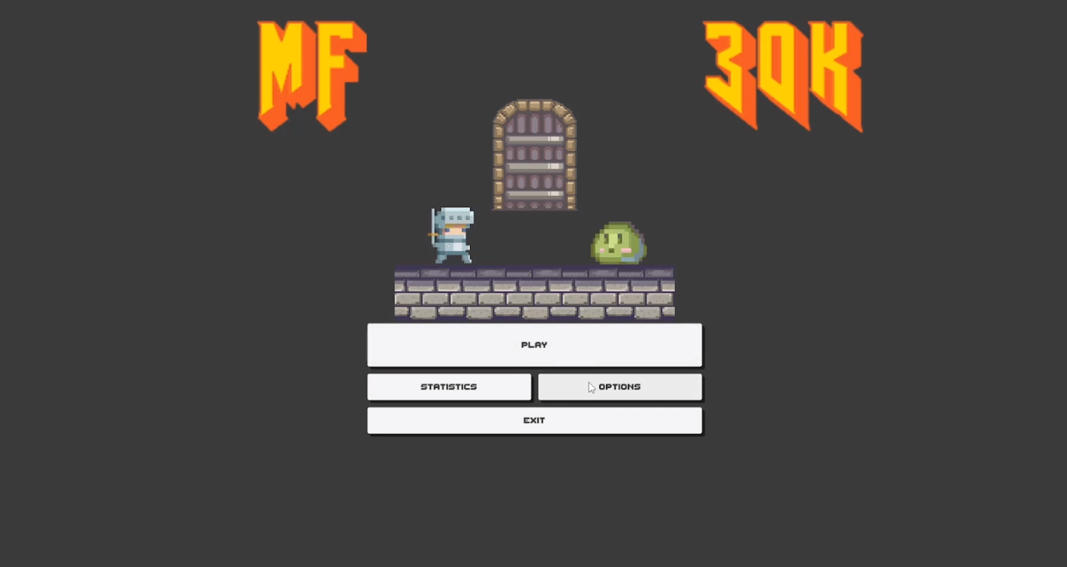

* Player can either play the game, see their statistics or access game options.
* Save/load file - Describe how a game file is saved and loaded and naming conventions for the player. Player options - Include image, sound and music, and player interface details. Include details on connecting links to options:
  + Video, audio, music, and subtitle settings; contrast tool; and alternate control settings (airplane controls, feedback on/off, and so on)

**Game flowchart** - Show how all the screens from "title/start screen" to "game over" connect with each other: Not applicable yet

**Loading screen** - Explain what the player sees when the game is loading. What images or information are presented? Not applicable yet

**Game camera(s)** – 2D Scrolling Camera, not controlled by the user, but automatically moved.

**HUD system** - Describe and/or illustrate how information will be presented on-screen to the player. Include images of all associated imagery such as health/status, power/fuel, money, timers, maps, speedometer, lives, targeting, and special view like "predator vision" or bullet-time.

The player can access their hand cards, use Equipment and access the Backpack.  
Items form the players hand (Consumables) can be used in the combatpreparation, and Equipement determines the fighting strength of the player.

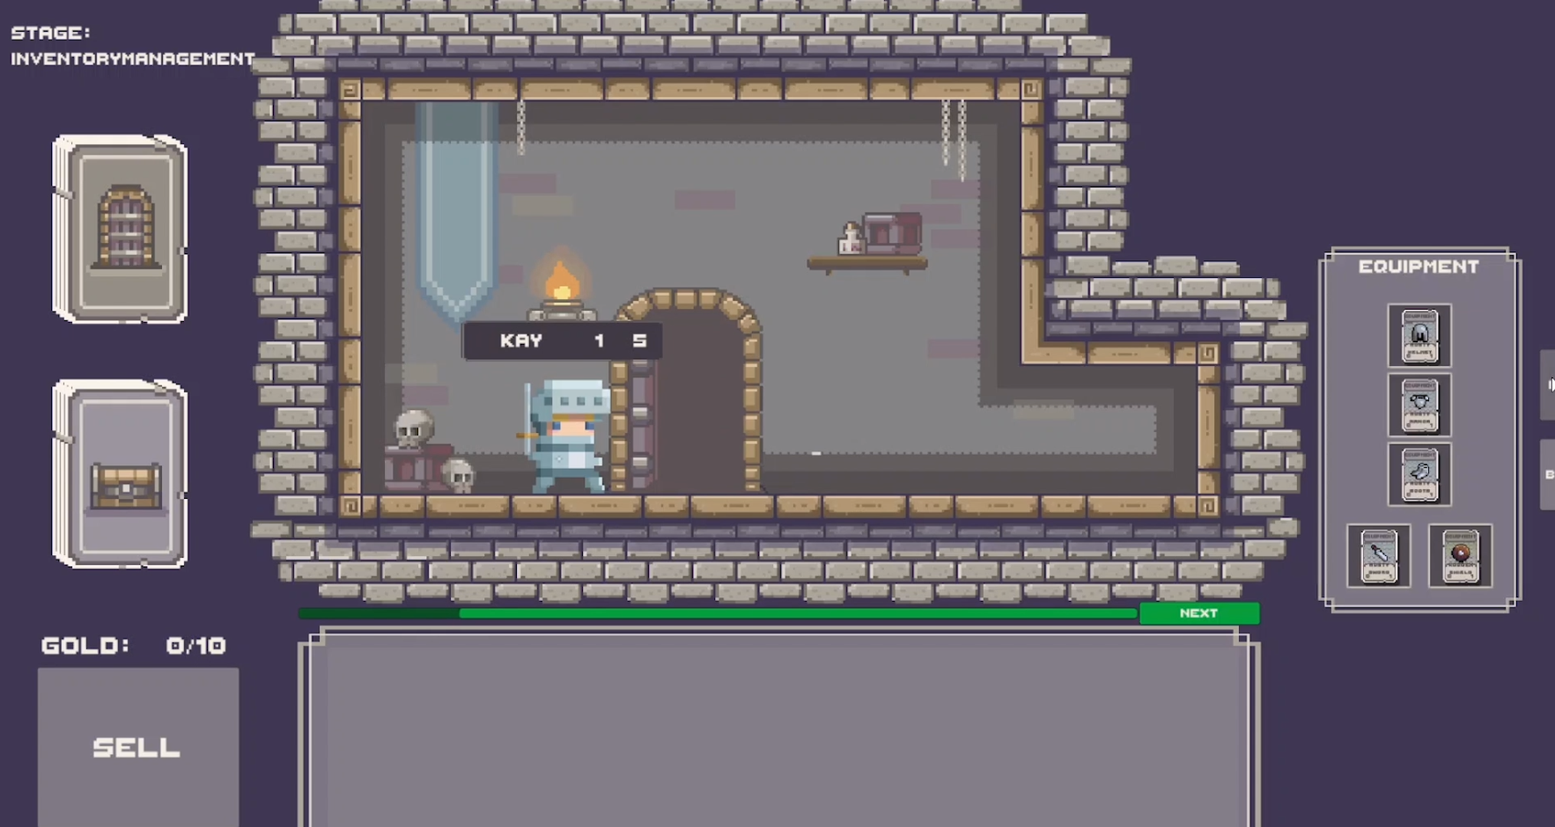

**Player character(s)** – Characters are created in the beginning of the game. Only one character of each name can exist, as they are persistent throughout different runs.

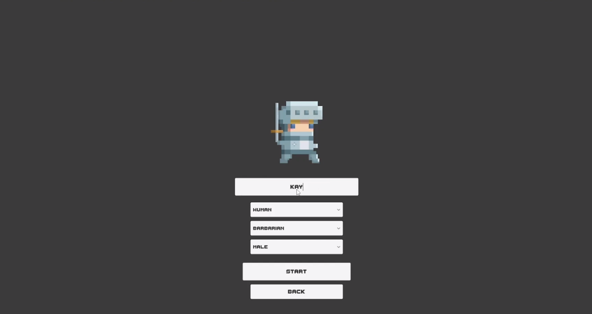

**Player metrics** - List and detail the player character and provide metrics related to movement, combat context-sensitive moves (such as QTEs), health, player death, and idles.

**Player skills** – Player skills are dependent on equipped items, class and race. The player by default does not have any skills.

**Player inventory tools** – Inventory is split into hand cards and cards in the backpack of the player. Hand cards are limited to 5, whereas the backpack has a limiting capacity of 10. The hand cards are private and invisible to other players, whereas the backpack is publicly visible for other players.

The backpack can contain only items (Equipment and consumables). The hand cards can be of any type, including monsters, class or race cards.

**Combat** – Before combat begins, there is a preparation stage

Player combat level after applying all equipment and consumable buffs are compared to the monster level. If higher, the player wins, else the monster wins.

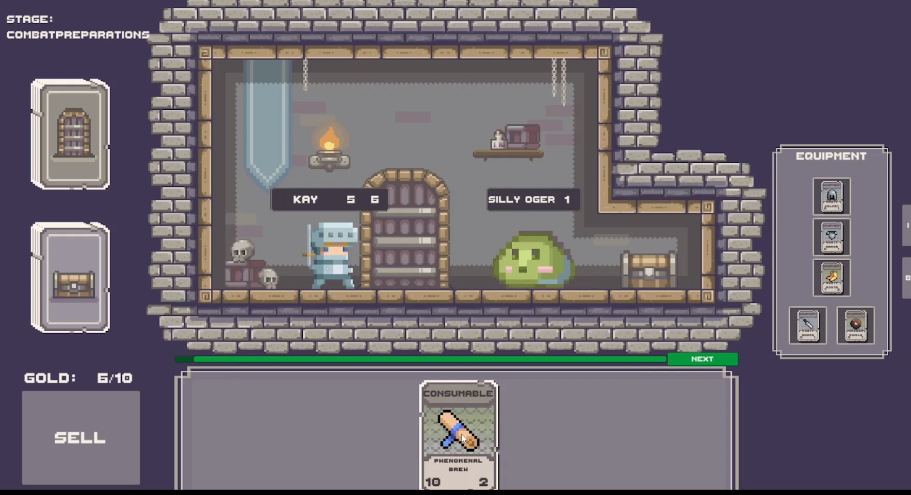

**Power-ups/state modifiers** - List power-ups and state modifiers. Show images and list what their effect and duration are.

**Health: Not applicable yet**- Describe how the player’s (or another game object’s, like car’s) health is tracked on HUD and how players can lose and replenish health. Describe how players can tell when health is low.

* Alternate states - Describe how alternate states (stunned, poisoned, turned into a baby, etc.) the player can get into and how it might affect controls.
* Lives (if applicable) - Explain how lives are earned or lost and what happens when the player runs out.
* Death (if applicable) - Describe what happens when death occurs. List situations requiring unique animations (fire, drowning, and so on). What happens when the game is over? What does the game-over screen look like? Is there a penalty for dying?
* Checkpoint system - Describe the in-game checkpoint system. How does the autosave system work?

**Scoring** – the score of each player is tracked by their player level. It can be increased by winning a fight against a monster.

**Rewards and economy** – Items (equipment and consumables) have a gold value. In the managing inventory phase items can be sold to the game to increase the player level. For every combined value of 10 goldpieces, the player can increase their level by one.

Winning against monsters also grants rewards. Monsters grant treasures in case of winning, which means for every one treasure, the player draws a random item card.

**Collectibles/object sets: Not applicable yet** - Provide a list of all items in the game, where they can be found, and what they do. Provide images.

**Vehicles** – Not applicable.

**Game progression outline** - Provide an overview of all game levels. You can do this with a Beat chart (<https://www.gamasutra.com/blogs/NickFilatov/20150623/246758/Beatchart__game_designers_best_friend.php>). Show how game play and story intertwines. Indicate introduction of major elements such as enemies, bosses, rewards, items, puzzles, or twists to the story.

In the beginn­ing, players are weak and the monsters seem strong, so they need to be working together to fight them. As the game progresses and the players level up, they are not keen to help each other anymore, but rather try to let the other players lose by using their consumables to help the monster.

**World overview/level select/navigation screen - Not applicable.** - Provide images and a control scheme showing how the player will navigate. List locations and where they lead to. Provide sound and music requirements.

**Universal game mechanics: Not applicable yet** - List mechanics that will be found throughout the game. Always include images of each mechanic. List each platform, portal, breakable, hazard, interactable object, and puzzle element and how the player interacts with them.

**Game levels** - List each of the levels mentioned in the world overview including name, short description, major gameplay, enemies, and items found in the level. Describe how the level relates to the story if applicable. Include a list of time of day, color guide, and music needs. You may even describe the level’s atmosphere, ambiance and provide a layout sketch, if applicable.

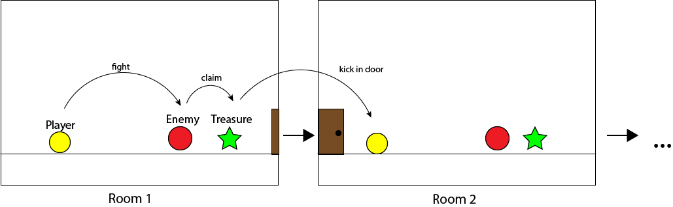

**General enemy rules** – Enemies can be found after kicking in a door. Each enemy has a combat level, and a set of consequences that are applied to the player in case of a loss. These include: death, losing equipment, losing hand cards, losing levels.

**Level specific enemies: Not applicable, as enemies are randomly generated.** - Provide an image and description of the enemy and where it appears in the game. List all movement and attack patterns and ways the player can defeat the enemy. Describe any combination attacks or encounters between different types of enemies. Describe what happens when the enemy is defeated and what the player gets for doing so. Describe also how much damage each enemy causes to the player and how much HP they have (e.g. in a table), if applicable.

**Bosses** – Not applicable. (yet)

**NPCs** (non-player characters) – not applicable.

**Mini games** – Not applicable.

**Monetization** – Not applicable.

**Music and SFX** – Background Music, Combat Music Title Screen Music, Sound effects for: Playing a card, combat, putting cards in your backpack, drawing a card, victory, defeat, level up.