User Manual: Monster Fighter 30K

Starting the game: Prerequisites
To start the game, you need to start of course the MF30K unity application, but you also need to start the server beforehand. Otherwise you can’t connect to the server. You can start the server, by running the mf30K-SpringApplication.
Starting the Game: Creating a user
To create a user, you simply type the username into the “ENTER USERNAME” field and click “SIGNUP”. If the username is already taken, you will be presented with an error, and you will need to choose a username, that is not already used.
To sign in to your account, type in your username and click “SIGNIN”.
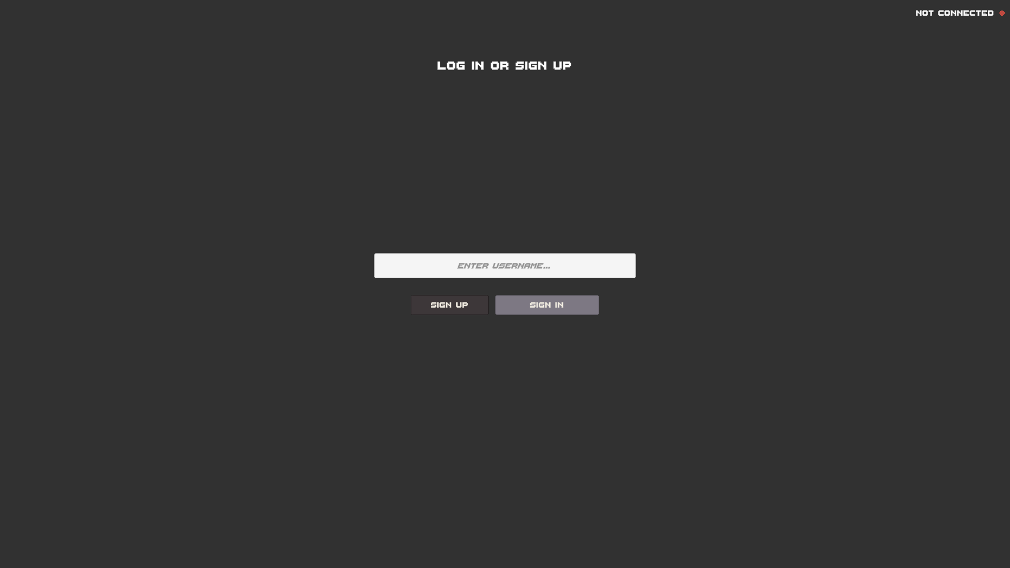
Playing the game: Starting a new Run.
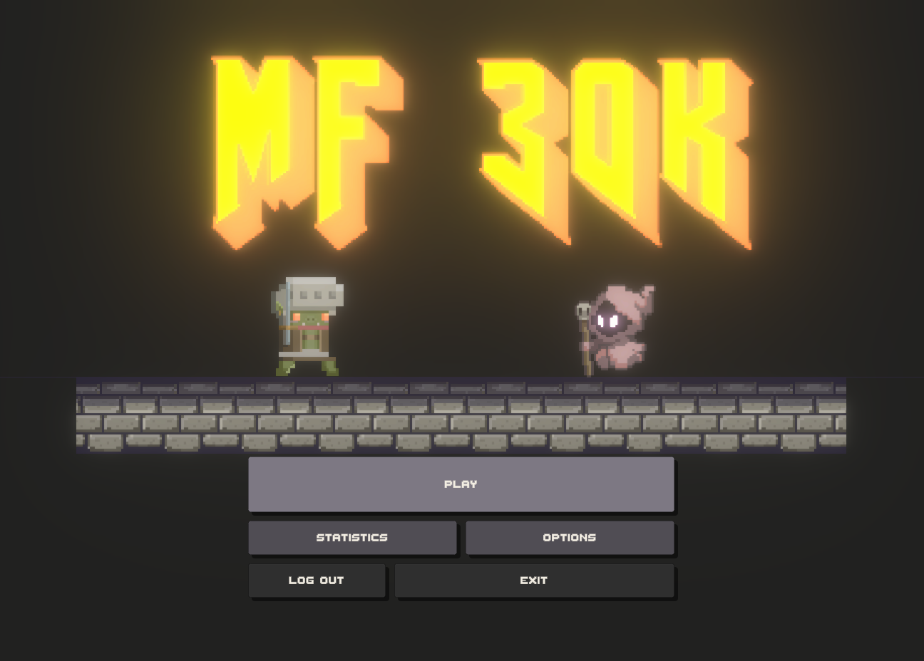
To play the game, click “PLAY” in the title screen. This leads you to the character selection.
Here you can select your race, profession and gender, by clicking on the corresponding field and selecting your choice from the drop down menu. There are three options for race and profession each.
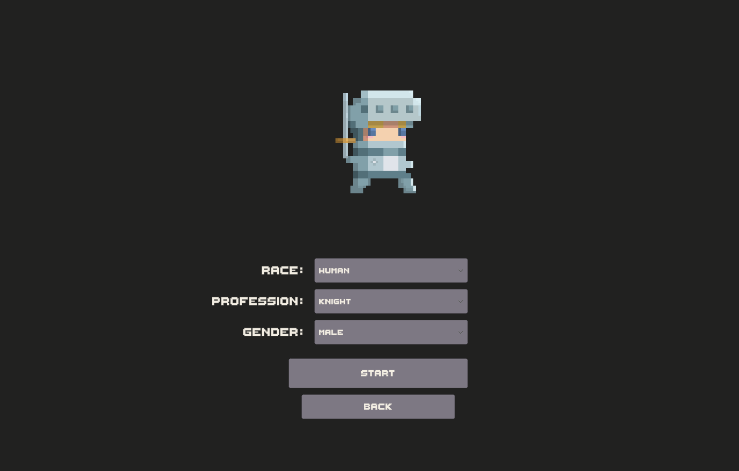
Race: Orc, Elf, Human
Profession: Knight, Wizard, Rogue
Gender: Male or Female
To start the game with your character click “START”. To go back to the title screen click “BACK”.

Playing the Game: HUD
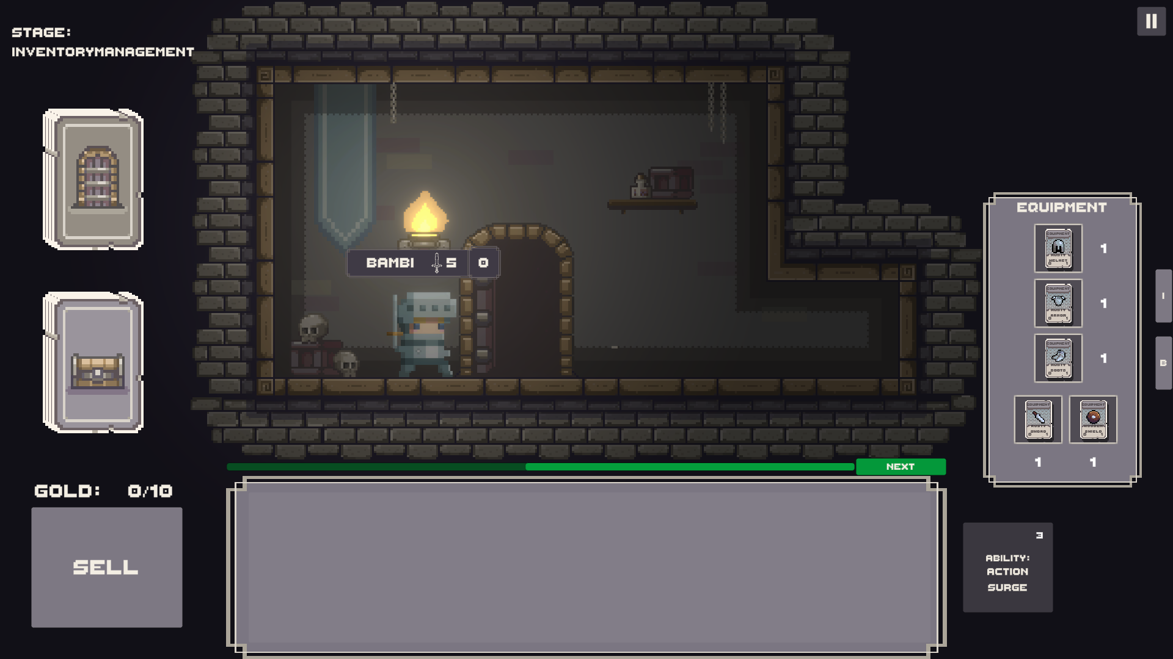
Your character has five slots for equipment, an inventory that can hold up to five cards and a backpack, that can hold up to ten cards. You can toggle between equipment and backpack, by clicking the “E” or “B” button on the right.
You start the game with standard starting equipment. You can drag and drop equipment from its slots to your inventory and the other way around. Note that you can only equip equipment in their designated slots (Helmets only in the topmost slot, Armor only in the upper middle slot, Boots only in the lower middle slot and Weapons only in the two bottom slots).
You have one skill, based on the profession you chose. You can see what your profession does, by hovering over the “ABILITY” field with your mouse. Once you activate your ability, you need to wait three rounds until you can activate it again.
You can sell cards, by dragging them onto the “SELL” field and you will automatically receive their gold value. For every ten gold, you gain one heroic level. (Your starting equipment does not have a gold value.)
Actually playing the game: Goal of the game
The goal of this game is, to fight monsters and loot their treasure. In order to do that, you are venturing deeper into the dungeon, trying to reach heroic level ten. Once you reach that level you can exit the dungeon. If you fail to do so, you are stuck in the dungeon forevermore.
To progress the game, you press the “NEXT” button above your inventory.
Once you do that, you will enter the dungeon, where monsters will await you!
Fighting Monsters: Preparation
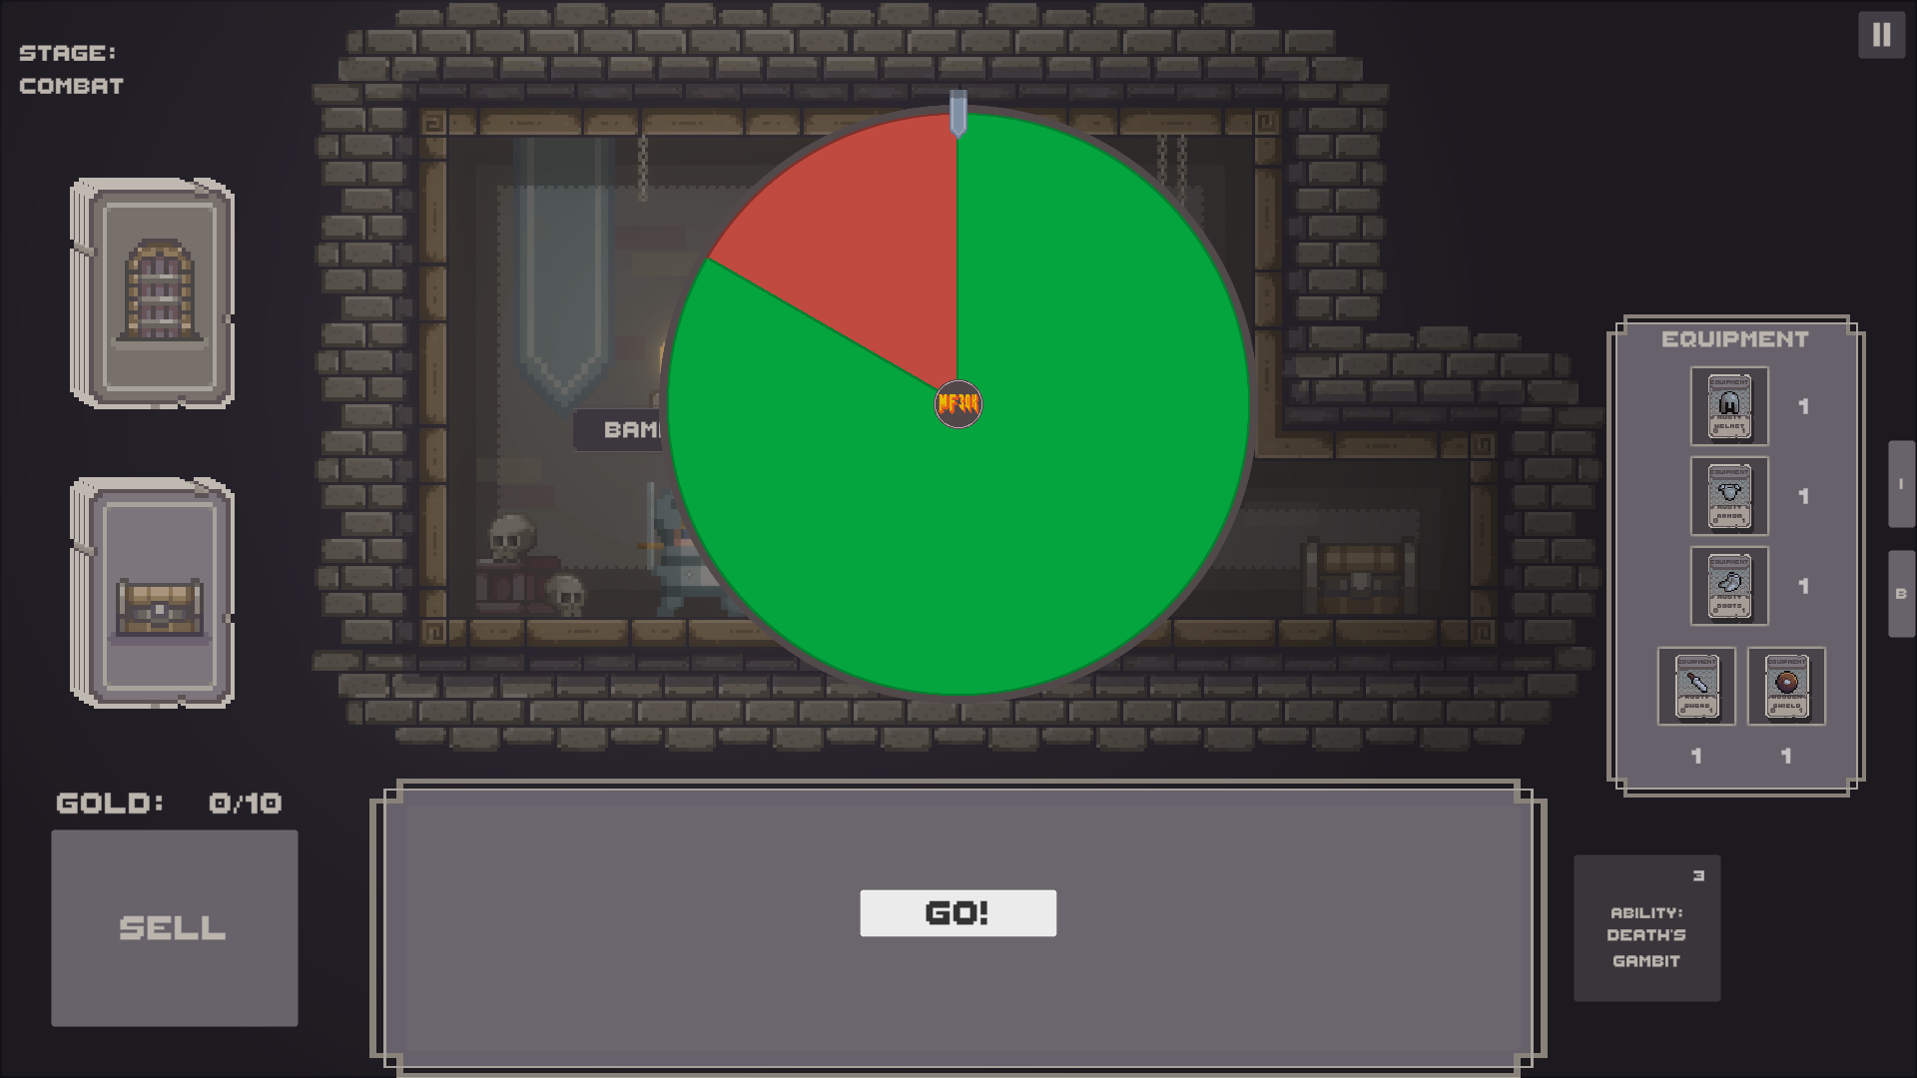
When you encounter a monster, you automatically fight it and the outcome is chance based! So you spin a wheel, and if it stops in the green zone you win, if it stops in the red zone, the monster wins! Your goal is, to stack the odds in your favor, because the ratio of the zones is directly proportional to your combat level, and the monsters combat level. The combat level is the sum of all your equipped equipment and your heroic level.
Before the fight, you have a combat preparation stage, where you can change your equipment, and use consumable items, that you will find as treasure in the dungeons. These consumables will boost your combat level for one fight, while equipment boosts your combat level as long as you have it equipped.
Note that you can’t access your backpack in this stage! Only your inventory and equipment! So you should think twice if you really want to put stuff in your backpack.
Winning and losing:
If you win against a monster, you receive treasures and you gain one heroic level. Treasures can be added to your inventory or backpack or they can be sold.
If you lose, you are presented with four cards, that look identical. On the backside are four different consequences, and you must choose one of them at random.
Consequences are:
- Losing a level.
- Losing a card from your hand.
- Losing a piece of equipment.
- Running away (nothing happens).
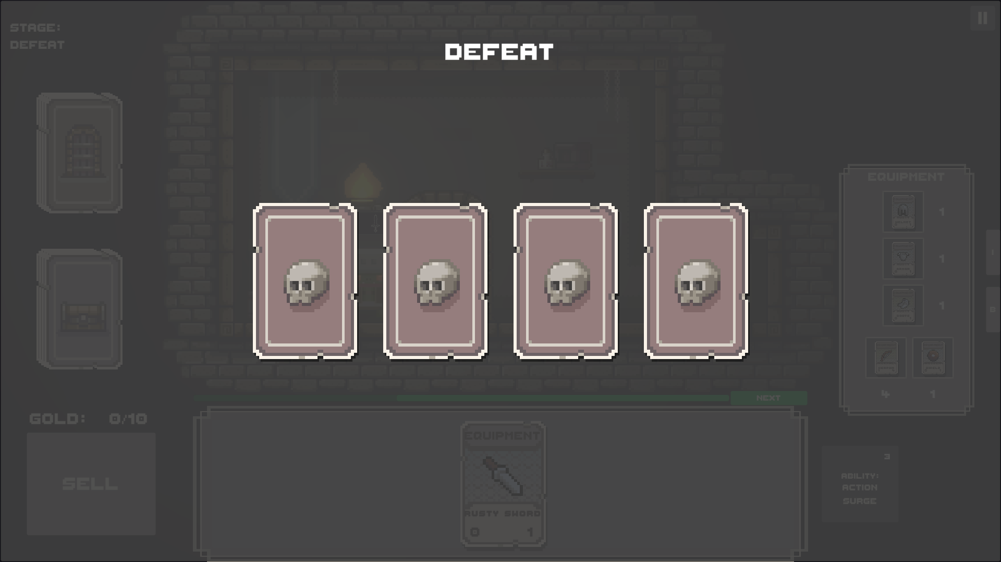
Using Abilities:
In the combat preparation stage, you can also choose to activate your ability. The three professions each grant one ability.
Wizard – “Charm Monster”: Reduces the monster level by half.
Knight – “Action Surge”: If you would lose the combat, spin the wheel a second time.
Rogue – “Death’s Gambit”: If you win, you receive an additional treasure, but if you lose you have no chance of running away. (You only have three cards to choose from, after a loss).
Effects of your race:
The race you choose in the beginning has a static effect on your combat level.
Elf: You have +1 against ghost monsters, and -1 against slime monsters. (Slimes are disgusting, and you don’t want that stuff on your clothes.)
Orc: You have +1 against slime monsters, and -1 against ghost monsters. (Slimes look kind of tasty, but ghosts are scary..)
Human: You are indifferent to the type of monster ±0 against both types. (Monster is monster.)

