Sample document with a figure
First paragraph. This document has a real text layer. The figure below shows quarterly results. After the figure, more text continues here. This is the final paragraph of the document.
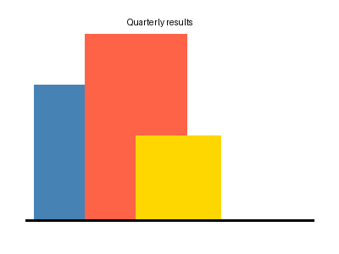
Caption: quarterly results chart.

