Garmin Bimodality Histogram
User Manual
A Claude skill for converting Garmin Connect sleep timeline screenshots into REM respiratory bimodality histograms.
Version: 1.0
Includes: 5 embedded test screenshots for installation validation
Distribution: garmin-bimodality-histogram.skill

1. What this skill does
This skill is a tool that lets Claude convert one or more Garmin Connect sleep timeline screenshots into a respiratory bimodality histogram with a Gaussian Mixture Model (GMM) overlay. It reads the black breathing-rate trace inside the magenta REM segments, calibrates against the right-axis brpm labels via OCR, and produces a labeled PNG histogram plus per-night statistics.
It is designed for users who collect Garmin sleep screenshots over time and want to assess whether their in-REM breathing distribution shows bimodality (two distinct breathing-rate modes) or unimodality (a single mode), and how those properties change across measurement periods.

Intended use
- Personal sleep-data analysis from Garmin Connect mobile or web screenshots.
- Research or self-experimentation tracking REM respiratory variability over time.
- Quantitative supplements to Garmin Health submissions, sleep-medicine notes, or longitudinal self-tracking projects.

Not intended for
- Clinical diagnosis or replacement of polysomnography. Garmin's sleep staging is a consumer-grade estimate; downstream analytics inherit that uncertainty.
- Real-time alerting. This skill processes after-the-fact screenshots, not live data.

2. Installation
The skill is distributed as a single .skill file. Install it once per Claude.ai account; Claude will trigger it automatically when you upload Garmin screenshots and ask for histogram analysis.

Steps
- Obtain the file garmin-bimodality-histogram.skill (distributed alongside this manual).
- Open Claude.ai and go to Settings → Capabilities → Skills.
- Click Upload skill and select the .skill file.
- Confirm the skill appears in your list. It is now available for use in any conversation.

Verifying the installation
Section 4 of this manual contains 5 test screenshots embedded as images. Right-click each, save them to your machine, upload them to a fresh Claude conversation, and ask Claude to generate a 5-night bimodality histogram. Compare the resulting numbers against the reference values in Section 5. If they match within the tolerances listed there, your installation is working correctly.

3. How to use the skill

Typical workflow
Open a new Claude conversation, attach one or more Garmin Connect sleep screenshots, and ask in natural language for the analysis you want. Claude will trigger the skill, run the underlying scripts, and return the histogram PNG plus per-night statistics.

Example prompts that trigger the skill
- "Here are 5 Garmin sleep screenshots. Build a bimodality histogram of the pooled REM samples."
- "Extract REM breathing-rate samples from this Garmin screenshot and show me the histogram."
- "Run a GMM test on these sleep timelines and tell me whether the distribution is bimodal."
- "Compute Ashman’s D and RMS deviation for each of these nights."

Acceptable screenshot formats
Garmin Connect sleep timeline screenshots must show:
- The black respiratory trace overlaid on the sleep-stage timeline.
- Pink/magenta vertical bars marking REM segments.
- Light-blue fills marking Light/Deep sleep.
- The right-side numeric brpm axis (e.g., "8 12 16 20" or "8 12 16 20 24 28 32").
- Bed Time and Wake Time labels at the top corners (optional but useful).
Both mobile-format and web-format Garmin Connect screenshots are supported. The skill auto-detects axis range, plot bounds, REM segments, and trace position. Dark-mode screenshots have not been validated and may require color-threshold adjustment.

What you get back
For each Garmin screenshot the skill returns:
- Number of REM segments detected.
- Number of brpm samples extracted (one per pixel column inside REM).
- Per-night mean brpm and RMS deviation from mean.
- Min/max brpm range.
- Axis calibration parameters (sanity check).
For a pooled multi-night analysis the skill also returns:
- Pooled-sample histogram PNG with k=1 (purple) and k=2 (red) GMM overlays.
- BIC for k=1 and k=2 fits.
- ΔBIC (positive favors bimodal).
- Mode separation in brpm.
- Ashman’s D statistic (D > 2 indicates clear separation).
- Verdict: "bimodal (k=2)" if ΔBIC > 6 AND D > 2, else "unimodal (k=1)".

4. Test data — five Garmin screenshots
The following five Garmin Connect sleep timeline screenshots are provided as synthetic test data. Each one is a real Garmin screenshot from a single night of sleep. Together, they form the validation dataset for this manual: process all five through the skill and compare against the reference numbers in Section 5.
To use the test data:
- Right-click each embedded image below and save it to your computer with the filename indicated.
- Upload all five PNG files to a fresh Claude conversation.
- Ask Claude: "Build a 5-night bimodality histogram from these Garmin screenshots."
- Compare the resulting per-night and pooled statistics against Section 5 of this manual.

Night 1 — save as night_01.png
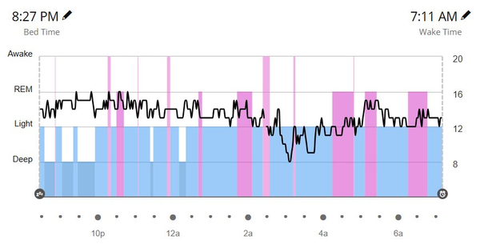
Expected extraction (within ±2 segments / ±0.1 brpm tolerance):
n_REM_segments = 10, n_samples ≈ 110, mean = 13.32 brpm, RMS = 1.20 brpm

Night 2 — save as night_02.png
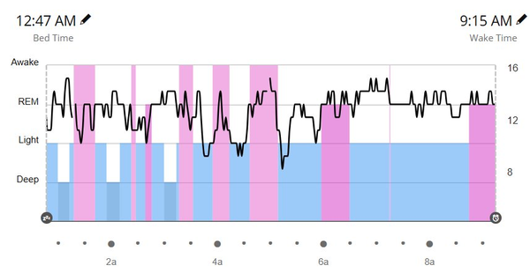
Expected extraction (within ±2 segments / ±0.1 brpm tolerance):
n_REM_segments = 8, n_samples ≈ 186, mean = 13.04 brpm, RMS = 1.00 brpm

Night 3 — save as night_03.png
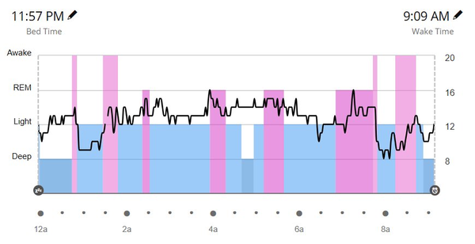
Expected extraction (within ±2 segments / ±0.1 brpm tolerance):
n_REM_segments = 7, n_samples ≈ 186, mean = 13.36 brpm, RMS = 1.57 brpm

Night 4 — save as night_04.png
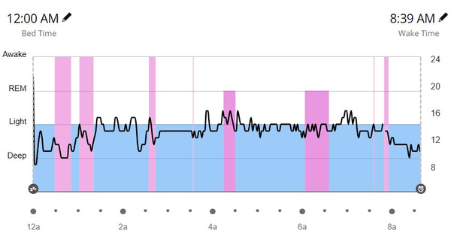
Expected extraction (within ±2 segments / ±0.1 brpm tolerance):
n_REM_segments = 7, n_samples ≈ 110, mean = 12.82 brpm, RMS = 1.85 brpm

Night 5 — save as night_05.png
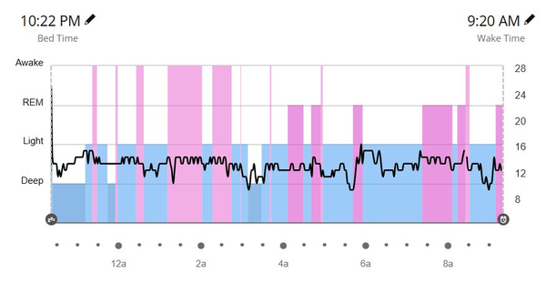
Expected extraction (within ±2 segments / ±0.1 brpm tolerance):
n_REM_segments = 12, n_samples ≈ 186, mean = 13.71 brpm, RMS = 0.75 brpm

5. Reference results
Below are the expected numerical results when all five test screenshots are processed and pooled. Use these as your installation-validation target. Small variations are expected due to OCR precision and pixel-thresholding noise (see tolerances in the previous section).

Per-night summary
Night | File | REM segs | Samples | Mean (brpm) | RMS (brpm)
1 | night_01.png | 10 | 110 | 13.32 | 1.20
2 | night_02.png | 8 | 186 | 13.04 | 1.00
3 | night_03.png | 7 | 186 | 13.36 | 1.57
4 | night_04.png | 7 | 110 | 12.82 | 1.85
5 | night_05.png | 12 | 186 | 13.71 | 0.75

Pooled five-night statistics
Nights pooled | 5
Total samples | 778
Period mean brpm | 13.25
Period mean RMS | 1.27 brpm
k=1 fit: μ | 13.29 brpm
k=1 fit: σ | 1.32 brpm
k=1 fit: BIC | 2652.3
k=2 fit: μ_A (low mode) | 11.83 brpm (29% weight)
k=2 fit: σ_A | 1.23 brpm
k=2 fit: μ_B (high mode) | 13.88 brpm (71% weight)
k=2 fit: σ_B | 0.78 brpm
k=2 fit: BIC | 2558.4
ΔBIC (BIC₁ − BIC₂) | +93.9 (favors k=2)
Mode separation | 2.05 brpm
Ashman's D | 1.99 (just below 2.0 threshold)
Verdict | unimodal (k=1)

Interpretation of the test result
This 5-night pool is a textbook borderline case. The Gaussian Mixture Model strongly prefers two components statistically (ΔBIC = +93.9, far above the conventional threshold of 6), but the modes are not quite separated enough to call clear bimodality (Ashman's D = 1.99, just below the D > 2 threshold). The skill applies a strict dual-threshold rule — bimodality requires BOTH ΔBIC > 6 AND D > 2 — and therefore reports the verdict as unimodal.
This is intentionally a borderline case in the test data so the manual exercises the verdict logic. On strongly bimodal periods (e.g., baselines from prior n=1 self-experiments), both thresholds are typically clearly exceeded (ΔBIC > 30, D > 2.3) and the verdict is unambiguous. On strongly unimodal periods (post-intervention), ΔBIC may be negative or D well below 1 and again the verdict is unambiguous. This test set lives in the interesting middle.

Reference histogram visualization
Below is the histogram you should see when the five-night pool is processed and rendered. The shape, fitted curves, and stats panel content should closely match what the skill returns.
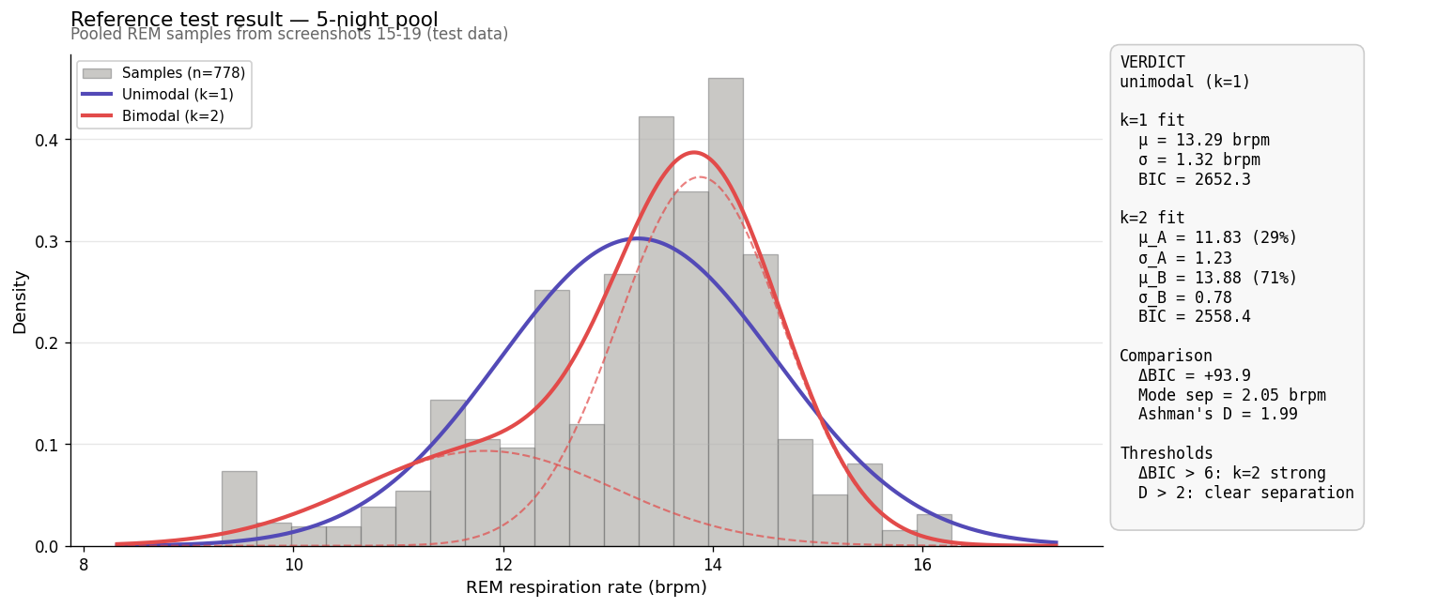

6. Understanding the output

Per-night statistics
Mean brpm: the arithmetic mean of all sampled breaths inside REM segments for that night. Typical adult values lie roughly between 12 and 16 brpm. Outliers below 9 or above 20 brpm usually indicate either a wake-transition artifact that escaped the edge-trim or a non-standard screenshot.
RMS deviation: the root-mean-squared deviation of samples from the nightly mean. This is the primary variability metric used in the underlying research. Values around 1.0–1.3 brpm are typical for unstabilized baseline nights; values below 0.9 brpm indicate notably stable in-REM breathing.
n_REM_segments: the number of contiguous pink REM bars detected. Typical adult nights contain 4–6 REM cycles; if Garmin classifies REM in many short bursts, this may run higher.
n_samples: the total number of brpm readings extracted (one per pixel column inside REM, with 3 columns trimmed at each REM-segment edge). More samples → tighter histogram → more reliable statistics.

Pooled-period statistics
ΔBIC = BIC(k=1) − BIC(k=2): the Bayesian Information Criterion difference. Positive favors the two-component fit. ΔBIC > 6 is the conventional threshold for strong evidence.
Mode separation: the brpm distance between the two fitted Gaussian centers. Separations below 1.0 brpm usually indicate the modes are too close to meaningfully resolve.
Ashman's D: a separation statistic that compares the gap between the two modes against their combined standard deviation. D > 2 is the conventional threshold for clear visual bimodality.
Verdict: the skill reports "bimodal (k=2)" only if ΔBIC > 6 AND D > 2. Both criteria must pass to avoid false positives from non-Gaussian unimodal distributions (which GMM may statistically prefer to fit with two overlapping components).

7. Honest caveats and limitations
This skill is precise enough for research and self-tracking use but has well-known limits. Please be aware of these when interpreting results.

Pixel precision
Each brpm reading is extracted from a single pixel column. With typical Garmin screenshots showing an 8–20 brpm axis over ~250 vertical pixels, one pixel ≈ 0.05 brpm. With a compressed 8–36 axis the same pixel ≈ 0.11 brpm. Reads with stretched axes are therefore less precise than those with compressed axes.

Wake-transition artifacts
At the edges of REM segments, the breathing rate often spikes upward into the wake-transition. The skill trims 3 columns at each REM-segment edge to mitigate this, but unusually short REM segments (< 7 columns) may still contribute transition-influenced samples.

REM classification accuracy
Garmin's REM classification is itself a consumer-grade estimate based on heart-rate variability and wrist motion, not EEG. False-positive REM (sometimes light sleep mis-classified) and false-negative REM (REM mis-classified as light) both occur. This skill cannot correct for that — it only analyzes what Garmin marks as REM.

OCR robustness
The right-axis label OCR works reliably on standard Garmin Connect screenshots from both mobile and web interfaces with default color schemes. Dark-mode screenshots and aggressively cropped screenshots may fail OCR; in such cases the skill returns an explicit error rather than fabricating a calibration.

Statistical power for single-night histograms
A single Garmin screenshot typically yields 50–200 in-REM samples, which is on the lower end for reliable Gaussian Mixture fits. Pooled multi-night histograms (n ≥ 500) give substantially more trustworthy bimodality verdicts. Single-night results should be treated as suggestive rather than definitive.

Not for clinical diagnosis
This skill is designed for self-tracking, research, and Garmin-data exploration. It does not produce clinically validated metrics. If you are concerned about respiratory disturbances during sleep, consult a sleep specialist; polysomnography remains the standard for clinical assessment.

8. Troubleshooting

"No REM samples extracted"
The skill could not find any pink/magenta REM bars in the screenshot. Possible causes:
- The screenshot does not contain REM segments (whole night classified as Light/Deep).
- The screenshot is from a non-standard Garmin theme that uses a different REM color.
- The screenshot was heavily compressed or otherwise mangled before upload.
Resolution: upload an uncompressed Garmin Connect screenshot from a night that includes REM sleep.

"OCR failed to detect 2+ axis labels"
The right-axis label OCR found fewer than two confident numeric labels. Possible causes:
- The screenshot is cropped and does not include the right-axis labels.
- The numeric labels are too small (image was scaled down before screenshotting).
- Dark-mode color scheme reducing OCR contrast.
Resolution: re-screenshot the original Garmin chart at full resolution, ensuring the entire right-axis is visible.

Per-night mean brpm seems wildly off (e.g., 5 or 30)
Almost always an axis calibration failure. Inspect the returned axis_calibration.labels field in the JSON output — if it shows fewer than two labels or implausible values (e.g., 100, 88), the OCR misread something. Try uploading the screenshot at higher resolution or trimming any non-Garmin-Connect UI elements from the image.

Verdict says "unimodal" but I can clearly see two bumps
If the histogram shows visible bimodality but the verdict is unimodal, check both numbers in the stats panel. The dual-threshold rule (ΔBIC > 6 AND D > 2) is intentionally strict; borderline cases with D between 1.7 and 2.0 read as unimodal even when the bumps are visible. The mode centers, weights, and separation values are still reported — interpret with judgment if the verdict is borderline.

9. Appendix

Files in this distribution
- garmin-bimodality-histogram.skill — the skill package (install via Claude.ai settings).
- garmin-bimodality-histogram_user-manual.docx — this document.
Inside the .skill package (.zip):
- SKILL.md — instructions Claude follows.
- scripts/extract_rem_samples.py — single-screenshot extractor.
- scripts/batch_extract.py — multi-screenshot pooler.
- scripts/make_histogram.py — GMM histogram renderer.

Dependencies (handled automatically inside Claude's runtime)
- Python 3.10+
- numpy, scipy, scikit-learn (Gaussian Mixture Model)
- Pillow (image loading)
- matplotlib (histogram rendering)
- pytesseract + tesseract-ocr (right-axis numeric OCR)

Glossary
BIC (Bayesian Information Criterion): a model-selection score that balances fit quality against parameter count. Lower is better.
GMM (Gaussian Mixture Model): a probability distribution modeled as a weighted sum of Gaussian components.
Ashman's D: a separation statistic defined as √2 · |μ_B − μ_A| / √(σ_A² + σ_B²). D > 2 indicates that two Gaussian components are clearly separated rather than blurring into a single broad mode.
REM: Rapid Eye Movement sleep stage, characterized by elevated and more variable breathing relative to NREM stages. The skill samples only within Garmin-classified REM segments.
brpm: breaths per minute, the unit of respiratory rate.
RMS deviation: root-mean-squared deviation from the per-night mean, in brpm. The primary variability metric for in-REM respiration.

Version history
1.0 — Initial release. Tested on 30 Garmin Connect screenshots across both mobile and web formats, with axis ranges from 8–20 to 8–36.

