Study proposal — occupational health pilot
REM-respiration bimodality as a candidate autonomic-stability biomarker in a power-station occupational cohort
A 100-participant Phase A pilot validating a software-only sleep biomarker derived from existing wearable data, in a cohort with elevated occupational respiratory and thermal burden.

Summary
Background. REM-respiration bimodality is a candidate autonomic-stability biomarker that has shown a substantial signal-to-noise advantage over standard heart-rate variability metrics in a single-subject longitudinal record (3.5 years pre, 4 months post personal intervention). The biomarker has not been tested at population scale anywhere. Validating it requires a defined cohort with elevated baseline prevalence of autonomic dysregulation, which makes occupational populations with respiratory and thermal burden uniquely informative.
Study design. 100-participant cross-sectional pilot, conducted on volunteer Eskom occupational personnel from a single power-station site, using consumer-grade Garmin wearables. Participants wear the device during sleep for 14 nights. The bimodality detection pipeline (Gaussian Mixture Model, k=1 vs k=2 with explicit false-positive control) is applied to per-night REM-respiration samples. Primary endpoint: prevalence and stability of the bimodality phenotype in the cohort. Secondary endpoint: distribution of bimodality severity by within-night time-of-occurrence.
What this study is. A biomarker validation pilot. The cohort is selected because elevated occupational respiratory burden creates a high prior probability of detectable signal, not because workplace performance is the outcome of interest.
What this study is not. Not a workplace surveillance study. Not a fitness-for-duty assessment. Not a study correlating biomarker data with shift performance, productivity, or operational outcomes. Worker health data is not linked to operational performance data in this study, by design and by ethical commitment. These distinctions are stated upfront because they bear directly on what union consultation, ethics approval, and worker informed consent will involve.
Anticipated outputs. (1) Peer-reviewed publication establishing population prevalence of REM-respiration bimodality in an occupational cohort — the first such report in the literature. (2) An evidence base for Eskom’s occupational health programme on autonomic recovery markers in workforce subgroups with elevated environmental exposure. (3) A characterised cohort and validated detection pipeline that supports follow-on studies if the Phase A signal is positive. (4) Reputational positioning for Eskom as a site of substantive occupational health research.
Indicative budget and timeline. Pilot envelope of approximately R465,000–R700,000 covering devices, ethics submission, participant compensation, data analysis, and dissemination. Indicative timeline of 9–12 months from approval to publication submission, with first interim analysis at month 6. Final figures depend on final protocol scope and Eskom’s preferred operational and contracting framework.

Background

The biomarker
Conventional wearable autonomic metrics (heart-rate variability, resting heart rate) measure variability — how much a signal moves around its mean. REM-respiration bimodality measures something different: whether the respiration signal is occupying one stable state or alternating between two distinct states during REM sleep. The distinction matters because a state-transition signal carries information that a variability signal does not.
In a single-subject longitudinal record (3.5 years baseline, 4 months post-intervention), bimodality fraction collapsed from approximately 90% of REM segments to 0%, with a sustained 25–29% reduction in within-REM respiratory RMS deviation. The transition was preserved across a multi-month follow-up window and tracked a coherent within-night temporal pattern (peak severity in the 02:00–05:00 window, coincident with overnight temperature minima). The full single-subject record is detailed in the next section.

Why this cohort
Occupational populations with elevated respiratory and thermal burden are well-established candidates for autonomic-recovery research, on the basis of long-running occupational health literature linking dust exposure, particulate burden, thermal stress, and shift-rotation patterns to elevated prevalence of sleep-disordered breathing and autonomic dysregulation. Power-station occupational cohorts in South Africa specifically combine multiple of these factors:
- Particulate exposure in coal-fired generation environments, particularly in proximity to ash-handling, boiler, and electrostatic precipitator infrastructure.
- Thermal load variability across shift patterns, with significant exposure differential between control room and field-based operational personnel.
- Shift-rotation patterns including night shifts, with associated circadian disruption.
- Highveld climatic context, with substantial overnight temperature amplitude that is itself a candidate modulator of within-night autonomic stability based on the single-subject data.
None of these factors is unique to power-station environments, but their concentration in this cohort — combined with the cohort’s well-characterised occupational exposure profile — makes it an unusually informative population for biomarker validation. If REM-respiration bimodality is a real and detectable autonomic-stability phenotype, prevalence in this cohort should be elevated relative to general-population baselines, providing a stronger statistical basis for Phase A detection than a general-population sample of equivalent size.

Why now
Three converging factors make this an unusually appropriate moment for the study:
- Wearable infrastructure already in place. Garmin’s consumer wearable ecosystem has reached a level of penetration and data quality that supports a software-only validation study with no proprietary device development required. The Garmin Connect data export and Garmin Health API provide the per-night REM-respiration samples needed for the bimodality pipeline.
- Detection methodology is fully specified and falsifiable. The Phase A pipeline is specified at the level of detail required for direct implementation, with explicit false-positive control via ground-truth-labelled synthetic validation datasets. The study can be executed by a single analyst with statistical training. Implementation risk is low.
- Population-level signals support timeliness. Public health surveillance indicators of population-level respiratory complaint frequency have remained substantially elevated since 2020 and have shown further acceleration in 2025–2026. While this does not by itself motivate the occupational study, it does suggest that any biomarker capable of detecting subclinical autonomic-respiratory instability is likely to be of broader public health interest beyond the immediate cohort.

The evidence base: single-subject record
This section summarises the single-subject longitudinal record that motivates the study. The record is provided as evidence that the biomarker is detectable and stable at the individual level; it is not a basis for any population-level claim. The proposed pilot is the first step toward establishing whether the phenotype is detectable in others.

The primary signal
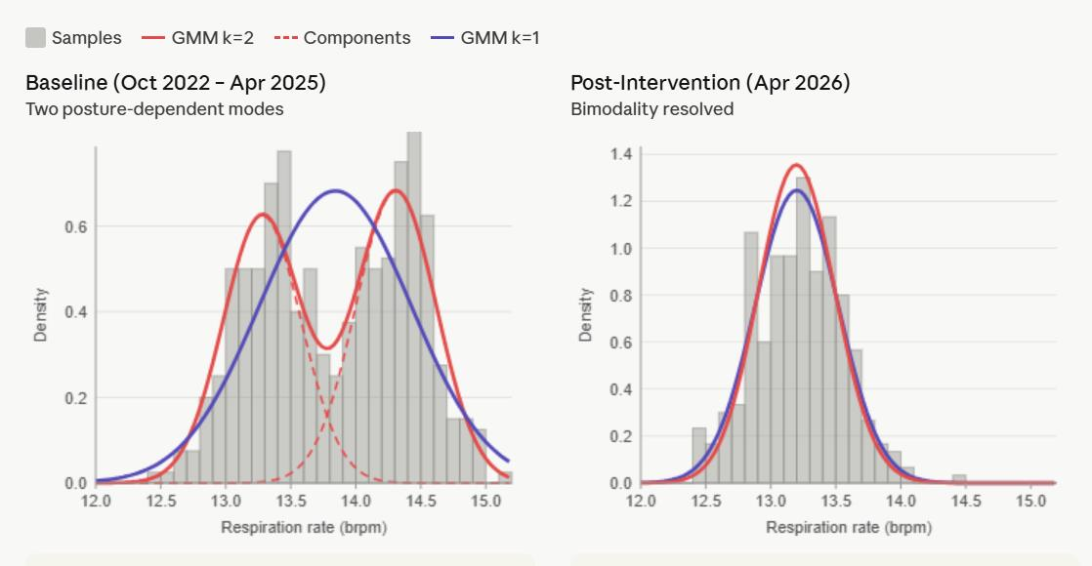
Figure 1. Left panel — baseline distribution shows two clear peaks at ~13.3 and ~14.3 brpm with the k=2 Gaussian mixture model tracking the bimodal structure while the k=1 fit visibly fails. Right panel — post-intervention distribution shows a single clean peak at ~13.2 brpm where k=1 and k=2 fits overlap completely, confirming bimodality is absent.

Supporting variability signal
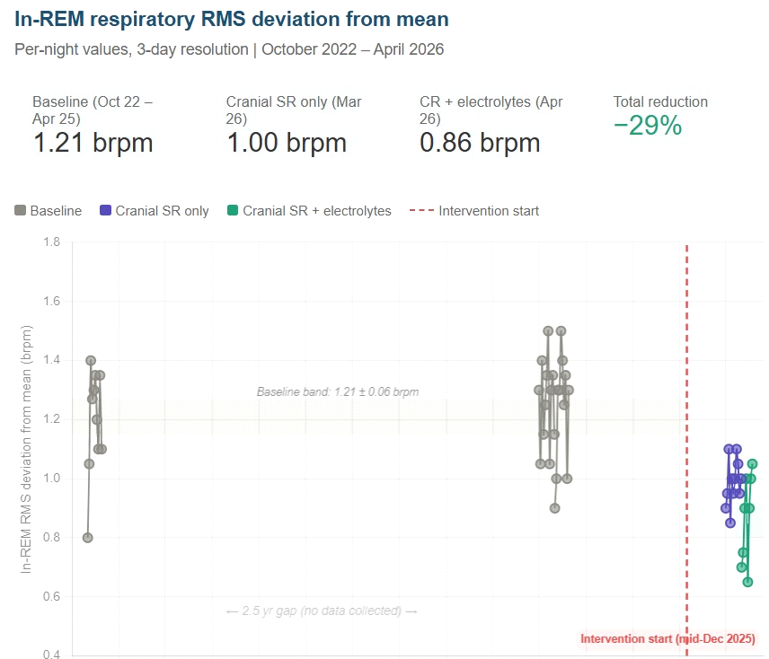
Figure 2. Per-night in-REM RMS deviation from segment mean. Baseline (Oct 2022 – Apr 2025): 1.21 brpm across 46 nights. Post-intervention conditions: 1.00 brpm (Mar 2026, 17 nights) and 0.87 brpm (Apr 2026, 11 nights), representing a 25–29% reduction sustained across four months.

Within-night temporal structure
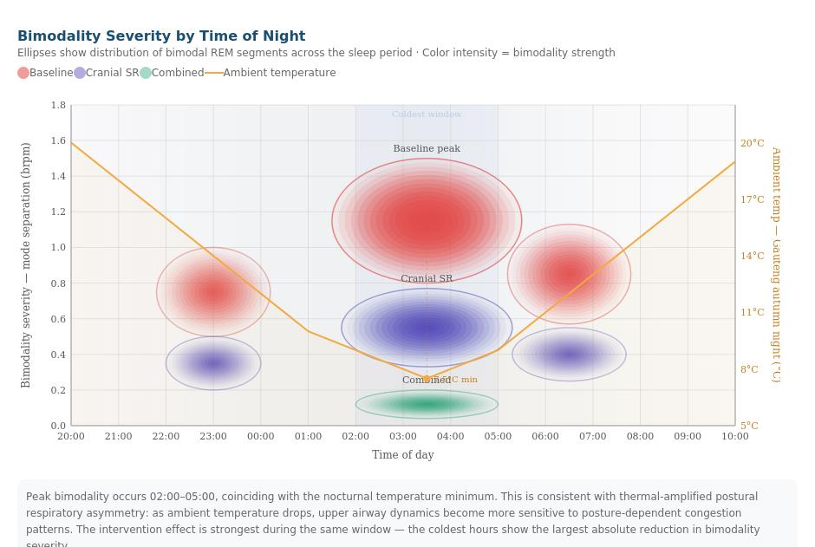
Figure 3. Bimodality severity by time of night, single-subject record. Severity concentrates in the 02:00–05:00 window, coincident with the nocturnal ambient temperature minimum (orange curve, right axis). The post-intervention reduction is largest in the same coldest-hours window in which baseline severity peaks. The within-night pattern provides a falsifiable secondary prediction for the proposed pilot.
These three figures, together, define the phenotype the proposed study is designed to detect: a bimodal distribution of within-REM respiration rate, concentrated in late-night hours, with an associated elevation of overall variability. The pilot tests whether this phenotype is detectable in a defined occupational cohort.

Multi-year stability
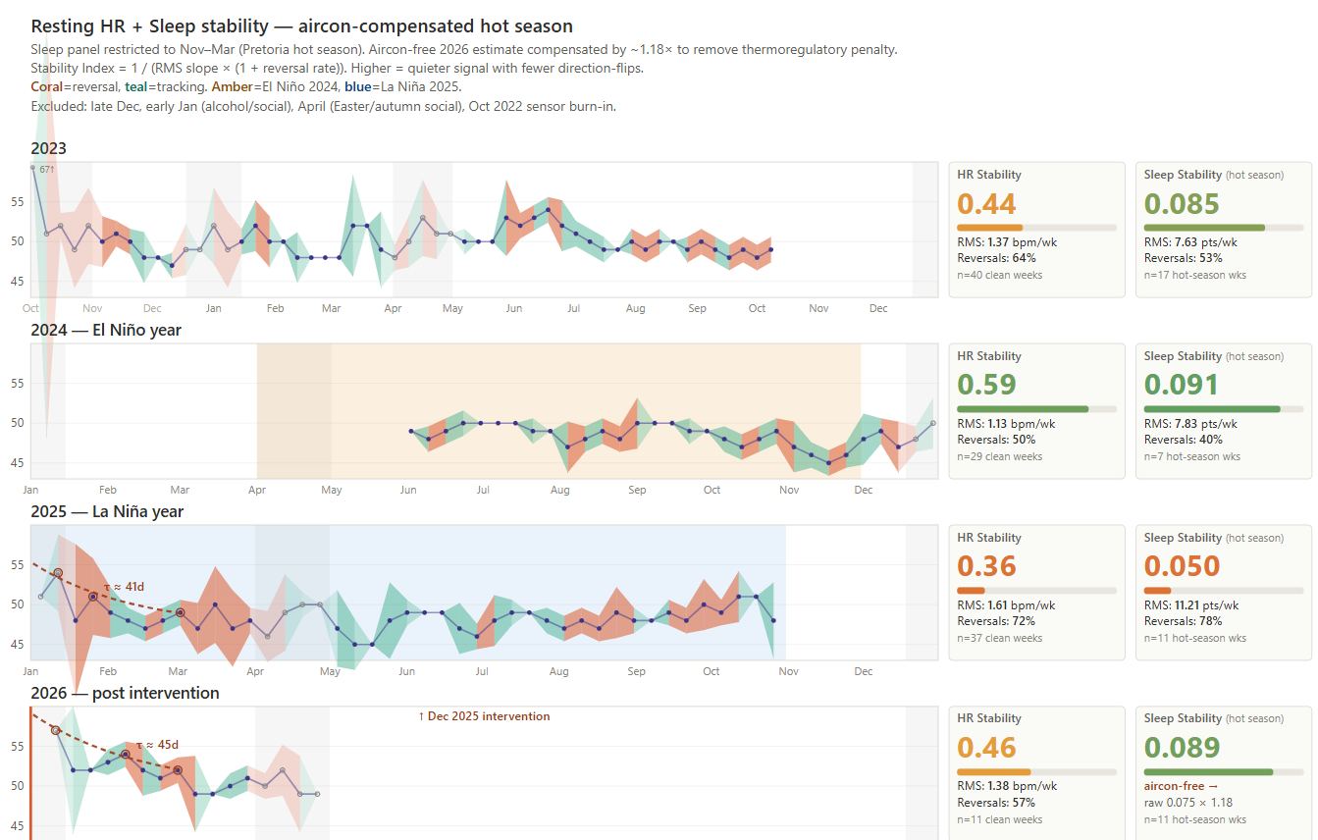
Stability provenance. Resting heart-rate dynamics across three baseline years (2023–2025, covering both El Niño and La Niña climatic regimes) and the 2026 post-intervention condition. The signal shows variability without monotonic drift across the multi-year baseline, supporting the interpretation that the observed post-intervention transition is a discrete change rather than an ongoing trend.

Study design

Design class
Single-arm, cross-sectional observational pilot. No intervention is administered. The study measures a candidate biomarker in a defined cohort and characterises its prevalence, distribution, and within-subject stability over a 14-night observation window.

Participants
- Sample size: 100 participants. Sized to characterise the bimodality prevalence distribution shape, false-positive behaviour at the cohort level, and per-segment phenotypic structure with adequate statistical power for the primary endpoint.
- Source population: Voluntary participation from Eskom personnel at a single power-station site, with stratification across operational role categories (control room, plant operations, ash handling, electrostatic precipitator operations, maintenance) to enable role-stratified prevalence reporting.
- Inclusion criteria: Adult (≥ 18), Eskom-employed at the participating site for ≥ 6 months, willing to wear a Garmin device during sleep for the 14-night study window, capable of providing informed consent in their preferred language.
- Exclusion criteria: Diagnosed and currently treated obstructive sleep apnoea on positive-pressure therapy (the device interaction confounds the REM-respiration signal); pregnancy; current cardiovascular medication classes that act on autonomic tone (beta-blockers); inability to provide informed consent.
- Recruitment: Voluntary opt-in, with recruitment materials made available through the site occupational health unit. Participation is fully voluntary, declining to participate carries no employment consequences, and this commitment is stated in the recruitment materials and the informed consent form.

Data collection
- Wearable device: Garmin consumer wearable supporting REM sleep staging and respiration sampling (specific model selection finalised in protocol stage based on availability and Garmin Connect data export compatibility). Devices are provided to participants for the study window and returned at study end.
- Data extracted: Per-night respiration samples during REM-classified segments only; per-night sleep staging timestamps; per-night resting heart rate (for ancillary analysis only). No GPS data, no daytime activity tracking, no heart-rate data outside the sleep window. Data minimisation is by design.
- Observation window: 14 consecutive nights per participant. This window provides sufficient nights to characterise within-subject stability while remaining within a feasible adherence envelope.

Analysis pipeline
Per-segment Gaussian Mixture Model fitting on REM-respiration samples within REM-classified segments of ≥ 10 minutes duration. For each segment, fit k=1 (unimodal) and k=2 (bimodal) Gaussian models and compare via Bayesian Information Criterion.
Bimodality classification criteria, all of which must be met:
- ΔBIC = BIC(k=1) − BIC(k=2) > 6
- Both component weights ≥ 0.25
- Mean separation between components ≥ 0.5 brpm
False-positive control. The identical pipeline is applied to ground-truth-labelled synthetic unimodal data with matched mean, variance, and segment-length distribution prior to analysis on participant data. Target false-positive rate: < 5%. Synthetic validation datasets are pre-generated and held fixed for the duration of the study.
Per-night and per-participant aggregation:
- Bimodality Index (BI). Fraction of REM segments per night classified as bimodal. Aggregated to a per-participant median over the 14-night window.
- Within-participant stability. Standard deviation of per-night BI across the 14-night window.
- Within-night structure. Stratification of per-segment BI by segment timestamp within the sleep period, to test the secondary endpoint of late-night concentration.

Endpoints
- Primary: Cohort-level distribution of per-participant median BI. Specifically, the proportion of the cohort with median BI above the false-positive floor, and the shape of the BI distribution (right-skewed with a non-trivial above-floor tail vs indistinguishable from synthetic-unimodal baseline).
- Secondary: Within-night temporal structure of per-segment BI; within-participant stability of per-night BI across the 14-night window; role-stratified prevalence.

Decision rule
The primary endpoint is binary at the level the study is designed to address:
- Positive: A non-trivial cohort fraction shows median BI above the false-positive floor with within-participant stability → phenotype is detectable in this cohort → grounds for follow-on broader-population study.
- Negative: BI distribution indistinguishable from synthetic-unimodal baseline → phenotype is not detectable in this cohort at this sample size → hypothesis is not supported by this evidence; no further work warranted on this pathway.
Either result is informative. The study is designed so that a negative result is publishable and useful, not a failure.

Ethics, governance, and worker protection
This section is load-bearing. The study is conducted on workers, on Eskom premises, with Eskom funding. The protections below are not optional add-ons — they are constitutive of what makes the study legitimate and what protects all parties (workers, Eskom, the research team) from foreseeable harms.

Research ethics committee approval
The study will be submitted for review and approval to a recognised South African Research Ethics Committee prior to any participant recruitment, in accordance with the National Health Research Ethics Council framework. Likely options include a university-affiliated REC (Wits, Pretoria, or Stellenbosch occupational and environmental health departments are all plausible affiliations) or a Health Research Ethics Committee accredited under the South African National Health Act. REC approval is a prerequisite for data collection; the study will not begin without it.

POPIA compliance
Sleep biomarker data is biometric personal information under the Protection of Personal Information Act. The study will operate under a documented POPIA compliance framework including: explicit informed consent for collection and processing of biometric data; data minimisation (only sleep-window data, no daytime activity); secure storage (encrypted at rest, access-logged); defined retention period with end-of-study destruction or anonymisation; and a designated Information Officer. Participants have the right to withdraw at any time and have their data destroyed.

Worker-employer separation
This is the most important governance principle in the study and the one that most distinguishes it from a workplace surveillance design:
- Individual data is not shared with Eskom management. Per-participant biomarker results are visible only to the research team and the participant themselves. Eskom’s access is limited to aggregate, de-identified cohort-level findings in the final report.
- No linkage to performance data. Participant biomarker data is not linked, in this study, to employment records, shift logs, performance evaluations, or operational metrics. This is stated in the protocol, the informed consent form, and the data-handling agreement with Eskom.
- Volunteer participation only. Participation is not a condition of employment, not requested by line management, and not part of any fitness-for-duty assessment. Recruitment is run through the occupational health unit, separated from operational reporting lines.
- Right to withdraw without consequence. Participants may withdraw at any point, with their data destroyed at their request, with no consequence to their employment.

Union consultation
The study protocol will be developed with consultation from recognised trade union representation at the participating site, prior to ethics submission. Union review of the protocol is not a formality — it is a substantive input on the worker-protection provisions, the recruitment process, and the framing of participant communications. The study is conducted in good faith as an occupational health research collaboration that includes worker representation in its design.

Incidental findings
If individual analysis surfaces a clinically actionable finding (e.g. a respiration pattern consistent with severe undiagnosed obstructive sleep apnoea), the participant is notified through a defined incidental-findings protocol and offered a referral to occupational health or their primary care provider. This is handled at the individual-participant level by the research team’s clinical lead, not via Eskom management.

Publication and dissemination
The pilot results, whether positive or negative, are published in a peer-reviewed occupational health or sleep medicine journal. Publication is a commitment, not a discretionary outcome — a study that runs and is not published produces no scientific value. Eskom’s contribution as a study site and funder is acknowledged in the publication. Eskom does not have right of veto over publication of negative results; this commitment is documented in the funding agreement.

Future work, briefly
This section is included so a reader can see the trajectory beyond the pilot, but it is explicitly not part of what is being requested. Each of the steps below would require separate ethics approval, separate funding, and separate union consultation.

Broader-cohort validation
If the pilot returns a positive primary endpoint, a natural follow-on is a broader-cohort study (n ≥ 1,000) to characterise prevalence at higher resolution, including across multiple sites and role categories. This would be a separate study with its own design and approval cycle.

Phenotype broadening
The single-subject record showed co-occurring autonomic markers alongside the bimodality phenotype, including a paired bradycardic / oscillating-respiration pattern that resolved alongside the bimodality collapse:
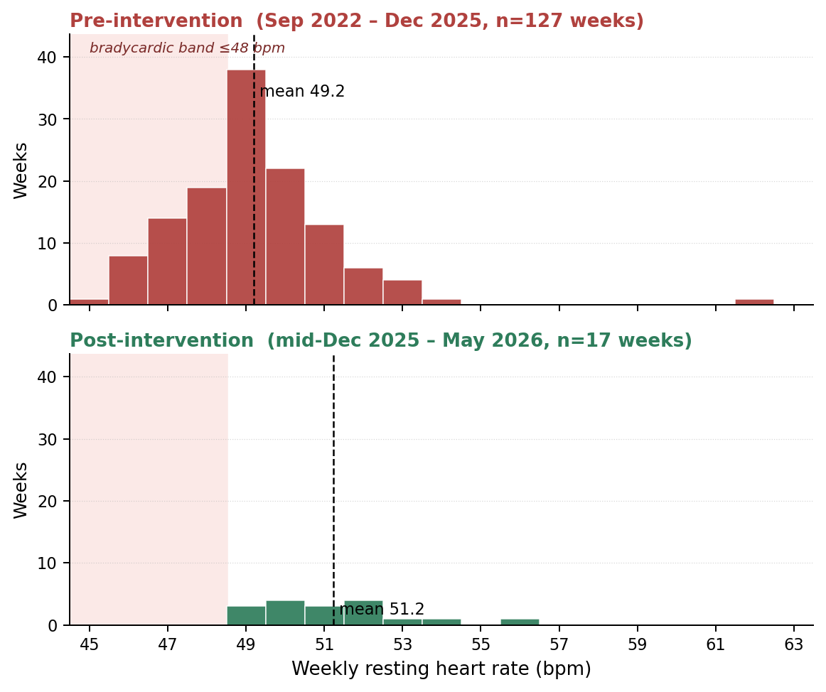
Co-occurring autonomic marker, single-subject record. Pre-intervention (top panel): weekly resting heart rate distribution shows a substantial left tail extending into the bradycardic band (≤ 48 bpm) over 127 weeks. Post-intervention (bottom panel): the bradycardic shoulder is absent over 17 weeks of follow-up. The pre-intervention bradycardic excursions were paired with oscillating respiratory traces consistent with periodic respiratory events during sleep. A follow-on analysis would test whether co-occurrence of bimodality with this paired marker is detectable at population scale.

Intervention studies
If the phenotype is detectable and stable, intervention studies become possible. The design class is: identify participants with stable bimodality at baseline, apply a candidate intervention (environmental, behavioural, or pharmacological), measure post-intervention bimodality. The single-subject record offers candidate interventions worth testing, but the choice of interventions for a workplace cohort is a separate ethical and design question that depends on Phase A and broader-cohort results.
None of these phases is part of the current proposal. The proposal is for the Phase A pilot only.

Indicative budget and timeline
The figures below are indicative for proposal purposes. Final budget is determined at protocol stage, after device selection, ethics submission scope, and Eskom’s preferred contracting and reporting framework are confirmed.

Indicative budget
Category | Indicative range (ZAR) | Notes
Wearable devices (100 units) | 180,000 – 240,000 | Consumer-grade Garmin devices; final selection at protocol stage.
Ethics submission and review fees | 15,000 – 30,000 | REC submission, document preparation, fees.
Participant compensation | 50,000 – 80,000 | Standard South African research compensation rates for 14-night participation.
Data analysis (analyst time) | 120,000 – 180,000 | Approximately 4–6 months part-time analyst plus statistical consulting.
Clinical lead and incidental findings protocol | 40,000 – 60,000 | Consulting clinician for incidental findings, occupational health liaison.
Publication and dissemination | 30,000 – 50,000 | Peer-review fees, conference presentation, internal Eskom dissemination.
Project management and contingency | 30,000 – 60,000 | Approximately 10% of total.
Indicative total | 465,000 – 700,000 | Final figure subject to protocol-stage refinement.

Indicative timeline
Month | Activity
1–2 | Protocol finalisation, union consultation, REC submission preparation.
3–4 | REC review and approval; participant recruitment materials development.
5 | Recruitment, informed consent, device distribution and onboarding.
6–7 | 14-night observation window per participant (rolling); ongoing data collection support.
7–8 | Data extraction, analysis pipeline execution, false-positive validation.
9 | Internal interim report to Eskom; cohort-level findings de-identified.
10–12 | Manuscript preparation, peer-review submission, conference dissemination.

The 9–12 month timeline assumes timely REC approval (typical SA timeline is 2–4 months for a study of this design) and adequate recruitment uptake. The protocol can absorb modest recruitment delays without affecting primary endpoint power.

Team and governance
The study requires a multidisciplinary team. The structure below is proposed; finalisation depends on Eskom’s preferred contracting framework and on confirmation of academic-institution affiliation.

Proposed roles
- Principal Investigator (academic affiliation): Senior researcher in occupational health, sleep medicine, or autonomic physiology, affiliated with a recognised South African university. Provides the institutional home for ethics submission and academic credibility for publication. To be confirmed.
- Co-Investigator (originating researcher): The author of this proposal, contributing the methodology, analysis pipeline design, single-subject evidence base, and analyst time.
- Clinical lead: Registered medical practitioner, ideally occupational health or sleep medicine specialty, responsible for the incidental findings protocol and clinical oversight.
- Eskom occupational health liaison: Senior staff member in Eskom’s occupational health structure, responsible for site coordination, recruitment support through the OH unit, and Eskom-side governance.
- Statistical consultant: Independent statistician, engaged for protocol review and analysis-stage consultation.
- Worker representative consultation: Trade union representative input at protocol design stage; this is consultation, not a study role, but is documented in the protocol.

Governance structure
A study steering committee meets monthly during active phases, comprising the Principal Investigator, the Eskom occupational health liaison, the clinical lead, and a worker representative observer. The steering committee’s role is protocol adherence oversight, not data review — individual participant data does not pass through the steering committee.
A separate data review takes place between the Principal Investigator, the Co-Investigator, and the statistical consultant, on the de-identified cohort-level dataset only.

About this proposal
This proposal originates from a multi-year personal research programme on autonomic recovery in extreme-climate conditions. The single-subject record on which the methodology rests was collected as a personal longitudinal monitoring exercise over 3.5 years; the bimodality finding emerged from re-analysis of that pre-existing dataset rather than from data collected to test the hypothesis.
The author is an electronic product design engineer based in Pretoria, with prior research experience in physiological adaptation to Highveld climatic conditions including a regional health-tech programme finalist position (The Innovation Hub, Pretoria) for a related thermoregulation product. The author is not a clinician, not an academic researcher in occupational health, and not in a position to lead this study independently. The proposal is structured around an academic Principal Investigator carrying institutional and clinical responsibility, with the author as Co-Investigator contributing methodology and analysis.
The proposal is offered in good faith, with no commercial intent and no proprietary stake in any specific intervention. The detection methodology is open and fully specified; the synthetic validation datasets that anchor the false-positive control are available on request. The author has no financial interest in any wearable manufacturer or any candidate intervention.
Questions, requests for the underlying methodology specification in greater detail, or requests for the synthetic validation datasets are welcomed and can be addressed directly to the author.

