**SOFTWARE PROJECT MANAGEMENT PLAN (SPMP):**

**Individual Project**

**Revision Sheet (Update History):**

|  |  |
| --- | --- |
| **Date:** | **Description of Revision:** |
| **N/A** | **N/A** |
|  |  |
|  |  |
|  |  |
|  |  |
|  |  |
|  |  |
|  |  |
|  |  |
|  |  |
|  |  |
|  |  |
|  |  |
|  |  |

**Preface:**

**Scope:**

|  |  |
| --- | --- |
| **PROJECT START DATE:** | 05/24/21 |
| **LAUNCH / GO-LIVE DATE:** | TBD |
| **PROJECT END DATE:** | 07/23/21 |
| **LIST ANY HARD DEADLINE(S):** | 06/30/21- Use Cases/Requirements and SPMP. |
| **KEY DATES:** | 06/30/21: Individual Project Tasks 1, 2, 3, 4 & 6  7/19/2021: Individual Project Presentations Week 1  7/23/2021: Individual Project Task 5 (Milestone Review) Due @ midnight  7/26/2021: Individual Project Presentations Week 2 |
| **BUDGET LIMITATIONS:** | Less Than 100 Dollars. |
| **QUALITY OR PERFORMANCE CONSTRAINTS:** | Potential Coding and HTML Issues. |
| **Estimate the hours required to complete the project.** | 50 Hours To Complete This Project |

**Goal and Purpose:**

The goal of the project is to create a personal website for the graphic design business of a close friend. My intention is to create a website using JavaScript and HTML in a React environment using the Visual Studio Code IDE.

The purpose of the project is to meet all specifications the client seeks and provide a seamless GUI while learning critical skills to better understand the software engineering and software development industry.

**Table of Contents:**

|  |
| --- |
| **SPMP: (Part 1)**………………………………………………………………………………….06-07 |
| 1.1 Project Overview………………………………………….………………………………..07 |
| 1.2 Project Deliverables………………………………………………………………………..07 |
| 1.3 Evolution of the SPMP……………………………………………………………………..07 |
| 1.4 Reference Materials………………………………………………………………………..07 |
| 1.5 Definitions and Acronyms…………………………………………………………………..07 |
| **SPMP: (Part 2)** …………………………………….…………………………………………..08 |
| 2.1 Process Model………………………….…………………………………………………..08 |
| 2.2 Organizational Structure……………………………………………..………..…………..08 |
| 2.3 Organizational Interfaces……………………………………………………...…………..08 |
| 2.4 Project Responsibilities……………………………………………..……………………..08 |
| **SPMP: (Part 3)** ………………………………………………………….……………………..08-09 |
| 3.1 Management Objectives and Priorities…………………………………………………………………………..……………..08-09 |
| 3.2 Assumptions, Dependencies and Constraints…………………………………………..09 |
| 3.3 Risk Management ………………………………………………………………………....09 |
| 3.4 Staffing Plan………………………………………………………………………….……..09 |
| 3.5 Monitoring and Controlling Mechanisms………………………………………….……..09 |
| **SPMP: (Part 4)** ……………………………………………………………………….………..09-10 |
| 4.1 Methods, Tools and Techniques……………………………………………………..…..09-10 |
| 4.2 Software Documentation…………………………………………………………………..10 |
| 4.3 Project Support Functions………………………………………………………………...10 |
| **SPMP: (Part 5)** ……………………………………………………………….………………..10-11 |
| 5.1 Work Breakdown Structure (WBS) ……………………………………..………………..10 |
| 5.2 Dependencies between tasks………………………………………………………….....11 |

**SPMP Part 1: Introduction**

**1.1 Project Overview**

Description of project: The project is meant to allow each student to design and implement a web-based product that they have researched and determined that a viable technology need exists.

Product summary: The product is a website meant to gather online traffic and produce potential customers for the client, a graphic designer and artist. The product will contain multiple pages including a homepage, personal background page, pricing page, and a page of previous works whereby they are displayed via slideshow. The product will be a live site, not local host, and will be written with a JavaScript frontend and a Backend of MongoDB.

**1.2 Project Deliverables**

The Individual Project will require the following deliverables:

* Use Cases
* Requirements
* A Software Project Management Plan
* Test Manual
* Source Code

The aforementioned deliverables will fall under the proceeding key dates:

|  |  |
| --- | --- |
| **Key Dates for Individual Project** | 06/30/21: Individual Project Tasks 1, 2, 3, 4 & 6  7/19/2021: Individual Project Presentations Week 1  7/23/2021: Individual Project Task 5 (Milestone Review) Due @ midnight  7/26/2021: Individual Project Presentations Week 2 |

**1.3 Evolution of the SPMP**

Upon necessity of change the SPMP documentation will be updated properly to ensure the written texts and documents are in conformity with the current condition of the Individual Project. The professor will be notified, and the GitHub repository will be updated to feature the new SPMP document.

**1.4 Reference Materials**

* GitHub Repository Link: <https://github.com/hartnettnr22/COSC-412_IndividualProject>

**1.5 Definitions and Acronyms**

* SPMP - Software Project Management Plan
* QA - Quality Assurance
* UI - User Interface
* UX - User Experience
* HTML - Hypertext Markup Language
* CSS - Cascading Style Sheets
* JS - JavaScript
* MySQL - Structured Query Language
* HTTPS - Hypertext Transfer Protocol Secure
* WBS - Work Breakdown Structure

**SPMP Part 2: Project Organization**

**2.1 Process Model**

The process model used for this project will be an Agile model that will allow us to have an iterative approach which will allow us to focus on the code rather than the design.

**2.2 Organizational Structure**

|  |  |
| --- | --- |
| **Sole Member of organization:** | **Nicholas Hartnett** |

**2.3 Organizational Interfaces**

* GitHub will be utilized to push codes, documents, and any other files pertinent to the project.
* Visual Studio Code IDE will be the environment in which the website will be written.
* MongoDB will be used as the database in which storage and retrieval will be conducted in the project.
* Blackboard is where assignments will be submitted and graded.

**2.4 Project Responsibilities**

Due to the nature of the project being an individual project, all of the following roles will solely be occupied and accomplished by **Nicholas Hartnett:** Team Lead, Product Owner, Tech Lead, Full Stack Developer, Front End Developer, Back End Developer, QA Lead, QA Engineer, Tester, UI Designer.

**SPMP Part 3: Managerial Process**

**3.1 Management Objectives and Priorities**

The Management Philosophy:

The philosophical approach to this project entails that the project follows a deliberate and timely process. All accomplished tasks will be stated, recorded, and completed in chronological order dependent on priority. The management of the website completion will adhere to all items listed within the SPMP and will be continuously updated and revised to resemble the intentions of the client.

Priorities among requirements:

The current top 5 requirements are as follows:

1. Have meeting with Professor for Use cases, Requirements, and SPMP.
2. Create skeleton for website in JavaScript/HTML/CSS.
3. Accomplish all necessary testing for website.
4. Connect Database and ensure data contained in tables is properly read into the website.
5. Ensure the website is live and not local host.

Schedule: The schedule is depicted in (**Figure 2**) on page 11.

Budget: The maximum budget for the individual project is $100.

**3.2 Assumptions, Dependencies and Constraints**

List of all external events the project depends on and constraints under which the project is to be conducted:

* The project is dependent on the timeline provided for the class.
* The connection between the Backend and the Frontend of the software
* The establishment of a live site
* Adherence to all documentation and continuous updates

**3.3 Risk Management**

Because of the time requirement of the project, if the size of the project becomes too large, the management group can consult with the client on restructuring the website in order to accommodate needs. If there are multiplying requirements, the management group will have to resize the project in order to specify the previous requirements to ensure enough time to finish the project. To validate client acceptance, prototypes will be provided to the client to ensure that the developer and client are in agreement. Establishment of a firm budget will prevent the risk of over and under spending. Establishment of a firm timeline in a Gantt chart provided in (**Figure 2**) prevents from going too far off schedule.

**3.4 Staffing Plan**

All necessary positions of staff will be operated solely by Nicholas Hartnett.

**3.5 Monitoring and Controlling Mechanisms**

Reporting will operate as follows:

When an error or bug is discovered, the issue will be recorded using a time stamp of discovery of the issue, description of the issue, and a confirmation of whether or not the issue was resolved along with a second time stamp indicating when the issue was fixed. The same ruling applies to documentation errors pertinent to the completion of the project.

**SPMP Part 4: Technical Process**

**4.1 Methods, Tools and Techniques**

The project will be written in JavaScript/HTML/CSS for the frontend of the code and the backend of the code will be accomplished using MongoDB. The site must be hosted which will fall under GoDaddy to register a domain. We may use digital ocean for hosting or name.com.

**4.2 Software Documentation**

ReadMe Documentation will be included in core file repositories, along with thorough documentation of the software development process. Standard coding practices will be implemented as well including but not limited to explanatory comments.

**4.3 Project Support Functions**

Plans for the following project support functions:

- Plan to ensure quality assurance: Document tests to make sure edge cases are fulfilled

- HTTPS: Secure site through certification

**SPMP Part 5: Description of Work Packages**

**5.1 Work Breakdown Structure (WBS)**

**(Figure 1: WBS)**

**5.2 Dependencies between tasks (Gantt Chart)**

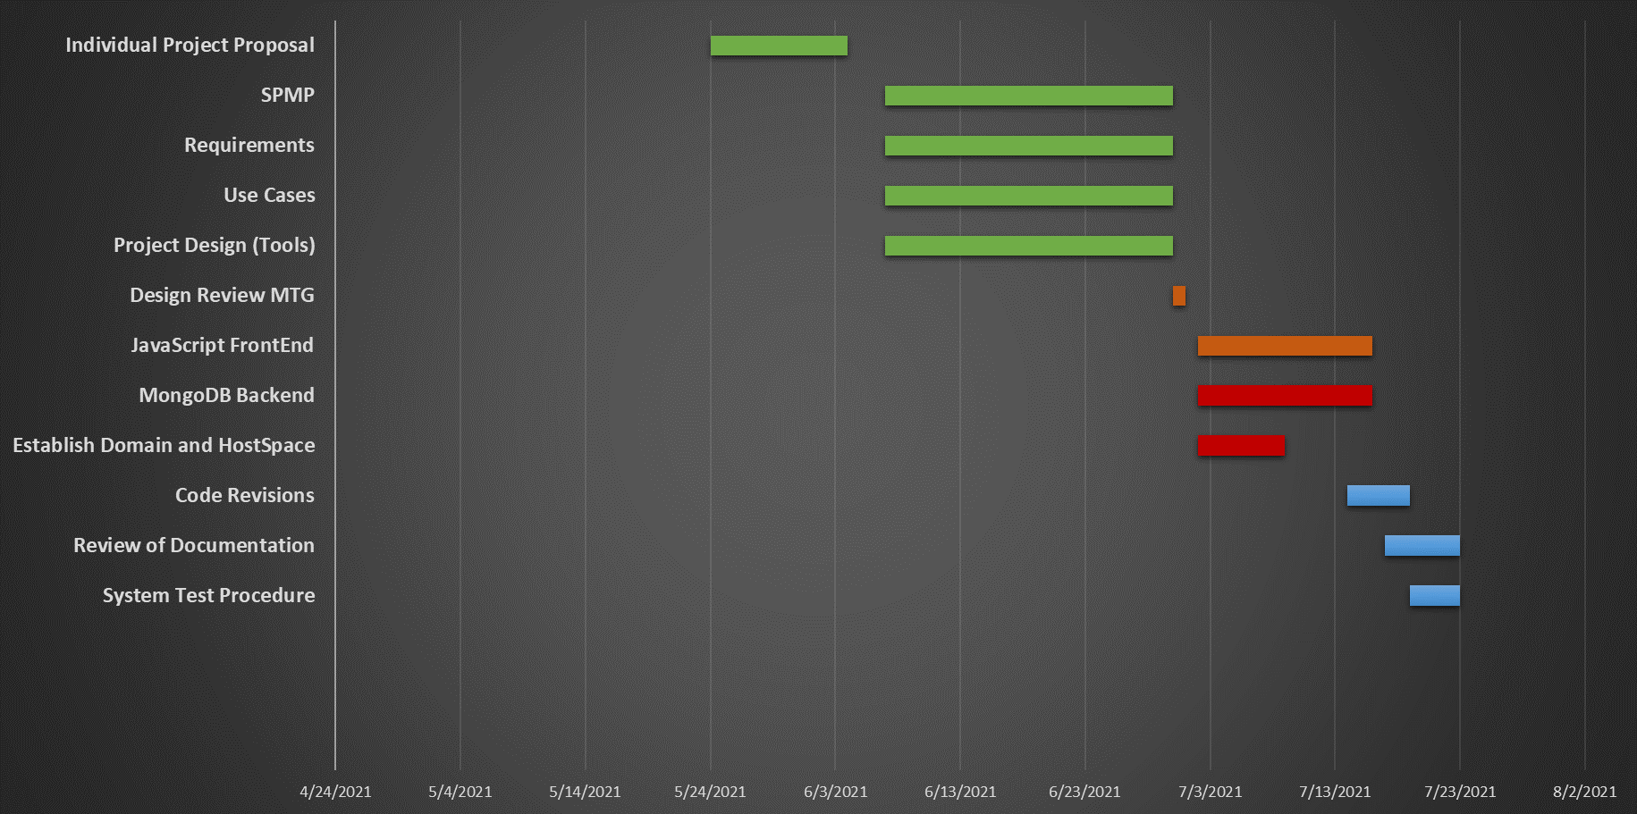**(Figure 2: Gantt Chart)**