Host richness increases the occurrence of bark beetle outbreak, but not basal area loss

Sarah Hart

October 20, 2022

# Abstract

1. Context
2. Methods
3. Results
4. Our results provide important insights into
5. *Synthesis*. Our findings highlight

# Keywords

bark beetle, species richness, plant-herbivore interactions, *Dendroctonus rufipennis*, *Dendroctonus ponderosae*, *Dryocoetes confusus*

# Introduction

A central goal of ecology is to understand how community diversity influences interactions between natural enemies and their resources (Elton 1958, Tilman et al. 1997, Johnson et al. 2013). In the case of plant-herbivore interactions, greater plant diversity often reduces the effects of herbivory [i.e., ‘associational resistance’, @barbosa2009], particularly when herbivores are specialists capable of rapid population growth (Otway et al. 2005). While increases in plant diversity may decrease the effects of herbivore species on individuals and populations of plants, it is also hypothesized to increase herbivore richness (i.e., ‘resource specialization,’ Keddy 1984). Further, a more diverse herbivore community has been hypothesized to cause more efficient use of the plant community, especially when herbivores are specialists [i.e., ‘complementary resource use’; MacArthur (1970); Cardinale et al. (2006); Finke and Snyder (2008)]. Yet little research has examined the effects of plant diversity on community-level outcomes of herbivory in natural systems where species-specific attributes (e.g., size, growth rates) vary greatly, the number of potential interactions is high, and the changes in plant diversity may be convoluted with changes in host quality (Finke and Snyder 2008, Jactel et al. 2021).

Native bark beetles (Curculionidae: Scolytinae) are

Some bark beetle species can undergo population eruptions. In the western United States outbreaks of native bark beetles have caused the death of 3.8 billion trees [1997-2018; Hicke et al. (2020)]. Bark beetles bore through a tree’s bark, where they mate, oviposit their eggs, and introduce pathogenic fungi (**raffa_natural_2015?**). Larvae feeding upon the phloem and fungal spread stop the translocation of water and nutrients, typically leading to tree death. Conifer defense against bark beetles consists primarily of resin exudation that physically expels the beetle and the production of chemical defenses, which repel and kill attacking beetles (**krokene_conifer_2015?**). To overcome these defenses, bark beetles rely on a mass-attack strategy, where pioneering beetles emit aggregation pheromones that call conspecifics to the focal tree. While bark beetles typically exist at low population levels and attack weakened trees, increases in population size allow bark beetles to attack increasingly better defended trees. The eruption of bark beetle populations to outbreak conditions is complex, but requires abundant, large diameter hosts, which reflects past natural disturbance and land-use history (**veblen_disturbance_1994?**). Given a susceptible landscape, outbreaks my be initiated by events that increase bark beetle development rates, notably temperature (**bentz_temperature-dependent_1991?**, **hansen_temperature-based_2001?**, **bone_improving_2019?**, **howe_landscape_2022?**), or events that decrease host tree resistance to bark beetle colonization [e.g., drought; (**chapman_spatiotemporal_2012?**); (**hart_drought_2014?**); (**harvey_droughty_2021?**)].

While across the region there are more than 25 native bark beetle species, the mountain pine beetle (MPB; *Dendroctonus ponderosae*), spruce beetle (SB; *Dendroctonus rufipennis*), and western balsam bark beetle (WBBB; *Dryocoetes confusus*) collectively have caused over 70% of the bark beetle-attributed tree mortality, most of which has occurred in high elevation forests (Hicke et al. 2020) .

Hotspots of biotic disturbance, areas where multiple biotic disturbances (e.g., outbreaks of insects or pathogens) overlap in space and time, are hypothesized to have the potential to dramatically alter post-disturbance successional rates and trajectories (Harvey et al. n.d.).

Associational resistance is commonly hypothesized to occur due to several non-mutually exclusive mechanisms. First, herbivory may be lower in more diverse systems if herbivores are less likely to find, stay, and reproduce in areas where their hosts are less abundant (i.e., ‘resource concentration hypothesis,’ **root_organization_1973?**). Second, reductions in herbivory may occur if heterospecific neighbors mask chemical or visual cues that herbivores use to find their hosts makes it challenging for insects to find their hosts (i.e. ‘host apparency hypothesis,’ **feeny_plant_1976?**, **schiebe_semiochemical_2011?**, **castagneyrol_effects_2014?**), Third, heterospecific neighbors may increase the abundance of herbivore natural enemies [i.e., ‘enemies hypothesis’, (**staab_influence_2020?**).

We also expected the severity of bark beetle infestation to vary with the number of agents present, but with two alternative hypotheses. If the population dynamics of each bark beetle species are independent or competitive release causes decreased investment in defense, then stands affected by multiple bark beetle species will experience higher tree mortality than stands with only one agent. Alternatively, lower tree mortality may occur if concurrent outbreaks of bark beetles of different species cause semiochemical confusion.

Given the occurrence of bark beetle outbreak, we further expect that basal area loss will be greater in stands affected by multiple species of bark beetles.

In contrast, we expect that the severity of outbreak for each bark beetle species will be lower when stands consist of multiple hosts (i.e., associational resistance), but that the probability of outbreak of any bark beetle species will be greater in stands that consist of multiple hosts.

To better understand interactions between tree and bark beetle communities in subalpine forests, we used a large data set consisting of XXX,XXX plots established by the United States Forest Service (USFS) Forest Inventory and Analysis Program (FIA).

Specifically, we ask:

1. How have host abundance and size influenced patterns of outbreak occurrence during the recent period of widespread bark beetle outbreaks?
2. Do stand conditions suitable for multiple outbreaks commonly co-occur?
3. Does outbreak occurrence or basal area loss increase with the number of susceptible hosts?
4. Do hotspots of bark beetle outbreaks result in more severe cumulative bark beetle mortality?

We expect that the probability of outbreak will increase with host basal area and size (i.e., resource concentration hypothesis). If the probability of outbreak increases with host basal area and host dominance, than stand conditions suitable for multiple outbreaks should be relatively rare. When stands are susceptible to outbreaks of multiple species of bark beetles, we expect that the probability of an outbreak of any speices occurring will be greater when more hosts are present (i.e., resource specialization hypothesis). Finally, when hotspots of bark beetle outbreaks occur, we expected greater total basal area loss (i.e., complementary resource use).

# Materials and Methods

## Study area

The study area consists of subalpine forests dominated by lodgepole pine (*Pinus contorta*), subalpine fir (*Abies lasiocarpa*), and/or Engelmann spruce (*Picea engelmannii*) located in the Intermountain West (Fig. (**ref?**)(fig:(FigMaps)). While these species are present in several other western states, we constrained our analyses to the Intermountain West because of regional differences in data collection that exist within the FIA program (Burrill et al. 2017).

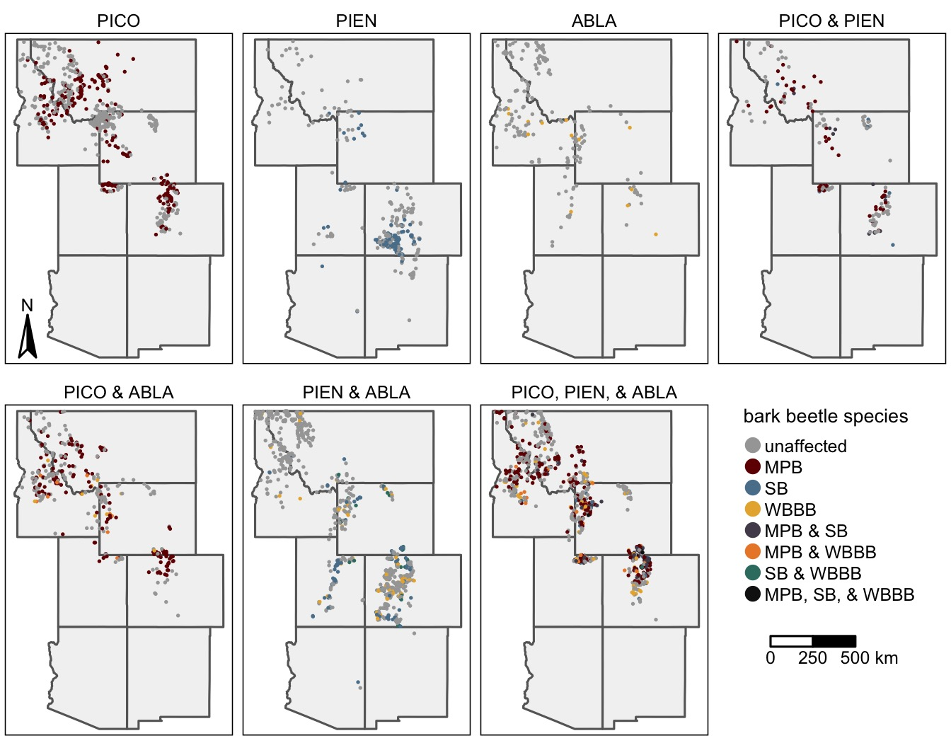

Figure 1: The distribution of FIA plots recently (ca. 2000 – 2019) affected by outbreaks of the mountain pine beetle (MPB), spruce beetle (SB), and western balsam bark beetle (WBBB) by the identity of host tree species present within each plot. For host identities, PICO is lodgepole pine, PIEN is Engelmann spruce, and ABLA is subalpine fir.

## Data

The FIA program inventories all public and private forested land using a spatially and temporally distributed sampling design, making it useful for the study of tree species distributions (e.g., **iverson_predicting_1998?**, **rehfeldt_empirical_2006?**) and tree demography (**derose_effects_2013?**). In the Western US, all FIA plots are visited once every ten years (**gray_forest_2012?**). At each plot, field crews collect data within four 7.32 m radius subplots arranged in a fixed pattern. For each tree within the plot, field crews record the species, size (diameter at breast height; DBH), and status (live or dead) for trees (>= 12.7 cm DBH). For each live tree, field crews additionally record up to three damaging agents likely to prevent the tree from surviving >2 years, reduce the growth of the tree in the near term, or negatively affect the tree’s marketable products (e.g., MPB) (**burrill_forest_2017?**). For dead trees that were alive at the previous visit, the proximate cause of death is also collected for any tree that was alive at the previous visit and at revisit is dead using visible evidence (e.g., fire scars, bark beetle galleries). Because identifying the mortality agent is more challenging, cause of death codes are broad (e.g., “insect” or “disease”).

We acquired all FIA data for the Intermountain West from the FIA Datamart (<https://apps.fs.usda.gov/fia/datamart/>), but restricted our analyses to the most recent inventory for each plot. Given our focus on subalpine forests dominated by lodgepole pine, subalpine fir, and/or Engelmann spruce, we further restricted our analyses to plots where the focal hosts accounted for at least 75% of the stand basal area. Finally given our interest in understanding how tree species diversity influences bark beetle outbreak occurrence and effects, we excluded all plots with important alternative hosts [i.e., ponderosa pine (*Pinus ponderosa*), limber pine (*Pinus flexilis*), whitebark pine (*Pinus albicualis*), bristlecone pine (*Pinus aristata*), or western white pine (*Pinus monticola*)] (Bentz et al. 2010).

To determine the occurrence of outbreaks of MPB, SB, and or WBBB within each plot, we first determined the presence/absence of each bark beetle species at the tree scale. For live lodgepole pine we listed the presence of MPB when the primary damage agent was listed as MPB or any bark beetle. Similarly, we listed the presence of SB in Engelmann spruce when the damage agent was listed as SB or a general bark beetle. For live subalpine fir, we listed the presence of WBBB when the damage agent was recorded as WBBB, a general bark beetle, or subalpine fir decline, a mortality complex of WBBB attack, drought stress, and/or pathogenic root fungi, including *Armillaria* spp. and *Heterobasidion parviporum* (Lalande et al. 2020). While not all trees affected by subalpine fir decline are necessarily attacked by WBBB, field surveys across the region suggest that 94% of trees killed by subalpine decline are affected by WBBB (Harvey et al. 2021). For recently killed tees, we assumed the mortality of lodgepole pine, Engelmann spruce, and subalpine fir that was attributed to an insect, was caused by the MPB, SB, and WBBB, respectively. While mortality due to other insects is possible, over the past two decades MPB, SB, and WBBB have caused vast majority of lodgepole pine, Engelmann spruce, and subalpine fir mortality, respectively (Fig. (**ref?**)(fig:FigADSSummary)). For each plot, we then listed the occurrence of an outbreak of each bark beetle species when tree mortality rates were above background rates, defined here as more than 10% of the host trees attacked by bark beetles in the past ten years (Mantgem et al. 2009).

## Analyses

To understand if and how host abundance and size influenced patterns of MPB, SB, and WBBB outbreak occurrence, we used a random forest (RF) modeling framework (Breiman 2001). RFs are a distribution-free approach useful for modelling nonlinear relationships and complex interactions characteristic of ecological systems (Cutler et al. 2007). We constructed separate models for the presence of MPB, SB, and WBBB and as predictor variables included host QMD, host BA, host dominance (percent basal area), and total BA, variables commonly linked to stand susceptibility to bark beetle outbreak (Schmid and Frye 1976, Shore and Safranyik 1992, Lalande et al. 2020). Because most stands in our data set were unaffected by bark beetles, we used a synthetic minority oversampling technique (SMOTE) to handle the imbalance in the response (Chawla et al. 2002). Briefly, the SMOTE approach over-samples the minority class by synthesizing new cases from the minority class (here affected stands).

We fit models by first splitting the data into separate training and testing data sets, consisting of 70% and 30% of the full data set, respectively. We then tuned the model hyperparameters (the number of variables to try at each split, number of trees, and minimum node size) on the training data set using a 10-fold cross-validation approach. We selected the hyperparameters that maximized the area under the receiver operation curve (AUC) statistic, which quantifies the performance of a classifier by comparing the false positive and true positive rates. After fitting the final model on the training data, we then assessed model performance by quantifying the model’s ability to correctly predict outbreak occurrence in the testing data using the AUC statistic. To assess the contribution of each variable to overall model fit, we calculated the permutation importance, which measures the change in prediction error that occurs when the focal variable is randomly permutated (Breiman 2001). Finally, we used accumulated local effects (ALE) plots to assess the relationship between each predictor variable and the probability of outbreak occurrence. Models were fit in R (R Core Team 2022) using the Tidymodels (Kuhn and Wickham 2020) and ranger (Wright and Ziegler 2017) packages. ALE plots were constructed using the ALEPlot package (Apley 2018).

To determine if stand conditions suitable for outbreaks of multiple bark beetle species commonly co-occur, we used output from the RF models. For each model, we first selected the threshold for predicting presence/absence of outbreak that maximized Youden’s J statistic, an integrated measure of model sensitivity (i.e., true positive rate) and specificity (i.e., true negative rate) (Youden 1950). We used this threshold to determine if each stand was suitable to bark beetle outbreaks of MPB, SB, and/or WBBB. We then tabulated the number of plots susceptible to outbreaks of multiple bark beetle species and compared theses values with the number of plots where multiple hosts were present.

To understand the contribution of each bark beetle species to the cumulative probability of outbreak occurrence, we calculated the proportion of plots affected by an outbreak of each bark beetle species within plots where the corresponding host was susceptible. We then used proportion tests to determine if the probability of outbreaks of each bark beetle species differed. To understand if the severity of bark beetle activity attributed to an outbreak of each bark beetle species differed we used a Krusksal-Wallace rank sum test, followed by a Dunn’s test of multiple comparisons to assess pairwise differences.

To determine if the proportion of plots with susceptible host(s) that were affected by a bark beetle outbreak of any species varied with the number or identity of susceptible hosts present, we used a multiple group proportion test. Given a significant difference, we then used pairwise proportion tests to determine if significant differences existed between groups. Next to understand if the severity of bark beetle activity varied with the number or identity of hosts present, we used a Krusksal-Wallace rank sum test, followed by a Dunn’s test of multiple comparisons to assess pairwise differences. Finally, to determine if the severity of tree mortality depended upon the number or identity of bark beetle species present, we used a Kruskall-Wallis rank sum test to compare cumulative mortality in stands affected by outbreaks of one, two, or three bark beetle species. Given a significant difference, we used a Dunn’s test to test for pairwise differences.

In all analyses, we adjusted p-values to account for multiple comparisons (Benjamini and Hochberg 1995). Analyses were performed in R (R Core Team 2022) using the packages dunn.test (Dinno 2017) and rcompanion Mangiafico (2022)

# Results

## How have host abundance and size influenced patterns of outbreak occurrence during the recent period of widespread bark beetle outbreaks?

Random forest models accurately predicted the presence of MPB, SB, and WBBB outbreak (AUC ≥ 0.80; Table 2). Optimal thresholds for predicting the presence/absence of outbreak varied by species (MPB=0.29, SB=0.22, WBBB=0.17; Table 1). The resulting sensitivities were generally greater than specificities, meaning that outbreak occurrence was better captured better by the model.

Host size QMD, BA, and dominance and total BA all contributed to the fit of models of outbreak occurrence, however variables that described host density and size were more important than total stand BA (Fig. 9). For all bark beetle species, when BA was less than 5 m2 ha-1, small increases in host BA were generally associated with large increases in the probability of outbreak (Fig. 2B and F). Once BA exceed this threshold, the probability of outbreak generally showed little change with increasing host BA. The relationship between outbreak occurrence and QMD was nonmonotonic (Fig. 2C and G). For all bark beetle species, when QMD was less than 20 cm, small increases were generally associated with large increases in the probability of outbreak. Once QMD exceeded this threshold, the probability of outbreak generally decreased. Increases in host dominance were generally associated with an increase in the probability of outbreak (Fig. 2 D and H). However, the probability of WBBB outbreak notably decreased with greater host dominance at very high values and the probability of SB outbreak increased dramatically when host dominance exceeded 30%. After controlling for variation in host size and density, ALE plots suggested that the relationship between total BA and probability of outbreak depended on agent identity. The probability of SB outbreak generally increased with total BA, the probability of MPB outbreak increased and then decreased at high total BA, and the probability of WBBB outbreak was greatest and low and high total stand BA (Fig. 2A). Nonetheless box-plots show that stands affected by outbreaks of WBBB, SB, and MPB were generally characterized by greater BA than unaffected stands (Fig. 2E).

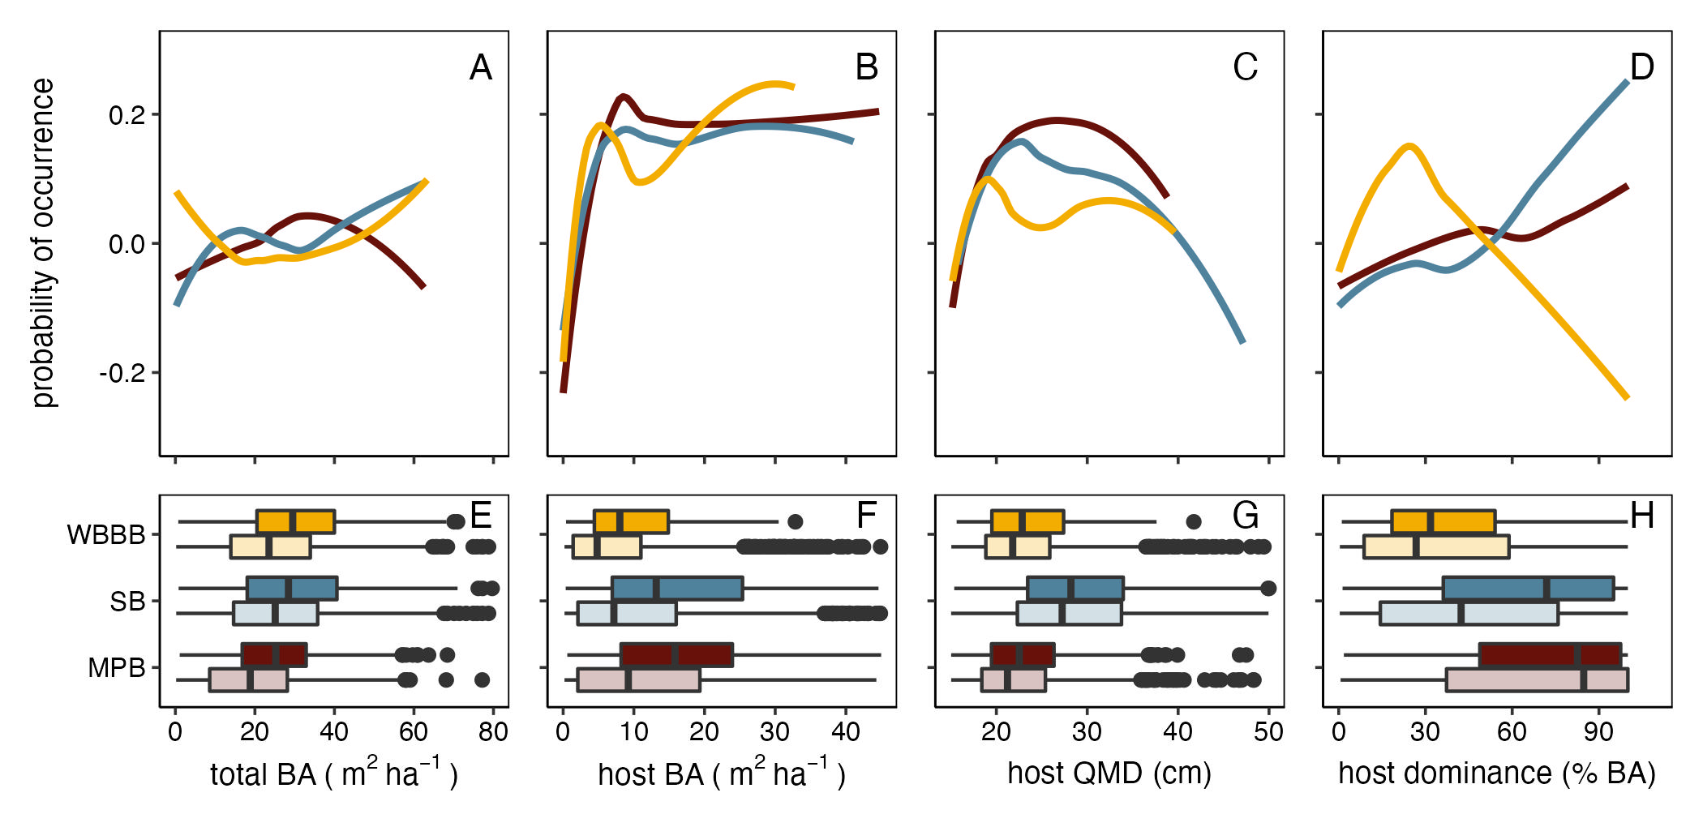

Figure 2: The associations between the probability of occurrence of the mountain pine beetle (MPB; red), spruce beetle (SB; blue); and western balsam bark beetle (WBBB; yellow) outbreak and stand structure and composition. The top row (A-D) illustrates the accumulated local effects (ALE) from Random Forest models of the presence/absence of outbreak. For visualization purposes, ALE values have been smoothed using local polynomial regression. Boxplots (E-H) show the distribution of values for stands affected (dark colors) and unaffected (light colors) by each bark beetle species. The bottom and top limits of each box are the lower and upper quartiles, respectively; the thick black line within the box is the median; error bars equal ±1.5 times the interquartile range; and points denote outliers, values outside ±1.5 times the interquartile range.

## Do stand conditions suitable for multiple outbreaks commonly co-occur?

Across the 3096 FIA plots with at least one of the target host species and no alternative host species, 39% (n=1215) contained two species and 24% (n=740) three species (Fig. 3). Lodgepole pine was present in 62% of plots (n=1913) plots. Engelmann spruce was present in 24% of plots (n=1916). Subalpine fir was present in 63% of plots (n=1962).

RF models predicted that 87% of plots (n=2704) were suitable for bark beetle outbreak. Of these plots 35% (n=933) were suitable for outbreaks of two bark beetle species and 14% of plots (n=377) were suitable for outbreaks of three bark beetle species. Of the plots with at least one susceptible host, 59% (n=1584) were susceptible to outbreaks of MPB, 59% (n=1596) were susceptible to outbreaks of SB, 45% (n=1211) were susceptible to outbreaks of WBBB (Fig. 3).

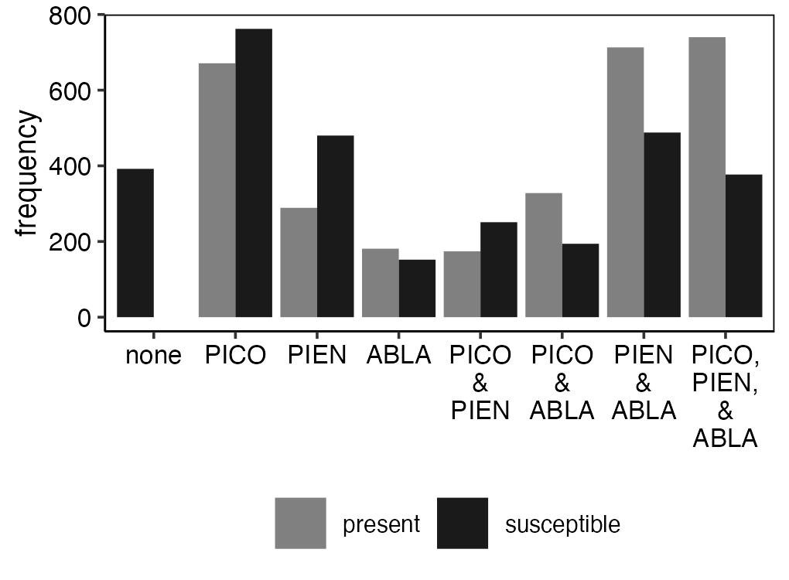

Figure 3: The frequency of plots by the identify of host present (gray) and hosts susceptible to outbreak (black). Gray bars indicate host species were present (i.e., at least one individual of the focal species was present within the plot). Black bars indicate stand structure and composition conditions were suitable to bark beetle outbreak in focal tree species. For host identities, PICO is lodgepole pine, PIEN is Engelmann spruce, and ABLA is subalpine fir.

Across the 2704 plots, we found that 43% of plots (n=1166) were affected by an outbreak of at least one species (. Outbreaks of MPB were most common (n=758), followed by outbreaks of SB (n= 382 plots). Outbreaks of WBBB were least common (n= 208 plots).

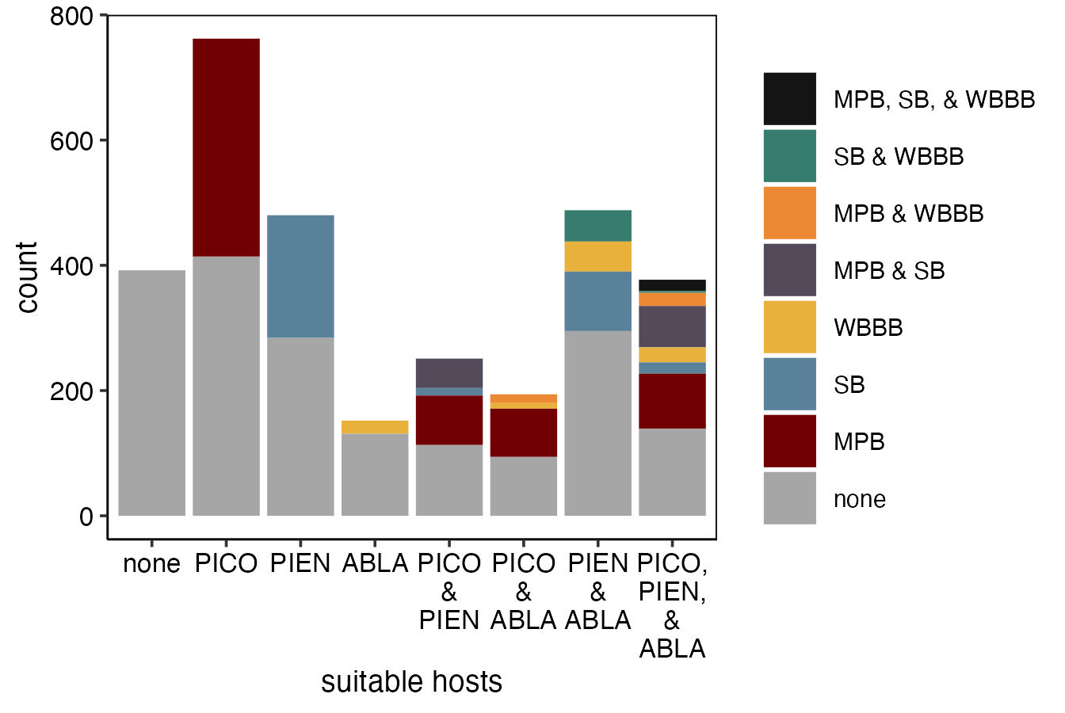

Figure 4: The frequency of plots affected by varying combinations of outbreaks of mountain pine beetle (MPB), spruce beetle (SB), and western balsam bark beetle (WBBB) by the identify of susceptible hosts present. For host identities, PICO is lodgepole pine, PIEN is Engelmann spruce, and ABLA is subalpine fir.

## Does the occurrence or severity of cumulative bark beetle activity increase with host species richness?

The proportion of plots affected by an outbreak of at least one bark beetle species was greatest in plots with all three hosts (proportion affected = 0.61; Fig. 5A), however it was not significantly different than the proportion of affected plots with either lodgepole pine and Engelmann spruce or lodgepole pine and subalpine fir (proportion affected = 0.55 and 0.52, respectively; Fig. 5A). Stands with only subalpine fir were least likely to experience outbreak (proportion affected = 0.16), followed by stands with both Engelmann spruce and subalpine fir (proportion affected = 0.35) or just Engelmann spruce (proportion affected = 0.33). Stands with only lodgepole pine experienced intermediate rates of outbreak occurrence (proportion affected = 0.46).

Basal area loss due outbreak(s) was greatest in stands with only Engelmann spruce (mean = 66%), followed by stands with only lodgepole pine (mean = 48%) (Fig. 5B). Stands with only subalpine fir generally experienced low, but variable, basal area loss , while all other host combinations experienced similar levels of basal area loss.

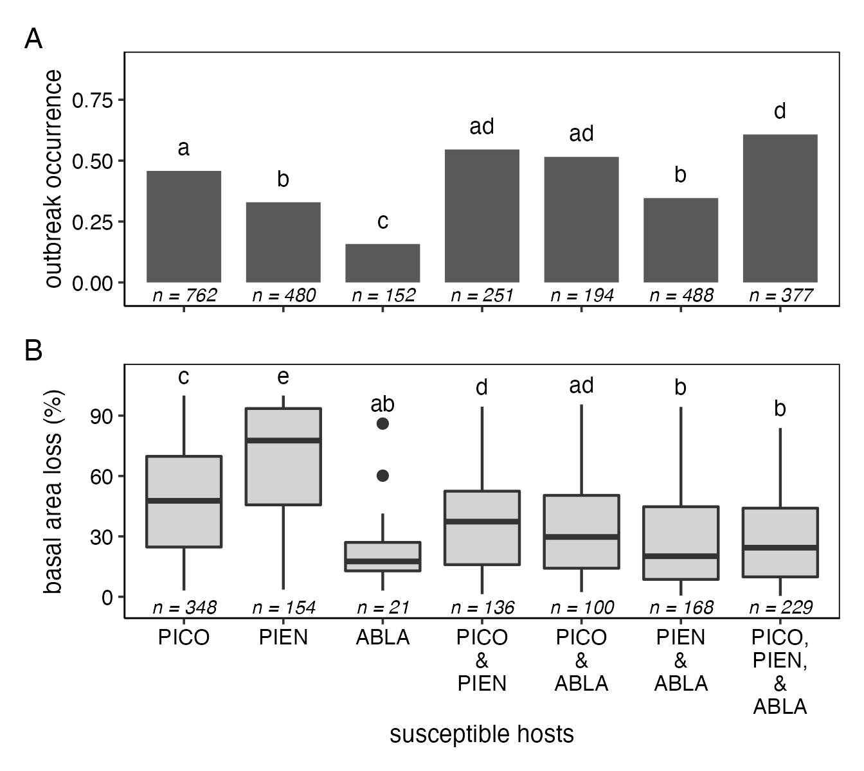

Figure 5: The proportion of plots affected by bark beetles by the identity of suitable hosts. Letters above bars indicate significant (p<0.05) difference between groups, as determined using pairwise proportion tests. Numbers below bars show sample sizes. For host identities, PICO is lodgepole pine, PIEN is Engelmann spruce, and ABLA is subalpine fir.

## Does the co-occurrence of multiple bark beetle species result in more severe cumulative bark beetle mortality?

Generally, stands affected by outbreaks of multiple bark beetle species experienced greater basal area loss than stands affected by only one outbreak (Fig. 6). In stands where all three hosts were susceptible to outbreak, stands affected by both MPB and SB or MPB, SB, and WBBB experienced the greatest basal area loss (mean BA loss = 41% and 45%, respectively)). In these stands, stands affected by only SB or WBBB, or both SB and WBBB experienced the lowest rates basal area loss (mean BA loss = 14%, 12%, and 4%, respectively), although few of these stands experienced outbreaks of both SB and WBBB (but not MPB). Outbreaks of MPB and hotspots of MPB and WBBB outbreaks within stands with all three hosts experienced intermediate levels of basal area loss (mean BA loss = 22% and 29%, respectively). In stands with only two susceptible hosts, hotspots were characterized by greater basal area loss only when outbreaks of MPB and SB co-occurred. In stands with susceptible subalpine fir and either lodgepole pine or subalpine fir, basal area loss due to WBBB was generally low and hotspots experienced similar basal area loss as in stands affected by only MPB or SB.

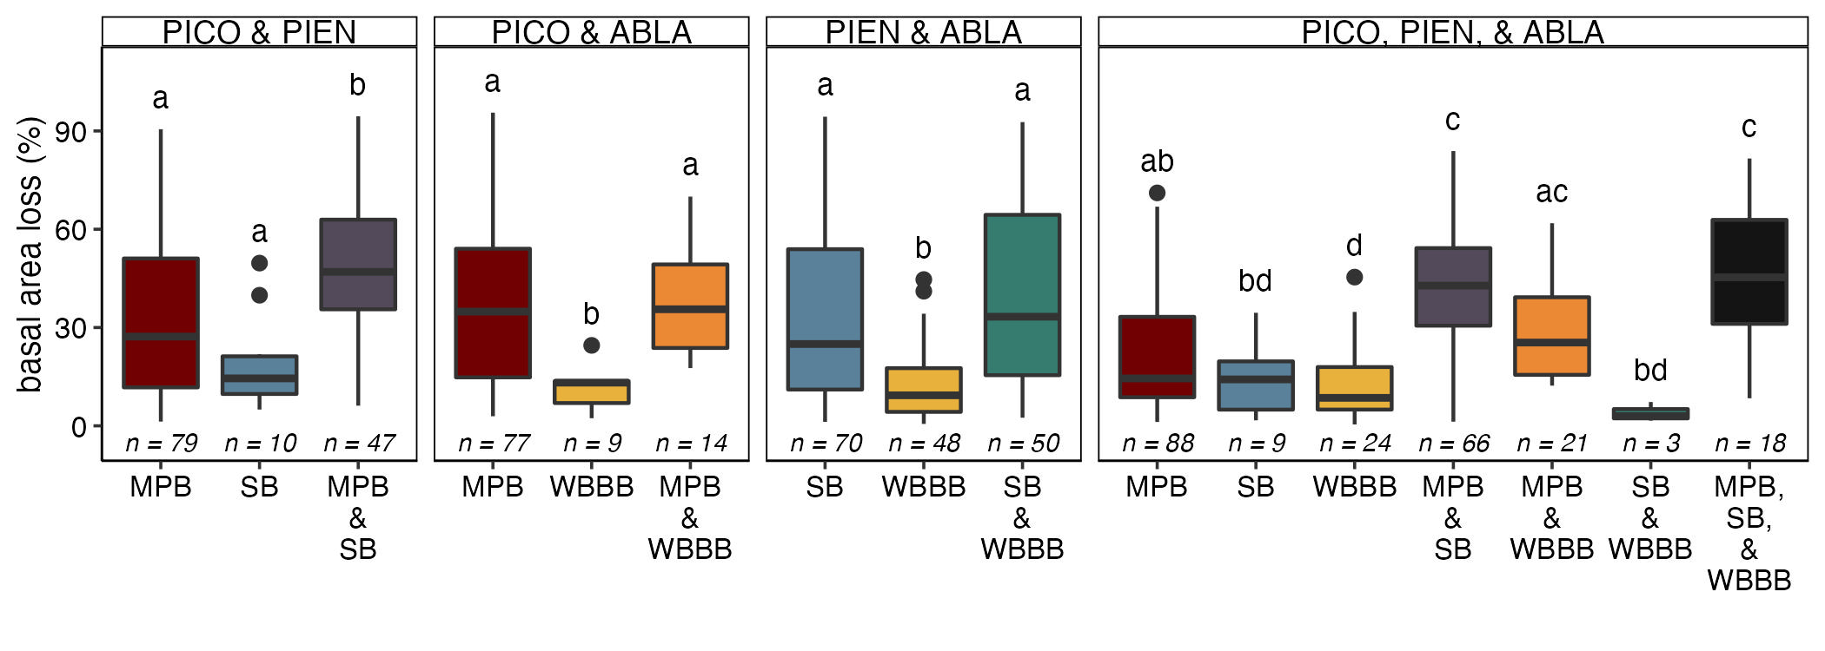

Figure 6: The severity of bark beetle mortality in plots with multiple tree species susceptible to bark beetles by the combination of bark beetle species present. Letters above boxes indicate significant differences between groups as determined by a Dunn test. The bottom and top limits of each box are the lower and upper quartiles, respectively; the thick black line within the box is the median; error bars equal ±1.5 times the interquartile range; and points denote outliers, values outside ±1.5 times the interquartile range.

# Discussion

## Resource concentration

Yes –> outbreaks of MPB, SB, and WBBB were all generally increased with increases in host basal area and host dominance. - discuss slight decrease that occurs at high values

## Effects of resource concentration on patterns of overlap

## Resource specialization

## caveats

* agent bias?

## future directions

* order? Comment

# Acknowledgements

# Author contributions

# References

{#refs}

# Supplement

## ADS summary

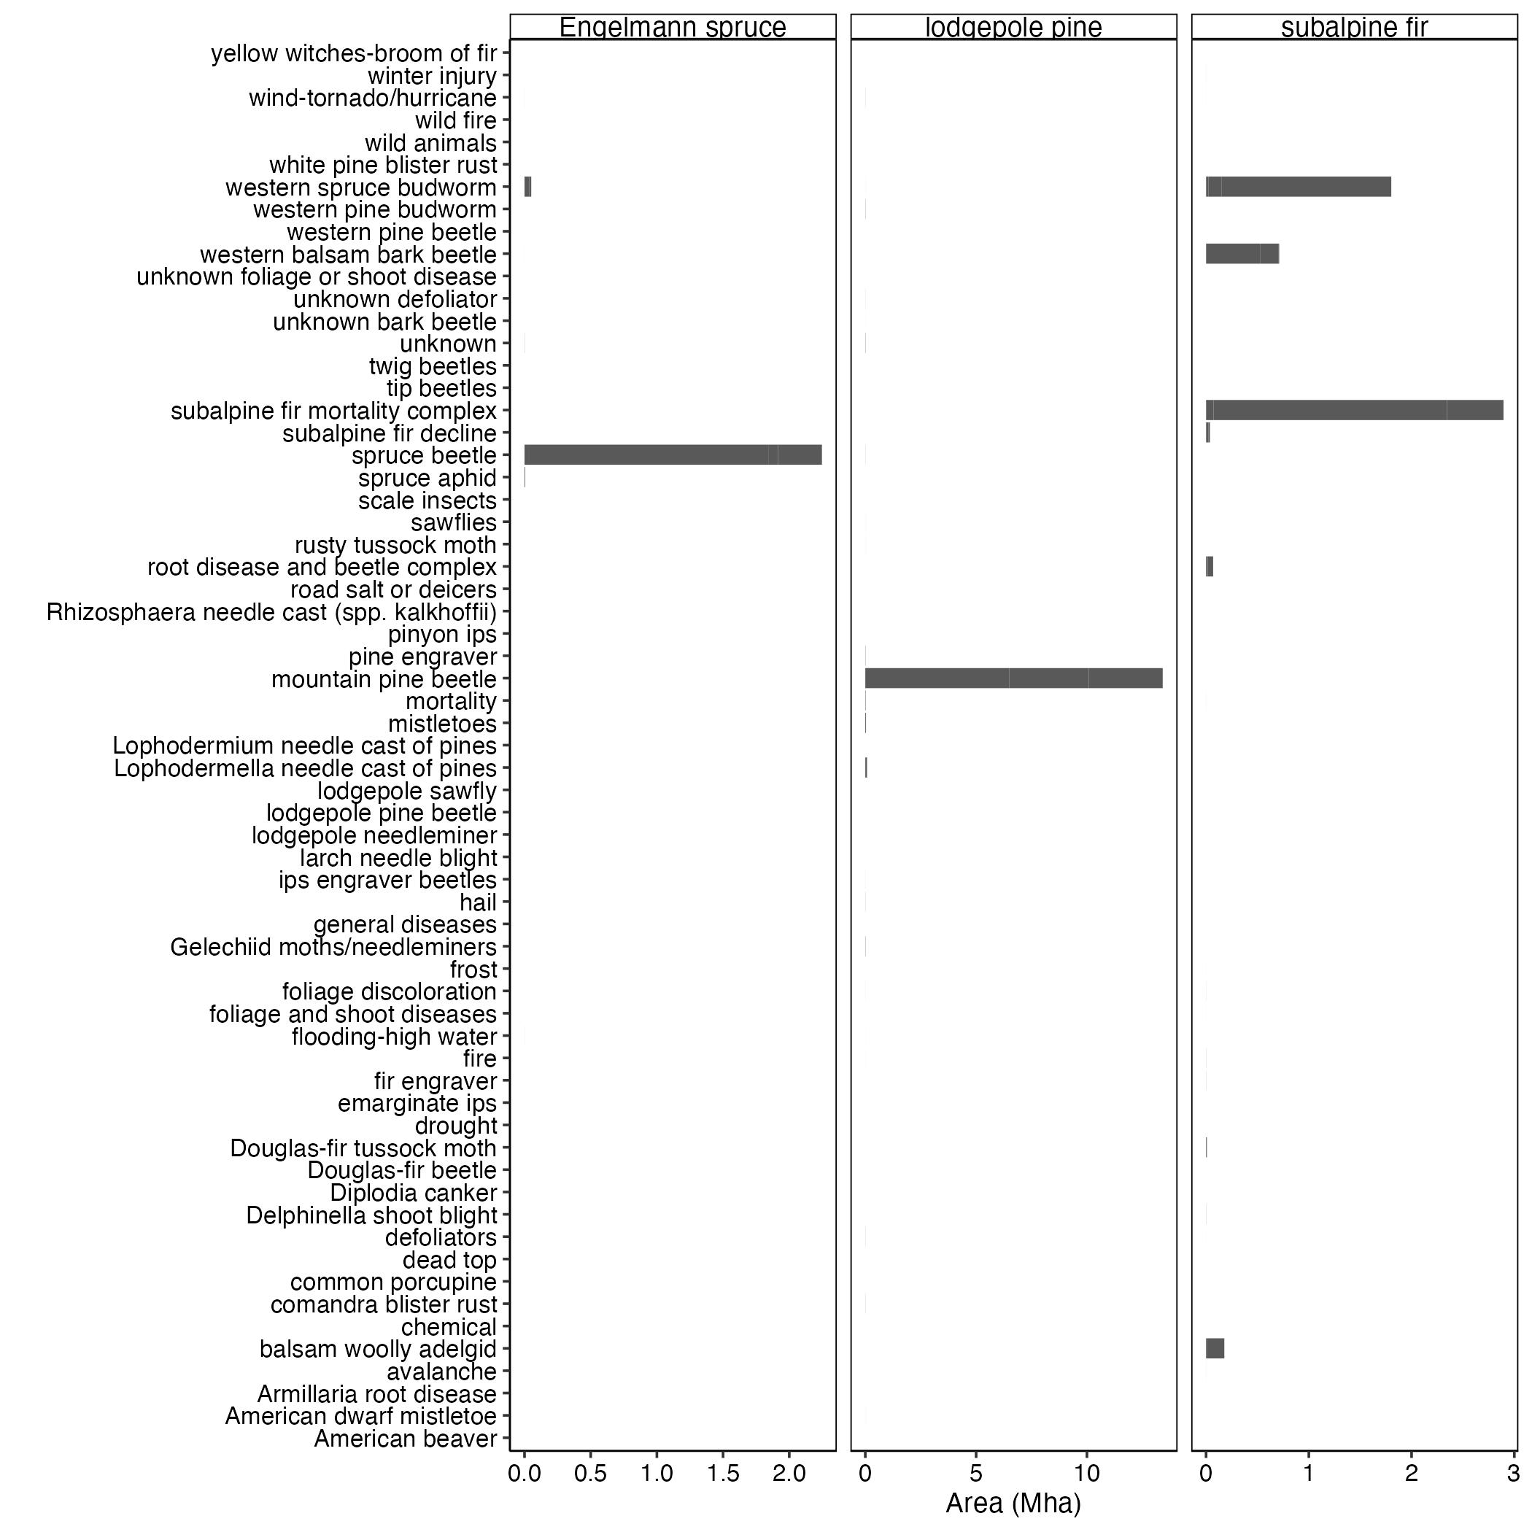

Figure 7: ADSSummary

## Exploratory analyses

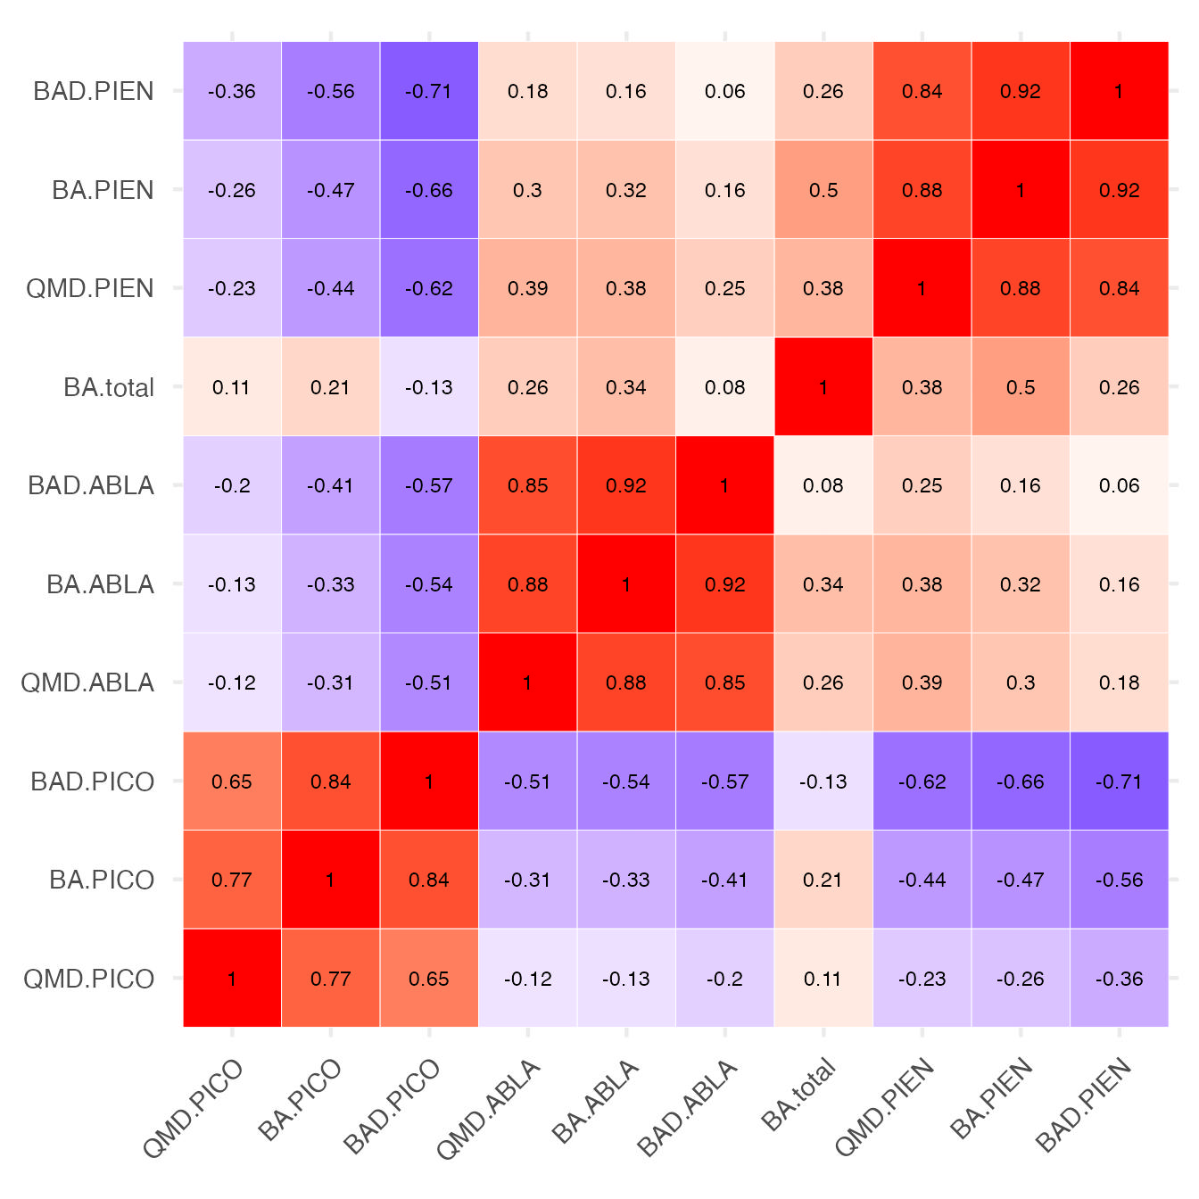

Figure 8: correlation matrix

## Random forest models

Table 1: The optimal thresholds for predicting the presence/absence of outbreaks of mountain pine beetle (MPB) in lodgepole pine, spruce beetle (SB) in Engelmann spruce, and western balsam bark beetle (WBBB) in subalpine fir. Optimal thresholds were selected using Youden's J statistic (Youden 1950).

| Agent | threshold | accuracy | specificity | sensitivity |
| --- | --- | --- | --- | --- |
| MPB | 0.29 | 0.72 | 0.65 | 0.96 |
| SB | 0.22 | 0.58 | 0.52 | 0.98 |
| WBBB | 0.17 | 0.65 | 0.63 | 0.87 |

Table 2: Accuracy statistics from Random Forest models predicting the presence/absence of outbreaks of mountain pine beetle (MPB) in lodgepole pine, spruce beetle (SB) in Engelmann spruce, and western balsam bark beetle (WBBB) in subalpine fir. AUC is the area under the receiver operating characteristic curve. Specificity and sensitivity were calculated using a threshold of 0.25.

| Agent | AUC | specificity | sensitivity |
| --- | --- | --- | --- |
| MPB | 0.83 | 0.63 | 0.97 |
| SB | 0.80 | 0.53 | 0.96 |
| WBBB | 0.80 | 0.68 | 0.75 |

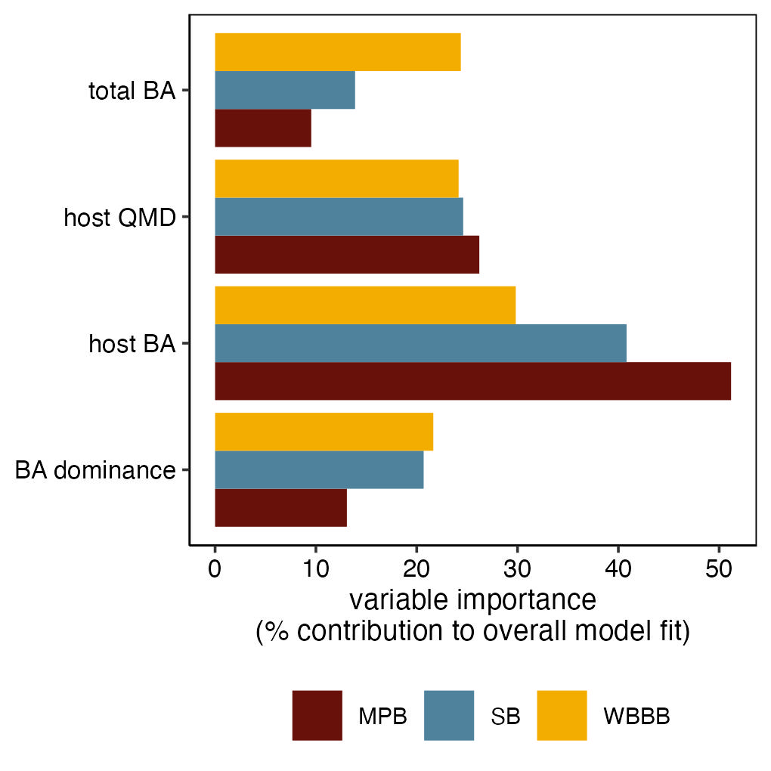

Figure 9: The relative contribution of basal area (BA), quadratic mean diameter (QMD), and host dominance (% BA) to the overall model fit for Random Forest models of mountain pine beetle (MPB; red), spruce beetle (SB; blue); and western balsam bark beetle (WBBB; yellow).

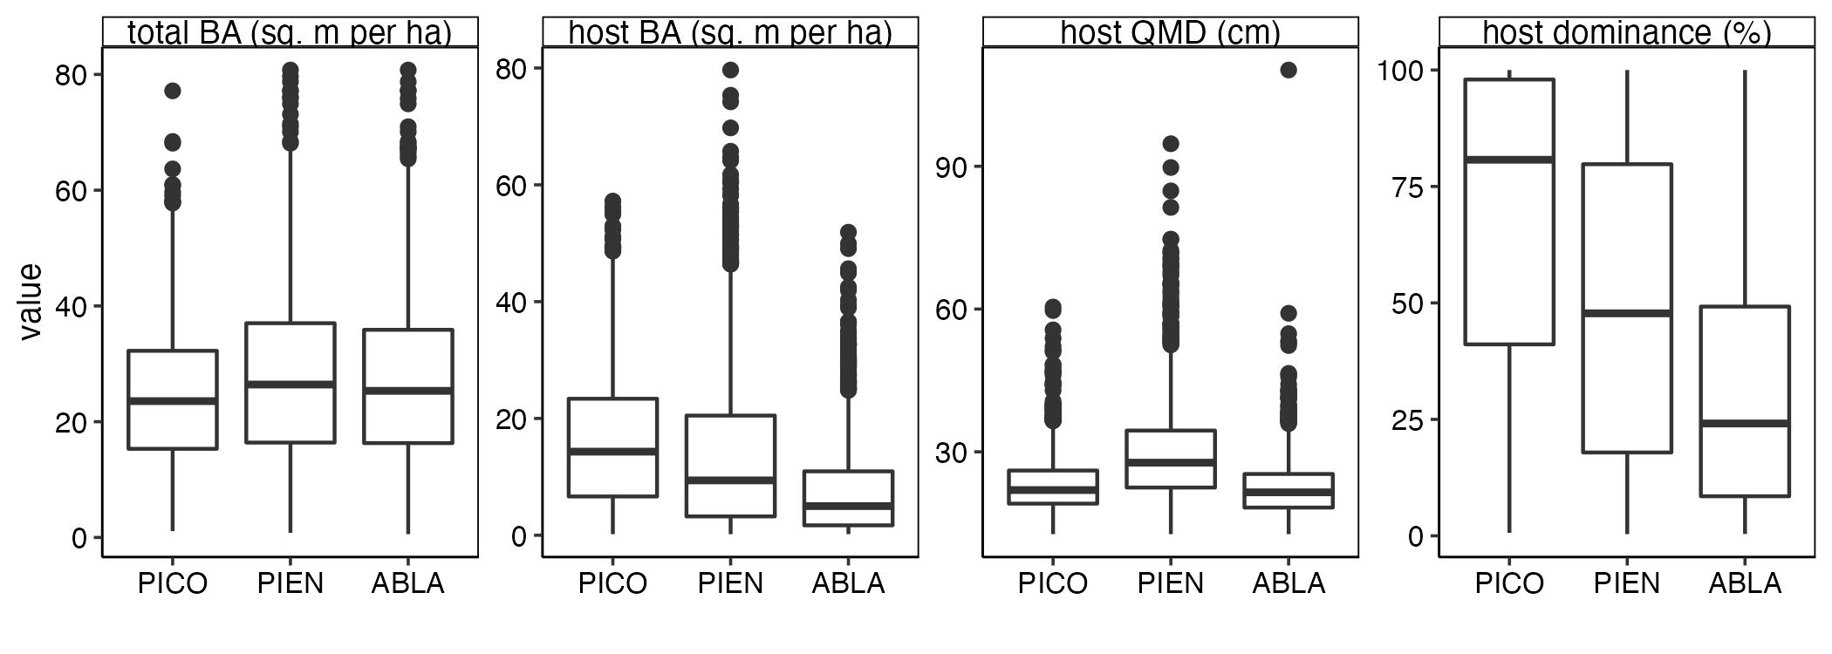

Figure 10: The variation in total basal area (BA), host BA, host quadratic mean diameter (QMD), and host dominance for plots with susceptible lodgepole pine (PICO), Engelmann spruce (PIEN), and subalpine fir (ABLA).

## Given the co-occurrence of multiple susceptible host species, what are the contributions of each bark beetle species to cumulative outbreak occurrence and severity?

Across the 2704 plots, we found that 43% of plots (n=1166) were affected by an outbreak of at least one species. Outbreaks of MPB were most common (n=758), followed by outbreaks of SB (n= 382 plots). Outbreaks of WBBB were least common (n= 208 plots). Consistent with these broad-scale patterns of outbreak, MPB outbreak was more likely to occur then either SB or WBBB given the co-occurrence of susceptible lodgepole pine with either susceptible Engelmann spruce or subalpine fir,(Fig. 11A). In stands with susceptible subalpine fir and Englemann spruce, outbreaks of SB and WBBB were equally likely to occur (Fig. 11A),

and more likely to cause more severe basal area loss (Fig. 11B). but SB outbreaks caused greater mortality (Fig. 11B).

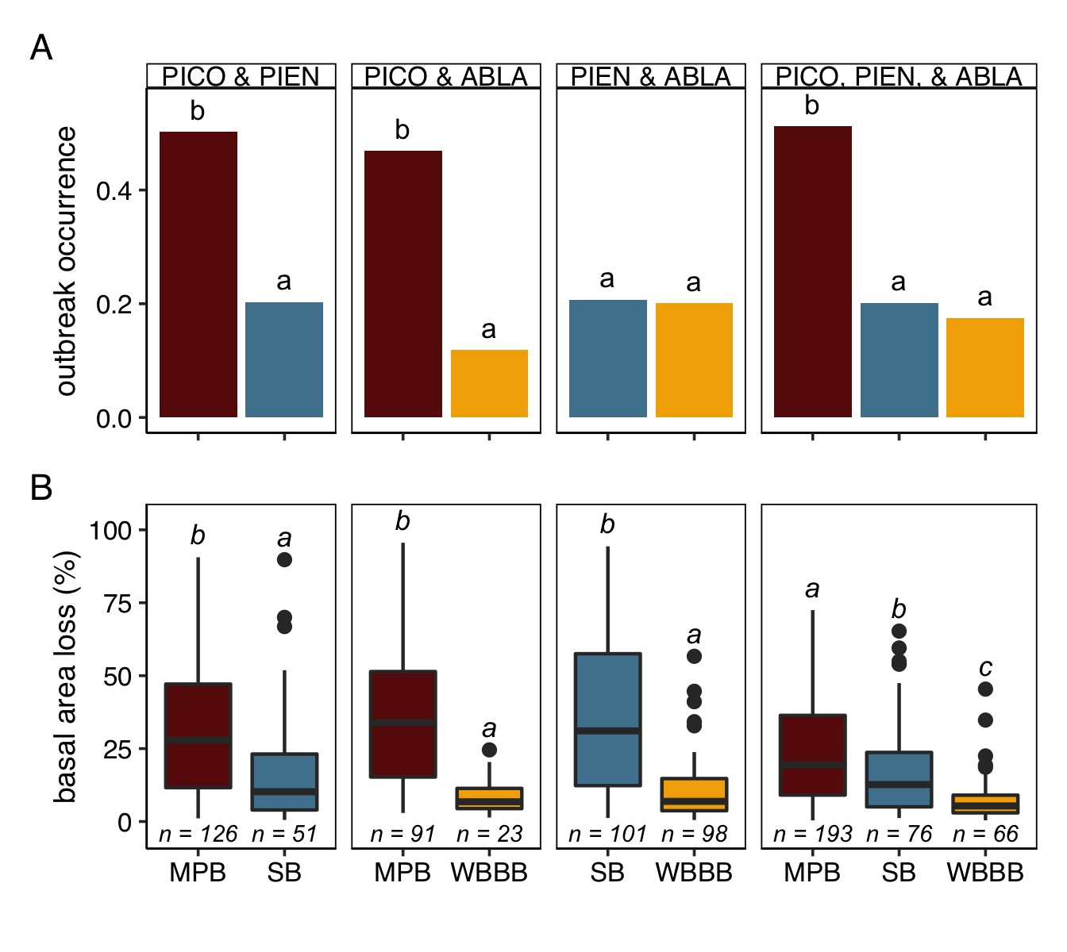

Figure 11: The probability of outbreak occurrence (A) and severity of bark beetle activity given an outbreak (B) by the identity of bark beetle species and host species susceptible to outbreak. Letters above bars (A) and boxes (B) indicate significant difference between groups, as determined using pairwise proportion tests (A) and a nonparametric Dunn test (B). In B, the bottom and top limits of each box are the lower and upper quartiles, respectively; the thick black line within the box is the median; error bars equal ±1.5 times the interquartile range; and points denote outliers, values outside ±1.5 times the interquartile range. For host identities, PICO is lodgepole pine, PIEN is Engelmann spruce, and ABLA is subalpine fir.

Apley, D. 2018. [ALEPlot: Accumulated local effects (ALE) plots and partial dependence (PD) plots](https://CRAN.R-project.org/package=ALEPlot).

Benjamini, Y., and Y. Hochberg. 1995. [Controlling the false discovery rate: A practical and powerful approach to multiple testing](https://www.stat.purdue.edu/~doerge/BIOINFORM.D/FALL06/Benjamini%20and%20Y%20FDR.pdf). Journal Of The Royal Statistical Society Series B (Methodological) 57:289–300.

Bentz, B. J., J. Régnière, C. J. Fettig, E. M. Hansen, J. L. Hayes, J. A. Hicke, R. G. Kelsey, J. F. Negrón, and S. J. Seybold. 2010. Climate change and bark beetles of the western united states and canada: Direct and indirect effects. BioScience 60:602613.

Breiman, L. 2001. [Random forests](http://www.springerlink.com/index/U0P06167N6173512.pdf). Machine learning 45:532.

Burrill, E., A. M. Wilson, J. A. Turner, S. A. Pugh, J. Menlove, G. Christiansen, B. L. Conkling, and W. David. 2017. [The forest inventory and analysis database: Database description and user guide version 7.2 for phase 2.](http://www.fia.fs.fed.us/library/database-documentation/) Pages 1–946.

Cardinale, B. J., D. S. Srivastava, J. Emmett Duffy, J. P. Wright, A. L. Downing, M. Sankaran, and C. Jouseau. 2006. [Effects of biodiversity on the functioning of trophic groups and ecosystems](https://doi.org/10.1038/nature05202). Nature 443:989–992.

Chawla, N. V., K. W. Bowyer, L. O. Hall, and W. P. Kegelmeyer. 2002. [SMOTE: Synthetic minority over-sampling technique](https://doi.org/10.1613/jair.953). Journal of Artificial Intelligence Research 16:321–357.

Cutler, D. R., T. C. Edwards Jr, K. H. Beard, A. Cutler, K. T. Hess, J. Gibson, and J. J. Lawler. 2007. Random forests for classification in ecology. Ecology 88:27832792.

Dinno, A. 2017. [Dunn.test: Dunn’s test of multiple comparisons using rank sums](https://CRAN.R-project.org/package=dunn.test).

Elton, C. S. 1958. The Ecology of Invasions by Animals and Plants. Springer Nature.

Finke, D. L., and W. E. Snyder. 2008. [Niche Partitioning Increases Resource Exploitation by Diverse Communities](https://doi.org/10.1126/science.1160854). Science 321:1488–1490.

Harvey, B. J., R. A. Andrus, M. A. Battaglia, J. F. Negrón, A. Orrego, and T. T. Veblen. 2021. [Droughty times in mesic places: factors associated with forest mortality vary by scale in a temperate subalpine region](https://doi.org/10.1002/ecs2.3318). Ecosphere 12:e03318.

Harvey, B. J., S. J. Hart, P. C. Tobin, T. T. Veblen, D. C. Donato, M. S. Buonanduci, A. Pane, H. Stanke, and K. C. Rodman. (n.d.). Emergent hotspots of biotic disturbances and their consequences for forest resilience. Frontiers in Ecology and Evolution.

Hicke, J. A., B. Xu, A. J. H. Meddens, and J. M. Egan. 2020. [Characterizing recent bark beetle-caused tree mortality in the western United States from aerial surveys](https://doi.org/10.1016/j.foreco.2020.118402). Forest Ecology and Management 475:118402.

Jactel, H., X. Moreira, and B. Castagneyrol. 2021. [Tree diversity and forest resistance to insect pests: Patterns, mechanisms, and prospects](https://doi.org/10.1146/annurev-ento-041720-075234). Annual Review of Entomology 66:277–296.

Johnson, P. T., D. L. Preston, J. T. Hoverman, and B. E. LaFonte. 2013. Host and parasite diversity jointly control disease risk in complex communities. Proceedings of the National Academy of Sciences 110:1691616921.

Keddy, P. A. 1984. [Plant zonation on lakeshores in nova scotia: A test of the resource specialization hypothesis](https://doi.org/10.2307/2259532). Journal of Ecology 72:797–808.

Kuhn, M., and H. Wickham. 2020. [Tidymodels: A collection of packages for modeling and machine learning using tidyverse principles.](https://www.tidymodels.org)

Lalande, B. M., K. Hughes, W. R. Jacobi, W. T. Tinkham, R. Reich, and J. E. Stewart. 2020. [Subalpine fir mortality in Colorado is associated with stand density, warming climates and interactions among fungal diseases and the western balsam bark beetle](https://doi.org/10.1016/j.foreco.2020.118133). Forest Ecology and Management 466:118133.

MacArthur, R. 1970. [Species packing and competitive equilibrium for many species](https://doi.org/10.1016/0040-5809(70)90039-0). Theoretical Population Biology 1:1–11.

Mangiafico, S. 2022. [Rcompanion: Functions to support extension education program evaluation](https://CRAN.R-project.org/package=rcompanion).

Mantgem, P. J. van, N. L. Stephenson, J. C. Byrne, L. D. Daniels, J. F. Franklin, P. Z. Fulé, M. E. Harmon, A. J. Larson, J. M. Smith, and A. H. Taylor. 2009. Widespread increase of tree mortality rates in the western united states. Science 323:521524.

Otway, S. J., A. Hector, and J. H. Lawton. 2005. [Resource dilution effects on specialist insect herbivores in a grassland biodiversity experiment](https://doi.org/10.1111/j.1365-2656.2005.00913.x). Journal of Animal Ecology 74:234–240.

R Core Team. 2022. [R: A language and environment for statistical computing](http://www.R-project.org). R Foundation for Statistical Computing, Vienna, Austria.

Schmid, J. M., and R. H. Frye. 1976. Stand ratings for spruce beetles. Page 4.

Shore, T. L., and L. Safranyik. 1992. Susceptibility and risk-rating systems for the mountain pine beetle in lodgepole pine stands.

Tilman, D., J. Knops, D. Wedin, P. Reich, M. Ritchie, and E. Siemann. 1997. [The Influence of Functional Diversity and Composition on Ecosystem Processes](https://doi.org/10.1126/science.277.5330.1300). Science.

Wright, M. N., and A. Ziegler. 2017. [Ranger: A fast implementation of random forests for high dimensional data in c++ and r](https://doi.org/10.18637/jss.v077.i01) 77.

Youden, W. J. 1950. [Index for rating diagnostic tests](https://doi.org/10.1002/1097-0142(1950)3:1%3c32::AID-CNCR2820030106%3e3.0.CO;2-3). Cancer 3:32–35.