Host richness increases the occurrence but not the severity of bark beetle-induced tree mortality

Sarah Hart

November 13, 2021

# Abstract

## Key findings

# Keywords

# Introduction

In the western United States, native bark beetles (Curculionidae: Scolytinae) have killed 3.8 billion trees over the past two decades [1997-2018; Hicke et al. (2020)]. While across the region there are more than 25 native bark beetle species, the mountain pine beetle (MPB; *Dendroctonus ponderosae*), spruce beetle (SB; *Dendroctonus rufipennis*), and western balsam bark beetle (WBBB; *Dryocoetes confusus*) collectively have caused over 70% of the bark beetle-attributed tree mortality, most of which has occurred in high elevation forests (**hicke_chacterizing_2020?**).

In the case of plant-herbivore interactions, greater plant diversity often reduces the effects of herbivory (i.e., ‘associational resistance,’ Barbosa et al. 2009), particularly when herbivores are specialists capable of rapid population growth (**otway_resource_2005?**). Associational resistance is commonly hypothesized to occur due to several non-mutually exclusive mechanisms. First, herbivory may be lower in more diverse systems if herbivores are less likely to encounter, stay, and reproduce in areas where their hosts are less abundant (i.e., ‘resource concentration hypothesis,’ Root 1973). Second, reductions in herbivory may occur if insects are less likely to find their hosts due to chemical or visual masking by heterospecific neighbors (**castagneryrol_effects_2014?**), Third, heterospecific neighbors may increase the abundance of herbivore natural enemies Staab and Schuldt (2020). However, evidence for associational resistance in natural (i.e. not plantations) forested ecosystems is limited.

While increases in plant diversity may decrease the effects of herbivore species on individuals and populations of plants, it is also hypothesized to increase herbivore richness (‘resource specialization hypothesis,’ **keddy_plant_1984?**), which may result in more efficient resource use and greater depletion of the plant community, especially when herbivores are specialists (**cardinale_effects_2005?**, **finke_niche_2008?**).

Yet little research has examined the effects of plant diversity on community-level outcomes of herbivory, which critically may drive key ecosystem processes. This is particularly true in natural systems, where the number of potential interactions is high, the effects of different herbivores on their focal host populations often differ greatly, and the changes in plant diversity are often convoluted with changes in host quality (Jactel et al. 2021).

Resource specialization Compensatory mechanisms - only meaningful if populations susceptible to bb infestionat co- occur with tree populatoin ssucess to other

To better understand interactions between tree and bark beetle communities in subalpine forests, we used a large dataset consisting of XXX,XXX plots established by the United States Forest Service Forest Inventory and Analysis Program (FIA; <https://www.fia.fs.fed.us/>). Specifically, we ask:

1. How often do stand conditions suitable for multiple bark beetle species occur?
2. Does host species richness effect the occurrence or severity of cumulative bark beetle activity increase with the host species richness?
3. Does the co-occurrence of multiple bark beetle species result in more severe cumulative bark beetle mortality?

We expect that co-occurrence of trees of different host species will be common (i.e. resource specialization hypothesis), but co-occurrence of stand conditions suitable for multiple bark beetle species will not (i.e. associational resistance).

When stand conditions are suitable for multiple bark beetle species, we expect that the

will be greater (i.e. resource specialization hypothesis), but severity will be lower (i.e. associational resistance). Alternatively, if

We also expected the severity of bark beetle infestation to vary with the number of agents present, but with two alternative hypotheses. If the population dynamics of each bark beetle species are independent, then stands with multiple agents will experience higher tree mortality than stands with only one agent. Alternatively, lower tree mortality may occur if concurrent outbreaks of bark beetles of different species cause semiochemical confusion or if competitive release increases tree defensive capacity.

# Methods

## Study area

The study area consists of subalpine forests with lodgepole pine (*Pinus contorta*), subalpine fir (*Abies lasiocarpa*), and Engelmann spruce (*Picea engelmannii*) that are located in the Intermountain West (i.e., Arizona, New Mexico, Colorado, Utah, Nevada, Idaho, Montana, and Wyoming; Fig. 1). Our study area was constrained to the Intermountain West due to regional differences in data collection that exist within the FIA program (Burrill et al. 2017).

## Data

The FIA program inventories all public and private forested land using a spatially and temporally distributed sampling design, making it useful for the study of tree species distributions (e.g., Iverson and Prasad 1998, Rehfeldt et al. 2006) and tree demography DeRose et al. (2013). In the Western US, all plots are visited once every ten years (Gray et al. 2012). At each plot, field crews collect data within four 7.32 m radius subplots arranged in a fixed pattern. For each tree within the plot, field crews record the species, size (diameter at breast height; DBH), and status (live or dead) for trees (>= 12.7 cm DBH).For each live tree, field crews additionally record up to three damaging agents (e.g. MPB), defined as any agent likely to prevent the tree from surviving >2 years, reduce the growth of the tree in the near term, or negatively affect the tree’s marketable products (Burrill et al. 2017). For dead trees that were alive at the previous visit, the proximate cause of death is also collected for any tree that was alive at the previous visit and at revisit is dead using visible evidence (e.g., fire scars, bark beetle galleries). Because identifying the mortality agent is more challenging cause of death codes are broad (e.g., “insect” or “disease”).

We acquired all FIA data for the Intermountain West, but restricted our analyses to the most recent inventory for plots that contained a focal host species and where all subplots were inventoried. We then characterized stand structure and composition using only live and recently killed (i.e. killed within the past ~10 years) trees. each plot we calculated the basal area, quadratic mean diameter (QMD), and basal area dominance (% total basal area) for each host species. Additionally, we characterized the presence (i.e., at least one tree infested) and severity of bark beetle activity (% total basal area) by bark beetle species. For live Engelmann spruce, we listed the presence of SB when the agent was listed as a general bark beetle or SB specifically. Similarly, we listed the presence of MPB in lodgepole when agent was listed as a general bark beetle or MPB specifically. For live subalpine fir, we listed the presence of WBBB when the damaging was recorded as, subalpine fir decline, a general bark beetle, or WBBB specifically. Finally, we assumed the mortality of lodgepole pine, Engelmann spruce, and subalpine fir that was attributed an insect, was caused by the MPB, SB, and WBBB, respectively.

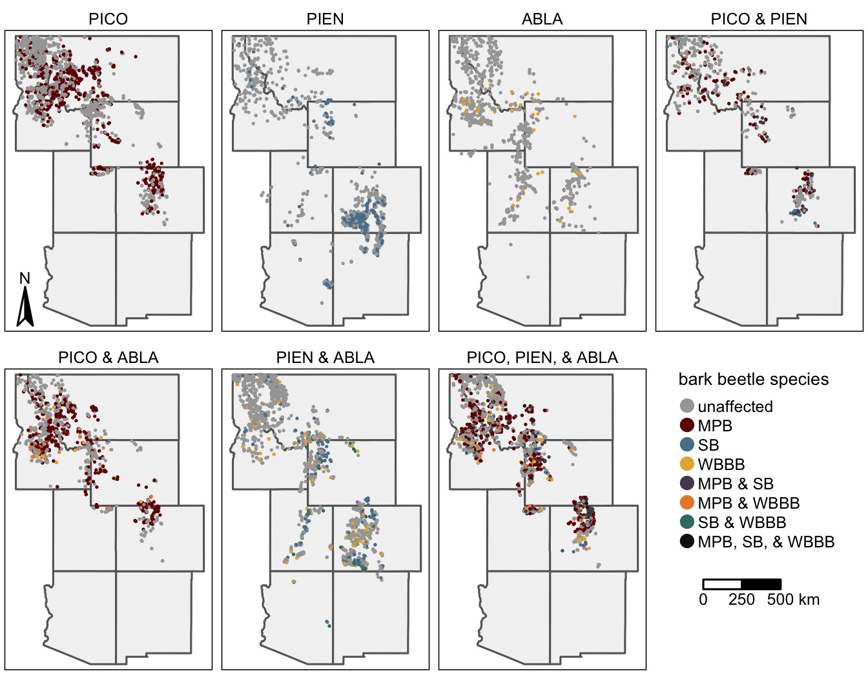

Figure 1: a caption

## Analyses

### Population

### Community

To determine how frequently co-occurrence of multiple bark beetle species was likely to occur, we first calculated the proportion of plots where multiple host species were present.

Because the effects of diversity may be convoluted with stand development processes and thus host size and availability, we limited our analyses to only the plots where host trees were susceptible to outbreak. To do so we used a random forest modeling framework (Breiman 2001), a distribution-free approach useful for modeling nonlinear relationships and complex interactions characteristic of ecological systems (Cutler et al. 2007). We constructed separate models for the presence of MPB, SB, and WBBB and as predictor variables included host QMD, host basal area, and host dominance, which have been commonly linked to increased risk of bark beetle activity [[e.g. REF MPB, REF SB, REF WBBB]. Because most stands in our dataset were unaffected by bark beetles, we used a synthetic minority oversampling technique (SMOTE) to deal the imbalance in the response (**chawla_smote_2002?**). Briefly, the SMOTE approach oversamples the minority class by synthesizing new cases from the minority class (here affected stands). Models were fit in R (Team 2020) using the **Tidymodels** package (**kuhn_tidymodels_2020?**). We then assumed that each host species was susceptible to infestation when the predicted probability of occurrence of the focal bark beetle species was greater than 0.5.

To determine if the proportion of plots affected by any bark beetle species varied with the number or identity of hosts present, we first used a proportion test to determine if groups differed followed by a pairwise proportion test to test for differences between groups. To account for multiple comparisons, we adjusted p-values using methods outlined by (**benjamini_false_1995?**).

To determine if the severity of cumulative bark beetle-driven tree mortality was greater in stands with multiple susceptible hosts, we subsetted our data to only the plots affected by at least one bark beetle species. We then used Kruskall-Wallis test to determine if cumulative mortality differed with the identify of bark beetle species present. Followed by a Dunn test to determine if difference existed between groups, again accounting for false discovery rate using the Benjamini and Hochberg (1995) method.

Finally, to determine ifWe then used Kruskall-Wallis test to determine if cumulative mortality differed with the identify of bark beetle species present.

# Results

## Do stand conditions suitable for multiple outbreaks commonly co-occur?

Across the 10,439 FIA plots with at least one of the target host species, 66% (n=5,850) contained at least two species (Fig. 2). Subalpine fir was most likely to occur with other target host species (50% of plots), followed by Engelmann spruce (45% plots), and lodgepole pine (36% of stands). However, random forest models predicted that only 21% of all plots (n=2,163) were suitable for more than one bark beetle species (Fig. 2). Again, conditions suitable for bark beetle attack in subalpine fir were most likely to co-occur with conditions suitable for bark beetle attack in another tree species (17% of stands).

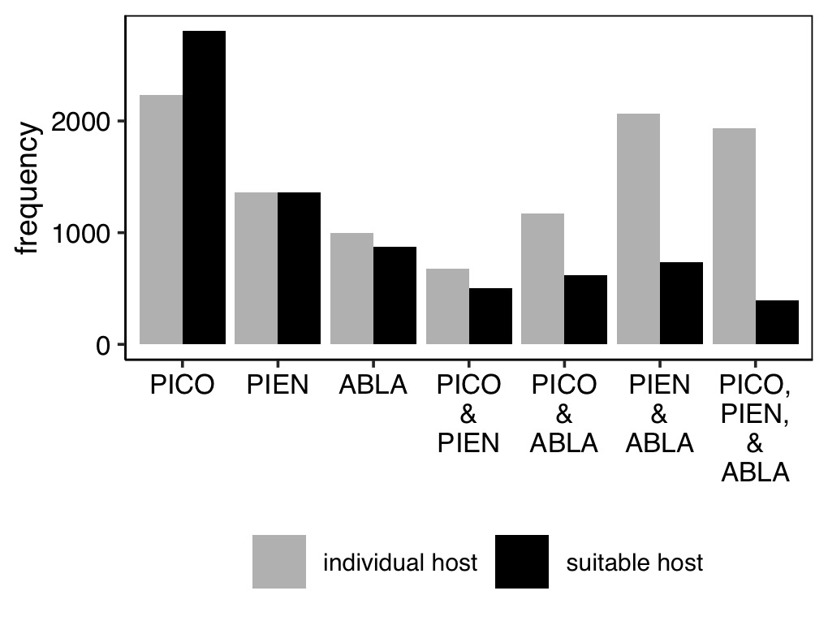

Figure 2: The frequency of plots by host identity. Gray bars indicate host species were present (i.e., at least one individual of the focal species was present within the plot). Black bars indicate stand structure and composition conditions were conducive to bark beetle infestation in focal tree species. For host identities, PICO is lodgepole pine, PIEN is Engelmann spruce, and ABLA is subalpine fir.

### Does the occurrence or severity of cumulative bark beetle activity increase with the host species richness?

Stands with all three hosts present were most likely to experience bark beetle outbreaks (Fig. 3). Similarly, plots with spruce and fir present, exhibited more bark beetle activity then plots with just spruce or fir. However, when lodgepole pine was present there was no effect of increased host richness on the occurrence of bark beetle activity.

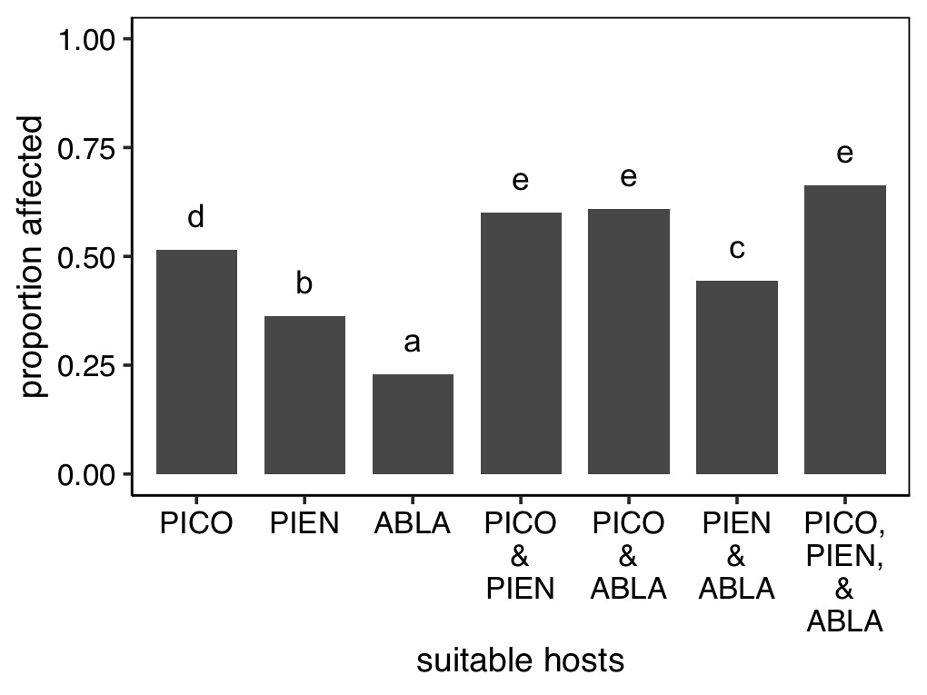

Figure 3: The proportion of plots affected by bark beetles by the identity of suitable hosts. Letters above bars indicate significant (p<0.05) difference between groups, as determined using a proportion test. For host identities, PICO is lodgepole pine, PIEN is Engelmann spruce, and ABLA is subalpine fir.

The effect of the number of susceptible hosts on the severity of bark beetle activity depended upon the identity of host species (Fig. 4.

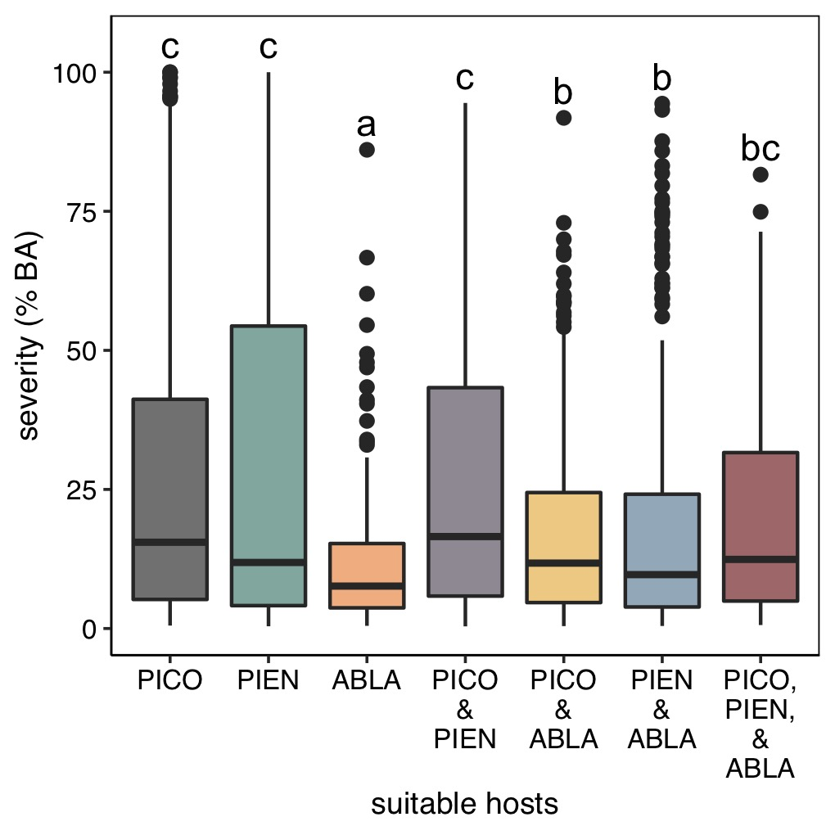

Figure 4: Boxplots illustrating the severity of mortality (% of total basal area) attributed to bark beetles (i.e., cumulative mortality due to MPB, SB and WBBB) by the identity of host species susceptible to bark beetle outbreak. For host identities, PICO is lodgepole pine, PIEN is Engelmann spruce, and ABLA is subalpine fir. The bottom and top limits of each box are the lower and upper quartiles, respectively; the thick black line within the box is the median; error bars equal ±1.5 times the interquartile range; and points denote outliers, values outside ±1.5 times the interquartile range. Letters above boxes indicate significant (p<0.05) difference between groups, as determined using a nonparametric Dunn test.

## Does the co-occurrence of multiple bark beetle species result in more severe cumulative bark beetle mortality?

Across all 10,439 FIA plots, only 5.3% (n=539) were affected by outbreaks of multiple bark beetle species.

Given the 2,163 plots where multiple tree species were susceptible to bark beetle infestation, 56.7% (n=1,227) were affected by at least one bark beetle species and 21.3% (n=461) were affected by multiple bark beetle species. The most commonly occurring agent was the MPB (n=768, 35.5% of plots), followed by the WBBB (n=503, 23.3%) and the SB (n=461, 21.3%). The most commonly occurring combination of bark beetle species was MPB and SB (33.2% of cases; n=153), followed by MPB and WBBB (31.2% of cases; n=144) and SB and WBBB (26% of case; n=120). The combination of all three agents was rare (9.5% of cases; n=44).

When plots contained two tree species susceptible to bark beetles, the presence of both bark beetle species increased activity relative to presence of only one bark beetle species (Fig. 5). The increase was greatest for stands that contained both MPB and SB; the median severity of plots with both MPB and SB was 33.7 percentage points greater than MPB alone and 38.3 percentage points greater than SB alone. The median severity of plots with both MPB and WBBB was 7.0 percentage points greater than MPB alone and 13.6 percentage points greater than WBBB alone. The median severity of plots with both SB and WBBB was 14.7 percentage points greater than SB alone and 19.8 percentage points greater than WBBB alone.

Given stand conditions that made all three tree species susceptible to bark beetle activity, the highest rates of bark beetle activity were in plots where both MPB and SB present; whether or not WBBB was also present did not affect mortality severity (~1 percentage point difference in median severity; Fig. 5).

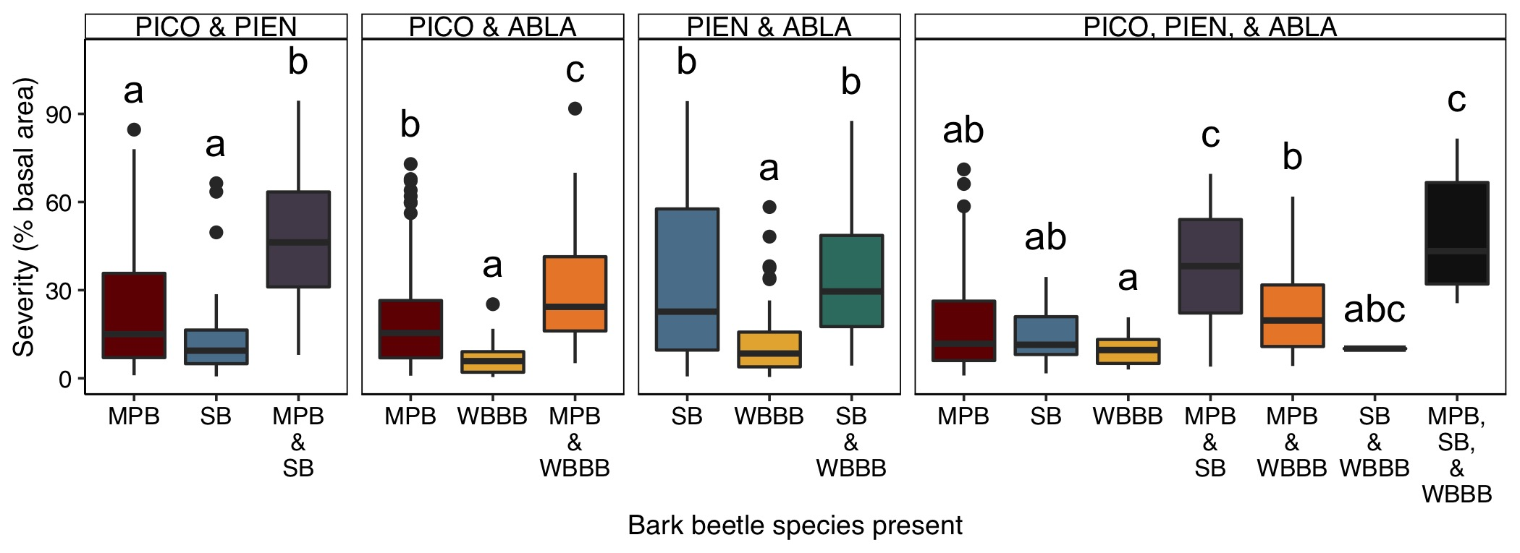

Figure 5: The severity of bark beetle mortality in plots with multiple tree species susceptible to bark beetles (columns) by the combinatin of bark beetle species present. Letters above boxes indicate significant (p < 0.05) differences between groups as determined by a Dunn test, a nonparametric rank sum test. The bottom and top limits of each box are the lower and upper quartiles, respectively; the thick black line within the box is the median; error bars equal ±1.5 times the interquartile range; and points denote outliers, values outside ±1.5 times the interquartile range.

# Discussion

# Acknowledgements

# Author contributions

# References

Barbosa, P., J. Hines, I. Kaplan, H. Martinson, A. Szczepaniec, and Z. Szendrei. 2009. Associational Resistance and Associational Susceptibility: Having Right or Wrong Neighbors. Annual Review of Ecology, Evolution, and Systematics 40:1–20.

Breiman, L. 2001. Random forests. Machine learning 45:5–32.

Burrill, E., A. M. Wilson, J. A. Turner, S. A. Pugh, J. Menlove, G. Christiansen, B. L. Conkling, and W. David. 2017. The Forest Inventory and Analysis database: Database description and user guide version 7.2 for Phase 2. Pages 1–946. U.S. Department of Agriculture, Forest Service.

Cutler, D. R., T. C. Edwards Jr, K. H. Beard, A. Cutler, K. T. Hess, J. Gibson, and J. J. Lawler. 2007. Random forests for classification in ecology. Ecology 88:2783–2792.

DeRose, R. J., B. J. Bentz, J. N. Long, and J. D. Shaw. 2013. Effects of increasing temperatures on the distribution of spruce beetle in Engelmann spruce forests of the Interior West, USA. Forest Ecology and Management 308:198–206.

Gray, A., T. Brandeis, J. Shaw, W. McWilliams, and P. Miles. 2012. Forest Inventory and Analysis database of the United States of America (FIA). Biodiversity & Ecology 4:225–231.

Hicke, J. A., B. Xu, A. J. H. Meddens, and J. M. Egan. 2020. Characterizing recent bark beetle-caused tree mortality in the western United States from aerial surveys. Forest Ecology and Management 475:118402.

Iverson, L. R., and A. M. Prasad. 1998. Predicting abundance of 80 tree species following climate change in the Eastern United States. Ecological Monographs 68:465–485.

Jactel, H., X. Moreira, and B. Castagneyrol. 2021. Tree diversity and forest resistance to insect pests: Patterns, mechanisms, and prospects. Annual Review of Entomology 66:277–296.

Rehfeldt, G. E., N. L. Crookston, M. V. Warwell, and J. S. Evans. 2006. Empirical analyses of plant-climate relationships for the western United States. International Journal of Plant Sciences 167:1123–1150.

Root, R. B. 1973. Organization of a Plant-Arthropod Association in Simple and Diverse Habitats: The Fauna of Collards (Brassica Oleracea). Ecological Monographs 43:95–124.

Shaw, J. D., B. E. Steed, and L. T. DeBlander. 2005. Forest Inventory and Analysis (FIA) annual inventory answers the question: What is happening to pinyon-juniper woodlands? Journal of Forestry 103:280–285.

Staab, M., and A. Schuldt. 2020. The Influence of Tree Diversity on Natural Enemies—a Review of the “Enemies” Hypothesis in Forests. Current Forestry Reports 6:243–259.

Team, R. C. 2020. R: A language and environment for statistical computing. R Foundation for Statistical Computing, Vienna, Austria.

## Supplement

### Appendix I: Random Forest Modeling

Models Table 1

Table 1: A caption

|  |  |  |  |
| --- | --- | --- | --- |
| Metric | MPB | SB | WBBB |
| ROC AUC | 0.83 | 0.81 | 0.79 |
| sensitivity | 0.68 | 0.72 | 0.76 |
| specificity | 0.88 | 0.76 | 0.60 |

Consistent with existing stand hazard ratings, the probability of each bark beetle species occurring generally increased with host basal area, quadratic mean diameter, and percent basal area (Fig. 6). However, both MPB and WBBB exhibited a slight decrease in the probability of outbreak at very high basal areas and all three bark beetle species exhibited a lower probability of outbreak in stands where host trees were very large (i.e. high QMD values). WBBB also exhibited a decline in the probability of outbreak when subalpine fir comprised a relatively high proportion of the basal area.

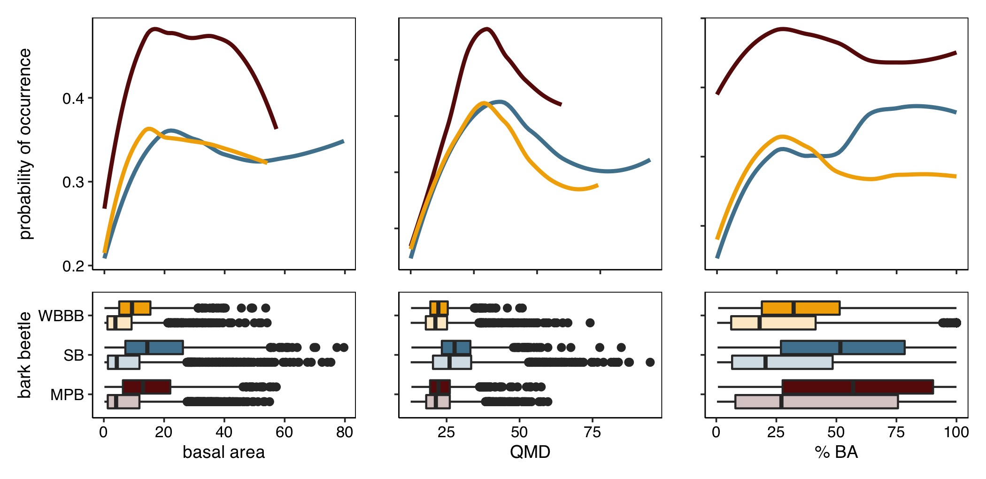

Figure 6: The associations between the probability of occurrence of the mountain pine beetle (MPB; red), spruce beetle (SB; blue); and western balsam bark beetle (WBBB; yellow) and three common measuree of stand suceptibility to bark beetl beetle outbreak, basal area (BA), quadratic mean diameter (QMD), and host dominance (% BA). The top row illustrates smoothed partial dependence results from Random Forest modeling, while in the bottom row boxplots show the distribution of values for stands affected (dark colors) and unaffected (light colors) by each bark beetle species.

### Maps

To determine if the proportion of plots affected by any bark beetle species was significantly greater (p <0.05) than the proportion affected by an individual species, we used a one-sided proportion test. Next, to determine if the severity of cumulative bark beetle activity was greater than the severity attributed to an individual species, we subset our data to only the plots affected by at least one bark beetle species. We then used Wilcox rank sum test to determine if cumulative mortality was greater that mortality due to an individual bark beetle species.