Host richness increases the occurrence but not the severity of bark beetle-induced tree mortality

Sarah J. Hart

September 14, 2021

# Abstract

# Keywords

# Introduction

Paragraph 1: Broad applied context

In this context there is a particular need to understand interactions between outbreaks of irruptive insects, which in recent years (2003-2012) have affected 85 million hectares of forest globally, or ca. 18 million hectares more than wildfire (van Lierop et al. 2015).

* insect outbreaks are causing widespread tree mortality in temperate forest worldwide
* future changes in climate are expected to increase tree mortality
* forests provide key ecosystem services
* management

Paragraph 2: Theoretical context - diversity & natural enemies - Many studies have sought to understand how community diversity influences interactions between natural enemies and their resources. - Key hypotheses: 1 - associational resistance - the abundance or damage of herbivores is lower when plant diversity is greater Jactel et al. (2021) hypotheses: 1 - resource concentration: the presence of heterospecific neighbors around a tree of a focal species grown in mixed stands leads to a lower probability of host tree finding by insect herbivores due to lower host abundance or frequency (Root 1973) 2 - host apparency: 3 - decoy: preference for non-host trees

However, benefits provided by mixtures are less evident for larger-scale disturbances (Jactel et al. 2021)

suggesting that changes in the structure of host communities, rather than biodiversity per se, can explain when a dilution effect should be observed.

Most studies have focused on individual- or population-level outcomes.

For instance, increased host community diversity may either increase or decrease the susceptibility of individuals to their natural enemies.

At the population-scale these effects may either scale-up or result in counter-intuitive effects. However, little research has examined community-level outcomes, which are often hard to quantify because of the number of potential interactions increases dramatically with increasing community diversity, particularly when natural enemies are generalists. Further, the effects of different natural enemies on their focal host populations often differ greatly, due to differences in susceptibility and mortality rates and the availability and quality (as viewed by their natural enemies) of resource communities. Critically, community-level outcomes may drive ecosystem processes, particularly when community diversity is low and natural enemy-resource relationships are highly dynamic.

*** paragraph about irruptive species and community host diversity*** - stand scale - landscape scale

To better understand how community diversity influences interactions between natural enemies and their resources, we use a natural system with inherently low resource and natural enemy diversity. Specifically our research focuses on tree mortality due to three bark beetle species, the mountain pine beetle (*Dendroctonus ponderosae*), spruce beetle (*D. rufipennis*), and western balsam bark beetle (*Dryocoetes confusus*), which in subalpine forests of Western North America predominantly attack lodgepole pine (*Pinus contorta*), Engelmann spruce (*Picea engelmannii*), and subalpine fir (*Abies lasiocarpa*), respectively. We use this system to ask whether host tree richness or identity influence the occurrence and severity of tree mortality due to bark beetles at the community-scale? We hypothesize that greater host richness will increase the probability of outbreak occurrence

Bark beetles (Curculionidae: Scolytinae) are among the few native insect species that can kill large numbers of trees in a single year. Bark beetles bore through the bark, where they mate and oviposit their eggs. Concurrently, bark beetles introduce pathogenic fungi Larvae feeding upon the phloem and fungal spread stop the translocation of water and nutrients and cause tree death. Conifer defense against bark beetles consists primarily of resin exudation that physically expels the beetle and allelochemicals, which repel or kill beetles. To overcome these defenses and colonize live trees, bark beetles rely on a mass-attack strategy, where pioneering beetles emit aggregation pheromones that call conspecifics to the tree. Typically bark beetles exist at low population levels and attack weakened trees, but as populations increase bark beetles attack increasingly better defended trees.For instance, in the continental western United States bark beetles have killed more than XXXX trees over the past X decades. Such severe mortality occurs only during outbreaks when pheromone-mediated mass-attack allows bark beetles to overcome tree defenses. For instance, a primary goal of the Western Bark Beetle is to promote resilience of forests to bark beetle outbreaks by increasing the diversity of age classes and tree species.

If greater host richness increases niche space for bark beetles, then community-level occurrence of bark beetle activity will be greater in more diverse communities. community-level severity, here the amount and proportion of basal area affected by bark beetles, will be lower in stands with more host species.

To test these hypotheses, we used a large dataset consisting of XXX,XXX plots established by the United States Forest Service Forest Inventory and Analysis Program (FIA; <https://www.fia.fs.fed.us/>). Specifically we ask: (1) Is the occurrence or severity of bark beetle

# Methods

## Study area

The study area consists of subalpine lodgepole pine (*Pinus contorta*), subalpine fir (*Abies lasiocarpa*), and Engelmann spruce (*Picea engelmannii*) forest in the Intermountain West (i.e., Arizona, New Mexico, Colorado, Utah, Nevada, Idaho, Montana, Wyoming; Fig. 1

## Data

### FIA data

The FIA program is a single inventory program that includes all public and private forested land (>= 0.4 ha in size and >= 10% canopy cover) in the US. In the Western US, all plots are visited once every ten years (Gray et al. 2012). The spatially and temporally distributed probabilistic sampling design is useful studies of the distribution of tree species (e.g., Iverson and Prasad 1998, Rehfeldt et al. 2006), forest insects (e.g., DeRose et al. 2013), and tree mortality (e.g., Shaw et al. 2005)

At each FIA plot, field crews collect data for trees (>= 12.7 cm DBH) within four 7.32 m radius subplots arranged in a fixed pattern. Data on the proximate cause of death is collected for any tree (>= 12.7 cm DBH) that was alive at the previous visit and at revisit is dead using visible evidence (e.g., fire scars, bark beetle galleries).

#### Determination of presence/absence of bark beetle activity

For each live tree (>= 12.7 cm DBH), field crews record up to three damaging agents, which are defined as agents that are likely to prevent the tree from surviving >2 years, reduce the growth of the tree in the near term, or negatively affect the tree’s marketable products (Burrill et al. 2017).

Cause of death codes are very broad (e.g., “insect” or “disease”). Accuracy of FIA data is commonly assessed using blind checks, where two crews perform independent inventories. Agreement between mortality agent codes recorded in the two inventories is generally >80% (Anderegg et al. 2015). Active damage is easier to identify, thus the codes for damaging agents are much more specific.

#### Calculation of stand characteristics

For each plot, we then calculated 1 - basal area by host species 2 - quadratic mean diameter (QMD) 3 - basal area dominance (% total basal area) by species 4 - presence and severity of bark beetle activity (% total basal area) by bark beetle species

#### Selection of plots

We selected all plots that were part of the annual inventory and where all subplots were inventoried.

Within this plots, we characterized stand structure and composition using only live and recently killed (i.e. killed within the past ~10 years) trees greater that 12.7 cm DBH within the subplot.

## Analyses

### Descriptive analyses

### Determine suitable hosts

Construct random forest models using synthetic minority oversampling technique (SMOTE)

#### MPB

#### SB

#### WBBB

### Given suitable stand conditions, is co-occurrence common?

### Is occurrence more likely or severity greater in stands with multiple hosts?

To determine if host diversity or identity influences the occurrence tree mortality attributed to bark beetles within a stand, we used simple Chi-square tests. Given a significant difference among groups, we then used pairwise Fisher’s exact tests to determine pairwise differences, while accounting for multiple comparisons (**Benjamini_controlling_1995?**).

# Results

### Patterns

Across the Intermountain West, the most commonly occurring species was lodgepole pine, which was present in 33% of plots, followed by subalpine fir (34% of plots), and Engelmann spruce (33% of plots). Given the presence of the focal host, the most commonly occurring bark beetle species was the MPB, which was found in 41% of plots with lodgepole pine. SB and WBBB, were found at much lower rates; SB was found in 17% of plots with Engelmann spruce and WBBB was found in 13% of plots with subalpine fir.

The most commonly occurring tree community included only lodgepole pine (n=2236), followed by plots with all three hosts (n=1935) and Engelmann spruce-sublapine fir plots (n=2065) (Figs. 1 - ??). Logepole pine-Engelmann spruce communities were the least common (n=678), followed by plots with only subalpine fir (n=994) and only Engelmann spruce ((n=1359)).

Consistent with diversity begets diversity hypothesis, the relative occurrence of bark beetle activity was greatest in stands with all three hosts (Fig ??; 53% of plots with all three hosts were affected by bark beetles). Stands with only one host were least likely to experience bark beetle infestation and stands with (29% of plots with only one host) and stands with two hosts were intermediate (34% of plots with two hosts).

However host richness also varied with other factors known to influence outbreak presence and severity, notably stand structure and composition (Fig. ??), climate (Fig. ??), and landscape scale patterns of host availability and bark beetle pressure (Fig. ??).

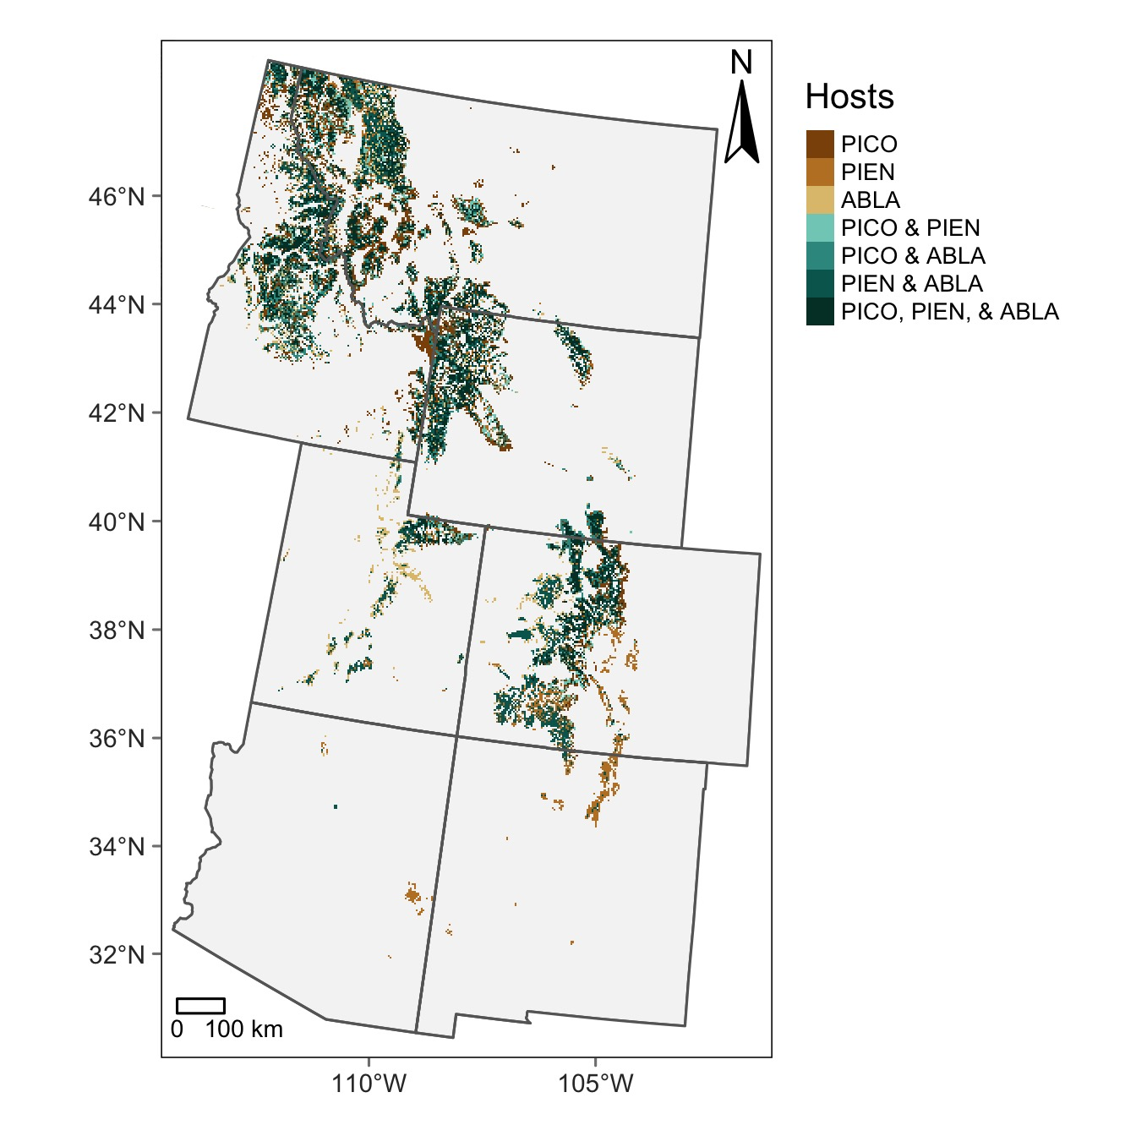

Figure : Figure 1: The distribution of host species presence across the study area. Data are from the Individual Tree Species Atlas (Ellenwood et al. 2015) and represent conditions in ca. 2002.

## Co-occurrence of agents

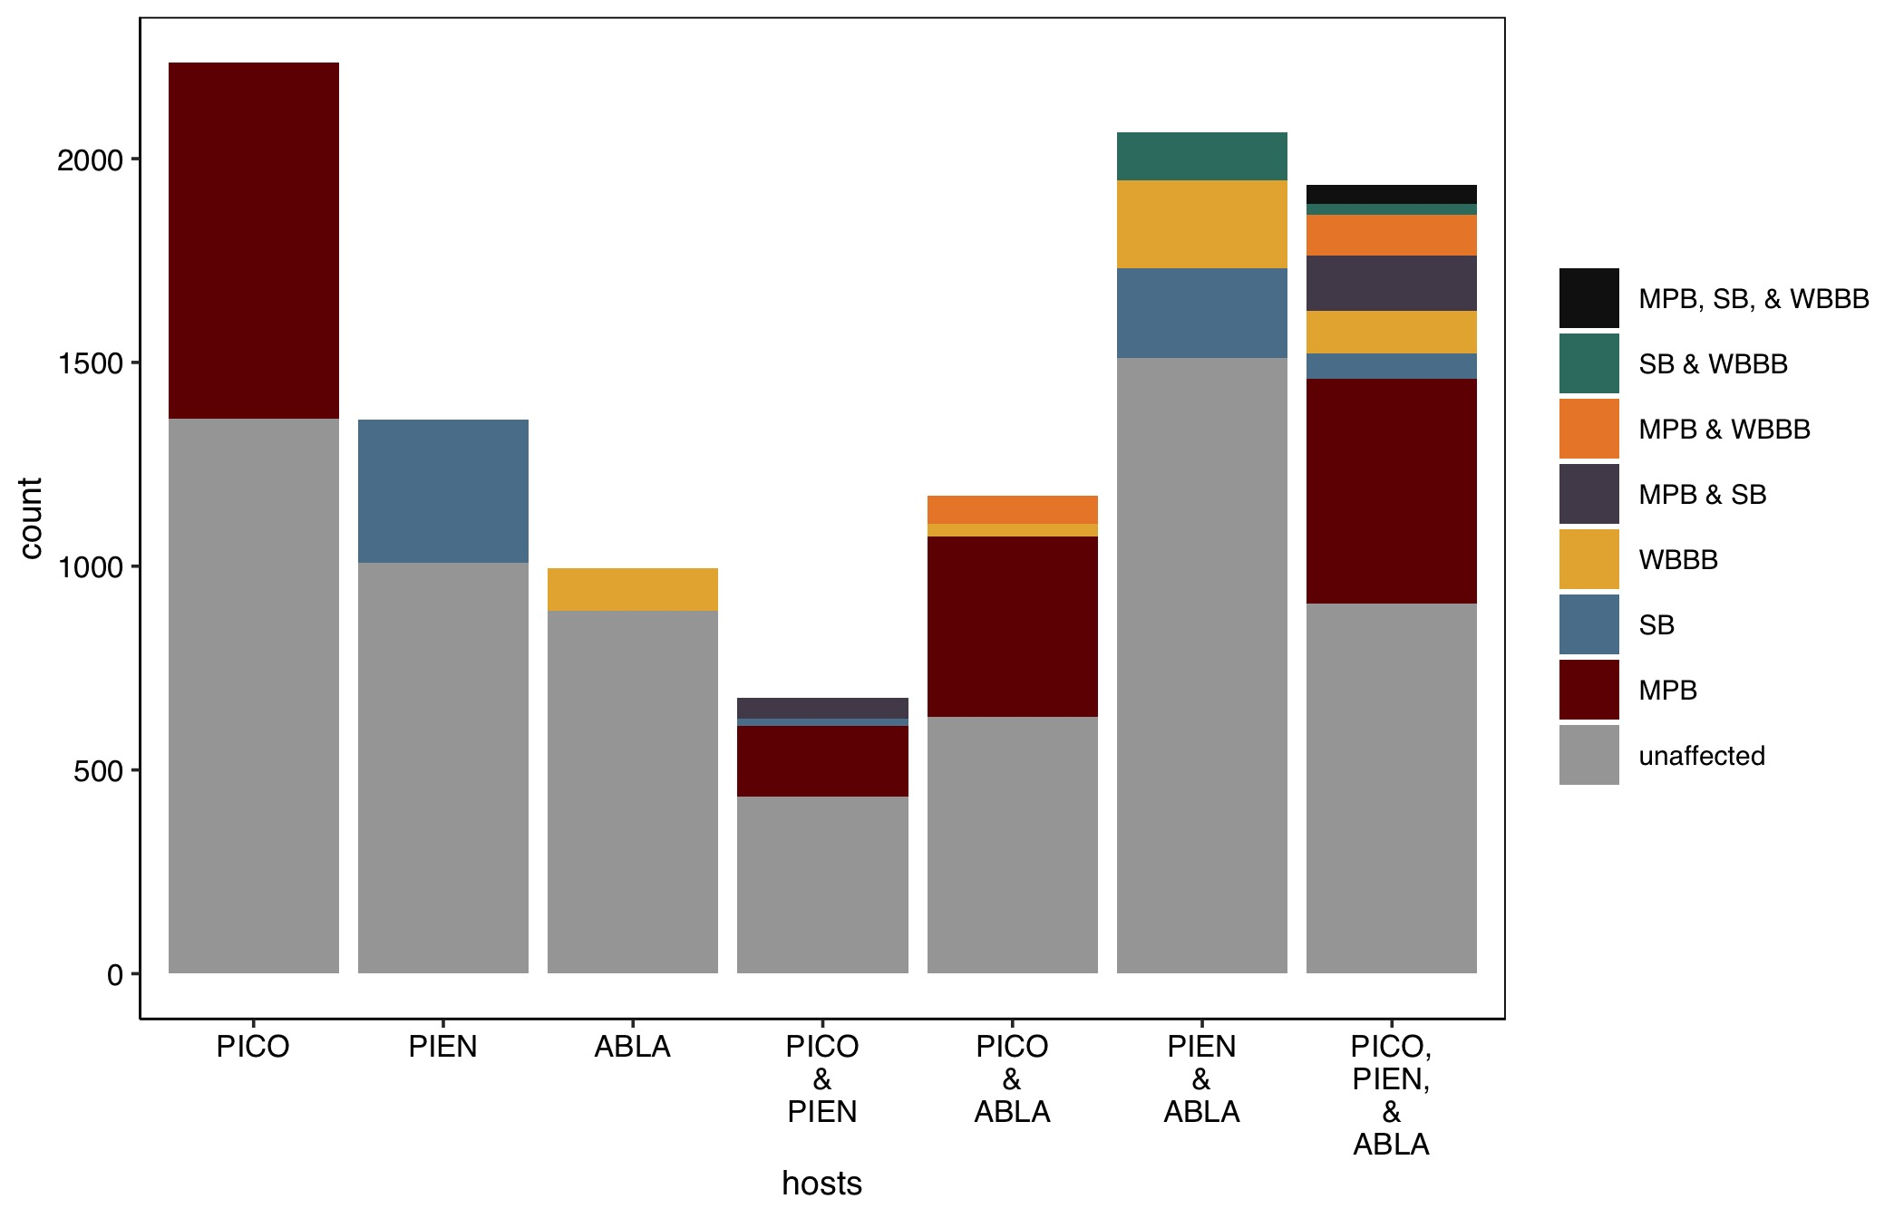

Figure : Figure 2: Co-occurrence

Few stands were affected by multiple agents.

### Is occurrence more likely or severity greater in stands with multiple hosts?

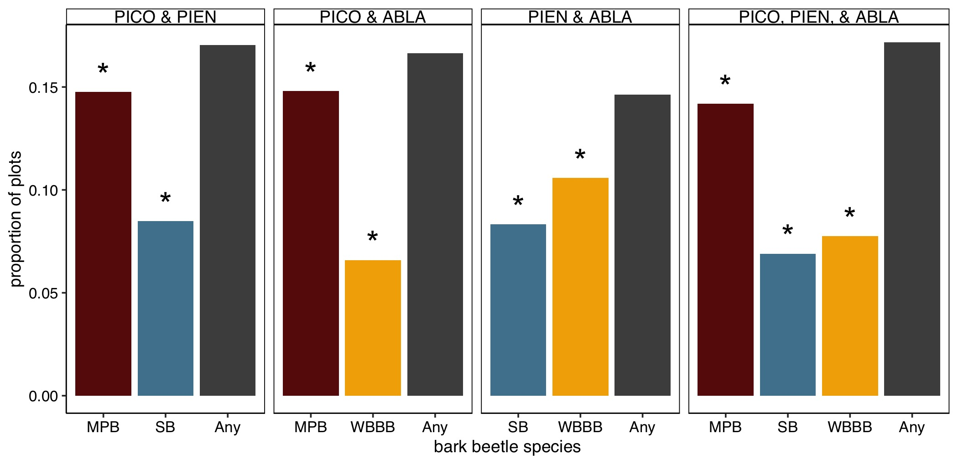

Figure : Figure 3: Severity

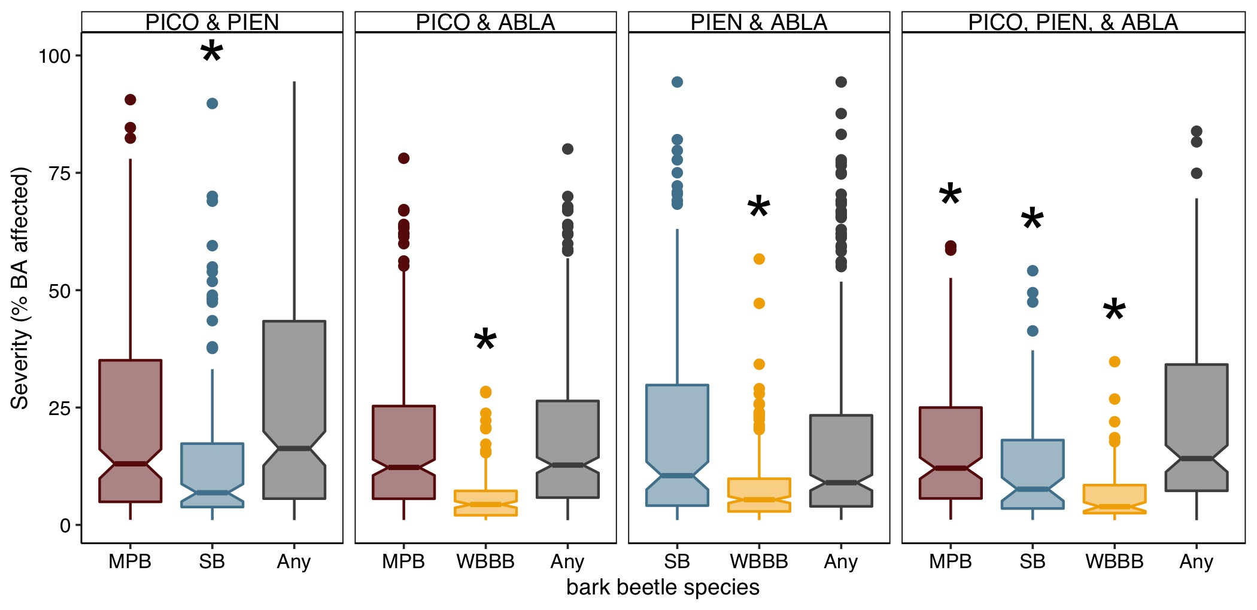

Figure : Figure 4: Severity

# Discussion

# References

Anderegg, W. R. L., J. A. Hicke, R. A. Fisher, C. D. Allen, J. Aukema, B. Bentz, S. Hood, J. W. Lichstein, A. K. Macalady, N. McDowell, Y. Pan, K. Raffa, A. Sala, J. D. Shaw, N. L. Stephenson, C. Tague, and M. Zeppel. 2015. Tree mortality from drought, insects, and their interactions in a changing climate. New Phytologist 208:674–683.

Barbosa, P., J. Hines, I. Kaplan, H. Martinson, A. Szczepaniec, and Z. Szendrei. 2009. Associational Resistance and Associational Susceptibility: Having Right or Wrong Neighbors. Annual Review of Ecology, Evolution, and Systematics 40:1–20.

Burrill, E., A. M. Wilson, J. A. Turner, S. A. Pugh, J. Menlove, G. Christiansen, B. L. Conkling, and W. David. 2017. The Forest Inventory and Analysis database: Database description and user guide version 7.2 for Phase 2. Pages 1–946. U.S. Department of Agriculture, Forest Service.

DeRose, R. J., B. J. Bentz, J. N. Long, and J. D. Shaw. 2013. Effects of increasing temperatures on the distribution of spruce beetle in Engelmann spruce forests of the Interior West, USA. Forest Ecology and Management 308:198–206.

Gray, A., T. Brandeis, J. Shaw, W. McWilliams, and P. Miles. 2012. Forest Inventory and Analysis database of the United States of America (FIA). Biodiversity & Ecology 4:225–231.

Iverson, L. R., and A. M. Prasad. 1998. Predicting abundance of 80 tree species following climate change in the Eastern United States. Ecological Monographs 68:465–485.

Jactel, H., X. Moreira, and B. Castagneyrol. 2021. Tree diversity and forest resistance to insect pests: Patterns, mechanisms, and prospects. Annual Review of Entomology 66:277–296.

Rehfeldt, G. E., N. L. Crookston, M. V. Warwell, and J. S. Evans. 2006. Empirical analyses of plant-climate relationships for the western United States. International Journal of Plant Sciences 167:1123–1150.

Root, R. B. 1973. Organization of a Plant-Arthropod Association in Simple and Diverse Habitats: The Fauna of Collards (Brassica Oleracea). Ecological Monographs 43:95–124.

Shaw, J. D., B. E. Steed, and L. T. DeBlander. 2005. Forest Inventory and Analysis (FIA) annual inventory answers the question: What is happening to pinyon-juniper woodlands? Journal of Forestry 103:280–285.

## Supplement

### Randon Forest Modeling

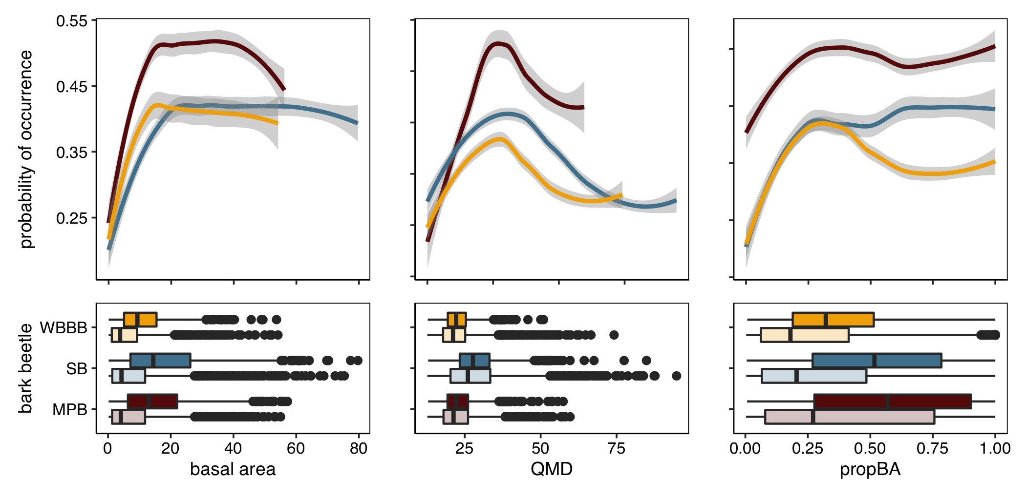

Figure : Figure 5: A caption

### Comparison of stand structure and composition, climate, and regional bark beetle activity

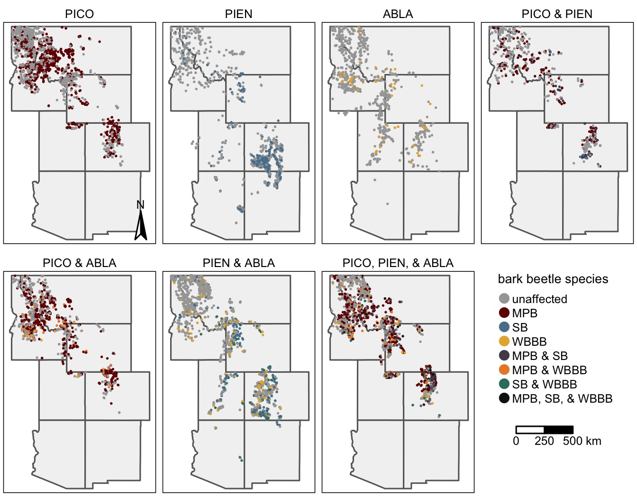

Figure : Figure 6: a caption