Title:

Authors: Sarah J. Hart1

1. Department of Forest and Rangeland Stewardship, Colorado State University ([sarah.hart@colostate.edu](mailto:sarah.hart@colostate.edu))

Abstract:

Synthesis

# Introduction

A central goal of ecology is to understand how community diversity influences interactions between natural enemies and their resources (Elton 1958, Tilman et al. 1997, Johnson et al. 2013). In the case of plant-herbivore interactions, greater plant diversity often reduces the effects of herbivory (i.e., ‘associational resistance,’ Barbosa et al. 2009). While increases in plant diversity may decrease the effects of herbivore species on individuals and populations of plants, it is also hypothesized to increase herbivore richness (i.e., “resource specialization”; Keddy 1984). Greater herbivore richness is expected lead to more efficient resource use and greater depletion of the plant community (Cardinale et al. 2006, Finke and Snyder 2008). Yet little research has examined the effects of plant diversity on community-level outcomes of herbivory, which critically may drive key ecosystem processes (Mulder et al. 1999). This is particularly true in natural systems, where the number of potential interactions is high, the effects of different herbivores on their focal host populations often differ greatly, and the changes in plant diversity may be convoluted with changes in host quality (Jactel et al. 2021).

, particularly when herbivores are specialists capable of rapid population growth (**otway_resource_2005?**). especially when herbivores are specialists and plant communities [@cardinale_effects_2006; @finke_niche_2008].

Bark beeltes (Coleoptera: Curculionidae: Scolytinae)

Associational resistance is commonly hypothesized to occur due to several non-mutually exclusive mechanisms. First, herbivory may be lower in more diverse systems if herbivores are less likely to find, stay, and reproduce in areas where their hosts are less abundant (i.e., ‘resource concentration hypothesis,’ Root 1973). Second, reductions in herbivory may occur if heterospecific neighbors mask chemical or visual cues that herbivores use to find their hosts makes it challenging for insects to find their hosts (Schiebe et al. 2011, Castagneyrol et al. 2014, i.e. ‘host apparency hypothesis,’ **feeny_plant_1976?**), Third, heterospecific neighbors may increase the abundance of herbivore natural enemies [i.e., ‘enemies hypothesis’, Staab and Schuldt (2020).

Bark beetles are key drivers of the structure, composition, and function of conifer forests across the western United States (Baker and Veblen 1990), where recent outbreaks have caused the death of 3.8 billion trees [1997-2018; Hicke et al. (2020)]. While across the region there are more than 25 native bark beetle species, the mountain pine beetle (MPB; *Dendroctonus ponderosae*), spruce beetle (SB; *Dendroctonus rufipennis*), and western balsam bark beetle (WBBB; *Dryocoetes confuses*) collectively have caused over 70% of the recent bark beetle-attributed tree mortality, most of which has occurred in high elevation forests (Hicke et al. 2020).

Bark beetles bore through a tree’s bark, where they mate, oviposit their eggs, and introduce pathogenic fungi (**raffa_natural_2015?**). Larvae feeding upon the phloem and fungal spread stop the translocation of water and nutrients, typically leading to tree death. Conifer defense against bark beetles consists primarily of resin exudation that physically expels the beetle and the production of chemical defenses, which repel and kill attacking beetles (**krokene_conifer_2015?**). To overcome these defenses, bark beetles rely on a mass-attack strategy, where pioneering beetles emit aggregation pheromones that call conspecifics to the focal tree. While bark beetles typically exist at low population levels and attack weakened trees, increases in population size allow bark beetles to attack increasingly better defended trees. The eruption of bark beetle populations to outbreak conditions is complex, but requires abundant, large diameter hosts, which reflects past natural disturbance and land-use history (Veblen et al. 1994). Given a susceptible landscape, outbreaks my be initiated by events that increase bark beetle development rates, notably temperature (Bentz et al. 1991, Hansen et al. 2001, Bone and Nelson 2019, **howe_landscape_2022?**), or events that decrease host tree resistance to bark beetle colonization [e.g., drought; Chapman et al. (2012); Hart et al. (2014); (**harveyarvey_drougthy_2021?**)].

To better understand interactions between tree and bark beetle communities in subalpine forests, we used a large dataset consisting of XXX,XXX plots established by the United States Forest Service Forest Inventory and Analysis Program. The FIA program inventories all public and private forested land using a spatially and temporally distributed sampling design, making it useful for the study of tree species distributions (e.g., Iverson and Prasad 1998, Rehfeldt et al. 2006) and tree demography DeRose et al. (2013). In the Western US, all FIA plots are visited once every ten years (Gray et al. 2012). At each plot, field crews collect data within four 7.32 m radius subplots arranged in a fixed pattern. For each tree within the plot, field crews record the species, size (diameter at breast height; DBH), and status (live or dead) for trees (>= 12.7 cm DBH). For each live tree, field crews additionally record up to three damaging agents likely to prevent the tree from surviving >2 years, reduce the growth of the tree in the near term, or negatively affect the tree’s marketable products (e.g., MPB) (Burrill et al. 2017). For dead trees that were alive at the previous visit, the proximate cause of death is also collected for any tree that was alive at the previous visit and at revisit is dead using visible evidence (e.g., fire scars, bark beetle galleries). Because identifying the mortality agent is more challenging, cause of death codes are broad (e.g., “insect” or “disease”).

Something something something Specifically, we ask:

1. How have host abundance and size influenced patterns of outbreak occurrence during the recent period of widespread bark beetle outbreaks?
2. Do stand conditions suitable for multiple outbreaks commonly co-occur?
3. Does outbreak occurrence or basal area loss increase with the number of susceptible hosts?
4. Does the co-occurrence of multiple bark beetle species result in more severe cumulative bark beetle mortality?

We expect that the probability of outbreak will increase with host basal area and size (i.e., resource concentration hypothesis) and total basal area (. If the probability of outbreak increases with host basal area and host dominance, than stand conditions suitable for multiple outbreaks should be relatively rare.

When stands are susceptible to outbreaks of multiple species of bark beetles, we expect that the probability of an outbreak occurring is greater when more hosts are present (i.e., resource specialization hypothesis). If resource specialization effects drive cumulative mortality due to bark beetle outbreaks, than outbreak severity should be greater in stands with more hosts. Alternatively, if resource concentration effects are more important in driving bark beetle activity than

We also expected the severity of bark beetle infestation to vary with the number of agents present, but with two alternative hypotheses. If the population dynamics of each bark beetle species are independent or competitive release causes decreased investment in defense, then stands affected by multiple bark beetle species will experience higher tree mortality than stands with only one agent. Alternatively, lower tree mortality may occur if concurrent outbreaks of bark beetles of different species cause semiochemical confusion.

Given the occurrence of bark beetle outbreak, we further expect that basal area loss will be greater in stands affected by multiple species of bark beetles.

In contrast, we expect that the severity of outbreak for each bark beetle species will be lower when stands consist of multiple hosts (i.e., associational resistance), but that the probability of outbreak of any bark beetle species will be greater in stands that consist of multiple hosts.

# Materials and Methods

## Study area

The study area consists of subalpine forests dominated by lodgepole pine (*Pinus contorta*), subalpine fir (*Abies lasiocarpa*), and/or Engelmann spruce (*Picea engelmannii*) located in the Intermountain West (Fig. 1). While these species are present in several other western states, our analyses were constrained to the Intermountain West because of regional differences in data collection within the FIA program (Burrill et al. 2017).

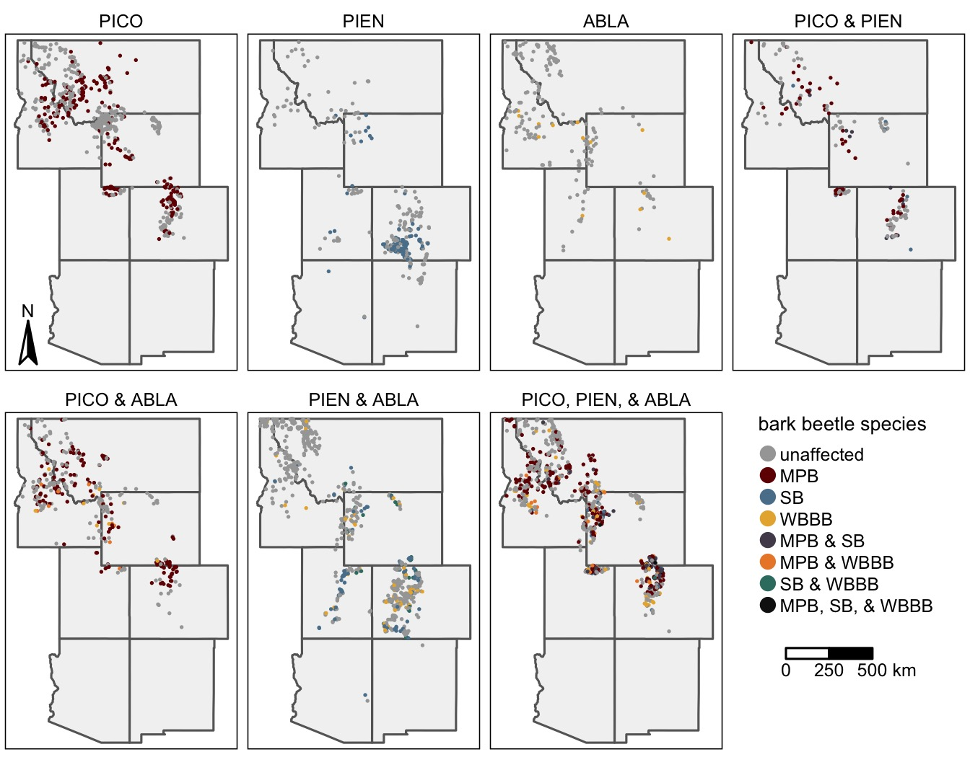

Figure 1: The distribution of FIA plots recently (ca. 2000 – 2019) affected by outbreaks of the mountain pine beetle (MPB), spruce beetle (SB), and western balsam bark beetle (WBBB) by the identity of host tree species present within each plot. For host identities, PICO is lodgepole pine, PIEN is Engelmann spruce, and ABLA is subalpine fir.

## Data

We acquired all FIA data for the Intermountain West from the FIA Datamart (<https://apps.fs.usda.gov/fia/datamart/>), but restricted our analyses to the most recent inventory for all forested plots. Given our focus on subalpine forests dominated by lodgepole pine, subalpine fir, and/or Engelmann spruce, we further the focal hosts accounted for. Finally given our interest in understanding how tree species diversity influences bark beetle outbreak occurrence and effects, we excluded all plots with important alternative hosts [i.e., ponderosa pine (*Pinus ponderosa)*, limber pine (*Pinus flexilis*), whitebark pine (*Pinus albicualis*), bristlecone pine (*Pinus aristata*), or western white pine (*Pinus monticola*)](Bentz et al. 2010).

For each inventoried tree, we determined the presence/absence of MPB, WBBB, and SB. For live lodgepole pine, we listed the presence of MPB when the primary damage agent was listed as MPB or any bark beetle. Similarly, we listed the presence of SB in Engelmann spruce when the damage agent was listed as SB or a general bark beetle. For live subalpine fir, we listed the presence of WBBB when the damage agent was recorded as WBBB, a general bark beetle, or subalpine fir decline, the progressive death of fir in response to drought stress, WBBB attack, and pathogenic root fungi, including *Armillaria* spp. and *Heterobasidion parviporum* (Lalande et al. 2020). Field surveys across the region suggest that 94% of subalpine fir killed in the previous decade by a biotic agent were affected by WBBB (Harvey et al. 2021). For recently killed tees, we assumed the mortality of lodgepole pine, Engelmann spruce, and subalpine fir that was attributed to an insect, was caused by the MPB, SB, and WBBB, respectively. While mortality due to other insects is possible, over the past two decades MPB, SB, and WBBB have caused vast majority of lodgepole pine, Engelmann spruce, and subalpine fir mortality, respectively (Fig. S1). For each plot, we then listed the occurrence of an outbreak of each bark beetle species, when tree mortality rates were above background rates, defined here as >10% of the host trees attacked by bark beetles in the past ten years (Van Mantgem et al. 2009).

## Analyses

### Understanding host abundance and size influenced patterns of outbreak occurrence

To understand if and how host abundance and size influenced patterns of MPB, SB, and WBBB outbreak occurrence, we used a random forest (RF) modeling framework (Breiman 2001). RFs are a distribution-free approach useful for modelling nonlinear relationships and complex interactions characteristic of ecological systems (Cutler et al. 2007). We constructed separate models for the presence of MPB, SB, and WBBB and as predictor variables included host QMD, host BA, host dominance (percent basal area), and total BA, variables commonly linked to stand susceptibility to bark beetle outbreak (Schmid and Frye 1976, Shore and Safranyik 1992, Lalande et al. 2020). Because most stands in our dataset were unaffected by bark beetles, we used a synthetic minority oversampling technique (SMOTE) to handle the imbalance in the response (Chawla et al. 2002). Briefly, the SMOTE approach over-samples the minority class by synthesizing new cases from the minority class (here affected stands).

We fit models by first splitting the data into separate training and testing datasets, consisting of 70% and 30% of the full dataset, respectively. We then tuned the model hyperparameters (the number of variables to try at each split, number of trees, and minimum node size) on the training dataset using a 10-fold cross-validation approach. We selected the hyperparameters that maximized the area under the receiver operation curve (AUC) statistic, which quantifies the performance of a classifier by comparing the false positive and true positive rates. After fitting the final model on the training data, we then assessed model performance by quantifying the model’s ability to correctly predict outbreak occurrence in the testing data using the AUC statistic. To assess the contribution of each variable to overall model fit, we calculated the permutation importance, which measures the change in prediction error that occurs when the focal variable is randomly permutated (Breiman 2001). Finally, we used accumulated local effects (ALE) plots to assess the relationship between each predictor variable and the probability of outbreak occurrence. Models were fit in R (R Core Team 2022) using the Tidymodels (Kuhn and Wickham 2020) and ranger (Wright et al. 2020) packages. ALE plots were constructed using the ALEPlot package (Apley 2018).

### Understanding how community diversity influences interactions between bark beetles and their hosts

To determine if stand conditions suitable for outbreaks of multiple bark beetle species commonly co-occur, we used output from the RF models. We assumed that each host species was susceptible to outbreak when the predicted probability of occurrence was greater than 0.33, We first selected the threshold for predicting the presence/absence of outbreak that optimized Youden’s J statistic, a performance diagist (Youden 1950) , We then tabulated the number of plots susceptible to outbreaks of multiple bark beetle species and compared theses values to the number of plots where multiple hosts were present.

To determine if the proportion of plots with susceptible host(s) that were affected by a bark beetle outbreak of any species varied with the number or identity of susceptible hosts present, we used a multiple group proportion test. Given a significant difference, we then used pairwise proportion tests to determine if significant differences existed between groups. Next to understand if the severity of bark beetle activity varied with the number or identity of hosts present, we used a Krusksal-Wallace rank sum test, followed by a Dunn’s test of multiple comparisons to assess pairwise differences.

To understand the contribution of each bark beetle species to the cumulative probability of outbreak occurrence, we calculated the proportion of plots affected by an outbreak of each bark beetle species within plots where the corresponding host was susceptible. We then used proportion tests to determine if the probability of outbreaks of each bark beetle species differed. Then we used a Wilcox test to determine if the severity of bark beetle activity attributed to each bark beetle species differed given an outbreak and a susceptible host.

Finally, to determine if the severity of tree mortality depended upon the number or identity of bark beetle species, we used a Kruskall-Wallis rank sum test to compare cumulative mortality in stands affected by outbreaks of one, two, or three bark beetle species. Given a significant difference, we used a Dunn’s test to test for pairwise differences.

In all analyses, we adjusted p-values to account for multiple comparisons using methods outlined by Benjamini and Hochberg (1995). Analyses were performed in R (**r_core_team_r:_2022?**) using the packages dunn.test (**dinno_dunntest_2017?**) and rcompanion (**mangiafico_rcompanion_2022?**).

# Results

## How have host abundance and size influenced patterns of outbreak occurrence during the recent period of widespread bark beetle outbreaks?

Random forest models accurately predicted the presence/absence of MPB, SB, and WBBB outbreak (AUC ≥ 0.80; Table S2). At a probability threshold of 0.33,

Host QMD, BA, and dominance and total BA all improved the fit of models of outbreak occurrence, however variables that described host density and size were more important than total stand basal area (Fig. SX). After controlling for variation in host size and density, the probability of MPB, SB, and WBBBB outbreak generally increased with total basal area, although at very high stand densities, outbreak probability decreased (Fig. 2A and 2E). For all bark beetle species, when BA was less than 10 m2 ha-1, small increases in host BA were generally associated with large increases in the probability of outbreak (Fig. 2B and 2F). Once BA exceed this threshold, the probability of outbreak generally decreased. The relationship between outbreak occurrence and QMD was also nonmonotonic (Fig. 2B). For all bark beetle species, when QMD was less than 20 cm, small increases were generally associated with large increases in the probability of outbreak. Once QMD exceeded this threshold, the probability of outbreak generally decreased. Increases in host dominance were generally associated with an increase in the probability of outbreak (Fig. 2D and 2H). However, the probability of WBBB outbreak notably decreased with greater host dominance at very high values and the probability of SB outbreak increased dramatically when host dominance exceeded 55%.

Figure 2: The associations between the probability of occurrence of the mountain pine beetle (MPB; red), spruce beetle (SB; blue); and western balsam bark beetle (WBBB; yellow) outbreak and stand structure and composition. The top row (A-D) illustrates the accumulated local effects (ALE) from Random Forest models of the presence/absence of outbreak. For visualization purposes, ALE values have been smoothed using local polynomial regression. Boxplots (E-H) show the distribution of values for stands affected (dark colors) and unaffected (light colors) by each bark beetle species. The bottom and top limits of each box are the lower and upper quartiles, respectively; the thick black line within the box is the median; error bars equal ±1.5 times the interquartile range; and points denote outliers, values outside ±1.5 times the interquartile range.

## Do stand conditions suitable for multiple outbreaks commonly co-occur?

Across the 3096 FIA plots with at least one of the target host species, 39% (n=1215) contained two species and 24% (n=740) three species (Fig. 3). Lodgepole pine was present in 62% of plots (n=1913) plots. Engelmann spruce was present in 62% of plots (n=1916). Subalpine fir was present in 63% of plots (n=1962). Stands with all three target host species were most common. RF models predicted that 86% of plots (n=2649) were suitable for bark beetle outbreak. Of these plots 32% of plots (n=859) were suitable for outbreaks of two bark beetle species and 12% of plots (n=318) were suitable for outbreaks of three bark beetle species. Of the plots with at least one susceptible host, 61% (n=1627) were susceptible to outbreaks of MPB, 58% (n=1541) were susceptible to outbreaks of SB, 37% (n=976) were susceptible to outbreaks of WBBB (Fig. 3). Stands with only susceptible lodgepole pine were the most commonly occurring combination of susceptible hosts.

Figure 3: The frequency of plots by the identify of host present (gray) and hosts susceptible to outbreak (black). Gray bars indicate host species were present (i.e., at least one individual of the focal species was present within the plot). Black bars indicate stand structure and composition conditions were suitable to bark beetle outbreak in focal tree species. For host identities, PICO is lodgepole pine, PIEN is Engelmann spruce, and ABLA is subalpine fir.

## Does the occurrence or severity of cumulative bark beetle activity increase with the host species richness?

Across 2686 plots with susceptible Engelmann spruce, lodgepole pine, and/or subalpine fir and without any alternative host species, we found that 44% of plots (n=1175) were affected by an outbreak of at least one species. The proportion of plots affected by an outbreak of at least one species was greatest in plots with all three hosts (prop = 0.63). The proportions of affected plots with lodgepole pine and Engelmann spruce (prop = 0.53) or lodgepole pine and subalpine fir (prop = 0.53) were both 10 percentage points lower than plots with all three hosts, but these differences were not statistically significant (p>0.05) (Figure 4A). Stands with only susceptible subalpine fir were least likely to experience outbreak (prop = 0.17), followed by stands with subalpine fir and Engelmann spruce (prop = 0.34) or Engelmann spruce (prop = 0.35).

Figure 4: The proportion of plots affected by bark beetles by the identity of suitable hosts. Letters above bars indicate significant (p<0.05) difference between groups, as determined using pairwise proportion tests. Numbers below bars show sample sizes. For host identities, PICO is lodgepole pine, PIEN is Engelmann spruce, and ABLA is subalpine fir.

Basal area loss due outbreak(s) was greatest in stands with only Engelmann spruce (mean = 66%), followed by stands with only lodgepole pine (mean = 47%) (Fig. 4B). Stands with only subalpine fir experienced the lowest rates of basal area loss (mean = 15%), followed by stands where all three hosts were present (mean = 27%). Outbreak severity was intermediate in stands with two hosts present (mean basal area loss = 31 – 38%).

## Given the co-occurrence of multiple susceptible host species, what are the contributions of each bark beetle species to cumulative outbreak occurrence and severity?

Given the co-occurrence of susceptible lodgepole pine with either susceptible Engelmann spruce and/or subalpine fir, MPB outbreak was more likely to occur then either SB or WBBB (Fig. 5A) and led to higher rates of basal area loss (Fig. 5B). In stands with susceptible subalpine fir and Engelmann spruce, outbreaks of SB and WBBB were equally likely to occur, but SB drove greater rates of basal area loss.

Figure 5: The probability of outbreak occurrence (A-D) and severity of bark beetle activity given an outbreak (E-H) by the identity of bark beetle species and host species susceptible to outbreak. Letters above bars (A-D) and boxes (E-H) indicate significant difference between groups, as determined using pairwise proportion tests (A-D) and a nonparametric Dunn test (E-H). In E-H, the bottom and top limits of each box are the lower and upper quartiles, respectively; the thick black line within the box is the median; error bars equal ±1.5 times the interquartile range; and points denote outliers, values outside ±1.5 times the interquartile range. For host identities, PICO is lodgepole pine, PIEN is Engelmann spruce, and ABLA is subalpine fir.

## Does the co-occurrence of multiple bark beetle species result in more severe cumulative bark beetle mortality?

Generally, stands affected by outbreaks of multiple bark beetle species experienced greater basal area loss than stands affected by only one outbreak, however the effects depended upon the bark beetle species (Fig. 6). In stands where all three hosts were susceptible to outbreak, basal area loss was greatest in stands affected by MPB, SB, and WBBB (mean = 42%) or MPB and SB (mean = 40%), followed by stands with MPB and WBBB (mean = 28%). For stands with all three hosts, the lowest basal area loss occurred in stand affected by SB and WBBB (mean = 6%) or only WBBB (mean = 9%), followed by stands affected by only SB (mean = 16%).

Figure 6: The severity of bark beetle mortality in plots with multiple tree species susceptible to bark beetles by the combination of bark beetle species present. Letters above boxes indicate significant differences between groups as determined by a Dunn test. The bottom and top limits of each box are the lower and upper quartiles, respectively; the thick black line within the box is the median; error bars equal ±1.5 times the interquartile range; and points denote outliers, values outside ±1.5 times the interquartile range.

When only two susceptible hosts were present, the additive effect of outbreaks of multiple bark beetle species only occurred in stands with both susceptible lodgepole pine and Engelmann spruce, where basal area loss due to MPB and SB (mean = 50%), was greater than mortality due to only MPB (mean = 35%) or SB (mean = 17%). In stands with susceptible subalpine fir and either lodgepole pine or Engelmann spruce, WBBB caused less mortality than SB or MPB. Further stands affected by both WBBB and MPB or WBBB and SB experienced similar mortality as stands affected by only MPB or only SB.

# Discussion

## Resource concentration

Yes –> outbreaks of MPB, SB, and WBBB were all generally increased with increases in host basal area and host dominance. - discuss slight decrease that occurs at high values

## Effects of resource concentration on patterns of overlap

## Resource specialization

## caveats

* agent bias?

## future directions

* order?

# Acknowledgements

# Conflict of Interest

# Author contributions

# Data Availability Statement

# References

Apley, D. 2018. [ALEPlot: Accumulated Local Effects (ALE) Plots and Partial Dependence (PD) Plots](https://cran.r-project.org/web/packages/ALEPlot/index.html).

Barbosa, P., J. Hines, I. Kaplan, H. Martinson, A. Szczepaniec, and Z. Szendrei. 2009. [Associational Resistance and Associational Susceptibility: Having Right or Wrong Neighbors](https://doi.org/10.1146/annurev.ecolsys.110308.120242). Annual Review of Ecology, Evolution, and Systematics 40:1–20.

Bentz, B., J. Logan, and G. Amman. 1991. [Temperature-dependent development of the mountain pine beetle (Coleoptera: Scolytidae) and simulation of its phenology](http://digitalcommons.usu.edu/barkbeetles/114). Canadian Entomologist 123:1083–1094.

Bone, C., and M. F. Nelson. 2019. [Improving Mountain Pine Beetle Survival Predictions Using Multi-Year Temperatures Across the Western USA](https://doi.org/10.3390/f10100866). Forests 10:866.

Breiman, L. 2001. [Random forests](http://www.springerlink.com/index/U0P06167N6173512.pdf). Machine learning 45:5–32.

Burrill, E., A. M. Wilson, J. A. Turner, S. A. Pugh, J. Menlove, G. Christiansen, B. L. Conkling, and W. David. 2017. [The Forest Inventory and Analysis database: Database description and user guide version 7.2 for Phase 2.](http://www.fia.fs.fed.us/library/database-documentation/) Pages 1–946. U.S. Department of Agriculture, Forest Service.

Castagneyrol, B., H. Jactel, C. Vacher, E. G. Brockerhoff, and J. Koricheva. 2014. [Effects of plant phylogenetic diversity on herbivory depend on herbivore specialization](https://doi.org/10.1111/1365-2664.12175). Journal of Applied Ecology 51:134–141.

Chapman, T. B., T. T. Veblen, and T. Schoennagel. 2012. [Spatiotemporal patterns of mountain pine beetle activity in the southern Rocky Mountains](https://doi.org/10.1890/11-1055.1). Ecology 93:2175–2185.

Cutler, D. R., T. C. Edwards Jr, K. H. Beard, A. Cutler, K. T. Hess, J. Gibson, and J. J. Lawler. 2007. Random forests for classification in ecology. Ecology 88:2783–2792.

DeRose, R. J., B. J. Bentz, J. N. Long, and J. D. Shaw. 2013. Effects of increasing temperatures on the distribution of spruce beetle in Engelmann spruce forests of the Interior West, USA. Forest Ecology and Management 308:198–206.

Gray, A., T. Brandeis, J. Shaw, W. McWilliams, and P. Miles. 2012. [Forest Inventory and Analysis database of the United States of America (FIA)](https://doi.org/10.7809/b-e.00079). Biodiversity & Ecology 4:225–231.

Hansen, E. M., B. J. Bentz, and D. L. Turner. 2001. Temperature-based model for predicting univoltine brood proportions in spruce beetle (Coleoptera: Scolytidae). The Canadian Entomologist 133:827–841.

Hart, S. J., T. T. Veblen, K. S. Eisenhart, D. Jarvis, and D. Kulakowski. 2014. Drought induces spruce beetle (Dendroctonus rufipennis) outbreaks across northwestern Colorado. Ecology 95:930–939.

Hicke, J. A., B. Xu, A. J. H. Meddens, and J. M. Egan. 2020. [Characterizing recent bark beetle-caused tree mortality in the western United States from aerial surveys](https://doi.org/10.1016/j.foreco.2020.118402). Forest Ecology and Management 475:118402.

Iverson, L. R., and A. M. Prasad. 1998. [Predicting abundance of 80 tree species following climate change in the Eastern United States](https://doi.org/10.1890/0012-9615(1998)068%5b0465:PAOTSF%5d2.0.CO;2). Ecological Monographs 68:465–485.

Jactel, H., X. Moreira, and B. Castagneyrol. 2021. [Tree diversity and forest resistance to insect pests: Patterns, mechanisms, and prospects](https://doi.org/10.1146/annurev-ento-041720-075234). Annual Review of Entomology 66:277–296.

Johnson, P. T., D. L. Preston, J. T. Hoverman, and B. E. LaFonte. 2013. Host and parasite diversity jointly control disease risk in complex communities. Proceedings of the National Academy of Sciences 110:16916–16921.

Lalande, B. M., K. Hughes, W. R. Jacobi, W. T. Tinkham, R. Reich, and J. E. Stewart. 2020. [Subalpine fir mortality in Colorado is associated with stand density, warming climates and interactions among fungal diseases and the western balsam bark beetle](https://doi.org/10.1016/j.foreco.2020.118133). Forest Ecology and Management 466:118133.

Rehfeldt, G. E., N. L. Crookston, M. V. Warwell, and J. S. Evans. 2006. Empirical analyses of plant-climate relationships for the western United States. International Journal of Plant Sciences 167:1123–1150.

Root, R. B. 1973. [Organization of a Plant-Arthropod Association in Simple and Diverse Habitats: The Fauna of Collards (Brassica Oleracea)](https://doi.org/10.2307/1942161). Ecological Monographs 43:95–124.

Schiebe, C., M. Blaženec, R. Jakuš, C. R. Unelius, and F. Schlyter. 2011. [Semiochemical diversity diverts bark beetle attacks from Norway spruce edges](https://doi.org/10.1111/j.1439-0418.2011.01624.x). Journal of Applied Entomology 135:726–737.

Schmid, J. M., and R. H. Frye. 1976. Stand ratings for spruce beetles. Page 4. USDA Forest Service, Rocky Mountain Research Station.

Shaw, J. D., B. E. Steed, and L. T. DeBlander. 2005. [Forest Inventory and Analysis (FIA) annual inventory answers the question: What is happening to pinyon-juniper woodlands?](https://doi.org/10.1093/jof/103.6.280) Journal of Forestry 103:280–285.

Shore, T. L., and L. Safranyik. 1992. Susceptibility and risk-rating systems for the mountain pine beetle in lodgepole pine stands.

Staab, M., and A. Schuldt. 2020. [The Influence of Tree Diversity on Natural Enemies—a Review of the “Enemies” Hypothesis in Forests](https://doi.org/10.1007/s40725-020-00123-6). Current Forestry Reports 6:243–259.

Van Mantgem, P. J., N. L. Stephenson, J. C. Byrne, L. D. Daniels, J. F. Franklin, P. Z. Fulé, M. E. Harmon, A. J. Larson, J. M. Smith, and A. H. Taylor. 2009. Widespread increase of tree mortality rates in the western United States. Science 323:521–524.

Veblen, T. T., K. S. Hadley, E. M. Nel, T. Kitzberger, M. Reid, and R. Villalba. 1994. [Disturbance regime and disturbance interactions in a Rocky Mountain subalpine forest](https://doi.org/10.2307/2261392). Journal of Ecology 82:125–135.

Baker, W. L., and T. T. Veblen. 1990. Spruce beetles and fires in the nineteenth-century subalpine forests of western Colorado, USA. Arctic and Alpine Research 22:65–80.

Bentz, B. J., J. Régnière, C. J. Fettig, E. M. Hansen, J. L. Hayes, J. A. Hicke, R. G. Kelsey, J. F. Negrón, and S. J. Seybold. 2010. Climate change and bark beetles of the Western United States and Canada: Direct and indirect effects. BioScience 60:602–613.

Cardinale, B. J., D. S. Srivastava, J. Emmett Duffy, J. P. Wright, A. L. Downing, M. Sankaran, and C. Jouseau. 2006. Effects of biodiversity on the functioning of trophic groups and ecosystems. Nature 443:989–992.

Chawla, N. V., K. W. Bowyer, L. O. Hall, and W. P. Kegelmeyer. 2002. SMOTE: Synthetic Minority Over-sampling Technique. Journal of Artificial Intelligence Research 16:321–357.

Elton, C. S. 1958. The Ecology of Invasions by Animals and Plants. Springer Nature.

Finke, D. L., and W. E. Snyder. 2008. Niche Partitioning Increases Resource Exploitation by Diverse Communities. Science 321:1488–1490.

Harvey, B. J., R. A. Andrus, M. A. Battaglia, J. F. Negrón, A. Orrego, and T. T. Veblen. 2021. Droughty times in mesic places: factors associated with forest mortality vary by scale in a temperate subalpine region. Ecosphere 12:e03318.

Johnson, P. T., D. L. Preston, J. T. Hoverman, and B. E. LaFonte. 2013. Host and parasite diversity jointly control disease risk in complex communities. Proceedings of the National Academy of Sciences 110:16916–16921.

Keddy, P. A. 1984. Plant Zonation on Lakeshores in Nova Scotia: A Test of the Resource Specialization Hypothesis. Journal of Ecology 72:797–808.

Kuhn, M., and H. Wickham. 2020. Tidymodels: a collection of packages for modeling and machine learning using tidyverse principles.

Lalande, B. M., K. Hughes, W. R. Jacobi, W. T. Tinkham, R. Reich, and J. E. Stewart. 2020. Subalpine fir mortality in Colorado is associated with stand density, warming climates and interactions among fungal diseases and the western balsam bark beetle. Forest Ecology and Management 466:118133.

Mulder, C. P. H., J. Koricheva, K. Huss-Danell, P. Högberg, and J. Joshi. 1999. Insects affect relationships between plant species richness and ecosystem processes. Ecology letters 2:237–246.

R Core Team. 2022. R: A language and environment for statistical computing. R Foundation for Statistical Computing, Vienna, Austria.

Schmid, J. M., and R. H. Frye. 1976. Stand ratings for spruce beetles. Page 4. USDA Forest Service, Rocky Mountain Research Station.

Shore, T. L., and L. Safranyik. 1992. Susceptibility and risk-rating systems for the mountain pine beetle in lodgepole pine stands.

Tilman, D., J. Knops, D. Wedin, P. Reich, M. Ritchie, and E. Siemann. 1997. The Influence of Functional Diversity and Composition on Ecosystem Processes. Science.

Wright, M. N., S. Wager, and P. Probst. 2020. ranger: A Fast Implementation of Random Forests.

Youden, W. J. 1950. Index for rating diagnostic tests. Cancer 3:32–35.

# Supporting Information

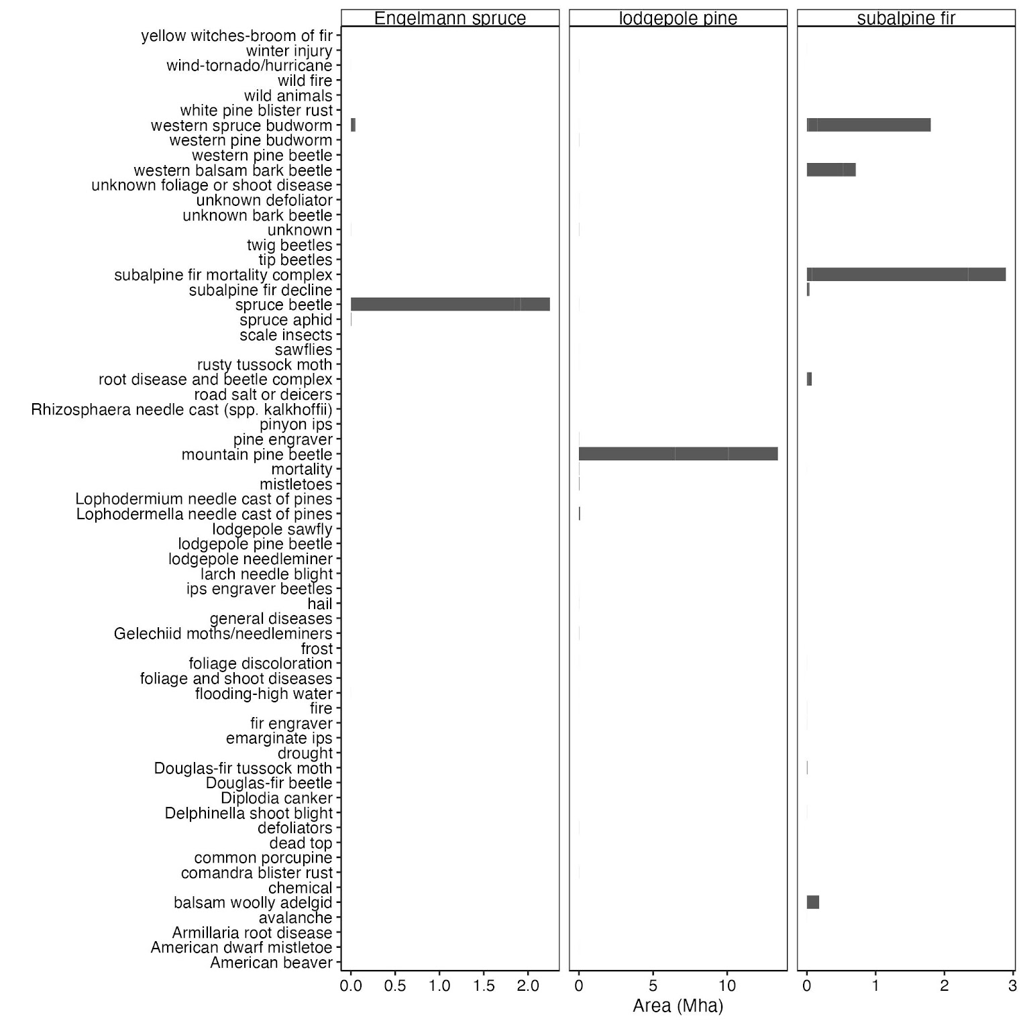

Figure S1

Table 1: The optimal thresholds for predicting the presence/absence of outbreaks of mountain pine beetle (MPB) in lodgepole pine, spruce beetle (SB) in Engelmann spruce, and western balsam bark beetle (WBBB) in subalpine fir. Optimal thresholds were selected using Youden's J statistic (Youden 1950).

| Agent | optimal  threshold | accuracy | specificity | sensitivity |
| --- | --- | --- | --- | --- |
| MPB | 0.40 | 0.73 | 0.66 | 0.96 |
| SB | 0.36 | 0.66 | 0.63 | 0.92 |
| WBBB | 0.25 | 0.63 | 0.61 | 0.90 |

Table 2: Accuracy statistics from Random Forest models predicting the presence/absence of outbreaks of mountain pine beetle (MPB) in lodgepole pine, spruce beetle (SB) in Engelmann spruce, and western balsam bark beetle (WBBB) in subalpine fir. AUC is the area under the receiver operating characteristic curve. Specificity and sensitivity were calculated using a threshold of 0.33.

| Agent | AUC | specificity | sensitivity |
| --- | --- | --- | --- |
| MPB | 0.84 | 0.64 | 0.97 |
| SB | 0.79 | 0.61 | 0.92 |
| WBBB | 0.79 | 0.66 | 0.82 |

Figure S2: The relative contribution of basal area (BA), quadratic mean diameter (QMD), and host dominance (% BA) to the overall model fit for Random Forest models of mountain pine beetle (MPB; red), spruce beetle (SB; blue); and western balsam bark beetle (WBBB; yellow).

Figure S3: The variation in total basal area (BA), host BA, host quadratic mean diameter (QMD), and host dominance for plots with susceptible lodgepole pine (PICO), Engelmann spruce (PIEN), and subalpine fir (ABLA).