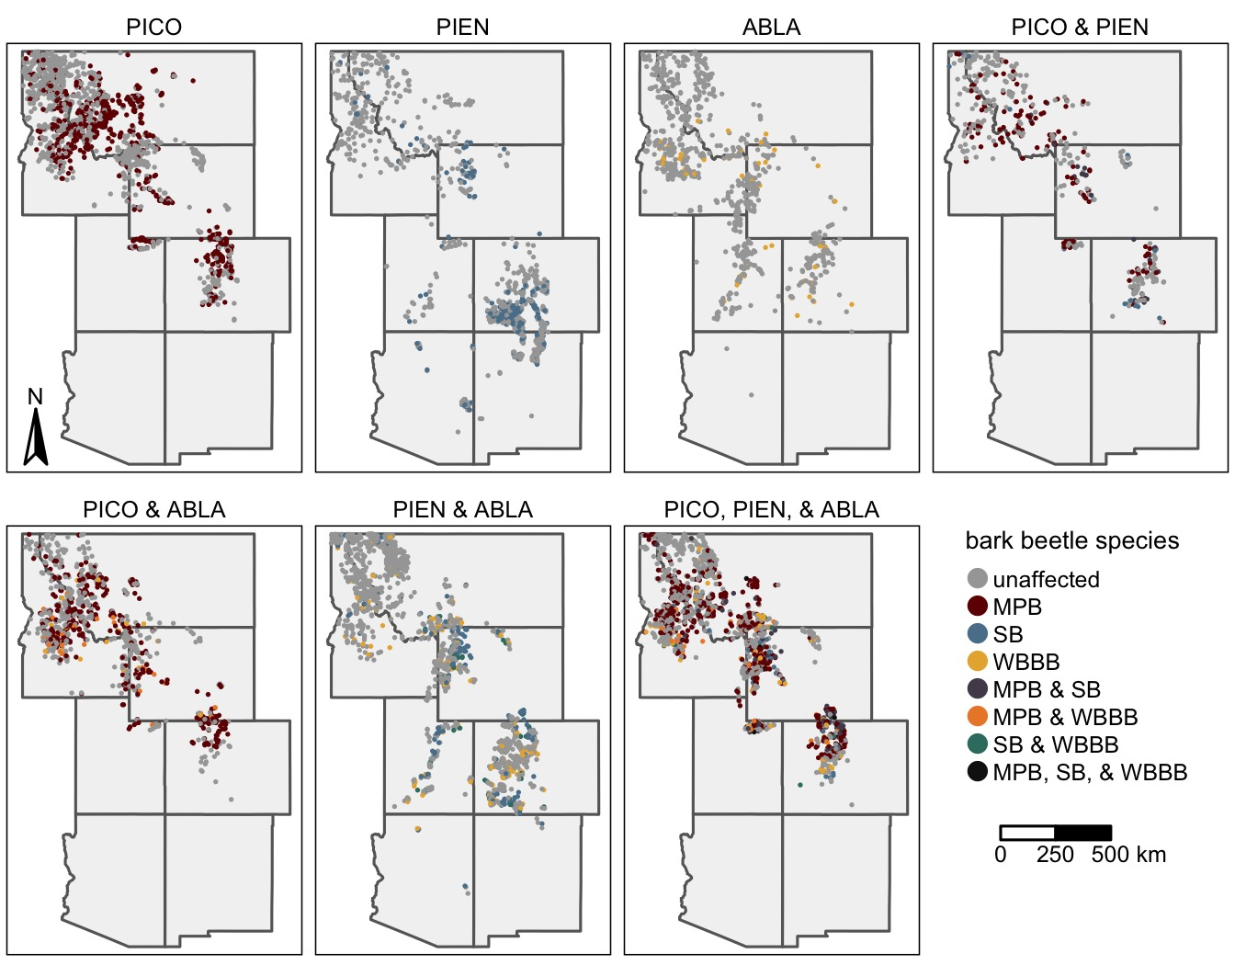

Figure 1: The distribution of FIA plots recently (ca. 2000 – 2019) affected by outbreaks of the mountain pine beetle (MPB), spruce beetle (SB), and western balsam bark beetle (WBBB) by the identity of host tree species present within each plot. For host identities, PICO is lodgepole pine, PIEN is Engelmann spruce, and ABLA is subalpine fir.

Figure 2: The associations between the probability of occurrence of the mountain pine beetle (MPB; red), spruce beetle (SB; blue); and western balsam bark beetle (WBBB; yellow) outbreak and stand structure and composition. The top row (A-D) illustrates the accumulated local effects (ALE) from Random Forest models of the presence/absence of outbreak. For visualization purposes, ALE values have been smoothed using local polynomial regression. Boxplots (E-H) show the distribution of values for stands affected (dark colors) and unaffected (light colors) by each bark beetle species. The bottom and top limits of each box are the lower and upper quartiles, respectively; the thick black line within the box is the median; error bars equal ±1.5 times the interquartile range; and points denote outliers, values outside ±1.5 times the interquartile range.

Figure 5: The probability of outbreak occurrence (A-D) and severity of bark beetle activity given an outbreak (E-H) by the identity of bark beetle species and host species susceptible to outbreak. Letters above bars (A-D) and boxes (E-H) indicate significant difference between groups, as determined using pairwise proportion tests (A-D) and a nonparametric Dunn test (E-H). In E-H, the bottom and top limits of each box are the lower and upper quartiles, respectively; the thick black line within the box is the median; error bars equal ±1.5 times the interquartile range; and points denote outliers, values outside ±1.5 times the interquartile range. For host identities, PICO is lodgepole pine, PIEN is Engelmann spruce, and ABLA is subalpine fir.

Figure 6: The severity of bark beetle mortality in plots with multiple tree species susceptible to bark beetles by the combination of bark beetle species present. Letters above boxes indicate significant differences between groups as determined by a Dunn test. The bottom and top limits of each box are the lower and upper quartiles, respectively; the thick black line within the box is the median; error bars equal ±1.5 times the interquartile range; and points denote outliers, values outside ±1.5 times the interquartile range.