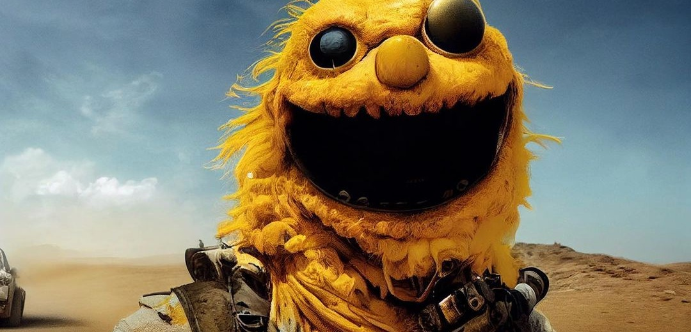
WHO KEEPS YELMO?
  - Storytelling Begins Where Generation Ends
Watson Hartsoe · Working Paper · 18 August 2026

The model could draw Yelmo. The group had to keep him.
Visual source: “Yelmo: Furry Road.” User-provided image, attributed by the user to @spitooon; attribution not independently verified.

Abstract
In 2022, a small Midjourney group set out to make a hero’s journey. They hit a more basic problem before the hero could get very far: the hero would not stay the same person. Their yellow, Elmo-like protagonist—Yelmo—could appear on a mountain, at dinner, or in another absurd scene, but his eyes moved, features appeared and vanished, and other characters could contaminate him. The group’s phrase was better than the later technical jargon: he was “not really the same dude each time.”
That failure exposes the real unit of generative storytelling. A story is not a pile of good images. It is a chain of obligations. Somebody has to remember what has already happened, decide which changes count as growth and which count as breakage, keep characters distinct when they meet, and refuse attractive outputs that violate the world. In the Yelmo experiment, Midjourney supplied variation at speed. The people supplied continuity. The generator proposed; the group judged, remembered, rejected, renamed, and carried the referent across the cut.
This paper argues that the central problem for generative storytelling is not authorship in the abstract and not prompt quality. It is shared continuity under pressure. The original Yelmo project matters because it found this problem by accident, before the product had a dedicated feature for character continuity and before the field had settled language for the failure. Scott Roberts’s own comics practice sharpens the point: long before generative AI, he described himself as someone who “experiment[s] while making comics,” built experimental books that work through sequence and transformation, and later moved generative tools into an animation classroom. Yelmo belongs in that longer problem: how to let a work change without losing the thing that makes the change matter.
Keywords: generative AI · Midjourney · animation · visual storytelling · character continuity · collaboration · improvisation · Scott Roberts
THE PRIMARY-SOURCE PROBLEM
The surviving 2022 notes identify a “Scott” who is an animator. Public evidence strongly fits Scott Roberts, but no direct archival bridge in the present record proves that identification. This paper keeps that gap visible rather than turning plausibility into fact.

1. A beautiful image is not a story
The original Yelmo proposal sounds almost trivial. A few friends wanted to see whether Midjourney could carry a Joseph Campbell-style hero’s journey through a series of images. They needed a protagonist—“someone that’s kind of repeatable.” Yellow Elmo became the test because the mistake was instantly legible: Elmo is not yellow, but the figure still reads. The group put him on a mountain, sent him to a fancy dinner, and kept throwing him into new situations.
Then the experiment broke in the useful place.
The image generator could make another yellow puppet. It could make a striking yellow puppet. It could make a funnier yellow puppet. It could not reliably honor the sentence that stories quietly require: this is the one we already met.
The notes say it plainly. Sometimes Yelmo had one eye. Sometimes a red frill appeared. Sometimes it vanished. The system seemed to merge different yellow-puppet possibilities. The problem was not bad art. The problem was reference. A single image could satisfy the prompt while breaking the story.
A gorgeous Yelmo on a mountain is still only one frame. The next image has to be him again.
Image generators are flattering when we judge one frame at a time. The frame can be beautiful while the sequence is dead. A story charges interest on every previous frame. If Yelmo climbed a mountain yesterday, the next image inherits a debt: it must contain somebody for whom that climb happened.
The original project therefore found the wrong target by trying to hit the right one. It asked, “Can Midjourney tell a hero’s journey?” The machine answered with a harder question: Can a hero survive the cut?
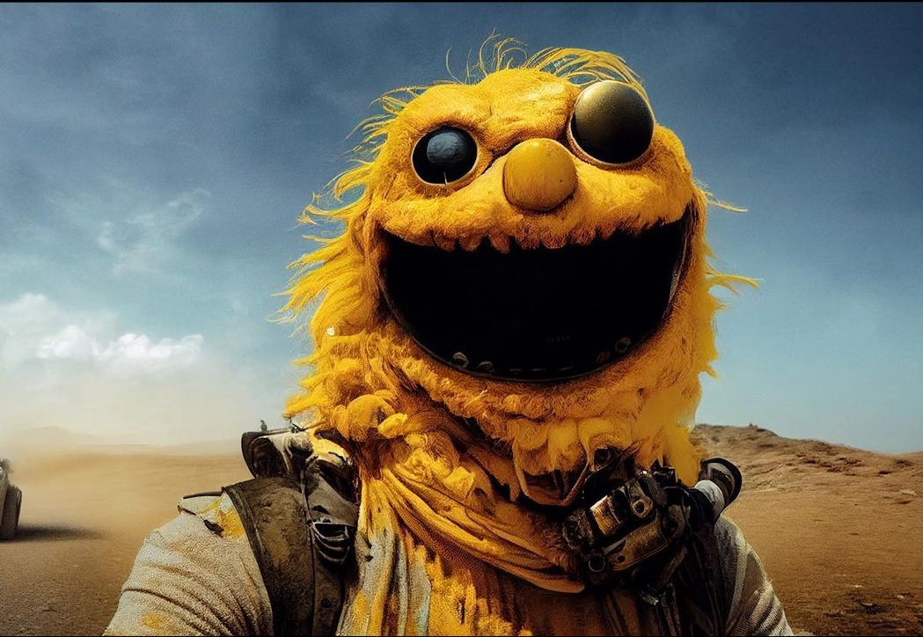 | FIGURE 1  Yelmo, already recognizable  “Yelmo: Furry Road.” User-provided image, attributed by the user to @spitooon; attribution not independently verified. The image is strong enough to make the research problem visible: one unforgettable frame cannot establish continuity.

2. The prompt repeated a description. The group carried a referent.
“Character consistency” sounds like a rendering feature. Yelmo shows why that description is too weak.
A character in a story must change. He gets wet. He ages. He loses a coat. He becomes afraid. He learns something. He enters a room lit differently from the last one. If consistency means freezing every visible trait, the character cannot live. If every trait can drift, the character cannot persist.
So the group had to perform a judgment the model could not yet perform reliably: which differences still belong to Yelmo?
That judgment did not live in the prompt alone. It lived in the conversation around the outputs. The group remembered prior versions. They compared. They laughed at some mutations and rejected others. They decided that one variant still counted and another did not. They turned a family of unstable images into one continuing somebody.
The community was not merely collaborating on images. It was doing the remembering that made the images sequential.
THE HANDOFF
The source notes describe people “riff[ing] off each other,” almost like music: one person proposes a Muppet, another moves it into space, another makes it a space pirate. Each machine output arrives as both artifact and invitation: what about this? The next person answers.

3. The second character reveals the real failure
The most important line in the surviving notes may be the ugliest one: “We couldn’t add other characters.” When they tried, Yelmo started altering them.
That failure is more serious than a crooked eye. A story requires difference between actors. Yelmo has to meet somebody who is not Yelmo. If the system blends their features, the relation destroys the things it is supposed to relate. The world cannot support an encounter because the encounter collapses the participants.
A usable story engine has to maintain boundaries and still permit interaction. Characters must touch without fusing. They must exchange objects without exchanging faces. One must be able to leave the frame without pulling the other person’s identity out with him.

4. Scott Roberts’s comics make the Yelmo question older than AI
Scott Roberts’s own comics practice matters here, but not as a credential. It matters because it changes what kind of historical story Yelmo belongs to.
On his comics page, Roberts writes: “I experiment while making comics.” That puts discovery inside the act of making. His books repeatedly treat sequence as material rather than a neutral container for a prewritten plot. *Happy Trails* is both a comic and a flip book; readers can move through the pages as story and as animation. *Get Comfortable With Being Uncomfortable* combines paintings and drawings across sixteen double-page spreads to tell an adventure and romance. *The Hound & The Musch* pushes a Grimm adaptation into a visual logic Edie Fake described as “untethered from syntax.”
The record does not prove that those works caused Yelmo. It proves something more useful: Roberts was already making work in which sequence, transformation, and experiment were live artistic problems. Midjourney did not invent those problems. It made them cheap and fast enough to provoke every few seconds.
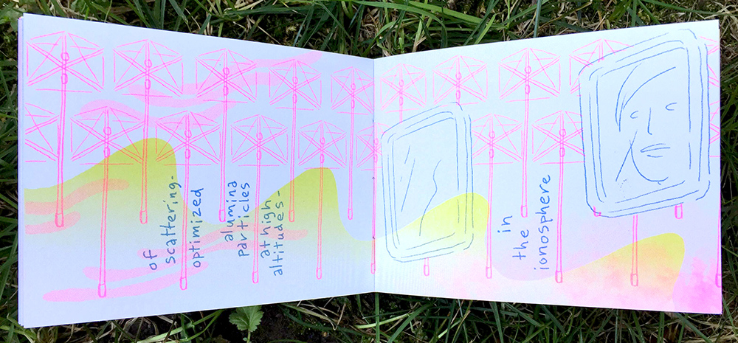  Happy Trails (2016)  Comic / flip book: the page is also a frame. | 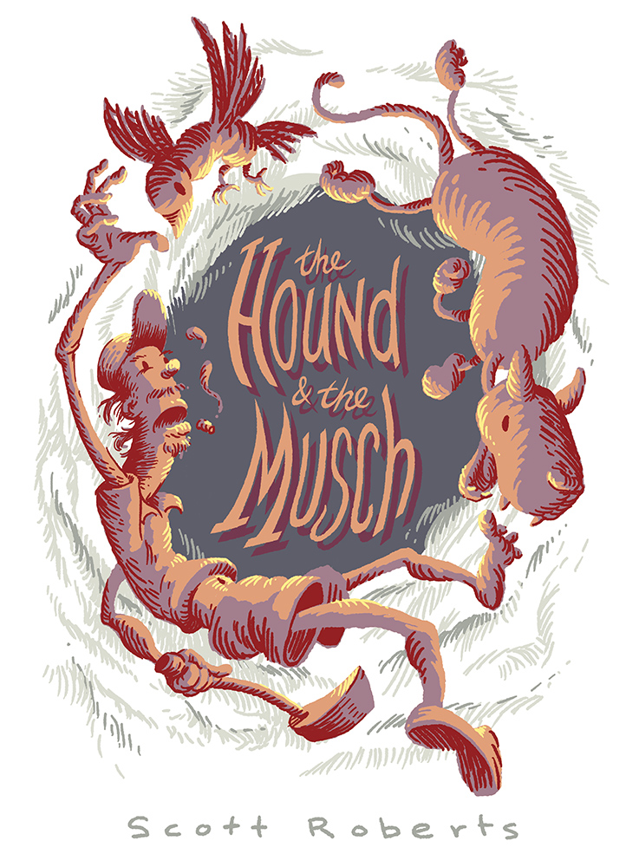  The Hound & The Musch (2012)  A Grimm adaptation driven by unstable visual syntax. | 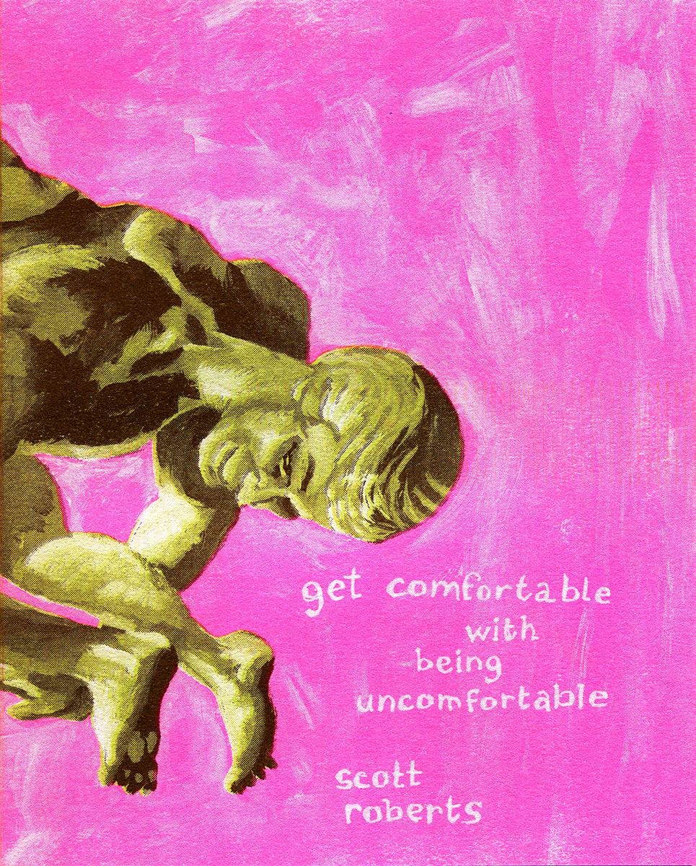  Get Comfortable With Being Uncomfortable (2018)  Sixteen double-page spreads built as an experimental art comic.
FIGURES 2–4. Images copyright Scott Roberts, reproduced for scholarly commentary from Ubutopia. Source URLs appear in References.
Yelmo is less interesting as an animator discovering AI than as an unstable new machine entering an older problem: how does a sequence change without losing what makes the change matter?

5. Control is not the opposite of surprise
The Yelmo notes refuse a clean solution because the people in the room wanted two things that pull against each other.
They wanted control. The animator’s complaint is concrete: without a repeatable character, the images stay trapped as one-offs. You cannot build a comic, sequence, or animation if the protagonist mutates every time the camera cuts.
They also wanted to be surprised. The notes say they were “being led by MJ” and were “not trying to control everything.” The group loved the machine for producing moves that a human artist would not have proposed.
A better system cannot solve this tension by choosing one side. Perfect obedience turns the generator into a puppet. Perfect surprise destroys the world. Storytelling needs a machine that can violate expectations without violating commitments.
This is the deeper Yelmo problem: keep him, but do not freeze him.
NOT PROMPT ENGINEERING
Prompt engineering asks how to make the machine obey. Yelmo asks how a group and a machine remain answerable to what they already made.

6. What a generative story tool has to remember
The product lesson is direct.
Do not build generative story systems as prompt boxes with longer context windows. Build them around obligations.
When a group decides that a particular nose, scar, coat, relationship, or event matters, the system should record that decision. When a new output violates it, the violation should be visible. When collaborators disagree, the disagreement should remain inspectable instead of disappearing under the next generation. When the group changes its mind, the change should leave a trace.
A story tool should know the difference between a fact and a suggestion, between canon and a candidate, between a deliberate transformation and accidental drift. It should also know who made the commitment. Shared storytelling does not erase agency; it makes the chain of agency legible enough that people can respond to one another.
PROPOSAL  Someone risks a move. | OUTPUT  The machine returns possibilities. | JUDGMENT  People decide what counts. | MEMORY  The decision becomes a commitment. | NEXT  The next move inherits it.
Midjourney eventually named part of this requirement. In March 2024 it introduced Character References, explicitly aimed at making a character match a reference image across new scenes. Current documentation still frames the feature around using the same character in multiple images. That product history does not prove that Yelmo influenced Midjourney. It shows that the limitation the group hit in 2022 became important enough to receive a named product operation.
The group had already written the requirement in plain English: same dude each time.

7. The real archive is the failure pile
If Scott Roberts and the other participants still have the early Yelmo material, the polished images are not the most important documents.
Publish the failures.
Publish the first yellow-Elmo prompt. Publish the eye that moved. Publish the red frill that appeared from nowhere. Publish the scene where adding another character changed both of them. Publish the prompt that worked three times and broke on the fourth. Publish the abandoned Campbell map, if there was one. Publish the screenshot where somebody says, “No, that isn’t him.”
Those failures contain the specification.
A clean retrospective would make the project smaller. It would turn an unstable practice into an origin story. The ugly record can do something better: show exactly where the human group had to step in because the model stopped carrying the world.
SCOTT, THIS IS THE PART ONLY THE ORIGINAL PARTICIPANTS CAN SETTLE
What did “repeatable” mean in the room? Who first called him Yelmo? Did you make a model sheet or choose a canonical image? Did seeds, image prompts, remix, Photoshop, or hand correction enter the workflow? Did the hero’s journey die because continuity failed, or because random Yelmo situations became the better project? Did your exquisite-corpse practice enter Yelmo consciously? The answers should be allowed to break this paper.

8. Who keeps Yelmo?
The easy story about generative AI says the machine makes the work and humans decide how much credit to claim.
Yelmo shows a different division of labor.
The machine made possibilities. The group made commitments.
The machine could produce another frame. The group decided whether the frame belonged to the same story.
The machine could surprise everyone. The group decided which surprises became history.
The machine could repeat a description. The group carried the referent.
That is what it means to tell a story with others using generative tools. It means sharing the burden of continuity. It means remembering for one another. It means letting somebody else change the thing without letting the thing disappear. It means refusing the gorgeous frame that breaks the world.
A protagonist is not a picture. A protagonist is a promise that survives the cut.
The model could draw Yelmo. The group had to keep him.

References
Chen, Hong, Yipeng Zhang, Simin Wu, Xin Wang, Xuguang Duan, Yuwei Zhou, and Wenwu Zhu. 2023. “DisenBooth: Identity-Preserving Disentangled Tuning for Subject-Driven Text-to-Image Generation.” arXiv:2305.03374. https://arxiv.org/abs/2305.03374.
Gal, Rinon, Yuval Alaluf, Yuval Atzmon, Or Patashnik, Amit H. Bermano, Gal Chechik, and Daniel Cohen-Or. 2022. “An Image Is Worth One Word: Personalizing Text-to-Image Generation Using Textual Inversion.” arXiv:2208.01618. https://arxiv.org/abs/2208.01618.
Midjourney. 2024. “Introducing Character References.” March 12, 2024. https://updates.midjourney.com/character-refs/.
Midjourney. “Character Reference.” Documentation. https://docs.midjourney.com/hc/en-us/articles/32162917505293-Character-Reference.
Roberts, Scott. 2012. The Hound & The Musch. Ubutopia. https://www.ubutopia.com/HoundMusch/HoundAndTheMusch.html.
Roberts, Scott. 2016. Happy Trails. Ubutopia. https://www.ubutopia.com/happytrails/happytrails.html.
Roberts, Scott. 2018. Get Comfortable With Being Uncomfortable. Ubutopia. https://www.ubutopia.com/uncomfortable/uncomfortable.html.
Roberts, Scott. “Comics.” Ubutopia. https://www.ubutopia.com/comics.html.
Roberts, Scott. Faculty profile. DePaul University. https://www.depaul.edu/faculty/scott-roberts.
Tewel, Yoad, Omri Kaduri, Rinon Gal, Yoni Kasten, Lior Wolf, Gal Chechik, and Yuval Atzmon. 2024. “Training-Free Consistent Text-to-Image Generation.” arXiv:2402.03286. https://arxiv.org/abs/2402.03286.
Unpublished Midjourney interview and field notes, 2022. User-provided research archive. Includes Yelmo project description, October 12, 2022 Office Hours notes, and reflections on collaborative prompting.

Source note
The identification of the “Scott” named in the surviving Yelmo interview notes with Scott Roberts remains unverified by a direct archival bridge. Roberts’s public biography, comics practice, early Midjourney activity, and later generative-AI teaching make the identification plausible, but this paper keeps the gap visible. The attribution “Yelmo: Furry Road @spitooon” comes from the user who supplied the image and has not been independently verified.
All Scott Roberts artwork reproduced here is drawn from Roberts’s Ubutopia website and is used for scholarly commentary.

