CS506 Midterm Group 6

How to Test:

1. Download server.py and client.py files
2. Ensure Python is installed
3. In command prompt, write the file path of server.py but insert “python” before “server.py”. This sets up the servers.

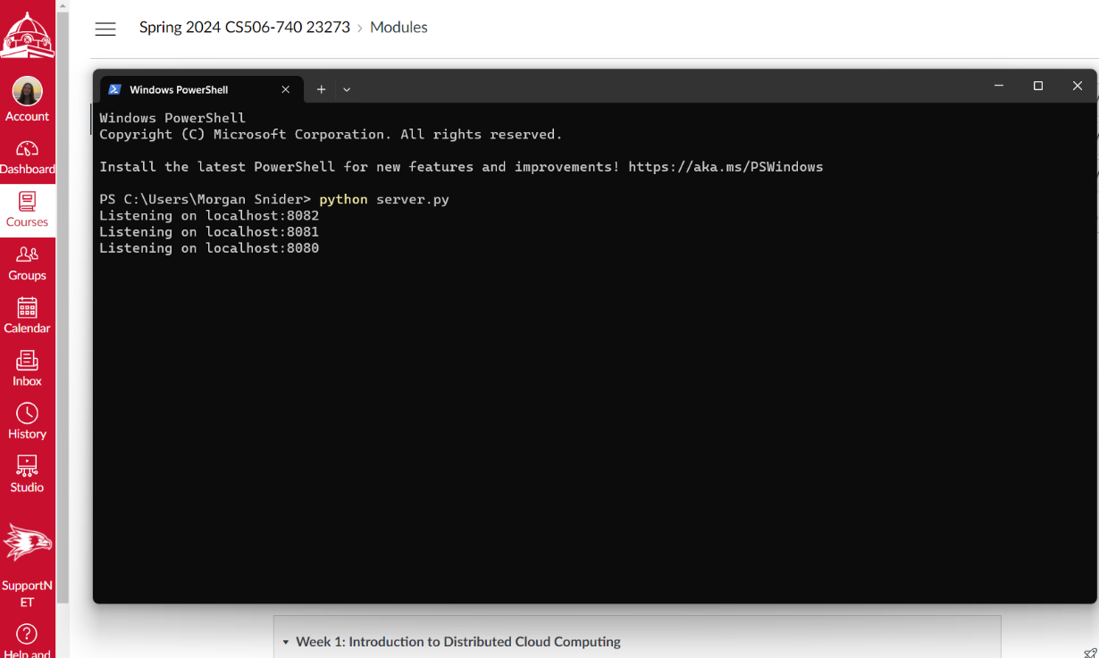

1. In a new command prompt window, write the file path of client.py but insert “python” before “client.py”. This will register a client.

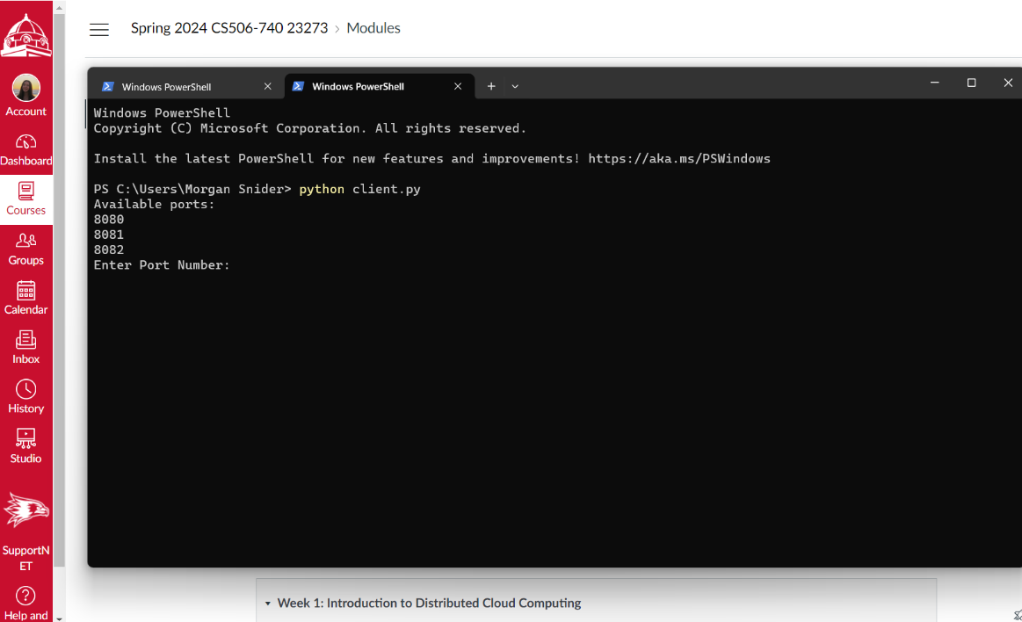

1. Enter one of the three port numbers provided and a nickname.

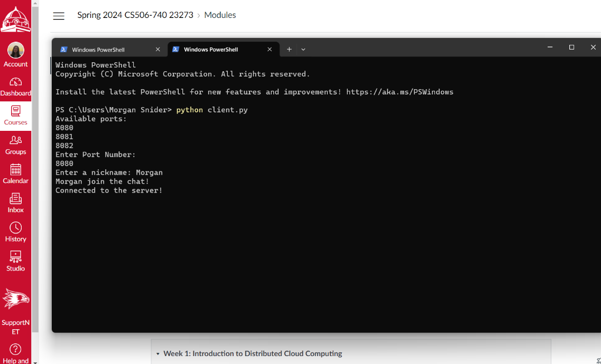

Message displayed on the server window to confirm client connection.

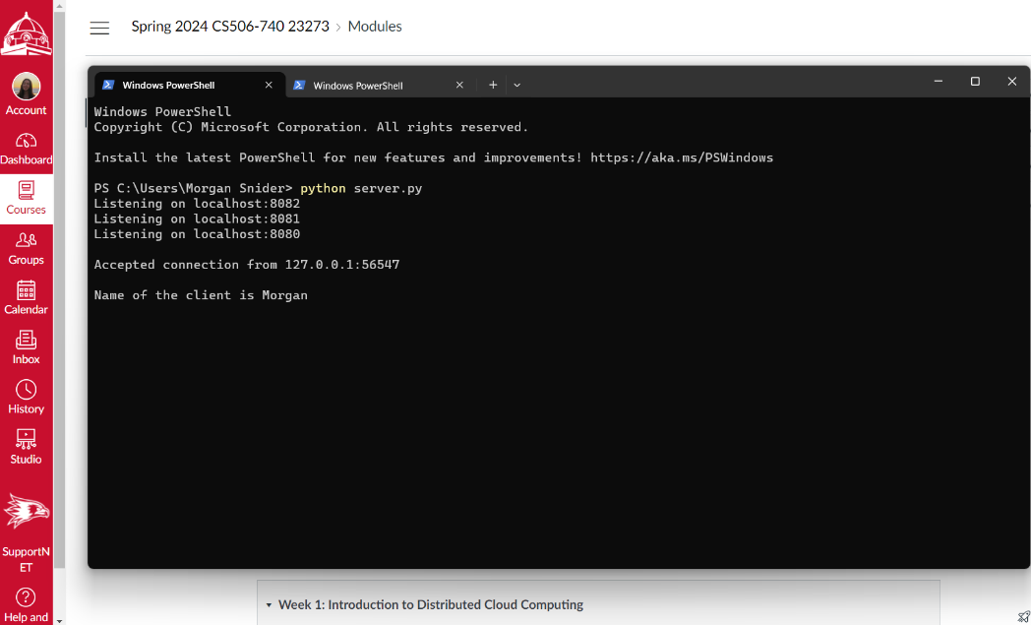

1. Repeat steps 4-5 for multiple clients on different ports.

2nd Client connection

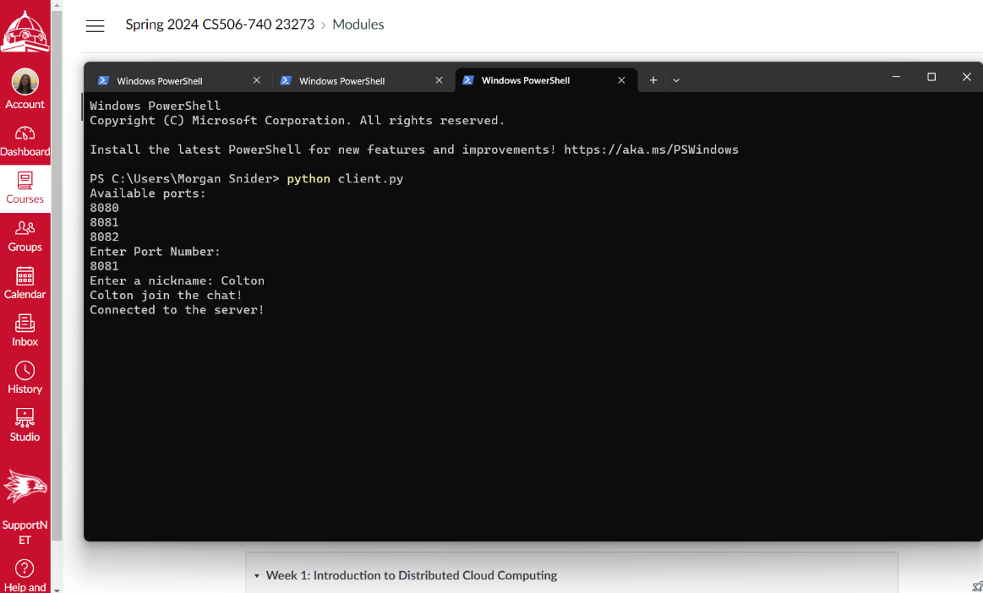

Message displayed on the server window to confirm 2nd client connection.

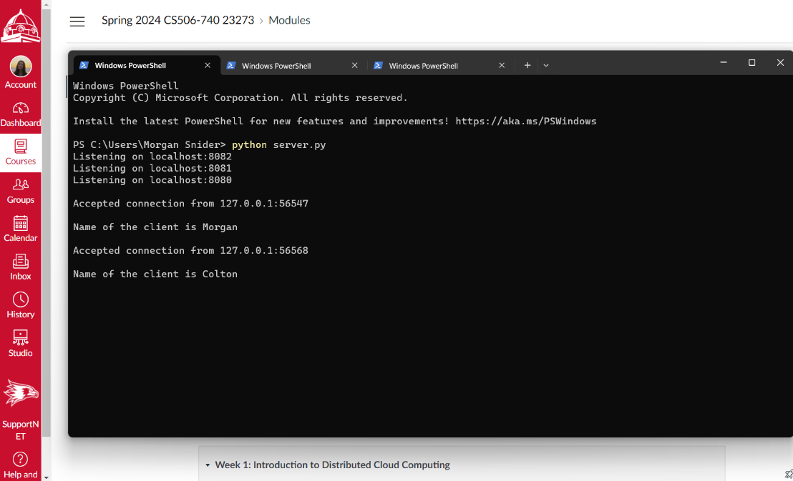

3rd Client connection

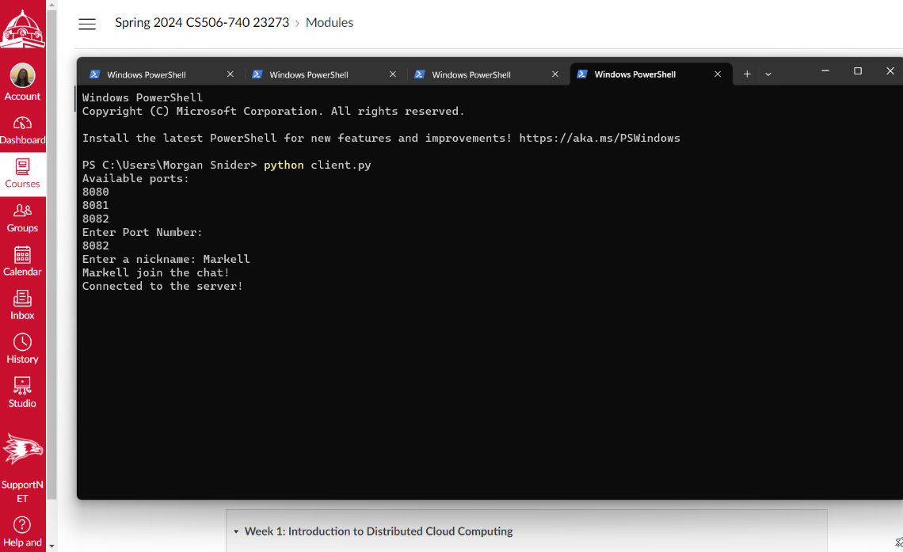

Message displayed on the server window to confirm 3rd client connection.

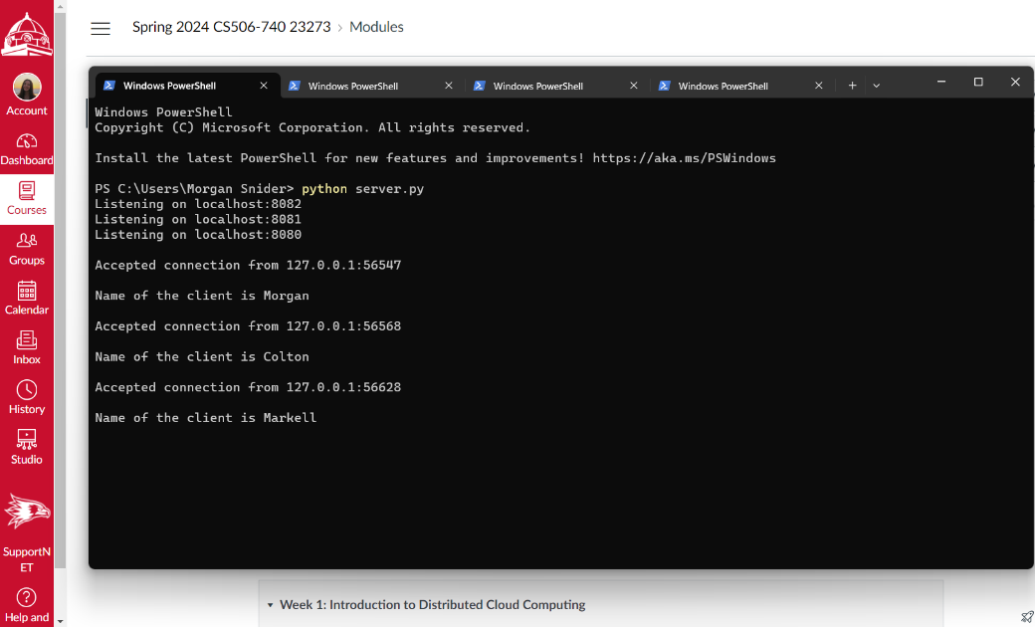

1. In a client window, type a message and hit enter. This shares data between the clients.

Client named Morgan sends a message, “Hello!”

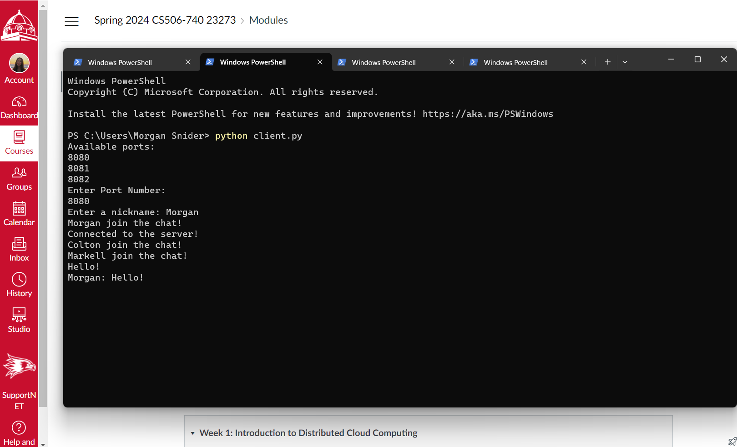

Client named Colton can see Morgan’s message

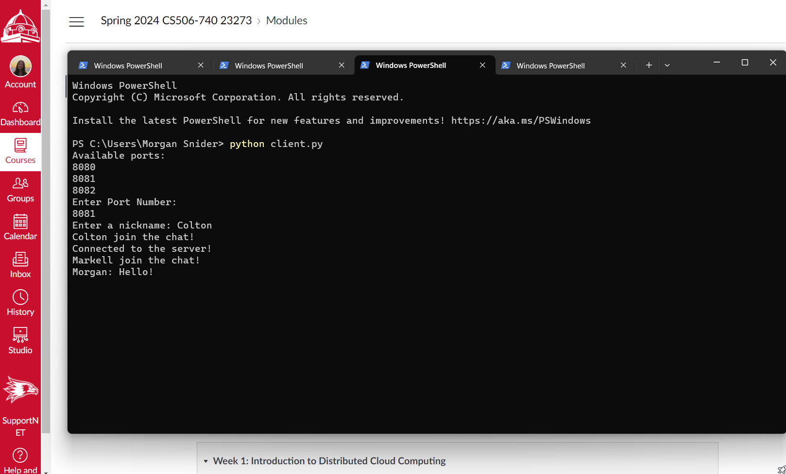

Colton sends a message, “Hi!”

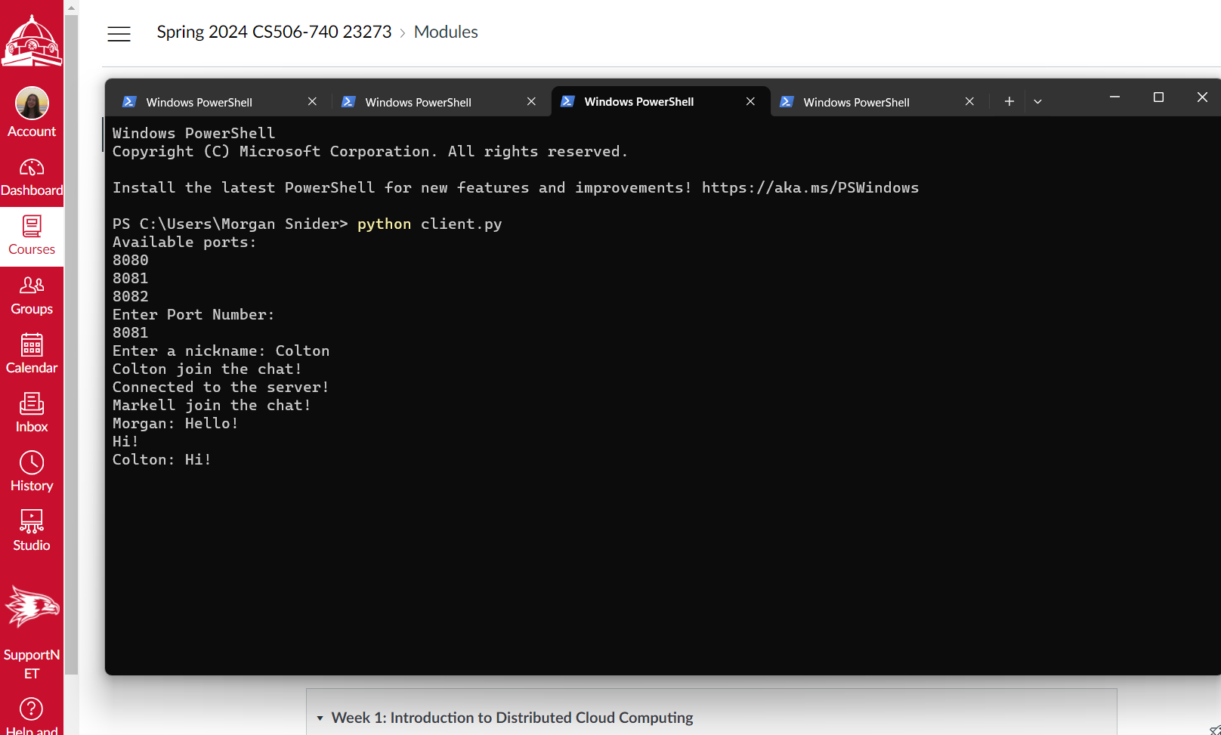

Client named Markell can see Morgan and Colton’s messages and send a message, “Hey!”

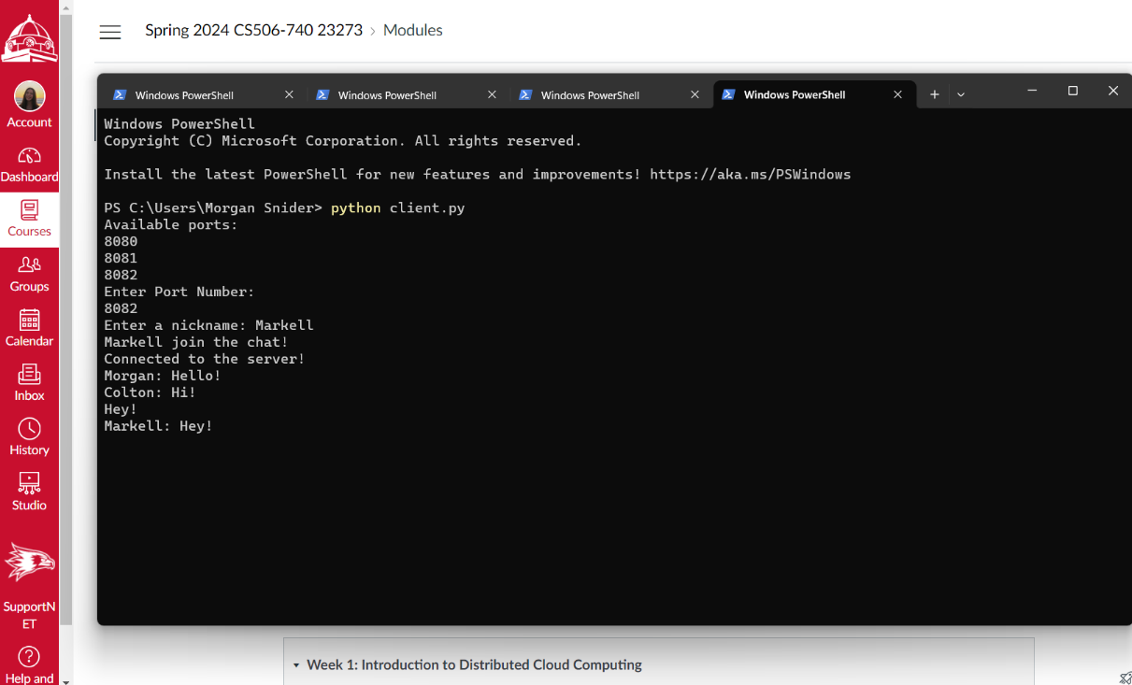

1. When a client window is closed, it sends a message to the other clients saying someone has left the chat.

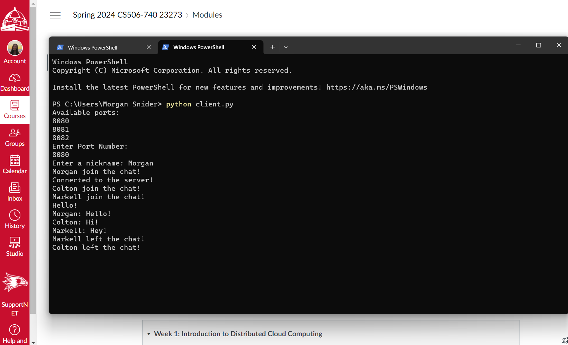

1. If a port number is entered incorrectly, the user will be prompted again.

