Digital Assignment – 1
Multilayer Perceptron Model
(Feed Forward Neural Network)

Description:
Neurons also known as linear perceptron forms the basic computational unit in any artificial neural networks. It takes input signals, applies weights, performs a summation, and passes the result through an activation function to produce an output. This enables the network to learn and make predictions based on the patterns and relationships in the data it processes.
Feed-forward neural networks, also known as multilayer perceptrons (MLPs), are a type of artificial neural network architecture. They are composed of multiple layers of interconnected neurons, with information flowing in one direction, from the input layer to the output layer, without cycles or loops. It consists of three types of layers: an input layer, one or more hidden layers, and an output layer.
The activation function introduces non-linearity into the model, enabling the neuron to capture complex patterns and relationships in the data.
Google Colab:
Google Colab, short for Colaboratory, is a cloud-based platform provided by Google that offers a free and convenient environment for writing and executing python code in python notebook format. This exercise is implemented in google colab.
Key Features:
- Free Access to GPU and TPU: provides free access to Graphics Processing Units (GPUs) and Tensor Processing Units (TPUs). This is particularly beneficial for users dealing with computationally intensive tasks, such as training deep learning models, as it significantly accelerates processing times.
- Collaborative Editing: Users can share their Colab notebooks just like they would with Google Docs or Sheets, allowing real-time collaboration on code and documentation.
- Integration with Google Drive: Colab is seamlessly integrated with Google Drive, enabling users to save and share their work directly from the platform. This integration simplifies version control and provides an easy way to organize and manage Colab notebooks.
- Pre-installed Libraries: Colab comes with a variety of pre-installed libraries, including popular machine learning frameworks such as TensorFlow and PyTorch. This eliminates the need for manual installations and ensures a smooth experience when working on data science and machine learning projects.
- Access to External Data: Colab allows users to easily import datasets from various sources, including Google Drive, GitHub, and external URLs.
- Markdown Support: Colab supports Markdown, allowing users to incorporate formatted text, images, and hyperlinks into their notebooks. This feature enhances the documentation aspect of the code, making it more accessible and comprehensible.

Advantages:
- Zero Setup Required: Colab eliminates the need for local machine setup. With just a browser and a Google account, users can start coding immediately, reducing the barriers to entry for beginners.
- Free Cloud Resources
- Educational Use
- Large Community and Resources
- Integration with Google Ecosystem

Limitations:
- Session Time Limits: Colab sessions have time limits, and after a certain period of inactivity, resources may be released. This can be a limitation for long-running computations or tasks requiring continuous monitoring.
- Resource Constraints: While Colab provides free GPU and TPU resources, these resources are shared among users, and there are limitations on usage. Users with high computational demands may encounter restrictions, prompting consideration of alternative, dedicated cloud computing solutions.
- Dependency on Internet Connection: Colab requires a stable internet connection as it is entirely cloud-based. Users without reliable internet access may face challenges in utilizing the platform consistently.
- Limited Storage: The storage capacity in Colab is linked to the user's Google Drive account. Although additional storage can be purchased, users may find the default storage limiting for large datasets or extensive projects.

Steps to execute python project in colab:
- Sign up / login in to google account and open colab.
- In the welcome page, open notebook window pops up from which code can be loaded from gdrive or github, it also lists recent projects. We can also create a new notebook and start working.
- Whenever we create a new notebook, we need to connect it to runtime environment either GPU or CPU or TPU as per our requirement.
- Once the python notebook instance is connected to a runtime, we can start import any libraries or install new libraries and start coding.
- As this is a python notebook, code can be split into multiple cells and colab provides features to add text blocks in between for better code visualization.
- The cells can be run one at a time or in multiple, by either selecting option from runtime in top menu window or by using keyboard shortcuts.
- There are multiple visualization options in colab, whenever a list or csv file is printed, there will be options to visualize the data in form of graphs, bar charts, etc, colab also provides the code upon clicking the graph options.

- Dataset can be loaded very easily in colab by either directly uploading the file from local storage to files option in the side pane of colab instance or by mounting the gdrive and using the files from drive.
- There is also colab AI, which will provide code snippets provided the requirement.
- The code is usually auto saved or can be saved from file option.
- By using share option in top right corner, we can share the notebook link with anyone and grant or restrict access to edit. This helps to achieve a colaboratory platform for projects.

Components of code:
Dataset: Student grade details
Dataset consists of marks of students in 5 subjects and their respective grade – A, B , C or D
Libraries used:
- Numpy - provides support for large, multi-dimensional arrays and matrices, along with mathematical functions to operate on these arrays.
- Pandas - data manipulation and analysis library. It introduces two primary data structures, Series and DataFrame, which are built on top of NumPy arrays. Pandas simplifies data cleaning, exploration, and transformation, making it a popular choice for working with structured data in data science and analytics. Used to import CSV file and visualise and preprocess the dataset.
- Sklearn - provides simple and efficient tools for data analysis and modeling. It includes a wide range of machine learning algorithms for classification, regression, clustering, and dimensionality reduction.
- Keras - open-source deep learning library written in Python. It supports both convolutional and recurrent neural networks and facilitates the development of complex models with minimal code.
Flow of code:
1. Dataset is imported as csv file and stored in dataframe.
2. Using get_dummies function from one hot encoding, the output classes(categorical variables) are converted into dummy or indicator variables and stored in y.
3. Unnecessary columns are removed from dataframe and only the input features are stored in x.
4. Using train_test_split from sklearn, dataset is split into training data 70% and test data 30%
5. From Keras, Sequential model class is used, which is feed forward neural network model.
6. One hidden layer with 8 neurons is added to the model and output layer with 4 neurons(4 classes).
7. For the hidden layer, sigmoid activation function is used – squashes input values to a range between 0 and 1, transforming them into probabilities.
8. For the output layer, softmax activation function is used – converts a vector of raw scores or logits into a probability distribution, where each element represents the probability of belonging to a particular class. Softmax function involves exponentiating each input element and then normalizing

the results to ensure they sum to 1. Useful when there are more than two classes, and it helps in selecting the class with the highest probability as the final prediction.
9. Loss function is set to categorical cross entropy loss – employed when the task involves predicting multiple classes, and the model output is a probability distribution over those classes. Categorical Crossentropy measures the dissimilarity between the predicted probability distribution and the true distribution of the target labels. It is mathematically defined as the negative log likelihood of the true class under the predicted probability distribution. The goal during training is to minimize the Categorical Crossentropy loss, which encourages the model to improve its predictions and assign higher probabilities to the correct classes.
10. Performance metric is set to accuracy – expressed as ratio of the number of correct predictions to the total number of predictions made by the model. Suitable for balanced datasets.
11. The model is compiled and fit with epoch 50 and batch size 5 to get optimum accuracy.
12. Random test inputs are given for prediction and the output is observed.

Code:
import numpy as np
import pandas as pd
#data frame -- df
#access data by adding Dataset path, to see 10 rows
df = pd.read_csv("/content/dlda.csv")
df.head(10)
#one hot encoding for Grade column- 4 types of grades- change to integer values
y = pd.get_dummies(df['Grade'])
y
#The get_dummies function is used to convert categorical variables into dummy or indicator variables.
#A dummy or indicator variable can have a value of 0 or 1.
x = df.drop(["Sl.no","Average","Grade"],axis=1)
x
#split DS 70:30 ratio, 70% DS - training and 30% DS-test

from sklearn.model_selection import train_test_split
x_train,x_test,y_train,y_test = train_test_split(x,y,test_size = 0.3)
x_train.head(10)
# create our own artifical neural network model: multilayer perceptron, so we need Keras library, MLP has minimum 1 hidden layer
# importing layers from keras library, Dense means hidden layers, Sequetial means create the layers in sequential manner, means feed forward
# x values are input layer means 1 st layer
# y values are output layer

# Dense is hidden layer
from keras import Sequential
from keras.layers import Dense
# run the model with adding the layers
model = Sequential()
#adding the dense layer, with 8 nodes in the hidden layer and activation function is 'sigmoid'
model.add(Dense (units='8', activation='sigmoid'))
# creating the output layer, 4 means there are 4 classes in the output coloumn, so finding thd highest probability for the flower compared to other 2 flowers
#softmax is the activation fucntion for outout, Softmax is a mathematical function that converts a vector of numbers into a vector of probabilities,
# where the probabilities of each value are proportional to the relative scale of each value in the vector
model.add(Dense (units='4', activation='softmax'))
#run the MLP model using the below, lossfunction is catagorical, metric is accuracy of the model
model.compile(optimizer='rmsprop', loss='categorical_crossentropy', metrics=["accuracy"])
# 1 epoch means a complete 1 set of iteration n dataset by the model, batch size means split the data set as batches to send in to the model.
model.fit (x_train, y_train, epochs=50, batch_size=5)
#testing the model performance
score = model.evaluate(x_test, y_test)
print("accuracy", score)
def testing_model(test):
i=model.predict([test])
print(i)
max_index = i.argmax()
cls = chr(ord('A') + max_index)
print("The given test data belongs to class", cls)
print("Checking if the prediction is correct...")
avg = sum(test) / len(test)
print("Avg of test data given = ",avg)
print("\n\n")

t1 = [40, 70, 50, 80, 66]
testing_model(t1)

t2 = [88, 92, 94, 80, 83]
testing_model(t2)

Output:
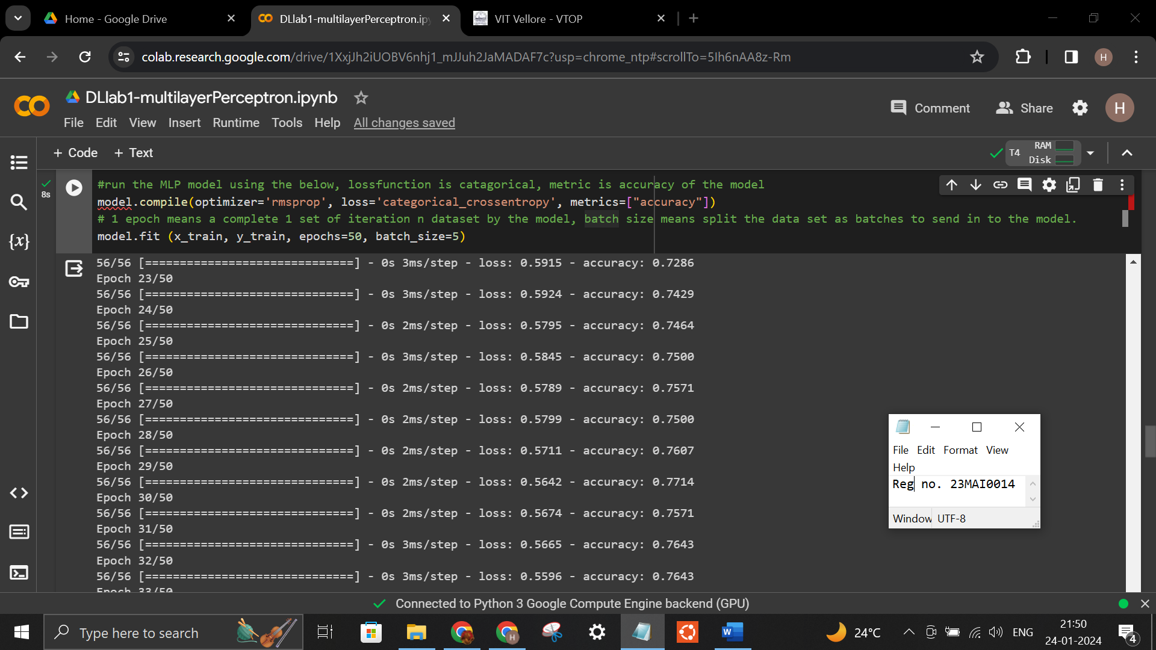
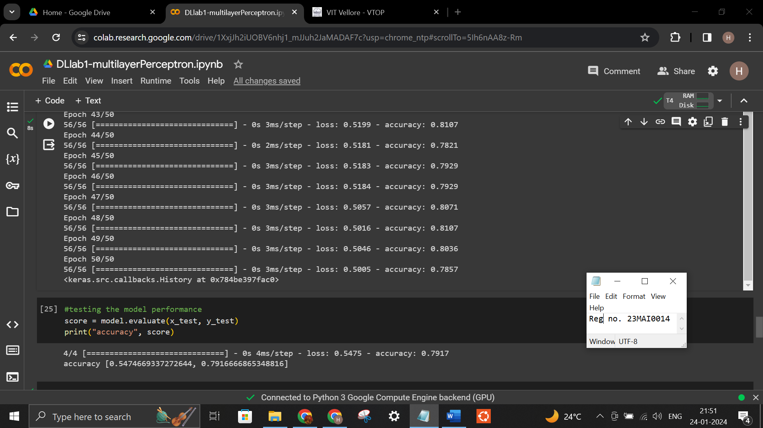

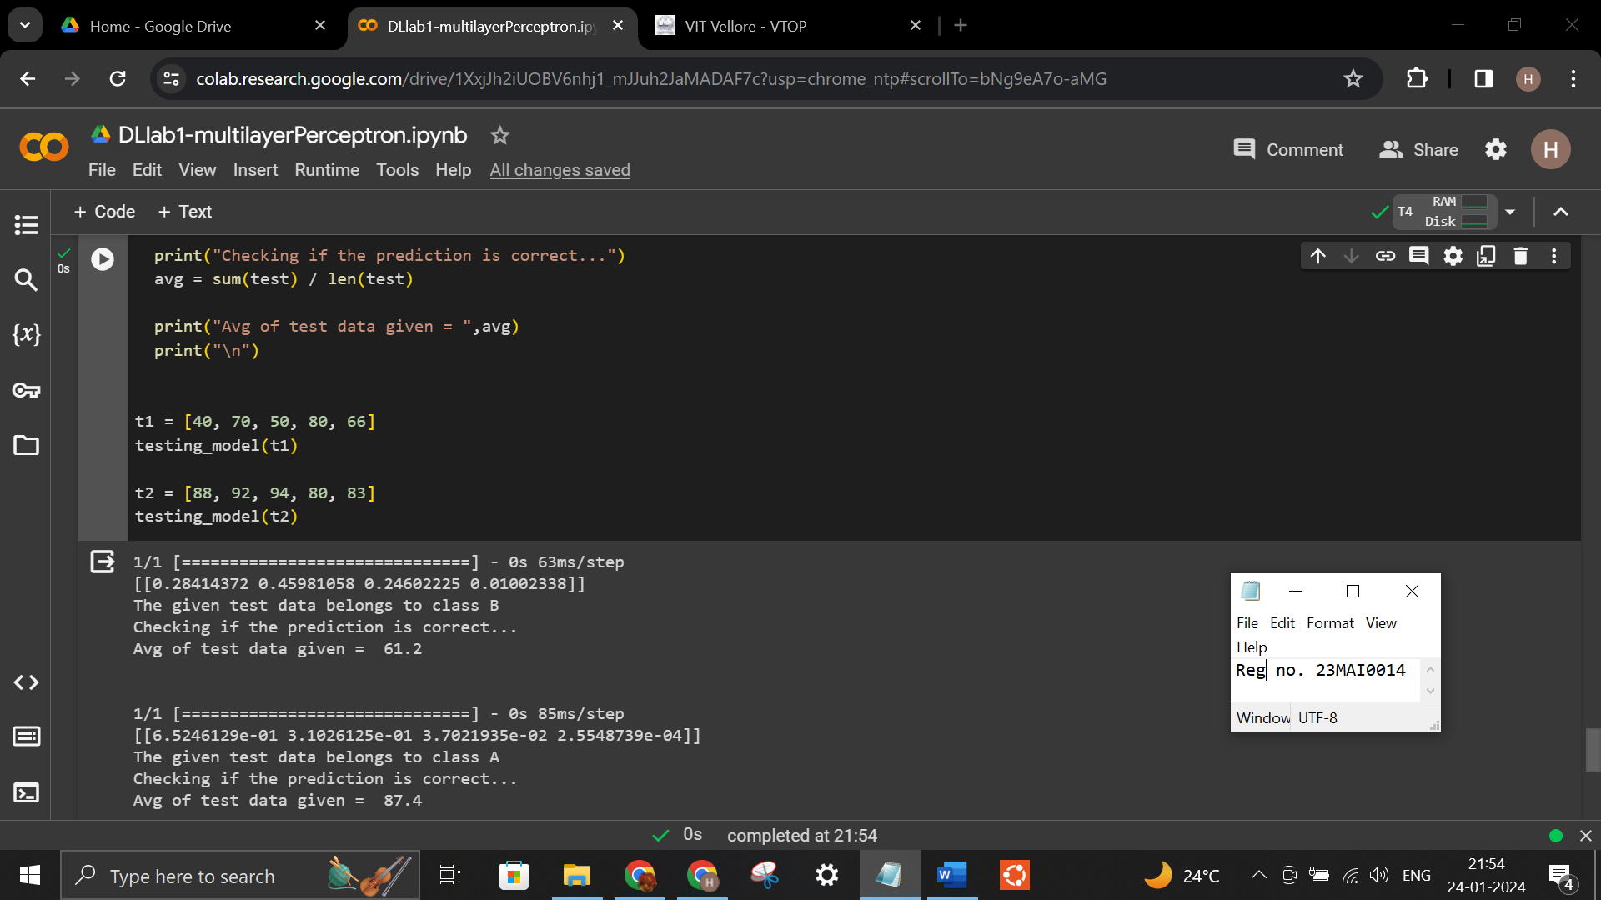

Google Colab Link:
https://colab.research.google.com/drive/1XxjJh2iUOBV6nhj1_mJJuh2JaMADAF7c?usp=sharing

Dataset:
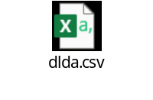

Output for Iris dataset:
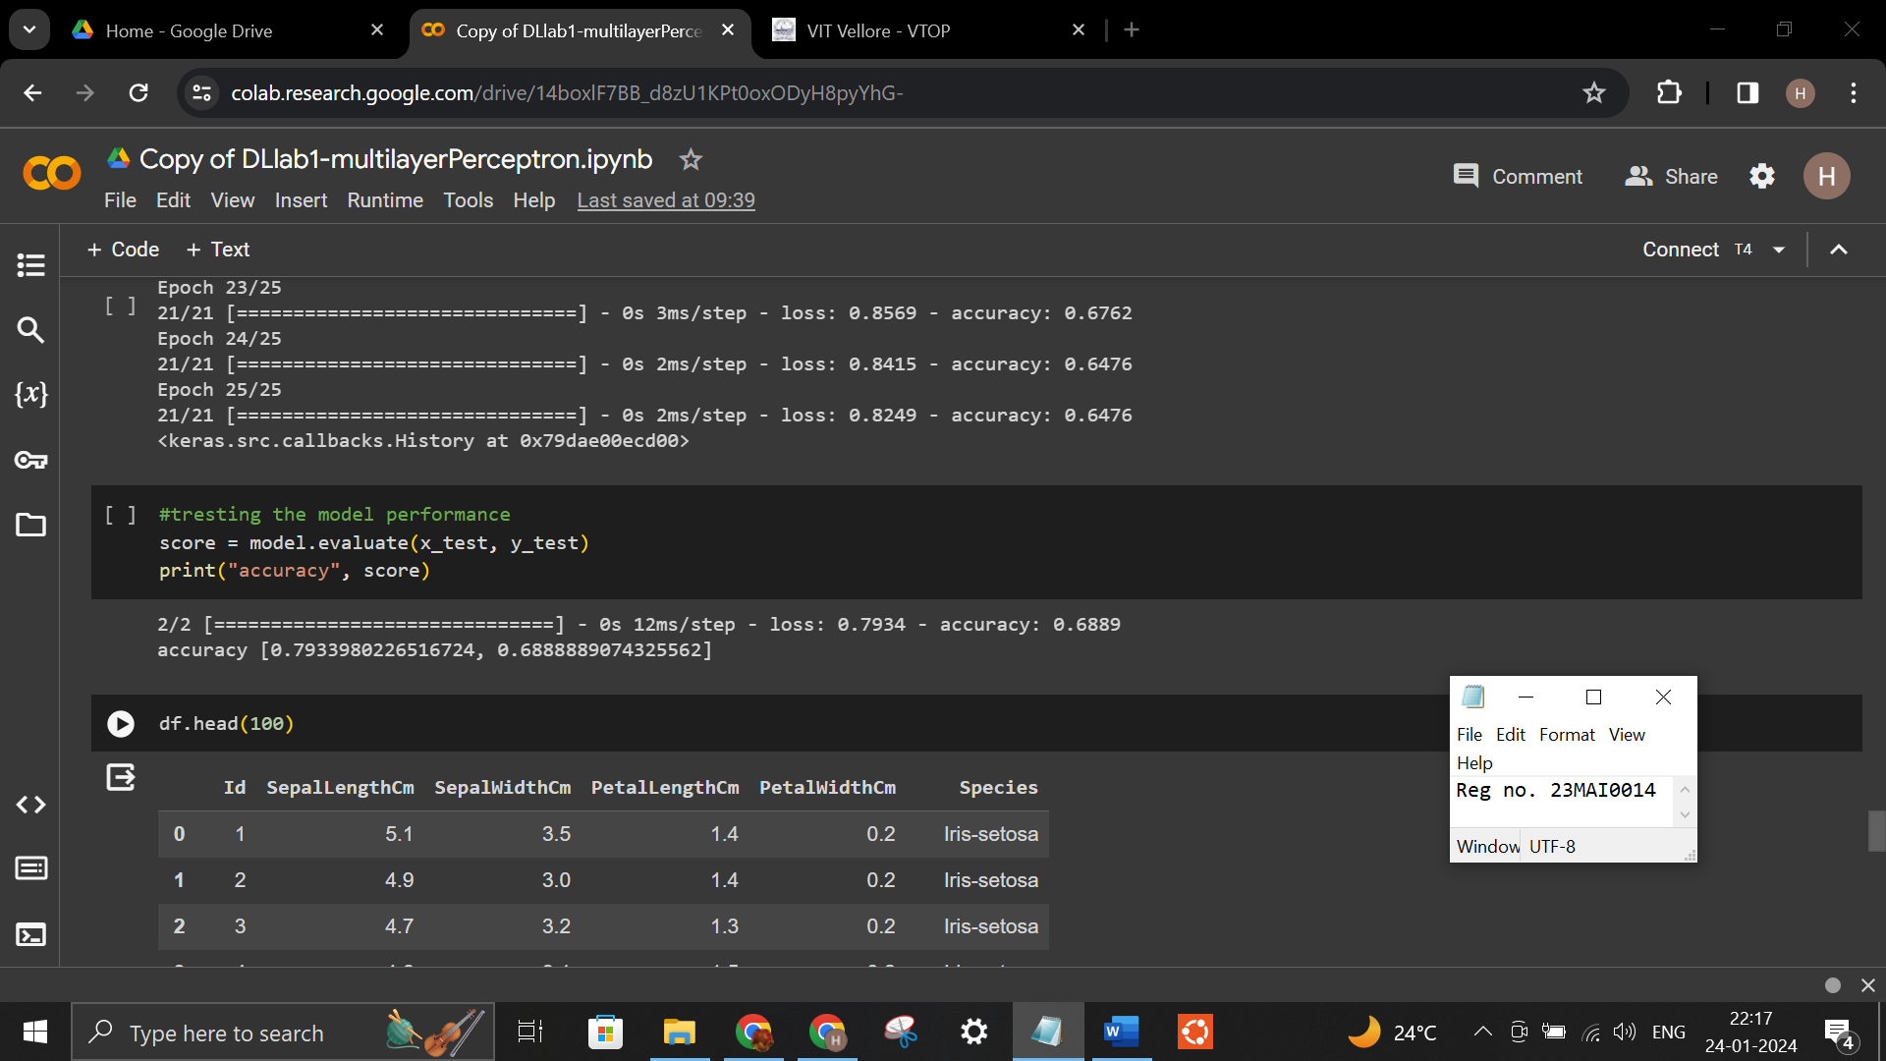
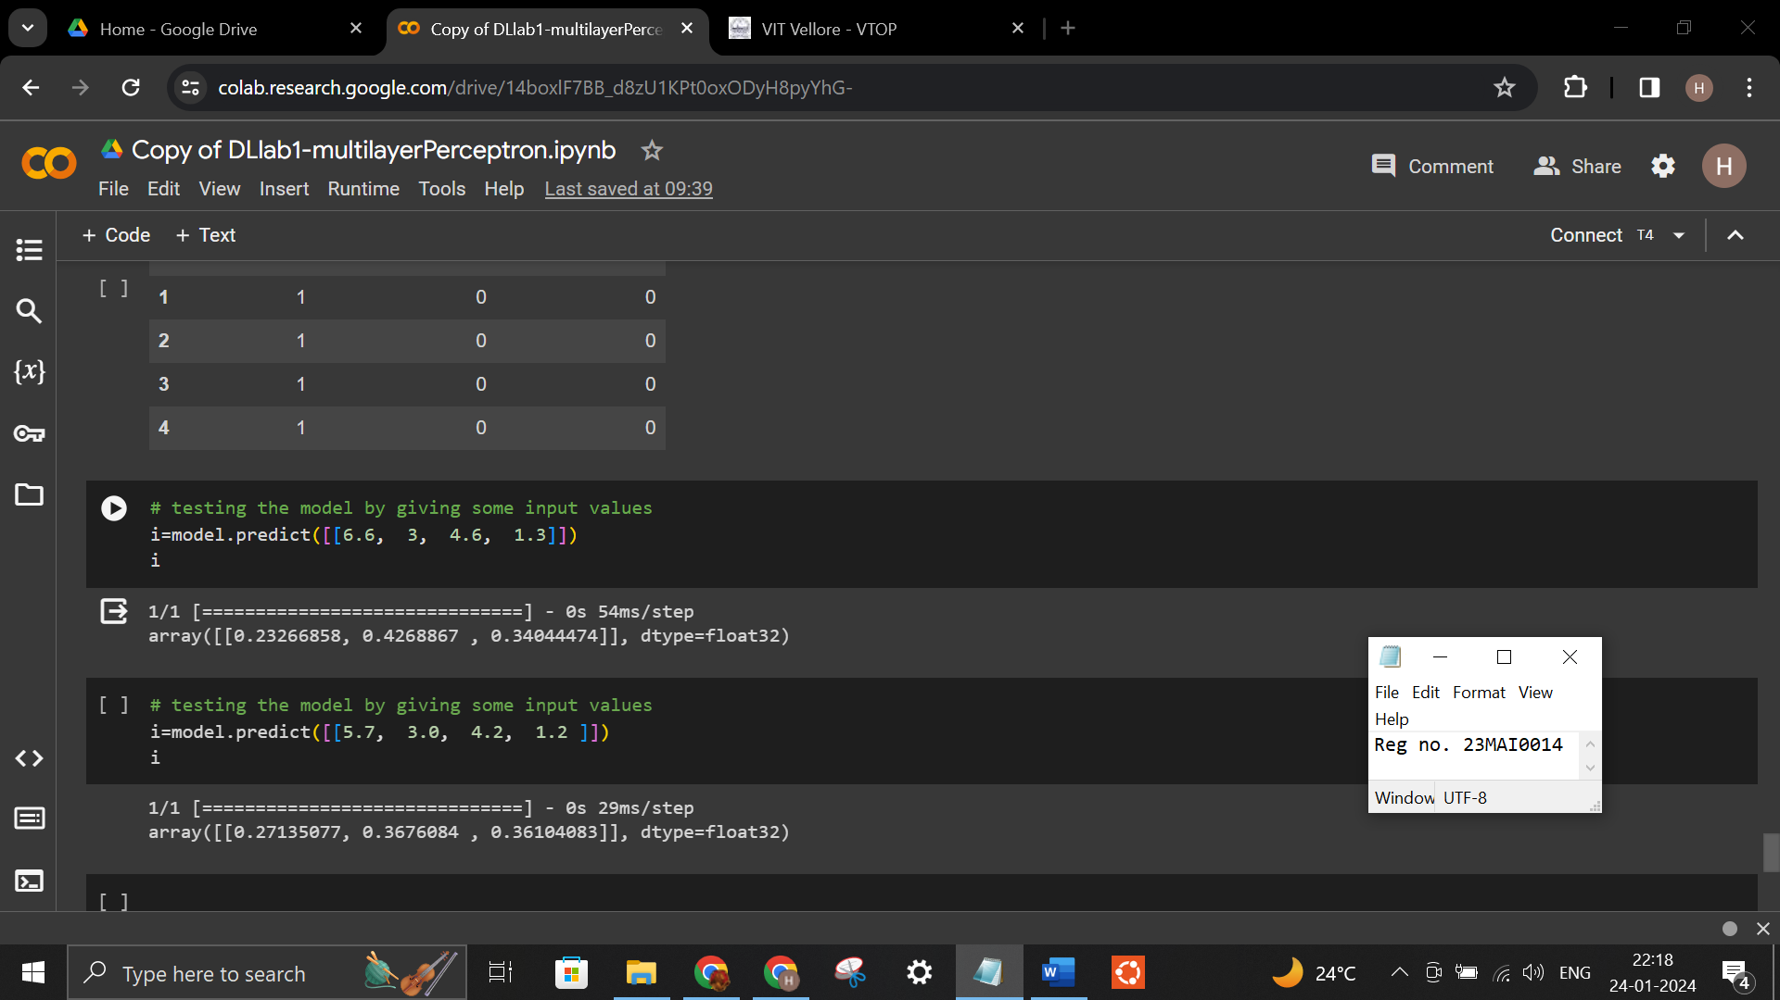

Conclusion:
Multilayer Perceptron is the simplest model in Deep Learning. Multilayer perceptrons (MLPs) are versatile and can be applied to a wide range of tasks, including classification, regression, and pattern recognition. This model works well for classification but as error increases, this model focuses more on performance and accuracy. MLPs can model complex, non-linear relationships within data, allowing them to learn and represent intricate patterns and features. This model has low mechanism to minimize error. It is prone to overfitting, computationally demanding, and sensitive to hyperparameters. From the observation, we see that the accuracy is lower even for simple dataset, but the prediction is correct.

