

Deep Learning Laboratory - MCSE603P
Reg No. : 23MAI0014
Name : Harini K
Slot : L47+48
Faculty : Dr.Anil Kumar K
College : Vellore Institute of Technology
Department : SCOPE
Assignment : 2
Experiment : Comparison of various optimizers,
Backpropagation

Digital Assignment – 2
Exercise – 1
Comparison Of Various Optimizers
Optimization algorithms are used in Machine Learning/ Deep Learning to minimize (or maximize) an objective function J(θ), which is typically a loss function that the model tries to minimize during training. The objective function depends on the model parameters θ.
Different Optimization Algorithms and their Applications:
1. Adagrad:
Adagrad (Adaptive Gradient Algorithm) is an optimization algorithm that adapts the learning rate to the parameters individually. It performs smaller updates for parameters associated with frequently occurring features and larger updates for parameters associated with infrequent features. It's well-suited for dealing with sparse data.
Key Points:
- Learning Rate: The learning rate is adapted for each parameter individually.
- Squared Gradients: The algorithm accumulates the squared gradients in the denominator; since every added term is positive, the accumulated sum keeps growing during training, causing the learning rate to shrink and eventually become infinitesimally small.
Adagrad is well suited for:
- Problems with sparse data where features occur infrequently.
- Large-scale learning with high-dimensional data.
Disadvantage: Adagrad might not perform well in scenarios where you need a constant or increasing learning rate throughout training..

2. RMSProp:
RMSProp (Root Mean Square Propagation) is an optimization algorithm designed to resolve Adagrad’s radically diminishing learning rates. It uses a moving average of squared gradients to normalize the gradient itself. This normalization balances the step size—decreasing the step for large gradients to avoid exploding and increasing the step for small gradients to avoid vanishing. It stabilizes the learning rate.
Key Points:
- Decay Rate: Introduces a decay rate to control the moving average window.
- Stabilized Learning Rate: Prevents the learning rate from becoming too small.
Use RMSProp for:
- Non-stationary tasks: Since RMSProp adapts the learning rate based on recent gradients, it performs well on problems where the statistics of the data change over time.

- Recurrent Neural Networks (RNNs): RNNs often suffer from the vanishing or exploding gradient problem, and RMSProp is effective at combatting this issue.
- RMSProp is generally a good choice unless you have a reason to use a more sophisticated optimizer like Adam, which combines the benefits of RMSProp with momentum.

3. Adadelta:
Adadelta is an extension of Adagrad that seeks to reduce its aggressive, monotonically decreasing learning rate. Instead of accumulating all past squared gradients, Adadelta restricts the window of accumulated past gradients to some fixed size.
Key Points:
- Window of Accumulated Gradients: Adadelta limits the accumulation of squared gradients to a fixed window size, implementing it as a moving average.
- No Need for a Default Learning Rate: The method derives its own adaptive learning rates that require no manual setting of a learning rate.
Use Adadelta for:
- Problems where manual tuning of the learning rate is to be avoided.
- Situations similar to RMSProp with non-stationary objectives or training problems requiring robustness to noisy gradient information.
Adadelta is particularly useful if you find that RMSProp is still too aggressive with its updates even after tuning its decay rate.

4. Adam:
Adam (Adaptive Moment Estimation) combines the ideas of momentum and RMSProp. In addition to storing an exponentially decaying average of past squared gradients like RMSProp, Adam also keeps an exponentially decaying average of past gradients similar to momentum.
Key Points:
- Moment Estimation: Maintains estimates for gradients and squared gradients.
- Bias Correction: Corrects moment estimates to prevent bias towards zero.
- Hyperparameters: Includes hyperparameters for the decay rates of these moment estimates.
Use Adam for:
- Deep learning applications: Adam is very popular in the training of deep neural networks, particularly because it combines the advantages of RMSProp and momentum, making it effective for a wide range of tasks.
- Problems with noisy gradients or gradients with high variance, as the moment estimation helps stabilize the updates.

- Large datasets and high-dimensional parameter spaces: Adam is computationally efficient and has little memory requirements, which is beneficial in these scenarios.
Adam is often the default choice for many deep learning tasks unless it demonstrates underperformance. In some cases, adaptive algorithms like Adam might lead to convergence to suboptimal solutions, and in such cases, a simple SGD with momentum might outperform it.

5. Stochastic Gradient Descent (SGD):
Stochastic Gradient Descent (SGD) is a fundamental optimization algorithm used in training machine learning models, particularly in scenarios with large datasets. SGD updates model parameters using gradients computed on mini-batches of training data. SGD is an iterative optimization algorithm used to minimize the loss function of a model by updating its parameters in the direction that reduces the loss. Unlike batch gradient descent, which computes the gradient using the entire dataset, SGD computes the gradient using a single randomly chosen training example at each iteration.
Key Points:
Efficiency and Scalability: SGD is computationally efficient and scalable. It enables faster convergence compared to batch gradient descent, particularly when the dataset is large.
Stochastic Nature: SGD introduces randomness into the optimization process due to the random selection of training examples for parameter updates. This stochastic nature helps the optimization algorithm escape local minima and reach better solutions.
Use SGD for:
- SGD is well-suited for large-scale datasets where computing the gradient of the loss function with respect to the entire dataset is computationally expensive.
- It is commonly used in deep learning for training neural networks on large datasets, such as image classification and natural language processing tasks.
Disadvantage: SGD's stochastic nature introduces noise into the optimization process, which can lead to noisy optimization trajectories and slower convergence compared to batch gradient descent. The choice of learning rate in SGD can significantly impact convergence and may require careful tuning.

Code:
import tensorflow as tf
import matplotlib.pyplot as plt
from tensorflow.keras.models import Sequential
from tensorflow.keras.layers import Dense, Flatten
from tensorflow.keras.optimizers import SGD, Adam, RMSprop, Adagrad, Adadelta

# Load and normalize MNIST
(x_train, y_train), (x_test, y_test) = tf.keras.datasets.mnist.load_data()
x_train, x_test = x_train / 255.0, x_test / 255.0

optimizers = [SGD(), Adam(), RMSprop(), Adagrad(), Adadelta()]
optimizer_names = ['SGD', 'Adam', 'RMSprop', 'Adagrad', 'Adadelta']

fig, (ax1, ax2) = plt.subplots(1, 2, figsize=(14, 5))

for opt, name in zip(optimizers, optimizer_names):
model = Sequential([
Flatten(input_shape=(28, 28)),
Dense(128, activation='relu'),
Dense(10, activation='softmax')
])

model.compile(
optimizer=opt,
loss='sparse_categorical_crossentropy',
metrics=['accuracy']
)

history = model.fit(
x_train, y_train,
epochs=5,
validation_data=(x_test, y_test),
verbose=0
)

# Accuracy subplot
ax1.plot(history.history['accuracy'], label=f'{name} Train')
ax1.plot(history.history['val_accuracy'], linestyle='--', label=f'{name} Val')

# Loss subplot
ax2.plot(history.history['loss'], label=f'{name} Train')
ax2.plot(history.history['val_loss'], linestyle='--', label=f'{name} Val')

# Accuracy plot formatting
ax1.set_title('Accuracy Comparison')
ax1.set_xlabel('Epochs')
ax1.set_ylabel('Accuracy')
ax1.legend()

# Loss plot formatting
ax2.set_title('Loss Comparison')
ax2.set_xlabel('Epochs')
ax2.set_ylabel('Loss')
ax2.legend()

plt.tight_layout()
plt.show()

import tensorflow as tf
from tensorflow.keras.models import Sequential
from tensorflow.keras.layers import Flatten, Dense
import matplotlib.pyplot as plt
from tensorflow.keras.optimizers import SGD,Adam,RMSprop,Adagrad,Adadelta,Adamax,Nadam
from keras import optimizers

# Load the dataset
mnist = tf.keras.datasets.mnist
(x_train, y_train), (x_test, y_test) = mnist.load_data()

# Normalize the pixel values to be between 0 and 1
x_train, x_test = x_train / 255.0, x_test / 255.0

optimizers = [SGD(), Adam(), RMSprop(),Adagrad(),Adadelta()]
optimizer_names = ['SGD', 'Adam', 'RMSprop','Adagrad','Adadelta']

plt.figure(figsize=(8, 8))

for i in range(len(optimizers)):
model = Sequential([
Flatten(input_shape=(28, 28)),
Dense(128, activation='relu'),
Dense(10, activation='softmax')
])

model.compile(optimizer=optimizers[i],
loss='sparse_categorical_crossentropy',
metrics=['accuracy'])

history = model.fit(x_train, y_train, epochs=5, validation_data=(x_test, y_test), verbose=0)

plt.plot(history.history['accuracy'], label=f'{optimizer_names[i]}_training')
plt.plot(history.history['val_accuracy'], label=f'{optimizer_names[i]}_validation')

plt.xlabel('Epochs')
plt.ylabel('Accuracy')
plt.legend()
plt.title('Model Accuracy Comparison for SGD, Adam, RMSProp,Adagrad and Adadelta')
plt.show()
# Load the dataset
mnist = tf.keras.datasets.mnist
(x_train, y_train), (x_test, y_test) = mnist.load_data()

# Normalize the pixel values to be between 0 and 1
x_train, x_test = x_train / 255.0, x_test / 255.0

optimizers = [SGD(), Adam(), RMSprop(),Adagrad(),Adadelta()]
optimizer_names = ['SGD', 'Adam', 'RMSprop','Adagrad','Adadelta']

plt.figure(figsize=(8, 8))
for i in range(len(optimizers)):
model = Sequential([
Flatten(input_shape=(28, 28)),
Dense(128, activation='relu'),
Dense(10, activation='softmax')
])

model.compile(optimizer=optimizers[i],
loss='sparse_categorical_crossentropy',
metrics=['accuracy'])

history = model.fit(x_train, y_train, epochs=5, validation_data=(x_test, y_test), verbose=0)

plt.plot(history.history['loss'], label=f'{optimizer_names[i]}_training')
plt.plot(history.history['val_loss'], label=f'{optimizer_names[i]}_validation')

plt.xlabel('Epochs')
plt.ylabel('Loss')
plt.legend()
plt.title('Model Loss Comparison for SGD, Adam, RMSProp, Adagrad and Adadelta')
plt.show()

Output:
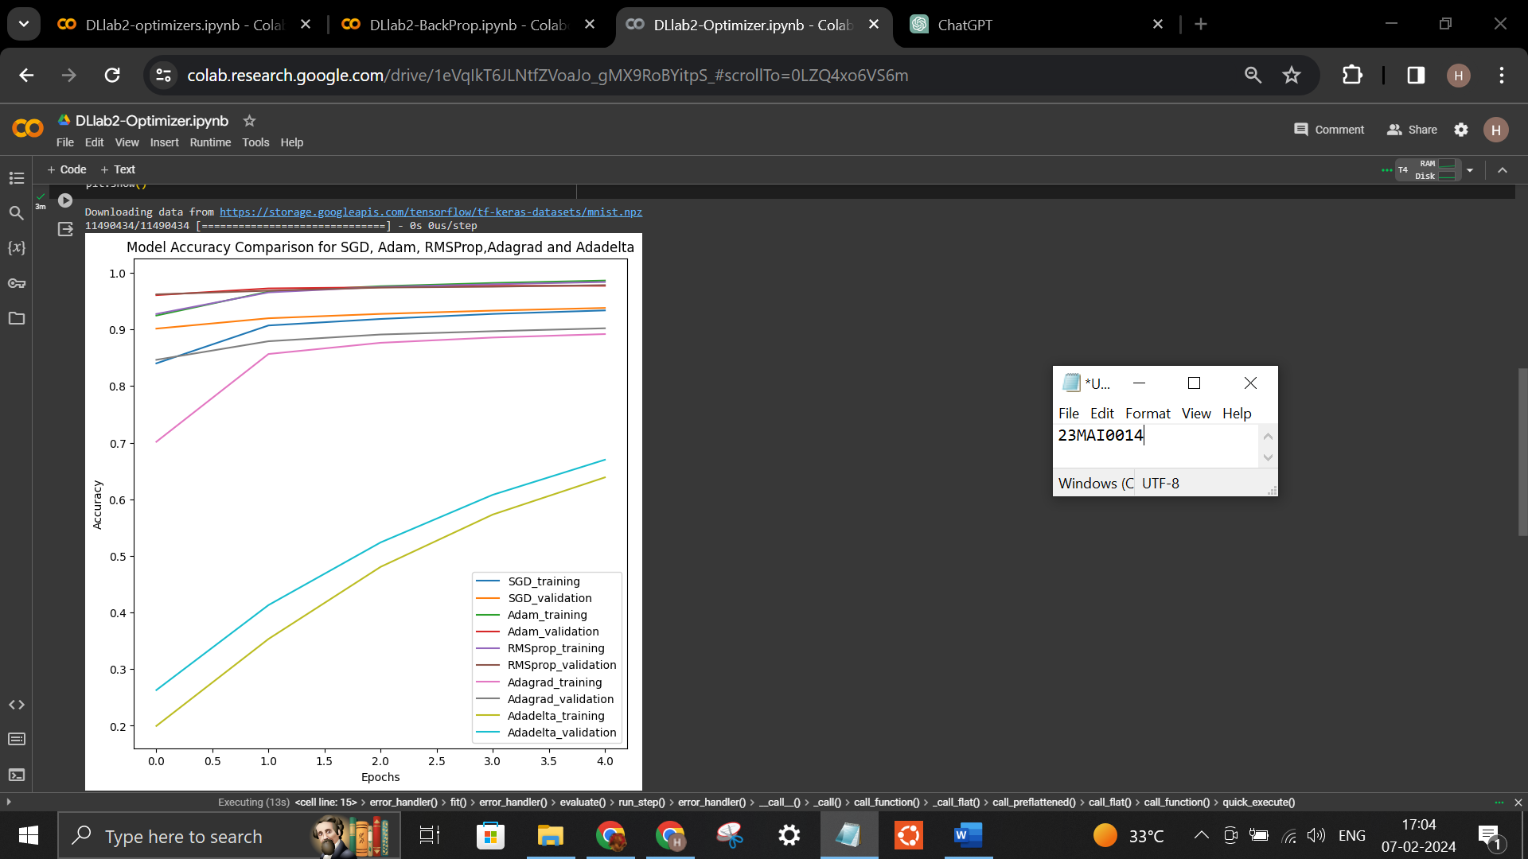

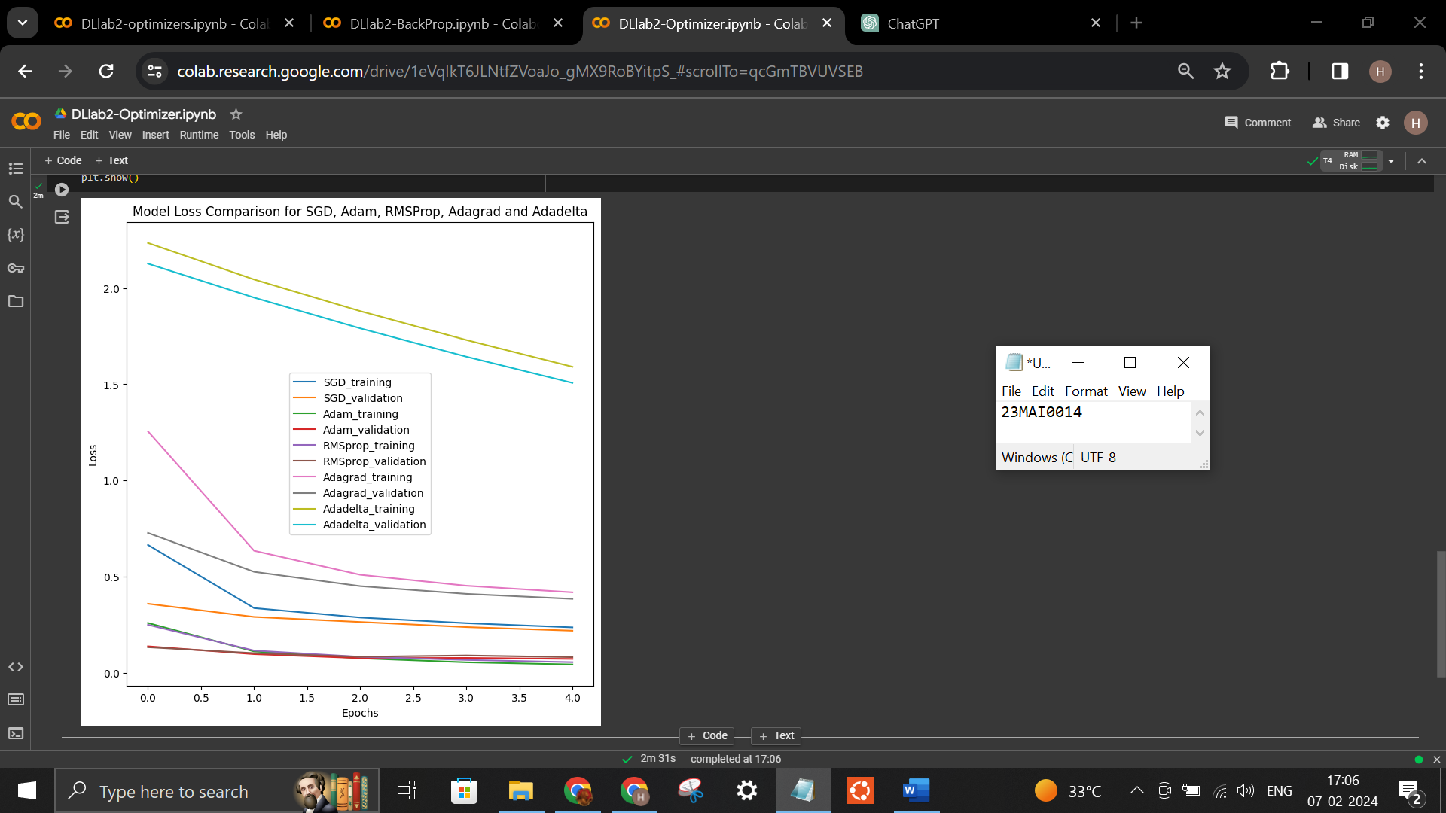

Dataset:
The MNIST dataset is a widely used benchmark dataset in the field of machine learning and computer vision. It consists of a large collection of handwritten digits, each digit being a grayscale image of size 28x28 pixels. The dataset is often used for training and testing machine learning models, particularly in the task of digit classification. The MNIST dataset contains 60,000 training images and 10,000 testing images, each labeled with the corresponding digit from 0 to 9.

Google Colab Link:
https://colab.research.google.com/drive/1eVqIkT6JLNtfZVoaJo_gMX9RoBYitpS_#scrollTo=qcGmTBVUVSEB

Conclusion:
The model accuracy using Adam was high. But from the accuracy plot we can see that RMSprop is able to achieve good accuracy in the early epochs. The best optimizer ultimately depends on your specific scenario and requirements. It's often recommended to experiment with multiple optimizers and hyperparameters to find the best combination for your particular problem. In summary, Adam and RMSprop optimization algorithms outperform others on the MNIST dataset due to their adaptive learning rates, momentum, and efficient parameter update mechanisms. These algorithms effectively navigate the parameter space, handle sparse gradients, and accelerate convergence, resulting in superior accuracy and loss compared to other optimization algorithms.

Exercise – 2
Back Propagation Algorithm
Backpropagation is the essence of neural network training. It is the method of fine-tuning the weights of a neural network based on the error rate obtained in the previous epoch (i.e., iteration). Proper tuning of the weights allows you to reduce error rates and make the model reliable by increasing its generalization. Backpropagation in neural network is a short form for “backward propagation of errors.”

Backpropagation Algorithm Working:
The Back propagation algorithm in neural network computes the gradient of the loss function for a single weight by the chain rule. It efficiently computes one layer at a time, unlike a native direct computation. It computes the gradient, but it does not define how the gradient is used. It generalizes the computation in the delta rule.
Initially weights are randomly selected and output for every neuron is calculated at each layer. The error in the outputs is calculated and propagated back from the output layer to the hidden layer to adjust the weights such that the error is decreased. Keep repeating the process until the desired output is achieved

Advantages of Backpropagation:
- Backpropagation is fast, simple and easy to program
- It has no parameters to tune apart from the numbers of input
- It is a flexible method as it does not require prior knowledge about the network
- It is a standard method that generally works well
- It does not need any special mention of the features of the function to be learned.

Types of Backpropagation Networks
- Static Back-propagation
- Recurrent Backpropagation

Static back-propagation
It is one kind of backpropagation network which produces a mapping of a static input for static output. It is useful to solve static classification issues like optical character recognition.

Recurrent Backpropagation
Recurrent Back propagation in data mining is fed forward until a fixed value is achieved. After that, the error is computed and propagated backward.
The main difference between both of these methods is: that the mapping is rapid in static back-propagation while it is nonstatic in recurrent backpropagation.

Backpropagation Key Points
- Simplifies the network structure by elements weighted links that have the least effect on the trained network

- It helps to assess the impact that a given input variable has on a network output. The knowledge gained from this analysis should be represented in rules.
- Backpropagation is especially useful for deep neural networks working on error-prone projects, such as image or speech recognition.
- Backpropagation takes advantage of the chain and power rules allows backpropagation to function with any number of outputs.

Disadvantages of using Backpropagation
- The actual performance of backpropagation on a specific problem is dependent on the input data.
- Back propagation algorithm in data mining can be quite sensitive to noisy data
- You need to use the matrix-based approach for backpropagation instead of mini-batch.
Code:
import matplotlib.pyplot as plt
import sklearn
import sklearn.datasets
import pandas as pd
import numpy as np
import math
%matplotlib inline
def sigmoid(x):
s = np.zeros((1, len(x[0])))
for i in range(0, len(x[0])):
s[0, i] = 1 / (1 + math.exp(-x[0, i]))
return s

def hard_threshold(x):
ot = 0
if x < 0.5:
ot = 0
else:
ot = 1
return ot

def feedforward(W1, W2, b1, b2, Xvec):
out = np.zeros((len(Xvec), 1))
for i in range(0, len(Xvec)):
z1 = Xvec[i].dot(W1) + b1
a2 = sigmoid(z1)
z2 = a2.dot(W2) + b2
a3 = sigmoid(z2)
out[i] = hard_threshold(a3)
return out

def train_test_model(trainSet, testSet, trainSetout, testSetout):
np.random.seed(100)
print("Setting initial values for weights to small random value")
W1 = np.random.random((2, 3)) / 1000
W2 = np.random.random((3, 1)) / 1000
print("W1= ", W1)
print("W2= ", W2)
print("\n")
b1 = np.zeros((1, 3))
b2 = np.zeros((1, 1))
ErrorData = np.zeros((320, 1))

print("Starting to train the model with the training set (80% data)")
for epoch in range(0, 320):
total_error = 0
for k in range(0, len(trainSet)):
for i in range(0, 1500):
z1 = trainSet[k].dot(W1) + b1
a2 = sigmoid(z1)
z2 = a2.dot(W2) + b2
a3 = sigmoid(z2)
alpha = 0.01

f_z3 = a3 * (1 - a3)
Err3 = trainSetout[k] - a3
delta3 = f_z3 * Err3

for j in range(0, len(W2)):
W2[j, 0] = W2[j, 0] + alpha * a2[0, j] * delta3

b2 = b2 + alpha * delta3

f_z2 = a2 * (1 - a2)
delta1_2 = f_z2[0, 0] * W2[0, 0] * delta3
delta2_2 = f_z2[0, 1] * W2[1, 0] * delta3
delta3_2 = f_z2[0, 2] * W2[2, 0] * delta3

W1[0, 0] = W1[0, 0] + alpha * trainSet[k, 0] * delta1_2
W1[0, 1] = W1[0, 1] + alpha * trainSet[k, 0] * delta2_2

total_error += np.abs(Err3)

# Update ErrorData with the average error for the epoch
ErrorData[epoch] = total_error / (len(trainSet) * 1500)

# Plot the training error over epochs
plt.plot(ErrorData)
plt.xlabel('Epochs')
plt.ylabel('Training Error')
plt.title('Training Error Over Epochs')
plt.show()

return W1, W2, b1, b2

# Example usage:
# Define your training and testing datasets
trainSet = np.array([[1, 0], [0, 1], [1, 1], [0, 0]]) # Example training data
testSet = np.array([[1, 0], [0, 1]]) # Example testing data
trainSetout = np.array([[1], [1], [0], [0]]) # Example training labels
testSetout = np.array([[1], [0]]) # Example testing labels

# Call the train_test_model function
W1, W2, b1, b2 = train_test_model(trainSet, testSet, trainSetout, testSetout)
def train_test_model(trainSet, testSet, trainSetout, testSetout):
np.random.seed(100)
print("Setting initial values for weights to small random value")
W1 = np.random.random((2, 3)) / 1000
W2 = np.random.random((3, 1)) / 1000
print("W1= ", W1)
print("W2= ", W2)
print("\n")
b1 = np.zeros((1, 3))
b2 = np.zeros((1, 1))
ErrorData = np.zeros((320, 1))
AccuracyData = np.zeros((320, 1)) # Array to store accuracy over epochs

print("Starting to train the model with the training set (80% data)")
for epoch in range(0, 320):
total_error = 0
correct_predictions = 0 # Initialize correct predictions counter
for k in range(0, len(trainSet)):
for i in range(0, 1500):
z1 = trainSet[k].dot(W1) + b1
a2 = sigmoid(z1)
z2 = a2.dot(W2) + b2
a3 = sigmoid(z2)
alpha = 0.01

f_z3 = a3 * (1 - a3)
Err3 = trainSetout[k] - a3
delta3 = f_z3 * Err3

for j in range(0, len(W2)):
W2[j, 0] = W2[j, 0] + alpha * a2[0, j] * delta3

b2 = b2 + alpha * delta3

f_z2 = a2 * (1 - a2)
delta1_2 = f_z2[0, 0] * W2[0, 0] * delta3
delta2_2 = f_z2[0, 1] * W2[1, 0] * delta3
delta3_2 = f_z2[0, 2] * W2[2, 0] * delta3

W1[0, 0] = W1[0, 0] + alpha * trainSet[k, 0] * delta1_2
W1[0, 1] = W1[0, 1] + alpha * trainSet[k, 0] * delta2_2
total_error += np.abs(Err3)

# Check if prediction matches the ground truth
if hard_threshold(a3) == trainSetout[k]:
correct_predictions += 1

# Update ErrorData and AccuracyData for the epoch
ErrorData[epoch] = total_error / (len(trainSet) * 1500)
AccuracyData[epoch] = correct_predictions / (len(trainSet) * 1500)

# Plot the training accuracy over epochs
plt.plot(AccuracyData)
plt.xlabel('Epochs')
plt.ylabel('Training Accuracy')
plt.title('Training Accuracy Over Epochs')
plt.show()

return W1, W2, b1, b2

# Example usage:Define your training and testing datasets
trainSet = np.array([[1, 0], [0, 1], [1, 1], [0, 0]]) # Example training data
testSet = np.array([[1, 0], [0, 1]]) # Example testing data
trainSetout = np.array([[1], [1], [0], [0]]) # Example training labels
testSetout = np.array([[1], [0]]) # Example testing labels
# Call the train_test_model function
W1, W2, b1, b2 = train_test_model(trainSet, testSet, trainSetout, testSetout)

Output:
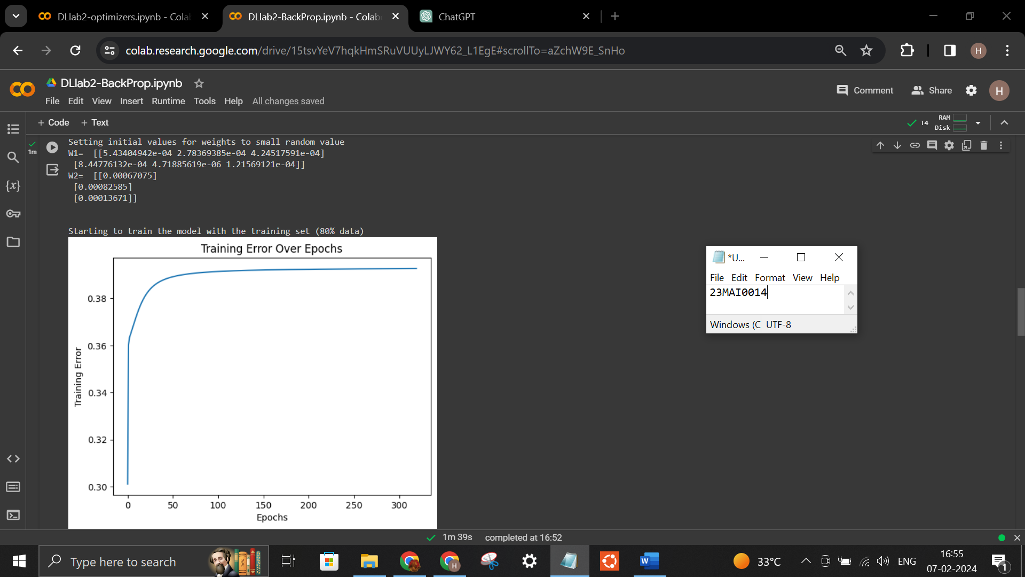
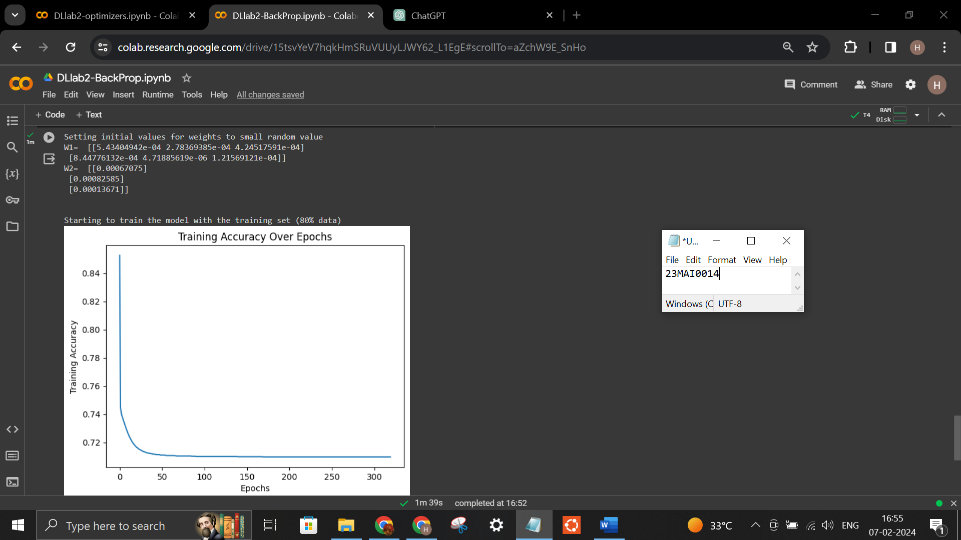

Google Colab Link:
https://colab.research.google.com/drive/15tsvYeV7hqkHmSRuVUUyLJWY62_L1EgE?usp=sharing

Conclusion:
In conclusion, backpropagation is a core algorithm in training neural networks, enabling efficient optimization by iteratively propagating errors backward through the network to update model parameters. Its ability to compute gradients of the loss function with respect to each parameter allows for effective learning and optimization, leading to improved model performance across various tasks in machine learning and artificial intelligence.

