

Deep Learning Laboratory - MCSE603P
Reg No. : 23MAI0014
Name : Harini K
Slot : L47+48
Faculty : Dr.Anil Kumar K
College : Vellore Institute of Technology
Department : SCOPE
Assignment : 3
Experiment : Convolutional Neural Network

Digital Assignment – 3

Convolutional Neural Network
A Convolutional Neural Network (CNN) is a type of deep neural network commonly used for analyzing visual imagery. CNNs are specifically designed to process data in the form of multiple arrays, such as a color image represented as a 3D array of pixel intensities.

Here's a brief overview of the key concepts of CNNs:
Convolutional Layers: These layers consist of filters (also called kernels) that slide over the input data and perform element-wise multiplication and summation operations. The output of this operation is called a feature map. Convolutional layers capture local patterns and spatial hierarchies in the input data.
Pooling Layers: Pooling layers reduce the spatial dimensions of the feature maps generated by convolutional layers by summarizing the presence of features in small regions. Max pooling and average pooling are common pooling operations used to downsample the feature maps.
Activation Functions: Non-linear activation functions, such as ReLU (Rectified Linear Unit), are applied after convolutional and pooling layers to introduce non-linearity into the network and enable it to learn complex patterns.
Fully Connected Layers: These layers are typically placed at the end of the CNN and are responsible for combining the features learned by the convolutional layers into high-level representations. They connect every neuron in one layer to every neuron in the next layer.
Flattening: Before passing the output of convolutional and pooling layers to fully connected layers, the feature maps are flattened into a 1D vector. This operation transforms the spatial information into a format suitable for input to the fully connected layers.
Dropout: Dropout is a regularization technique used to prevent overfitting by randomly setting a fraction of the input units to zero during training. This helps the model generalize better to unseen data.
CNNs have been highly successful in various computer vision tasks, such as image classification, object detection, and image segmentation, due to their ability to automatically learn hierarchical representations of visual data. They have become a fundamental building block in many state-of-the-art deep learning architectures for image-related tasks.

In this exercise, we are trying to build a CNN model to classify images from CIFAR100 Dataset.
CIFAR100 Dataset
The CIFAR-100 dataset consists of 60000 32x32 colour images in 100 classes, with 600 images per class. The 100 classes in the CIFAR-100 are grouped into 20 superclasses. Each image comes with a "fine" label (the class to which it belongs) and a "coarse" label (the superclass to which it belongs). There are 50000 training images and 10000 test images.
The meta file contains the label names of each class and superclass.
Here is the list of the 100 classes in the CIFAR-100:
Classes:
1-5) beaver, dolphin, otter, seal, whale
6-10) aquarium fish, flatfish, ray, shark, trout
11-15) orchids, poppies, roses, sunflowers, tulips
16-20) bottles, bowls, cans, cups, plates
21-25) apples, mushrooms, oranges, pears, sweet peppers
26-30) clock, computer keyboard, lamp, telephone, television
31-35) bed, chair, couch, table, wardrobe
36-40) bee, beetle, butterfly, caterpillar, cockroach
41-45) bear, leopard, lion, tiger, wolf
46-50) bridge, castle, house, road, skyscraper
51-55) cloud, forest, mountain, plain, sea
56-60) camel, cattle, chimpanzee, elephant, kangaroo
61-65) fox, porcupine, possum, raccoon, skunk
66-70) crab, lobster, snail, spider, worm
71-75) baby, boy, girl, man, woman
76-80) crocodile, dinosaur, lizard, snake, turtle
81-85) hamster, mouse, rabbit, shrew, squirrel
86-90) maple, oak, palm, pine, willow
91-95) bicycle, bus, motorcycle, pickup truck, train
96-100) lawn-mower, rocket, streetcar, tank, tractor
and the list of the 20 superclasses:
1) aquatic mammals (classes 1-5)
2) fish (classes 6-10)
3) flowers (classes 11-15)
4) food containers (classes 16-20)
5) fruit and vegetables (classes 21-25)
6) household electrical devices (classes 26-30)
7) household furniture (classes 31-35)
8) insects (classes 36-40)
9) large carnivores (classes 41-45)
10) large man-made outdoor things (classes 46-50)
11) large natural outdoor scenes (classes 51-55)
12) large omnivores and herbivores (classes 56-60)
13) medium-sized mammals (classes 61-65)
14) non-insect invertebrates (classes 66-70)
15) people (classes 71-75)
16) reptiles (classes 76-80)
17) small mammals (classes 81-85)
18) trees (classes 86-90)
19) vehicles 1 (classes 91-95)
20) vehicles 2 (classes 96-100)

Model Overview
Importing Libraries: Import necessary libraries such as TensorFlow, NumPy, and Keras modules for building and training the CNN model.
Loading CIFAR-100 Dataset: Load the CIFAR-100 dataset using the datasets.cifar100.load_data() function provided by TensorFlow.
Normalization: Normalize pixel values of the images to be between 0 and 1 by dividing by 255.0.
One-Hot Encoding: Convert class vectors to binary class matrices (one-hot encoding) using tf.keras.utils.to_categorical. This step is necessary for categorical classification tasks.
Defining the CNN Architecture: Define the CNN model using the Sequential API provided by Keras. This model consists of multiple convolutional blocks followed by fully connected layers.
Convolutional Blocks: Define convolutional blocks consisting of Conv2D layers with BatchNormalization, ReLU activation functions, MaxPooling layers, and Dropout layers. These blocks help the model learn hierarchical features from the input images. In our model we have used 1 input layer, 3 convolutional blocks and 1 output layer as follows:
- Input Layer: (1st Conv Block)
- The input layer is defined using layers.Conv2D with 32 filters and a kernel size of (3, 3).
- The padding parameter is set to 'same', which pads the input such that the output has the same length as the original input.
- The input_shape parameter is set to (32, 32, 3), indicating that the input images are 32x32 pixels with 3 channels (RGB).
- Conv2D is followed by Batch Normalization, and again Conv2D with 32 filters of kernel size (3,3) here relu activation is used and another Batch Normalization and finally a max pooling block of size (2,2) and dropout of 0.2
- Hidden Layer: (2nd Conv Block)
Conv2D with 64 filters with kernel size (3,3) with relu activation
Batch Normalization
Conv2D with 64 filters of kernel size (3,3) with relu activation
Batch Normalization
Max pooling block of size (2,2)
Dropout of 0.3
- Hidden Layer: (3rd Conv Block)
Conv2D with 128 filters with kernel size (3,3) with relu activation
Batch Normalization
Conv2D with 128 filters of kernel size (3,3) with relu activation
Batch Normalization
Max pooling block of size (2,2)
Dropout of 0.4

- Flatten dense layer with 128 neurons using relu activation followed by Batch Normalization and Dropout of 0.5
- Output dense layer – fully connected layer with 100 neurons – representing number of classes in dataset, here softmax activation is used for multiclass classification.
Flattening and Dense Layers: Flatten the output from the convolutional layers into a 1D vector and add fully connected dense layers to classify the input images into 100 different classes using softmax activation.
Compiling the Model: Compile the model using the Adam optimizer, categorical cross-entropy loss function, and accuracy metric.
Data Augmentation: Create an instance of the ImageDataGenerator class from preprocessing.image module to perform data augmentation. Data augmentation helps prevent overfitting by applying random transformations to the training images such as rotation, width and height shifts, horizontal flips, and zoom.
Training the Model: Train the model using the fit method with data generated by the ImageDataGenerator instance. This allows the model to train on augmented data in batches. Specify the batch size, number of epochs, training data, validation data, and verbosity level.
Model Evaluation: Evaluate the trained model on the test data using the evaluate method to calculate the test loss and test accuracy.
Printing Test Results: Print the test accuracy and test loss obtained by the model. Plot the Accuracy vs Epoch graph and Loss vs Epoch Graph.

Code
from tensorflow.keras.preprocessing.image import ImageDataGenerator
from tensorflow.keras import layers, models, optimizers
from tensorflow.keras.utils import to_categorical
import numpy as np
import tensorflow as tf
from tensorflow.keras import datasets, layers, models, preprocessing

# Load the CIFAR-100 dataset
(train_images, train_labels), (test_images, test_labels) = datasets.cifar100.load_data()
#Normalize pixel values to be between 0 and 1 I
train_images, test_images = train_images/255.0, test_images/255.0

# Convert class vectors to binary class matrices (one-hot encoding)
train_labels = tf.keras.utils.to_categorical(train_labels, 100)
test_labels = tf.keras.utils.to_categorical(test_labels, 100)

# Define the CNN architecture
model = models.Sequential()

#First convolutional block with 32 filters

model.add(layers.Conv2D(32, (3, 3), padding='same', input_shape=(32,32,3)))
model.add(layers.BatchNormalization())
model.add(layers.Conv2D(32, (3, 3), activation='relu'))
model.add(layers.BatchNormalization())
model.add(layers.MaxPooling2D(pool_size=(2, 2)))
model.add(layers.Dropout(0.2))

#Second convolutional block with 64 filters
model.add(layers.Conv2D(64, (3, 3), padding='same', activation='relu'))
model.add(layers.BatchNormalization())
model.add(layers.Conv2D(64, (3, 3), activation='relu'))
model.add(layers.BatchNormalization())
model.add(layers.MaxPooling2D(pool_size=(2, 2)))
model.add(layers.Dropout(0.3))

#Third convolutional block with 128 filters
model.add(layers.Conv2D(128, (3, 3), padding='same', activation='relu'))
model.add(layers.BatchNormalization())
model.add(layers.Conv2D(128, (3, 3), padding='same', activation='relu'))
model.add(layers.BatchNormalization())
model.add(layers.MaxPooling2D(pool_size=(2, 2)))
model.add(layers.Dropout(0.4))

#Flatten the output from 3D to 100 and add a dense layer

model.add(layers.Flatten())
model.add(layers.Dense(128, activation='relu'))
model.add(layers.BatchNormalization())
model.add(layers.Dropout(0.5))

# Output layer with 100 units (one per class) with a softmax activation
model.add(layers.Dense(100, activation='softmax'))

# Compile the model
model.compile(optimizer='adam', loss='categorical_crossentropy', metrics=['accuracy'])

#Data augmentation to prevent overfitting
datagen = preprocessing.image.ImageDataGenerator(
rotation_range=15,
width_shift_range=0.1,
height_shift_range=0.1,
horizontal_flip=True,
zoom_range=0.2
)

#Train the model
batch_size = 64
epochs = 100
history = model.fit(datagen.flow(train_images,train_labels, batch_size=batch_size),
epochs=epochs,
validation_data=(test_images, test_labels),
verbose=2)
#Evaluate the model
test_loss, test_acc = model.evaluate(test_images, test_labels, verbose=2)
print(f'Test accuracy: {test_acc}, Test loss: {test_loss}')
import matplotlib.pyplot as plt

# Plot training & validation accuracy values
plt.plot(history.history['accuracy'], color = 'green', linewidth=2, linestyle='-')
plt.plot(history.history['val_accuracy'], color = 'orange', linewidth=2, linestyle='-')
plt.title('Model accuracy')
plt.ylabel('Accuracy')
plt.xlabel('Epoch')
plt.legend(['Train', 'Validation'], loc='upper left')
plt.show()
# Plot training & validation loss values
plt.plot(history.history['loss'], color = 'green', linewidth=2, linestyle='-')
plt.plot(history.history['val_loss'], color = 'orange', linewidth=2, linestyle='-')
plt.title('Model loss')
plt.ylabel('Loss')
plt.xlabel('Epoch')
plt.legend(['Train', 'Validation'], loc='upper left')
plt.show()

Output
CIFAR100 Dataset
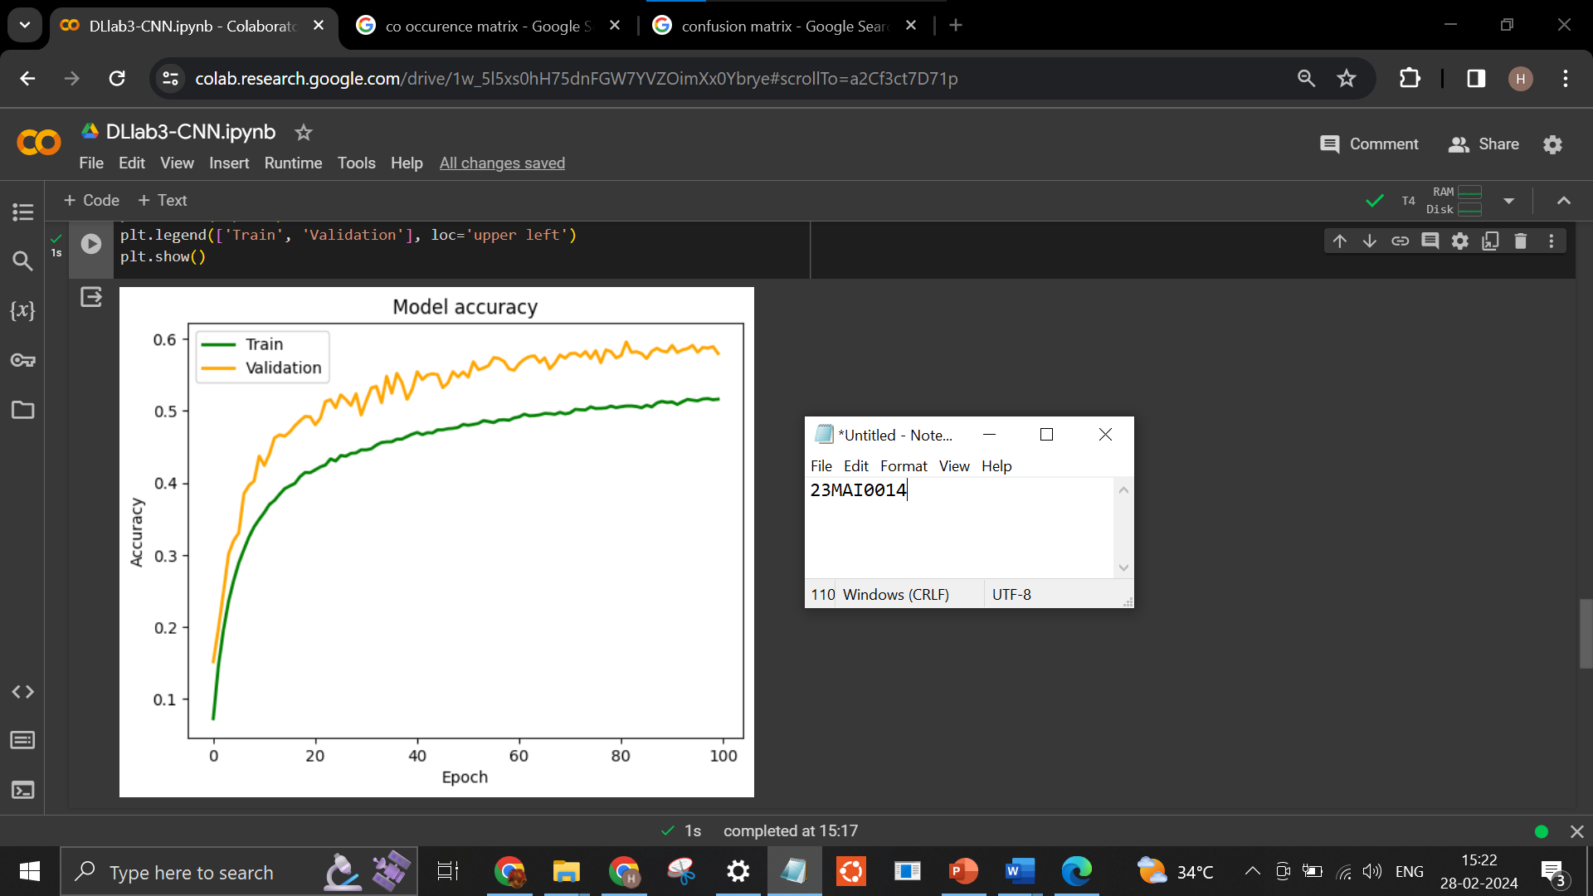

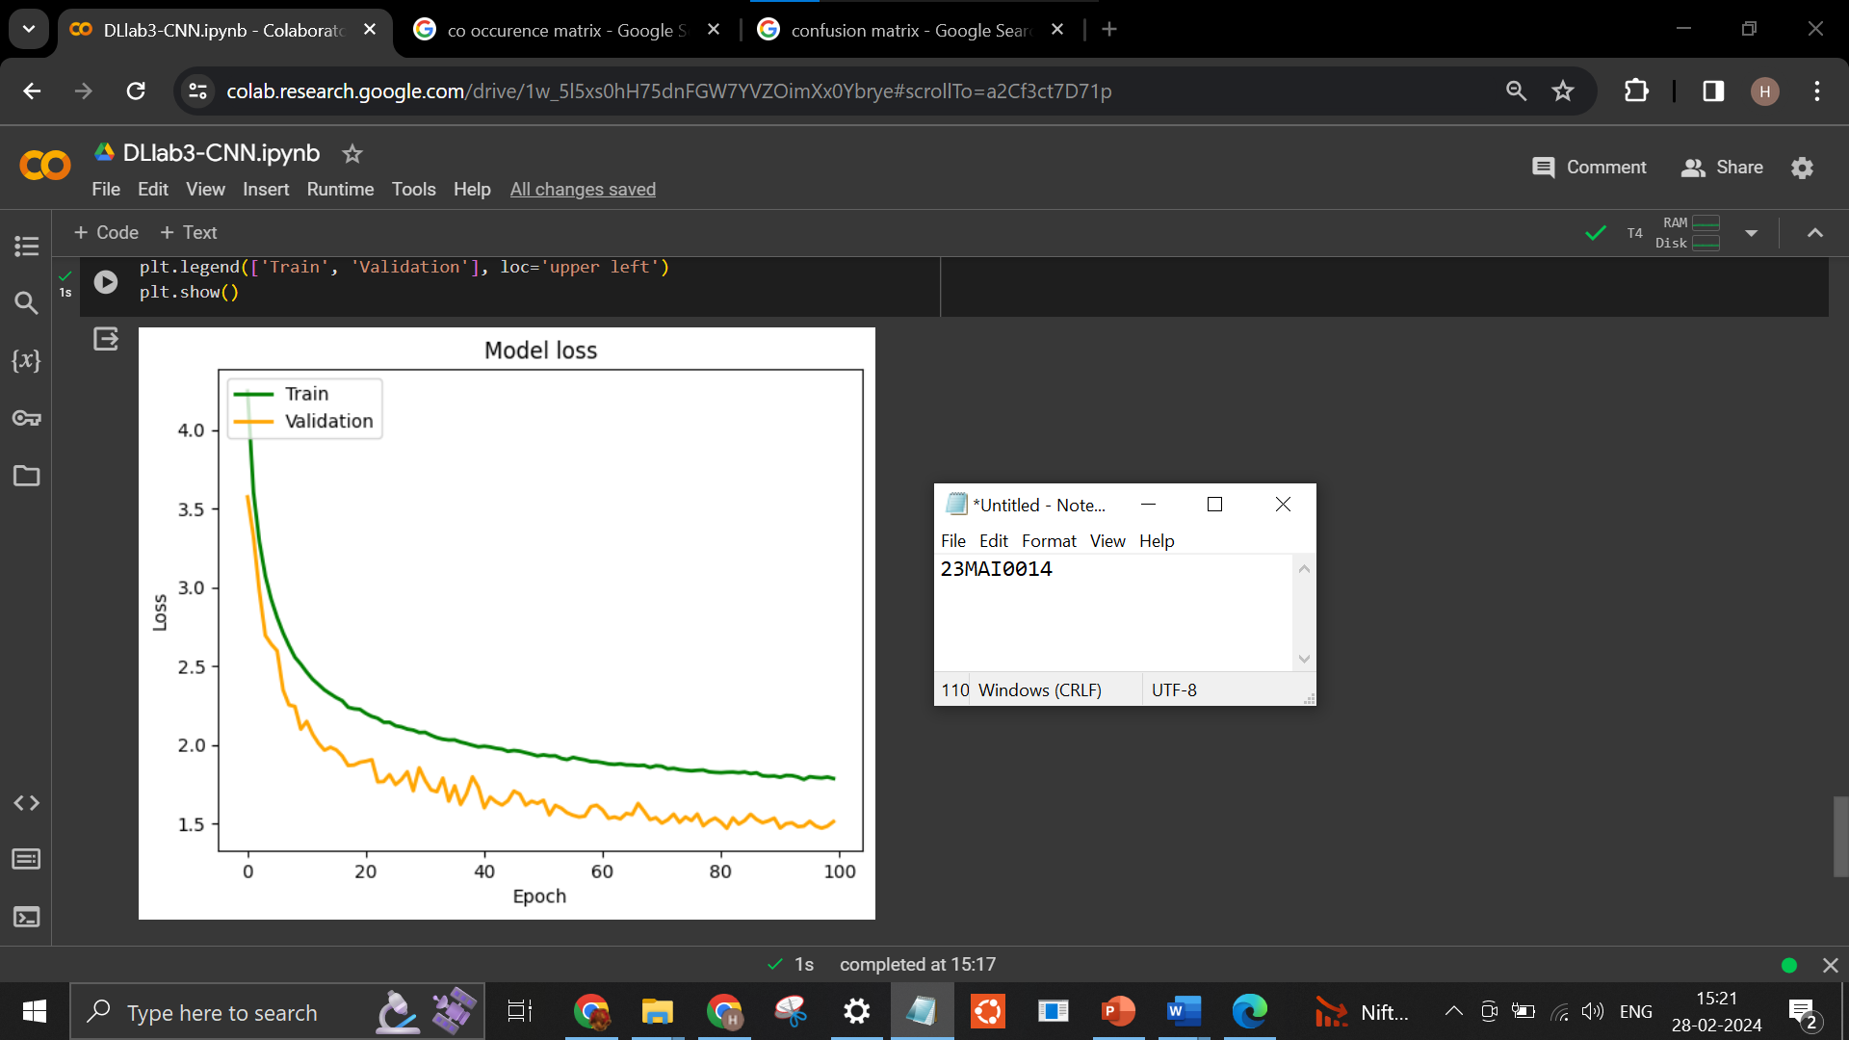

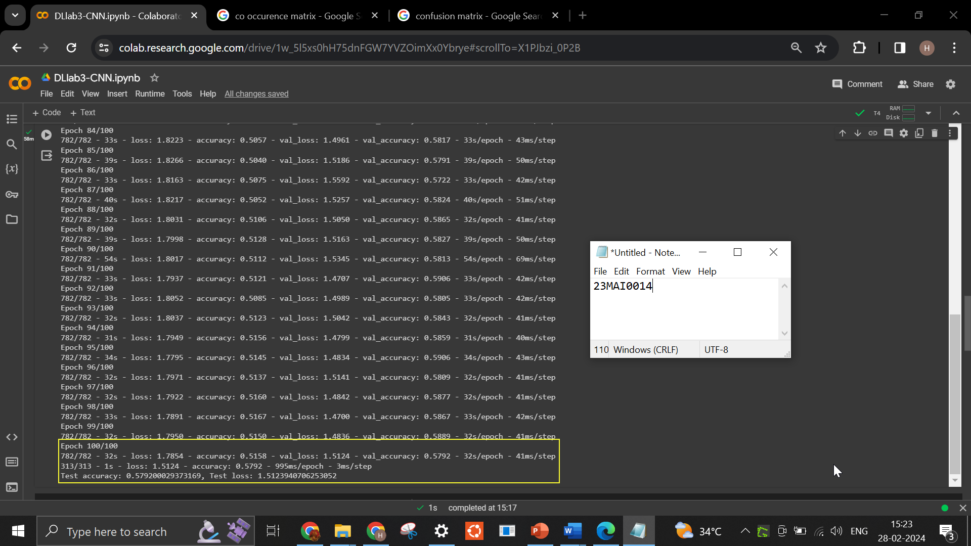

Output for CIFAR10 Dataset – 10 classes
CIFAR-10 is an established computer-vision dataset used for object recognition. It is a subset of the 80 million tiny images dataset and consists of 60,000 32x32 color images containing one of 10 object classes, with 6000 images per class. It was collected by Alex Krizhevsky, Vinod Nair, and Geoffrey Hinton. Classes - airplane, automobile, bird, cat, deer, dog, frog, horse, ship, truck.
Epochs used = 50
Batch Size = 64
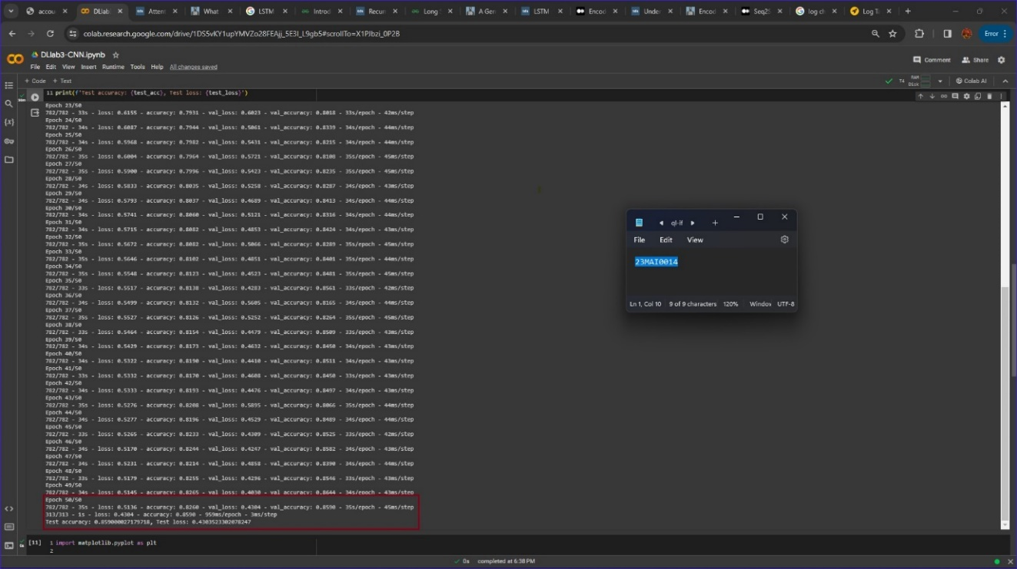

Obtained results:
training loss - 0.5136
training accuracy = 0.8260

validation loss = 0.4304
validation accuracy = 0.8590

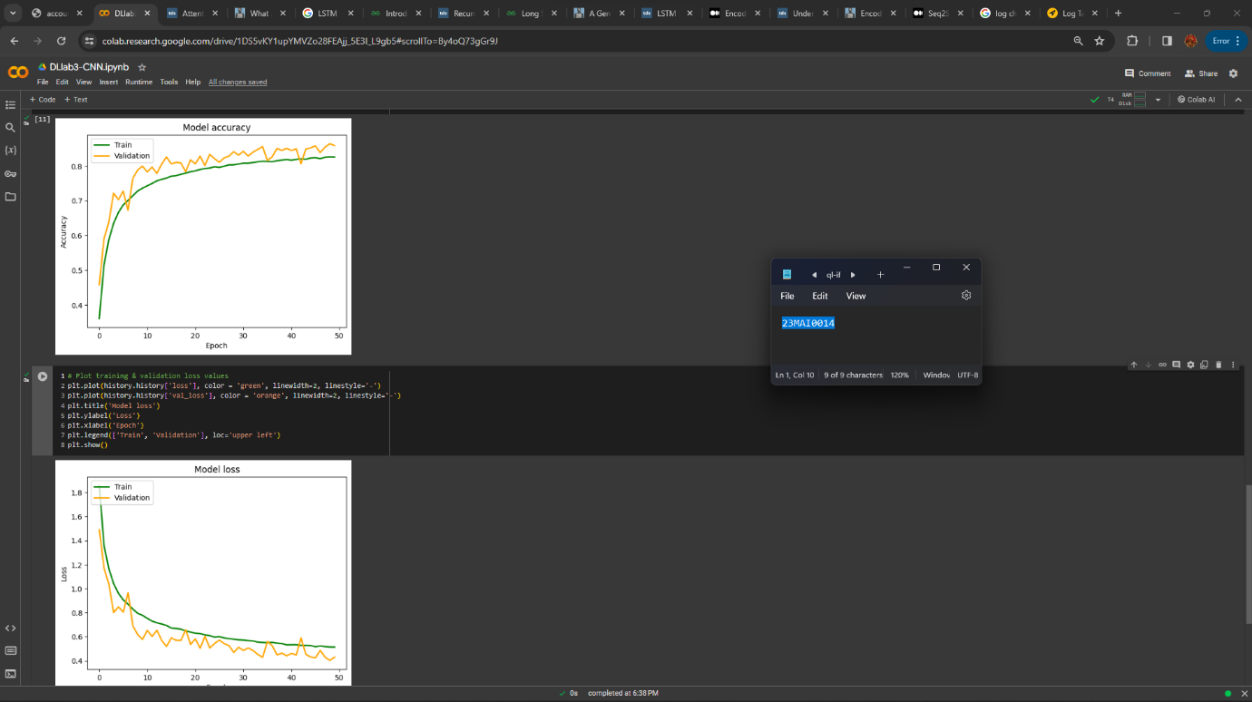

Google Colab Link
https://colab.research.google.com/drive/1w_5l5xs0hH75dnFGW7YVZOimXx0Ybrye?usp=sharing

Conclusion
Training the proposed model for 100 epochs with 64 batch size on CIFAR100 Dataset, an accuracy of 0.5158 i.e., 51.58% and loss of 1.7854 is observed on training data split and on test data split, validation accurracy of 0.5792 (57.92%) and validation loss of 1.5124 is observed. By changing the number of epochs, batch size and other model parameters in hidden layer like number of convolution filters, dropout, etc., model performance can be further improved.

