

Deep Learning Laboratory - MCSE603P
Reg No. : 23MAI0014
Name : Harini K
Slot : L47+48
Faculty : Dr.Anil Kumar K
College : Vellore Institute of Technology
Department : SCOPE
Assignment : 4
Experiment : AlexNet

Digital Assignment – 4

AlexNet
Context and Significance
- Developed By: Alex Krizhevsky, Ilya Sutskever, and Geoffrey Hinton.
- Year Introduced: 2012.
- Key Achievement: Won the ImageNet Large Scale Visual Recognition Challenge (ILSVRC) in 2012 by a significant margin.
- Impact: Marked the resurgence of neural networks, particularly deep convolutional neural networks (CNNs), in computer vision.

Architecture
- Type: Deep Convolutional Neural Network.
- Layers: Composed of five convolutional layers followed by three fully connected layers.
- Activation Functions: Utilized the Rectified Linear Unit (ReLU) activation function, which helped the network train faster and more effectively by mitigating the vanishing gradient problem.
- Input Size: Accepts an input image of size 224 x 224 x 3 (width x height x color channels).

Key Features
- GPU Training: One of the first models to use CUDA on GPUs (NVIDIA GTX 580) for training, which significantly sped up the learning process. The network was split across two GPUs due to memory constraints.
- Local Response Normalization: Used after the first and second convolutional layers, a technique that encourages lateral inhibition and was believed to improve generalization.
- Overlapping Pooling: Applied max pooling with overlapping windows, which helped reduce the network's size and overfitting.
- Data Augmentation: Implemented to prevent overfitting by artificially increasing the size of the training dataset through transformations such as image translations, horizontal reflections, and patch extractions.
- Dropout: A regularization technique used in the first two fully connected layers, where during training, units are randomly "dropped" along with their connections. This helps prevent co-adaptation of features.
- Pooling Layers: Max-pooling layers are used to downsample feature maps, reducing the spatial dimensions of the input, and extracting the most important features.

Network Details
Convolutional Layers:
- The first layer filters the 224x224x3 input image with 96 kernels of size 11x11x3 with a stride of 4 pixels.
- The second layer takes the output of the first layer and filters it with 256 kernels of size 5x5x48.
- The third, fourth, and fifth layers are connected without any intervening pooling or normalization layers.
- The third layer has 384 kernels of size 3x3x256 connected to the outputs of the second layer.
- The fourth layer has 384 kernels of size 3x3x192, and the fifth layer has 256 kernels of size 3x3x192.

Fully Connected Layers:
- The first two fully connected layers have 4096 neurons each.
- The final fully connected layer has 1000 neurons, one for each class in the ImageNet challenge.

Training
- Initialization: Weights were initialized with a small amount of noise for symmetry breaking, and the biases were initialized to a small constant value.
- Optimization: Stochastic Gradient Descent (SGD) with momentum was used for training, with a batch size of 128 examples, momentum of 0.9, and weight decay of 0.0005.
- Learning Rate: Started with 0.01 and reduced by a factor of 10 manually when the validation error rate stopped improving.

Results
- AlexNet achieved a top-5 error rate of 15.3% on the ImageNet test set, which was significantly lower than the runner-up's error rate of 26.2% at the time. This performance showcased the potential of deep CNNs in computer vision tasks and triggered a wave of research into deep learning architectures.

AlexNet's architecture has been foundational for many subsequent CNN designs, and it remains an important reference point for understanding the development of CNNs in computer vision.

In this exercise, we are trying to build a AlexNet model to classify images from CIFAR10 Dataset and CIFAR100 Dataset.
CIFAR100 Dataset
The CIFAR-100 dataset consists of 60000 32x32 colour images in 100 classes, with 600 images per class. The 100 classes in the CIFAR-100 are grouped into 20 superclasses. Each image comes with a "fine" label (the class to which it belongs) and a "coarse" label (the superclass to which it belongs). There are 50000 training images and 10000 test images.
The meta file contains the label names of each class and superclass.
Here is the list of the 100 classes in the CIFAR-100:
Classes:
1-5) beaver, dolphin, otter, seal, whale
6-10) aquarium fish, flatfish, ray, shark, trout
11-15) orchids, poppies, roses, sunflowers, tulips
16-20) bottles, bowls, cans, cups, plates
21-25) apples, mushrooms, oranges, pears, sweet peppers
26-30) clock, computer keyboard, lamp, telephone, television
31-35) bed, chair, couch, table, wardrobe
36-40) bee, beetle, butterfly, caterpillar, cockroach
41-45) bear, leopard, lion, tiger, wolf
46-50) bridge, castle, house, road, skyscraper
51-55) cloud, forest, mountain, plain, sea
56-60) camel, cattle, chimpanzee, elephant, kangaroo
61-65) fox, porcupine, possum, raccoon, skunk
66-70) crab, lobster, snail, spider, worm
71-75) baby, boy, girl, man, woman
76-80) crocodile, dinosaur, lizard, snake, turtle
81-85) hamster, mouse, rabbit, shrew, squirrel
86-90) maple, oak, palm, pine, willow
91-95) bicycle, bus, motorcycle, pickup truck, train
96-100) lawn-mower, rocket, streetcar, tank, tractor
and the list of the 20 superclasses:
1) aquatic mammals (classes 1-5)
2) fish (classes 6-10)
3) flowers (classes 11-15)
4) food containers (classes 16-20)
5) fruit and vegetables (classes 21-25)
6) household electrical devices (classes 26-30)
7) household furniture (classes 31-35)
8) insects (classes 36-40)
9) large carnivores (classes 41-45)
10) large man-made outdoor things (classes 46-50)
11) large natural outdoor scenes (classes 51-55)
12) large omnivores and herbivores (classes 56-60)
13) medium-sized mammals (classes 61-65)
14) non-insect invertebrates (classes 66-70)
15) people (classes 71-75)
16) reptiles (classes 76-80)
17) small mammals (classes 81-85)
18) trees (classes 86-90)
19) vehicles 1 (classes 91-95)
20) vehicles 2 (classes 96-100)
CIFAR-10 is an established computer-vision dataset used for object recognition. It is a subset of the 80 million tiny images dataset and consists of 60,000 32x32 color images containing one of 10 object classes, with 6000 images per class. It was collected by Alex Krizhevsky, Vinod Nair, and Geoffrey Hinton. Classes - airplane, automobile, bird, cat, deer, dog, frog, horse, ship, truck.

Model/Code Overview
Imported Libraries:
- torch, torch.nn, torch.optim, torch.nn.functional: PyTorch libraries for tensors, neural network modules, optimization algorithms, and functional operations.
- torchvision: PyTorch's library for computer vision tasks, including datasets, models, and image transformations.
- numpy: Library for numerical computations in Python.
- matplotlib.pyplot: Library for creating plots and visualizations in Python.
Code Explanation:
Loading CIFAR-100 Dataset:
- train_dataset and test_dataset are created using torchvision's CIFAR100 dataset class. These datasets contain images and labels for training and testing.
- The transform=transforms.ToTensor() converts the images to PyTorch tensors.
- The download=True argument ensures that the datasets are downloaded if they are not already available locally.

Setting Data Loaders:
- train_loader and test_loader are created using torch.utils.data.DataLoader. These data loaders enable efficient loading of batches of data during training and testing.
- batch_size determines the number of samples in each batch.
- shuffle=True shuffles the data for each epoch during training to ensure randomness.
- num_workers=2 specifies the number of subprocesses used for data loading.
Displaying Sample Images:
- imshow function is defined to display images.
- The first batch of images from the training dataset is retrieved using iter(train_loader) and next(dataiter).
- torchvision.utils.make_grid is used to create a grid of images.
- imshow is called to display the grid of images.
Defining AlexNet Architecture:
- AlexNet class defines the architecture of the AlexNet neural network.
- It consists of convolutional layers followed by max-pooling layers, and then fully connected layers.
- ReLU activation function is used after each convolutional layer.
- Dropout layers are included to prevent overfitting.
- The forward method defines the forward pass through the network.
Convolutional Layers:
First Convolutional Layer:
- nn.Conv2d(3, 64, kernel_size=3, padding=1):
- Input channels: 3 (RGB channels)
- Output channels: 64 (number of filters)
- Kernel size: 3x3
- Padding: 1 (adds a border of zeros around the input tensor)
- The ReLU activation function is applied after this convolution.
Second Convolutional Layer:
- nn.Conv2d(64, 192, kernel_size=5, padding=2):
- Input channels: 64 (output channels from the previous layer)
- Output channels: 192
- Kernel size: 5x5
- Padding: 2
- The ReLU activation function is applied after this convolution.
Third Convolutional Layer:
- nn.Conv2d(192, 384, kernel_size=3, padding=1):
- Input channels: 192
- Output channels: 384
- Kernel size: 3x3

- Padding: 1
- The ReLU activation function is applied after this convolution.
Fourth Convolutional Layer:
- nn.Conv2d(384, 256, kernel_size=3, padding=1):
- Input channels: 384
- Output channels: 256
- Kernel size: 3x3
- Padding: 1
- The ReLU activation function is applied after this convolution.
Fifth Convolutional Layer:
- nn.Conv2d(256, 256, kernel_size=3, padding=1):
- Input channels: 256
- Output channels: 256
- Kernel size: 3x3
- Padding: 1
- The ReLU activation function is applied after this convolution.
Max Pooling Layers:
- nn.MaxPool2d(kernel_size=2, stride=2):
- Kernel size: 2x2
- Stride: 2 (how much the pooling window shifts during each step)
- These layers reduce the spatial dimensions of the feature maps by taking the maximum value within each pooling window.
Fully Connected Layers:
First Fully Connected Layer:
- nn.Linear(256 * 4 * 4, 4096):
- Input features: 256 * 4 * 4 (size of the flattened feature maps from the last convolutional layer)
- Output features: 4096
- The ReLU activation function is applied after this fully connected layer.
Second Fully Connected Layer:
- nn.Linear(4096, 4096):
- Input features: 4096
- Output features: 4096
- The ReLU activation function is applied after this fully connected layer.
Output Layer:
- nn.Linear(4096, num_classes):
- Input features: 4096
- Output features: Number of classes (specified by num_classes)

Instantiating the Model:
- An instance of AlexNet is created with the number of output classes (100 for CIFAR-100) and moved to the appropriate device (GPU if available, otherwise CPU).
Optimizing the Model:
- Cross-entropy loss is used as the loss function.
- Stochastic Gradient Descent (SGD) optimizer is used with a learning rate of 0.01, momentum of 0.9, and weight decay of 5e-4.
Training the Model:
- The model is trained for 30 epochs.
- Training and validation loss and accuracy are printed for each epoch.
- Lists are maintained to store the training and validation loss and accuracy for later visualization.

Code
import torch
import torchvision
import torch.nn as nn
import torch.nn.init as init
import torch.optim as optim
import torch.nn.functional as F
import torchvision.transforms as transforms
import numpy as np
from matplotlib import pyplot as plt
# load CIFA-10 data
train_dataset = torchvision.datasets.CIFAR100(
root='./data/',
train=True,
transform=transforms.ToTensor(),
download=True)

test_dataset = torchvision.datasets.CIFAR100(
root='./data/',
train=False,
transform=transforms.ToTensor(),
download=True)

print ('train_dataset = ', len(train_dataset))
print ('test_dataset = ', len(test_dataset))
image, label = train_dataset[0]
print (image.size())
# set data loader
train_loader = torch.utils.data.DataLoader(
dataset=train_dataset,
batch_size=64,
shuffle=True,
num_workers=2)

test_loader = torch.utils.data.DataLoader(
dataset=test_dataset,
batch_size=64,
shuffle=False,
num_workers=2)
import matplotlib.pyplot as plt
import numpy as np

classes = (
'plane', 'car', 'bird', 'cat', 'deer', 'dog', 'frog', 'horse', 'ship', 'truck',
'beaver', 'dolphin', 'otter', 'seal', 'whale', 'aquarium fish', 'flatfish', 'ray', 'shark', 'trout',
'orchids', 'poppies', 'roses', 'sunflowers', 'tulips', 'bottles', 'bowls', 'cans', 'cups', 'plates',
'apples', 'mushrooms', 'oranges', 'pears', 'sweet peppers', 'clock', 'computer keyboard', 'lamp', 'telephone', 'television',
'bed', 'chair', 'couch', 'table', 'wardrobe', 'bee', 'beetle', 'butterfly', 'caterpillar', 'cockroach',
'bear', 'leopard', 'lion', 'tiger', 'wolf', 'bridge', 'castle', 'house', 'road', 'skyscraper',
'cloud', 'forest', 'mountain', 'plain', 'sea', 'camel', 'cattle', 'chimpanzee', 'elephant', 'kangaroo',
'fox', 'porcupine', 'possum', 'raccoon', 'skunk', 'crab', 'lobster', 'snail', 'spider', 'worm',
'baby', 'boy', 'girl', 'man', 'woman', 'crocodile', 'dinosaur', 'lizard', 'snake', 'turtle',
'hamster', 'mouse', 'rabbit', 'shrew', 'squirrel', 'maple', 'oak', 'palm', 'pine', 'willow',
'bicycle', 'bus', 'motorcycle', 'pickup truck', 'train', 'lawn-mower', 'rocket', 'streetcar', 'tank', 'tractor'
)

# functions to show an image

def imshow(img):
img = img / 2 + 0.5 # unnormalize
npimg = img.numpy()
plt.imshow(np.transpose(npimg, (1, 2, 0)))
plt.show()

dataiter = iter(train_loader)
images, labels = next(dataiter)

# print images
imshow(torchvision.utils.make_grid(images))

# Alexnet
class AlexNet(nn.Module):

def __init__(self, num_classes):
super(AlexNet, self).__init__()
self.features = nn.Sequential(
nn.Conv2d(3, 64, kernel_size=3, padding=1),
nn.ReLU(inplace=True),
nn.MaxPool2d(kernel_size=2, stride=2),
nn.Conv2d(64, 192, kernel_size=5, padding=2),
nn.ReLU(inplace=True),
nn.MaxPool2d(kernel_size=2, stride=2),
nn.Conv2d(192, 384, kernel_size=3, padding=1),
nn.ReLU(inplace=True),
nn.Conv2d(384, 256, kernel_size=3, padding=1),
nn.ReLU(inplace=True),
nn.Conv2d(256, 256, kernel_size=3, padding=1),
nn.ReLU(inplace=True),
nn.MaxPool2d(kernel_size=2, stride=2),
)
self.classifier = nn.Sequential(
nn.Dropout(),
nn.Linear(256 * 4 * 4, 4096),
nn.ReLU(inplace=True),
nn.Dropout(),
nn.Linear(4096, 4096),
nn.ReLU(inplace=True),
nn.Linear(4096, num_classes),
)

def forward(self, x):
x = self.features(x)
x = x.view(x.size(0), 256 * 4 * 4)
x = self.classifier(x)
return x

# select device
num_classes = 100
device = 'cuda' if torch.cuda.is_available() else 'cpu'
net = AlexNet(num_classes).to(device)

# optimizing
criterion = nn.CrossEntropyLoss()
optimizer = optim.SGD(net.parameters(), lr=0.01, momentum=0.9, weight_decay=5e-4)
# training
num_epochs = 20
train_loss_list, train_acc_list, val_loss_list, val_acc_list = [], [], [], []

### training
for epoch in range(num_epochs):
train_loss, train_acc, val_loss, val_acc = 0, 0, 0, 0

# ====== train_mode ======
net.train()
for i, (images, labels) in enumerate(train_loader):
images, labels = images.to(device), labels.to(device)
optimizer.zero_grad()
outputs = net(images)
loss = criterion(outputs, labels)
train_loss += loss.item()
train_acc += (outputs.max(1)[1] == labels).sum().item()
loss.backward()
optimizer.step()

avg_train_loss = train_loss / len(train_loader.dataset)
avg_train_acc = train_acc / len(train_loader.dataset)

# ====== val_mode ======
net.eval()
with torch.no_grad():
for images, labels in test_loader:
images = images.to(device)
labels = labels.to(device)
outputs = net(images)
loss = criterion(outputs, labels)
val_loss += loss.item()
val_acc += (outputs.max(1)[1] == labels).sum().item()
avg_val_loss = val_loss / len(test_loader.dataset)
avg_val_acc = val_acc / len(test_loader.dataset)

print ('Epoch [{}/{}], Loss: {:.4f}, Acc: {:.4f}, val_loss: {:.4f}, val_acc: {:.4f}'
.format(epoch+1, num_epochs, avg_train_loss, avg_train_acc, avg_val_loss, avg_val_acc))
train_loss_list.append(avg_train_loss)
train_acc_list.append(avg_train_acc)
val_loss_list.append(avg_val_loss)
val_acc_list.append(avg_val_acc)

print("Training finished.")
print(f"Training Loss: {train_loss_list[-1]:.4f}")
print(f"Training Accuracy: {train_acc_list[-1]:.4f}")
print(f"Validation Loss: {val_loss_list[-1]:.4f}")
print(f"Validation Accuracy: {val_acc_list[-1]:.4f}")

# plot graph
import matplotlib.pyplot as plt

plt.figure(figsize=(10, 5))

# Plotting training and validation loss
plt.subplot(1, 2, 1)
plt.plot(range(num_epochs), train_loss_list, color='blue', linestyle='-', label='train_loss')
plt.plot(range(num_epochs), val_loss_list, color='green', linestyle='--', label='val_loss')
plt.legend()
plt.xlabel('epoch')
plt.ylabel('loss')
plt.title('Training and validation loss')
plt.grid()

# Plotting training and validation accuracy
plt.subplot(1, 2, 2)
plt.plot(range(num_epochs), train_acc_list, color='blue', linestyle='-', label='train_acc')
plt.plot(range(num_epochs), val_acc_list, color='green', linestyle='--', label='val_acc')
plt.legend()
plt.xlabel('epoch')
plt.ylabel('accuracy')
plt.title('Training and validation accuracy')
plt.grid()

plt.tight_layout()
plt.show()

Output
CIFAR10 Dataset
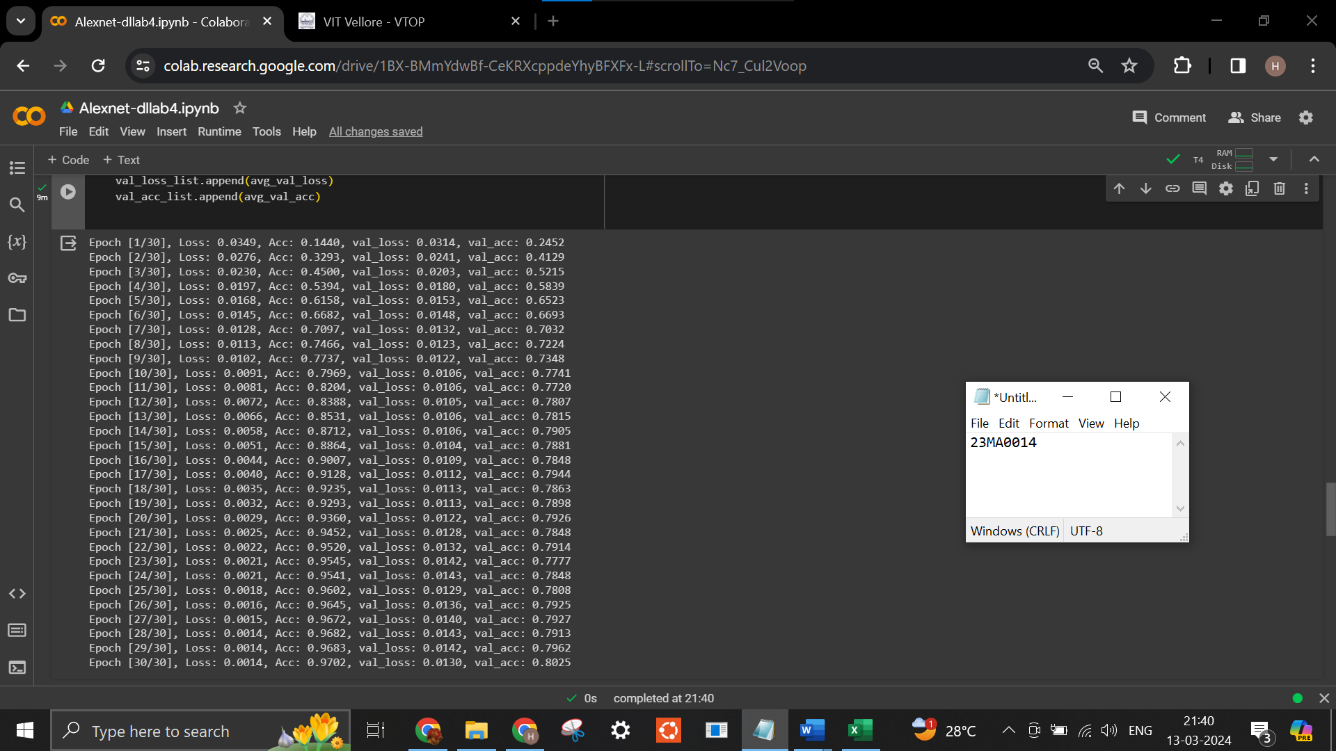
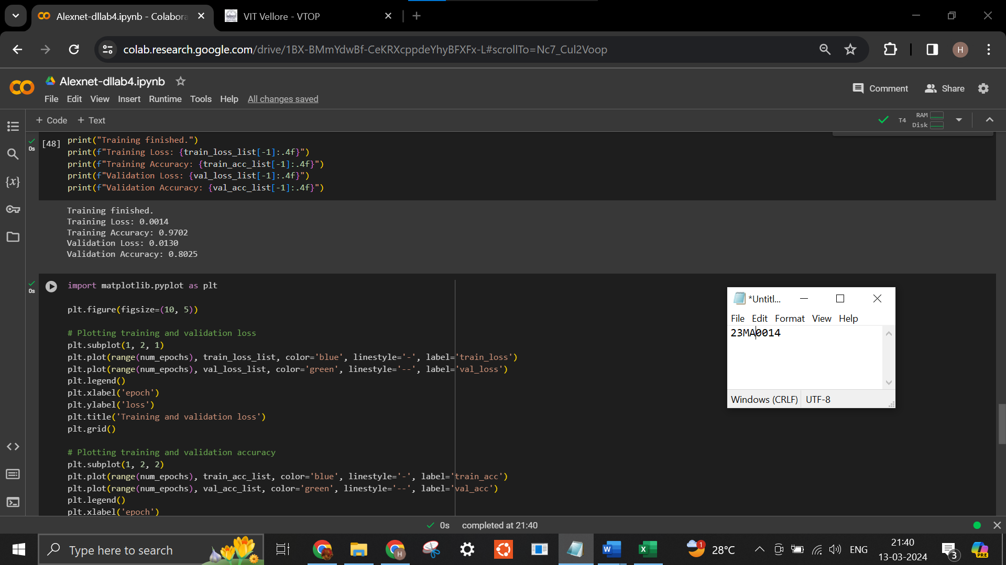

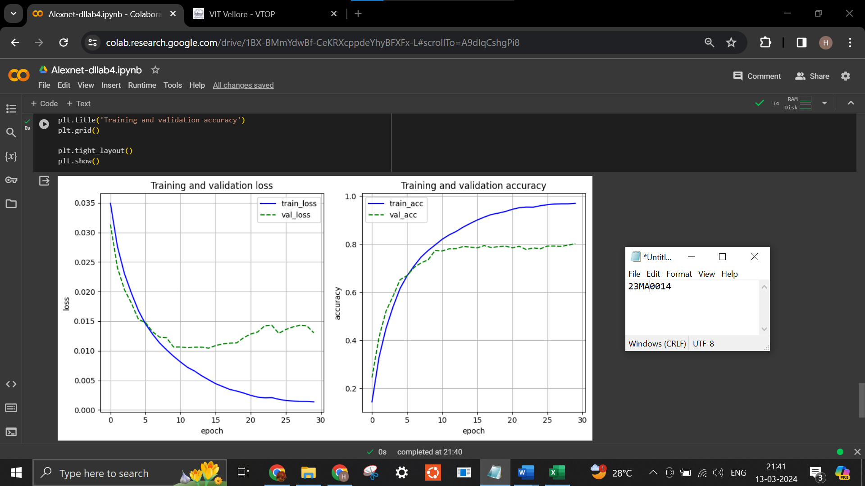

Output for CIFAR100 Dataset
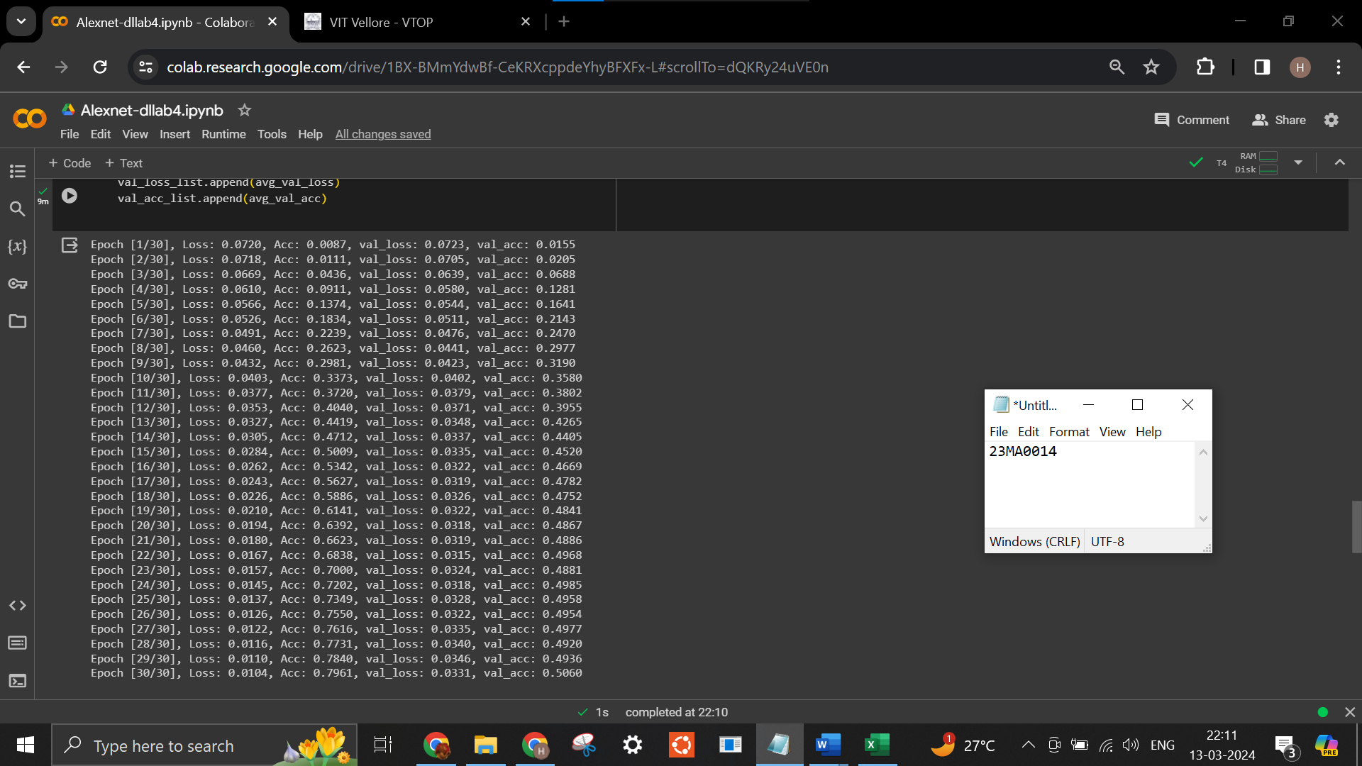

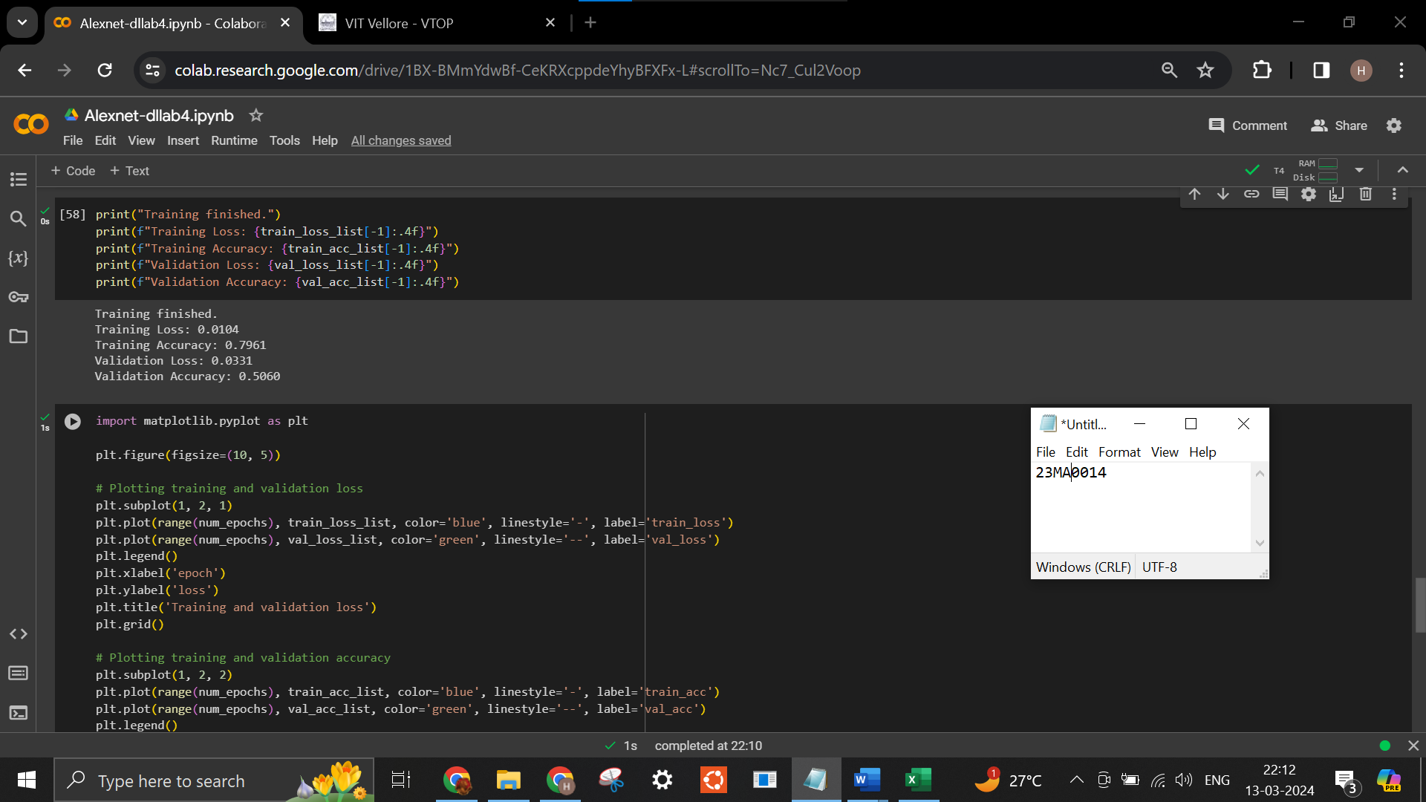

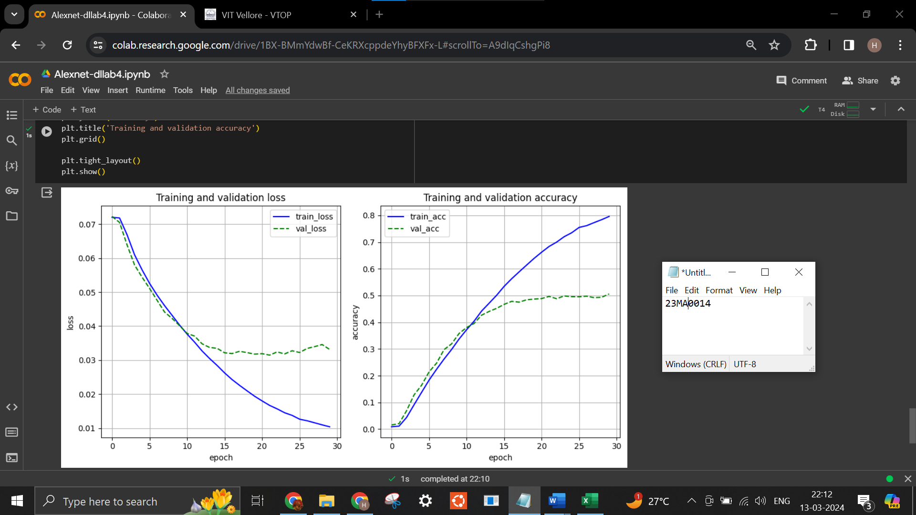

Google Colab Link
https://colab.research.google.com/drive/1BX-BMmYdwBf-CeKRXcppdeYhyBFXFx-L?usp=sharing

Conclusion
Training the AlexNet model for 30 epochs with 64 batch size on CIFAR100 Dataset, the below results are observed.
- Training Loss: 0.0104
- Training Accuracy: 0.7961
- Validation Loss: 0.0331
- Validation Accuracy: 0.5060

Training the AlexNet model for 30 epochs with 64 batch size on CIFAR10 Dataset, the below results are observed.
- Training Loss: 0.0014
- Training Accuracy: 0.9702
- Validation Loss: 0.0130
- Validation Accuracy: 0.8025

