

Deep Learning Laboratory - MCSE603P
Reg No. : 23MAI0014
Name : Harini K
Slot : L47+48
Faculty : Dr.Anil Kumar K
College : Vellore Institute of Technology
Department : SCOPE
Assignment : 6
Experiment : BERT

Digital Assignment – 6
Ex.No: 1
BERT (Bidirectional Encoder Representations from Transformers)
BERT, or Bidirectional Encoder Representations from Transformers, is a deep learning model introduced by Google in 2018. It represents a significant milestone in the field of natural language processing (NLP) due to its ability to capture contextual information bidirectionally, unlike previous models that processed text sequentially either left-to-right or right-to-left. Let's dive into its workings in detail:
Transformer Architecture: BERT is built upon the Transformer architecture, which was introduced in the paper "Attention is All You Need" by Vaswani et al. Transformers rely on self-attention mechanisms to weigh the importance of different words in a sentence when encoding or decoding.
Pre-training: BERT is pre-trained on a large corpus of text using two unsupervised learning tasks:
Masked Language Model (MLM): BERT randomly masks some of the words in the input sentence and then tries to predict those masked words based on the context provided by the surrounding words.
Next Sentence Prediction (NSP): BERT is trained to predict whether one sentence follows another sentence in the original text. During pre-training, BERT is provided with pairs of sentences and learns to predict whether the second sentence is the actual next sentence in the sequence.
Tokenization: BERT uses WordPiece tokenization, which breaks down words into subwords or tokens. This allows BERT to handle out-of-vocabulary words by breaking them down into smaller units that it has been trained on.
Architecture: BERT consists of multiple layers of Transformer encoders. It has two main variants:
BERT Base: This variant has 12 Transformer layers with 768 hidden units and 12 self-attention heads.
BERT Large: This variant has 24 Transformer layers with 1024 hidden units and 16 self-attention heads.
Fine-tuning: After pre-training, BERT can be fine-tuned on downstream NLP tasks such as text classification, named entity recognition, question answering, etc. During fine-tuning, the pre-trained BERT model is further trained on task-specific labeled data to adapt its parameters to the specifics of the downstream task.
Contextualized Representations: One of the key advantages of BERT is its ability to generate contextualized word representations. It captures the context of each word in a sentence by considering both left and right contexts. This allows BERT to better understand the nuances of language and perform well on various NLP tasks without extensive task-specific feature engineering.
Overall, BERT has demonstrated state-of-the-art performance on a wide range of NLP tasks and has become a foundational model in the field, paving the way for numerous advancements in natural language understanding and generation.

Code:
import numpy as np
import pandas as pd
import torch
import torch.nn as nn
from sklearn.model_selection import train_test_split
from sklearn.metrics import classification_report
import transformers
from transformers import AutoModel, BertTokenizerFast

# specify GPU
device = torch.device("cuda")
df = pd.read_csv("/content/sample_data/spamdata_v2.csv")
df.head()
# check class distribution
df['label'].value_counts(normalize = True)
# split train dataset into train, validation and test sets
train_text, temp_text, train_labels, temp_labels = train_test_split(df['text'], df['label'],
random_state=2018,
test_size=0.3,
stratify=df['label'])

val_text, test_text, val_labels, test_labels = train_test_split(temp_text, temp_labels,
random_state=2018,
test_size=0.5,
stratify=temp_labels)
# import BERT-base pretrained model
bert = AutoModel.from_pretrained('bert-base-uncased')

# Load the BERT tokenizer
tokenizer = BertTokenizerFast.from_pretrained('bert-base-uncased')
# get length of all the messages in the train set
seq_len = [len(i.split()) for i in train_text]

pd.Series(seq_len).hist(bins = 30)
# tokenize and encode sequences in the training set
tokens_train = tokenizer.batch_encode_plus(
train_text.tolist(),
max_length = 25,
pad_to_max_length=True,
truncation=True
)

# tokenize and encode sequences in the validation set
tokens_val = tokenizer.batch_encode_plus(
val_text.tolist(),
max_length = 25,
pad_to_max_length=True,
truncation=True
)

# tokenize and encode sequences in the test set
tokens_test = tokenizer.batch_encode_plus(
test_text.tolist(),
max_length = 25,
pad_to_max_length=True,
truncation=True
)
## convert lists to tensors

train_seq = torch.tensor(tokens_train['input_ids'])
train_mask = torch.tensor(tokens_train['attention_mask'])
train_y = torch.tensor(train_labels.tolist())

val_seq = torch.tensor(tokens_val['input_ids'])
val_mask = torch.tensor(tokens_val['attention_mask'])
val_y = torch.tensor(val_labels.tolist())

test_seq = torch.tensor(tokens_test['input_ids'])
test_mask = torch.tensor(tokens_test['attention_mask'])
test_y = torch.tensor(test_labels.tolist())
from torch.utils.data import TensorDataset, DataLoader, RandomSampler, SequentialSampler

#define a batch size
batch_size = 32

# wrap tensors
train_data = TensorDataset(train_seq, train_mask, train_y)

# sampler for sampling the data during training
train_sampler = RandomSampler(train_data)

# dataLoader for train set
train_dataloader = DataLoader(train_data, sampler=train_sampler, batch_size=batch_size)

# wrap tensors
val_data = TensorDataset(val_seq, val_mask, val_y)

# sampler for sampling the data during training
val_sampler = SequentialSampler(val_data)

# dataLoader for validation set
val_dataloader = DataLoader(val_data, sampler = val_sampler, batch_size=batch_size)
# freeze all the parameters
for param in bert.parameters():
param.requires_grad = False
class BERT_Arch(nn.Module):

def __init__(self, bert):
super(BERT_Arch, self).__init__()

self.bert = bert

# dropout layer
self.dropout = nn.Dropout(0.1)

# relu activation function
self.relu = nn.ReLU()

# dense layer 1
self.fc1 = nn.Linear(768,512)

# dense layer 2 (Output layer)
self.fc2 = nn.Linear(512,2)

#softmax activation function
self.softmax = nn.LogSoftmax(dim=1)

#define the forward pass
def forward(self, sent_id, mask):

#pass the inputs to the model
_, cls_hs = self.bert(sent_id, attention_mask=mask, return_dict=False)

x = self.fc1(cls_hs)

x = self.relu(x)

x = self.dropout(x)

# output layer
x = self.fc2(x)

# apply softmax activation
x = self.softmax(x)

return x
# pass the pre-trained BERT to our define architecture
model = BERT_Arch(bert)

# push the model to GPU
model = model.to(device)
# optimizer from hugging face transformers
from transformers import AdamW

# define the optimizer
optimizer = AdamW(model.parameters(),lr = 1e-5)
from sklearn.utils.class_weight import compute_class_weight

#compute the class weights
class_weights = compute_class_weight(class_weight='balanced', classes=np.unique(train_labels), y=train_labels)

print("Class Weights:",class_weights)
# converting list of class weights to a tensor
weights= torch.tensor(class_weights,dtype=torch.float)

# push to GPU
weights = weights.to(device)

# define the loss function
cross_entropy = nn.NLLLoss(weight=weights)

# number of training epochs
epochs = 20
# function to train the model
def train():

model.train()
total_loss, total_accuracy = 0, 0

# empty list to save model predictions
total_preds=[]

# iterate over batches
for step,batch in enumerate(train_dataloader):

# progress update after every 50 batches.
if step % 50 == 0 and not step == 0:
print(' Batch {:>5,} of {:>5,}.'.format(step, len(train_dataloader)))

# push the batch to gpu
batch = [r.to(device) for r in batch]

sent_id, mask, labels = batch

# clear previously calculated gradients
model.zero_grad()

# get model predictions for the current batch
preds = model(sent_id, mask)

# compute the loss between actual and predicted values
loss = cross_entropy(preds, labels)

# add on to the total loss
total_loss = total_loss + loss.item()

# backward pass to calculate the gradients
loss.backward()

# clip the the gradients to 1.0. It helps in preventing the exploding gradient problem
torch.nn.utils.clip_grad_norm_(model.parameters(), 1.0)

# update parameters
optimizer.step()

# model predictions are stored on GPU. So, push it to CPU
preds=preds.detach().cpu().numpy()

# append the model predictions
total_preds.append(preds)

# compute the training loss of the epoch
avg_loss = total_loss / len(train_dataloader)

# predictions are in the form of (no. of batches, size of batch, no. of classes).
# reshape the predictions in form of (number of samples, no. of classes)
total_preds = np.concatenate(total_preds, axis=0)

#returns the loss and predictions
return avg_loss, total_preds
# function for evaluating the model
def evaluate():

print("\nEvaluating...")

# deactivate dropout layers
model.eval()

total_loss, total_accuracy = 0, 0

# empty list to save the model predictions
total_preds = []

# iterate over batches
for step,batch in enumerate(val_dataloader):

# Progress update every 50 batches.
if step % 50 == 0 and not step == 0:

# Calculate elapsed time in minutes.
elapsed = format_time(time.time() - t0)

# Report progress.
print(' Batch {:>5,} of {:>5,}.'.format(step, len(val_dataloader)))

# push the batch to gpu
batch = [t.to(device) for t in batch]

sent_id, mask, labels = batch

# deactivate autograd
with torch.no_grad():

# model predictions
preds = model(sent_id, mask)

# compute the validation loss between actual and predicted values
loss = cross_entropy(preds,labels)

total_loss = total_loss + loss.item()

preds = preds.detach().cpu().numpy()

total_preds.append(preds)

# compute the validation loss of the epoch
avg_loss = total_loss / len(val_dataloader)

# reshape the predictions in form of (number of samples, no. of classes)
total_preds = np.concatenate(total_preds, axis=0)

return avg_loss, total_preds
# set initial loss to infinite
best_valid_loss = float('inf')

# empty lists to store training and validation loss of each epoch
train_losses=[]
valid_losses=[]

#for each epoch
for epoch in range(epochs):

print('\n Epoch {:} / {:}'.format(epoch + 1, epochs))

#train model
train_loss, _ = train()

#evaluate model
valid_loss, _ = evaluate()

#save the best model
if valid_loss < best_valid_loss:
best_valid_loss = valid_loss
torch.save(model.state_dict(), 'saved_weights.pt')

# append training and validation loss
train_losses.append(train_loss)
valid_losses.append(valid_loss)

print(f'\nTraining Loss: {train_loss:.3f}')
print(f'Validation Loss: {valid_loss:.3f}')
#load weights of best model
path = 'saved_weights.pt'
model.load_state_dict(torch.load(path))
# get predictions for test data
with torch.no_grad():
preds = model(test_seq.to(device), test_mask.to(device))
preds = preds.detach().cpu().numpy()
# model's performance
preds = np.argmax(preds, axis = 1)
print(classification_report(test_y, preds))

Google Colab link:
https://colab.research.google.com/drive/1ijhDKg7Sl2GtdtK2aISdAQqSNHBWSj1Z?usp=sharing
Output:
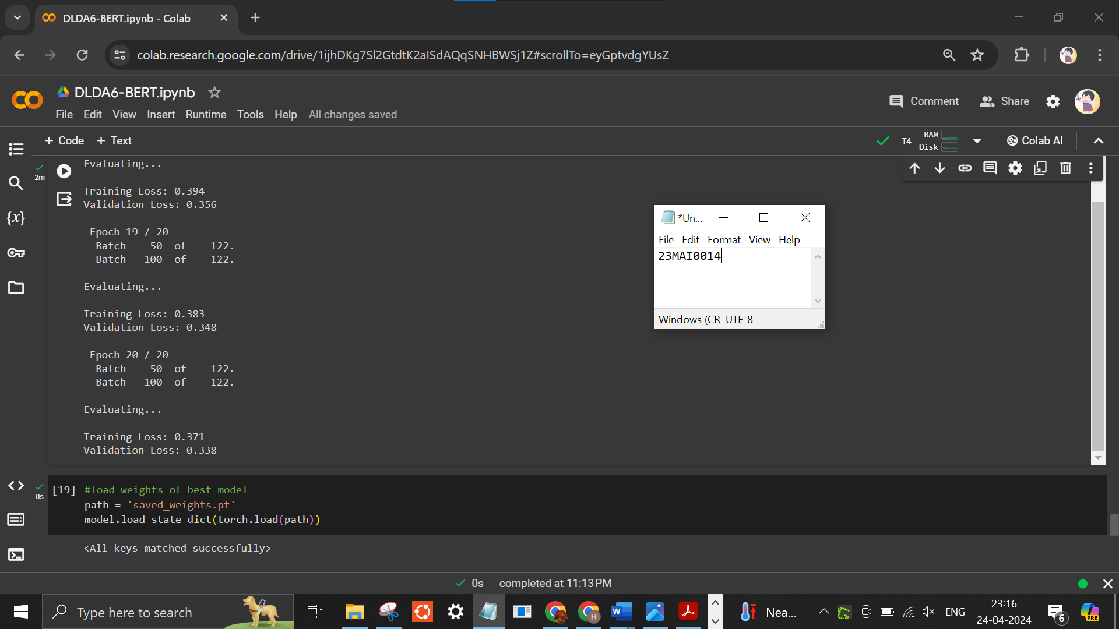
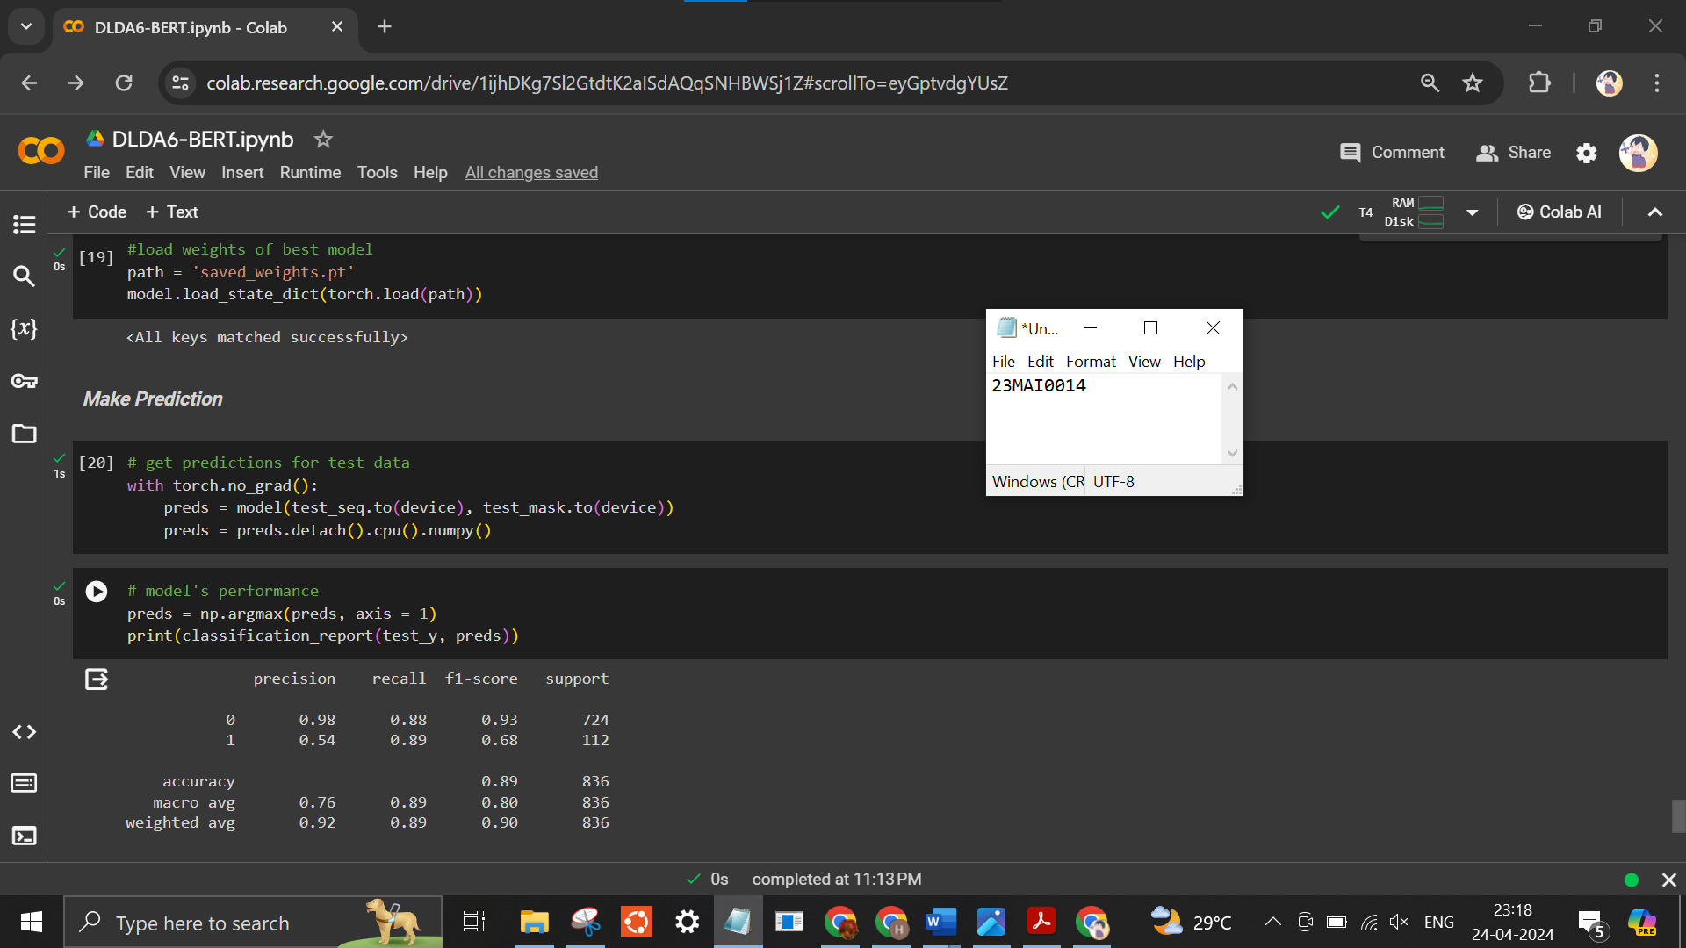

Conclusion:
In conclusion, following 20 epochs of training, the BERT-based model demonstrates strong performance in spam classification, yielding an accuracy of 89% alongside notable precision and recall scores. The training loss decreases from 0.669 to 0.371, while the validation loss exhibits a similar decline and results in 0.338. This suggests effective learning and generalization. Further fine-tuning may enhance results, yet these findings underscore BERT's prowess in addressing spam detection challenges.

