

Deep Learning Laboratory - MCSE603P
Reg No. : 23MAI0014
Name : Harini K
Slot : L47+48
Faculty : Dr.Anil Kumar K
College : Vellore Institute of Technology
Department : SCOPE
Assignment : 5
Experiments : 1. VGG Net
2. GoogleNet
3. Resnet
4. LSTM in RNN
5. Bi-LSTM in RNN

Digital Assignment – 5

- VGG Net
VGG (Visual Geometry Group) is a convolutional neural network (CNN) architecture that was introduced by researchers at the University of Oxford. VGG is renowned for its simplicity and effectiveness in image classification tasks. It achieved second place in the ImageNet Large Scale Visual Recognition Challenge (ILSVRC) 2014.
The key characteristic of VGG is its deep architecture, featuring convolutional layers with small 3x3 filters stacked on top of each other. The network consists of a series of convolutional layers followed by max-pooling layers for down-sampling. This architecture is repeated multiple times, resulting in a deep network with a high number of trainable parameters.
One of the most popular variants of VGG is VGG-16, which consists of 16 layers, including 13 convolutional layers and 3 fully connected layers. There is also a deeper version called VGG-19, which includes 19 layers. These architectures are relatively straightforward compared to more modern networks like ResNet or Inception, making them easier to understand and implement.
Despite its simplicity, VGG achieved impressive performance on various image classification tasks due to its deep architecture and the use of small convolutional filters, which help capture intricate features in images. However, one downside of VGG is its large number of parameters, making it computationally expensive and memory-intensive, especially when deployed on resource-constrained devices.
Overall, VGG played a significant role in advancing the field of computer vision and deep learning, serving as a benchmark architecture for subsequent research and inspiring the development of more efficient and powerful convolutional neural networks.

Code
import torch
import torch.nn as nn
import torch.optim as optim
from torchvision import datasets, transforms
from torch.utils.data import DataLoader
# Check if CUDA is available and set the device
device = torch.device("cuda" if torch.cuda.is_available() else "cpu")

# CIFAR-10 dataset has 10 classes
num_classes = 10
# Define the VGG block
def vgg_block(num_convs, in_channels, out_channels):
layers = []
for _ in range(num_convs):
layers.append(nn.Conv2d(in_channels, out_channels, kernel_size=3, padding=1))
layers.append(nn.BatchNorm2d(out_channels))
layers.append(nn.ReLU(inplace=True))
in_channels = out_channels
layers.append(nn.MaxPool2d(kernel_size=2, stride=2))
return nn.Sequential(*layers)
# Define the VGG network
class VGG(nn.Module):
def __init__(self, conv_arch, num_classes=10):
super(VGG, self).__init__()
self.conv_layers = self._make_layers(conv_arch)
self.fc_layers = nn.Sequential(
nn.Linear(conv_arch[-1][1] * 1 * 1, 4096),
nn.ReLU(True),
nn.Dropout(p=0.5),
nn.Linear(4096, 4096),
nn.ReLU(True),
nn.Dropout(p=0.5),
nn.Linear(4096, num_classes)
)

def _make_layers(self, conv_arch):
layers = []
in_channels = 3
for (num_convs, out_channels) in conv_arch:
layers.append(vgg_block(num_convs, in_channels, out_channels))
in_channels = out_channels
return nn.Sequential(*layers)

def forward(self, x):
x = self.conv_layers(x)
x = x.view(x.size(0), -1) # Flatten the features
x = self.fc_layers(x)
return x
# Define the VGG architecture
conv_arch = ((2, 64), (2, 128), (3, 256), (3, 512), (3, 512))

# Instantiate the model
model = VGG(conv_arch, num_classes=num_classes).to(device)

# Hyperparameters
learning_rate = 0.001
batch_size = 64
epochs = 100
# Image preprocessing modules
transform = transforms.Compose([
transforms.ToTensor(),
transforms.Normalize((0.5, 0.5, 0.5), (0.5, 0.5, 0.5))
])
# CIFAR-10 data
train_dataset = datasets.CIFAR10(root='./data', train=True, transform=transform,
download=True)
test_dataset = datasets.CIFAR10(root='./data', train=False, transform=transform)
# Data loader
train_loader = DataLoader(dataset=train_dataset, batch_size=batch_size, shuffle=True)
test_loader = DataLoader(dataset=test_dataset, batch_size=batch_size, shuffle=False)
# Loss and optimizer
criterion = nn.CrossEntropyLoss()
optimizer = optim.Adam(model.parameters(), lr=learning_rate)
# Function for training the model
def train(model, criterion, optimizer, train_loader, epochs):
model.train()
for epoch in range(epochs):
for i, (images, labels) in enumerate(train_loader):
images = images.to(device)
labels = labels.to(device)

# Forward pass
outputs = model(images)
loss = criterion(outputs, labels)

# Backward and optimize
optimizer.zero_grad()
loss.backward()
optimizer.step()
if (i+1) % 100 == 0:
print(f'Epoch [{epoch+1}/{epochs}], Step [{i+1}/{len(train_loader)}], Loss: {loss.item():.4f}')
# Function for testing the model
def test(model, test_loader):
model.eval()
with torch.no_grad():
correct = 0
total = 0
for images, labels in test_loader:
images = images.to(device)
labels = labels.to(device)
outputs = model(images)
_, predicted = torch.max(outputs.data, 1)
total += labels.size(0)
correct += (predicted == labels).sum().item()
accuracy = 100 * correct / total
print(f'Accuracy of the model on the test images: {accuracy}%')
# Train the model
train(model, criterion, optimizer, train_loader, epochs)
# Test the model
test(model, test_loader)

Output
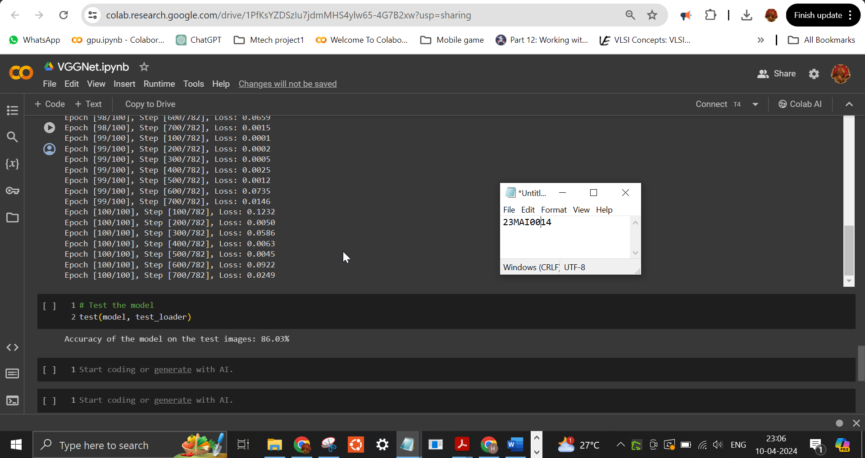

Google Colab Link
https://colab.research.google.com/drive/1ciNLfKi27yzVqaRVi2R-urfGRU_XFrgH?usp=sharing
Conclusion:
In conclusion, VGG (Visual Geometry Group) stands as a pivotal milestone in the evolution of convolutional neural network architectures for image classification tasks. Its simplicity, coupled with its deep architecture and small convolutional filters, contributed to its effectiveness and widespread adoption in the field of computer vision.

- GoogleNet

GoogleNet, also known as Inception-v1, is a convolutional neural network (CNN) architecture developed by researchers at Google. It was introduced in 2014 and won the ImageNet Large Scale Visual Recognition Challenge (ILSVRC) that year. GoogleNet is renowned for its innovative use of "Inception modules," which significantly reduce the number of parameters while maintaining high performance in image classification tasks.
The key innovation of GoogleNet lies in its Inception modules, which employ multiple parallel convolutional operations of different sizes within the same layer. This allows the network to capture features at different scales effectively while reducing the computational cost. Additionally, GoogleNet utilizes global average pooling instead of fully connected layers at the end of the network, further reducing the number of parameters and preventing overfitting.
The architecture of GoogleNet consists of multiple stacked Inception modules, interspersed with max-pooling layers for down-sampling. The network culminates in an average pooling layer followed by a softmax output layer for classification. Notably, GoogleNet is deeper than previous architectures like VGG but maintains a relatively low number of parameters, making it more computationally efficient.
One of the most significant advantages of GoogleNet is its superior performance compared to previous architectures while being more computationally efficient. It achieved this by striking a balance between depth and computational complexity through the innovative design of Inception modules. Additionally, GoogleNet served as a catalyst for subsequent research into more efficient CNN architectures, inspiring variants like Inception-v2, Inception-v3, and Inception-ResNet.
In conclusion, GoogleNet represents a groundbreaking advancement in the field of deep learning, demonstrating the effectiveness of the Inception modules in reducing computational complexity without sacrificing performance. Its impact extends beyond image classification, inspiring further research into efficient neural network architectures and contributing to the ongoing evolution of artificial intelligence.

Code
import torch
import torch.nn as nn
import torch.nn.functional as F
import torch.optim as optim
from torchvision import datasets, transforms, models
from torch.utils.data import DataLoader

# Check if CUDA is available
device = torch.device("cuda:0" if torch.cuda.is_available() else "cpu")
print(f'Using device: {device}')

# CIFAR-10 has 10 classes
num_classes = 10

# Image Preprocessing
transform = transforms.Compose([
transforms.ToTensor(),
transforms.Normalize((0.5, 0.5, 0.5), (0.5, 0.5, 0.5)) # Normalization
])

# Download and load the CIFAR-10 data
train_dataset = datasets.CIFAR10(root='./data', train=True, transform=transform, download=True)
test_dataset = datasets.CIFAR10(root='./data', train=False, transform=transform)

# Data Loader
train_loader = DataLoader(dataset=train_dataset, batch_size=64, shuffle=True)
test_loader = DataLoader(dataset=test_dataset, batch_size=64, shuffle=False)

# Define a GoogLeNet model for CIFAR-10
class GoogLeNetCIFAR10(models.GoogLeNet):
def __init__(self, num_classes=10):
super(GoogLeNetCIFAR10, self).__init__(num_classes=num_classes, aux_logits=False, init_weights=True)
# Redefine the first convolutional layer to accept CIFAR-10's 32x32 pixel images
self.conv1 = nn.Conv2d(3, 64, kernel_size=3, stride=1, padding=1)

def forward(self, x):
# Follow the forward pass of the GoogLeNet model
return super(GoogLeNetCIFAR10, self).forward(x)

# Instantiate the model and transfer it to the GPU
model = GoogLeNetCIFAR10(num_classes=num_classes).to(device)

# Loss and Optimizer
criterion = nn.CrossEntropyLoss()
optimizer = optim.Adam(model.parameters(), lr=0.001)

# Function to train the model
def train(model, criterion, optimizer, train_loader, epochs=10):
model.train()
for epoch in range(epochs):
running_loss = 0.0
for i, (inputs, labels) in enumerate(train_loader, 0):
# Transfer inputs and labels to the GPU
inputs, labels = inputs.to(device), labels.to(device)

optimizer.zero_grad()
outputs = model(inputs)
loss = criterion(outputs, labels)
loss.backward()
optimizer.step()
running_loss += loss.item()
if i % 100 == 99:
print(f'Epoch {epoch + 1}, Batch {i + 1}, Loss: {running_loss / 100}')
running_loss = 0.0

# Function to test the model
def test(model, test_loader):
model.eval()
correct = 0
total = 0
with torch.no_grad():
for images, labels in test_loader:
# Transfer images and labels to the GPU
images, labels = images.to(device), labels.to(device)

outputs = model(images)
_, predicted = torch.max(outputs.data, 1)
total += labels.size(0)
correct += (predicted == labels).sum().item()
accuracy = 100 * correct / total
return accuracy

# Start training
train(model, criterion, optimizer, train_loader, epochs=10)

# Test the model
accuracy = test(model, test_loader)
print(f'Accuracy of the model on the 10000 test images: {accuracy}%')

Output
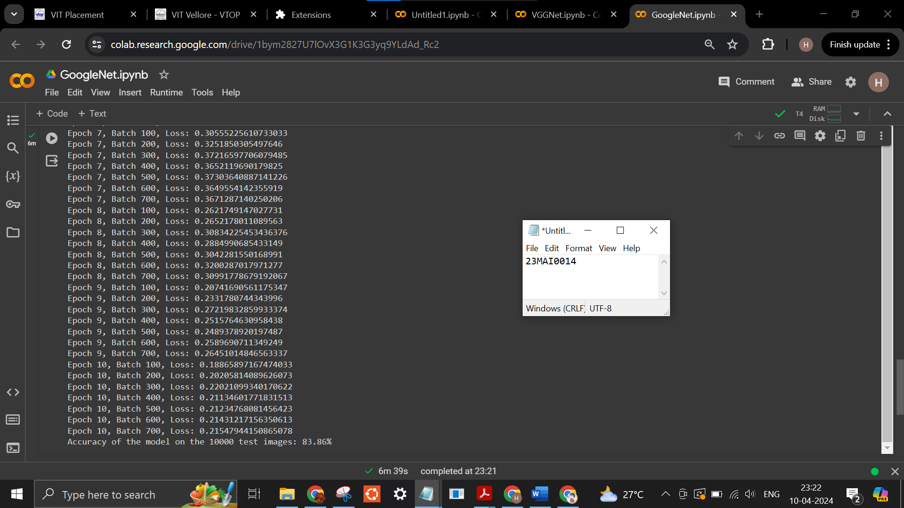
Google Colab link:

https://colab.research.google.com/drive/1bym2827U7lOvX3G1K3G3yq9YLdAd_Rc2?usp=sharing

Conclusion:
In conclusion, GoogleNet, with its inception modules and "network in network" concept, revolutionized convolutional neural network architectures for image classification. Its innovative design balances computational efficiency and performance, setting a benchmark for subsequent models.

- Resnet

ResNet, short for Residual Network, is a groundbreaking convolutional neural network (CNN) architecture that was introduced by researchers at Microsoft Research in 2015. ResNet's innovation lies in its use of residual connections, which address the problem of vanishing gradients in deep neural networks. This enables the training of significantly deeper networks compared to previous architectures.
The key idea behind ResNet is the introduction of residual blocks, or "identity shortcut connections," which allow the network to skip over certain layers during training. Instead of directly learning the desired underlying mapping, ResNet learns residual mappings, making it easier for the network to learn the identity function. This mitigates the degradation problem that arises when adding more layers to a neural network, as deeper networks typically suffer from diminishing performance due to vanishing gradients.
By using residual connections, ResNet architectures can be scaled up to hundreds or even thousands of layers while still maintaining good performance. This depth enables ResNet models to capture increasingly complex features and patterns in data, leading to state-of-the-art performance in various computer vision tasks such as image classification, object detection, and semantic segmentation.
ResNet's impact extends beyond the realm of computer vision, as its architecture has inspired advancements in other domains of deep learning, including natural language processing and reinforcement learning. Its effectiveness and scalability have made it one of the most widely adopted CNN architectures in both academic research and industrial applications.
In summary, ResNet represents a significant milestone in deep learning, demonstrating the power of residual connections in enabling the training of extremely deep neural networks. Its robustness, scalability, and performance have solidified its status as a foundational architecture in the field, driving progress and innovation in artificial intelligence.

Code
import torch
import torch.nn as nn
import torch.optim as optim
from torchvision import datasets, transforms
from torch.utils.data import DataLoader
# Check if CUDA is available and set the device
device = torch.device("cuda" if torch.cuda.is_available() else "cpu")

# Define the basic block for ResNet
class BasicBlock(nn.Module):
expansion = 1

def __init__(self, in_planes, planes, stride=1):
super(BasicBlock, self).__init__()
self.conv1 = nn.Conv2d(in_planes, planes, kernel_size=3, stride=stride, padding=1, bias=False)
self.bn1 = nn.BatchNorm2d(planes)
self.conv2 = nn.Conv2d(planes, planes, kernel_size=3, stride=1, padding=1, bias=False)
self.bn2 = nn.BatchNorm2d(planes)

self.shortcut = nn.Sequential()
if stride != 1 or in_planes != self.expansion * planes:
self.shortcut = nn.Sequential(
nn.Conv2d(in_planes, self.expansion * planes, kernel_size=1, stride=stride, bias=False),
nn.BatchNorm2d(self.expansion * planes)
)

def forward(self, x):
out = nn.ReLU()(self.bn1(self.conv1(x)))
out = self.bn2(self.conv2(out))
out += self.shortcut(x)
out = nn.ReLU()(out)
return out

# Define the ResNet model
class ResNet(nn.Module):
def __init__(self, block, num_blocks, num_classes=10):
super(ResNet, self).__init__()
self.in_planes = 64

self.conv1 = nn.Conv2d(3, 64, kernel_size=3, stride=1, padding=1, bias=False)
self.bn1 = nn.BatchNorm2d(64)
self.layer1 = self._make_layer(block, 64, num_blocks[0], stride=1)
self.layer2 = self._make_layer(block, 128, num_blocks[1], stride=2)
self.layer3 = self._make_layer(block, 256, num_blocks[2], stride=2)
self.layer4 = self._make_layer(block, 512, num_blocks[3], stride=2)
self.linear = nn.Linear(512 * block.expansion, num_classes)

def _make_layer(self, block, planes, num_blocks, stride):
strides = [stride] + [1] * (num_blocks - 1)
layers = []
for stride in strides:
layers.append(block(self.in_planes, planes, stride))
self.in_planes = planes * block.expansion
return nn.Sequential(*layers)

def forward(self, x):
out = nn.ReLU()(self.bn1(self.conv1(x)))
out = self.layer1(out)
out = self.layer2(out)
out = self.layer3(out)
out = self.layer4(out)
out = nn.AvgPool2d(4)(out)
out = out.view(out.size(0), -1)
out = self.linear(out)
return out

# Define ResNet-18
def ResNet18():
return ResNet(BasicBlock, [2, 2, 2, 2])

# Instantiate the model
model = ResNet18().to(device)

# Hyperparameters
learning_rate = 0.001
batch_size = 64
epochs = 10

# Image preprocessing modules
transform = transforms.Compose([
transforms.Resize((32, 32)),
transforms.ToTensor(),
transforms.Normalize(mean=[0.485, 0.456, 0.406], std=[0.229, 0.224, 0.225])
])

# CIFAR-10 data
train_dataset = datasets.CIFAR10(root='./data', train=True, transform=transform, download=True)
test_dataset = datasets.CIFAR10(root='./data', train=False, transform=transform)

# Data loader
train_loader = DataLoader(dataset=train_dataset, batch_size=batch_size, shuffle=True)
test_loader = DataLoader(dataset=test_dataset, batch_size=batch_size, shuffle=False)

# Loss and optimizer
criterion = nn.CrossEntropyLoss()
optimizer = optim.Adam(model.parameters(), lr=learning_rate)

# Function for training the model
def train(model, criterion, optimizer, train_loader, epochs):
model.train()
for epoch in range(epochs):
for i, (images, labels) in enumerate(train_loader):
images, labels = images.to(device), labels.to(device)

# Forward pass
outputs = model(images)
loss = criterion(outputs, labels)

# Backward and optimize
optimizer.zero_grad()
loss.backward()
optimizer.step()

if (i+1) % 100 == 0:
print(f'Epoch [{epoch+1}/{epochs}], Step [{i+1}/{len(train_loader)}], Loss: {loss.item():.4f}')

# Function for testing the model
def test(model, test_loader):
model.eval()
with torch.no_grad():
correct = 0
total = 0
for images, labels in test_loader:
images, labels = images.to(device), labels.to(device)
outputs = model(images)
_, predicted = torch.max(outputs.data, 1)
total += labels.size(0)
correct += (predicted == labels).sum().item()
accuracy = 100 * correct / total
print(f'Accuracy of the model on the test images: {accuracy}%')

# Train the model
train(model, criterion, optimizer, train_loader, epochs)

# Test the model
test(model, test_loader)

Output
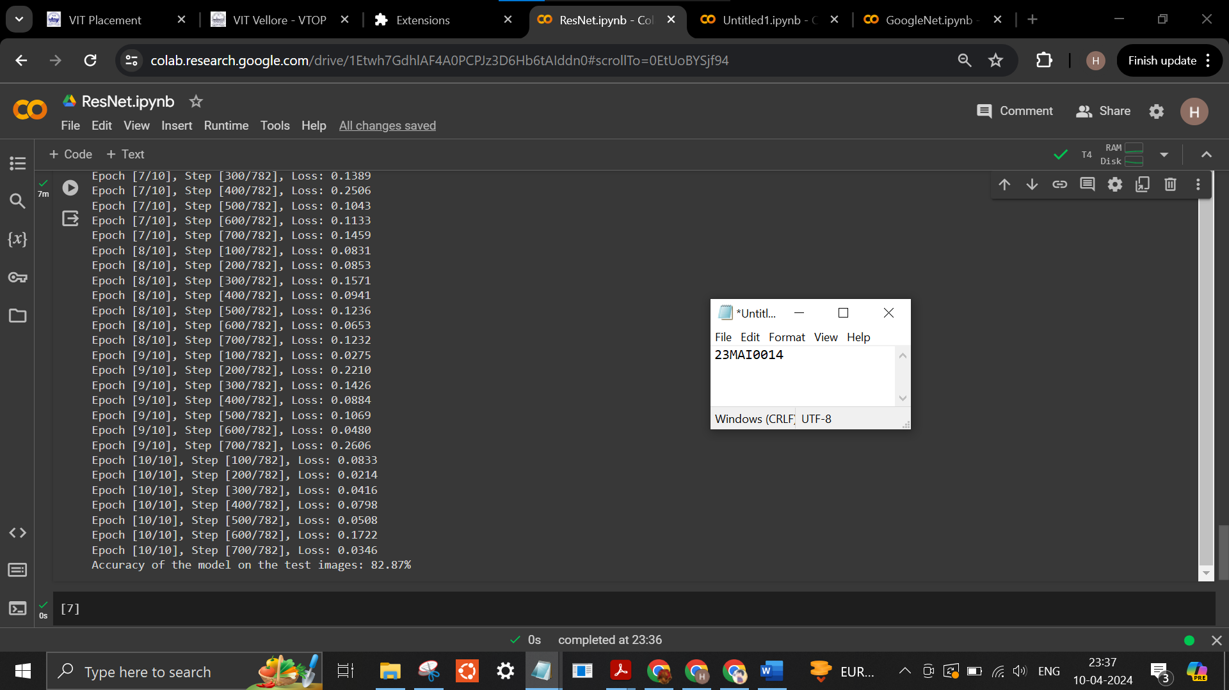

Google Colab Link
https://colab.research.google.com/drive/1Etwh7GdhlAF4A0PCPJz3D6Hb6tAIddn0?usp=sharing
Conclusion
In conclusion, ResNet revolutionized convolutional neural network architectures by introducing residual connections, enabling training of significantly deeper networks while mitigating vanishing gradient issues. Its scalability, robustness, and state-of-the-art performance solidify its status as a foundational model in computer vision.

- LSTM in RNN

Long Short-Term Memory (LSTM) is a type of recurrent neural network (RNN) architecture that addresses the limitations of traditional RNNs in handling long sequences of data. Traditional RNNs suffer from the vanishing gradient problem, where gradients diminish exponentially as they propagate backward through time, making it challenging to learn long-range dependencies. LSTM was proposed by Hochreiter and Schmidhuber in 1997 as a solution to this problem. The key innovation of LSTM lies in its memory cells, which are equipped with self-loop connections, allowing them to retain information over long periods.

LSTM networks consist of interconnected LSTM cells, each containing a cell state and three gates: the input gate, forget gate, and output gate. These gates regulate the flow of information within the cell, controlling the input, retention, and output of information, respectively. During the forward pass, the input gate determines which information should be stored in the cell state, while the forget gate decides what information should be discarded. The cell state is updated based on the input and forget gate decisions, as well as the current input. Finally, the output gate determines which information from the cell state should be passed to the next time step.
The ability of LSTM cells to retain information over long sequences makes them well-suited for tasks involving temporal dependencies, such as time series prediction, natural language processing, and speech recognition. In natural language processing, for example, LSTMs have been used for tasks like language modeling, sentiment analysis, machine translation, and named entity recognition. In speech recognition, LSTMs have been applied to tasks such as speech-to-text conversion and speaker identification.

One of the main advantages of LSTMs is their ability to handle sequences of varying lengths. Traditional feedforward neural networks require fixed-size inputs, making them unsuitable for tasks involving sequential data. Another advantage of LSTMs is their ability to capture long-range dependencies in sequential data. Traditional RNNs struggle with this task due to the vanishing gradient problem, which limits their ability to learn from distant past information. LSTMs overcome this limitation by using memory cells with self-loop connections, allowing them to retain information over long periods.

Code
#read the corpus(this is a sample file, upload task specific corpus in corpus text file and proceed)
corpus=open("/content/corpus.txt").read()
#preprocess the corpus
import re
corpus=corpus.lower()
clean_corpus=re.sub('[^a-z0-9]+',' ', corpus)
#required libraries
import nltk
nltk.download('punkt')
from nltk.tokenize import word_tokenize
from keras.preprocessing.text import Tokenizer
from keras.utils import to_categorical
import numpy as np
#tokenizing the text into words
tokens = word_tokenize(clean_corpus)
tokens

#length of the sequence to train
train_len = 3
#converting the data into required sequence
text_sequences = []
for i in range(train_len,len(tokens)+1):
seq = tokens[i-train_len:i]
text_sequences.append(seq)
#converting the texts into integer sequence
tokenizer = Tokenizer()
tokenizer.fit_on_texts(text_sequences)
sequences = tokenizer.texts_to_sequences(text_sequences)
sequences
sequences=np.asarray(sequences)
#vocabulary size
vocabulary_size = len(tokenizer.word_counts)+1
vocabulary_size
#trainX
train_inputs=sequences[:,:-1]
#input sequence length
seq_length=train_inputs.shape[1]
seq_length
#trainY
train_targets=sequences[:,-1]
#one hot encoding
train_targets = to_categorical(train_targets, num_classes=vocabulary_size)
#required libraries
import torch
from torch.optim import Adam
import torch.nn as nn
#lstm model
class lstm(nn.Module):
def __init__(self, vocab_size, embed_size, hidden_size):
super().__init__()
#simple lookup table that stores embeddings of a fixed dictionary and size.
self.embed = nn.Embedding(vocab_size, embed_size)

#lstm
self.lstm = nn.LSTM(embed_size, hidden_size, num_layers=2, bidirectional=False)

#fully connected layer
self.linear = nn.Linear(hidden_size*seq_length,vocab_size)

def forward(self, input_word):
#input sequence to embeddings
embedded = self.embed(input_word)

#passing the embedding to lstm model
output, hidden = self.lstm(embedded)

#reshaping
output=output.view(output.size(0), -1)

#fully connected layer
output = self.linear(output)
return output,hidden

model=lstm(vocab_size=vocabulary_size,embed_size=128, hidden_size=256)
#Adam optimizer
optimizer= Adam(model.parameters(), lr=0.07)

#loss
criterion = nn.BCEWithLogitsLoss()
#training the model
def train(epoch):
#set the model to train
model.train()
tr_loss=0

#clearing the Gradients
optimizer.zero_grad()

#predict the output
y_pred, (state_h, state_c) = model(torch.from_numpy(train_inputs))

#compute the loss
loss=criterion(y_pred,torch.from_numpy(train_targets))
losses.append(loss)

#backpropagate
loss.backward()

#update the parameters
optimizer.step()
tr_loss = loss.item()

print("Epoch : ",epoch,"loss : ",loss)
#number of epoch
no_epoch=50
losses=[]
for epoch in range(1,no_epoch+1):
train(epoch)
def predict_next_word(text):
#set the model to evaluation
model.eval()

#preprocess
text = text.lower().strip()

#converting the text to word tokens
input_tokens = word_tokenize(text)

#converting the tokens to integer sequence
sequences = tokenizer.texts_to_sequences([input_tokens])

#converting to array
sequences=np.asarray(sequences)
with torch.no_grad():
#converting to tensor
sequences=torch.from_numpy(sequences)
#predicting the output
predict,(hidden,cell)=model(sequences)

#applying the softmax layer
softmax = torch.exp(predict)
prob = list(softmax.numpy())

#index of the predict word
predictions = np.argmax(prob)

#converting the sequence back to word
next_word=tokenizer.sequences_to_texts([[predictions]])
return next_word
#we trained our model with sequence length of 2
input_text="next word"
print("Possible next word will be:")
predict_next_word(input_text)
#we trained our model with sequence length of 2
input_text="NLP language"
print("Possible next word will be:")
predict_next_word(input_text)

Output
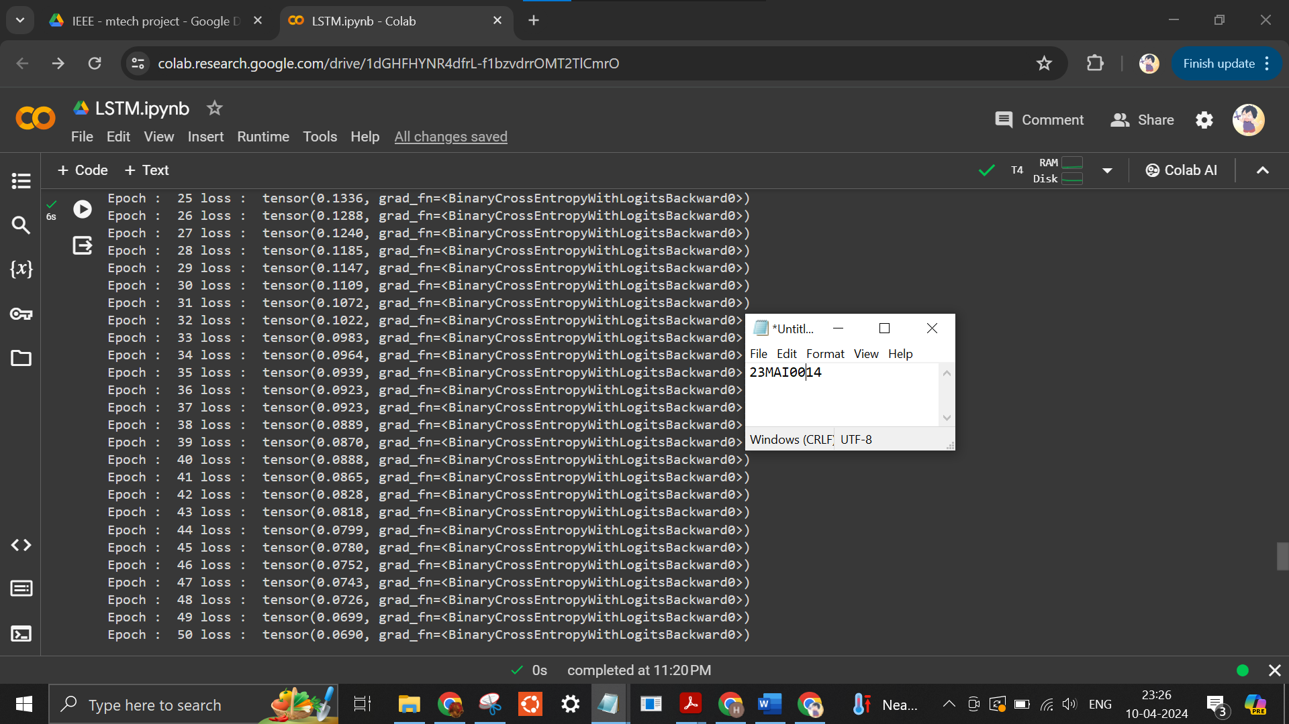
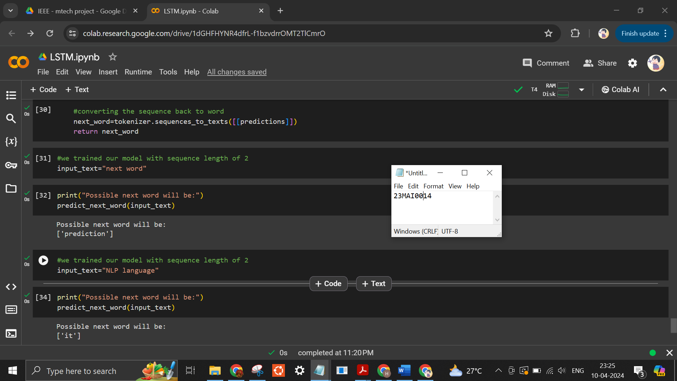
Google Colab Link
https://colab.research.google.com/drive/1dGHFHYNR4dfrLf1bzvdrrOMT2TlCmrO?usp=sharing
Conclusion
In conclusion, LSTM networks offer a solution to the vanishing gradient problem, enabling effective modeling of long-range dependencies in sequential data, making them a fundamental building block in deep learning architectures. Their versatility and effectiveness have propelled their widespread adoption across various domains, demonstrating their significance in advancing the field of recurrent neural networks.

- Bi-LSTM in RNN

Bi-LSTM, short for Bidirectional Long Short-Term Memory, represents a significant advancement in the field of recurrent neural networks (RNNs), particularly in tasks requiring nuanced understanding of sequential data.

Unlike traditional LSTMs, which process input sequences in only one direction, Bi-LSTM incorporates two separate LSTM layers—one processing the sequence forwards and the other backwards.

This bidirectional processing enables the model to capture context from both past and future timesteps, allowing for a more comprehensive understanding of the data.

Bi-LSTM has found wide application in natural language processing tasks such as part-of-speech tagging, named entity recognition, sentiment analysis, and machine translation, where context plays a crucial role in understanding meaning.

By effectively capturing bidirectional dependencies, Bi-LSTM has become a staple in sequential modeling, offering enhanced performance and accuracy in various domains.

Its versatility and effectiveness make it a valuable tool for researchers and practitioners seeking to tackle complex sequential data analysis tasks.

Code
import pandas as pd
import os
import numpy as np

import tensorflow as tf
from tensorflow.keras.preprocessing.sequence import pad_sequences
from tensorflow.keras.layers import Embedding, LSTM, Dense, Bidirectional
from tensorflow.keras.preprocessing.text import Tokenizer
from tensorflow.keras.models import Sequential
from tensorflow.keras.optimizers import Adam
medium_data = pd.read_csv('/content/medium_data.csv')
medium_data.head()
print("Number of records: ", medium_data.shape[0])
print("Number of fields: ", medium_data.shape[1])
medium_data['title']
medium_data['title'] = medium_data['title'].apply(lambda x: x.replace(u'\xa0',u' '))
medium_data['title'] = medium_data['title'].apply(lambda x: x.replace('\u200a',' '))
tokenizer = Tokenizer(oov_token='<oov>') # For those words which are not found in word_index
tokenizer.fit_on_texts(medium_data['title'])
total_words = len(tokenizer.word_index) + 1

print("Total number of words: ", total_words)
print("Word: ID")
print("------------")
print("<oov>: ", tokenizer.word_index['<oov>'])
print("Strong: ", tokenizer.word_index['strong'])
print("And: ", tokenizer.word_index['and'])
print("Consumption: ", tokenizer.word_index['consumption'])
input_sequences = []
for line in medium_data['title']:
token_list = tokenizer.texts_to_sequences([line])[0]
#print(token_list)

for i in range(1, len(token_list)):
n_gram_sequence = token_list[:i+1]
input_sequences.append(n_gram_sequence)

# print(input_sequences)
print("Total input sequences: ", len(input_sequences))
# pad sequences
max_sequence_len = max([len(x) for x in input_sequences])
input_sequences = np.array(pad_sequences(input_sequences, maxlen=max_sequence_len, padding='pre'))
input_sequences[1]
# create features and label
xs, labels = input_sequences[:,:-1],input_sequences[:,-1]
ys = tf.keras.utils.to_categorical(labels, num_classes=total_words)
print(xs[5])
print(labels[5])
print(ys[5][14])
model = Sequential()
model.add(Embedding(total_words, 100, input_length=max_sequence_len-1))
model.add(Bidirectional(LSTM(150)))
model.add(Dense(total_words, activation='softmax'))
adam = Adam(lr=0.01)
model.compile(loss='categorical_crossentropy', optimizer=adam, metrics=['accuracy'])
history = model.fit(xs, ys, epochs=50, verbose=1)
#print model.summary()
print(model)
import matplotlib.pyplot as plt

def plot_graphs(history, string):
plt.plot(history.history[string])
plt.xlabel("Epochs")
plt.ylabel(string)
plt.show()
plot_graphs(history, 'accuracy')
plot_graphs(history, 'loss')
seed_text = "implementation of"
next_words = 2

for _ in range(next_words):
token_list = tokenizer.texts_to_sequences([seed_text])[0]
token_list = pad_sequences([token_list], maxlen=max_sequence_len-1, padding='pre')
predicted = model.predict_classes(token_list, verbose=0)
output_word = ""
for word, index in tokenizer.word_index.items():
if index == predicted:
output_word = word
break
seed_text += " " + output_word
print(seed_text)

Output
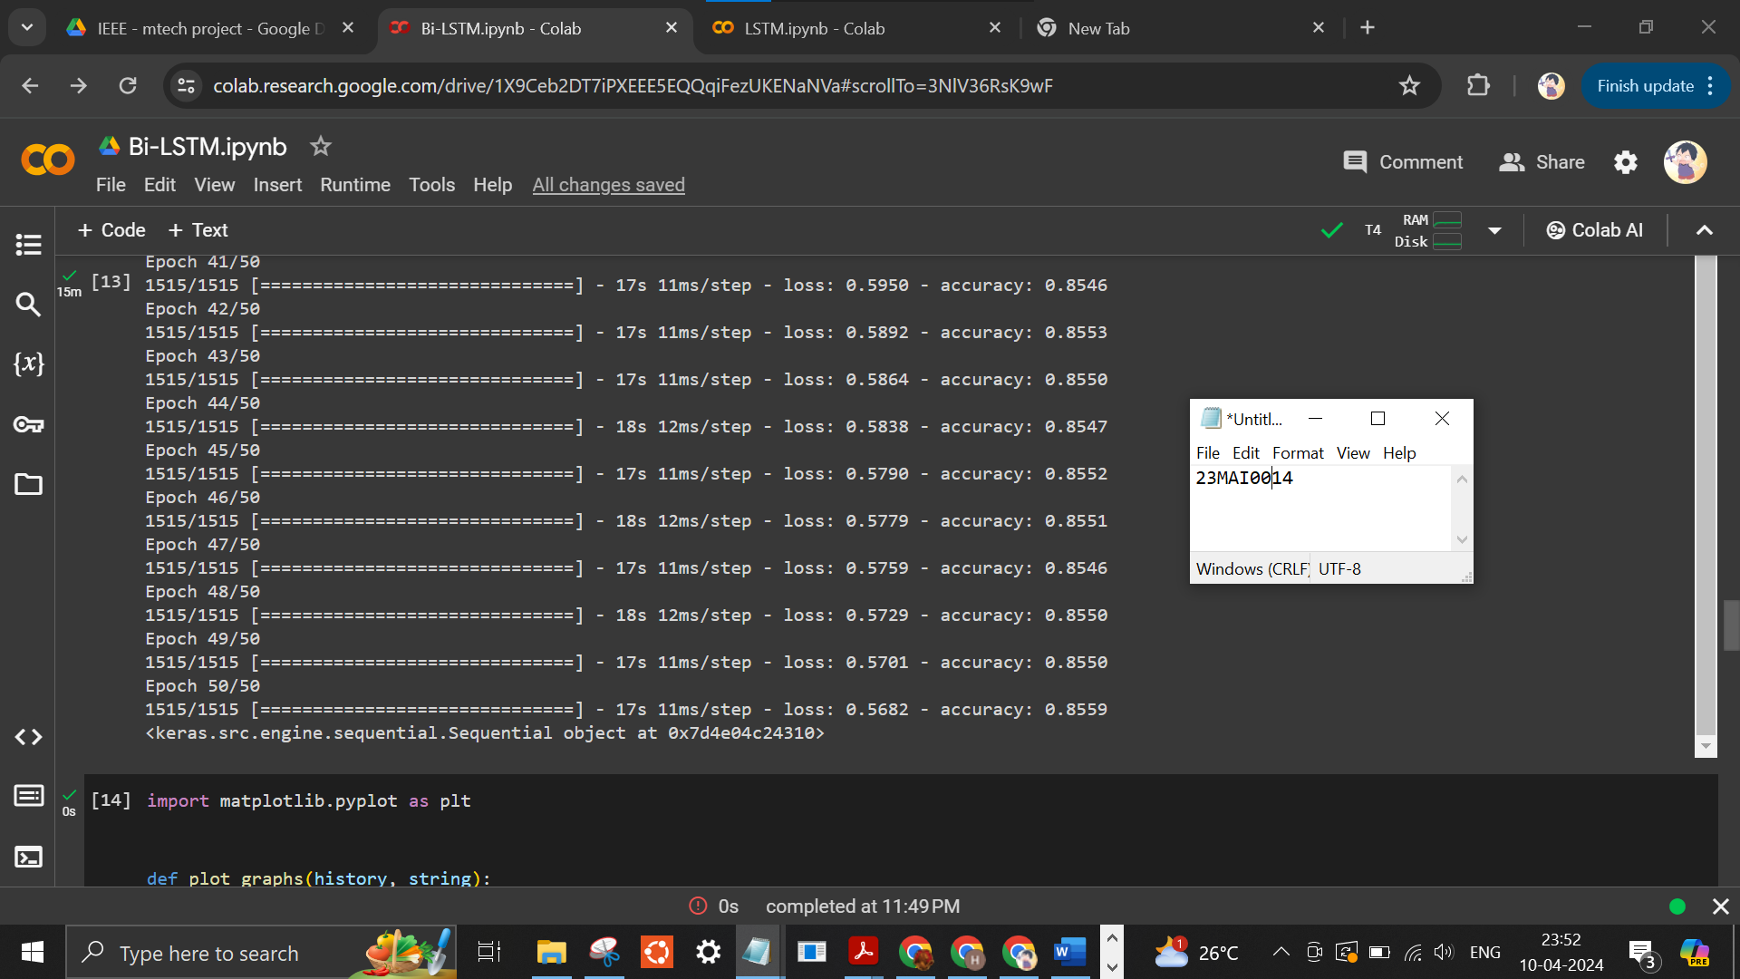
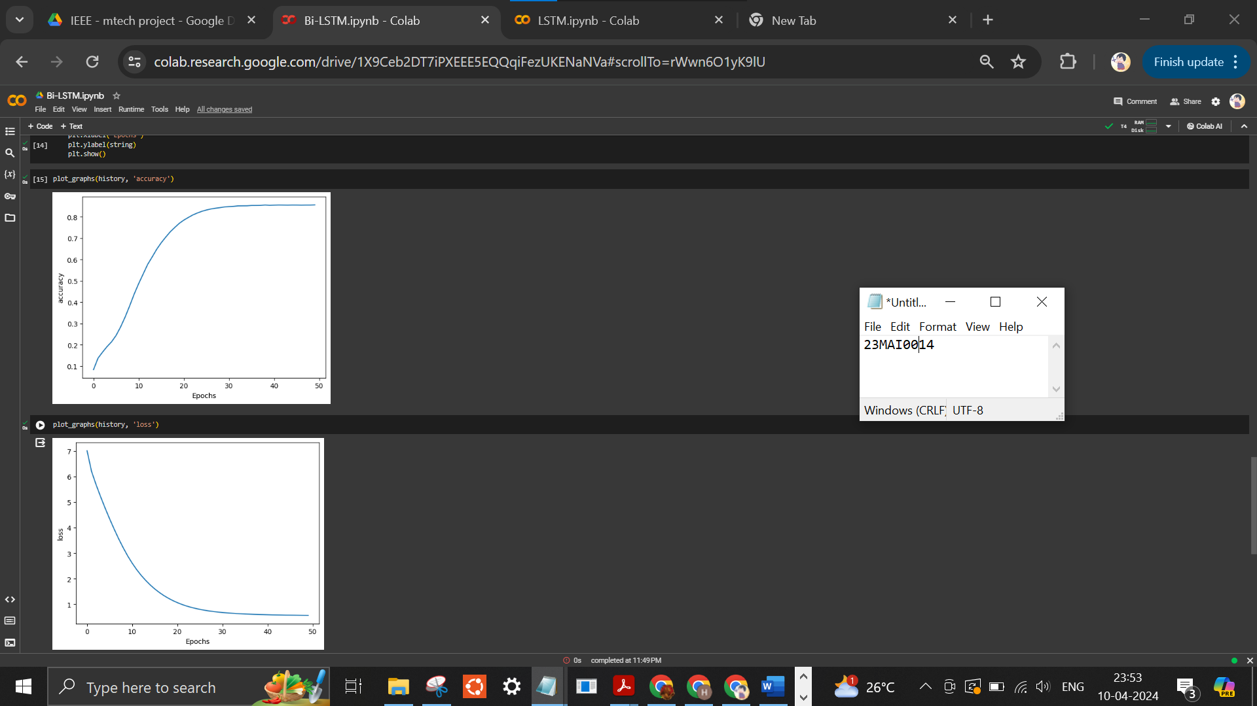

Google Colab link
https://colab.research.google.com/drive/1X9Ceb2DT7iPXEEE5EQQqiFezUKENaNVa?usp=sharing

Conclusion
In conclusion, Bi-LSTM's bidirectional processing enhances its ability to capture context from both past and future timesteps, making it a powerful tool for sequential data analysis tasks in natural language processing and beyond. Its versatility and effectiveness solidify its status as a pivotal advancement in recurrent neural network architectures.

