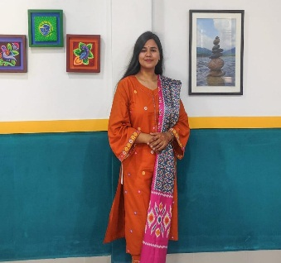

Father’s Name: A. B. AM. Omer Faruq

Mother’s Name: Gulnaher

Region: Islam

Marital status: Single

Nationality: Bangladeshi

Blood Group: B+

Permanent Address: Village Sararchar , Thana Bajitpur , District: Kishoreganj .

**ADDITIONAL INFORMATION INFORMATION**

**Shikorh** (SUST)

Member

**ACTIVITIES**

**Shahjalal University of Science & Technology**

BA(HONS)in Bangla

4th year 2nd Semester

**Aftab Uddin School & College**

HSC (2019)

GPA: 4.42

**Begum Rahima Girl’s High School**

SSC (2017)

GPA: 5.00

* Proficient in Microsoft word, excel and Power point
* Effective Written & Verbal Communication in both Bangla & English

**EDUCATION**

* Volunteer work and Fundraising
* Novel Recitation

**EXTRA CURRICULAM**

**INTERESTS**

* Reading Book
* Writing
* Bangla
* English

**LANGUAGE**

**SKILLS**

Date of Birth: 13 March 2002

Gender: Female

Phone: 01948882242

Email : haruajannatarpa@gmail.com

Address: Bajitpur, Kishoreganj

**Harua Jannat Arpa**