■DDL回答

**・customers TBL**

CREATE TABLE customers(   
 customer_id INT PRIMARY KEY  
 , name VARCHAR (255)  
 , email VARCHAR (255)  
 , phone VARCHAR (255)  
);

COMMENT ON COLUMN customers.customer_id IS '顧客ID';  
COMMENT ON COLUMN customers.name IS '顧客名';  
COMMENT ON COLUMN customers.email IS 'メールアドレス';  
COMMENT ON COLUMN customers.phone IS '電話番号';

**・orders TBL**

CREATE TABLE orders(   
 order_id INT PRIMARY KEY  
 , customer_id INT  
 , order_date DATE  
 , total DECIMAL (10, 2)  
 , FOREIGN KEY (customer_id) REFERENCES customers(customer_id)  
);

COMMENT ON COLUMN orders.order_id IS '注文ID';  
COMMENT ON COLUMN orders.customer_id IS '顧客ID';  
COMMENT ON COLUMN orders.order_date IS '注文日';  
COMMENT ON COLUMN orders.total IS '合計金額';

**・orders_items TBL**

CREATE TABLE order_items(   
 order_id INT  
 , product_id INT  
 , quantity INT  
 , price DECIMAL (10, 2)  
 , PRIMARY KEY (order_id, product_id)  
 , FOREIGN KEY (order_id) REFERENCES orders(order_id)  
 , FOREIGN KEY (product_id) REFERENCES products(product_id)  
);

COMMENT ON COLUMN order_items.order_id IS '注文ID';  
COMMENT ON COLUMN order_items.product_id IS '製品ID';  
COMMENT ON COLUMN order_items.quantity IS '数量';  
COMMENT ON COLUMN order_items.price IS '価格';

**・products TBL**

CREATE TABLE products(   
 product_id INT PRIMARY KEY  
 , name VARCHAR (255)  
 , price DECIMAL (10, 2)  
 , category VARCHAR (255)  
);

COMMENT ON COLUMN products.product_id IS '製品ID';  
COMMENT ON COLUMN products.name IS '製品名';  
COMMENT ON COLUMN products.price IS '価格';  
COMMENT ON COLUMN products.category IS 'カテゴリ';  
  
■テーブル名コメント  
COMMENT ON TABLE customers IS '顧客情報';  
COMMENT ON TABLE order_items IS '注文アイテム';  
COMMENT ON TABLE orders IS '注文情報';  
COMMENT ON TABLE products IS '製品情報';

■DML回答

**・customers TBL**

INSERT   
INTO customers(customer_id, name, email, phone)   
VALUES (   
 1  
 , '山田太郎'  
 , 'yamada@example.com'  
 , '012-3456-7890'  
)   
, (   
 2  
 , '田中花子'  
 , 'tanaka@example.com'  
 , '090-1234-5678'  
)   
, (   
 3  
 , '鈴木次郎'  
 , 'suzuki@example.com'  
 , '080-8765-4321'  
);

**・orders TBL**

INSERT   
INTO orders(order_id, customer_id, order_date, total)   
VALUES (1, 1, '2022-01-01', 160000.00)  
, (2, 1, '2022-02-01', 240000.00)  
, (3, 2, '2022-03-01', 120000.00)  
, (4, 3, '2022-04-01', 100000.00);

**・products TBL**

INSERT   
INTO products(product_id, name, price, category)   
VALUES (1, 'iPhone12', 80000.00, 'スマートフォン')  
, (2, 'iPad Pro', 120000.00, 'タブレット')  
, (3, 'MacBook Pro', 200000.00, 'パソコン')  
, (4, 'エアコン', 50000.00, '家電')  
, (5, 'テレビ', 100000.00, '家電');

**・orders_items TBL**

INSERT   
INTO order_items(order_id, product_id, quantity, price)   
VALUES (1, 1, 2, 80000.00)  
, (2, 3, 1, 200000.00)  
, (2, 4, 1, 50000.00)  
, (2, 5, 2, 200000.00)  
, (3, 2, 1, 120000.00)  
, (4, 4, 2, 100000.00);

■テーブルスクリーンショット

**customers TBL**

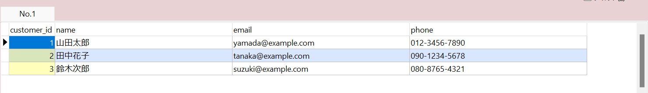

**ordersTBL**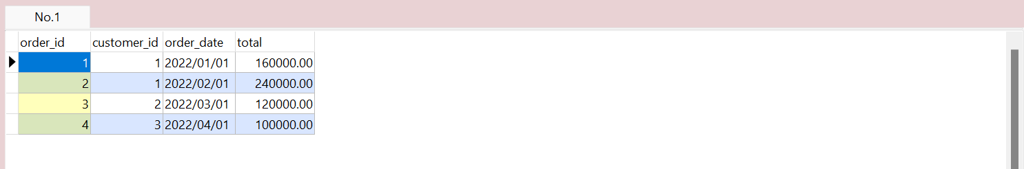

**productsTBL**

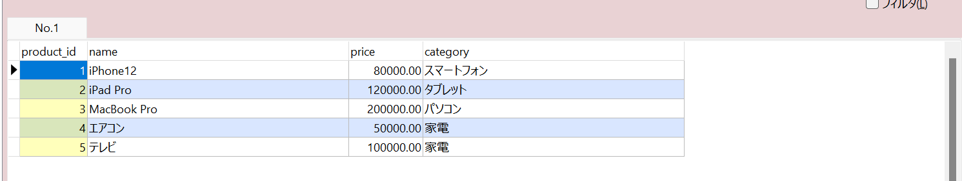

**orders_itemsTBL**

