When Universal Coverage Meets Local Capacity: A Prefectural Ecological Analysis of Perioperative Oral Care in Japan
Running title: Perioperative Oral Care Under Universal Coverage

Abstract
Rationale: Universal health coverage should align evidence-based care with clinical need, yet regional delivery may remain supply-sensitive. Perioperative oral functional management (POFM) is nationally reimbursed in Japan since 2012, but whether provision reflects surgical demand or healthcare supply capacity is unknown.
Aims and Objectives: To characterize prefectural variation in POFM delivery across Japan, identify its association with cancer surgical demand and dental workforce supply, and assess spatial clustering.
Method: Prefectural ecological study (N = 47) using Japan’s 10th NDB Open Data (fiscal year 2023). The primary outcome was POFM claim density per 100,000 population; the need-side exposure was major cancer surgery density (16 K-codes). We applied OLS regression with HC3 robust standard errors, seven pre-specified sensitivity analyses, Global Moran’s I, Lagrange Multiplier tests, and spatial lag regression.
Results: POFM density varied 2.25-fold across 47 prefectures (68,804–154,850 per 100,000). Cancer surgery density was not significantly associated with POFM density in any sensitivity specification (0/7 significant). Dentist density was the strongest predictor (r = 0.617, p < 0.0001). Significant positive spatial autocorrelation was identified (Moran’s I = 0.210, p = 0.024). The Spatial Lag Model confirmed a significant autoregressive coefficient (ρ = 0.354, p = 0.002), with cancer surgery density remaining non-significant.
Conclusion: POFM delivery is supply-sensitive rather than need-aligned under Japan’s universal coverage system. Equitable implementation may require simultaneous investment in dental workforce capacity, hospital–dental integration, and knowledge transfer alongside reimbursement.
Keywords: perioperative oral care; supply-driven care; universal health coverage; NDB Open Data; ecological study; spatial autocorrelation; Japan

1. Introduction
Healthcare systems aim to allocate evidence-based care according to patient need. However, regional healthcare delivery often reflects provider availability, institutional capacity, and local practice patterns rather than need alone [1–4]. This gap between need-driven allocation and supply-sensitive delivery has been central to the literature on unwarranted geographic variation in healthcare, but has been less often examined for dental-medical integration within universal health insurance systems.
Perioperative oral functional management (POFM) is an evidence-based practice that reduces postoperative complications such as aspiration pneumonia, surgical site infections, and mucositis in patients undergoing major surgery, radiotherapy, or chemotherapy [5–11]. In Japan, POFM has been incorporated into the national health insurance fee schedule since 2012 and was further expanded in the 2020 and 2022 diagnostic fee revisions to include a broader range of surgical and oncological indications [12]. In principle, such nationwide reimbursement should support need-based access.
In practice, however, POFM delivery may depend not only on the number of eligible surgical patients but also on whether local health systems have the dental workforce, hospital dental departments, referral pathways, and multidisciplinary routines needed to deliver the service [13–16]. This distinction is important because universal coverage creates formal eligibility, but implementation capacity determines whether evidence-based care actually reaches patients.
The National Database of Health Insurance Claims and Specific Health Checkups (NDB) Open Data provides prefecture-level aggregate medical and dental claims in Japan [17,18]. By linking major cancer surgery claims with POFM management fee claims, this study examined whether POFM provision is geographically aligned with a need-side proxy or instead reflects supply-side implementation capacity. The aims were to describe prefectural variation in POFM claim density, test its association with cancer surgical demand, assess spatial clustering, and interpret the pattern as a claims-based health services signal of need-driven versus supply-driven implementation.

2. Methods

2.1 Study Design and Setting
We conducted a cross-sectional ecological analysis of all 47 Japanese prefectures using the 10th NDB Open Data (fiscal year 2023: April 2023-March 2024) [17]. Only publicly available aggregate statistics were used; individual-level data were not accessed.

2.2 Data Sources

2.2.1 Primary Outcome: POFM Density
The primary outcome was perioperative oral management density (POFM density), defined as:
$$\text{POFM density}=\frac{\text{Annual claim count of B001-2 + B001-3}}{\text{Prefectural population}}×100,000$$
where B001-2 (Perioperative Oral Functional Management Fee I) and B001-3 (Perioperative Oral Functional Management Fee II) are the dental management procedure codes covering the pre-operative assessment, intraoperative support, and post-operative management phases of POFM in the Japanese dental fee schedule. These codes are billed recurrently throughout the perioperative period; the density metric reflects the aggregate utilization intensity across all POFM-eligible patients (including cancer surgery, chemotherapy, and radiation therapy patients) in each prefecture.

2.2.2 Exposure Variable: Major Cancer Surgery Density
The exposure was major cancer surgery density, defined as annual claims for 16 representative cancer surgery K-codes per 100,000 population. These 16 K-codes were selected to represent the principal oncological surgical procedures for which perioperative dental assessment and POFM referral are routinely recommended under the Japanese national health insurance fee schedule, encompassing the major cancer surgery types for which B001-2/3 claims are most frequently generated [5,7–11]. Because POFM eligibility also extends to chemotherapy and radiotherapy patients, cancer surgery density should be regarded as a pragmatic demand-side proxy rather than a comprehensive measure of total POFM-eligible need.

2.2.3 Covariates
- Prefecture-level covariates were selected a priori to capture demographic and socioeconomic context:
- Per-capita income: Ten-thousand Japanese yen units, from the same prefectural statistics
- Population density: Persons per km², from the same prefectural statistics
- Physicians per 100,000 population (sensitivity analysis only): Fiscal year 2023, included as an additional covariate in one sensitivity specification
- Dentists per 100,000 population (sensitivity analysis only): Calendar year 2022, derived from the Survey of Physicians, Dentists and Pharmacists (Ministry of Health, Labour and Welfare) [19], capturing the density of dentists working in medical facilities (hospitals and clinics)

2.3 Statistical Analysis

2.3.1 Primary Analysis
The primary analysis used ordinary least-squares regression with POFM density as the dependent variable and cancer surgery density as the independent variable. Models were estimated unadjusted and adjusted for aging rate, per-capita income, and population density. HC3 robust standard errors were used.
Two OLS regression models were estimated with HC3 heteroscedasticity-consistent standard errors. Model 1 (unadjusted) regressed POFM density on cancer surgery density alone. Model 2 (adjusted) additionally included aging rate, per-capita income, and population density.

2.3.2 Sensitivity Analysis
A pre-specified sensitivity analysis comprising seven model specifications was performed with cancer surgery density as the focus predictor and POFM density as the outcome. The specifications were: (1) baseline OLS with conventional standard errors; (2) the same model with HC3 robust standard errors (primary specification); (3) exclusion of prefectures with Cook’s distance greater than 4/n; (4) exclusion of the three central prefectures of Japan’s three major metropolitan areas (Tokyo, Osaka, and Aichi); (5) log-transformation of both outcome and exposure; (6) addition of physicians per 100,000 population as an extra covariate; and (7) addition of dentists per 100,000 population as an extra covariate. Because dentist density may lie partly on the causal pathway from supply capacity to POFM uptake, Specification 7 was treated as exploratory rather than part of the main adjusted model.

2.3.3 Spatial Analysis
Global Moran’s I tested spatial autocorrelation in POFM density. Lagrange Multiplier tests guided spatial model selection. A Spatial Lag Model (SLM) was selected when spatial lag dependence was supported [20,21]. Local Moran’s I (LISA) identified High-High and Low-Low clusters [22].
Local spatial clustering was examined using Local Indicators of Spatial Association (LISA; Local Moran’s I) with 999 permutations, classifying significant prefectures (p < 0.05) into High-High (HH), Low-High (LH), Low-Low (LL), or High-Low (HL) clusters [22].

2.3.4 Post-hoc Statistical Power
Post-hoc power was estimated for the main OLS models using a non-central F distribution [23]. Because the ecological unit was fixed at 47 prefectures, power estimates were interpreted descriptively.
All analyses were performed in Python 3.14 using pandas, statsmodels, geopandas, libpysal, esda, and spreg.

3. Results

3.1 Descriptive Statistics
All 47 prefectures were included. POFM density showed a 2.25-fold variation across prefectures (range: 68,804–154,850 /100K), while cancer surgery density varied 1.65-fold (173.6–287.0 /100K). Among the covariates examined, dentist density (dentists per 100,000 population) showed the strongest bivariate association with POFM density (r = 0.617, p < 0.0001), followed by population density (r = 0.425, p = 0.003) and per-capita income (r = 0.387, p = 0.007). Cancer surgery density (r = 0.094, p = 0.529) and aging rate (r = −0.234, p = 0.114) were not significantly correlated with POFM density.
(See Table 1)

3.2 Spatial Distribution of POFM and Cancer Surgery Density
The POFM density map (Figure 3) showed clustering, with higher densities in Tokai and western Japan and lower densities in Hokkaido and parts of Tohoku. The cancer surgery density map (Supplementary Figure S1) showed a different pattern, with the highest surgical volumes in urban prefectures such as Tokyo, Osaka, and Aichi.
(See Figure 3 and Supplementary Figure S1)

3.3 Association Between Cancer Surgery Density and POFM Density
The scatter plot (Figure 4) shows no clear linear association between cancer surgery density and POFM density across prefectures.
(See Appendix Figure A4)
(See Table 2)
In the adjusted model, the coefficients for aging rate (β = 538.6, p = 0.796), per-capita income (β = 10.5, p = 0.645), and population density (β = 7.2, p = 0.254) were also non-significant. Adjusted R² = 0.121.

3.4 Sensitivity Analysis
The forest plot (Figure 5) summarizes the cancer surgery density coefficient across seven sensitivity specifications. None of the seven specifications yielded a statistically significant association (p < 0.05; 0/7 specifications significant). In Specification 7 (adjusted additionally for dentist density), cancer surgery density remained non-significant (p > 0.05), while the inclusion of dentist density did not materially alter other model estimates.
(See Appendix Figure A5)

3.5 Spatial Autocorrelation and Spatial Regression
Global Moran’s I for POFM density was I = 0.210 (p = 0.024), indicating positive spatial autocorrelation. Two prefectures lacked Queen contiguity neighbors and were assigned median neighborhood weights.
Lagrange Multiplier tests on OLS residuals were significant for both lag and error dependence (LM-lag = 7.65, p = 0.006; LM-error = 7.45, p = 0.006). The Spatial Lag Model (SLM) was selected based on the robust tests.
The SLM produced a significant spatial autoregressive coefficient (ρ = 0.354, z = 3.14, p = 0.002). Cancer surgery density remained non-significant (β = 114.2, z = 0.79, p = 0.431). Model fit improved relative to OLS (pseudo-R² = 0.350; AIC 1081.1 vs. 1087.1; Supplementary Table S1).
Selected spatial lag model coefficients are provided in Supplementary Table S1.
LISA identified three High-High clusters in western Japan (Hyogo, Okayama, Saga) and three Low-Low clusters (Hokkaido, Iwate, Okinawa; Figure 6). No High-Low or significant Low-High clusters were detected.
(See Figure 6)

4. Discussion

4.1 Summary of Findings
The principal implication of this study extends beyond perioperative oral care. Universal insurance coverage did not necessarily translate into need-based delivery of evidence-based care. POFM provision varied 2.25-fold across prefectures, was not associated with cancer surgery density, was most strongly correlated with dentist density (r = 0.617, p < 0.0001), and showed positive spatial autocorrelation.

4.2 Healthcare Reimbursement Does Not Equal Healthcare Implementation
Coverage is necessary but insufficient for equitable delivery. Japan’s fee schedule creates a national reimbursement pathway for POFM, yet claim density differed more than twofold and was not aligned with regional cancer surgery density. This pattern is consistent with unwarranted variation and supply-sensitive care, where local capacity and practice infrastructure shape use even when insurance coverage is broad [1-4]. POFM may therefore serve as a signal of whether regional systems can implement an evidence-based perioperative service.
This interpretation does not imply that need is irrelevant; rather, the available cancer surgery measure should be viewed as an incomplete proxy for POFM-eligible clinical need.
Even so, the observed pattern is difficult to explain by need alone. Supply-side capacity, including hospital dental departments, trained POFM providers, referral pathways, and multidisciplinary perioperative routines, may strongly influence local uptake [13-15].
Historical implementation momentum may also matter. Early-adopting prefectures or university hospitals may have maintained higher utilization through accumulated expertise and referral routines, consistent with diffusion of healthcare innovations [24,25].

4.3 Spatial Diffusion of Supply-Driven Implementation
The significant spatial autoregressive coefficient (ρ = 0.354, p = 0.002) indicates that POFM uptake was spatially patterned. This is compatible with regional diffusion through professional networks, dental school outreach, and shared hospital dentistry staff pools, although these mechanisms were not directly measured [14,16,25,26].
The SLM fit better than OLS (ΔAIC = -6.0; pseudo-R² = 0.350 vs. OLS R² = 0.197), supporting the importance of spatial dependence in prefecture-level utilisation analyses [21]. Cancer surgery density remained non-significant in the SLM, again indicating that this demand proxy alone did not explain POFM provision.
LISA localized the spatial signal to HH clusters in Hyogo, Okayama, and Saga, and LL clusters in Hokkaido, Iwate, and Okinawa (Figure 6). These patterns are compatible with established medical-dental collaboration in some western regions and more constrained healthcare access in peripheral areas [16,25,27-29].

4.4 Supply-Side Determinants of Need-Based POFM Delivery
The findings point to supply-side capacity as a plausible driver of POFM provision (Figure 1). Three mechanisms are relevant.
First, dental workforce capacity is central. Dentist density showed the strongest bivariate association with POFM density (r = 0.617, p < 0.0001; Figure 2). HH clusters generally had average or above-average dentist density, whereas Okinawa, an LL cluster, had among the lowest dentist densities in Japan [19]. National surveys also show uneven hospital dentist employment, dental referral patterns, perioperative oral care capacity, and dental hygienist roles across facilities [13-16,30-33].
(See Appendix Figure A2)
Second, multidisciplinary infrastructure, including oral medicine specialists, dental representation in cancer care, and standardized referral protocols, can facilitate POFM implementation even where surgical caseload is not high [16,28].
Third, implementation lags may follow fee-schedule revisions. Expanded reimbursement requires institutional registration, credentialled personnel, and functioning referral routes; these requirements may diffuse unevenly across regions [12,24,34].

4.5 Comparison with Prior Studies and Health Policy Implications
Prior Japanese studies have examined POFM mainly at the hospital or patient level and documented postoperative benefits [5,7-10]. This study adds a macro-level health services perspective: even nationally reimbursed evidence-based care may remain supply-sensitive. POFM may therefore function as a case study of supply-driven implementation within universal health insurance.
The implications may extend beyond perioperative oral care. Other multidisciplinary services requiring cross-professional coordination may similarly depend on local implementation capacity rather than clinical need alone.

4.6 Strengths and Limitations
Strengths: The NDB Open Data provide nationwide prefecture-level aggregate claims for Japan [17,18]. The analysis combined sensitivity specifications, spatial methods, and national dental workforce data to evaluate a claims-based signal of supply-sensitive implementation.
Limitations: First, ecological analyses cannot support individual-level inference [35,36]. Second, POFM claim density captures utilization intensity, not the proportion of eligible patients receiving care. Third, cancer surgery K-codes capture only part of the POFM-eligible population, which may attenuate demand-implementation associations. Fourth, key supply-side variables, including hospital dental department density, cancer-designated hospital capacity, dental school outreach, and referral pathways, were unavailable in open prefecture-level data. Fifth, the cross-sectional design and fixed resolution of 47 prefectures limit causal inference and statistical power; the null finding should be interpreted as no detectable association at this aggregate level, not proof that surgical need is unrelated to delivery. Finally, median neighborhood weights for two island prefectures may marginally influence spatial estimates.

4.7 Policy Implications: Coverage Alone Does Not Ensure Equitable Implementation
Coverage alone does not ensure equitable implementation; implementation capacity matters. Substantial variation and LL clusters suggest that reimbursement should be paired with supply-side strengthening, including hospital-dental collaboration, workforce training, referral pathway development, and inter-prefectural knowledge transfer [12,14]. More broadly, financing reforms alone may be insufficient when local implementation capacity remains heterogeneous. Monitoring claims-based regional variation can identify evidence-based services that are formally covered but not yet delivered in a need-aligned manner.
Beyond Japan, these findings carry implications for health systems considering the introduction of perioperative oral care reimbursement. As POFM efficacy in reducing postoperative complications is well established [5–11], reimbursement may increasingly be adopted internationally. However, this study suggests that coverage alone may be insufficient: parallel investment in dental workforce development, hospital-dental integration, referral pathway infrastructure, and multidisciplinary care routines may be equally necessary to translate formal eligibility into equitable access to evidence-based perioperative care.

4.8 Conclusions
This ecological analysis demonstrated substantial prefectural variation in POFM provision in Japan, which was not explained by regional cancer surgical demand. POFM appears more supply-driven than need-driven, with dental workforce capacity, hospital-dental integration, and regional professional networks shaping implementation. These findings suggest that universal health insurance does not necessarily guarantee need-based delivery of evidence-based care. POFM may represent a case study of supply-sensitive implementation under universal coverage, with implications for healthcare systems seeking to translate coverage into equitable access to evidence-based care.

Acknowledgments
The authors thank the Ministry of Health, Labour and Welfare of Japan for providing access to the NDB Open Data. All data used are publicly available aggregate statistics.

Conflicts of Interest
The authors declare no conflicts of interest.

Data Availability
The NDB Open Data used in this analysis are publicly available from the Ministry of Health, Labour and Welfare of Japan (https://www.mhlw.go.jp/stf/seisakunitsuite/bunya/0000177182.html). Analysis code is available at https://github.com/haruki00430/NDB_POFM and archived on Zenodo (https://doi.org/10.5281/zenodo.20756258).

Author Contributions
Haruki Saito: Conceptualization, Data curation, Formal analysis, Investigation, Methodology, Software, Visualization, Writing – original draft, Writing – review and editing.
Tetsuya Ohira: Conceptualization, Supervision, Writing – review and editing.

Funding
None declared.

Declaration of Generative AI and AI-Assisted Technologies in the Manuscript Preparation Process
During the preparation and writing of this work, the authors used AI-assisted tools to support manuscript drafting and statistical analysis scripting. Cursor 3.0 (Anysphere) and Google Antigravity (Google) were used for AI-assisted writing and Python code development. Large language models used through these platforms included Claude Sonnet 4.6 and Claude Opus 4.8 (Anthropic) and GPT-5.5 (OpenAI) and Gemini 3 Pro (Google). These tools were used only for text drafting and code generation; no generative AI or AI-assisted tools were used to create, alter, or otherwise process any figures, images, or artwork in this manuscript. The authors reviewed and edited all AI-assisted outputs and were responsible for the study design, selection of statistical methods, interpretation of findings, conclusions, and final reference list. The authors take full responsibility for the integrity and accuracy of the final content. AI was not listed as an author.

References
1. Wennberg JE, Gittelsohn A. Small area variations in health care delivery. Science. 1973;182(4117):1102-8. doi:10.1126/science.182.4117.1102.
2. Wennberg JE, Fisher ES, Skinner JS. Geography and the debate over Medicare reform. Health Aff (Millwood). 2002;Suppl Web Exclusives:W96-114. doi:10.1377/hlthaff.w2.96.
3. Fisher ES, Wennberg DE, Stukel TA, Gottlieb DJ, Lucas FL, Pinder EL. The implications of regional variations in Medicare spending. Part 1: The content, quality, and accessibility of care. Ann Intern Med. 2003;138(4):273-87. doi:10.7326/0003-4819-138-4-200302180-00006.
4. Wennberg JE. Time to tackle unwarranted variations in practice. BMJ. 2011;342:d1513. doi:10.1136/bmj.d1513.
5. Ishimaru M, Matsui H, Ono S, Hagiwara Y, Morita K, Yasunaga H. Preoperative oral care and effect on postoperative complications after major cancer surgery. Br J Surg. 2018;105(12):1688-96. Available from: https://pubmed.ncbi.nlm.nih.gov/30088267/
6. Camus-Jansson F, Longueira-Diaz N, Salinas-Diaz B, Granic-Chinchon A, Cueto-Urbina W, Parra-Parra M, et al. Preoperative oral practices and incidence of postoperative complications in hospital medical-surgical procedures: A meta-analysis. Med Oral Patol Oral Cir Bucal. 2023;28(3):e217-28. Available from: https://pubmed.ncbi.nlm.nih.gov/37026607/
7. Shin JH, Kunisawa S, Fushimi K, Imanaka Y. Effects of preoperative oral management by dentists on postoperative outcomes following esophagectomy: Multilevel propensity score matching and weighting analyses using the Japanese inpatient database. Medicine (Baltimore). 2019;98(17):e15376. Available from: https://pubmed.ncbi.nlm.nih.gov/31027127/
8. Soutome S, Yanamoto S, Funahara M, Hasegawa T, Komori T, Yamada SI, et al. Effect of perioperative oral care on prevention of postoperative pneumonia associated with esophageal cancer surgery: A multicenter case-control study with propensity score matching analysis. Medicine (Baltimore). 2017;96(33):e7436. Available from: https://pubmed.ncbi.nlm.nih.gov/28816937/
9. Iwata E, Hasegawa T, Yamada SI, Kawashita Y, Yoshimatsu M, Mizutani T, et al. Effects of perioperative oral care on prevention of postoperative pneumonia after lung resection: Multicenter retrospective study with propensity score matching analysis. Surgery. 2019;165(5):1003-7. Available from: https://pubmed.ncbi.nlm.nih.gov/30765141/
10. Nobuhara H, Yanamoto S, Funahara M, Matsugu Y, Hayashida S, Soutome S, et al. Effect of perioperative oral management on the prevention of surgical site infection after colorectal cancer surgery: A multicenter retrospective analysis of 698 patients via analysis of covariance using propensity score. Medicine (Baltimore). 2018;97(40):e12545. Available from: https://pubmed.ncbi.nlm.nih.gov/30290611/
11. Duan L, Li D, Li Z, Luo W, Chu X. Effect of perioperative oral care on postoperative pneumonia in thoracic surgery patients: A systematic review and meta-analysis. Sci Rep. 2025 Dec 5;16(1):951. doi:10.1038/s41598-025-30492-6.
12. Ministry of Health, Labour and Welfare. Medical fee schedule revision for fiscal year 2022 (Reiwa 4). 2022. Available from: https://www.mhlw.go.jp/stf/seisakunitsuite/bunya/0000188411_00037.html
13. Kodama T, Ida Y, Oshima K, Miura H. Are public oral care services evenly distributed? Nation-wide assessment of the provision of oral care in Japan using the national database of health insurance claims. Int J Environ Res Public Health. 2021;18(20):10850.
14. Ishimaru M, Taira K, Zaitsu T, Inoue Y, Kino S, Takahashi H, et al. Characteristics of hospitals employing dentists, and utilization of dental care services for hospitalized patients in Japan: A nationwide cross-sectional study. Int J Environ Res Public Health. 2022;19(11):6448.
15. Nomura Y, Ohara Y, Yamamoto Y, Okada A, Hosoya N, Hanada N, et al. Dental hygienists’ practice in perioperative oral care management according to the Japanese dental hygienists survey 2019. Int J Environ Res Public Health. 2021;18(1):114. Available from: https://pubmed.ncbi.nlm.nih.gov/33375276/
16. Taira K, Mori T, Ishimaru M, Iwagami M, Sakata N, Watanabe T, et al. Regional inequality in dental care utilization in Japan: An ecological study using the national database of health insurance claims. Lancet Reg Health West Pac. 2021;12:100170.
17. Ministry of Health, Labour and Welfare. National Database of Health Insurance Claims and Specific Health Checkups Open Data: 10th release. 2024. Available from: https://www.mhlw.go.jp/stf/seisakunitsuite/bunya/0000177182.html
18. Sato S, Yasunaga H. A review of studies using Japanese nationwide administrative claims databases. Ann Clin Epidemiol. 2023;5(2):58-64. Available from: https://pubmed.ncbi.nlm.nih.gov/38505730/
19. Ministry of Health, Labour and Welfare. Survey of physicians, dentists and pharmacists: Reiwa 4 (2022). 2023. Available from: https://www.mhlw.go.jp/toukei/saikin/hw/ishi/22/index.html
20. Anselin L. Spatial econometrics: Methods and models. Dordrecht: Kluwer Academic Publishers; 1988.
21. LeSage JP, Pace RK. Introduction to spatial econometrics. Boca Raton: Chapman and Hall/CRC; 2009.
22. Anselin L. Local indicators of spatial association-LISA. Geogr Anal. 1995;27(2):93-115.
23. Cohen J. Statistical power analysis for the behavioral sciences. 2nd ed. Hillsdale (NJ): Lawrence Erlbaum Associates; 1988.
24. Greenhalgh T, Robert G, Macfarlane F, Bate P, Kyriakidou O. Diffusion of innovations in service organizations: Systematic review and recommendations. Milbank Q. 2004;82(4):581-629.
25. Ibuka Y, Matsuda Y, Shoji K, Ishigaki T. Evaluation of regional variations in healthcare utilization. Jpn J Stat Data Sci. 2020;3(1):349-65.
26. Seo Y, Takikawa T. Regional variation in national healthcare expenditure and health system performance in central cities and suburbs in Japan. Healthcare (Basel). 2022;10(6):968.
27. Shirakawa Y. Perioperative team cooperation at Okayama University Hospital [in Japanese]. Nihon Geka Gakkai Zasshi. 2017;118(2):149-54.
28. Kunitomi T, Miyagami T, Teranaka S, Matsumoto T, Yoshimatsu Y, Matsumoto S, et al. Current state and challenges of dental intervention in aspiration pneumonia management from the perspective of hospitalists: A cross-sectional survey in Japan. Int J Gen Med. 2025;18:6889-98.
29. Shirakura Y, Shobugawa Y, Saito R. Geographic variation in inpatient medical expenditure among older adults aged 75 years and above in Japan: A three-level multilevel analysis of nationwide data. Front Public Health. 2024;12:1306013.
30. Takazawa I, Suzuki H, Sugimoto K, Kabasawa Y, Adachi N, Yoshida N. Survey on status of oral care practices and factors associated with confidence in oral care skills in ward nurses at an acute hospital in Japan. BMC Oral Health. 2026;26(1):469.
31. Koike T, Ohta R, Matsuda Y, Sano C, Kanno T. Oral care awareness and factors related to the burden of nurses at a community hospital in Japan. Healthcare (Basel). 2022;10(6):1073.
32. Hashimura T, Tanimoto T, Morita T, Kami M. Distribution of dentists in the greater Tokyo area, Japan. Int Dent J. 2019;69(2):150-7. Available from: https://pubmed.ncbi.nlm.nih.gov/30350864/
33. Yamamoto T, Hanazato M, Hikichi H, Kondo K, Osaka K, Kawachi I, et al. Change in geographic accessibility to dental clinics affects access to care. J Dent Res. 2023;102(7):719-26. Available from: https://pubmed.ncbi.nlm.nih.gov/37204154/
34. Sato Y, Fukai K, Kunori Y, Yoshioka E, Saijo Y. Trends in dental expenditures in Japan with a universal health insurance system. PLoS One. 2023;18(10):e0292547.
35. Morgenstern H. Ecologic studies in epidemiology: Concepts, principles, and methods. Annu Rev Public Health. 1995;16:61-81. Available from: https://pubmed.ncbi.nlm.nih.gov/7639884/
36. Greenland S. Ecologic versus individual-level sources of bias in ecologic estimates of contextual health effects. Int J Epidemiol. 2001;30(6):1343-50. Available from: https://pubmed.ncbi.nlm.nih.gov/11821344/

Tables
Table 1. Descriptive statistics for all 47 prefectures
Variable | Mean (SD) | Min | Max | CV (%)
POFM density (/100K) | 103,963 (20,390) | 68,804 | 154,850 | 19.6
Cancer surgery density (/100K) | 237.7 (28.5) | 173.6 | 287.0 | 12.0
Aging rate (%) | 31.2 (3.1) | 24.4 | 38.3 | —
Per-capita income (¥10K) | 3,039 (280) | 2,553 | 4,055 | —
Population density (persons/km²) | 329 (482) | 63 | 6,363 | —
Dentists per 100,000 population | 77.0 (12.9) | 55.9 | 116.1 | 16.7

Table 2. Main regression results: POFM density vs. cancer surgery density
Model | n | β (cancer surgery density) | SE | p-value | 95% CI | R²
Model 1: Unadjusted | 47 | 98.3 | 153.3 | 0.510 | −210.2, 406.9 | 0.009
Model 2: Adjusted | 47 | 84.7 | 178.9 | 0.641 | −275.5, 444.9 | 0.197
Adjusted model: adjusted for aging rate, per-capita income, and population density.

Main Figures
Figure 3: Prefectural distribution of perioperative oral management (POFM) density (B001-2 + B001-3 claim counts per 100,000 population, FY2023).
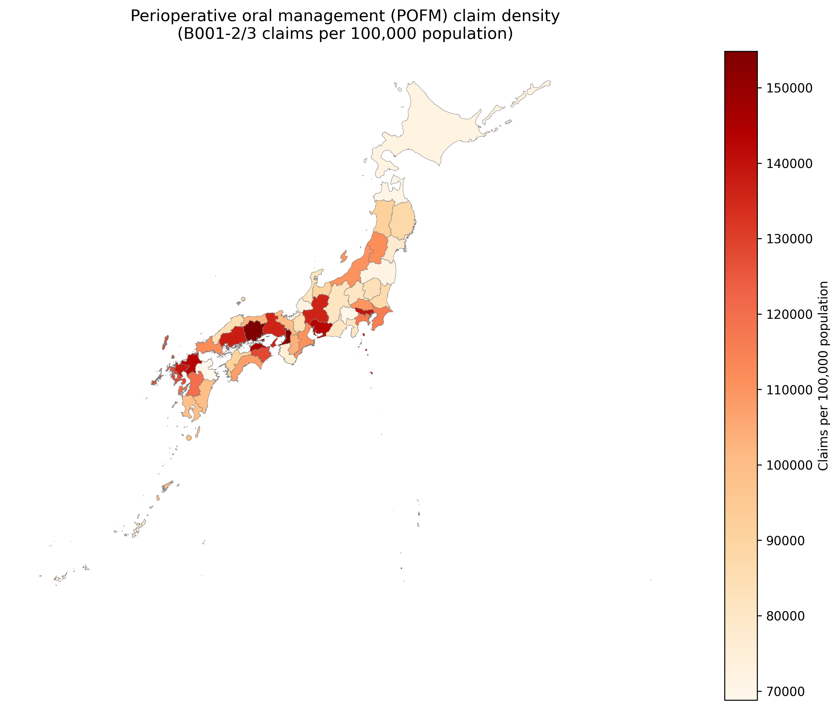
Choropleth map of POFM density by prefecture
Figure 6: Local Indicators of Spatial Association (LISA) cluster map of POFM density across 47 Japanese prefectures (999 permutations, p < 0.05). Red = High-High (HH, n=3); Blue = Low-Low (LL, n=3); Light blue = Low-High (LH, n=1); Grey = Not significant (n=40).
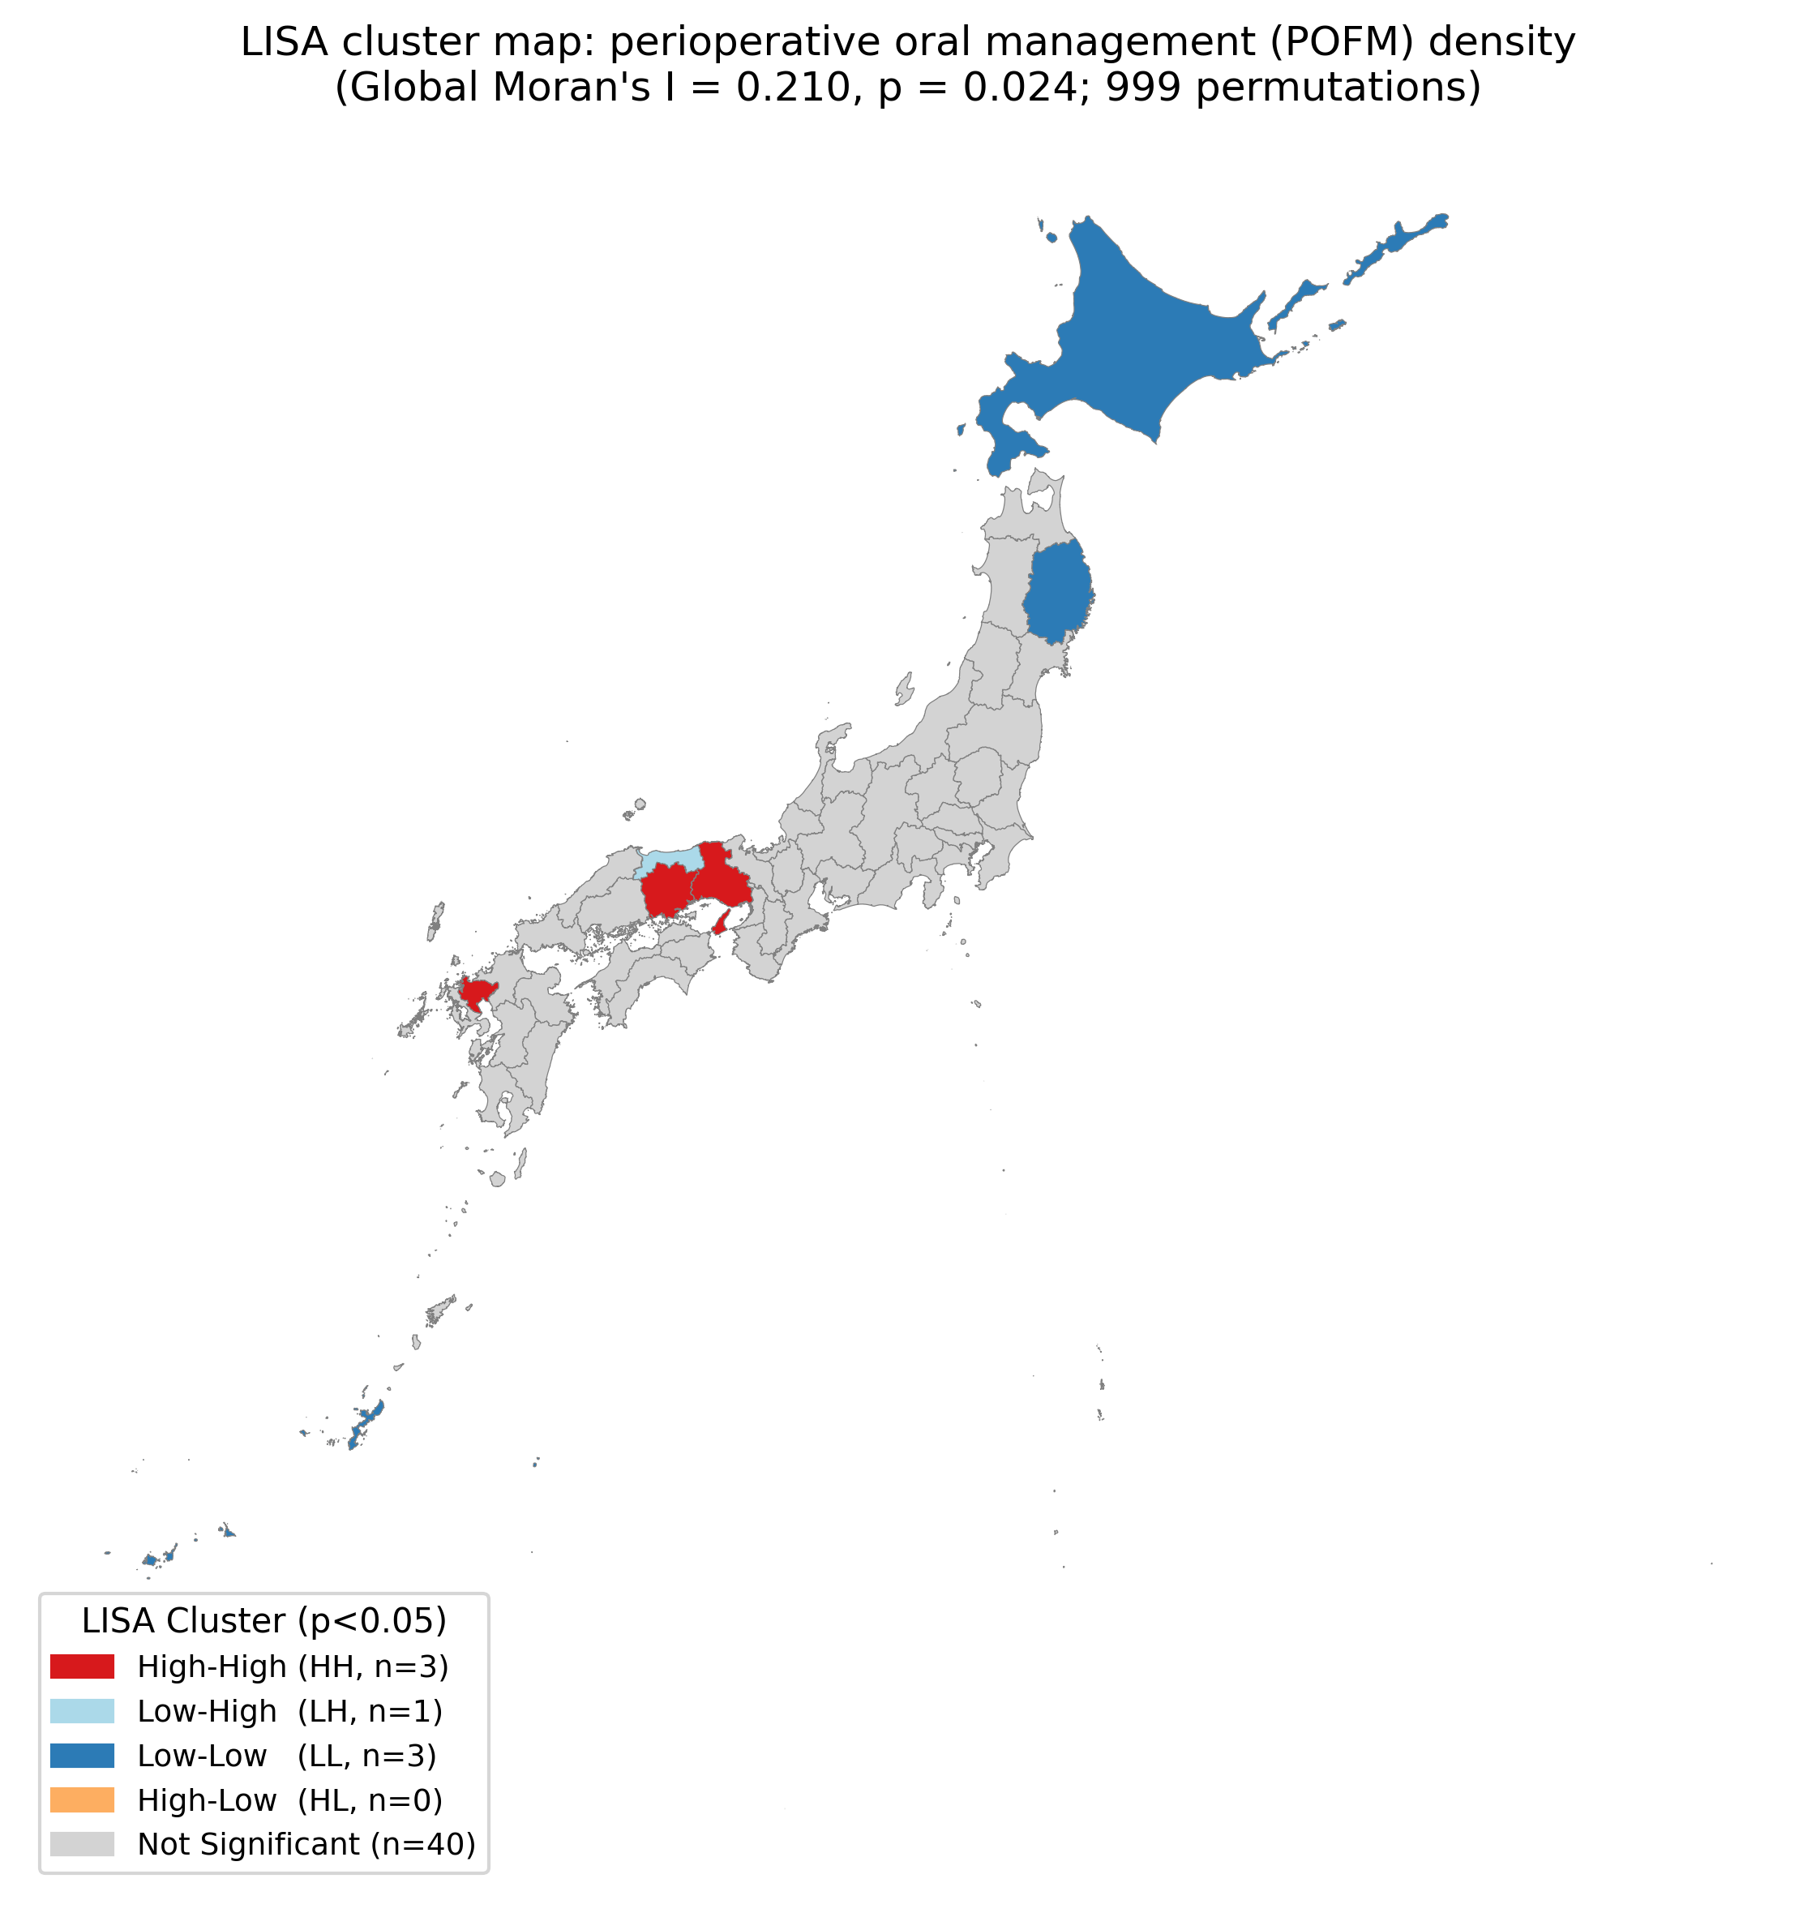
LISA cluster map of POFM density

Appendix
Appendix Table A1. Selected Spatial Lag Model (SLM) results
Parameter | Estimate | z-statistic | p-value
Spatial lag (ρ) | 0.354 | 3.14 | 0.002
Cancer surgery density (β) | 114.2 | 0.79 | 0.431
Aging rate (β) | −1,562.2 | −0.87 | 0.385
Per-capita income (β) | −6.2 | −0.33 | 0.742
Population density (β) | 8.1 | 1.81 | 0.071
Constant | 103,519.5 | 1.17 | 0.241
Pseudo-R² | 0.350 | — | —
AIC | 1,081.1 | — | —
Log-likelihood | −534.5 | — | —
n | 47 | — | —
All model coefficients, the spatial lag parameter (ρ), and model fit statistics are reported. HC3 robust standard errors were not applied to the SLM (maximum likelihood estimation). Adjusted for aging rate, per-capita income, and population density.

Appendix Figures
Appendix Figure A1: Conceptual framework for need-driven versus supply-driven POFM implementation under universal health coverage.
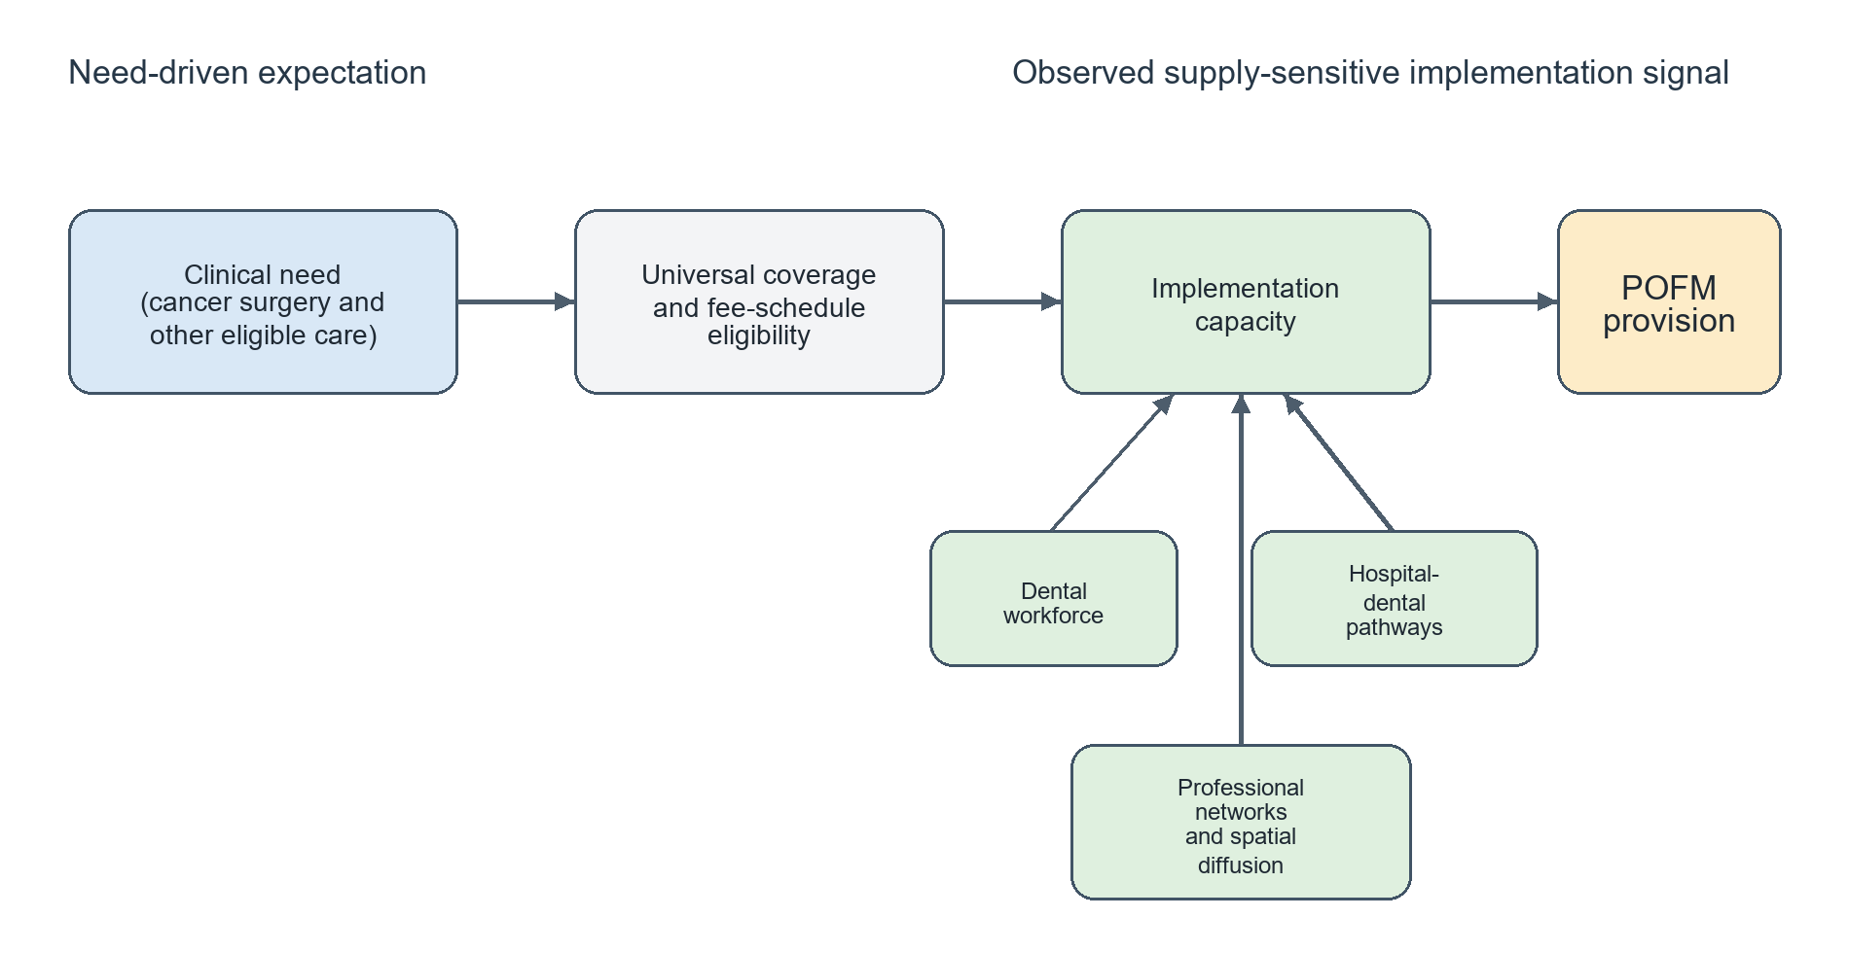
Appendix Figure A2: Scatter plot of prefectural dentist density (dentists per 100,000 population, 2022) vs. POFM density (B001-2 + B001-3 per 100,000 population, FY2023) across 47 Japanese prefectures. Red labels = High-High LISA clusters (Hyogo, Okayama, Saga); Blue labels = Low-Low LISA clusters (Hokkaido, Iwate, Okinawa).
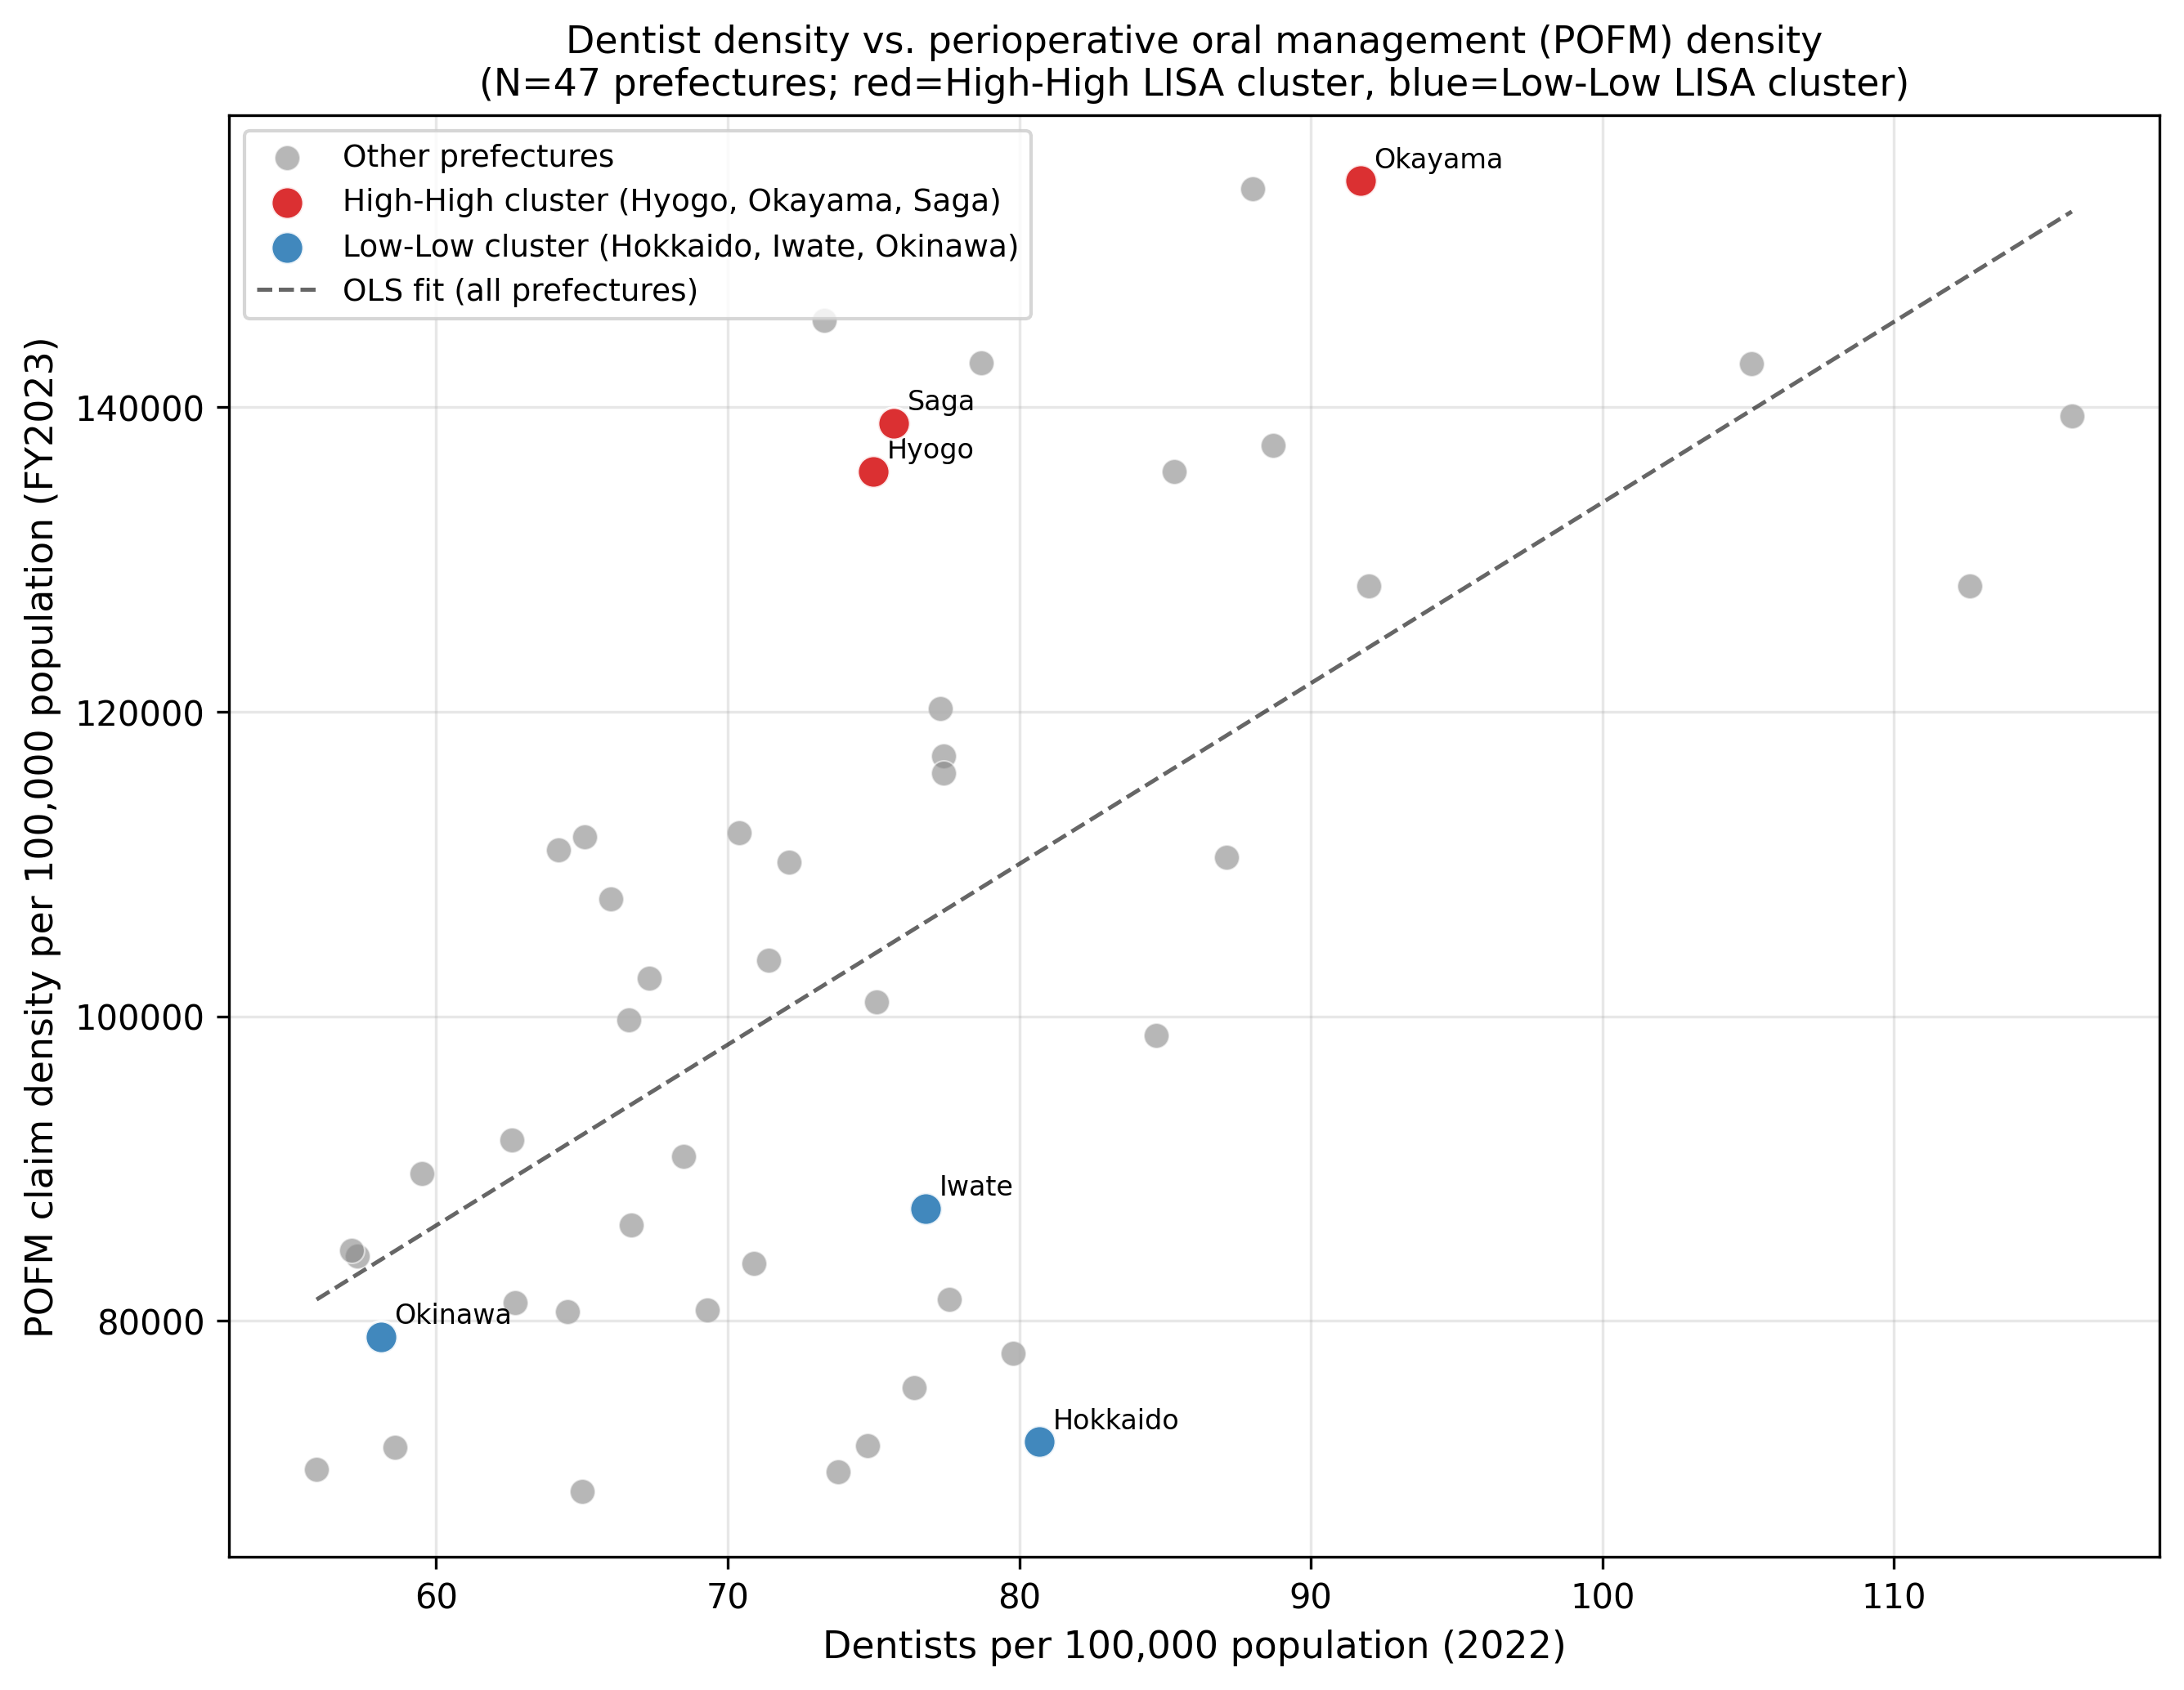
Appendix Figure A4: Scatter plot of cancer surgery density vs. POFM density by prefecture (N = 47). The dashed line indicates the OLS regression fit (β = 98.3, p = 0.510).
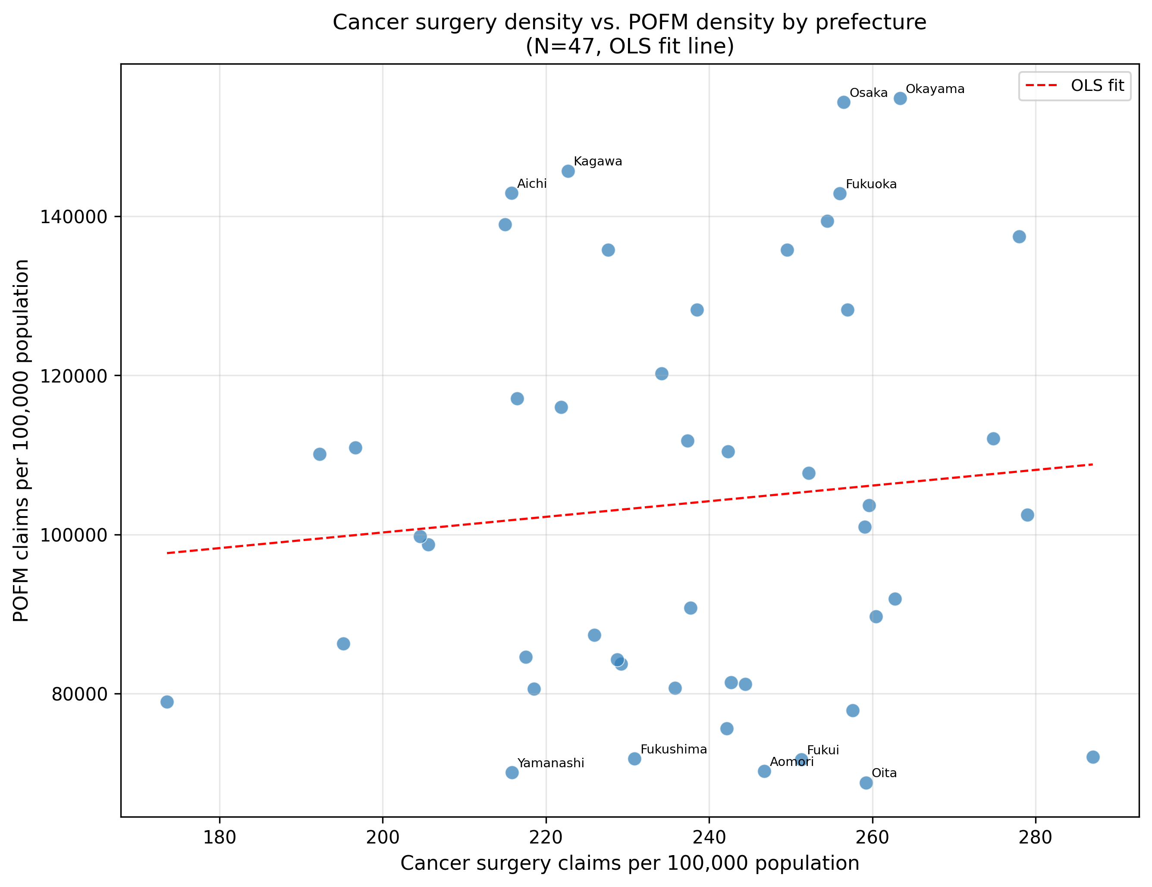
Scatter plot of cancer surgery density vs. POFM density
Appendix Figure A5: Forest plot of cancer surgery density regression coefficients across seven sensitivity analysis specifications. Bars represent 95% confidence intervals. Red = p<0.05; Blue = p≥0.05.
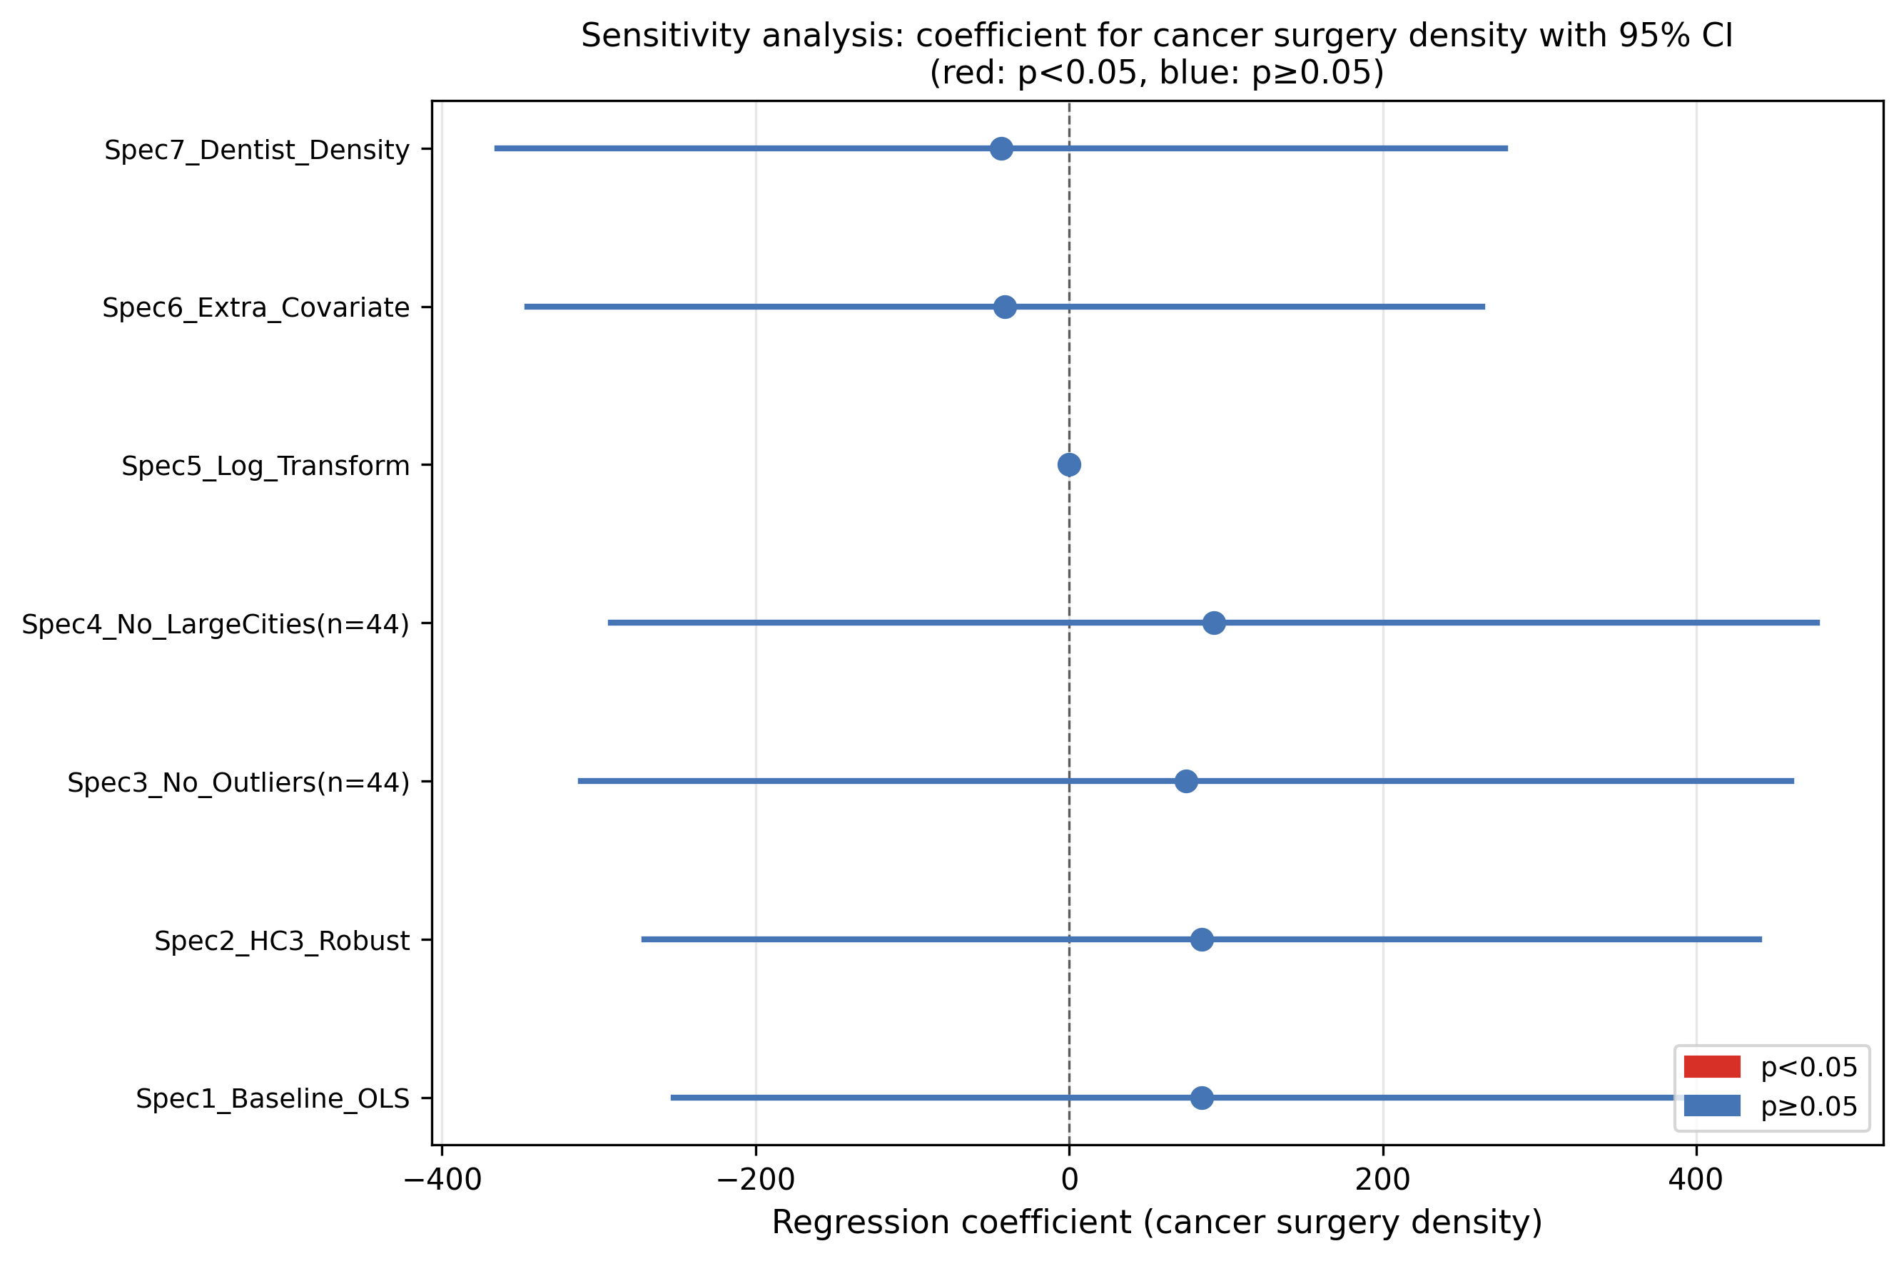
Forest plot of sensitivity analysis coefficients

Supplementary Figures
Supplementary Figure S1: Prefectural distribution of major cancer surgery density (16 K-codes per 100,000 population, FY2023).
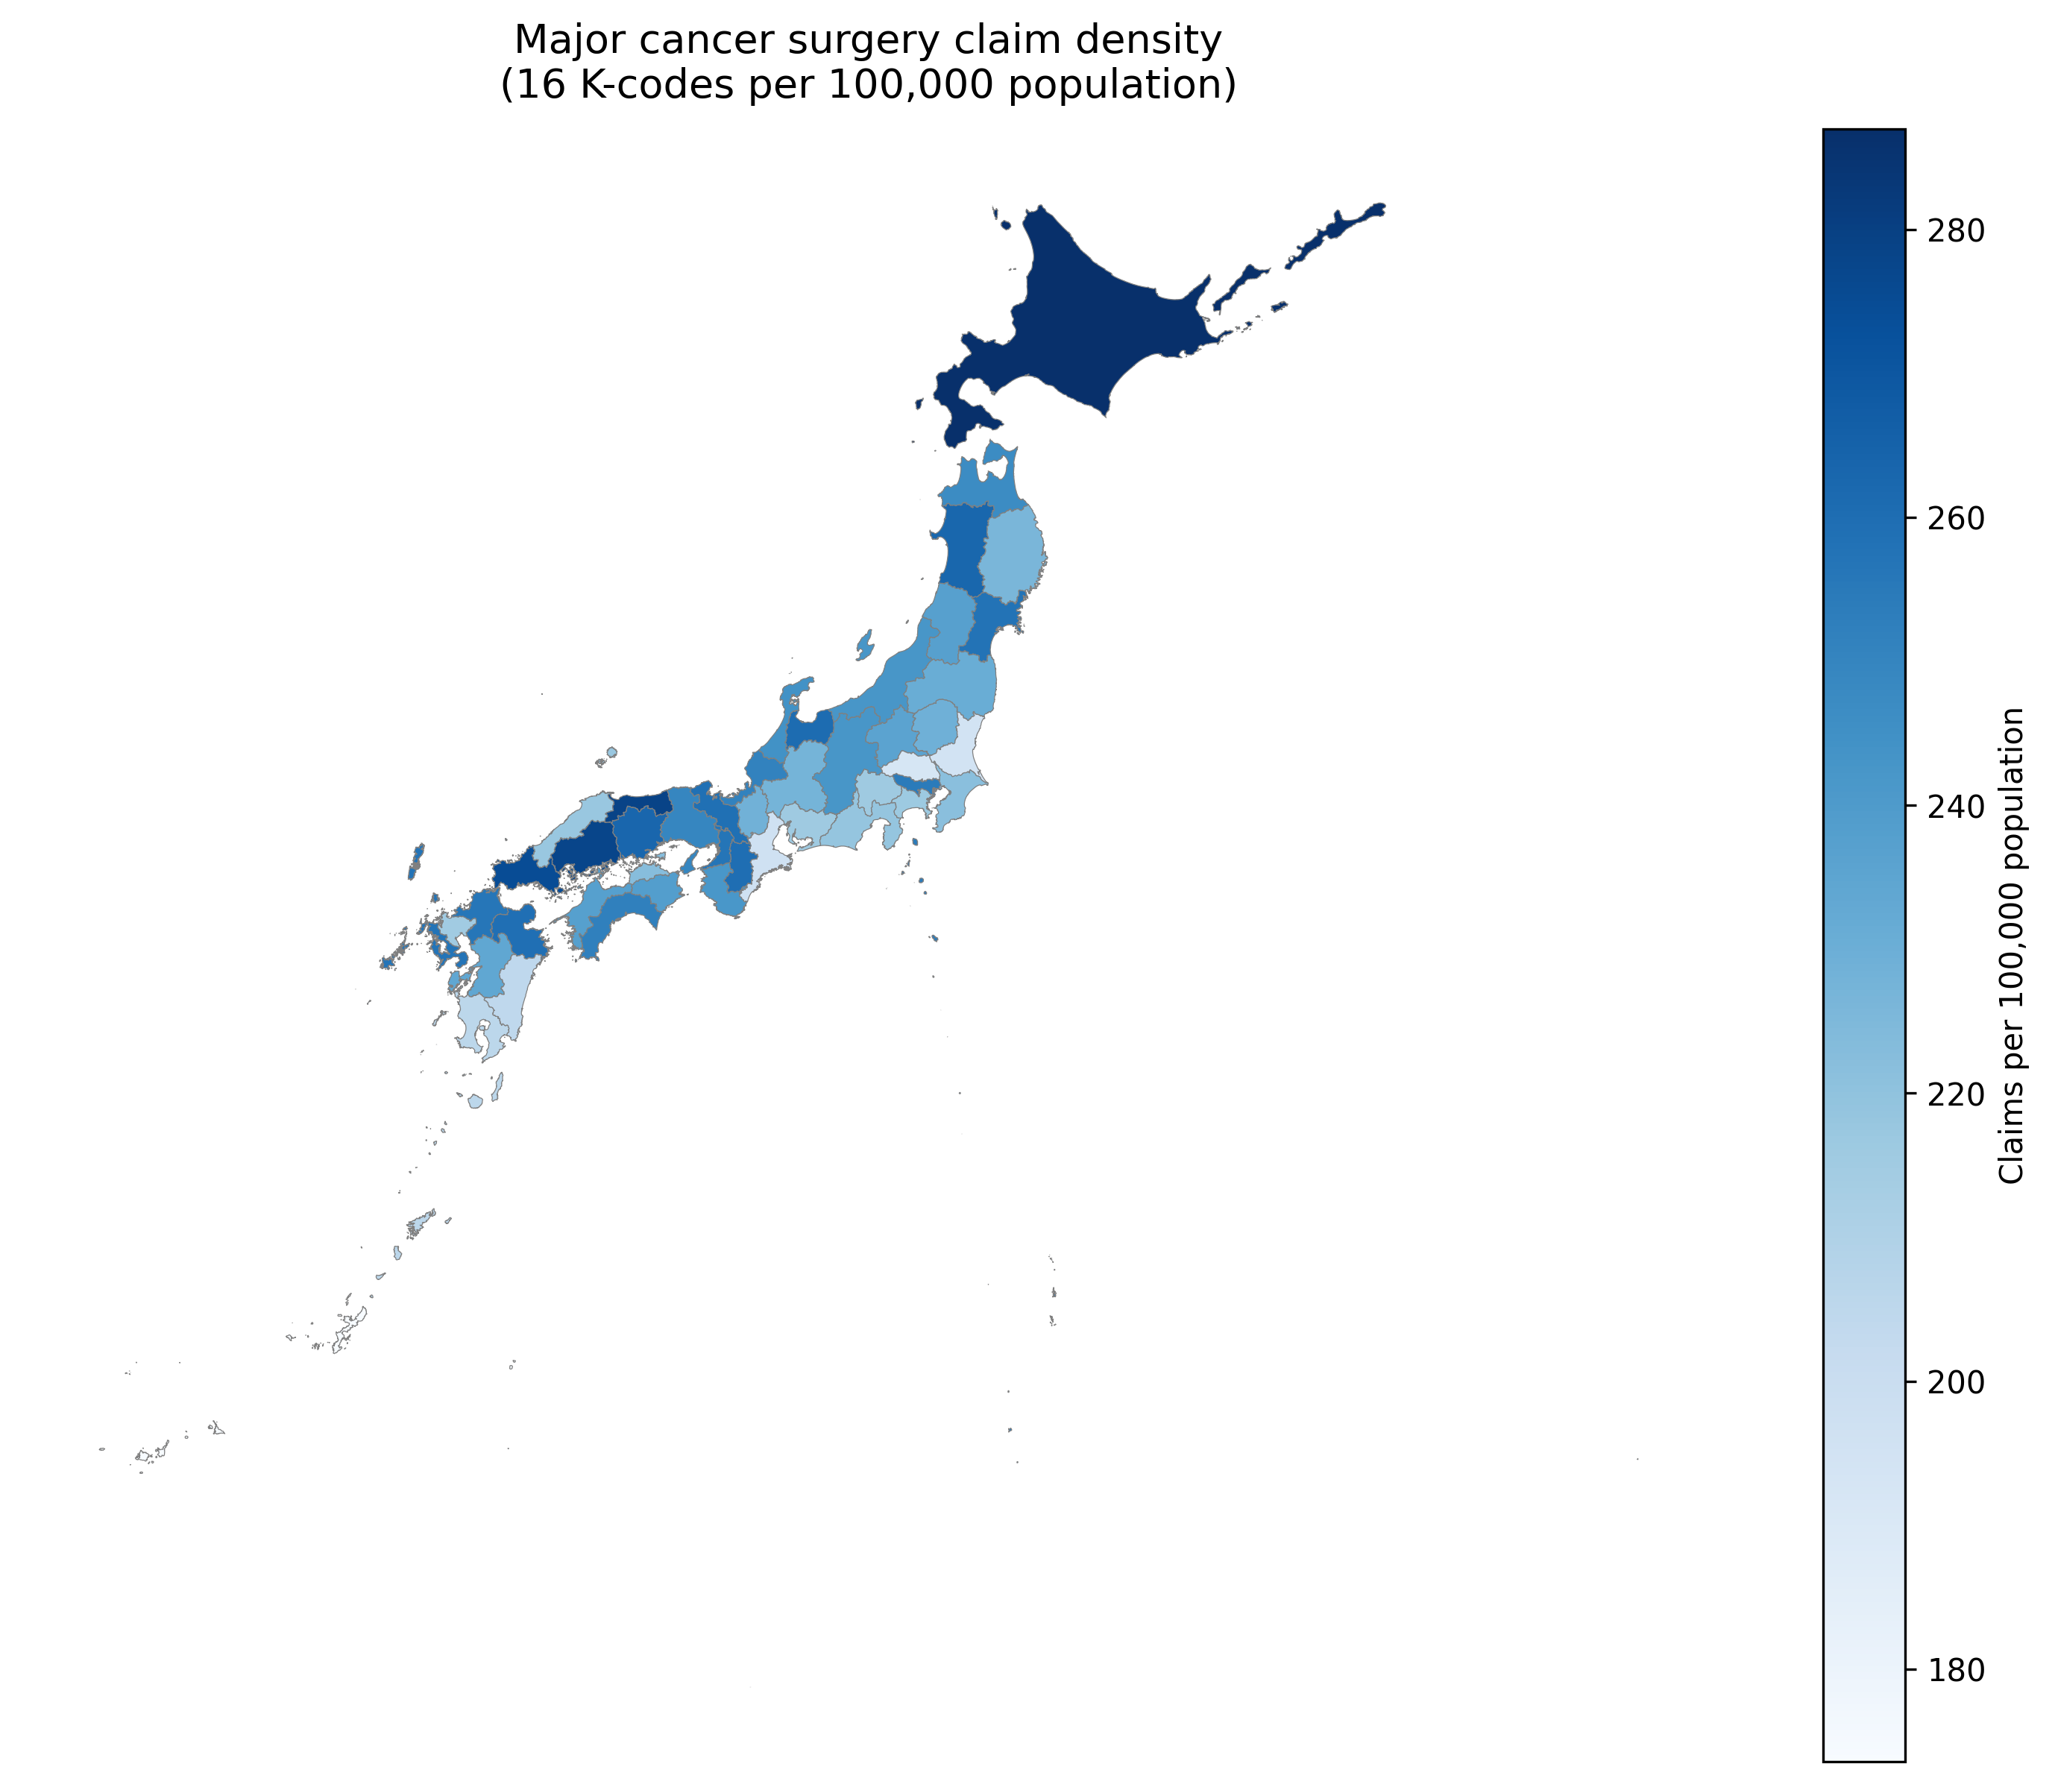
Cancer surgery density map by prefecture
Scatter plot of dentist density vs. POFM density

