Supplementary Material
Appendix
Appendix Table A1. Selected Spatial Lag Model (SLM) results
All model coefficients, the spatial lag parameter (ρ), and model fit statistics are reported. HC3 robust standard errors were not applied to the SLM (maximum likelihood estimation). Adjusted for aging rate, per-capita income, and population density.

Appendix Figures
Appendix Figure A1: Conceptual framework for need-driven versus supply-driven POFM implementation under universal health coverage.
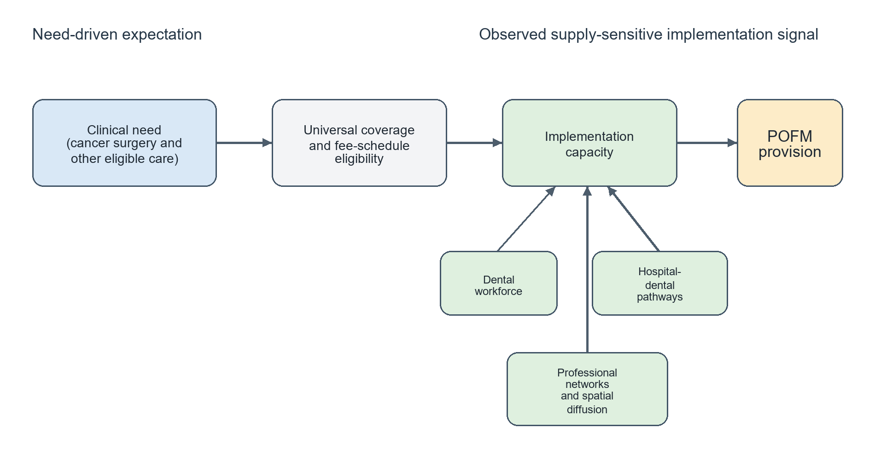
Appendix Figure A2: Scatter plot of prefectural dentist density (dentists per 100,000 population, 2022) vs. POFM density (B001-2 + B001-3 per 100,000 population, FY2023) across 47 Japanese prefectures. Red labels = High-High LISA clusters (Hyogo, Okayama, Saga); Blue labels = Low-Low LISA clusters (Hokkaido, Iwate, Okinawa).
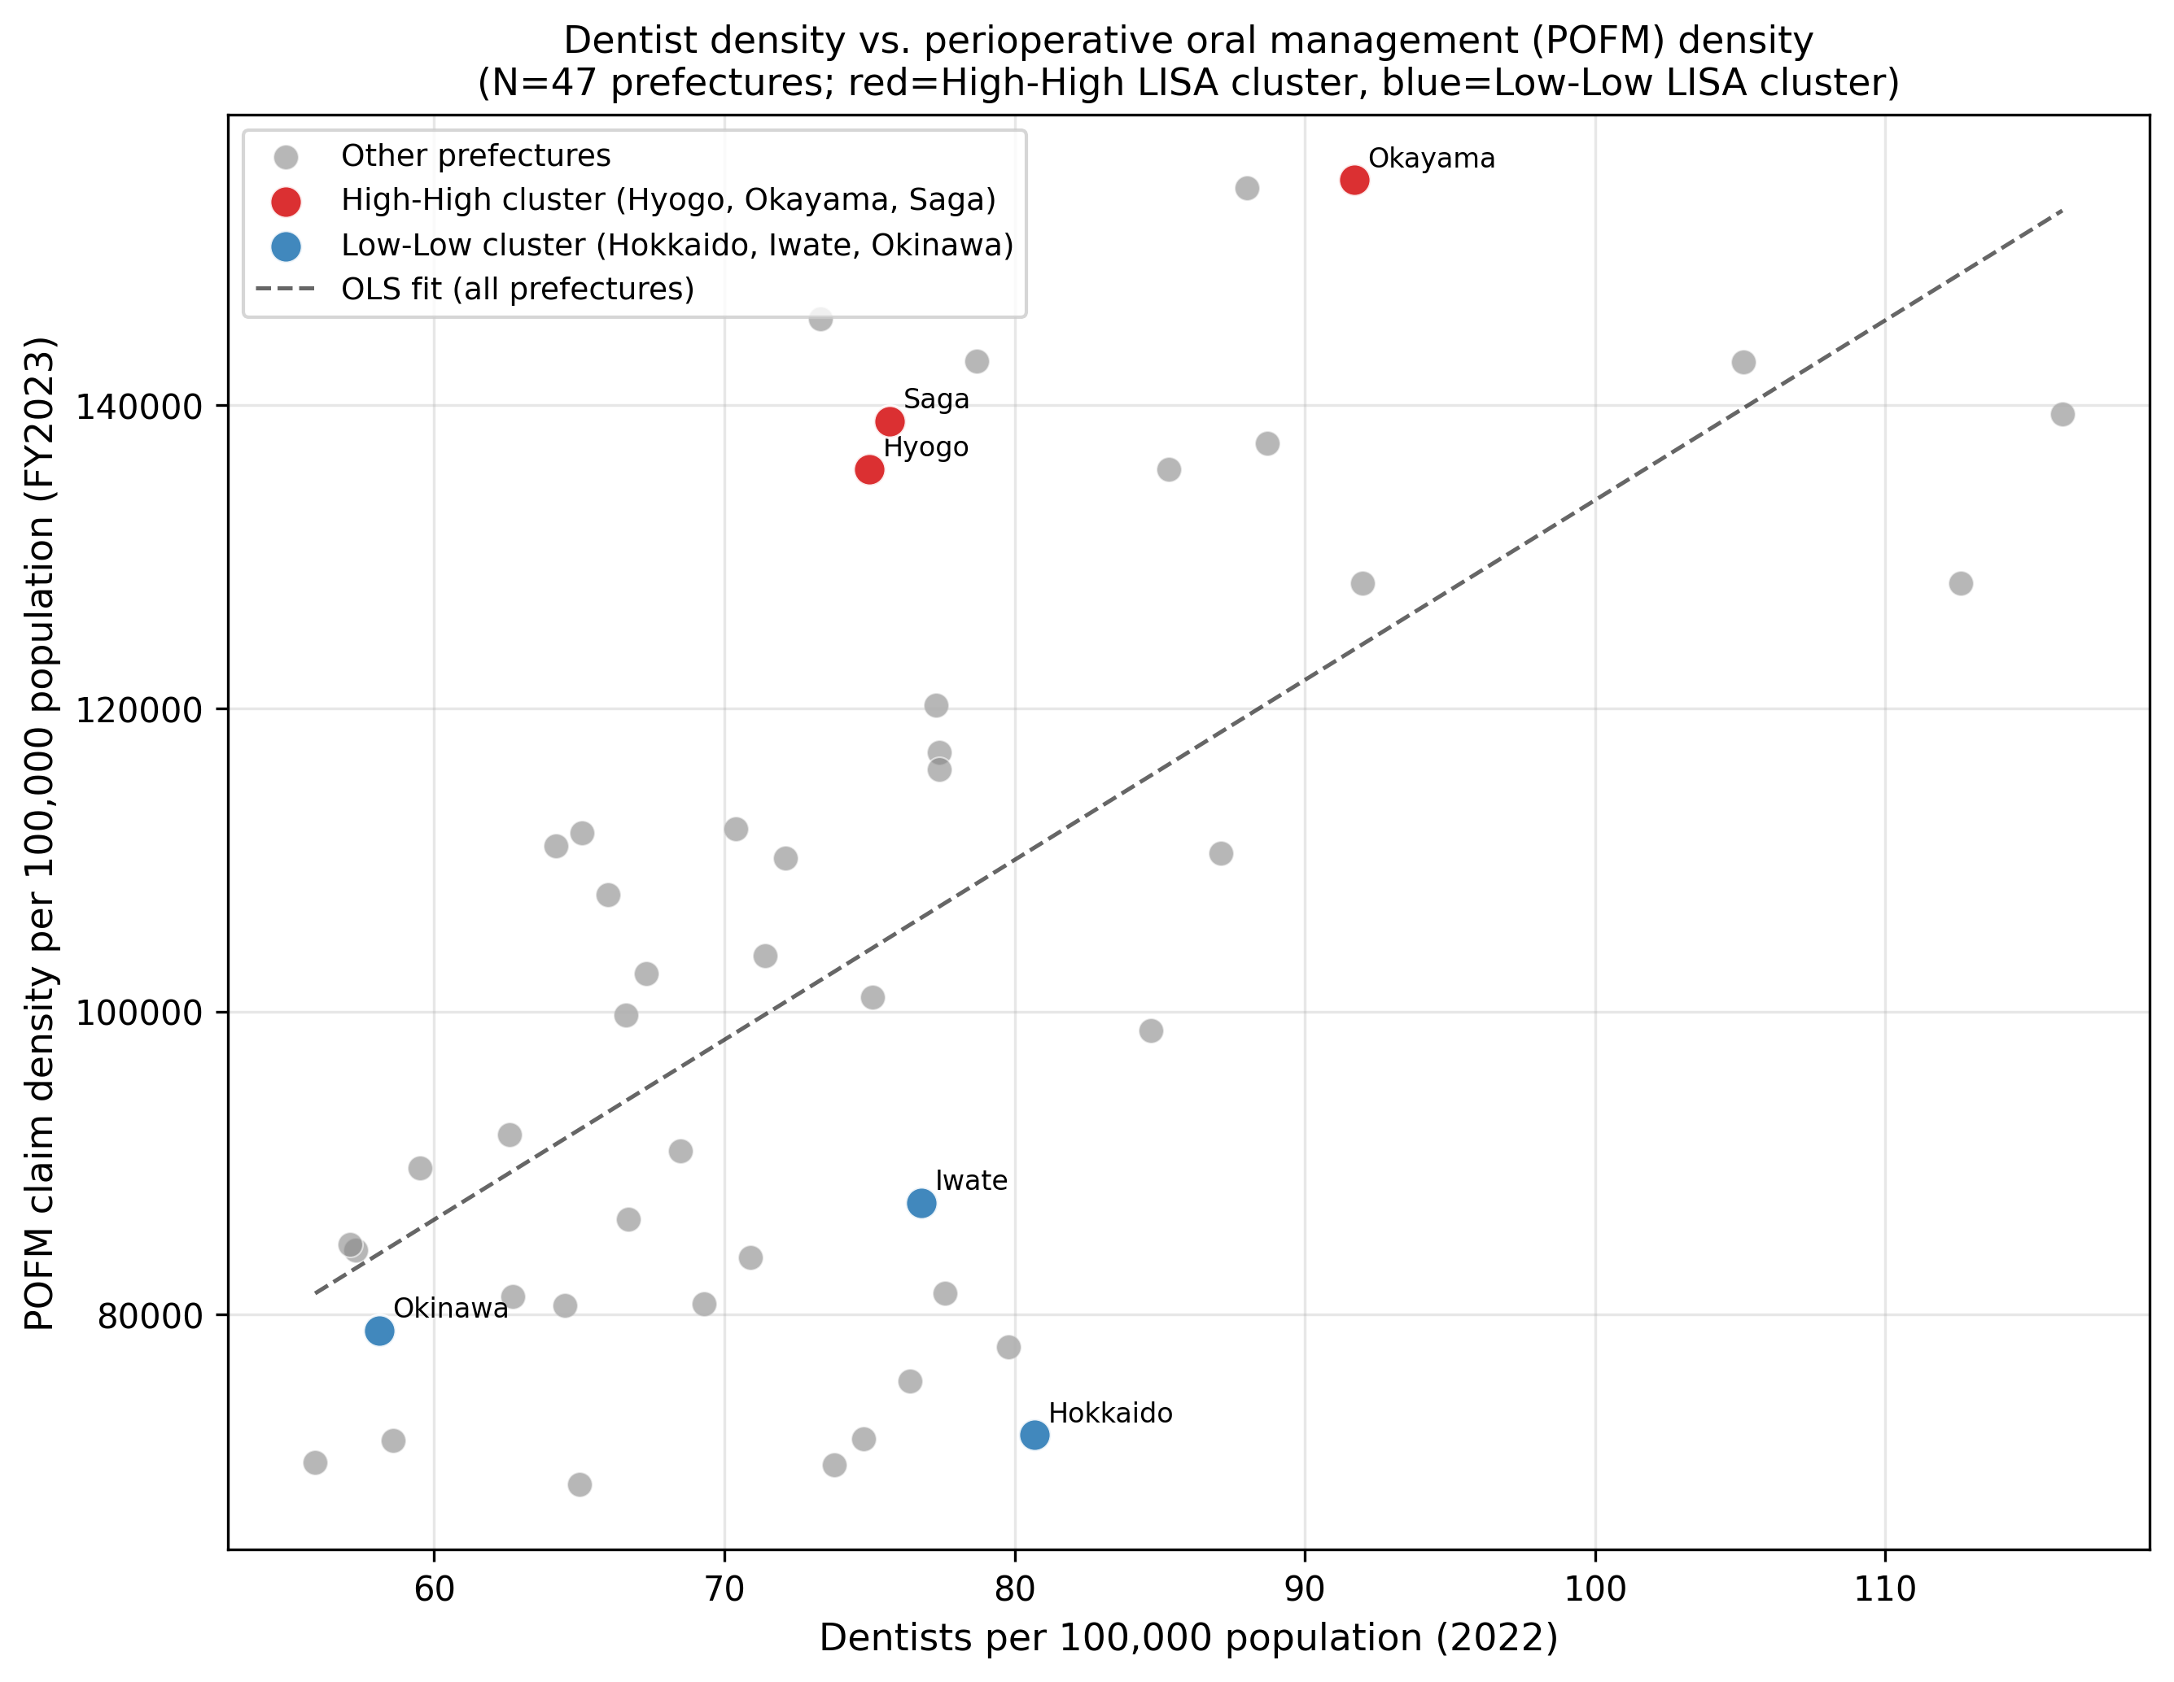
Appendix Figure A4: Scatter plot of cancer surgery density vs. POFM density by prefecture (N = 47). The dashed line indicates the OLS regression fit (β = 98.3, p = 0.510).
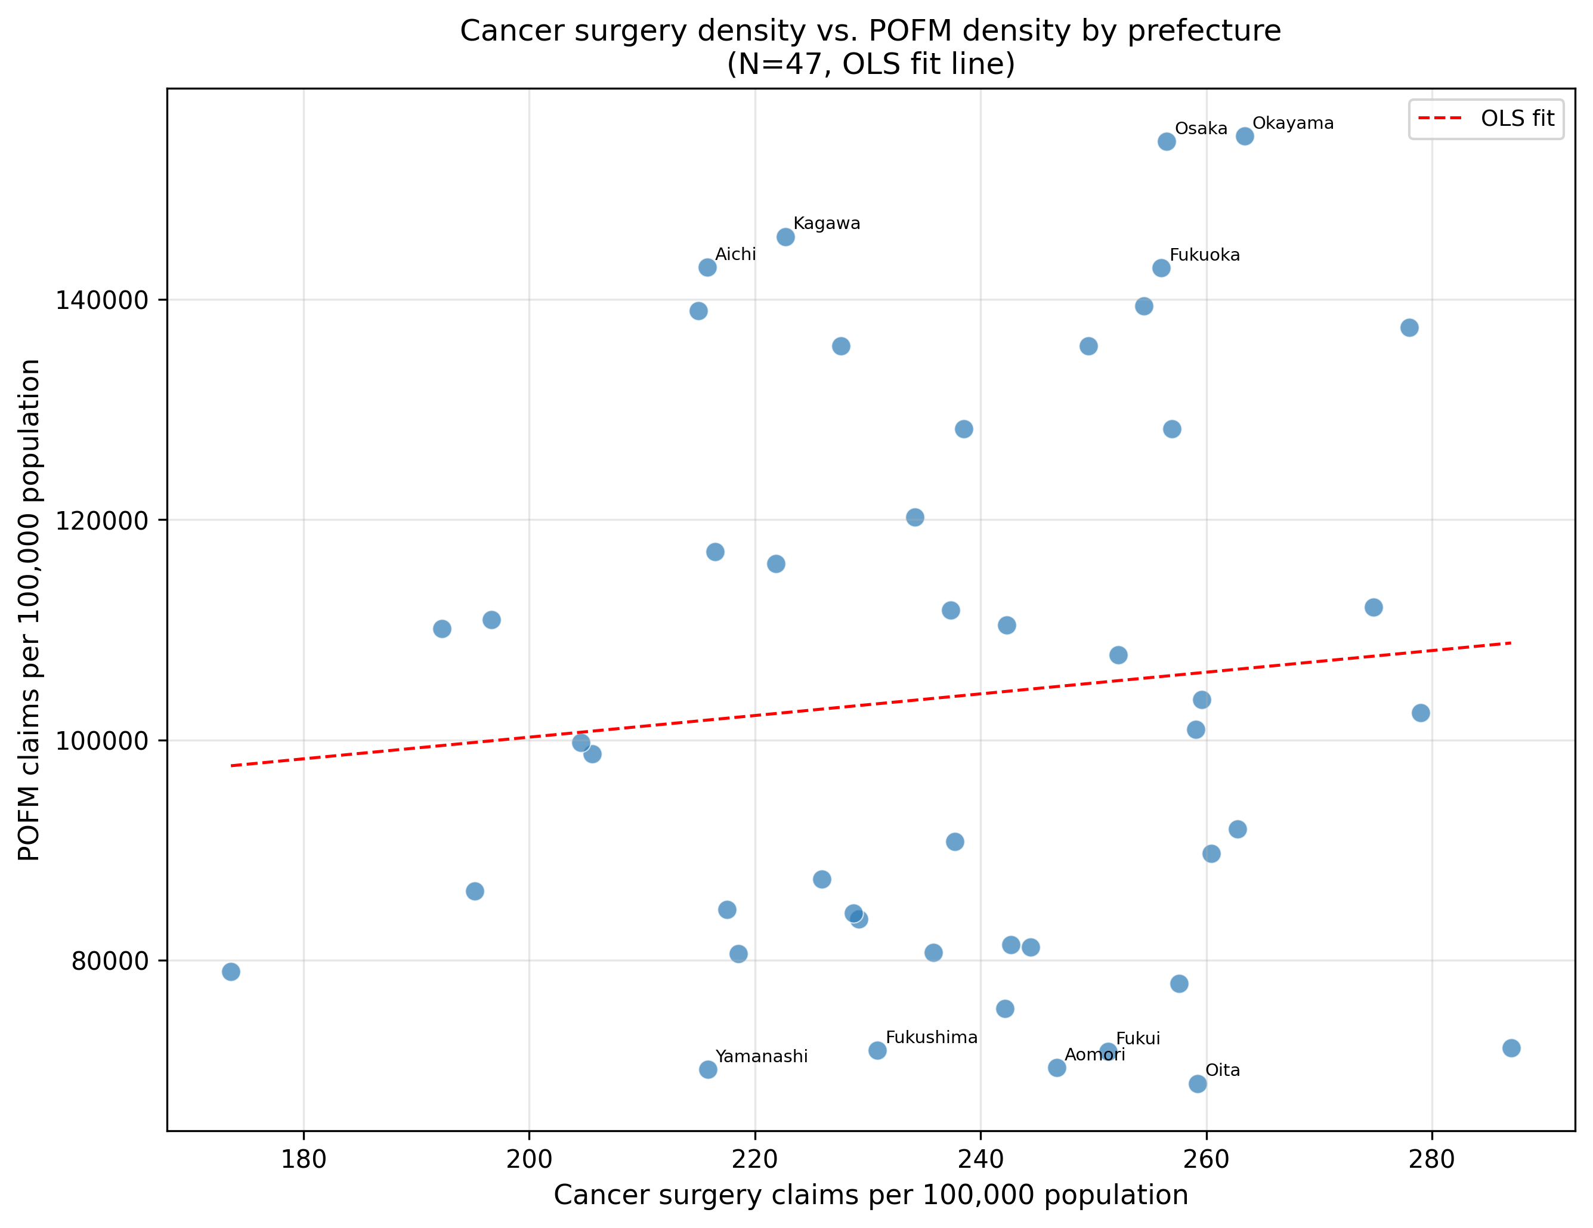
Scatter plot of cancer surgery density vs. POFM density
Appendix Figure A5: Forest plot of cancer surgery density regression coefficients across seven sensitivity analysis specifications. Bars represent 95% confidence intervals. Red = p<0.05; Blue = p≥0.05.
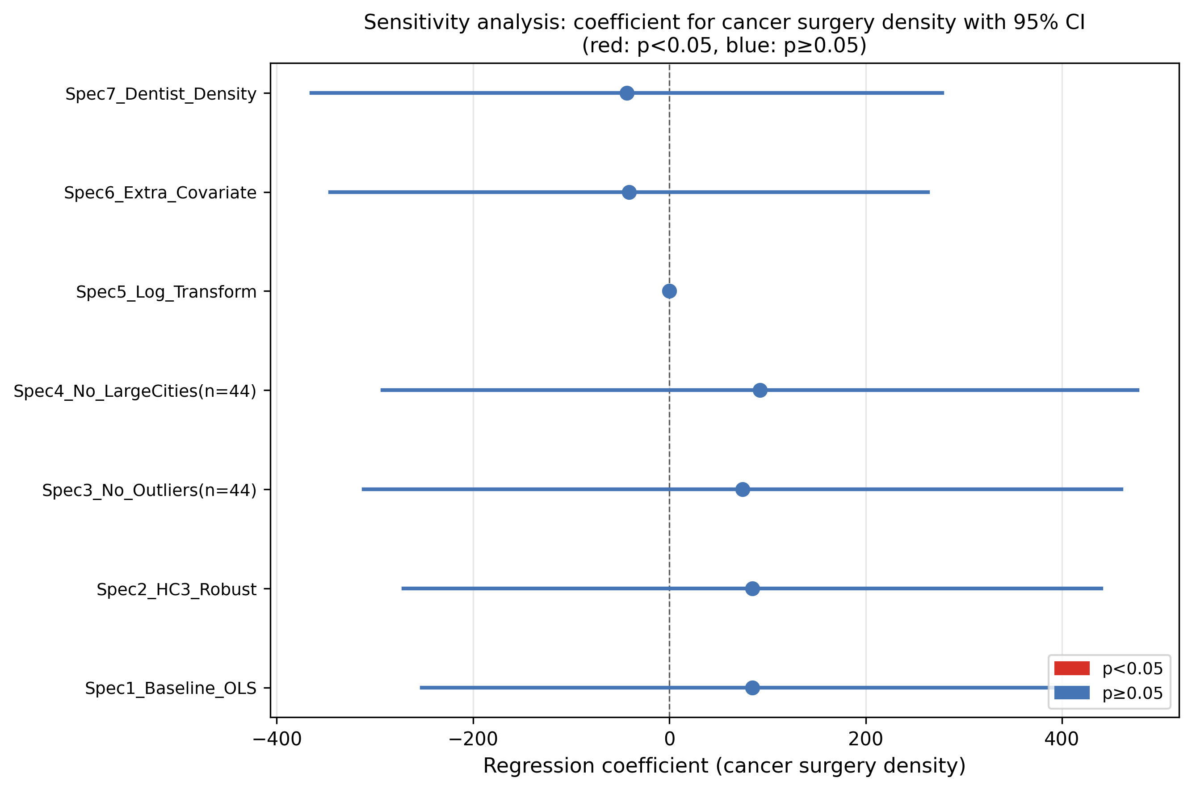
Forest plot of sensitivity analysis coefficients

Supplementary Figures
Supplementary Figure S1: Prefectural distribution of major cancer surgery density (16 K-codes per 100,000 population, FY2023).
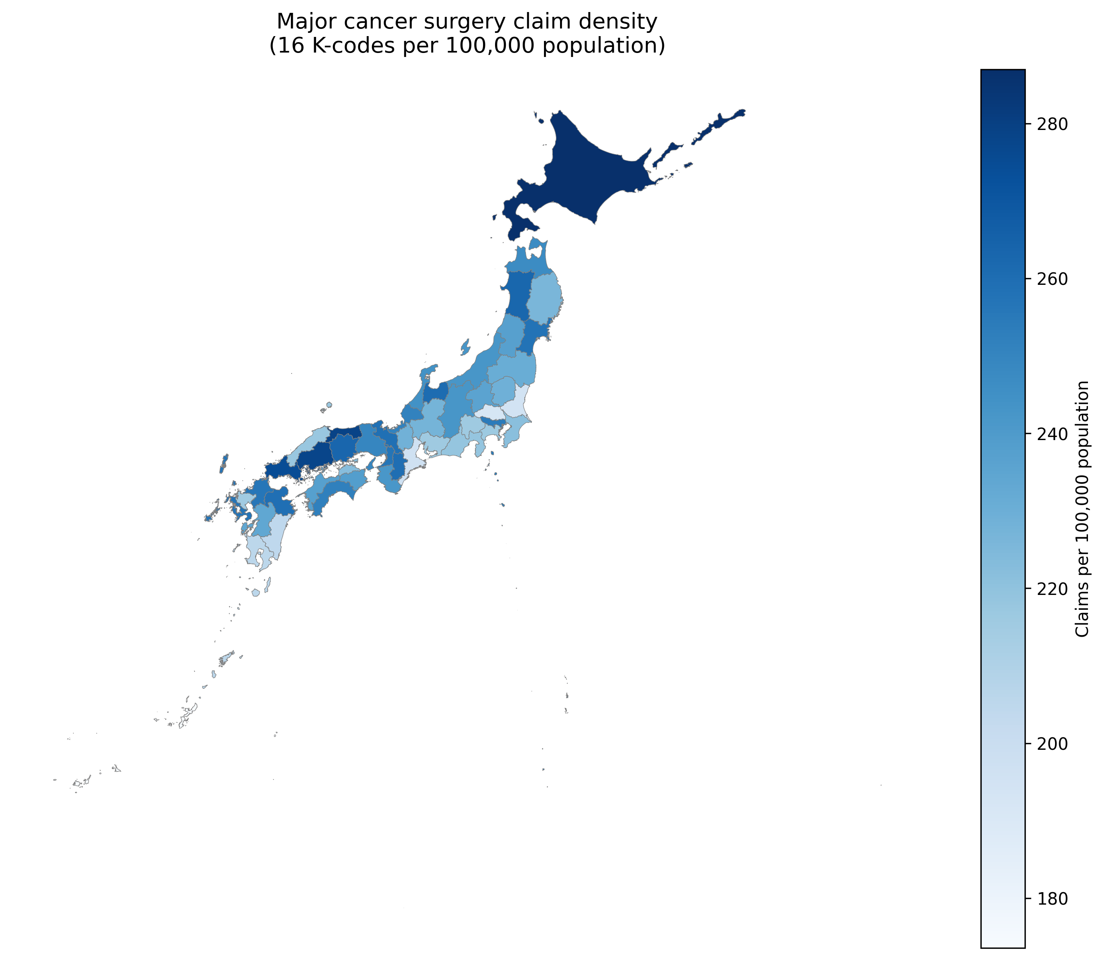
Cancer surgery density map by prefecture
Scatter plot of dentist density vs. POFM density

