Geographic Alignment Between Periodontal Treatment Utilization and Diabetic Complication Management Claims Across Japanese Prefectures: An Ecological Analysis of NDB Open Data
Haruki Saito^{1,2}, Kazumasa Yamagishi^{3,4}, Narumi Funakubo², Eri Eguchi², Shiho Sato^{2,5}, Takeyasu Kakamu⁶, Michio Shimabukuro⁷, Atsushi Hozawa^{8,9}, Tetsuya Ohira^{2,5}

- Fukushima Medical University School of Medicine, Fukushima, Japan
- Department of Epidemiology, Fukushima Medical University School of Medicine, Fukushima, Japan
- Department of Public Health, Graduate School of Medicine, Juntendo University, Tokyo, Japan
- Department of Public Health Medicine, Institute of Medicine, and Health Services Research and Development Center, University of Tsukuba, Ibaraki, Japan
- Radiation Medical Science Center for the Fukushima Health Management Survey, Fukushima Medical University, Fukushima, Japan
- Department of Hygiene and Preventive Medicine, Fukushima Medical University School of Medicine, Fukushima, Japan
- Department of Diabetes, Endocrinology, and Metabolism, Fukushima Medical University School of Medicine, Fukushima, Japan
- Tohoku Medical Megabank Organization, Tohoku University, Sendai, Japan
- Graduate School of Medicine, Tohoku University, Sendai, Japan
2026-06-15

1. Abstract
Background: Periodontal disease and diabetes are biologically linked, but prefectural claims data cannot measure clinical prevalence or individual-level causality. This study examined whether claims-based periodontal treatment utilization aligns geographically with diabetic complication management claims in Japan.
Methods: We conducted a cross-sectional ecological analysis of the 10th NDB Open Data release across 47 prefectures. The exposure was periodontal disease claims per 100,000 population (ICD-10: K05). Outcomes were diabetic complication management claims (B001-20), dialysis prevention guidance claims (B001-27), HbA1c high-value rate, and mean HbA1c. Models adjusted for aging rate and population density, with sensitivity analyses, a caries negative-control exposure, and spatial statistics.
Results: Periodontal treatment claim rates varied 2.1-fold (71,340-149,168 per 100,000). In the primary adjusted model, higher periodontal treatment claims were associated with higher diabetic complication management claims (beta = 0.00184, 95% CI: 0.00011-0.00357, p = 0.038, R2 = 0.104). The association remained positive across sensitivity specifications but was attenuated after income, smoking, and BMI adjustment. No comparable association was observed for caries claims or HbA1c-based indicators. Periodontal treatment claims showed spatial clustering (Moran's I = 0.359, p = 0.002).
Conclusions: Periodontal treatment utilization and diabetic complication management claims were geographically aligned across prefectures. These findings indicate a health services signal at the intersection of oral healthcare utilization, regional disparities, and diabetes complication management, not individual-level causality. Individual-level and service-area analyses are warranted.
Keywords: periodontal treatment claims; diabetes complications; ecological study; National Database; Japan; regional disparities; negative control; spatial analysis; health services research

2. Introduction
Periodontal disease is among the most prevalent chronic inflammatory conditions worldwide, affecting nearly half of adults globally (1). In Japan, periodontal disease remains common in adults (2), with marked regional variation in dental care access and utilization (3).
Beyond its oral manifestations, periodontal disease has been recognized as bidirectionally linked with type 2 diabetes mellitus (4,5). Chronic periodontal inflammation may worsen insulin resistance through systemic inflammatory pathways, while hyperglycemia can impair periodontal tissue repair (6–9). Clinical evidence suggests that periodontal treatment may modestly improve glycemic control in some settings, although trial findings remain mixed (10–13).
The downstream complications of diabetes, including nephropathy and foot-related complications, represent a major public health and health services burden in Japan. International comparative data indicate that treated end-stage kidney disease varies markedly across countries, with Japan among the countries reporting high dialysis prevalence per million population (14–16). At the regional level, periodontal treatment claims may therefore be geographically aligned with diabetes complication management claims through a mixture of clinical need, healthcare access, and service utilization patterns. This ecological health services hypothesis has not been examined using Japan's national claims database.
Japan's National Database of Health Insurance Claims and Specific Health Checkups (NDB) covers virtually all medical encounters under universal health insurance (17), providing an opportunity to examine prefectural-level variation in claims-based indicators of oral healthcare utilization and diabetes-related complication management. Previous NDB-based ecological studies have demonstrated regional variations in metabolic syndrome management and renal disease patterns (18), but the geographic alignment between periodontal treatment claims and diabetic complication management claims has not been explored.
The present study aimed to: (1) describe regional disparities in claims-based periodontal treatment utilization across 47 Japanese prefectures; (2) examine the ecological association between periodontal treatment claims and claims-based indicators of diabetes-related complication management; (3) assess specificity using a dental caries negative-control exposure; and (4) evaluate the robustness of associations through ten sensitivity specifications and spatial statistics.

3. Methods

3.1 Study Design and Setting
We conducted a cross-sectional ecological study using NDB open data (10th release, fiscal year 2023: April 2023–March 2024). The unit of analysis was the 47 Japanese prefectures. This study used only publicly available aggregate statistics; individual-level data were not accessed.

3.2 Data Sources

3.2.1 Primary Exposure
Periodontal disease claim rate: The number of dental claims for periodontal diseases (ICD-10: K05, including gingivitis [K05.0–K05.1] and periodontitis [K05.2–K05.3]) per 100,000 population was extracted from the NDB No.10 open-data tabulations for dental diseases and injuries (prefectural-level aggregates excluding claims covered by public expense). Population denominators were derived from prefectural specific health checkup enrollment data. The claim count was standardized per 100,000 population.

3.2.2 Negative Control Exposure
Dental caries claim rate: The number of dental claims for dental caries (ICD-10: K02) per 100,000 population was extracted from the same tabulations. Caries shares determinants with periodontal disease, including dental access and socioeconomic status, but lacks the same systemic inflammatory pathway (6). This exposure was used as a negative control (19).

3.2.3 Outcome Variables
Diabetic complication management claim rate: Claim counts for B001-20 (diabetic complication management fee) per 100,000 population. This fee is claimed for patients with diabetic foot complications receiving structured multidisciplinary management, serving as a surrogate for advanced peripheral diabetic complication burden.
Dialysis prevention guidance claim rate: Claim counts for B001-27 (dialysis prevention guidance management fee) per 100,000 population. This fee reflects structured intervention for patients at high risk of dialysis due to diabetic nephropathy.
HbA1c high-value rate: The proportion (%) of specific health checkup participants with HbA1c ≥6.5%, derived from NDB specific health checkup distribution data.
Mean HbA1c: Mean HbA1c (%) among specific health checkup participants.

3.2.4 Adjustment Variables
- Aging rate: Proportion of the population aged ≥65 years (derived from NDB No.10 specific health checkup data)
- Population density: Persons per km² (2020 census, e-Stat)
- Income per capita (sensitivity analysis only): Prefectural per-capita taxable income (thousand yen), derived from municipal taxation statistics previously compiled for regional health studies
- Smoking rate (sensitivity analysis only): Prefectural smoking prevalence (%) among specific health checkup participants, derived from NDB No.10 standard health questionnaire item Q5. This estimate is lower than general population prevalence (~16–20%) because it reflects self-reported smoking among health checkup attendees, a healthier-than-average subgroup.
- BMI obesity rate (sensitivity analysis only): Proportion (%) of specific health checkup participants with BMI ≥25.0 kg/m², derived from NDB No.10 examination outcomes data

3.3 Statistical Analysis

3.3.1 Primary Analysis
Ordinary least squares (OLS) regression was used to examine the association between the periodontal disease claim rate (exposure) and each of the four outcome variables, adjusting for aging rate and population density:
$${\text{Outcome}}_{i}=β_{0}+β_{1}⋅{\text{PeriodontalRate}}_{i}+β_{2}⋅{\text{AgingRate}}_{i}+β_{3}⋅{\text{PopDensity}}_{i}+ε_{i}$$
Pearson correlation coefficients were calculated for bivariate characterization. Variance inflation factors (VIF) were computed to assess multicollinearity.

3.3.2 Sensitivity Analyses
Ten sensitivity specifications were applied to the periodontal disease claim rate and diabetic complication management claim rate. Specification 1 was baseline OLS; Specification 2 used HC3 robust standard errors (20); Specification 3 excluded prefectures exceeding +/-3 SD; Specification 4 excluded Tokyo, Osaka, and Aichi; Specification 5 used log-transformed exposure and outcome; Specification 6 adjusted for aging rate only; Specifications 7-9 added income, smoking rate, and BMI obesity rate separately; and Specification 10 adjusted for all covariates simultaneously.
Variance inflation factors (VIF) were calculated for each specification to assess multicollinearity (threshold: VIF < 10).
An association was considered robust if significant (p < 0.05) in ≥5 of the first seven primary OLS specifications. Specifications 8–10 were pre-specified additional confounders to address cardiovascular risk factor confounding.

3.3.3 Negative Control Analysis
The negative control exposure (dental caries claim rate) was regressed on the diabetic complication management claim rate using the same six sensitivity specifications as the primary analysis. Specificity was assessed by comparing whether a significant periodontal disease claim rate association coexisted with a null caries rate association.

3.3.4 Spatial Analysis
Global Moran's I was computed for periodontal disease claim rate using Queen contiguity weights with KNN=1 supplementation for islands (21). LM-Lag and LM-Error tests were applied to OLS residuals using the Anselin decision rule (22). Local Moran's I clusters were classified as High-High, Low-Low, High-Low, or Low-High at p < 0.05 with 999 permutations. Analyses used Python 3.14 with statsmodels, scipy, libpysal, esda, and spreg.

4. Results

4.1 Descriptive Statistics
All 47 prefectures were included. Periodontal disease claim rates varied 2.1-fold across prefectures (mean: 112,944 per 100,000; SD: 20,161; range: 71,340-149,168) (Table 1). Diabetic complication management rates (B001-20) ranged from 57.8 to 451.4 per 100,000 (mean: 226.5, SD: 103.9). HbA1c high-value rates among specific health checkup participants ranged from 5.9% to 9.7%.
(See Table 1)

4.2 Bivariate Correlations
Periodontal disease rate showed a modest positive correlation with diabetic complication management rate (r = 0.310, p = 0.034) and a modest negative correlation with HbA1c high-value rate (r = −0.314, p = 0.031). Correlations with dialysis prevention guidance rate (r = −0.167, p = 0.26) and mean HbA1c (r = −0.210, p = 0.16) were not statistically significant.
The inverse bivariate correlation with HbA1c high-value rate was not reproduced in the adjusted primary models (Table 2).

4.3 Primary Regression Results
In the primary OLS model (adjusted for aging rate and population density), periodontal disease rate was significantly positively associated with diabetic complication management rate (β = 0.00184, 95% CI: 0.00011–0.00357, p = 0.038, R² = 0.104) (Table 2). No significant associations were observed for HbA1c high-value rate, mean HbA1c, or dialysis prevention guidance rate (all p > 0.14).
(See Table 2)

4.4 Sensitivity Analyses
The positive association between periodontal disease rate and diabetic complication management rate was observed in 5 of 7 primary OLS specifications (Table 3). HC3 robust SE yielded p = 0.011. Exclusion of metropolitan prefectures (Specification 4) attenuated the association to borderline significance (p = 0.054). Log-transformation (Specification 5, p = 0.015) and aging-rate-only adjustment (Specification 6, p = 0.043) were significant. Additional adjustment for per-capita income (Specification 7) attenuated the association to non-significance (p = 0.140).
When smoking rate was added (Specification 8), the association was borderline significant (β = 0.00174, p = 0.054; VIF_max = 1.92). Additional adjustment for BMI obesity rate (Specification 9) further attenuated the association (β = 0.00110, p = 0.193), as did full simultaneous adjustment for income, smoking, and BMI (Specification 10: β = 0.00119, p = 0.192; VIF_max = 6.6). Across all 10 specifications, coefficients were positive (β range: 0.0011-0.0018). No other outcome demonstrated consistent significance across specifications 1-10.
(See Table 3)

4.5 Negative Control Analysis
The negative control exposure (dental caries claim rate) showed no statistically significant association with diabetic complication management rate across all six sensitivity specifications (all p > 0.70; Figure 4). Periodontal disease claim rate showed a significant association in 5 of 7 primary OLS specifications, whereas caries rate showed none in 0 of 6 specifications.

4.6 Spatial Analysis
Global Moran's I for periodontal disease rate was 0.359 (z = 3.530, p = 0.002). LISA cluster analysis (Figure 5) identified High-High clusters in the Tohoku and Kyushu regions and Low-Low clusters in the metropolitan belt (Tokyo-Osaka corridor).
Lagrange Multiplier tests on OLS residuals for the primary outcome (diabetic complication management claim rate) yielded LM-Lag p = 0.216 and LM-Error p = 0.324. Under the Anselin decision rule, spatial regression modeling (SLM/SEM) was not selected for the primary regression.

5. Discussion

5.1 Summary of Findings
In this prefectural ecological analysis of Japanese NDB Open Data, claims-based periodontal treatment utilization was positively associated with diabetic complication management claims (B001-20). The association was statistically significant in the baseline adjusted model and remained positive across sensitivity specifications, although it was attenuated after additional adjustment for income, smoking, and BMI-related obesity. No comparable association was observed for the dental caries negative-control exposure, and no significant associations were observed for HbA1c-based indicators or dialysis prevention guidance claims.
Taken together, these results are best interpreted as a geographic health services signal rather than proof of an individual-level biological pathway. Prefectures with higher periodontal treatment claims may represent settings where oral healthcare utilization, diabetes care patterns, and diabetic complication management demand intersect.

5.2 Interpretation of the Positive Association
The observed association is compatible with the biological literature linking periodontitis and diabetes. However, this analysis cannot determine whether individuals with periodontal disease were the same individuals who later required diabetic complication management.
The claims-based nature of the exposure is central to interpretation. A high periodontal disease claim rate may reflect greater clinical periodontal need, better access to dental services, greater treatment-seeking behavior, more active coding of periodontal diagnoses, or some combination of these factors. Similarly, B001-20 claims reflect structured management of diabetic foot-related complications rather than the true population prevalence of diabetic complications. The association should therefore be read as alignment between two claims-based healthcare indicators, not as a direct estimate of disease causation.
The attenuation after income, smoking, and BMI-related obesity adjustment is central to interpretation. Socioeconomic context may explain part of the observed geographic alignment, because regional factors can shape both dental treatment utilization and diabetes complication management. The positive coefficient across specifications should therefore be interpreted cautiously, as a directional claims pattern rather than independence from socioeconomic structure.

5.3 Negative Control and Specificity
The negative-control analysis strengthens the interpretation that the primary association is not merely a generic marker of dental claims volume or regional socioeconomic patterning. Dental caries claims share several determinants with periodontal claims, including dental access, care-seeking behavior, and socioeconomic conditions, yet caries claims were not associated with diabetic complication management claims across the examined specifications.
This contrast supports some specificity of the periodontal treatment signal. Nevertheless, a negative-control result cannot eliminate residual confounding in an ecological study. It should be viewed as supportive evidence that helps contextualize the finding, rather than as definitive evidence for a causal periodontal pathway.

5.4 Interpretation of the Null HbA1c and Dialysis Prevention Findings
The absence of significant associations with HbA1c-based outcomes is an important finding rather than a simple inconsistency. HbA1c measures in NDB Open Data derive from specific health checkup participants, a selected population that may be healthier and more prevention-oriented than the general population. This selection can restrict variation and reduce the ability to detect ecological associations.
The modest negative bivariate correlation between periodontal treatment claims and HbA1c high-value rate should be interpreted in this same context. Prefectures with higher dental treatment utilization may also have higher preventive service engagement and healthier specific health checkup participants, producing an inverse ecological association that does not imply a protective effect of periodontal disease or treatment claims.
A second explanation is the difference between short-term metabolic indicators and accumulated complication-management claims. HbA1c reflects glycemic control over the preceding several months, whereas B001-20 claims reflect structured management of complications that develop over longer periods. Cross-sectional prefectural data may therefore capture alignment with cumulative complication management more readily than alignment with contemporaneous glycemic measurements.
The null finding for dialysis prevention guidance claims also requires caution. B001-27 claims may be influenced by regional program penetration, nephrology referral patterns, and coding practices. Individual-level Japanese evidence linking periodontal care and kidney outcomes remains biologically relevant, but the present prefectural analysis was not designed to test that pathway directly.

5.5 Spatial Pattern and Regional Policy Relevance
Periodontal treatment claims showed significant positive spatial autocorrelation, with clustering in selected regions. This suggests that dental treatment utilization is not randomly distributed across Japan but reflects broader regional environments, including dental care infrastructure, socioeconomic context, population aging, urbanicity, and healthcare utilization patterns.
From a policy perspective, the value of this analysis lies less in estimating an individual-level risk effect and more in identifying regions where oral healthcare use and diabetes complication management claims overlap. Such regions may be appropriate candidates for closer surveillance, service-area analyses, and evaluation of integrated dental-medical care pathways. The findings support further policy evaluation, not immediate causal claims about the effectiveness of intervention.

5.6 Strengths and Limitations
The strengths of this study include the use of nationwide NDB Open Data, complete inclusion of all 47 prefectures, multiple sensitivity analyses, a negative-control exposure, and spatial assessment. These features provide a structured view of regional variation in oral healthcare claims and diabetes-related management claims across Japan.
Several limitations are substantial. First, the ecological design precludes individual-level causal inference and is vulnerable to ecological bias. Second, periodontal claims indicate treatment contacts and coding, not clinical periodontitis prevalence. Third, the single-year design prevents assessment of temporality. Fourth, HbA1c outcomes came from specific health checkup participants and may not represent the full population with diabetes. Fifth, prefectural aggregation limits power and may obscure smaller-area variation.
For these reasons, causal-sensitivity calculations and mediation findings are supplementary exploratory information rather than central evidence. Future individual-level claims, clinical dental data, service-area identifiers, and longitudinal designs are needed to clarify the observed geographic signal.

5.7 Conclusions
In this prefectural ecological analysis of Japanese NDB Open Data, claims-based periodontal treatment utilization was positively associated with diabetic complication management claims, while dental caries claims and HbA1c-based indicators did not show comparable associations. The results identify a geographically patterned health services signal linking oral healthcare utilization and diabetes complication management across Japan.
Because claims-based ecological data cannot establish clinical disease prevalence, temporality, or individual-level causality, the findings should be interpreted as hypothesis-generating. They nevertheless suggest that integrated dental-medical perspectives may be useful for understanding regional disparities in chronic disease management and for designing future individual-level and service-area studies.

6. Acknowledgments
The authors thank the Ministry of Health, Labour and Welfare of Japan for providing access to the NDB Open Data. All data used are publicly available aggregate statistics.

7. Conflicts of Interest
The authors declare no conflicts of interest.

8. Data Availability
All data are publicly available from the NDB Open Data website (https://www.mhlw.go.jp/stf/seisakunitsuite/bunya/0000177182.html). Analysis code is available upon request.

9. Declaration of Generative AI and AI-Assisted Technologies in the Manuscript Preparation Process
During the preparation and writing of this work, the authors used AI-assisted tools to support manuscript drafting and statistical analysis scripting. Cursor 3.0 (Anysphere) and Google Antigravity (Google) were used for AI-assisted writing and Python code development. Large language models used through these platforms included Claude Sonnet 4.6 and Claude Opus 4.8 (Anthropic) and Gemini 3 Pro (Google). These tools were used only for text drafting and code generation; no generative AI or AI-assisted tools were used to create, alter, or otherwise process any figures, images, or artwork in this manuscript. The authors reviewed and edited all AI-assisted outputs and were responsible for the study design, selection of statistical methods, interpretation of findings, conclusions, and final reference list. The authors take full responsibility for the integrity and accuracy of the final content. AI was not listed as an author.

10. References
1. Kassebaum NJ, Bernabe E, Dahiya M, Bhandari B, Murray CJL, Marcenes W. Global burden of severe periodontitis in 1990–2010: A systematic review and meta-regression. Journal of Dental Research. 2014 Nov;93(11):1045–53.
2. Sekino S, Takahashi R, Numabe Y, Okamoto H. Current status of periodontal disease in adults in Takahagi, Japan: A cross-sectional study. BMC Oral Health. 2020;20(1):60.
3. Taira K, Mori T, Ishimaru M, Iwagami M, Sakata N, Watanabe T, et al. Regional inequality in dental care utilization in Japan: An ecological study using the National Database of Health Insurance Claims. The Lancet Regional Health - Western Pacific. 2021;12:100170.
4. Chapple ILC, Genco R. Diabetes and periodontal diseases: Consensus report of the Joint EFP/AAP Workshop on Periodontitis and Systemic Diseases. Journal of Clinical Periodontology. 2013;40:S106–12.
5. Sanz M, Ceriello A, Buysschaert M, Chapple I, Demmer RT, Graziani F, et al. Scientific evidence on the links between periodontal diseases and diabetes: Consensus report and guidelines of the joint workshop on Periodontal diseases and Diabetes by the International Diabetes Federation and the European Federation of Periodontology. Journal of Clinical Periodontology. 2018;45(2):138–49.
6. Mealey BL, Ocampo GL. Diabetes mellitus and periodontal disease. Periodontology 2000. 2007;44:127–53.
7. Iwamoto Y, Nishimura F, Nakagawa M, Sugimoto H, Shikata K, Makino H, et al. The effect of antimicrobial periodontal treatment on circulating tumor necrosis factor-alpha and glycated hemoglobin level in patients with type 2 diabetes. Journal of Periodontology. 2001 Jun;72(6):774–8.
8. Wu Z, Zhang Y, Wang L, Yi Y, Dai B, Chen H, et al. Periodontitis and systemic diseases: Insights into the correlation, mechanisms, and clinical implications. Frontiers in Immunology. 2026 Mar;17:1777955.
9. Du Y, Xiao H, Luo R, Li G, Ren Y. The role of HbA1c in the bidirectional relationship between periodontitis and diabetes and related interventions: A narrative review. Frontiers in Nutrition. 2025 Jun;12:1606223.
10. Teeuw WJ, Gerdes VEA, Loos BG. Effect of periodontal treatment on glycemic control of diabetic patients: A systematic review and meta-analysis. Diabetes Care. 2010 Feb;33(2):421–7.
11. Simpson TC, Weldon JC, Worthington HV, Needleman I, Wild SH, Moles DR, et al. Treatment of periodontal disease for glycaemic control in people with diabetes mellitus. Cochrane Database of Systematic Reviews. 2015;(11):CD004714.
12. Umezaki Y, Yamashita A, Nishimura F, Naito T. The role of periodontal treatment on the reduction of hemoglobinA1c, comparing with existing medication therapy: A systematic review and meta-analysis. Frontiers in Clinical Diabetes and Healthcare. 2025 Feb;6:1541145.
13. Engebretson SP, Hyman LG, Michalowicz BS, Schoenfeld ER, Gelato MC, Hou W, et al. The effect of nonsurgical periodontal therapy on hemoglobin A1c levels in persons with type 2 diabetes and chronic periodontitis: A randomized clinical trial. JAMA. 2013 Dec;310(23):2523–32.
14. Bello AK, Levin A, Lunney M, Osman MA, Ye F, Ashuntantang GE, et al. Status of care for end stage kidney disease in countries and regions worldwide: International cross sectional survey. BMJ. 2019;367:l5873.
15. Thurlow JS, Joshi M, Yan G, Norris KC, Agodoa LY, Yuan CM, et al. Global epidemiology of end-stage kidney disease and disparities in kidney replacement therapy. American Journal of Nephrology. 2021;52(2):98–107.
16. Hanafusa N, Abe M, Joki N, Hoshino J, Taniguchi M, Kikuchi K, et al. Annual dialysis data report 2022, Japanese Society for Dialysis Therapy (JSDT) Renal Data Registry. Renal Replacement Therapy. 2025 Jul;11(1):54.
17. Ministry of Health, Labour and Welfare. The 10th Release of NDB Open Data (National Database of Health Insurance Claims and Specific Health Checkups of Japan) [Internet]. Ministry of Health, Labour and Welfare, Japan; 2024 [cited 2026 Jun 15]. Available from: https://www.mhlw.go.jp/stf/seisakunitsuite/bunya/0000177182.html
18. Wakasugi M, Narita I. Prefecture-specific prevalence of overweight/obesity is associated with regional variation in the incidence of treated ESKD in Japan. Clinical and Experimental Nephrology. 2023;27(2):132–40.
19. Lipsitch M, Tchetgen Tchetgen E, Cohen T. Negative controls: A tool for detecting confounding and bias in observational studies. Epidemiology. 2010 May;21(3):383–8.
20. White H. A heteroskedasticity-consistent covariance matrix estimator and a direct test for heteroskedasticity. Econometrica. 1980;48(4):817–38.
21. Anselin L. Local indicators of spatial association—LISA. Geographical Analysis. 1995;27(2):93–115.
22. Anselin L. Spatial econometrics: Methods and models. Dordrecht: Kluwer Academic Publishers; 1988.
23. VanderWeele TJ, Ding P. Sensitivity analysis in observational research: Introducing the E-value. Annals of Internal Medicine. 2017 Aug;167(4):268–74.
24. Imai K, Keele L, Tingley D. A general approach to causal mediation analysis. Psychological Methods. 2010;15(4):309–34.

11. Tables
Table 1. Descriptive statistics of study variables (N = 47 prefectures)
Variable | Mean | SD | Min | Max
Periodontal disease rate (per 100,000) | 112,944 | 20,161 | 71,340 | 149,168
Caries rate (per 100,000) | — | — | — | —
Diabetic complication management rate (per 100,000) | 226.5 | 103.9 | 57.8 | 451.4
Dialysis prevention guidance rate (per 100,000) | 81.8 | 54.0 | 7.2 | 277.6
HbA1c high-value rate (%) | 7.64 | 0.83 | 5.85 | 9.66
Mean HbA1c (%) | 5.686 | 0.040 | 5.606 | 5.772
Aging rate (%) | 30.7 | 3.10 | 22.6 | 36.4
Population density (persons/km²) | 657 | 1,223 | 62.6 | 6,403
Income per capita (thousand yen) | 3,249 | 373 | 2,822 | 4,920
Smoking rate (%, specific health checkup-based) | 3.71 | 0.64 | 2.39 | 5.93
BMI obesity rate (%, BMI ≥25.0 kg/m²) | 30.1 | 2.55 | 26.1 | 39.9

Table 2. Primary OLS regression results: Periodontal disease rate and diabetes-related outcomes (N = 47)
Outcome | Beta | 95% CI | p-value | R²
Diabetic complication management rate (B001-20) | 0.00184 | 0.00011, 0.00357 | 0.038 | 0.104
Dialysis prevention rate (B001-27) | −0.000683 | −0.00161, 0.000239 | 0.143 | 0.056
HbA1c high-value rate | −4.1×10⁻⁶ | -1.67×10⁻⁵, 8.46×10⁻⁶ | 0.514 | 0.247
Mean HbA1c | −9.0×10⁻⁸ | -7.10×10⁻⁷, 5.30×10⁻⁷ | 0.771 | 0.233
Adjusted for aging rate and population density.
For HbA1c-based outcomes, 95% confidence intervals were reconstructed from the reported coefficient and two-sided p-value assuming the primary OLS model degrees of freedom.

Table 3. Sensitivity analysis results: Periodontal disease claim rate and diabetic complication management rate (B001-20)
Sensitivity model | Beta | p-value | Significant
Baseline OLS | 0.00184 | 0.038 | Yes
HC3 robust SE | 0.00184 | 0.011 | Yes
Outliers excluded (±3 SD) | 0.00184 | 0.038 | Yes
Metropolitan prefectures excluded | 0.00180 | 0.054 | No
Log–log transformation | 1.087 (log-log β) | 0.015 | Yes
Aging rate only (covariate) | 0.00165 | 0.043 | Yes
+ Per-capita income | 0.00140 | 0.140 | No
+ Smoking rate | 0.00174 | 0.054 | No (borderline)
+ BMI obesity rate | 0.00110 | 0.193 | No
Full adjustment (all covariates) | 0.00119 | 0.192 | No
Five models (baseline, HC3, outlier exclusion, log–log, aging-only) were significant at p < 0.05; metropolitan exclusion and the smoking-extended model were marginally non-significant (both p ≈ 0.054). Coefficient direction remained consistently positive across all ten models.

12. Figures
Figure 1: Choropleth map of prefectural periodontal disease claim rates (per 100,000 population) across 47 Japanese prefectures, fiscal year 2023.
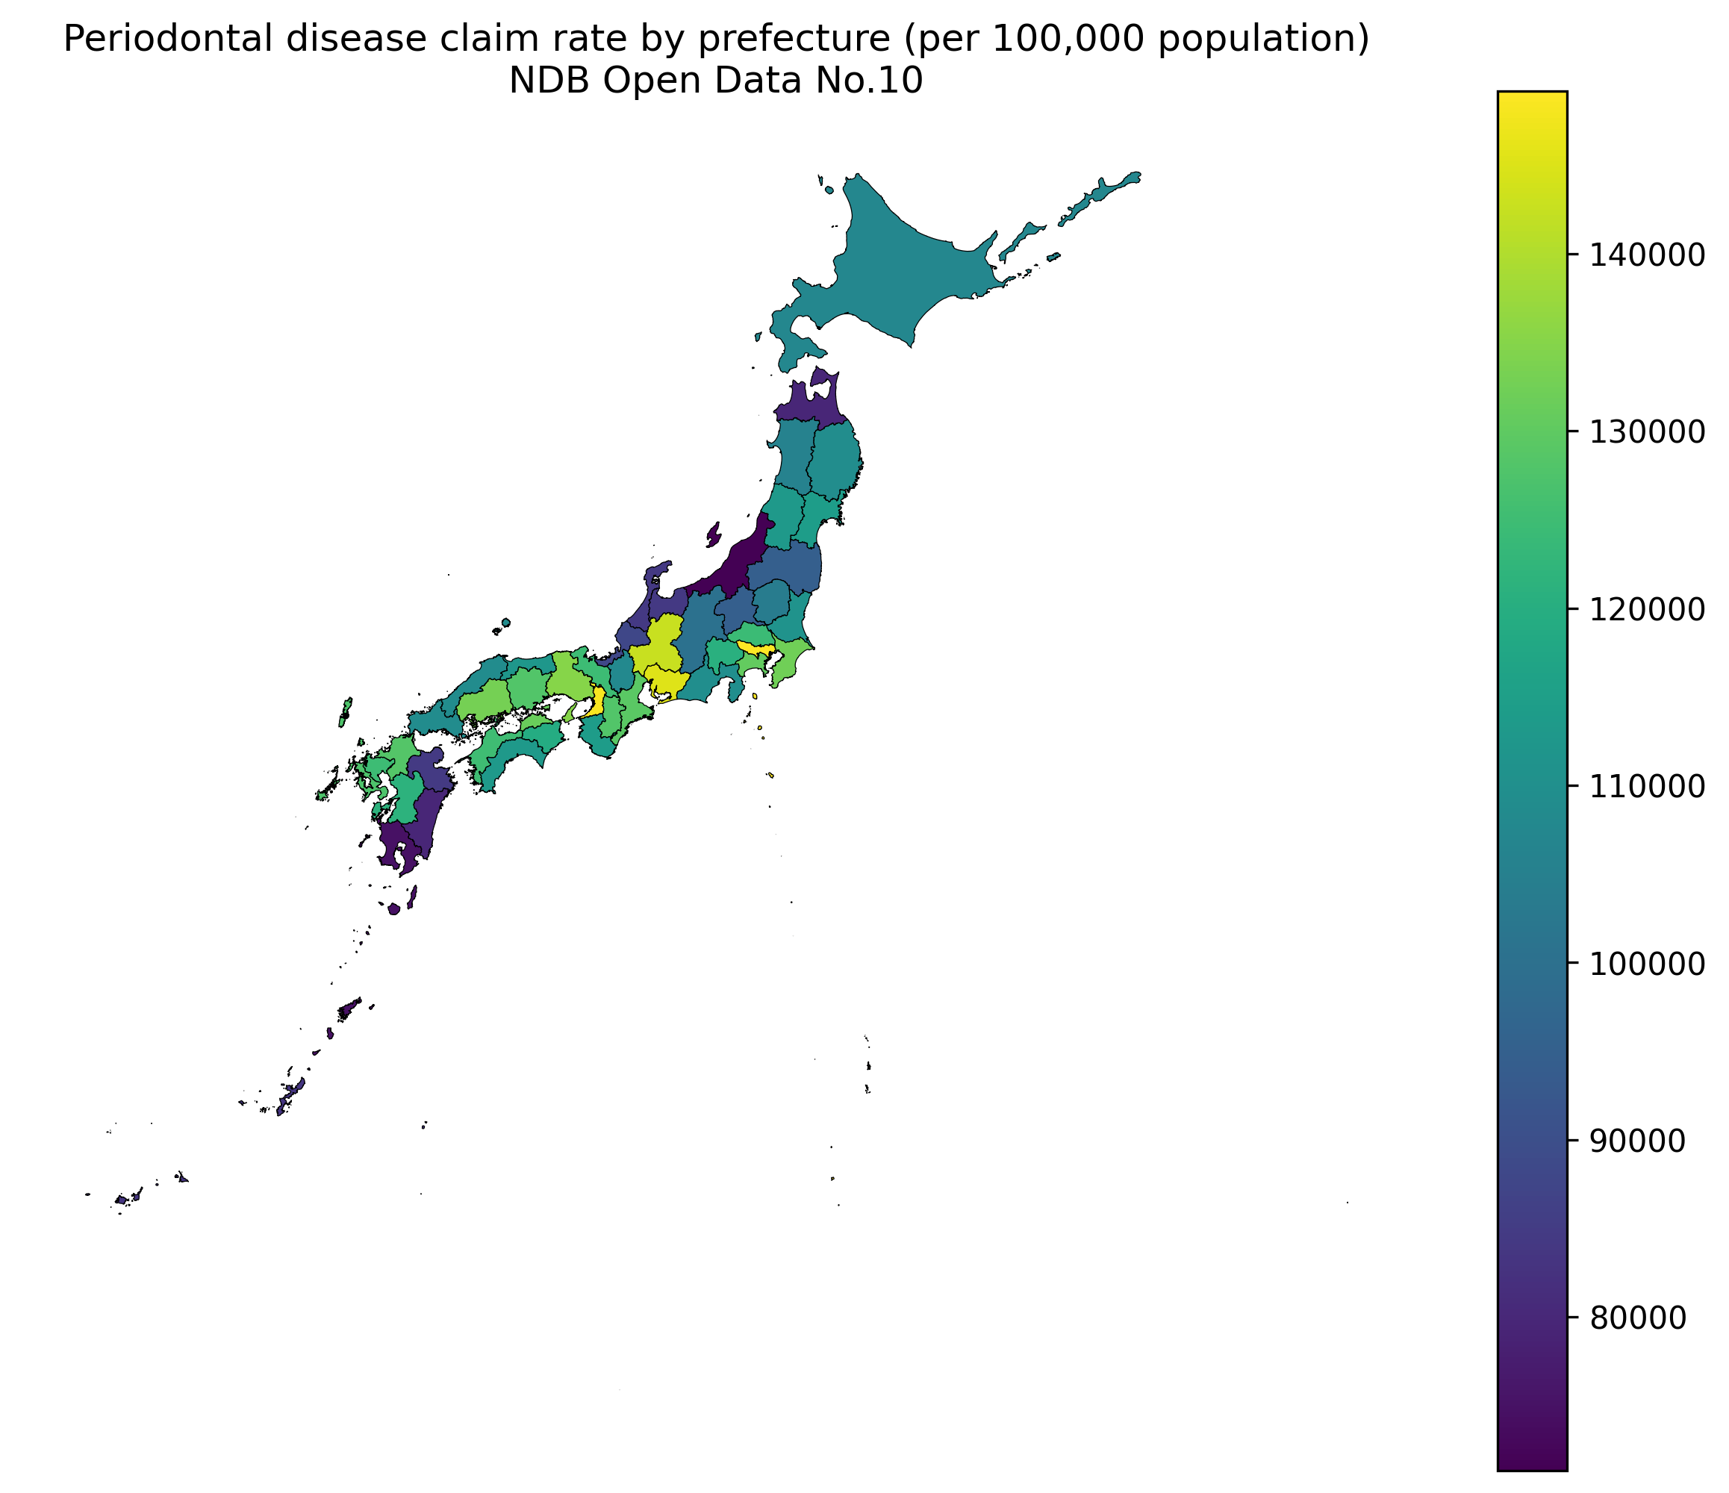
Choropleth map of periodontal disease rates by prefecture
Figure 2: Scatter plot of periodontal disease rate vs. HbA1c high-value rate by prefecture (N = 47; r = −0.314, p = 0.031).
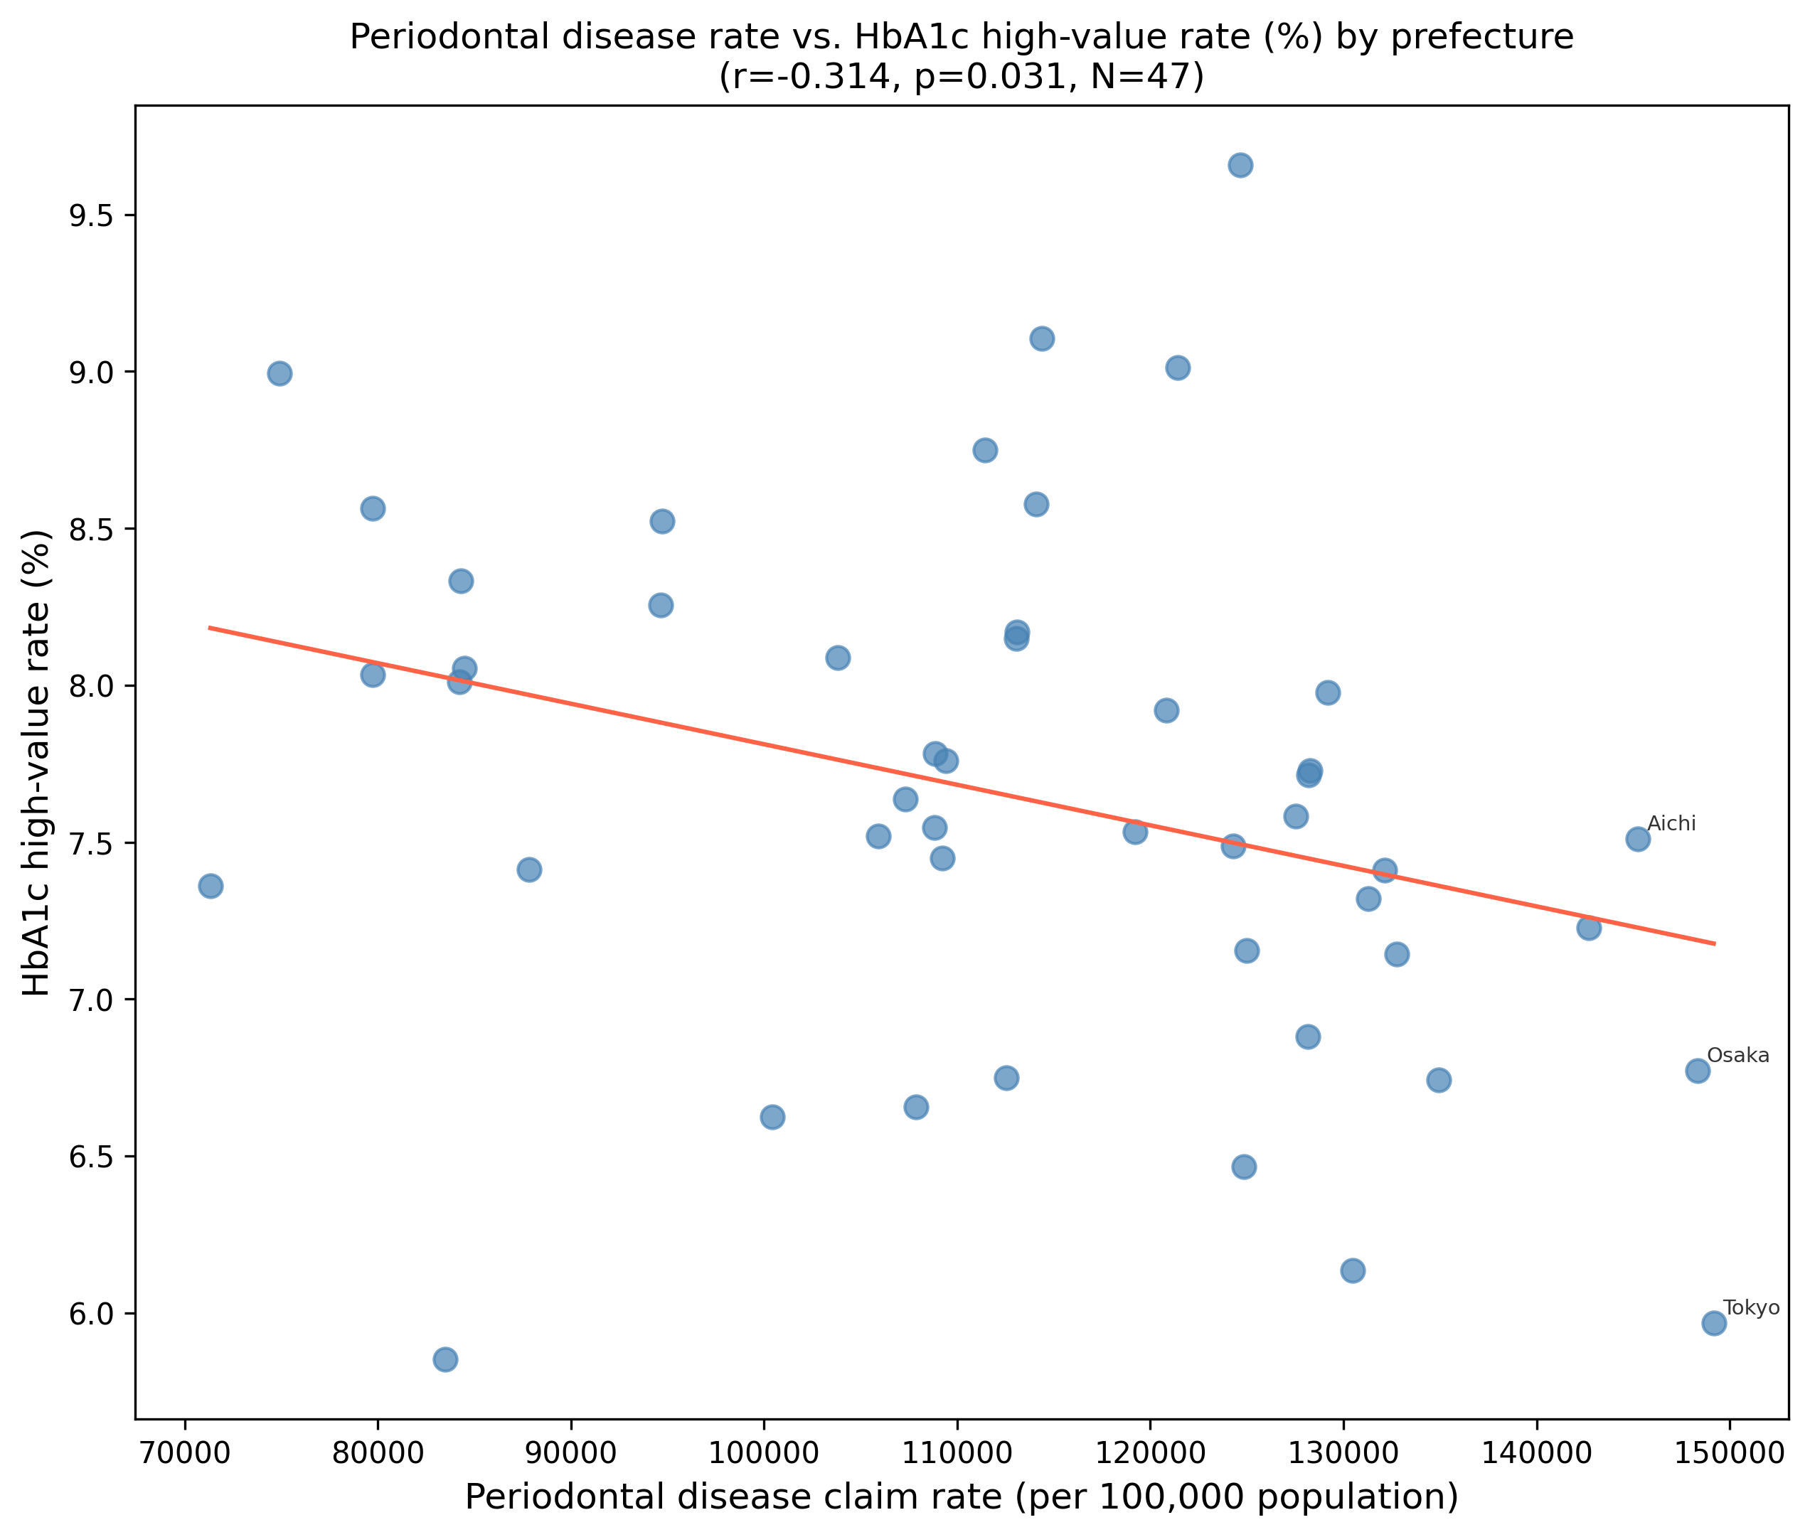
Scatter plot: periodontal disease claim rate versus HbA1c high-value rate
Figure 3: Scatter plot of periodontal disease rate vs. diabetic complication management rate (B001-20) by prefecture (N = 47; r = 0.310, p = 0.034).
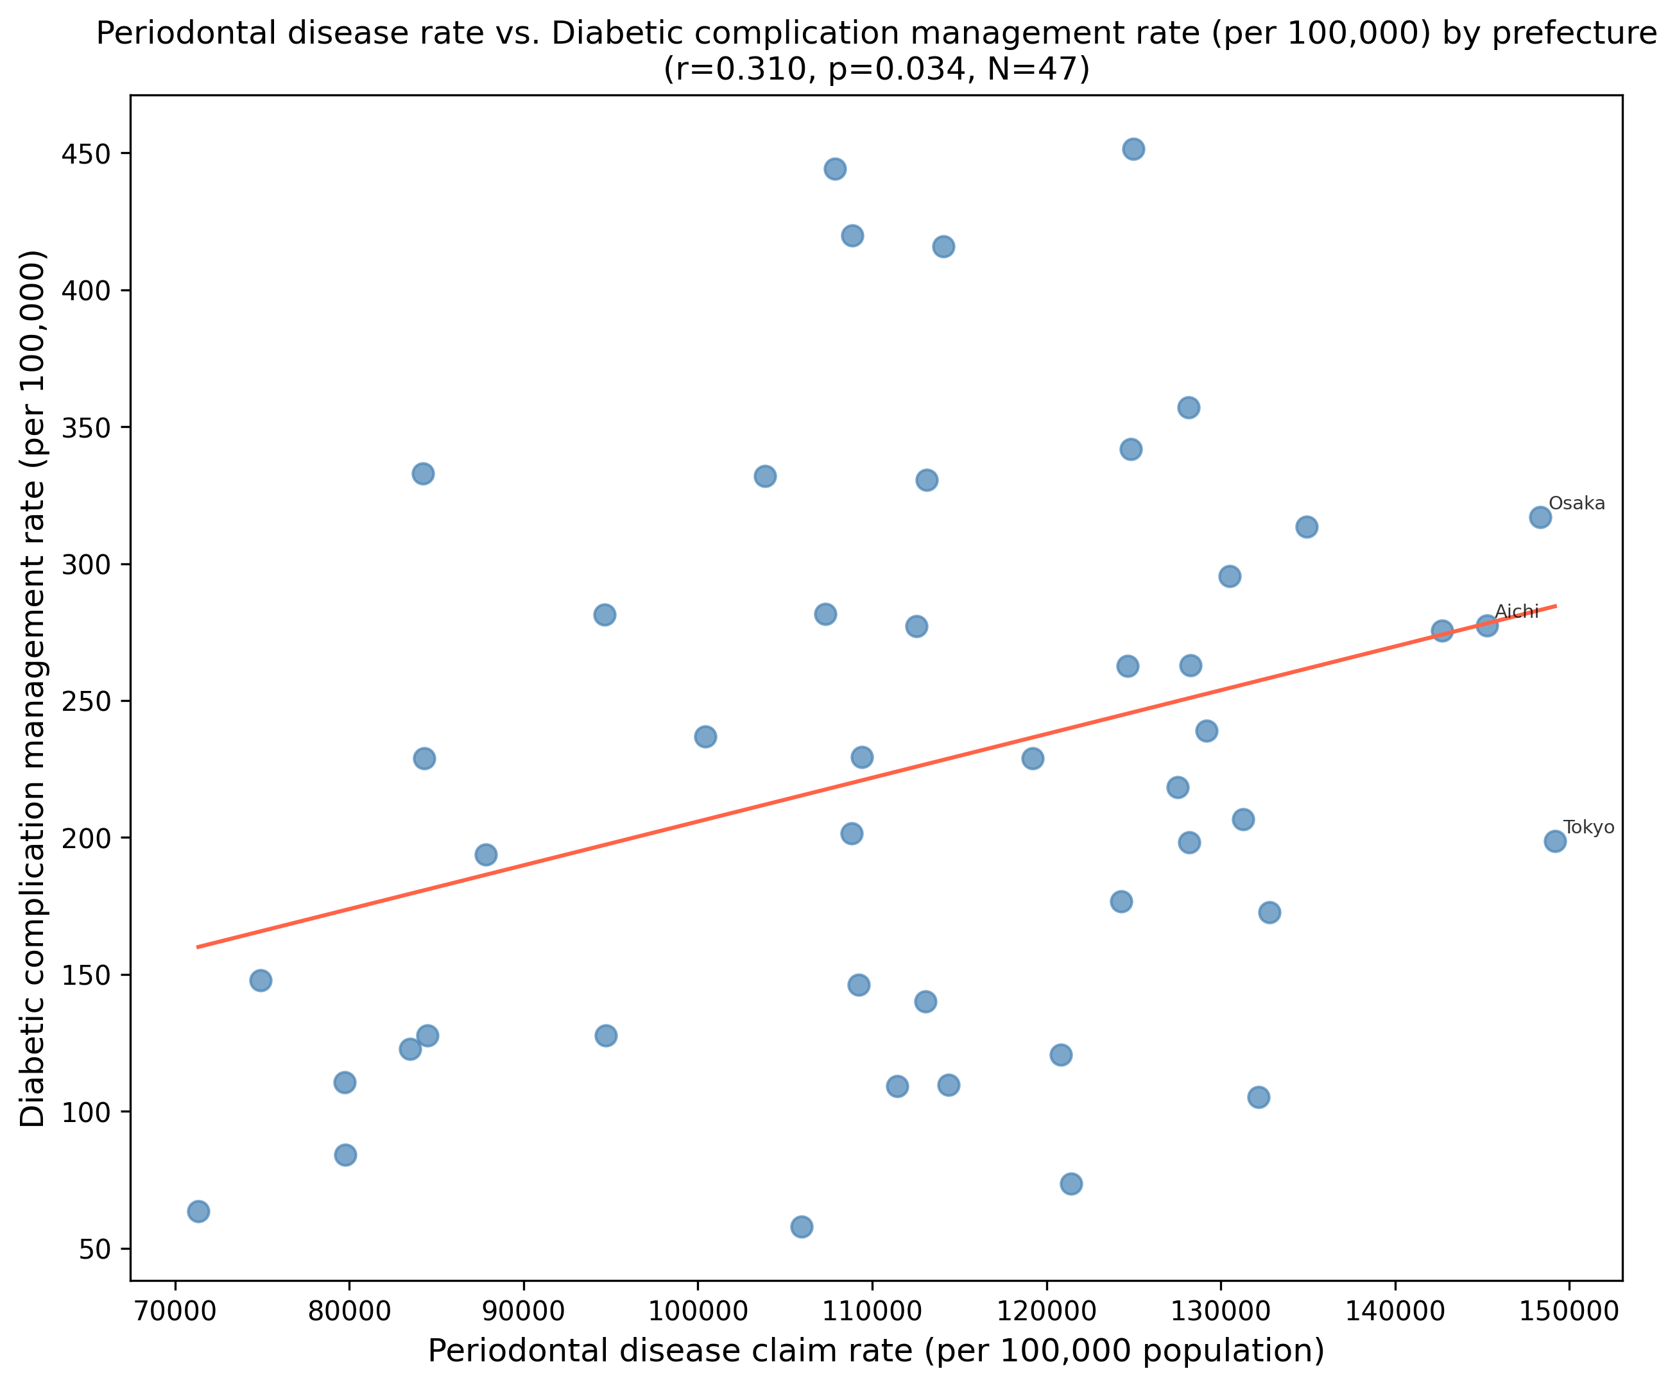
Scatter plot: periodontal disease claim rate versus diabetic complication management rate
Figure 4: Forest plot comparison of sensitivity analysis results for diabetic complication management rate (B001-20): primary exposure (periodontal disease claim rate, left panel; 5 of 7 primary OLS specifications significant) versus negative control exposure (dental caries claim rate, right panel; 0 of 6 specifications significant).
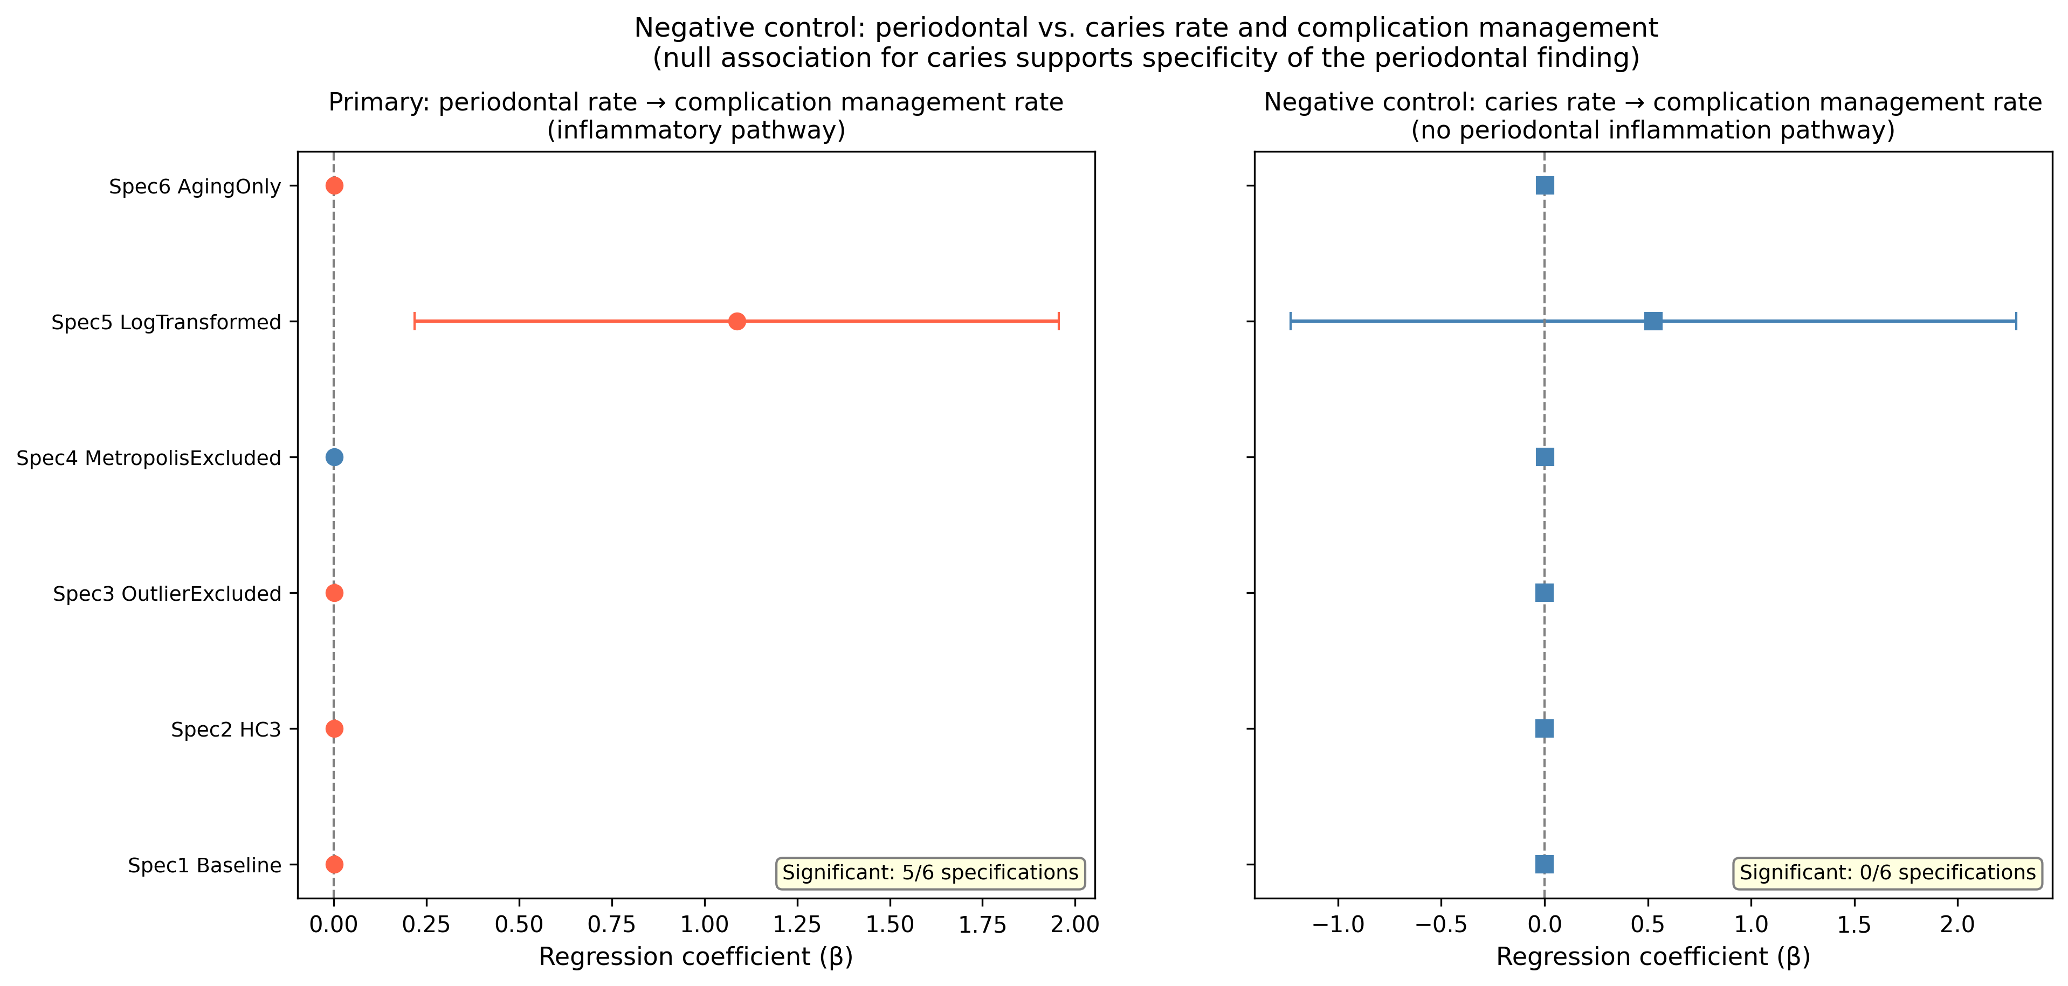
Forest plot: negative control comparison
Figure 5: Local Moran’s I (LISA) cluster map of prefectural periodontal disease claim rates. High-High (HH) clusters indicate prefectures with elevated rates surrounded by similarly elevated neighbors; Low-Low (LL) clusters indicate the reverse. Global Moran’s I = 0.359 (p = 0.002).
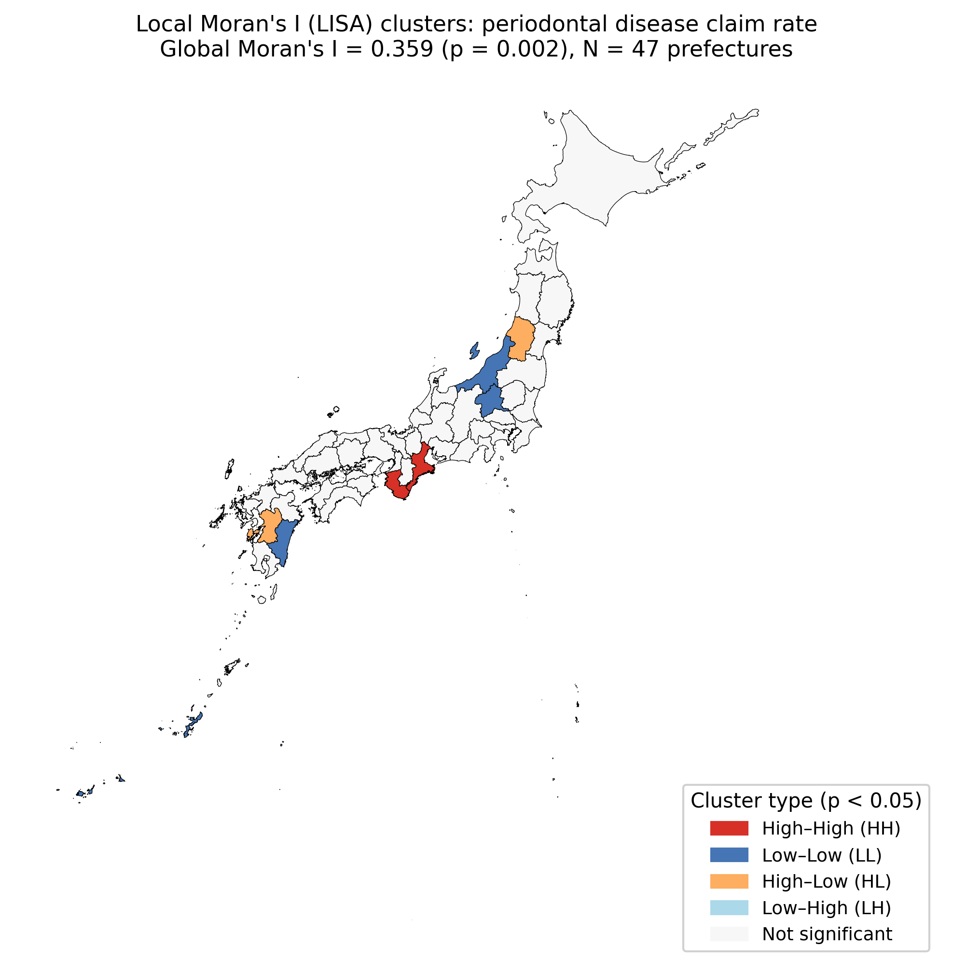
LISA cluster map of periodontal disease rates
Supplementary Figure 1: Extended forest plot of sensitivity analysis results for the primary outcome (diabetic complication management rate, B001-20) across all ten pre-specified sensitivity models. Red diamonds indicate p < 0.05; grey diamonds indicate p ≥ 0.05. The coefficient direction is consistently positive across all models.
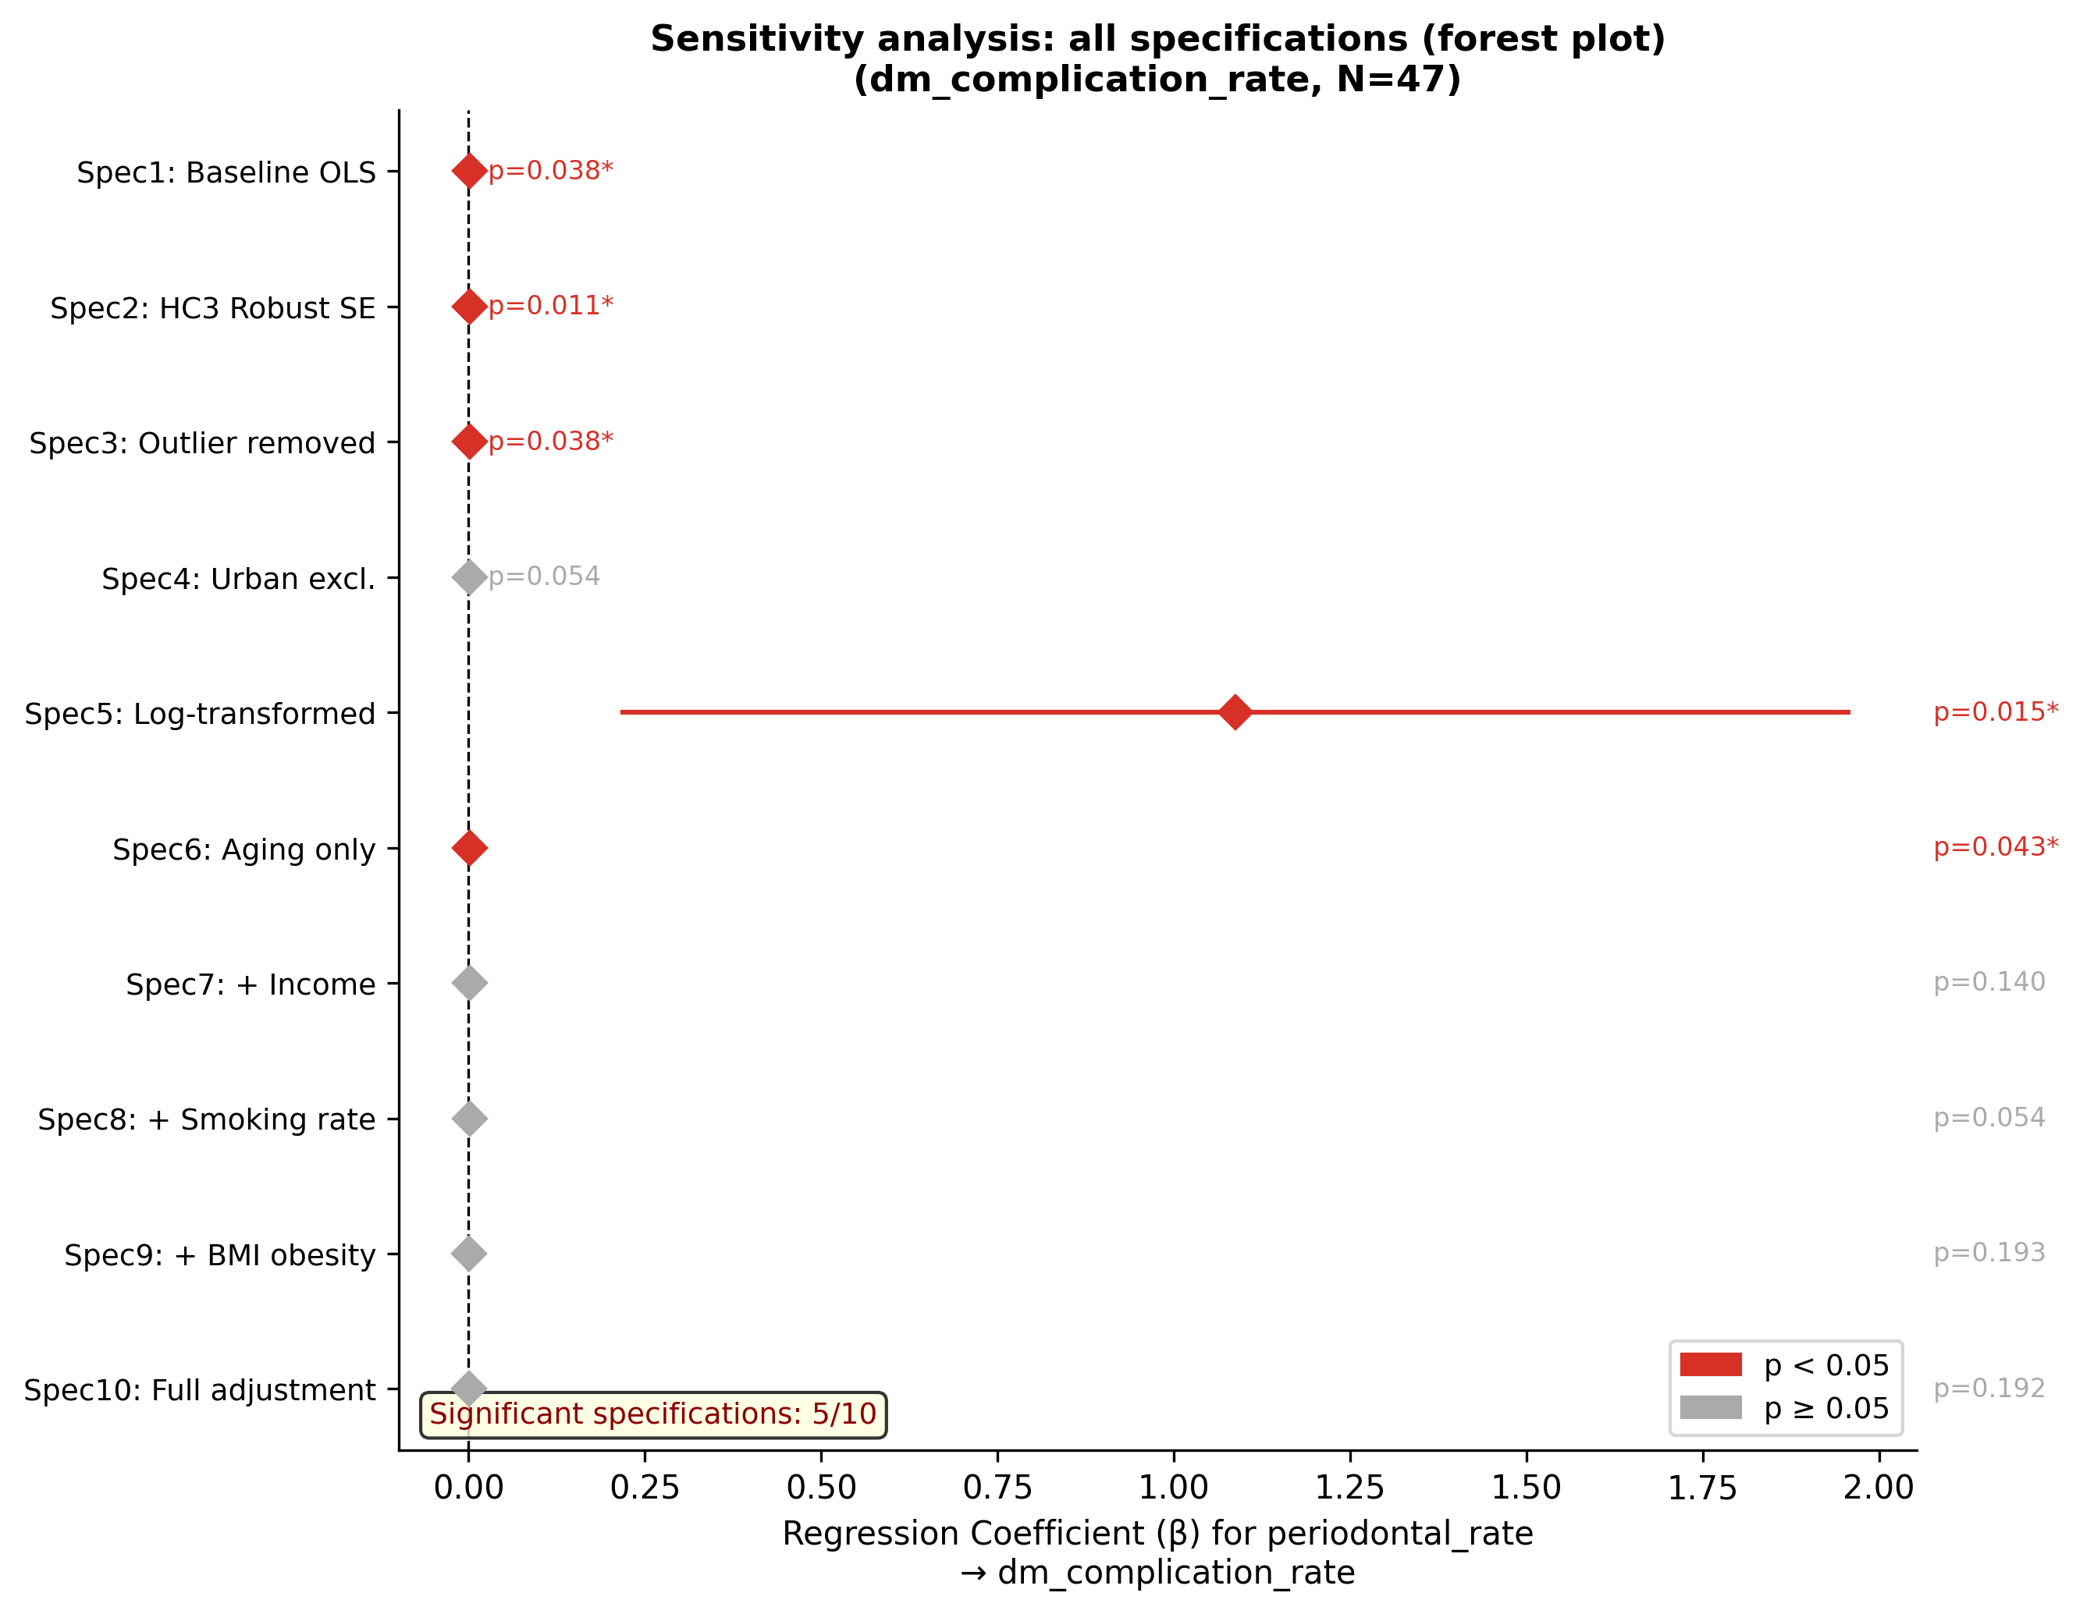
Extended forest plot: ten sensitivity models for diabetic complication management rate
Supplementary Figure 2: E-value visualization. The curve shows the minimum E-value required for each hypothetical risk ratio level. The red dashed line indicates the observed RR (point estimate = 1.43, E-value = 2.21) and the orange dashed line indicates the lower confidence limit (RR = 1.02, E-value = 1.17). The blue dash-dot line shows the approximate RR associated with per-capita income (the strongest known confounder), which falls below the E-value threshold.
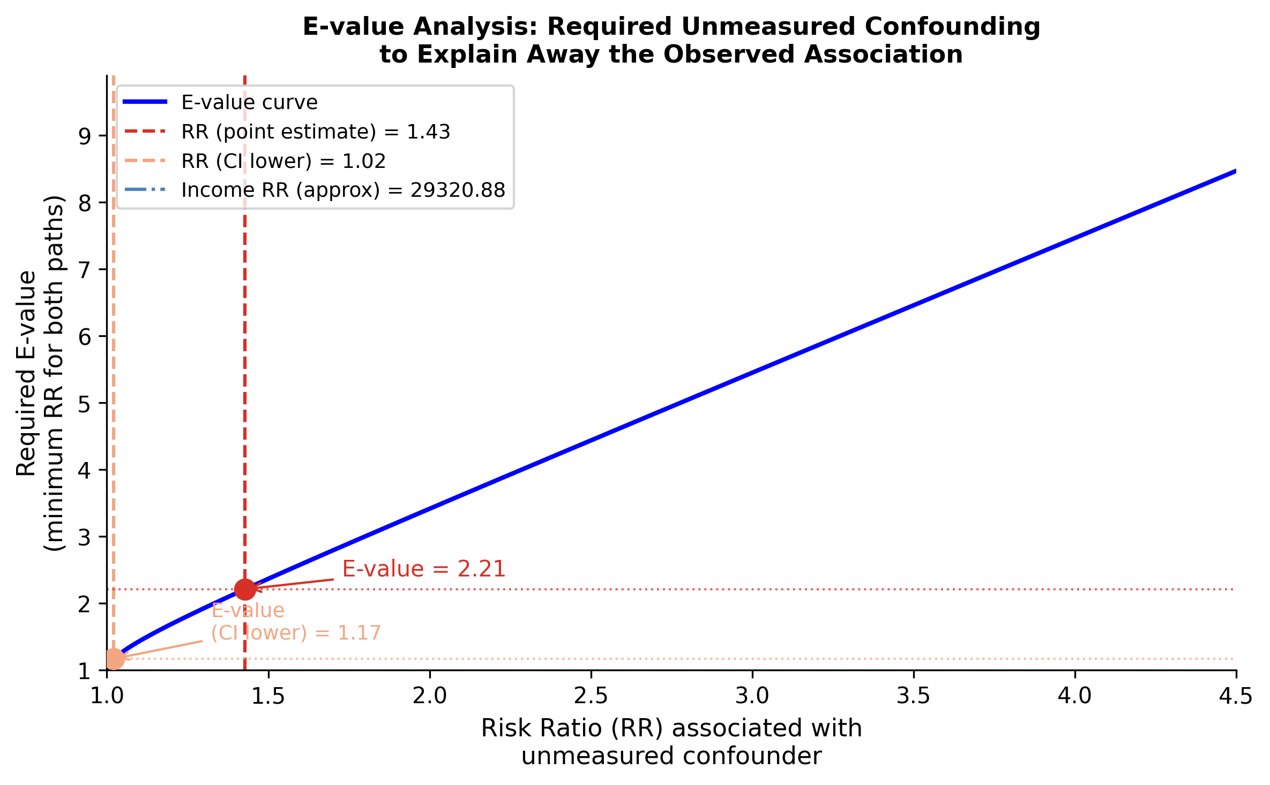
E-value visualization for the primary association
Supplementary Figure 3: Forest plot of sensitivity analysis results for HbA1c high-value rate (all specifications non-significant).
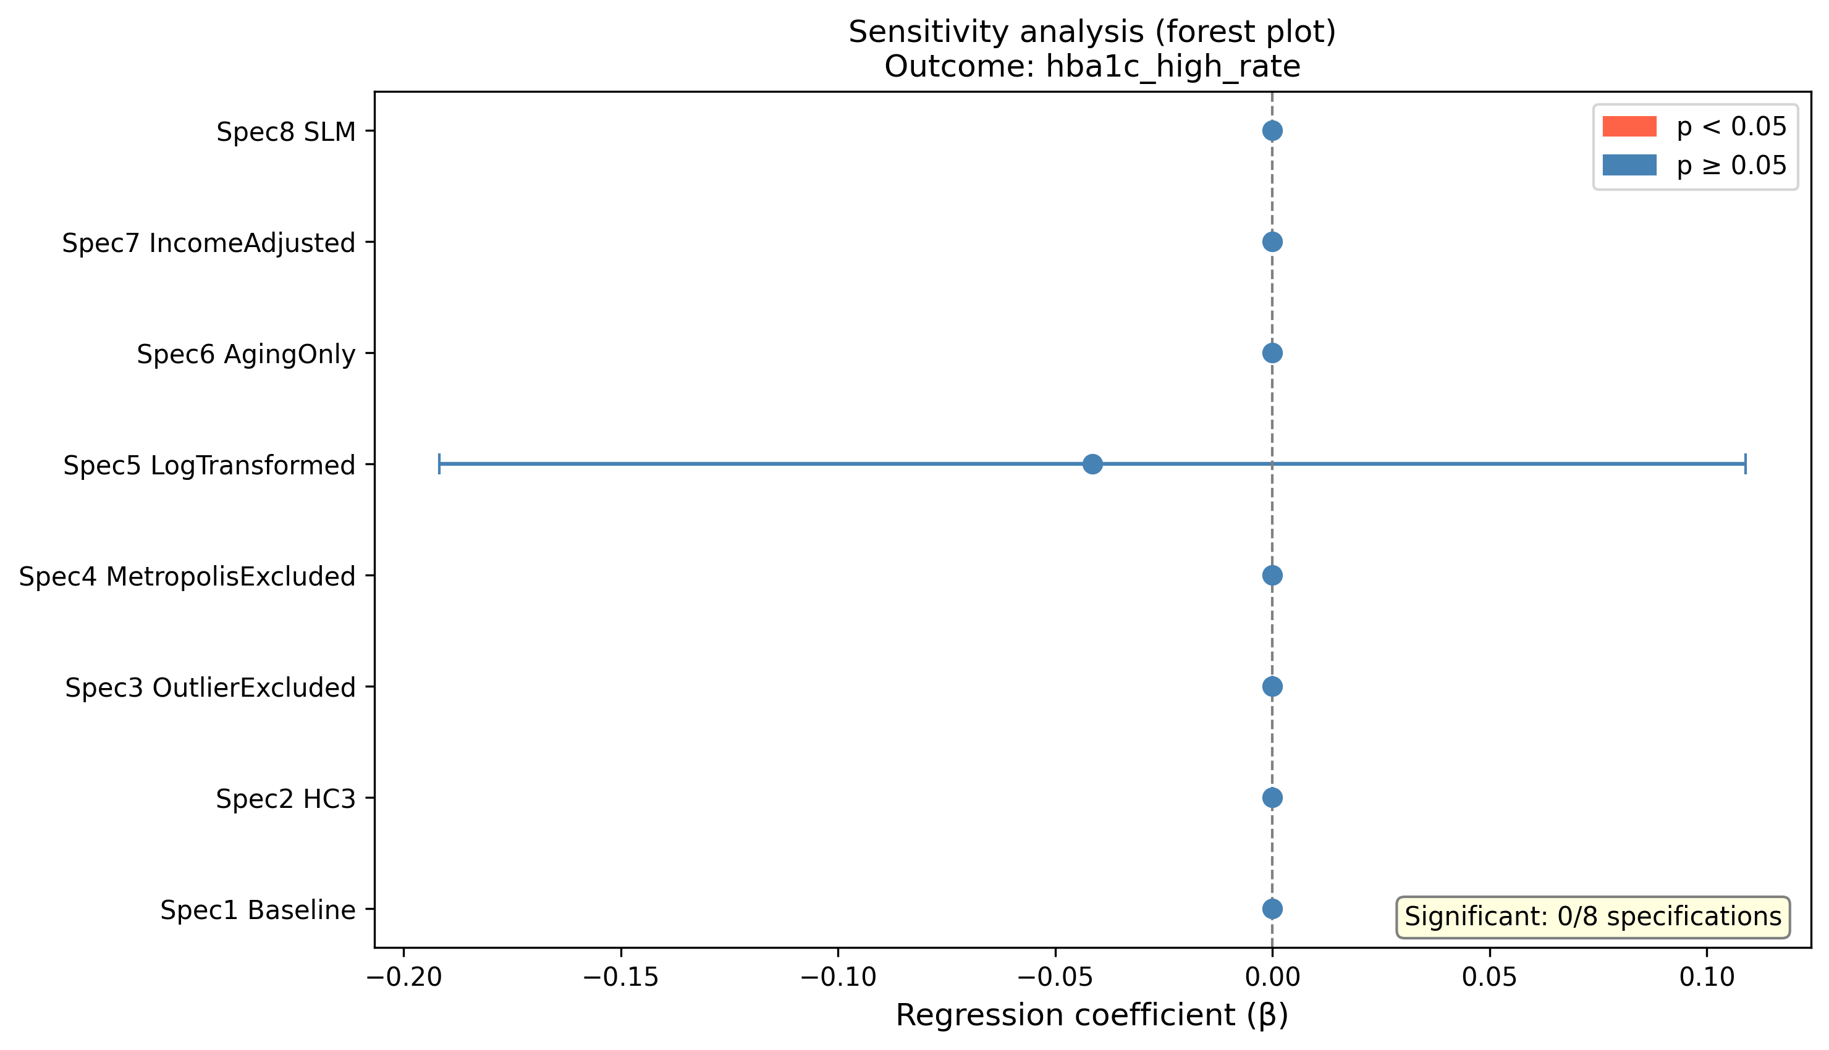
Forest plot: sensitivity analyses for HbA1c high-value rate

Supplementary Text

Supplementary Methods: E-value and Population Attributable Fraction
E-values were calculated following VanderWeele and Ding (23) to provide an exploratory bound on the strength of unmeasured confounding required to explain away the observed association. Because the main analysis used prefectural ecological claims data and did not aim to estimate individual-level causality, these calculations were treated as supplementary sensitivity information rather than central causal evidence.
Population attributable fractions were estimated using a quartile-based relative-risk approximation comparing mean diabetic complication management claim rates in the highest versus lowest periodontal treatment claim quartiles. These estimates were retained only as exploratory contextual calculations and should not be interpreted as causal burden estimates.

Supplementary Methods: Income Mediation Analysis
A supplementary mediation analysis was conducted following the general causal mediation framework (24) to explore whether per-capita income behaved as a confounder or partial mediator in the claims-based association. Given the prefectural ecological design and limited sample size (N = 47), the mediation analysis was considered descriptive and exploratory.

Supplementary Results: E-value, Population Attributable Fraction, and Income Mediation
The primary association corresponded to an approximate RR of 1.43 and an E-value of 2.21 for the point estimate. A quartile-based comparison yielded an illustrative PAF of approximately 8.9%. In the mediation analysis, the income-related indirect pathway was not statistically significant, consistent with limited power and the ecological nature of the data. These findings were not used as primary evidence for causality.

