Supplementary Material
Administrative Diabetes Indicators Capture Distinct Stages of the Care Cascade: An Ecological Study of 335 Secondary Medical Areas in Japan

Supplementary Figures
Supplementary Figure S1. Outlier-exclusion sensitivity across five scenarios.
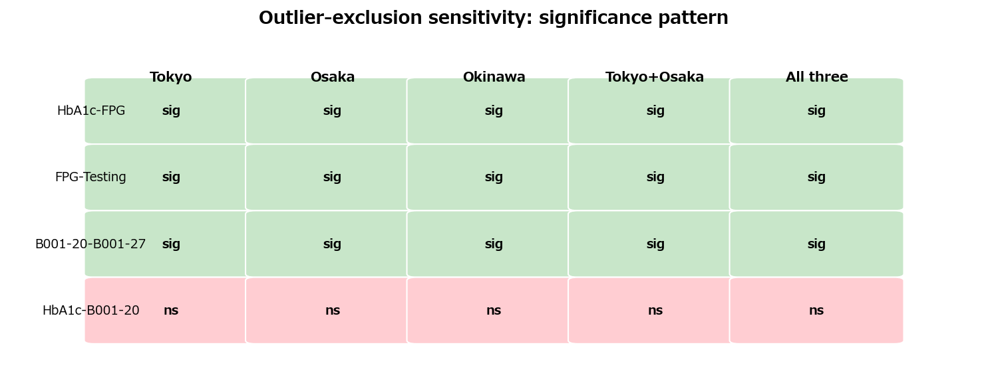
Across all five prefecture-exclusion scenarios (excluding Tokyo, Osaka, Okinawa, Tokyo+Osaka, and all three), HbA1c elevation × B001-20 remained non-significant (rho range −0.07 to −0.08, all p>0.19). Three indicator pairs were consistently significant (p<0.001): HbA1c elevation × FPG abnormality (rho 0.29–0.33), FPG abnormality × HbA1c testing count (rho 0.39–0.43), and B001-20 × B001-27 (rho 0.43 in all scenarios). The null HbA1c elevation–B001-20 association was not attributable to any single outlying prefecture.
Supplementary Figure S2. MAUP risk summary for secondary medical areas versus prefectures.
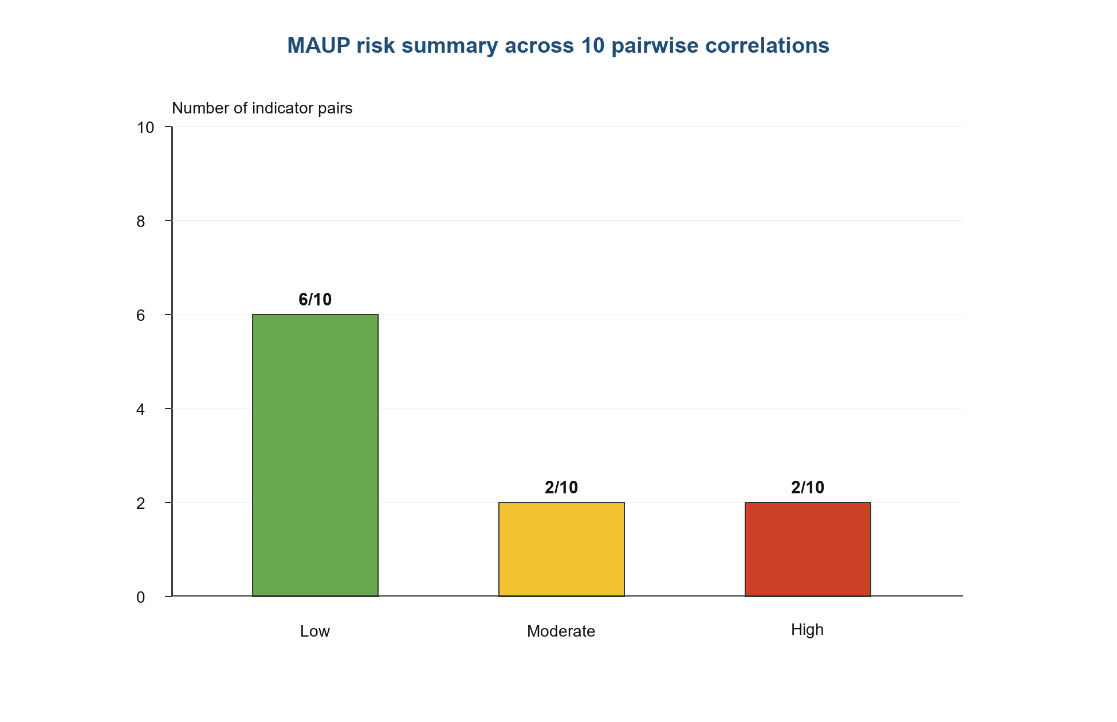
Low risk indicates absolute change in rho below the prespecified threshold; moderate and high risk identify pairs with larger scale sensitivity or direction changes. This descriptive MAUP risk classification is distinct from the |Delta rho|<0.15 scale-comparison stability screen, so the 6/2/2 risk counts should not be read as the inverse of the 8/10 stable-pair count.
Supplementary Figure S3. Proxy-denominator sensitivity for HbA1c elevation versus B001-20.
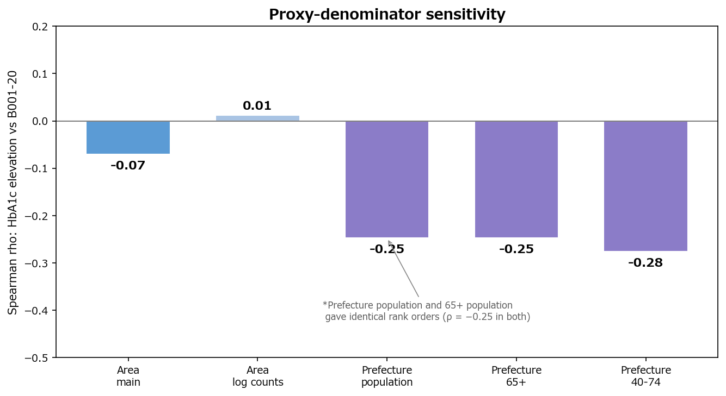
At the secondary medical area level (main analysis: per 1,000 health-check participants), HbA1c elevation × B001-20: rho = −0.07 (main); log-count transformation: rho = +0.01 (|Δrho| = 0.08, stable). Prefecture-level analyses with three population denominators (total population, 65+ population, 40–74 population) yielded rho = −0.25, −0.25, and −0.28 respectively; total population and 65+ population denominators produced identical rank orders. The shared proxy denominator did not artefactually inflate the near-zero district-level association.

Supplementary Tables
Supplementary Table S1. Full Spearman correlation matrix among five diabetes-related indicators.
Indicator | HbA1c elevation | FPG abnormality | HbA1c testing | B001-20 | B001-27
HbA1c elevation | 1.00 | 0.32*** | 0.04 | -0.07 | 0.15**
FPG abnormality | 0.32*** | 1.00 | 0.43*** | -0.23*** | -0.04
HbA1c testing | 0.04 | 0.43*** | 1.00 | 0.00 | -0.01
B001-20 | -0.07 | -0.23*** | 0.00 | 1.00 | 0.43***
B001-27 | 0.15** | -0.04 | -0.01 | 0.43*** | 1.00
Pairwise complete observations, n=251-335. **p<0.01; ***p<0.001. FPG, fasting plasma glucose.
Supplementary Table S2. Sensitivity and robustness analyses.
Analysis | Finding | Interpretation
Scale comparison | 8/10 pairs had absolute change in rho <0.15; HbA1c elevation-B001-20 changed from -0.07 to -0.24. | Most pairs were stable, but screening-management contrasts were scale-sensitive.
Outlier exclusions | HbA1c-FPG, FPG-HbA1c testing, and B001-20-B001-27 were significant in 5/5 scenarios; HbA1c-B001-20 was non-significant in 5/5. | Core null pattern was not driven by Tokyo, Osaka, or Okinawa.
Prescription indicator | Drug-HbA1c testing rho=0.870***; drug-FPG rho=0.532***; drug-B001-20 rho=-0.201; drug-B001-27 rho=-0.142. | Prescription volume aligned with testing and screening indicators, not management claims.
Proxy denominator | Area log-count HbA1c-B001-20 rho range -0.07 to 0.01; prefecture population-denominator rho range -0.25 to -0.28; PC2 remained management-dominated. | The screening-management separation was not explained by the shared checkup denominator alone.
MAUP summary | Low risk 6/10; moderate risk 2/10; high risk 2/10. | Uses a descriptive risk classification distinct from the 0.15 stability screen.

