Administrative Diabetes Indicators Capture Distinct Stages of the Care Cascade:
  - An Ecological Study of 335 Secondary Medical Areas in Japan
Haruki Saito¹ (Corresponding author)
ORCID: 0009-0009-7890-6068

Tetsuya Ohira¹²
ORCID: 0000-0003-4532-7165

¹ Department of Epidemiology, Fukushima Medical University School of Medicine, Fukushima, Japan
² Radiation Medical Science Center for the Fukushima Health Management Survey, Fukushima Medical University, Fukushima, Japan
Corresponding author: Haruki Saito, Department of Epidemiology, Fukushima Medical University School of Medicine, 1 Hikarigaoka, Fukushima-shi, Fukushima 960-1295, Japan. Email: m211039@fmu.ac.jp
Manuscript type: Research Article (Epidemiology; prepared for Diabetes Research and Clinical Practice)

Abstract
Aims: Administrative healthcare indicators are often treated as interchangeable proxies for regional disease burden, yet they may capture different stages of detection and care. We examined whether diabetes-related administrative indicators reflect one common construct or distinct dimensions of the care cascade.
Methods: Using openly released National Database Open Data from Japan, we assembled five diabetes-related indicators for 335 secondary medical areas: HbA1c elevation rate, fasting plasma glucose abnormality rate, HbA1c testing volume, diabetes complication management claims (B001-20), and dialysis prevention management claims (B001-27). Spearman correlations, principal component analysis, and robustness analyses across geographic scales and alternative specifications were applied.
Results: The indicators did not converge on one dimension. HbA1c elevation and fasting glucose abnormality were correlated (rho=0.32), and fasting glucose abnormality correlated with HbA1c testing volume (rho=0.43). HbA1c elevation showed little correlation with complication management claims (rho=-0.07). The first principal component (31.2% of variance) loaded on screening and testing indicators; the second (24.0%) loaded on complication management indicators.
Conclusions: Administrative diabetes indicators reflect different combinations of metabolic risk, detection, monitoring, and management. Regional comparisons should define the intended care-cascade construct before selecting an indicator.
Keywords: administrative data; diabetes mellitus; ecological study; healthcare utilization; measurement; principal component analysis

1. Introduction
Administrative healthcare databases are widely used to describe chronic disease burden, compare regions, and guide service planning. Their scale and routine availability make them attractive for population monitoring. However, a count in an administrative database is produced by both health need and the care process that converts need into a recorded event. Reporting guidance for routinely collected data therefore emphasizes clear definitions, provenance, and limitations of coded outcomes [1-5].
Diabetes illustrates this measurement problem. A screening abnormality, a laboratory claim, a prescription, and a complication management claim can all be called a diabetes indicator. These measures do not arise at the same point in care. Screening values depend on participation and metabolic risk. Testing counts depend on access, clinical practice, and monitoring frequency. Management claims require eligible patients, organized services, and successful billing. A care-cascade view therefore predicts that these indicators may not be interchangeable, even when each is relevant to diabetes [6-8].
This distinction is important for construct validity. An indicator can be measured reliably while representing a different construct from the one assumed by the analyst [9]. Ecological comparisons add another layer: regional associations do not identify individual-level relations, and observed patterns can change when the geographic unit changes [10-13]. Treating all diabetes-related counts as prevalence proxies may therefore obscure differences between metabolic risk, diagnostic activity, and downstream management capacity.
We examined five publicly available diabetes-related indicators across Japan's secondary medical areas. Our primary purpose was not to identify a single ground truth. Instead, we asked whether the indicators converged on a common regional dimension or separated into distinct care-cascade dimensions. We combined pairwise correlations, principal component analysis (PCA), and prespecified robustness checks. We expected indicators generated at similar stages of care to align more closely than indicators generated at distant stages.
Figure 1. Care-cascade framework for interpreting administrative diabetes indicators.
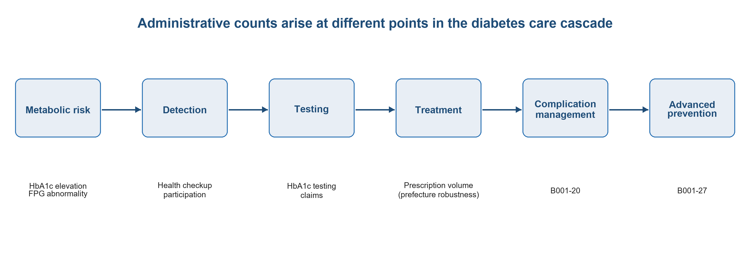

2. Subjects, Materials and Methods

2.1. Study design and data source
This study applied an aggregate, area-level design to the 11th National Database (NDB) Open Data release of the Ministry of Health, Labour and Welfare, Japan [15], with secondary medical areas as the geographic unit. The release contains aggregate statistics from fiscal year (FY) 2024 claims and FY2023 specific health checkups. The unit of the primary analysis was the secondary medical area, a regional planning unit for general inpatient and related services. The assembled dataset contained 335 areas. All source data were publicly available aggregates; no individual-level records were accessed.

2.2. Indicator selection and construction
We selected five indicators that were available at the secondary-medical-area level, were specific to diabetes or glycemic assessment, and represented more than one stage of the care cascade. The indicators were: (1) the proportion of health-check participants with HbA1c at least 6.5% (48 mmol/mol); (2) the proportion with fasting plasma glucose at least 110 mg/dL; (3) the number of billed HbA1c tests; (4) the number of patients with claims for the diabetes complication management fee (B001-20); and (5) the number with claims for the diabetes dialysis prevention guidance management fee (B001-27). Prescription counts for antidiabetic drugs (therapeutic class 396) were available only by prefecture and were therefore excluded from the primary analysis. They were used in a prefecture-level robustness analysis.
Table 1. Diabetes-related indicators and their intended care-cascade positions
Indicator | Source period | Operational definition | Primary care-cascade position
HbA1c elevation rate | FY2023 checkups | HbA1c >=6.5% (48 mmol/mol) among checkup participants | Screening abnormality / metabolic risk
FPG abnormality rate | FY2023 checkups | Fasting plasma glucose >=110 mg/dL among participants | Screening abnormality / metabolic risk
HbA1c testing volume | FY2024 claims | Billed HbA1c tests per 1,000 checkup participants | Diagnostic and monitoring activity
B001-20 | FY2024 claims | Patients with diabetes complication management claims per 1,000 participants | Complication management
B001-27 | FY2024 claims | Patients with diabetes dialysis prevention management claims per 1,000 participants | Advanced complication prevention

2.3. Standardization and missing values
The two screening proportions were directly standardized to the 2020 Census population aged 40-74 years in seven 5-year age groups. Age-specific counts were not available by secondary medical area for the three clinical claims indicators. These indicators were therefore expressed per 1,000 specific-health-check participants as a common proxy denominator. This conversion is not equivalent to direct age standardization and was treated as a measurement limitation. Counts below 10 were suppressed in the source data. Suppressed values were coded as missing and were not imputed. B001-20 was missing in 45 areas (13.4%), and B001-27 was missing in 44 areas (13.1%). The other indicators had no suppressed area-level values.

2.4. Statistical analysis
We calculated pairwise Spearman rank correlations using available pairs (n=251-335). Two-sided p values below 0.05 were considered statistically significant. We then standardized the five indicators as z scores and performed PCA in complete cases (n=251). We retained three components for description and interpreted the first two from their largest loadings. To examine external patterning without treating another variable as a gold standard, we correlated component scores with the regional proportion aged 65-74 years. PCA is a descriptive dimension-reduction method; component labels were assigned after inspection of the loadings [16].
Five robustness analyses were performed. First, we recalculated the correlation matrix for 47 prefectures and compared it with the secondary-area matrix. For this geographic scale-comparison screen, an absolute change in rho below 0.15 was defined as broadly stable. Second, we recalculated correlations after excluding Tokyo, Osaka, and Okinawa singly or in combinations. Third, we added prefecture-level antidiabetic prescription volume as a sixth indicator. Fourth, we summarized scale sensitivity as low, moderate, or high risk according to differences in magnitude and direction between geographic levels. Fifth, we assessed whether the shared proxy denominator shaped the correlation structure. For this analysis, we recalculated the three clinical claims indicators at the prefecture level using total population, population aged 65 years and older, and population aged 40-74 years as alternative denominators. At the secondary-medical-area level, we also examined log1p-transformed raw counts as a specification without a shared rate denominator. For the proxy-denominator sensitivity analysis, a pairwise correlation was defined as stable when the absolute change in rho was below 0.10. These analyses were descriptive and were not used to infer individual-level effects.

3. Results

3.1. Pairwise correlations
The two screening abnormalities were positively correlated (rho=0.32, p<0.001). Fasting plasma glucose abnormality was correlated with HbA1c testing volume (rho=0.43, p<0.001). The two management indicators were also correlated (rho=0.43, p<0.001). HbA1c elevation was weakly correlated with B001-27 (rho=0.15, p<0.01) and had little correlation with B001-20 (rho=-0.07). Fasting plasma glucose abnormality was inversely correlated with B001-20 (rho=-0.23, p<0.001). HbA1c testing volume was not correlated with either management indicator. Figure 2 displays the same structure visually.
Figure 2. Correlation heatmap of the five diabetes-related indicators.
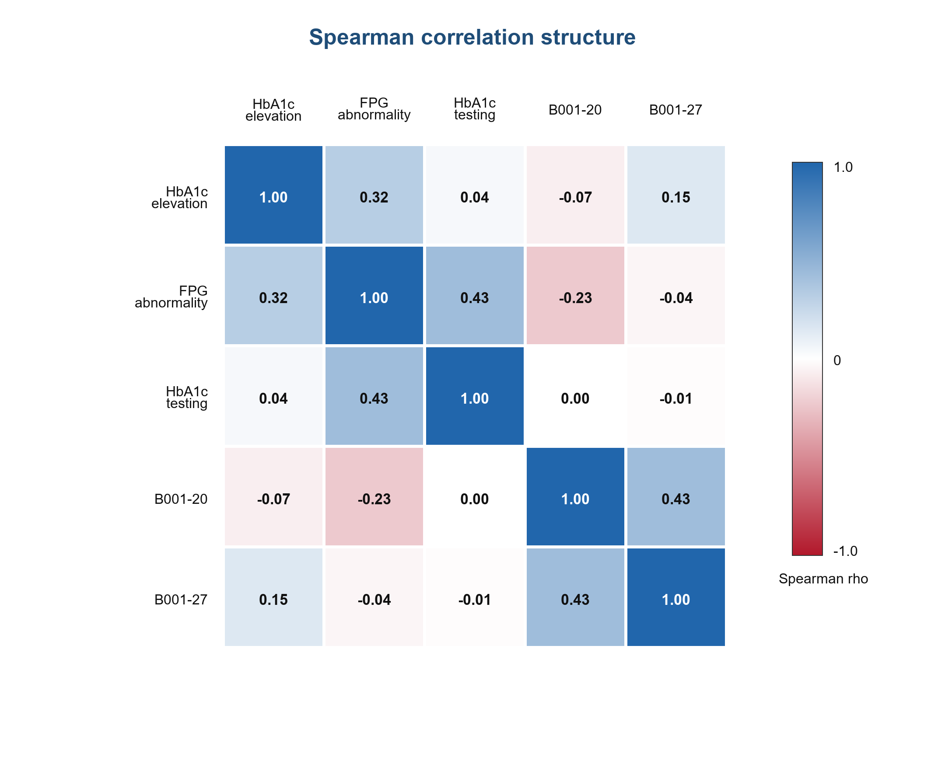

3.2. Principal components
PC1 explained 31.2% of total variance. Its largest positive loadings were for fasting plasma glucose abnormality (0.66), HbA1c testing volume (0.53), and HbA1c elevation (0.47). PC2 explained 24.0% and loaded mainly on B001-20 (0.74) and B001-27 (0.63). Together, PC1 and PC2 explained 55.2%. PC3 explained 20.4%. The proportion aged 65-74 years was positively correlated with PC1 (rho=0.426, p<0.001) and inversely correlated with PC2 (rho=-0.300, p<0.001) and PC3 (rho=-0.319, p<0.001). Figure 3 shows the reported loading pattern, and Table 2 summarizes the component interpretation.
Figure 3. PCA loading map for five diabetes-related indicators (n=251 complete cases). PC1 (31.2% of variance) reflects screening and testing intensity; PC2 (24.0%) reflects complication management intensity.
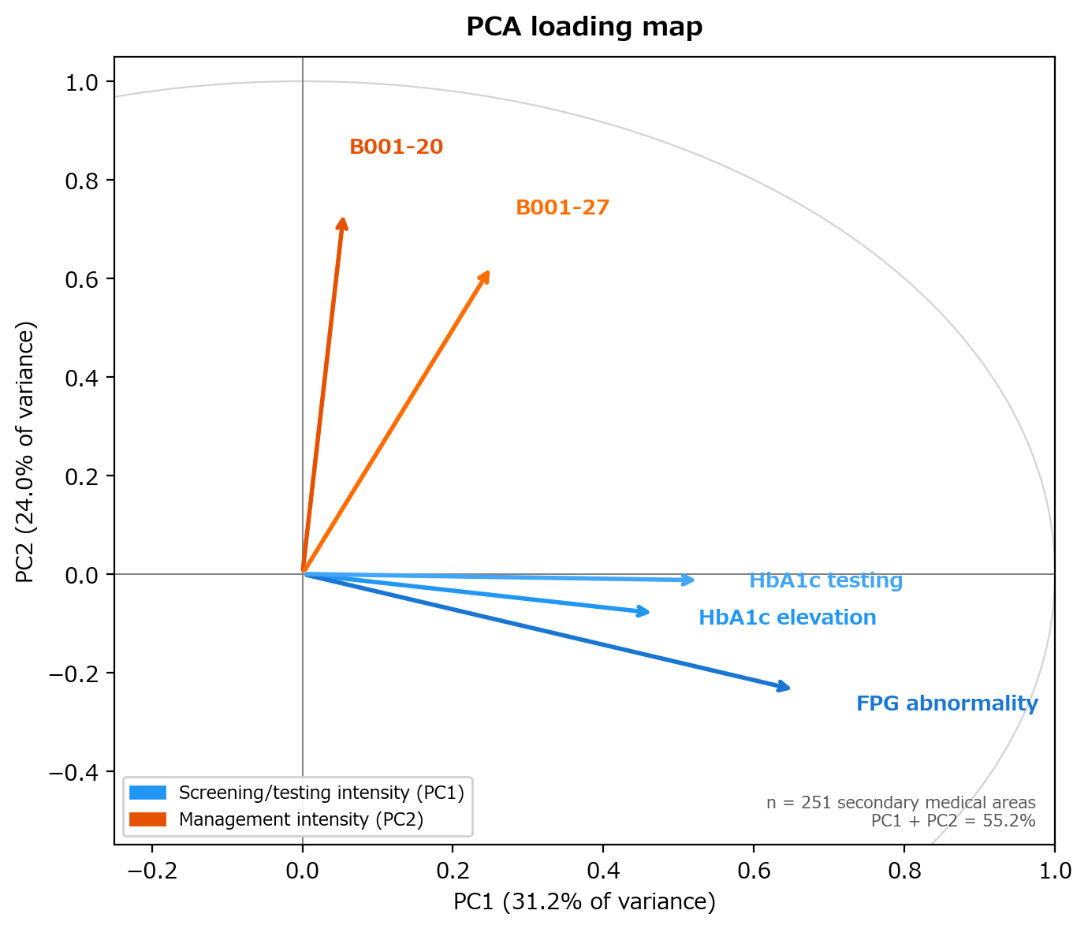
Table 2. Principal component summary
Component | Variance explained | Largest loadings | Descriptive interpretation | Correlation with age 65-74
PC1 | 31.2% | FPG abnormality 0.66; HbA1c testing 0.53; HbA1c elevation 0.47 | Screening and testing intensity | 0.426***
PC2 | 24.0% | B001-20 0.74; B001-27 0.63 | Complication management intensity | -0.300***
PC3 | 20.4% | Not prespecified for interpretation | Not assigned | -0.319***
PCA complete cases, n=251. Component labels are descriptive. ***p<0.001.

3.3. Robustness analyses
Eight of 10 pairwise correlations differed by less than 0.15 between secondary medical areas and prefectures. This 0.15 threshold was used only for the geographic scale-comparison screen. The HbA1c elevation-B001-20 correlation changed from -0.07 at the secondary-area level to -0.24 at the prefecture level (absolute change in rho=0.17). The B001-20-B001-27 pair also exceeded the threshold (district rho=0.43, prefecture rho=0.14; absolute change in rho=0.29). In all five outlier-exclusion scenarios, HbA1c elevation remained uncorrelated with B001-20. The HbA1c elevation-fasting plasma glucose, fasting plasma glucose-HbA1c testing, and B001-20-B001-27 pairs remained significant.
At the prefecture level, antidiabetic prescription volume correlated with HbA1c testing (rho=0.870, p<0.001) and fasting plasma glucose abnormality (rho=0.532, p<0.001). It was not correlated with B001-20 (rho=-0.201) or B001-27 (rho=-0.142). The geographic-scale assessment classified six of 10 indicator pairs as low risk of scale distortion, two as moderate risk, and two as high risk. This MAUP risk classification used a descriptive scale-sensitivity rule distinct from the 0.15 stability screen. In the proxy-denominator sensitivity analysis, the area-level correlation between HbA1c elevation and B001-20 remained weak when clinical indicators were expressed as log counts without a shared rate denominator (rho=-0.07 to 0.01; absolute change 0.08). At the prefecture level, HbA1c elevation and B001-20 remained weakly negatively correlated under all three population-based denominators (rho=-0.25 to -0.28; absolute change <0.10 versus the prefecture main specification). This 0.10 threshold was the stricter proxy-denominator sensitivity threshold, not the scale-comparison threshold. Across these specifications, PC2 continued to load primarily on complication management indicators. The largest loading was on B001-27 under population-based denominators. Detailed robustness displays are provided in Supplementary Figures S1-S3 and Supplementary Tables S1-S2.

4. Discussion

4.1. Principal findings
Five diabetes-related administrative indicators did not behave as interchangeable measures of one regional diabetes burden. Screening abnormalities and testing activity contributed mainly to one component. Complication management claims contributed mainly to another component. The near-zero area-level correlation between HbA1c elevation and B001-20 was consistent across the five outlier-exclusion scenarios. These findings support a measurement interpretation. The indicators may occupy different positions between metabolic risk, detection, monitoring, and organized complication management.

4.2. Care-cascade interpretation
A recorded administrative event requires several transitions. A person must have an underlying health state, encounter screening or clinical care, receive a test or service, and generate a record under the relevant coding and payment rules. Each indicator is therefore a product of need and delivery. HbA1c and fasting glucose abnormalities among health-check participants are closest to detected metabolic risk, although participation remains selective. HbA1c testing and prescription counts are influenced by clinical contact and monitoring practice. B001-20 and B001-27 require more specific eligibility, service organization, and billing. Their separation from screening indicators is therefore plausible and does not imply that one group is valid and the other invalid.
The divergent associations between HbA1c elevation and the two management indicators are also informative. B001-27 is targeted to patients at elevated risk of diabetic nephropathy progression and may therefore retain a modest association with regional glycemic burden (rho=0.15), whereas B001-20 reflects broader service organization and billing practices for routine complication management and showed no association with HbA1c elevation (rho=-0.07).
The PCA results should not be read as proof of two biological subtypes. PCA describes covariance in the observed indicators. The labels 'screening and testing intensity' and 'complication management intensity' summarize the dominant loadings, not latent variables established by external validation. The correlations with regional age structure provide context but not a criterion standard. This distinction is central because no single aggregate indicator in the dataset represents true regional diabetes prevalence.

4.3. Implications for research and policy
Indicator selection should follow the study question. Screening abnormalities may be useful for describing detected risk among participants. Testing and prescription counts may be useful for examining contact with medical care or treatment intensity. Specific management claims may be more relevant to service implementation and capacity. Combining these measures without an explicit model can produce a composite whose meaning is unclear. At minimum, studies should state the care-cascade stage, denominator, suppression rule, and service requirements represented by each indicator.
Regional comparisons should also test geographic sensitivity. Most correlations were broadly stable across secondary areas and prefectures, but the relation between screening abnormalities and B001-20 changed in magnitude. This is compatible with the modifiable areal unit problem: aggregation can alter ecological associations even when the source records are unchanged [13]. A single national map or correlation coefficient should not be treated as a data-intrinsic property.

4.4. Strengths and limitations
This study compared multiple indicators within one national open-data system, used a policy-relevant geographic unit, and examined the stability of findings across specifications. The symmetric correlation design avoided declaring one indicator to be the ground truth. PCA offered a compact description of shared and distinct variation, and the prescription analysis provided an additional indicator at the prefecture level.
Several limitations require caution. First, the design was ecological. Associations among areas cannot be applied to individuals [10,11]. Second, the source periods differed: screening measures were from FY2023 and claims measures from FY2024. Third, the clinical claims indicators could not be directly age-standardized because area-level age strata were unavailable. Rates per 1,000 health-check participants used a proxy denominator and may reflect regional participation. However, sensitivity analyses using population-based denominators and log-count specifications showed that the weak association between HbA1c elevation and B001-20 was not explained by the proxy denominator alone. Fourth, suppression affected approximately 13% of B001-20 and B001-27 values. Complete-case PCA may therefore underrepresent areas with small counts. Fifth, coding practices, eligibility rules, provider supply, and billing behavior can influence claims independently of need. Sixth, PCA labels were interpretive, and the first two components explained 55.2% of variance. Finally, scale sensitivity was present for some indicator pairs, and no external criterion standard for true regional diabetes burden was available.
This study deliberately focuses on a single methodological question: whether co-existing diabetes-related administrative indicators represent one common construct or distinct dimensions of the care cascade. It addresses this through the construct validity and multidimensionality of the indicators, examined with correlation and principal component structure. It does not attempt to establish a single ground-truth measure of regional diabetes prevalence, and its scope is limited to how these indicators relate to one another rather than to how any individual outcome should be defined.

5. Conclusions
Administrative healthcare counts are not neutral substitutes for disease prevalence. In this national ecological analysis, diabetes-related screening, testing, prescription, and complication management indicators captured partly distinct regional dimensions. Researchers and policy makers should define the intended care-cascade construct before choosing an indicator, document how the count is generated, and examine whether conclusions change across geographic scales.

Declarations

Ethics approval and consent to participate
This study used publicly available aggregate data. Individual informed consent was not required, and institutional ethics review was not applicable in accordance with Japanese ethical guidelines for epidemiological research.

Consent for publication
Not applicable.

Availability of data and materials
The datasets supporting this study are openly released by the Ministry of Health, Labour and Welfare of Japan as part of the NDB Open Data and contain no individual-level records (https://www.mhlw.go.jp/stf/seisakunitsuite/bunya/0000177182.html). Aggregate area-level data and analysis code used to produce the reported results are available at https://github.com/haruki00430/administrative-diabetes-indicators-japan and archived on Zenodo (https://doi.org/10.5281/zenodo.21127212).

Competing interests
The authors declare no conflicts of interest.

Funding
None declared.

Author contributions
Haruki Saito: Conceptualization, Data curation, Formal analysis, Investigation, Methodology, Software, Visualization, Writing – original draft, Writing – review and editing.
Tetsuya Ohira: Conceptualization, Supervision, Writing – review and editing.

Acknowledgements
The authors acknowledge the Ministry of Health, Labour and Welfare of Japan for making the NDB Open Data openly available. The analyses rely solely on aggregate, publicly released figures.

List of abbreviations
NDB, National Database of Health Insurance Claims and Specific Health Checkups of Japan; FY, fiscal year; HbA1c, glycated hemoglobin A1c; FPG, fasting plasma glucose; PCA, principal component analysis; PC, principal component; MAUP, modifiable areal unit problem; B001-20, medical fee code for diabetes complication management guidance; B001-27, medical fee code for diabetes dialysis prevention guidance management.

Declaration of generative AI and AI-assisted technologies in the manuscript preparation process
During the preparation and writing of this work, the authors used AI-assisted tools to support manuscript drafting and statistical analysis scripting. Cursor 3.0 (Anysphere) and Google Antigravity (Google) were used for AI-assisted writing and Python code development. Large language models used through these platforms included Claude Sonnet 4.6, Sonnet 5 and Claude Opus 4.8 (Anthropic) and GPT-5.5 (OpenAI) and Gemini 3 Pro (Google). These tools were used only for text drafting and code generation; no generative AI or AI-assisted tools were used to create, alter, or otherwise process any figures, images, or artwork in this manuscript. The authors reviewed and edited all AI-assisted outputs and were responsible for the study design, selection of statistical methods, interpretation of findings, conclusions, and final reference list. The authors take full responsibility for the integrity and accuracy of the final content. AI was not listed as an author.

References
1. Benchimol EI, Smeeth L, Guttmann A, et al. The REporting of studies Conducted using Observational Routinely-collected health Data (RECORD) statement. PLoS Med. 2015;12:e1001885. doi:10.1371/journal.pmed.1001885.
2. von Elm E, Altman DG, Egger M, Pocock SJ, Gotzsche PC, Vandenbroucke JP. The Strengthening the Reporting of Observational Studies in Epidemiology (STROBE) statement. PLoS Med. 2007;4:e296. doi:10.1371/journal.pmed.0040296.
3. Benchimol EI, Manuel DG, To T, Griffiths AM, Rabeneck L, Guttmann A. Development and use of reporting guidelines for assessing the quality of validation studies of health administrative data. J Clin Epidemiol. 2011;64:821-829. doi:10.1016/j.jclinepi.2010.10.006.
4. Iezzoni LI. Assessing quality using administrative data. Ann Intern Med. 1997;127(8 Pt 2):666-674. doi:10.7326/0003-4819-127-8_Part_2-199710151-00048.
5. Schneeweiss S, Avorn J. A review of uses of health care utilization databases for epidemiologic research on therapeutics. J Clin Epidemiol. 2005;58(4):323-337. doi:10.1016/j.jclinepi.2004.10.012.
6. Donabedian A. Evaluating the quality of medical care. Milbank Mem Fund Q. 1966;44:166-206. doi:10.2307/3348969.
7. Ali MK, Bullard KM, Saaddine JB, Cowie CC, Imperatore G, Gregg EW. Achievement of goals in U.S. diabetes care, 1999-2010. N Engl J Med. 2013;368:1613-1624. doi:10.1056/NEJMsa1213829.
8. Gardner EM, McLees MP, Steiner JF, Del Rio C, Burman WJ. The spectrum of engagement in HIV care and its relevance to test-and-treat strategies for prevention of HIV infection. Clin Infect Dis. 2011;52(6):793-800. doi:10.1093/cid/ciq243.
9. Cronbach LJ, Meehl PE. Construct validity in psychological tests. Psychol Bull. 1955;52:281-302. doi:10.1037/h0040957.
10. Robinson WS. Ecological correlations and the behavior of individuals. Am Sociol Rev. 1950;15:351-357. doi:10.2307/2087176.
11. Morgenstern H. Uses of ecologic analysis in epidemiologic research. Am J Public Health. 1982;72:1336-1344. doi:10.2105/AJPH.72.12.1336.
12. Rothman KJ, Greenland S, Lash TL. Modern Epidemiology. 3rd ed. Philadelphia: Lippincott Williams & Wilkins; 2008.
13. Openshaw S. The Modifiable Areal Unit Problem. Norwich: Geo Books; 1984.
14. Fotheringham AS, Wong DWS. The modifiable areal unit problem in multivariate statistical analysis. Environ Plan A. 1991;23(7):1025-1044. doi:10.1068/a231025.
15. Ministry of Health, Labour and Welfare of Japan. NDB Open Data. Available from: https://www.mhlw.go.jp/stf/seisakunitsuite/bunya/0000177182.html. Accessed 22 June 2026.
16. Jolliffe IT, Cadima J. Principal component analysis: a review and recent developments. Philos Trans A Math Phys Eng Sci. 2016;374:20150202. doi:10.1098/rsta.2015.0202.

