Not All Environmental Indicators Travel: Lessons from Greenspace and Mental Health Service Use in Japan
Haruki Saito¹,* and Tetsuya Ohira¹,²
¹ Department of Epidemiology, Fukushima Medical University School of Medicine, 1 Hikarigaoka, Fukushima-shi, Fukushima 960-1295, Japan
² Radiation Medical Science Center for the Fukushima Health Management Survey, Fukushima Medical University, Fukushima, Japan
*Corresponding author: Haruki Saito. Email: m211039@fmu.ac.jp. ORCID: 0009-0009-7890-6068
Tetsuya Ohira. Email: teoohira@fmu.ac.jp. ORCID: 0000-0003-4532-7165
Article type: Research Article
Word count (main text): approximately 2,490 | Abstract: approximately 159 | Tables and figures: 6 (3 tables + 3 figures) | References: 28

Abstract
Environmental epidemiology often relies on administrative indicators as proxies for human exposure. Greenspace quantity is widely used as a protective environmental determinant of mental health, but area-level coverage may not capture accessibility, quality, utilization, or healthcare pathways. We examined whether prefecture-level greenspace coverage predicts psychiatric medication prescriptions across all 47 Japanese prefectures using National Database (NDB) Open Data (FY 2023), national land-use statistics, and socioeconomic indicators. Spatial autocorrelation was assessed with Moran's I; ordinary least squares, spatial lag, spatial error, and Spatial Durbin models were compared. Stratified and interaction analyses tested urban-rural heterogeneity. Greenspace ratio and prescription rates showed significant spatial clustering, but after socioeconomic and spatial adjustment greenspace did not predict prescriptions (Spatial Durbin β=1,326, p=0.836). Stratified coefficients differed in direction but interaction tests showed no effect modification. Administrative greenspace quantity was a weak proxy for mental health-relevant environmental exposure; indicators should be validated against intended exposure pathways before use in ecological mental health surveillance.
Keywords: Greenspace; Mental health; Spatial epidemiology; Environmental epidemiology; Japan

Introduction
Environmental epidemiology often depends on indicators that are administratively available, geographically comparable, and easy to map. These indicators support surveillance and policy, but they are also proxies for human exposure, experience, behavior, and service pathways that are rarely measured directly. A central methodological question is therefore whether an environmental indicator remains valid when it is applied across settings (1,2).
Greenspace is a useful example of this problem. Natural environments may support mental health through restoration, physical activity, social interaction, and reduced exposure to urban stressors (3-12). However, area-level greenspace coverage measures the amount of green land within an administrative unit, a scale that may itself shape exposure classification (13,14). It does not measure whether residents can reach that space, whether it is safe or maintained, whether it is biodiverse or restorative, or whether people use it. Forests, parks, agricultural land, street trees, and inaccessible green areas may be collapsed into one ratio despite having different public-health meanings.
This measurement gap may be especially important when environmental indicators are linked to administrative health-service outcomes. Psychiatric medication prescriptions are not direct measures of mental illness prevalence. They are claims-based service-use signals shaped by need, access to psychiatric care, prescribing practice, treatment continuation, and healthcare-seeking behavior. Therefore, a greenspace indicator may fail to predict prescription volume because the environmental proxy and the health-service outcome are distant in the causal and measurement chain (15-17).
This study used nationwide prefecture-level data from Japan to examine whether greenspace quantity travels as a valid environmental indicator for mental health service use. We examined whether prefecture-level greenspace coverage predicted psychiatric medication prescriptions after socioeconomic and spatial adjustment, and whether apparent urban-rural differences were supported by formal interaction tests. The broader aim was to assess one boundary condition under which an environmental indicator may lose predictive power.

Materials and methods

1. Study Design and Setting
We conducted a nationwide ecological study using prefecture-level data (N=47) in Japan. The unit of analysis was the administrative prefecture, the largest subnational administrative division in Japan. Prescription outcomes were measured for fiscal year 2023; socioeconomic covariates were obtained from publicly available 2020 prefecture-level statistics (see covariate list below).

2. Data Sources

Psychiatric Medication Prescriptions
Prescription data were obtained from the National Database of Health Insurance Claims (NDB) Open Data No.10 (fiscal year 2023) published by the Ministry of Health, Labour and Welfare (18). We extracted total quantities of psychiatric medications (hypnotics, anxiolytics, antidepressants, and related agents) and expressed them as tablets per 100,000 population using prefecture population from the 2020 Population Census as the denominator. This outcome was interpreted as a claims-based mental health service-use signal rather than individual-level psychiatric disease prevalence.

Greenspace Ratio
Greenspace data were obtained from the National Land Numerical Information land-use subdivided mesh dataset (L03-b) published by the Ministry of Land, Infrastructure, Transport and Tourism (19). Prefecture-level forest and park areas were aggregated from 1-km mesh cells and divided by total prefecture area (km²), expressed as a percentage. Forest area included the forest land-use class; park area included parks and green space. This variable was treated as an administrative environmental proxy: it captures quantity, but not accessibility, quality, safety, biodiversity, perceived restorative value, or actual use.

Socioeconomic and Healthcare Covariates
Covariates were obtained from the e-Stat portal (Statistics Bureau of Japan) (20) and the Ministry of Health, Labour and Welfare medical facility survey:
Aging rate (%): Proportion of population aged ≥65 years (Population Census 2020)
Unemployment rate (%): Complete unemployment rate (Population Census 2020)
Population density (persons/km²): Total population divided by habitable land area
Income per capita (JPY): Per-capita taxable income (Municipal Taxation Statistics, FY 2020)
College graduate rate (%): Proportion of population aged ≥25 years with a college degree or higher (Employment Status Survey 2017)
Psychiatric clinic density: Number of psychiatric clinics per 100,000 population (Medical Facility Survey 2020)
These variables were selected a priori as potential confounders based on previous literature documenting associations between socioeconomic status, healthcare access, and both greenspace availability and mental health outcomes (21,22).

3. Statistical Analysis

Descriptive Statistics
We calculated means, standard deviations, medians, and interquartile ranges for all continuous variables. Normality was assessed using the Shapiro-Wilk test. Pearson correlation coefficients were computed to examine bivariate associations.

Spatial Autocorrelation
To assess whether neighboring prefectures exhibited similar values (positive spatial autocorrelation), we calculated Global Moran’s I statistics for greenspace ratio, prescription rate, and socioeconomic covariates (23,24). Spatial weights were defined using Queen contiguity (shared borders or vertices) (25). Statistical significance was evaluated using 999 permutations.

Spatial Regression Models
We fitted four spatial regression models (24,26):
- Ordinary Least Squares (OLS): Baseline non-spatial model
- Spatial Lag Model (SLM): Includes a spatially lagged dependent variable (W×Y) to account for spatial dependence in the outcome
- Spatial Error Model (SEM): Includes a spatially autocorrelated error term (λ) to account for spatial dependence in unobserved factors
- Spatial Durbin Model (SDM): Includes spatially lagged dependent and independent variables to capture spillover effects (26)
The general model specification was:
$${\text{Prescription}}_{i}=β_{0}+β_{1}×{\text{Greenspace}}_{i}+β_{2}×{\text{Aging}}_{i}+β_{3}×{\text{Unemployment}}_{i}+β_{4}×{\text{Income}}_{i}+β_{5}×{\text{ClinicDensity}}_{i}+ϵ_{i}$$
Model selection was based on Akaike Information Criterion (AIC), with lower values indicating better fit. Lagrange Multiplier (LM) tests were used to diagnose spatial dependence in OLS residuals.

Stratified Analysis and Interaction Tests
To examine urban-rural heterogeneity, we conducted stratified analyses by dividing prefectures into two groups based on median population density (urban: ≥median; rural: <median). Separate OLS regressions were fitted for each stratum, focusing on the greenspace coefficient. To formally test whether the greenspace-prescription association differed by urbanization level, we estimated interaction models in the full sample including product terms: (1) Greenspace × Aging rate, (2) Greenspace × Single household rate, (3) Greenspace × Urban indicator (binary variable based on median population density), and (4) Greenspace × Population density (continuous variable). Statistical significance of interaction terms was assessed using t-tests at α=0.05.

Sensitivity Analysis
We conducted two sensitivity analyses: (1) outlier diagnostics using Cook’s distance and standardized residuals; (2) exclusion of island prefectures (Hokkaido and Okinawa) to assess robustness.
All analyses were performed using Python 3.14 with the libpysal, spreg, geopandas, and matplotlib libraries. Statistical significance was set at α=0.05 (two-tailed).

Use of AI tools: During analysis scripting and manuscript preparation, the authors used AI-assisted coding tools (Cursor, Claude Code). All statistical analyses were implemented and verified by the authors; NDB raw data were not transmitted to AI systems. See Declaration of generative AI below for full disclosure.
Ethics: This study used publicly available, anonymized, aggregate-level data from government statistical databases, including the NDB Open Data (Ministry of Health, Labour and Welfare of Japan), the National Land Numerical Information land-use dataset (Ministry of Land, Infrastructure, Transport and Tourism), and e-Stat (Statistics Bureau of Japan). No individual-level data were accessed. Under applicable Japanese national guidelines, formal ethics committee review is not required for secondary research using publicly available aggregate statistics. No informed consent was required.

Results

1. Descriptive Statistics
Table 1 presents descriptive statistics for all variables across 47 prefectures. The mean psychiatric medication prescription quantity was 6,812,617 tablets per 100,000 population (SD=767,166), equivalent to approximately 68 tablets per capita per year. The mean greenspace ratio was 63.1% (SD=15.0%), ranging from 29.6% to 83.7%. Aging rate ranged from 22.6% to 36.4% (mean=31.8%, SD=3.4%). Population density varied widely, from 64 to 6,462 persons/km2 (median=257, mean=650). Pearson correlations showed positive bivariate correlations between prescription rate and greenspace ratio (r=0.450, p=0.001), aging rate (r=0.636, p<0.001), and single household rate (r=0.664, p<0.001). The full correlation matrix is reported in Supplementary Table S1.

2. Spatial Autocorrelation
Global Moran’s I statistics indicated significant positive spatial autocorrelation for all key variables (Table 2):
- Greenspace ratio: I=0.270 (p=0.006)
- Prescription rate: I=0.349 (p=0.001)
- Aging rate: I=0.360 (p=0.001)
- Population density: I=0.238 (p=0.021)
These results indicated that neighboring prefectures exhibited similar values. Spatial regression models were then fitted.

3. Spatial Regression Models
Table 3 summarizes the results of spatial regression models. The OLS model showed R2=0.529, with significant associations for aging rate (beta=193,621, p<0.001) and unemployment rate (beta=401,625, p=0.041). The greenspace ratio was not statistically significant (beta=1,483, p>0.05). In the spatial lag and Spatial Durbin models, greenspace remained non-significant, while model fit improved modestly in the Spatial Durbin model (AIC=1368.48).

4. Stratified Analysis by Urban-Rural Status
Supplementary Table S2 presents stratified analysis results by population density. In urban prefectures (N=24), greenspace ratio had a non-significant positive coefficient (beta=5,206, p=0.457). In rural prefectures (N=23), greenspace ratio had a non-significant negative coefficient (beta=-8,416, p=0.805).
Interaction terms between greenspace and urbanization-related measures were not statistically significant. The interaction term for Greenspace x Urban indicator was beta=389 (p=0.987), indicating no statistical evidence that the greenspace-prescription association differed between urban and rural prefectures.

5. Sensitivity Analysis
Outlier diagnostics identified Tokushima Prefecture as having a high standardized residual (<-2). Excluding island prefectures (Hokkaido, Okinawa) yielded consistent non-significant results (N=45, greenspace beta=3,385, p=0.606). These sensitivity analyses did not change the overall null greenspace finding.

Discussion

1. Principal Findings
This study should be interpreted primarily as a proxy-validation study rather than a conventional greenspace-health association study. A commonly used environmental indicator did not travel cleanly from general greenspace-health theory to prefecture-level mental health service-use data in Japan. Greenspace ratio and psychiatric medication prescriptions were both spatially clustered, and greenspace was correlated with several demographic indicators. However, after socioeconomic and spatial adjustment, greenspace quantity did not predict psychiatric medication prescription volume. Stratified analyses showed opposite directional patterns in urban and rural prefectures, but interaction tests did not support statistically meaningful effect modification.

2. Proxy Limits, Not Evidence Against Nature
The main contribution is a measurement finding. Administrative greenspace quantity appeared to be a weak proxy for mental health-relevant environmental exposure in this ecological setting. This should not be interpreted as evidence that natural environments have no mental health benefit. Instead, it indicates that the proxy may be too coarse for the outcome and scale being studied.
Greenspace ratio collapses several distinct constructs into one number: amount of green land, type of green land, accessibility, safety, maintenance, biodiversity, social use, and perceived restorative value. These constructs may point in different directions across Japanese prefectures. A heavily forested rural prefecture may have high greenspace coverage but limited daily recreational access for many residents, while a dense urban prefecture may have lower coverage but more usable parks, street greenery, or transit-accessible public spaces. In this sense, the indicator is geographically concrete but epidemiologically incomplete.

3. Why Health-Service Outcomes Amplify the Measurement Problem
The outcome further widens the gap between proxy and construct. Psychiatric medication prescriptions are a claims-based mental health service-use signal. They reflect need, diagnosis, care-seeking, healthcare access, prescribing norms, provider supply, and treatment continuation. Therefore, the association between greenspace and prescriptions is not simply an exposure-outcome relationship; it also passes through the health system.
This distinction is important for interpreting regional variation under universal health coverage. High prescription volume may indicate greater need, better access, more sustained treatment, or local prescribing practice. Low prescription volume may indicate lower need, underuse, alternative care pathways, or service constraints. A coarse environmental proxy is unlikely to predict such a composite utilization outcome unless it also captures the social and service pathways through which exposure becomes measurable health care use.

4. Boundary Conditions for Environmental Indicators
The findings illustrate one example of how environmental indicators may lose predictive power when administrative quantity is substituted for human exposure. Greenspace quantity may be useful for urban planning, land-cover surveillance, and broad environmental comparison, but it may be less valid as a proxy for individual exposure or mental health service use at a large administrative scale. Indicators may travel poorly when the measured object is far from the lived exposure, when urban and rural meanings differ, and when the health outcome is shaped by healthcare access and utilization.
This framing converts a null result into a bounded methodological lesson. The relevant question is not only whether greenspace predicts mental health outcomes in Japan, but whether an environmental indicator has been validated against the exposure pathway it is intended to represent (1,2,17). The present findings provide one example in which environmental quantity alone was insufficient for that task.

5. Implications for Research and Policy
For research, the study supports greater use of proxy-validation designs. Future studies should test whether greenspace indicators capture the exposure pathway they are intended to represent, including accessibility, walking distance, perceived safety, maintenance, biodiversity, blue space, frequency of use, and perceived restorative experience. Linking environmental data to individual-level or smaller-area health data would help distinguish exposure validity from health-service utilization patterns.
For policy, the findings caution against treating mapped greenspace coverage as a direct mental health metric. Expanding green coverage may still be valuable, but mental health-oriented environmental policy should prioritize usable, safe, equitable, and socially meaningful spaces. Administrative coverage metrics can inform planning, but they should be complemented by indicators of access, quality, use, and distribution.

6. Strengths and Limitations

Strengths
Nationwide coverage of all 47 prefectures, minimizing selection bias
Use of spatial regression models to account for spatial autocorrelation
Formal interaction tests to assess urban-rural heterogeneity
Interpretation of a null association as a proxy-validity and measurement-limit finding rather than as evidence against greenspace benefits

Limitations
Several limitations warrant consideration. First, this was an ecological study; prefecture-level associations cannot be translated into individual-level mental health effects (27,28). Second, prescription quantity is a treatment-volume measure rather than a direct measure of diagnosed prevalence or symptom burden. Third, the greenspace ratio combined forests and parks and did not capture accessibility, quality, safety, biodiversity, blue space, perceived restorative value, or actual use. Fourth, only 47 prefectures were available, limiting statistical power for interaction testing and multivariable subgroup analysis; the prefecture scale may also introduce modifiable-areal-unit and uncertain-geographic-context concerns (13,14,16). Fifth, unmeasured confounding may remain despite adjustment for available socioeconomic indicators. Finally, the cross-sectional design, temporal mismatch between land-use and claims data, and alignment of fiscal year 2023 prescription outcomes with 2020 socioeconomic covariates prevent causal inference.

Conclusions
In this nationwide spatial ecological study, prefecture-level greenspace quantity did not predict psychiatric medication prescription volume after socioeconomic and spatial adjustment. Apparent urban-rural directional differences were not supported by interaction tests. These findings do not argue against the mental health value of natural environments. Rather, they illustrate how an environmental indicator may lose predictive power when administrative quantity is substituted for human exposure and linked to a health-service outcome. Future environmental epidemiology should validate indicators against the exposure pathways they are intended to represent before treating them as portable predictors of population health.

Acknowledgments
We thank the Ministry of Health, Labour and Welfare for providing access to the National Database of Health Insurance Claims (NDB) Open Data, and the Ministry of Land, Infrastructure, Transport and Tourism for providing land-use data used to construct greenspace indicators.

Authors' contributions
Haruki Saito: Conceptualization, Data curation, Formal analysis, Investigation, Methodology, Software, Visualization, Writing – original draft, Writing – review and editing.
Tetsuya Ohira: Conceptualization, Supervision, Writing – review and editing.
All authors read and approved the final manuscript.

Funding
This research received no specific grant from any funding agency in the public, commercial, or not-for-profit sectors.

Disclosure statement
The authors report there are no competing interests to declare.

Data availability statement
All data used in this study are publicly available. NDB Open Data (Ministry of Health, Labour and Welfare): https://www.mhlw.go.jp/stf/seisakunitsuite/bunya/0000177182.html. National Land Numerical Information L03-b land-use data (Ministry of Land, Infrastructure, Transport and Tourism): https://nlftp.mlit.go.jp/ksj/gml/datalist/KsjTmplt-L03-b.html. e-Stat (Statistics Bureau of Japan): https://www.e-stat.go.jp/. Analysis code and aggregate prefecture-level data (N = 47) are openly available at https://github.com/haruki00430/greenspace-mental-health-japan and https://doi.org/10.5281/zenodo.20951145.

Declaration of Generative AI and AI-Assisted Technologies in the Manuscript Preparation Process
During the preparation and writing of this work, the authors used AI-assisted tools to support manuscript drafting and statistical analysis scripting. Cursor 3.0 (Anysphere) and Google Antigravity (Google) were used for AI-assisted writing and Python code development. Large language models used through these platforms included Claude Sonnet 4.6 and Claude Opus 4.8 (Anthropic) and GPT-5.5 (OpenAI) and Gemini 3 Pro (Google). These tools were used only for text drafting and code generation; no generative AI or AI-assisted tools were used to create, alter, or otherwise process any figures, images, or artwork in this manuscript. The authors reviewed and edited all AI-assisted outputs and were responsible for the study design, selection of statistical methods, interpretation of findings, conclusions, and final reference list. The authors take full responsibility for the integrity and accuracy of the final content. AI was not listed as an author.

References
1. Nieuwenhuijsen MJ, editor. Exposure Assessment in Environmental Epidemiology. 2nd ed. Oxford: Oxford University Press; 2015. doi:10.1093/med/9780199378784.001.0001.
2. Armstrong BG. Effect of measurement error on epidemiological studies of environmental and occupational exposures. Occupational and Environmental Medicine. 1998;55(10):651-656. doi:10.1136/oem.55.10.651.
3. Markevych I, Schoierer J, Hartig T, Chudnovsky A, Hystad P, Dzhambov AM, et al. Exploring pathways linking greenspace to health: Theoretical and methodological guidance. Environmental Research. 2017;158:301-317. doi:10.1016/j.envres.2017.06.028.
4. Gascon M, Triguero-Mas M, Martinez D, Dadvand P, Forns J, Plasencia A, et al. Mental health benefits of long-term exposure to residential green and blue spaces: A systematic review. International Journal of Environmental Research and Public Health. 2015;12(4):4354-4379. doi:10.3390/ijerph120404354.
5. van den Bosch M, Ode Sang A. Urban natural environments as nature-based solutions for improved public health: A systematic review of reviews. Environmental Research. 2017;158:373-384. doi:10.1016/j.envres.2017.05.040.
6. Twohig-Bennett C, Jones A. The health benefits of the great outdoors: A systematic review and meta-analysis of greenspace exposure and health outcomes. Environmental Research. 2018;166:628-637. doi:10.1016/j.envres.2018.06.030.
7. Kaplan S. The restorative benefits of nature: Toward an integrative framework. Journal of Environmental Psychology. 1995;15(3):169-182. doi:10.1016/0272-4944(95)90001-2.
8. Lachowycz K, Jones AP. Towards a better understanding of the relationship between greenspace and health: Development of a theoretical framework. Landscape and Urban Planning. 2013;118:62-69. doi:10.1016/j.landurbplan.2012.10.012.
9. Hartig T, Mitchell R, de Vries S, Frumkin H. Nature and health. Annual Review of Public Health. 2014;35:207-228. doi:10.1146/annurev-publhealth-032013-182443.
10. Maas J, Verheij RA, Groenewegen PP, de Vries S, Spreeuwenberg P. Green space, urbanity, and health: How strong is the relation? Journal of Epidemiology and Community Health. 2006;60(7):587-592. doi:10.1136/jech.2005.043125.
11. de Vries S, Verheij RA, Groenewegen PP, Spreeuwenberg P. Natural environments--healthy environments? An exploratory analysis of the relationship between greenspace and health. Environment and Planning A. 2003;35(10):1717-1731. doi:10.1068/a35111.
12. Lee AC, Maheswaran R. The health benefits of urban green spaces: A review of the evidence. Journal of Public Health. 2011;33(2):212-222. doi:10.1093/pubmed/fdq068.
13. Openshaw S. The Modifiable Areal Unit Problem. Norwich: Geo Books; 1984.
14. Kwan MP. The uncertain geographic context problem. Annals of the Association of American Geographers. 2012;102(5):958-968. doi:10.1080/00045608.2012.687349.
15. Diez Roux AV. Investigating neighborhood and area effects on health. American Journal of Public Health. 2001;91(11):1783-1789. doi:10.2105/AJPH.91.11.1783.
16. Flowerdew R, Manley DJ, Sabel CE. Neighbourhood effects on health: Does it matter where you draw the boundaries? Social Science & Medicine. 2008;66(6):1241-1255. doi:10.1016/j.socscimed.2007.11.042.
17. Zandbergen PA, Green JW. Error and bias in determining exposure potential of children at school locations using proximity-based GIS techniques. Environmental Health Perspectives. 2007;115(9):1363-1370. doi:10.1289/ehp.9668.
18. Ministry of Health, Labour and Welfare. NDB Open Data No.10. https://www.mhlw.go.jp/stf/seisakunitsuite/bunya/0000177182.html; 2022.
19. Ministry of Land, Infrastructure, Transport and Tourism. National Land Numerical Information land-use subdivided mesh data (L03-b). https://nlftp.mlit.go.jp/ksj/gml/datalist/KsjTmplt-L03-b.html; 2022.
20. Statistics Bureau of Japan. e-Stat: Portal Site of Official Statistics of Japan. https://www.e-stat.go.jp/; 2022.
21. Maas J, Verheij RA, de Vries S, Spreeuwenberg P, Schellevis FG, Groenewegen PP. Morbidity is related to a green living environment. Journal of Epidemiology and Community Health. 2009;63(12):967-973. doi:10.1136/jech.2008.079038.
22. Mitchell R, Popham F. Effect of exposure to natural environment on health inequalities: An observational population study. The Lancet. 2008;372(9650):1655-1660. doi:10.1016/S0140-6736(08)61689-X.
23. Anselin L. Spatial Econometrics: Methods and Models. Dordrecht: Kluwer Academic Publishers; 1988.
24. Pfeiffer DU, Robinson TP, Stevenson M, Stevens KB, Rogers DJ, Clements AC. Spatial Analysis in Epidemiology. Oxford: Oxford University Press; 2008.
25. Cliff AD, Ord JK. Spatial Processes: Models and Applications. London: Pion; 1981.
26. LeSage J, Pace RK. Introduction to Spatial Econometrics. Boca Raton: CRC Press; 2009.
27. Morgenstern H. Ecologic studies in epidemiology: Concepts, principles, and methods. Annual Review of Public Health. 1995;16:61-81. doi:10.1146/annurev.pu.16.050195.000425.
28. Robinson WS. Ecological correlations and the behavior of individuals. American Sociological Review. 1950;15(3):351-357. doi:10.2307/2087176.

Tables and Figures

Table 1. Descriptive Statistics (N=47 Prefectures)
Variable | Mean (SD) | Median | Range
Greenspace ratio (%) | 63.1 (15.0) | 68.2 | 29.6-83.7
Prescription per 100k (tablets) | 6,812,617 (767,166) | 6,541,695 | 5,680,676-9,299,906
Aging rate (%) | 31.8 (3.4) | 32.0 | 22.7-39.5
Population density (per km²) | 650.0 (1,227.5) | 257.4 | 64.3-6,462.0
Income per capita (JPY × 1,000) | 1,575.8 (269.4) | 1,557.7 | 1,272.3-2,793.7
College graduate rate (%) | 57.6 (7.1) | 57.4 | 46.7-74.1

Table 2. Global Moran’s I Results
Variable | Moran’s I | Expected Value | p-value | z-score | Interpretation
Greenspace ratio (%) | 0.270 | -0.022 | 0.006 | 2.780 | Significant positive spatial autocorrelation
Prescription per 100k | 0.349 | -0.022 | 0.001 | 3.436 | Significant positive spatial autocorrelation
Aging rate (%) | 0.360 | -0.022 | 0.001 | 3.556 | Significant positive spatial autocorrelation
Population density | 0.238 | -0.022 | 0.021 | 2.775 | Significant positive spatial autocorrelation

Table 3. Spatial Regression Models (N=47 Prefectures)
Variable | OLS β (SE) | SLM β (z) | SDM β (z)
Intercept | -3,471,480 | -4,317,385 | -3,044,151
Greenspace ratio (%) | 1,483 (8,092) | -939 (-0.127) | 1,326 (0.207)
Aging rate (%) | 193,621*** (43,884) | 234,089*** (5.242) | 235,786*** (6.209)
Unemployment rate | 401,625* (190,545) | 391,188* (2.269) | 32,759 (0.198)
Income per capita | 955 (533) | 1,254* (2.493) | 1,561*** (3.330)
Psych clinic density | 110,166 (55,722) | 105,706* (2.107) | 167,126*** (3.529)
Model Fit
R²/Pseudo-R² | 0.529 | 0.562 | 0.735
AIC | 1382.77 | 1381.44 | 1368.48
Log-likelihood | -685.39 | -683.72 | -672.24
Spatial parameter | — | ρ=-0.105 | ρ=0.245
†p<0.10, *p<0.05, **p<0.01, ***p<0.001

Figure 1. Spatial Distribution of Greenspace Ratio
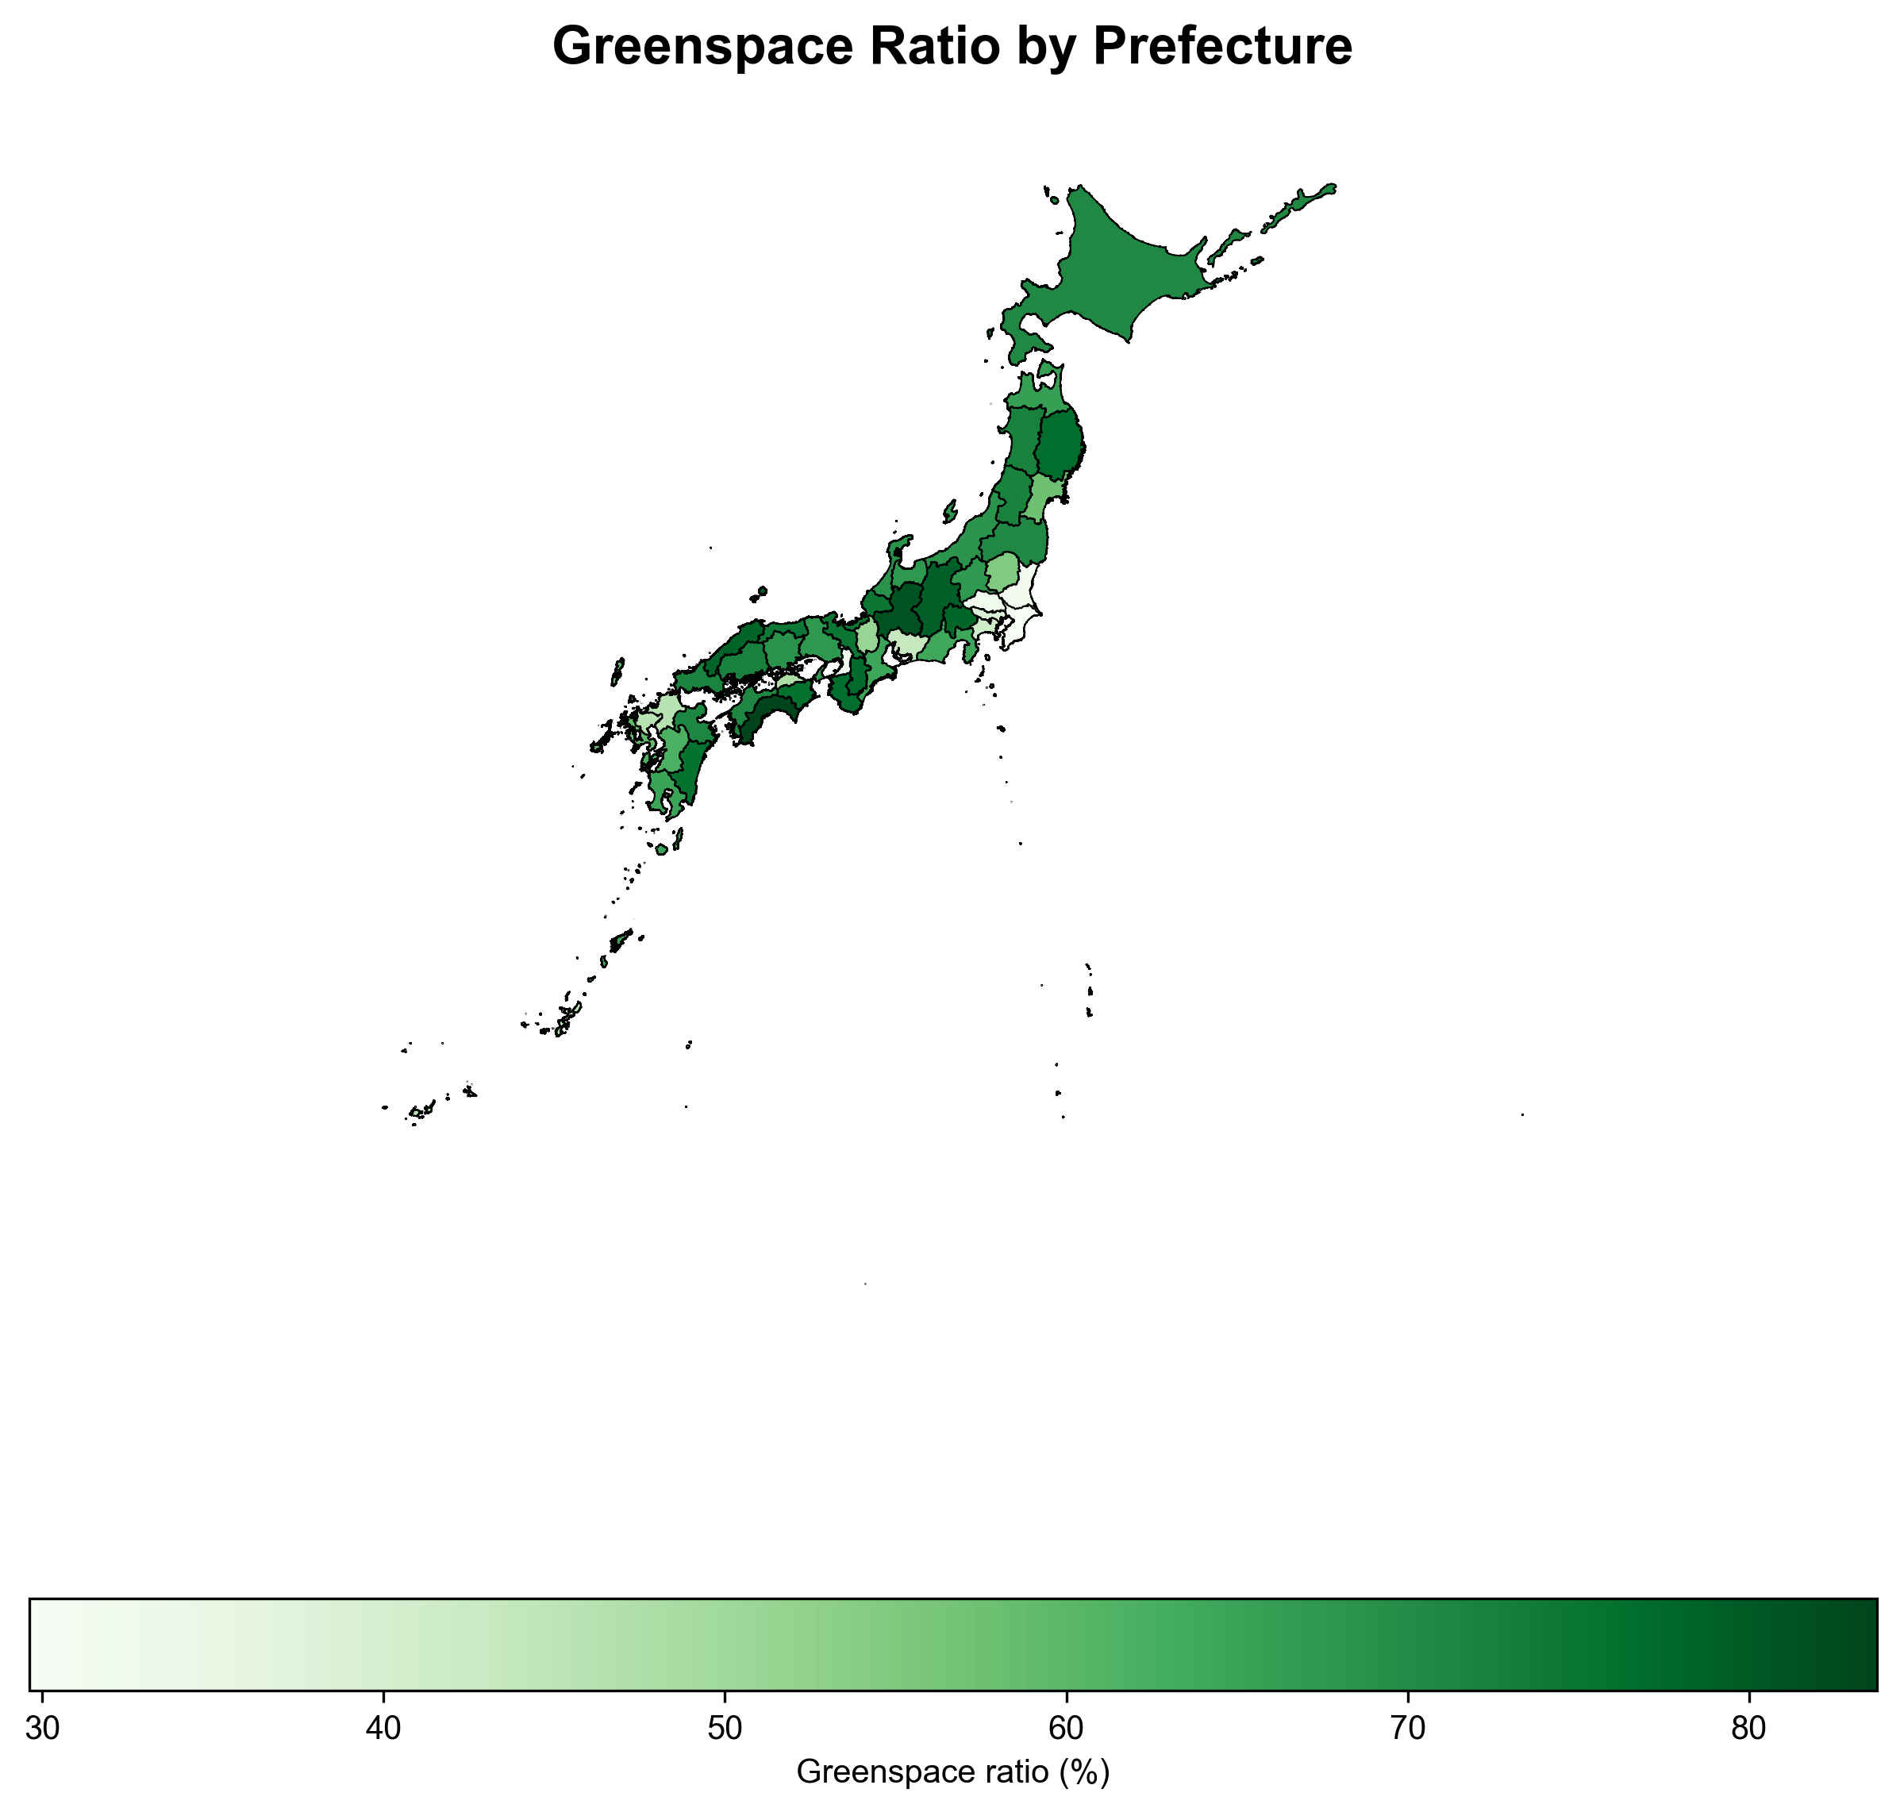
Choropleth map of greenspace ratio across 47 Japanese prefectures

Figure 2. Spatial Distribution of Prescription Rates
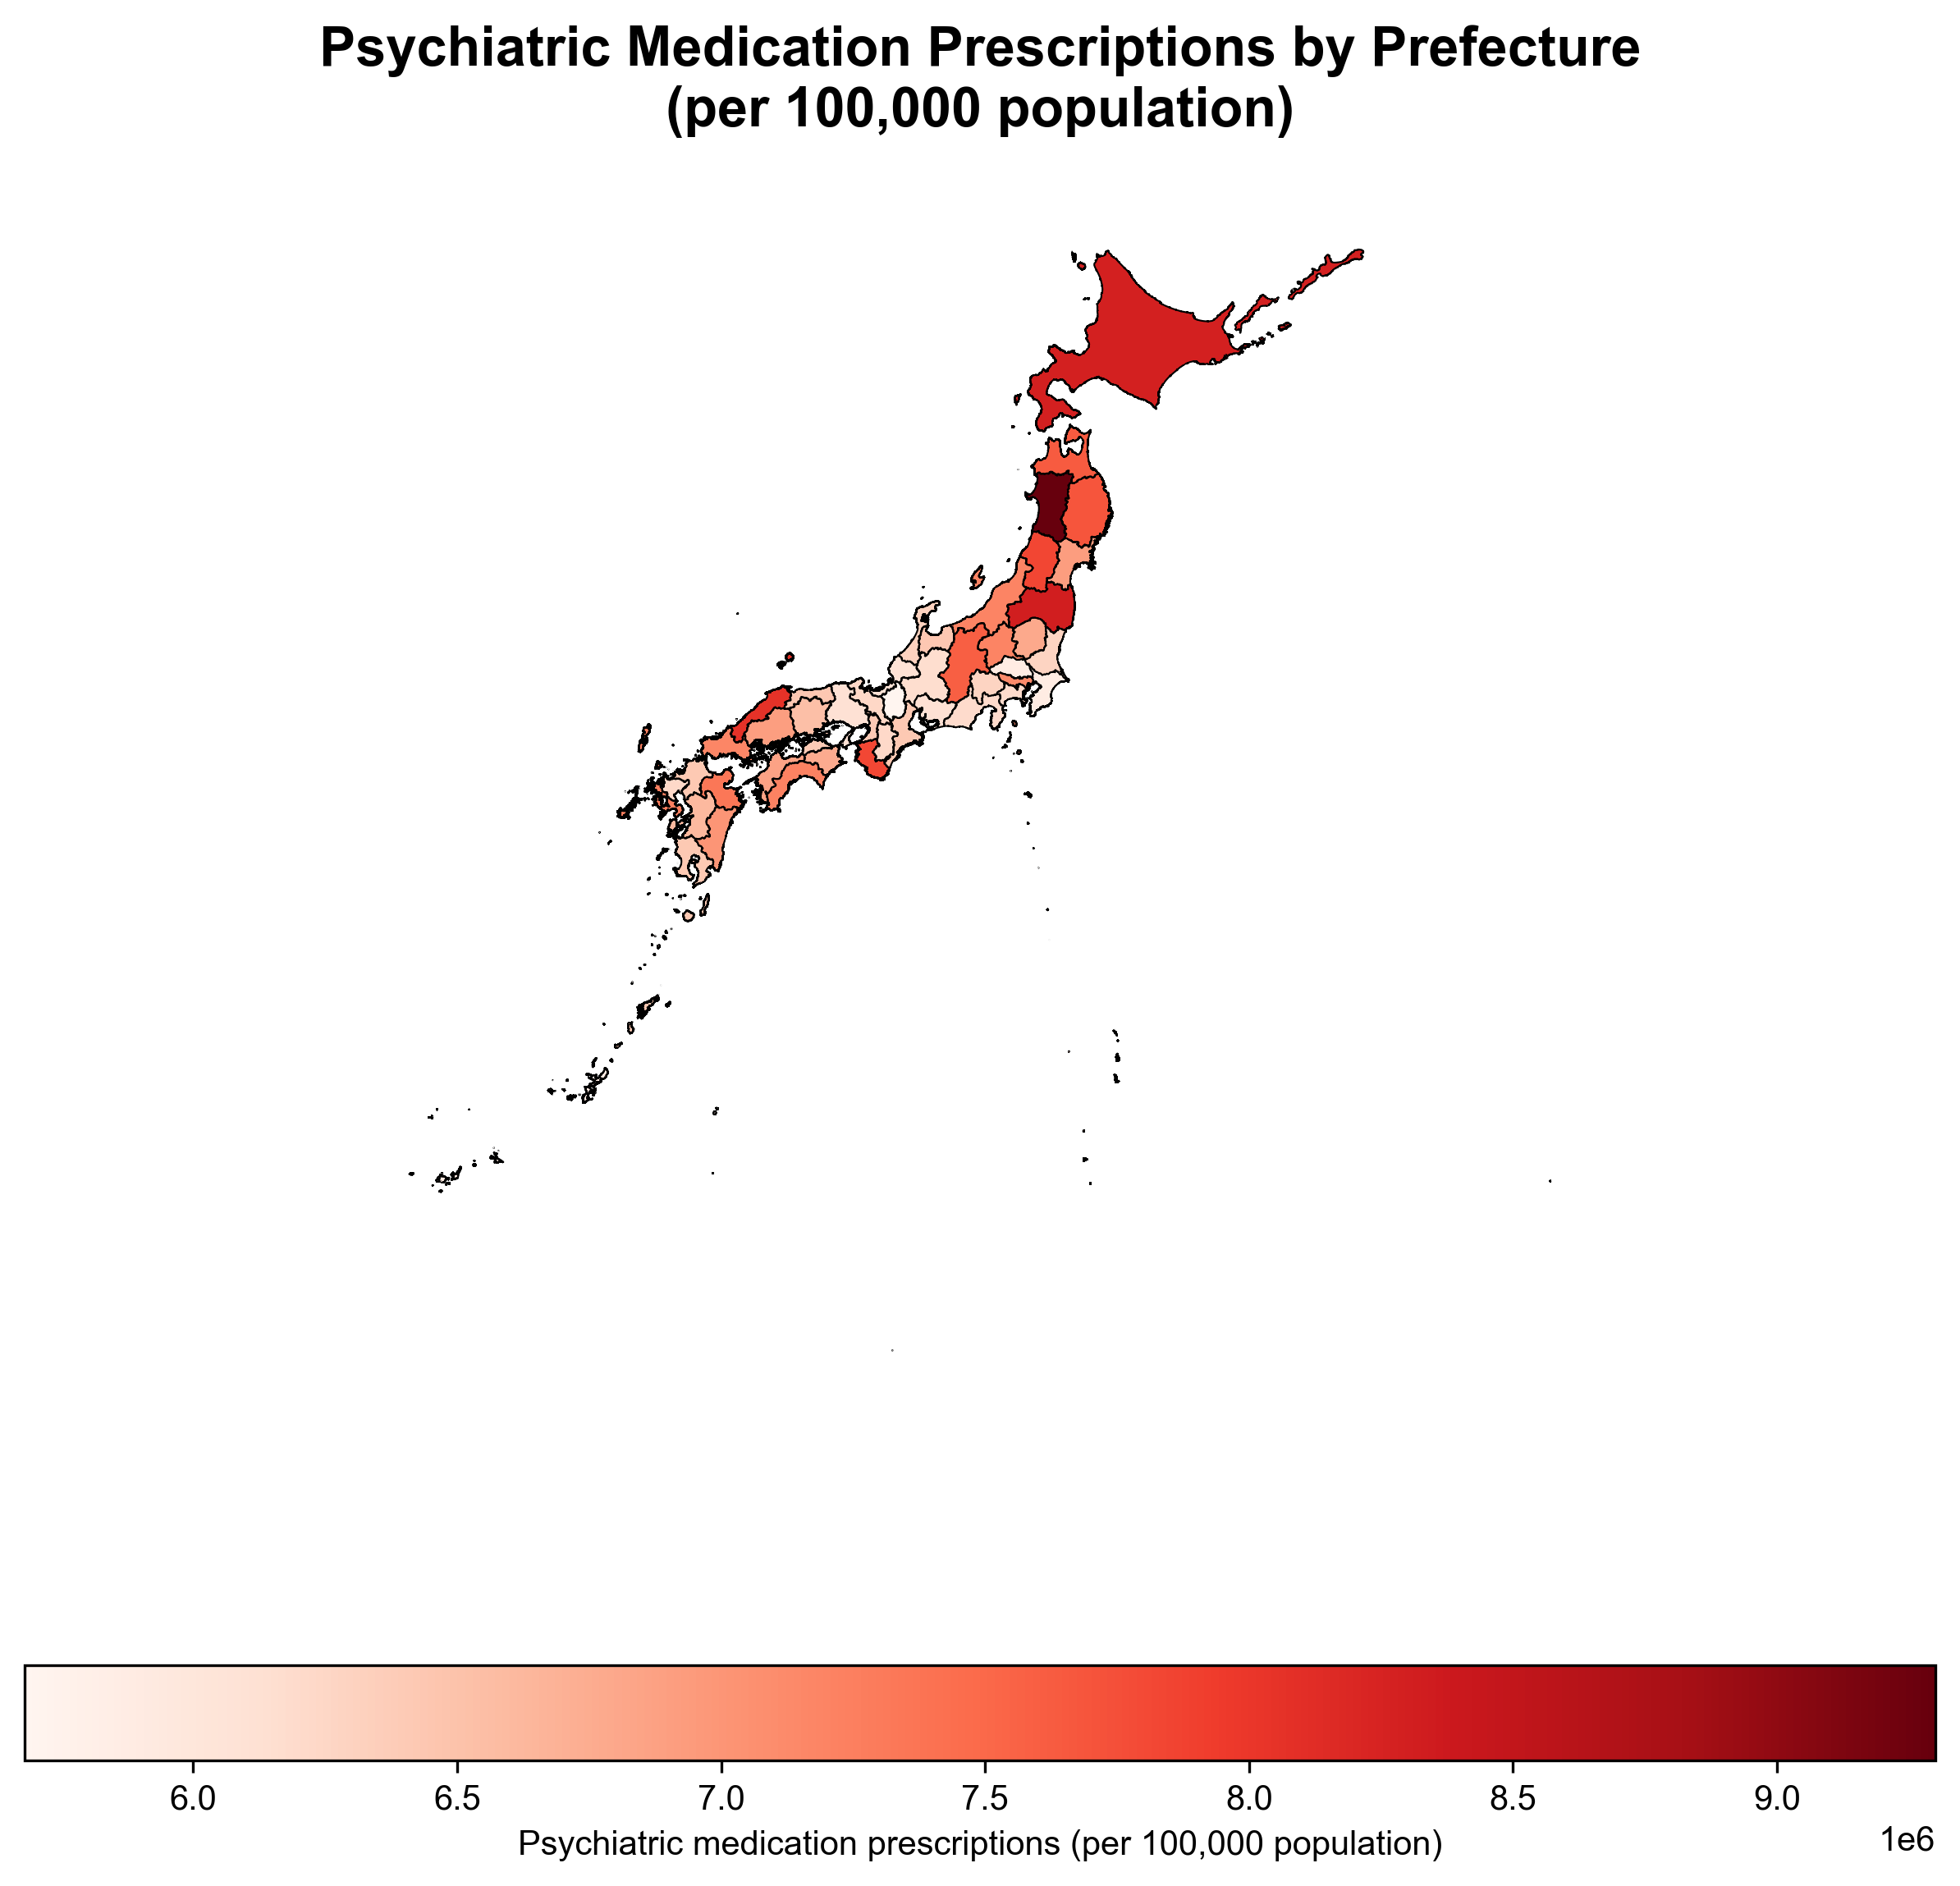
Choropleth map of psychiatric medication prescription rates per 100,000 population

Figure 3. Local Indicators of Spatial Association (LISA)
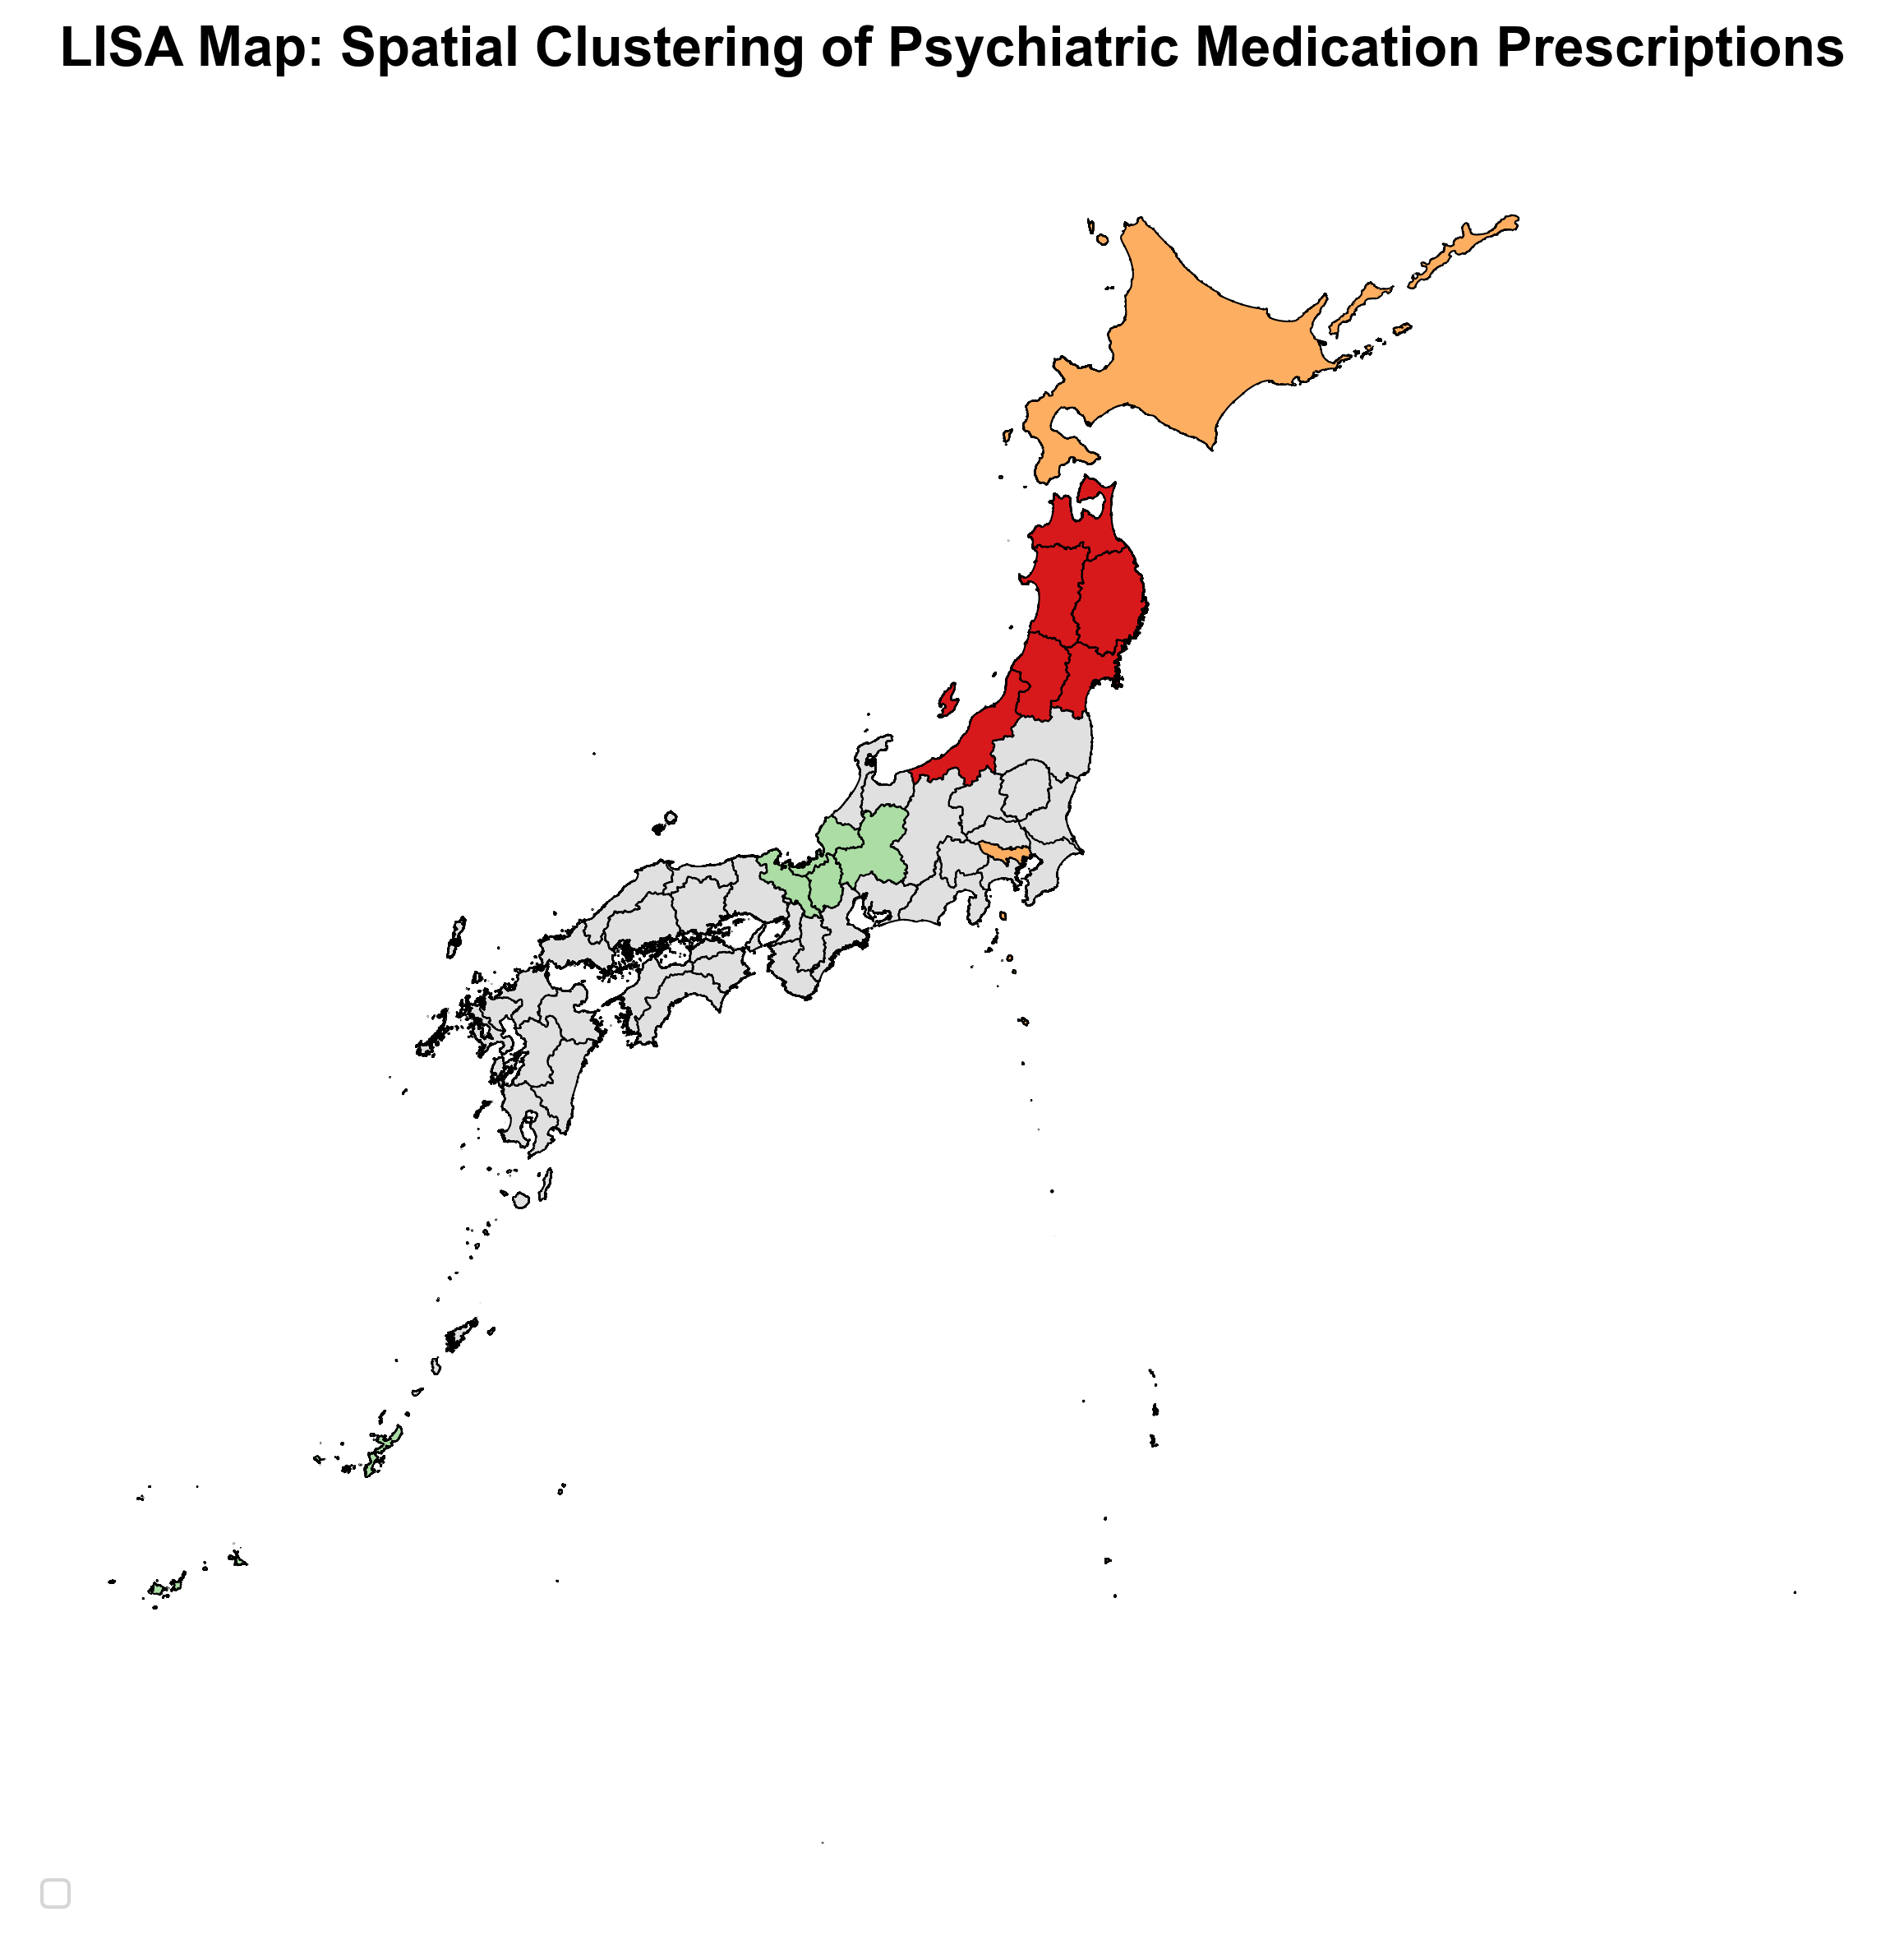
LISA cluster map showing High-High, Low-Low, and High-Low clusters for prescription rates

End of Manuscript

