How Spatial Dependence Alters Ecological Interpretation of Administrative Healthcare Data: Lessons From Rehabilitation Provision and Hip Fracture Surgery Rates in Japan
Haruki Saito
Tetsuya Ohira
Department of Epidemiology, Fukushima Medical University School of Medicine, 1 Hikarigaoka, Fukushima-shi, Fukushima 960-1295, Japan
*Corresponding author: Haruki Saito (haruki00430@gmail.com; ORCID: 0009-0009-7890-6068)
Running title: Spatial dependence alters ecological healthcare data interpretation
2026-06-19

Highlights
• Ecological study of 47 Japanese prefectures using NDB Open Data.
• OLS showed positive rehab–fracture association (6/6 sensitivity specs).
• Strong spatial autocorrelation in both variables (Moran's I > 0.54).
• Spatial Error Model attenuated association to non-significance (p=0.130).
• Spatial diagnostics should be routine in administrative open-data studies.

Abstract
Background: Ecological analyses using administrative healthcare data are increasingly used for health policy evaluation, yet spatial dependence may substantially alter their interpretation. We examined whether the apparent association between rehabilitation provision and hip fracture surgery rates in Japan changes after accounting for spatial dependence.
Methods: We conducted a cross-sectional ecological study of Japan's 47 prefectures using NDB Open Data No.10 (FY2023). Rehabilitation claim rates and hip fracture surgery rates were calculated per 100,000 population. Ordinary least squares (OLS) regression with six pre-specified sensitivity specifications was complemented by Global Moran's I, Lagrange Multiplier diagnostics, and LM-guided spatial regression models.
Results: Rehabilitation claim rates varied 6.8-fold across prefectures, and hip fracture surgery rates varied 1.97-fold. In adjusted OLS models, rehabilitation rate was positively associated with hip fracture surgery rate (beta = 0.0005; p < 0.001), with significance across all six sensitivity specifications. Both variables showed strong positive spatial autocorrelation (Moran's I > 0.54, p = 0.001). Spatial diagnostics favored a Spatial Error Model, which fit better than OLS (delta AIC = -16.6). After accounting for spatial error dependence, the rehabilitation coefficient was attenuated and no longer statistically significant (beta = 0.000164, p = 0.130).
Conclusions: Accounting for spatial dependence materially changed interpretation of the rehabilitation-fracture ecological association, and interpretation depended on the spatial model adopted. This empirical example supports routine spatial diagnostics and explicit model selection in ecological analyses using administrative healthcare data, irrespective of clinical domain.
Keywords: rehabilitation; hip fracture; ecological study; spatial dependence; spatial error model; Japan

Introduction
Hip fracture is a major cause of disability, institutionalization, and excess mortality among older adults worldwide (1-3) and in Japan, where incidence rates are among the highest in Asia (4-6). Rehabilitation after hip fracture is clinically important for functional recovery (7,8). However, individual-level clinical benefit does not imply that prefectures with more rehabilitation claims should necessarily have lower fracture surgery rates, because aggregate administrative data also reflect regional differences in population structure, provider supply, coding practice, care pathways, and historical healthcare organization.
Japan's National Health Insurance system (9,10) covers five categories of inpatient rehabilitation (H000-H004 under the medical fee schedule): cardiac and vascular, cerebrovascular, disuse syndrome, musculoskeletal, and pulmonary rehabilitation. Despite universal coverage, rehabilitation claims vary substantially across regions (11,12). This variation is important for health services research, but interpreting it as need, access, or effectiveness is difficult when unmeasured regional factors are spatially clustered. Prior studies have documented geographic variation in healthcare utilization generally (13,14) and rehabilitation provision specifically (15,16), yet less attention has been paid to whether apparent associations between rehabilitation provision and fracture-related outcomes survive spatial econometric scrutiny.
We therefore used prefecture-level rehabilitation provision and hip fracture surgery rates as a case study in spatially dependent ecological inference. Rather than testing whether rehabilitation prevents hip fracture at the individual level, we asked whether a conventional ecological association changes after accounting for spatial dependence. We focused on three questions: (1) how strongly rehabilitation claim rates and hip fracture surgery rates vary across prefectures, (2) whether OLS models identify an apparent association, and (3) how that association changes after Global Moran's I, Lagrange Multiplier diagnostics, and spatial regression models are applied.

Methods

Study Design and Setting
Cross-sectional ecological study at the 47-prefecture level in Japan. The unit of analysis was the prefecture (N = 47). Data were drawn from NDB Open Data No.10 (17,18), covering fee-for-service claims from April 2023 to March 2024 (FY2023), and the 2020 Population Census.

Exposure Variables
Rehabilitation claim data were extracted from the NDB Open Data No.10 “H_リハビリテーション 都道府県別算定回数／単位数” (prefectural rehabilitation claim counts). Five rehabilitation categories were extracted:
- H000: Cardiac and vascular rehabilitation
- H001: Cerebrovascular and other neurological rehabilitation
- H002: Disuse syndrome rehabilitation (primary exposure of interest)
- H003: Musculoskeletal rehabilitation (primary exposure of interest)
- H004: Pulmonary rehabilitation
Three exposure variables were defined: (1) rehabilitation total claim rate (sum of H000–H004 per 100,000 population), (2) H002 claim rate (disuse syndrome, per 100,000), and (3) H003 claim rate (musculoskeletal, per 100,000).

Outcome Variables
Hip fracture surgery rates were derived from NDB Open Data No.10 surgical procedure data, extracted in a prior study (NDB_XXX_slope_fracture). Femoral fracture surgery procedures included: K044 (bone fragment removal), K045 (internal fixation), K046 (closed reduction with internal fixation), K081 (femoral head replacement: hemiarthroplasty), and K082 (total hip arthroplasty: THA). Primary outcome was the aggregate hip fracture surgery rate per 100,000 total population. Secondary outcomes included THA-specific (K082) and hemiarthroplasty-specific (K081) rates.

Covariates
Two a priori covariates were included: (1) aging rate (proportion aged >=65 years, 2020 Census (19)) and (2) population density (persons per km2, 2020 Census). Aging rate captures a major demographic determinant of fracture burden and rehabilitation demand, while population density captures broad urbanicity and healthcare access context. Because ecological associations may remain sensitive to unmeasured regional structure even after these adjustments, spatial diagnostics were treated as a central part of the analysis rather than a post-hoc check.

Statistical Analysis
Descriptive statistics: Means, standard deviations, and ranges were calculated for all variables.
Correlation analysis: Pearson correlation coefficients (r) between key variable pairs were calculated.
Primary regression: Ordinary least squares (OLS) regression of each outcome on each exposure, adjusting for aging rate and population density (Spec1 baseline).
Sensitivity analyses were conducted using six pre-specified specifications (Supplementary Table S1), including HC3 heteroskedasticity-robust standard errors (20).
Variance inflation factors (VIF) were calculated for all models. All VIF values were < 2.0, indicating no multicollinearity.
Spatial autocorrelation: Global Moran’s I was calculated for rehabilitation total rate and hip fracture rate using the Queen contiguity spatial weight matrix (libpysal; transformed to row-standardized) (21,22). Statistical significance was assessed by 999-permutation conditional randomization.
All analyses were performed in Python 3.14 using pandas, statsmodels, scipy, geopandas, libpysal, and esda. Statistical significance was defined as p < 0.05 (two-sided). Confidence intervals are 95%.

Results

Descriptive Statistics
Table 1 summarizes the key variables across 47 prefectures.
Rehabilitation total claim rates showed a 6.8-fold variation across prefectures (Iwate 27,183 to Kagoshima 183,490 per 100,000). The five prefectures with the highest rehabilitation rates—Kagoshima, Saga, Kochi, Oita, and Fukuoka—were all located in Kyushu and Shikoku regions. The five prefectures with the lowest rates—Iwate, Akita, Fukushima, Niigata, and Aomori—were concentrated in the Tohoku region. Hip fracture surgery rates varied 1.97-fold (Iwate 167.6 to Akita 329.6 per 100,000). Geographic distributions of rehabilitation total rate and hip fracture surgery rate are illustrated in Figure 1 and Figure 2, respectively.

Spatial Autocorrelation
Rehabilitation total rate (Moran's I = 0.547, p = 0.001) and hip fracture rate (I = 0.563, p = 0.001) both showed positive spatial autocorrelation. Two prefectures (Okinawa and Kyoto in the GeoJSON) were identified as spatial islands with no shared boundary in the Queen contiguity matrix; results were robust to their exclusion.

Regression Analysis

Primary Outcome: Hip Fracture Surgery Rate
Figure 3 illustrates the scatter relationship between rehabilitation total rate and hip fracture surgery rate. In the adjusted OLS baseline model (Spec1), rehabilitation total rate was positively associated with hip fracture surgery rate (beta = 0.0005; 95% CI, 0.0003-0.0007; p < 0.001; adjusted R2 = 0.477). The association was statistically significant across all six sensitivity specifications (Figure 4).
Similarly, H002 (disuse syndrome rehabilitation) rate was positively associated with hip fracture rate (Supplementary Figure S1; Spec1: beta = 0.0005; 95% CI, 0.0003-0.0008; p < 0.001; 6/6 specifications significant), and H003 (musculoskeletal rehabilitation) rate was positively associated with hip fracture rate (Supplementary Figure S2; Spec1: beta = 0.040; 95% CI, 0.010-0.071; p = 0.010; 6/6 specifications significant). Table 2 summarizes the exposure-outcome sensitivity results.

Secondary Outcome: THA Rate
No statistically significant associations were observed between any rehabilitation exposure and THA-specific rate across sensitivity specifications (rehab_total_rate to THA: Spec1 beta = 0.0001, p = 0.145; 0/6 specifications significant).

Summary of Sensitivity Analysis

Spatial Regression Analysis
Given the strong spatial autocorrelation in both variables (Moran’s I > 0.54), we applied Lagrange Multiplier (LM) tests to select an appropriate spatial econometric model (22). For the primary exposure (rehabilitation total rate) and outcome (hip fracture rate), the LM test for spatial error dependence was significant (LM-error: statistic = 12.09, p < 0.001) whereas the LM test for spatial lag dependence was not (LM-lag: statistic = 3.31, p = 0.069). Robust versions confirmed this pattern (RLM-error: statistic = 9.11, p = 0.003; RLM-lag: p = 0.567). Following the LM test cascade, a Spatial Error Model (SEM) was estimated by maximum likelihood.
The SEM had lower AIC than OLS (AIC = 430.95 vs 447.58; delta AIC = -16.6), with a significant spatial error parameter (lambda = 0.671; z = 6.65; p < 0.001). After accounting for spatial error dependence, the coefficient for rehabilitation total rate was attenuated and was not statistically significant (beta = 0.000164; z = 1.51; p = 0.130). The Spatial Lag Model (SLM) yielded a different fit pattern: the spatial autoregressive parameter was borderline non-significant (rho = 0.128; p = 0.067) and the rehabilitation coefficient remained positive (beta = 0.000440; p < 0.001), with minimal AIC improvement over OLS (delta AIC = -1.3).
The OLS coefficient was statistically significant, whereas the SEM coefficient was attenuated and non-significant. The SLM coefficient remained positive and statistically significant.

Correlation Analysis
Pearson correlations among key variables are shown in Figure 5. Rehabilitation total rate was positively correlated with hip fracture rate (r = 0.447, p = 0.002). Aging rate was positively correlated with hip fracture rate (r = 0.533, p < 0.001) but not with rehabilitation total rate (r = -0.054, p = 0.717). H002 (disuse syndrome) rate was correlated with hip fracture rate (r = 0.344, p = 0.018), as was H003 (musculoskeletal) rate (r = 0.345, p = 0.018).

Discussion

Principal Findings
The principal contribution of this study is methodological rather than clinical. This study uses rehabilitation provision and hip fracture surgery rates as an empirical example demonstrating how spatial dependence can materially alter ecological interpretation in administrative open data. In standard OLS models, prefectures with higher rehabilitation claim rates also had higher hip fracture surgery rates across the primary exposure and six sensitivity specifications. However, this apparent association was substantially attenuated and rendered non-significant when spatial error dependence was modeled using the LM-test-preferred Spatial Error Model (SEM; delta AIC = -16.6 vs OLS; lambda = 0.671, p < 0.001).

Interpretation: Spatial Dependence and Ecological Inference
Our findings do not identify the specific source of spatial dependence. Rather, they demonstrate that accounting for spatial dependence materially changed the ecological interpretation of a healthcare association derived from administrative data. Spatially structured residual dependence may reflect unmeasured regional factors related to both rehabilitation utilization and hip fracture surgery rates, but the present analysis cannot determine which factors are responsible. This distinction is central: the analysis supports caution in ecological inference, not a definitive causal account of why regions differ.
Possible sources of spatial structure. Both rehabilitation rates and fracture surgery rates were strongly spatially autocorrelated (Moran's I > 0.54) and showed a broad regional pattern. Such structure could reflect multiple unmeasured regional processes, including provider distribution, historical healthcare resource allocation, hospital capacity, coding or care-pathway differences, socioeconomic conditions, and dietary patterns such as regional variation in vitamin K-related exposure (23). These examples should be interpreted as plausible sources of spatial structure, not as mechanisms proven by the present analysis.
Model choice as part of ecological inference. The LM-test cascade favored the SEM, in which the rehabilitation coefficient became non-significant. However, the Spatial Lag Model yielded a different pattern, with the rehabilitation coefficient remaining positive and statistically significant despite minimal AIC improvement over OLS. Thus, the message is not simply that one spatial model replaces OLS; rather, the interpretation of ecological healthcare associations can depend on the spatial process assumed and the diagnostic evidence used to choose among models.
Implications for administrative open data. Claims-based open data aggregate patient need, provider supply, coding practice, service availability, and regional care organization into the same observed rates. A healthcare exposure in such data may therefore function partly as a marker of local health-system structure. Spatial diagnostics help reveal when an apparent exposure-outcome association is entangled with regional structure, even when they cannot identify the underlying source of that structure.
Unmeasured case-mix confounding. Prefectural-level aggregation masks individual-level case mix. Regions with higher rehabilitation rates may serve more complex or severe cases (e.g., multi-morbid patients, those with prior stroke or disuse syndrome) whose fracture risk is intrinsically higher. NDB Open Data lacks individual-level data to adjust for case-mix severity (17,24).
Role of the clinical example. The rehabilitation-fracture setting remains important because it is clinically plausible, policy-relevant, and measurable in open claims data. Nevertheless, the empirical example should not be read as estimating the individual effect of rehabilitation. Individual-level rehabilitation benefits, reverse direction from fracture burden to rehabilitation claims, and case-mix differences may all coexist with the spatial pattern observed here. The same principle may apply to other ecological analyses using nationwide claims databases, including studies of pharmaceutical utilization, preventive services, chronic disease management, and healthcare resource allocation.

Comparison with Prior Literature
Prior clinical studies demonstrate that intensive rehabilitation improves post-fracture functional recovery (7,8), while exercise programs can reduce fall risk and subsequent fractures (25). These individual-level findings remain clinically relevant, but they cannot be directly translated into ecological correlations. The ecological fallacy--attributing individual-level relationships to aggregate data--is a fundamental limitation first described by Robinson (26) and extensively documented in epidemiological literature (27). Our findings are not evidence that rehabilitation is harmful; rather, they show that prefecture-level claims and surgery rates can share spatial structure that conventional ecological regression may overinterpret.
Geographic variation in rehabilitation use in Japan has been documented in multiple ecological studies using NDB data (11,12), and the 6.8-fold range in rehabilitation total rates observed here is consistent with prior reports of regional disparities in cardiac rehabilitation (16) and outpatient rehabilitation trends (15). The present study extends that literature by showing that spatial diagnostics can change the interpretation of a healthcare-outcome association derived from open claims data.

Limitations
First, the ecological design precludes individual-level inference. Results should not be interpreted as indicating that rehabilitation harms individuals or that individual patients receiving rehabilitation have higher fracture risk.
Second, NDB Open Data No.10 is cross-sectional (FY2023), preventing assessment of temporal precedence. The direction of causality cannot be determined. Additionally, NDB Open Data suppresses cell counts below 10 (data masking), which may introduce underestimation in prefectures with low claim volumes for specific procedures (24).
Third, although we conducted LM-test-guided spatial regression (SEM), the spatial weight matrix relied on a Queen contiguity scheme with two islands (Okinawa, Kyoto in the administrative boundary GeoJSON), which may slightly affect estimates. Alternative weight matrices (KNN, distance-based) should be explored in future work.
Fourth, fracture surgery rates are a proxy for fracture incidence; procedural variation in surgical decision-making (e.g., preference for conservative management in some regions) could independently affect rates.
Fifth, unmeasured factors--including orthopedic surgeon density (28), hospital bed supply, provider distribution, socioeconomic conditions, dietary patterns, and regional clinical culture--may contribute to the observed spatial structure. The SEM addresses spatially structured residual dependence, but it does not identify the specific unmeasured factors responsible for that structure. Finally, conclusions differed across spatial specifications: the LM-test-preferred SEM attenuated the rehabilitation coefficient to non-significance, whereas the SLM retained a positive coefficient. This reinforces the need to report spatial diagnostics and model-selection logic rather than treating spatial adjustment as a single uniform procedure.

Conclusions
The apparent positive OLS association between rehabilitation provision and hip fracture surgery rates at the prefecture level was materially altered after spatially structured residual dependence was modeled, as shown by attenuation and loss of statistical significance of the rehabilitation coefficient in the LM-test-preferred Spatial Error Model (beta = 0.000164, p = 0.130; delta AIC = -16.6). The interpretation also depended on the spatial model adopted, underscoring the importance of spatial diagnostics and model selection in ecological analyses. The present empirical example suggests that spatial diagnostics should be considered a routine component of ecological analyses using administrative healthcare data, irrespective of the specific clinical domain under investigation. Future studies should combine spatial diagnostics, longitudinal designs, and individual-level data to distinguish healthcare delivery signals from spatially structured residual dependence. Routine spatial diagnostics may improve the validity and reproducibility of ecological analyses based on nationwide administrative healthcare databases.

Declarations

Ethics Statement
This study used anonymized, publicly available, aggregated NDB Open Data (no individual-level data). Ethical approval was not required.

Data Availability
NDB Open Data No.10 is publicly available at: https://www.mhlw.go.jp/stf/seisakunitsuite/bunya/0000177182.html
Analysis scripts and aggregate prefecture-level datasets are available at https://github.com/haruki00430/spatial-ecological-inference-ndb-japan and on Zenodo (https://doi.org/10.5281/zenodo.XXXXXXX). NDB Open Data No.10 is publicly available at: https://www.mhlw.go.jp/stf/seisakunitsuite/bunya/0000177182.html

Competing Interests
The authors declare no competing interests.

Funding
Not applicable.

Authors’ Contributions
Haruki Saito: Conceptualization, Data curation, Formal analysis, Visualization, Writing – original draft. Tetsuya Ohira: Methodology, Writing – review & editing.

Declaration of generative AI and AI-assisted technologies in the manuscript preparation process
During the preparation and writing of this work, the authors used AI-assisted tools to support manuscript drafting and statistical analysis scripting. Cursor 2.0 (Anysphere) and Google Antigravity (Google) were used for AI-assisted writing and Python code development. Large language models used through these platforms included Claude Sonnet 4.6 and Claude Opus 4.6 (Anthropic) and Gemini 3 Pro (Google). These tools were used only for text drafting and code generation; no generative AI or AI-assisted tools were used to create, alter, or otherwise process any figures, images, or artwork in this manuscript. The authors reviewed and edited all AI-assisted outputs and were responsible for the study design, selection of statistical methods, interpretation of findings, conclusions, and final reference list. The authors take full responsibility for the integrity and accuracy of the final content. AI was not listed as an author.

References
1. Sing CW, Lin TC, Bartholomew S, Bell JS, Bennett C, Beyene K, et al. Global epidemiology of hip fractures: Secular trends in incidence rate, post-fracture treatment, and all-cause mortality. Journal of Bone and Mineral Research. 2023;38(8):1064-75.
2. Johnell O, Kanis JA. An estimate of the worldwide prevalence and disability associated with osteoporotic fractures. Osteoporosis International. 2006;17(12):1726-33.
3. Abrahamsen B, Staa T van, Ariely R, Olson M, Cooper C. Excess mortality following hip fracture: A systematic epidemiological review. Osteoporosis International. 2009;20(10):1633-50.
4. Orimo H, Yaegashi Y, Onoda T, Fukushima Y, Hosoi T, Sakata K. Hip fracture incidence in Japan: Estimates of new patients in 2007 and 20-year trends. Archives of Osteoporosis. 2009;4(1-2):71-7.
5. Orimo H, Hashimoto T, Sakata K, Yoshimura N, Suzuki T, Hosoi T. Trends in the incidence of hip fracture in Japan, 1987-1997: The third nationwide survey. Journal of Bone and Mineral Metabolism. 2000;18(3):126-31.
6. Takusari E, Sakata K, Hashimoto T, Fukushima Y, Nakamura T, Orimo H. Trends in hip fracture incidence in Japan: Estimates based on nationwide hip fracture surveys from 1992 to 2017. JBMR Plus. 2020;5(2):e10428.
7. Magaziner J, Hawkes W, Hebel JR, Zimmerman SI, Fox KM, Dolan M, et al. Recovery from hip fracture in eight areas of function. The Journals of Gerontology Series A: Biological Sciences and Medical Sciences. 2000;55(9):M498-507.
8. Handoll HH, Cameron ID, Mak JCS, Panagoda CE, Finnegan TP. Multidisciplinary rehabilitation for older people with hip fractures. Cochrane Database of Systematic Reviews. 2021;11(11):CD007125.
9. Ikegami N, Yoo BK, Hashimoto H, Matsumoto M, Ogata H, Babazono A, et al. Japanese universal health coverage: Evolution, achievements, and challenges. Lancet. 2011;378(9796):1106-15.
10. Katori T. Japan's healthcare delivery system: From its historical evolution to the challenges of a super-aged society. Global Health & Medicine. 2024;6(1):6-12.
11. Ohtera S, Kato G, Ueshima H, Mori Y, Nakatani Y, Nakayama T, et al. Variation in utilization of postoperative rehabilitation after total hip arthroplasty in Japan. Archives of Physical Medicine and Rehabilitation. 2024;105(5):850-6.
12. Morii Y, Abiko K, Ishikawa T, Fujiwara K, Konomura K, Ogasawara K. Regional disparity in the provision of rehabilitation services using the open data from the Japanese national claims database: An ecological study. BMJ Open. 2023;13(6):e071670.
13. Jin X, Iwagami M, Sakata N, Mori T, Uda K, Tamiya N. Regional variation in long-term care spending in Japan. BMC Public Health. 2022;22(1):1810.
14. Toyabe S. Trend in geographic distribution of physicians in Japan. International Journal for Equity in Health. 2009;8:5.
15. Hori S, Ushida K, Momosaki R. Trends in outpatient rehabilitation practices in Japan: Analysis using the National Database of Health Insurance Claims Open Data. Journal of Rural Medicine. 2022;17(3):125-30.
16. Ito T, Kameda I, Fujimoto N, Momosaki R. Regional disparities in cardiac rehabilitation volume throughout Japan based on open data from a National Database of Health Insurance Claims. Journal of Rural Medicine. 2022;17(4):221-7.
17. Yasunaga H. Updated information on NDB. Annals of Clinical Epidemiology. 2024;6(3):73-6.
18. Ministry of Health, Labour and Welfare. NDB Open Data Japan (10th release) [Internet]. Ministry of Health, Labour and Welfare, Japan; 2023. Available from: https://www.mhlw.go.jp/stf/seisakunitsuite/bunya/0000177182.html
19. Statistics Bureau of Japan. 2020 Population Census of Japan [Internet]. Statistics Bureau, Ministry of Internal Affairs and Communications, Japan; 2021. Available from: https://www.stat.go.jp/data/kokusei/2020/
20. White H. A heteroskedasticity-consistent covariance matrix estimator and a direct test for heteroskedasticity. Econometrica. 1980;48(4):817-38.
21. Moran PAP. Notes on continuous stochastic phenomena. Biometrika. 1950;37(1-2):17-23.
22. Anselin L. Spatial econometrics: Methods and models. Dordrecht: Kluwer Academic Publishers; 1988.
23. Kaneki M, Hodges SJ, Hosoi T, Fujiwara S, Lyons A, Crean SJ, et al. Japanese fermented soybean food as the major determinant of the large geographic difference in circulating levels of vitamin K2: Possible implications for hip-fracture risk. Nutrition. 2001;17(4):315-21.
24. Suto M, Iba A, Sugiyama T, Kodama T, Takegami M, Taguchi R, et al. Literature review of studies using the national database of the health insurance claims of Japan (NDB): Limitations and strategies in using the NDB for research. JMA Journal. 2024;7(1):10-20.
25. Sherrington C, Whitney JC, Lord SR, Herbert RD, Cumming RG, Close JCT. Effective exercise for the prevention of falls: A systematic review and meta-analysis. Journal of the American Geriatrics Society. 2008;56(12):2234-43.
26. Robinson WS. Ecological correlations and the behavior of individuals. American Sociological Review. 1950;15(3):351-7.
27. Piantadosi S, Byar DP, Green SB. The ecological fallacy. American Journal of Epidemiology. 1988;127(5):893-904.
28. Kido M, Ikoma K, Kobayashi Y, Maki M, Ohashi S, Shoda K, et al. The inter-prefectural regional disparity of healthcare resources and representative surgical procedures in orthopaedics and general surgery: A nationwide study in Japan during 2015-2019. BMC Musculoskeletal Disorders. 2023;24(1):726.

Tables
Table 1. Descriptive statistics of prefecture-level variables (N = 47 prefectures).
Variable | Mean (SD) | Min | Max
Rehab total rate (per 100,000) | 88,389 (35,945) | 27,183 | 183,490
H002 rate (per 100,000) | 73,892 (30,905) | 22,472 | 158,473
H003 rate (per 100,000) | 278 (299) | 0 | 1,401
Hip fracture rate (per 100,000) | 254.0 (37.6) | 167.6 | 329.6
THA rate (per 100,000) | 70.1 (11.4) | 41.0 | 91.0
Aging rate (%) | 30.7 (3.1) | 22.6 | 36.4
Population density (per km²) | 657 (1,223) | 62.6 | 6,403
Table 2. Summary of adjusted OLS sensitivity analyses for rehabilitation exposures and hip fracture surgery rates.
Exposure | Outcome | n | β (Spec1) | 95% CI | p (Spec1) | Sig specs
Rehab total rate | Hip fracture rate | 47 | 0.0005 | 0.0003–0.0007 | <0.001 | 6/6
Rehab total rate | THA rate | 47 | 0.0001 | −0.0000–0.0002 | 0.145 | 0/6
H002 rate | Hip fracture rate | 47 | 0.0005 | 0.0003–0.0008 | <0.001 | 6/6
H002 rate | THA rate | 47 | 0.0001 | −0.0001–0.0002 | 0.214 | 0/6
H003 rate | Hip fracture rate | 47 | 0.040 | 0.010–0.071 | 0.010 | 6/6
H003 rate | THA rate | 47 | — | — | — | —
Supplementary Tables
Supplementary Table S1. Pre-specified sensitivity specifications.
Specification | Description
Spec1 | Baseline OLS (aging_rate + pop_density)
Spec2 | HC3 heteroskedasticity-robust standard errors (20)
Spec3 | Outlier exclusion (residuals ±3 IQR)
Spec4 | Metropolitan exclusion (Tokyo, Osaka, Aichi, Kanagawa, Saitama, Chiba; N = 41)
Spec5 | Log-transformed exposure and outcome
Spec6 | Aging rate only as covariate

Main Figures
Figure 1. Choropleth map of prefectural rehabilitation total claim rates (per 100,000 population), Japan FY2023. Higher rates (darker colors) are concentrated in Kyushu and Shikoku regions; lower rates in Tohoku.
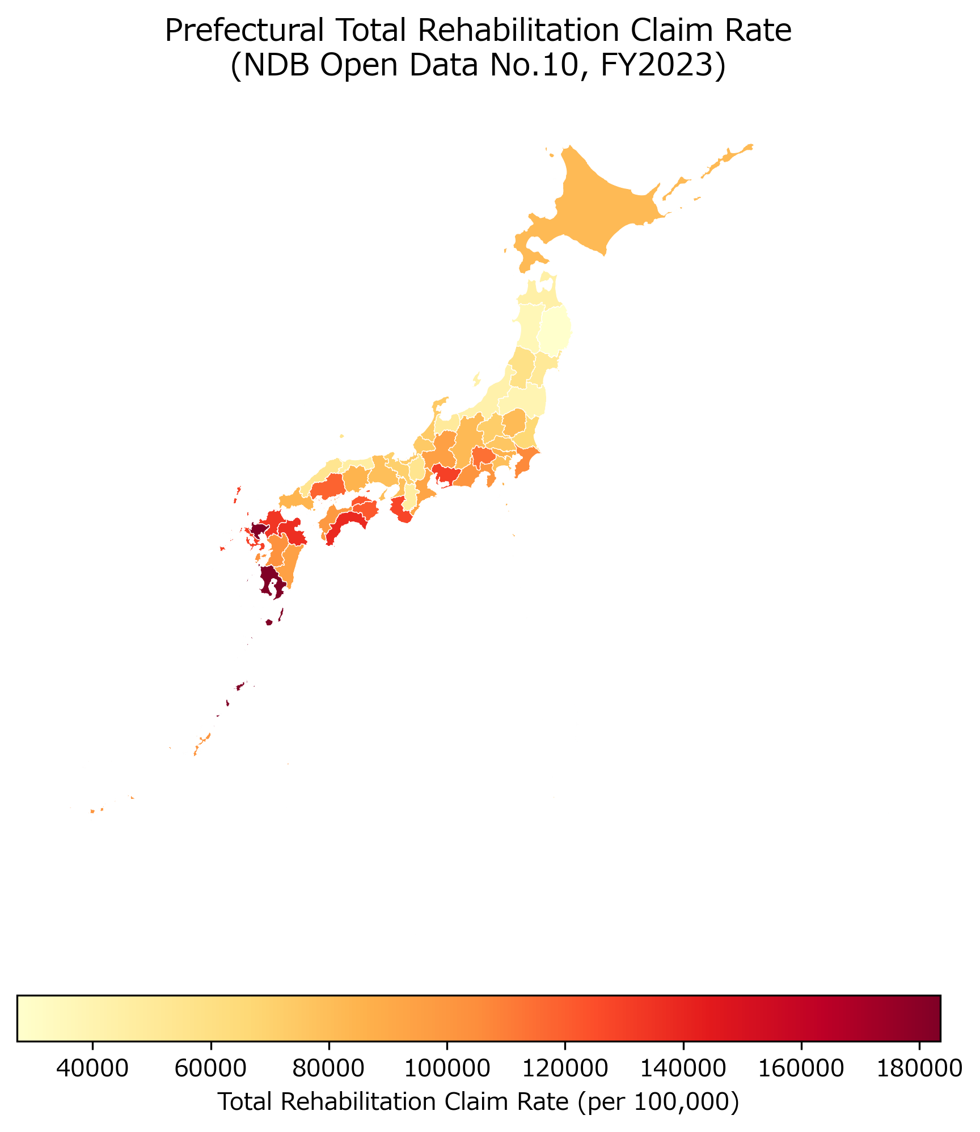
Figure 1. Choropleth map of rehabilitation total claim rates

Figure 2. Choropleth map of prefectural hip fracture surgery rates (per 100,000 population), Japan FY2023.
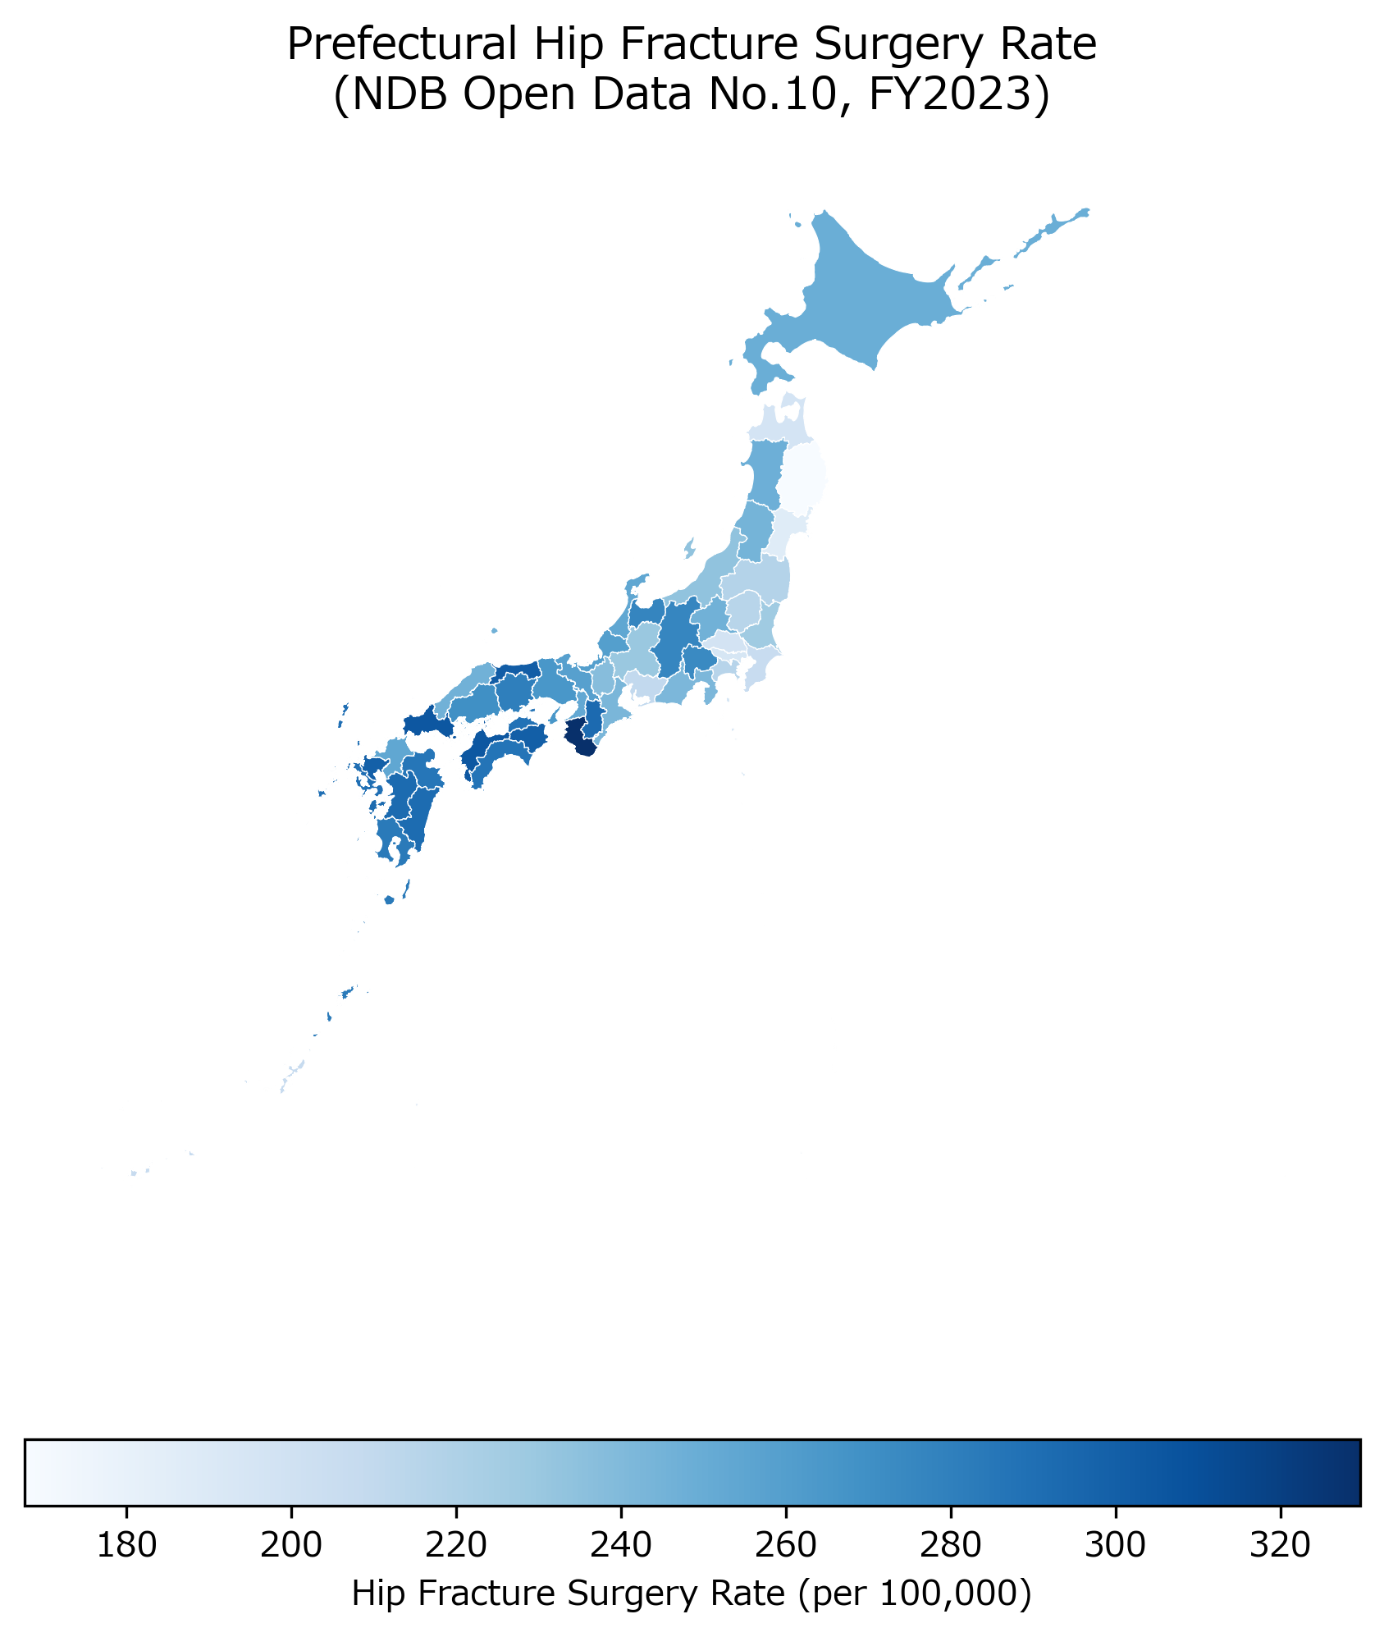
Figure 2. Choropleth map of hip fracture surgery rates

Figure 3. Scatter plot of rehabilitation total claim rate versus hip fracture surgery rate by prefecture (N = 47). Regression line shown with 95% confidence band. Pearson r = 0.447, p = 0.002.
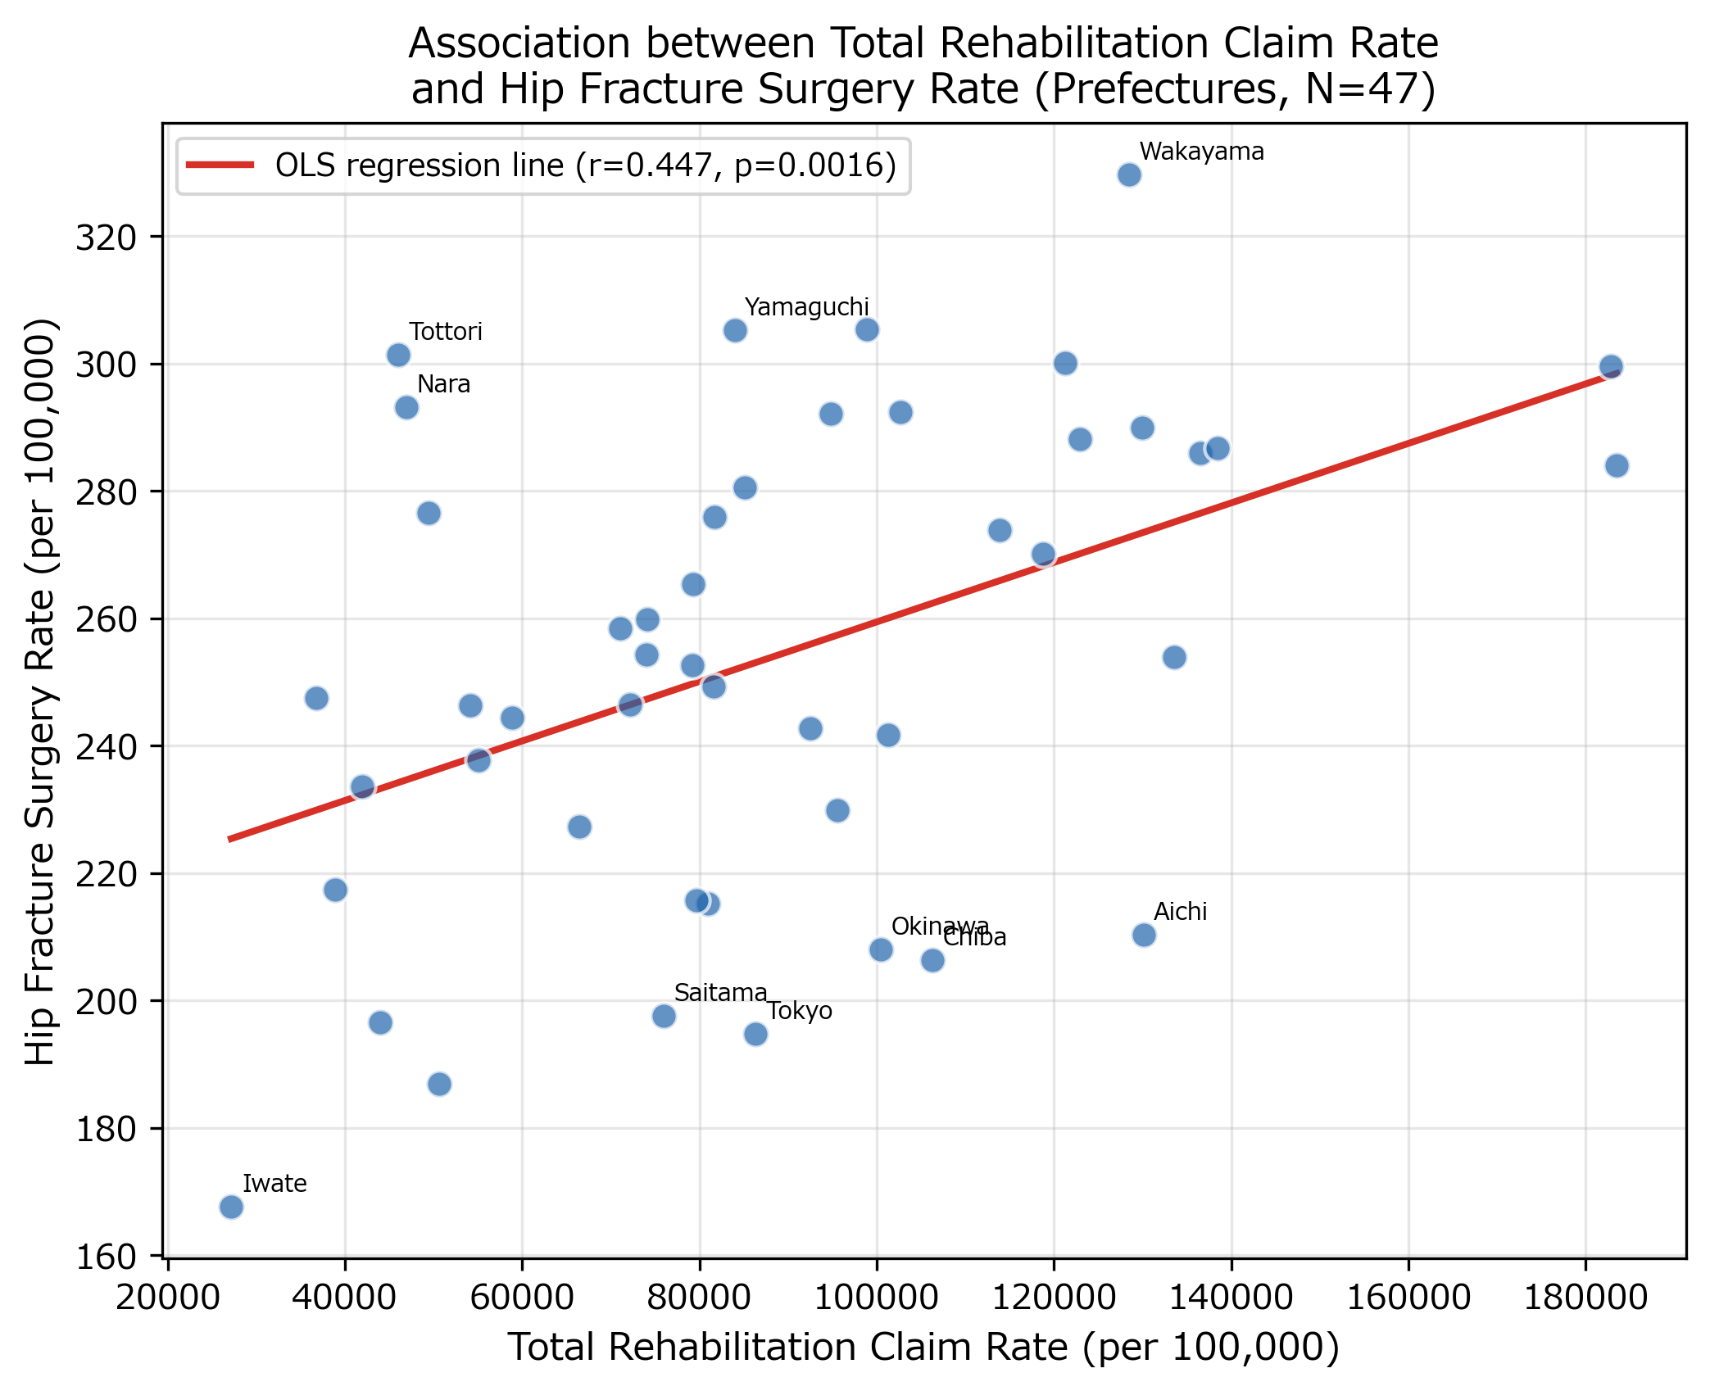
Figure 3. Scatter plot of rehabilitation rate vs hip fracture rate

Figure 4. Forest plot of six sensitivity analyses for the primary exposure (rehabilitation total rate) and outcome (hip fracture surgery rate). Red markers indicate p < 0.05; all six specifications are statistically significant.
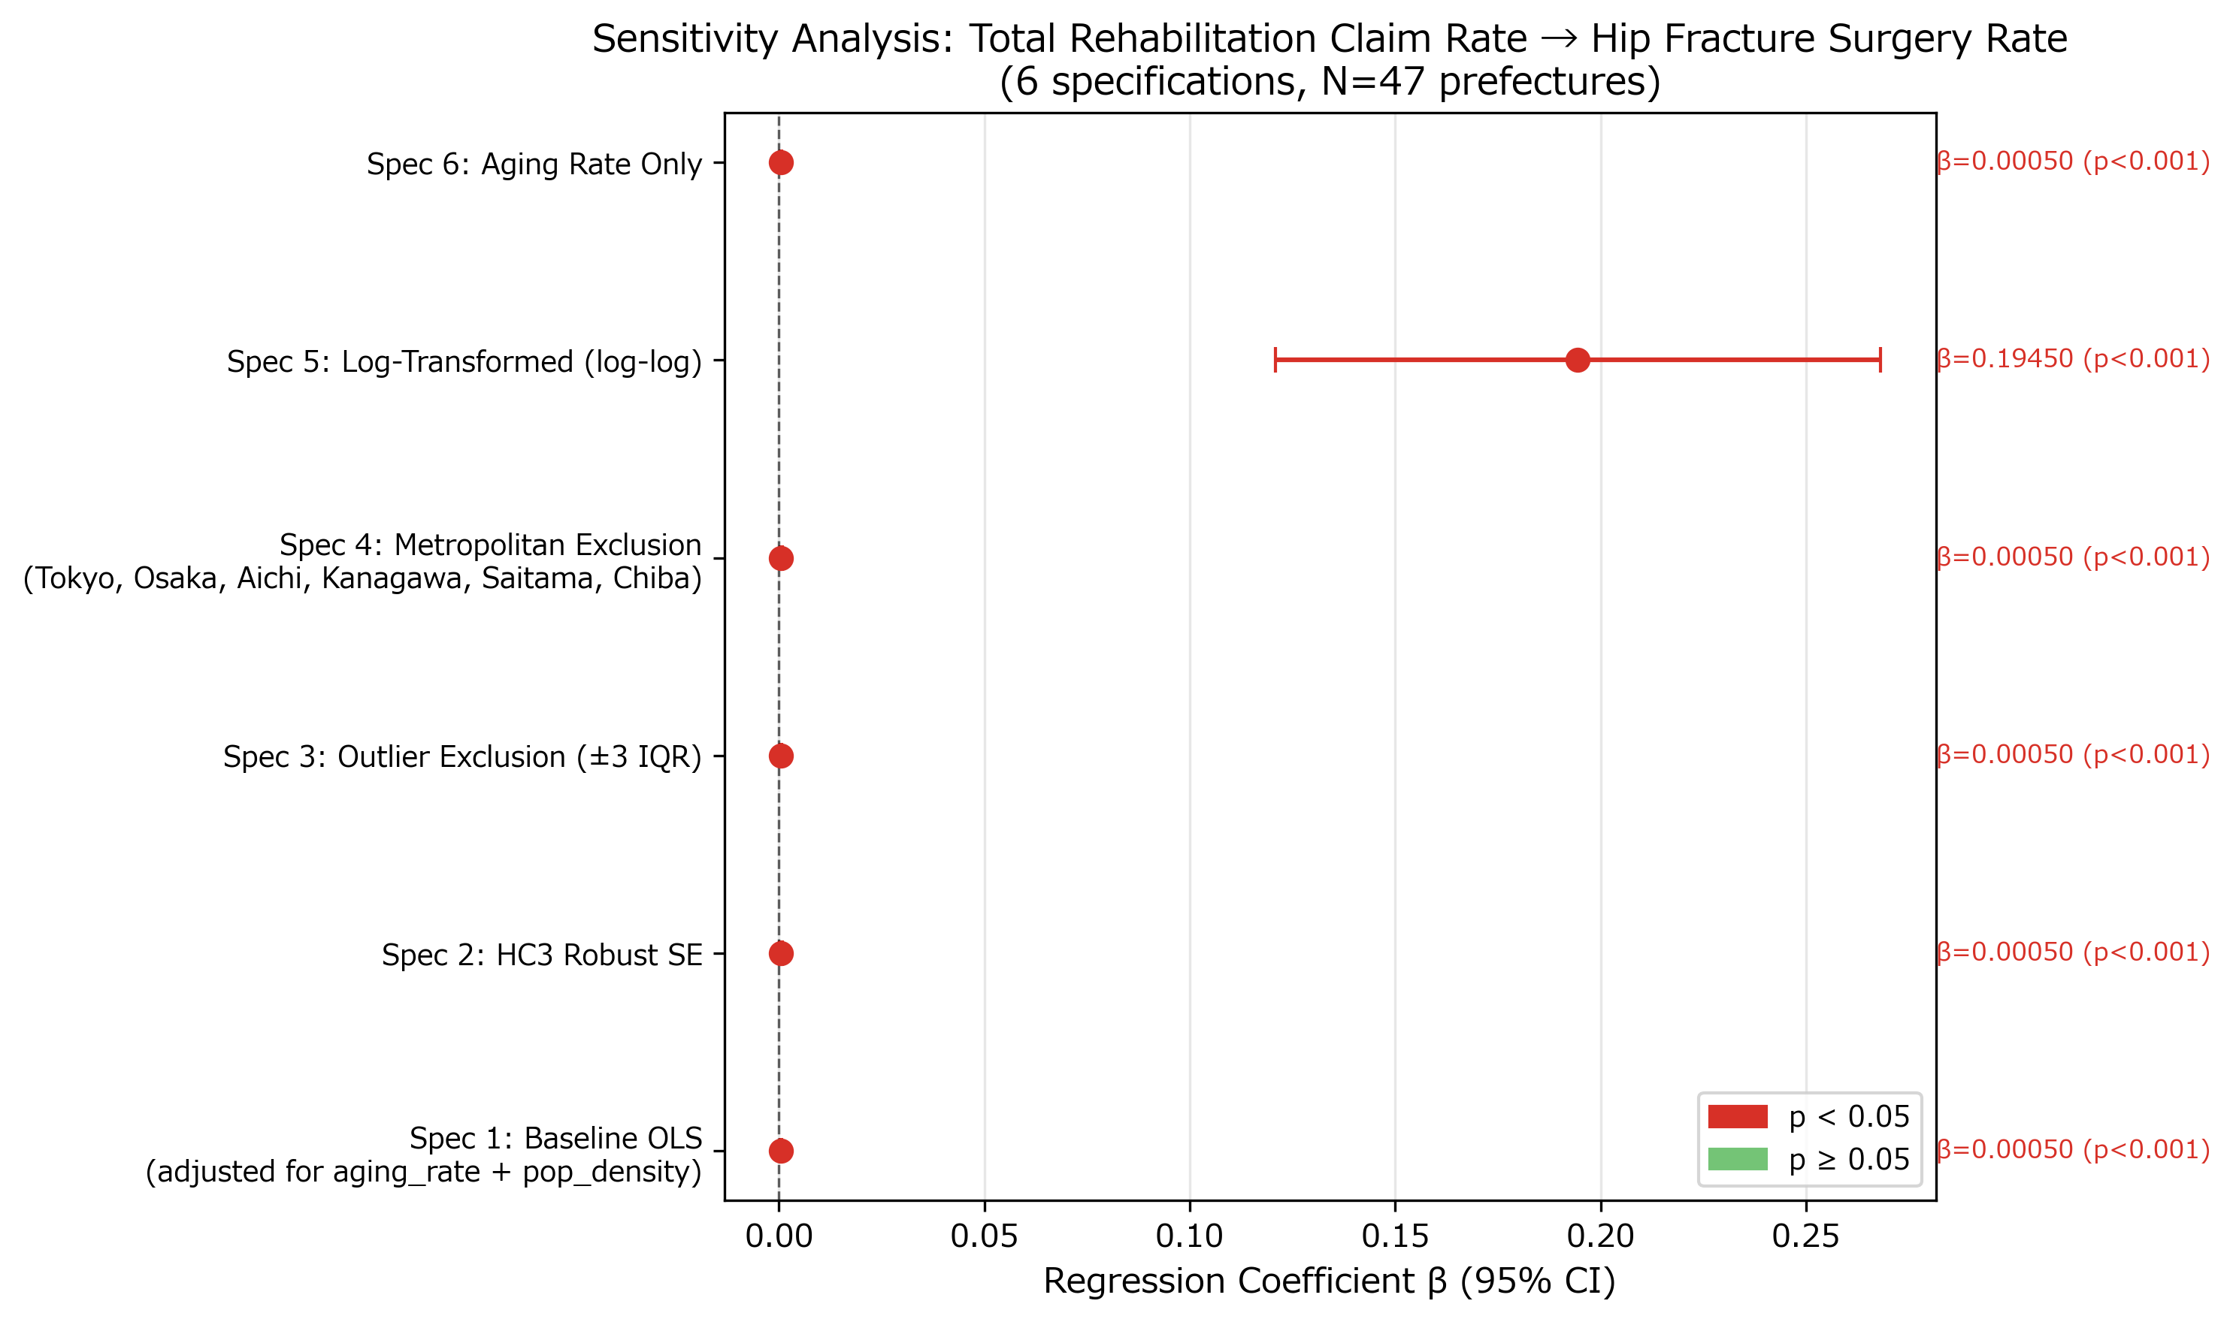
Figure 4. Forest plot of sensitivity analyses.

Figure 5. Correlation heatmap among key variables (N = 47 prefectures). Cell values are Pearson correlation coefficients.
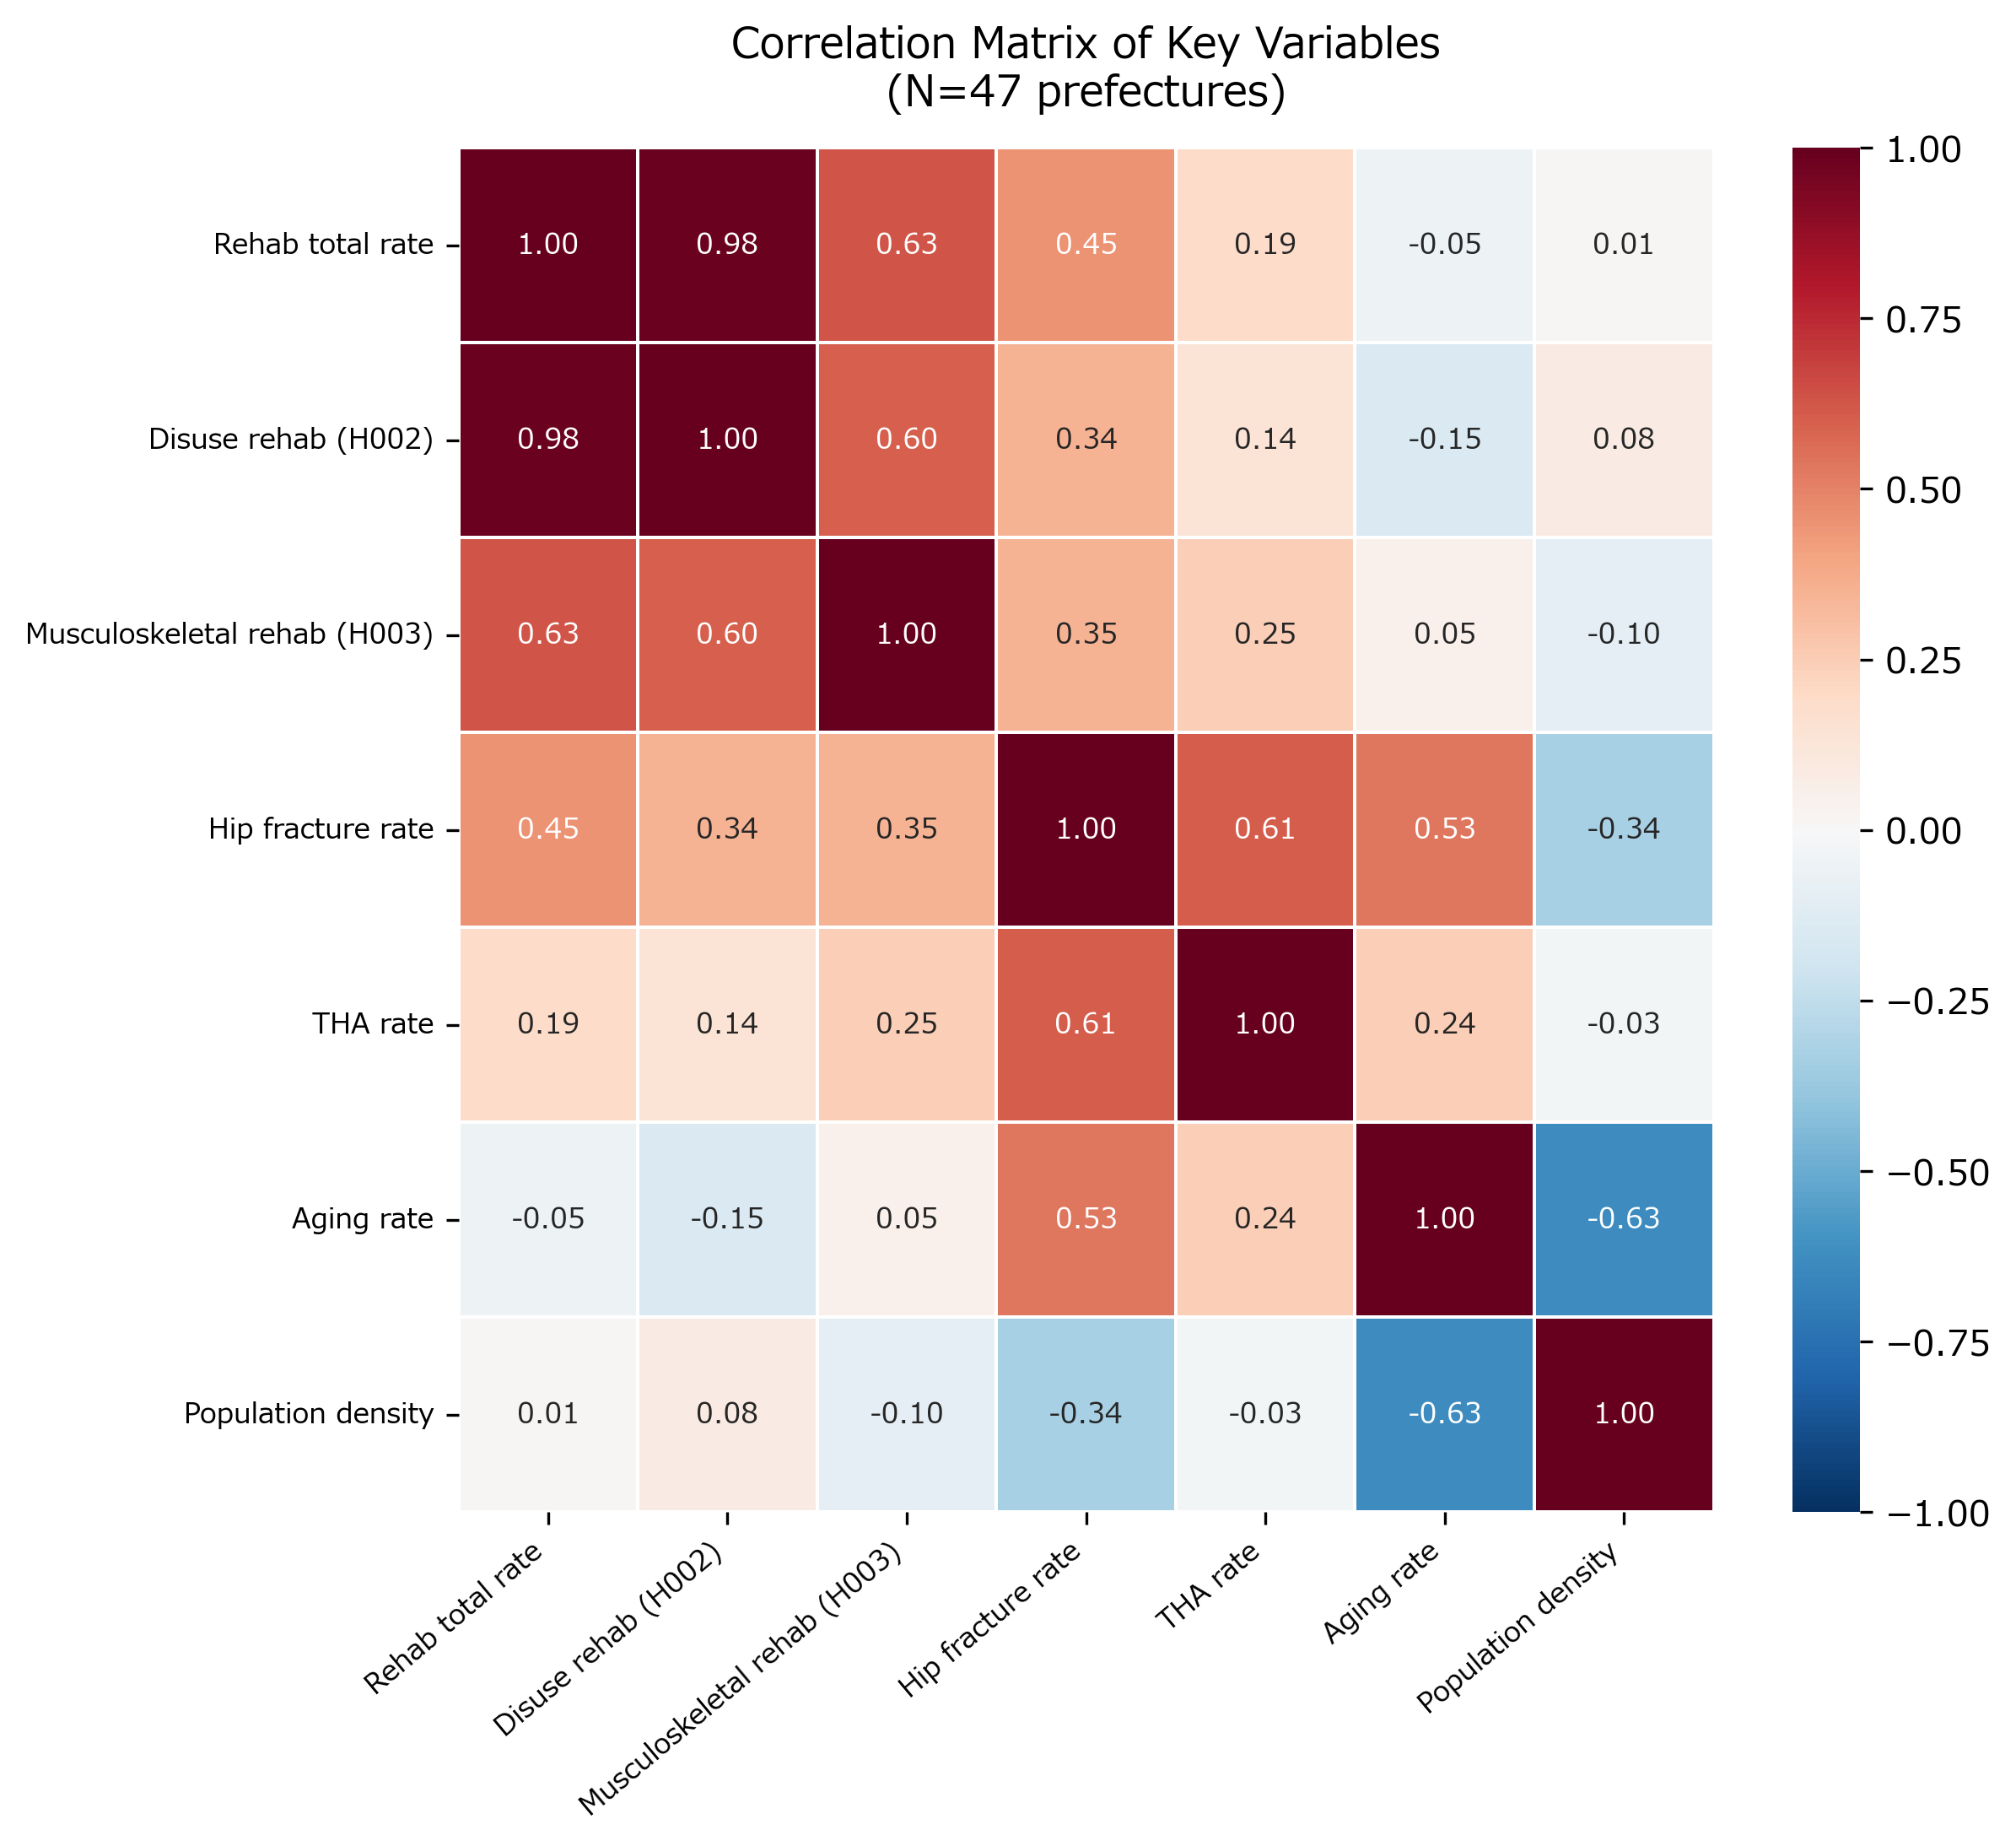
Figure 5. Correlation heatmap.
Supplementary Figures
Supplementary Figure S1. Scatter plot of disuse-syndrome rehabilitation rate (H002) versus hip fracture surgery rate by prefecture (N = 47). Pearson r = 0.344, p = 0.018.
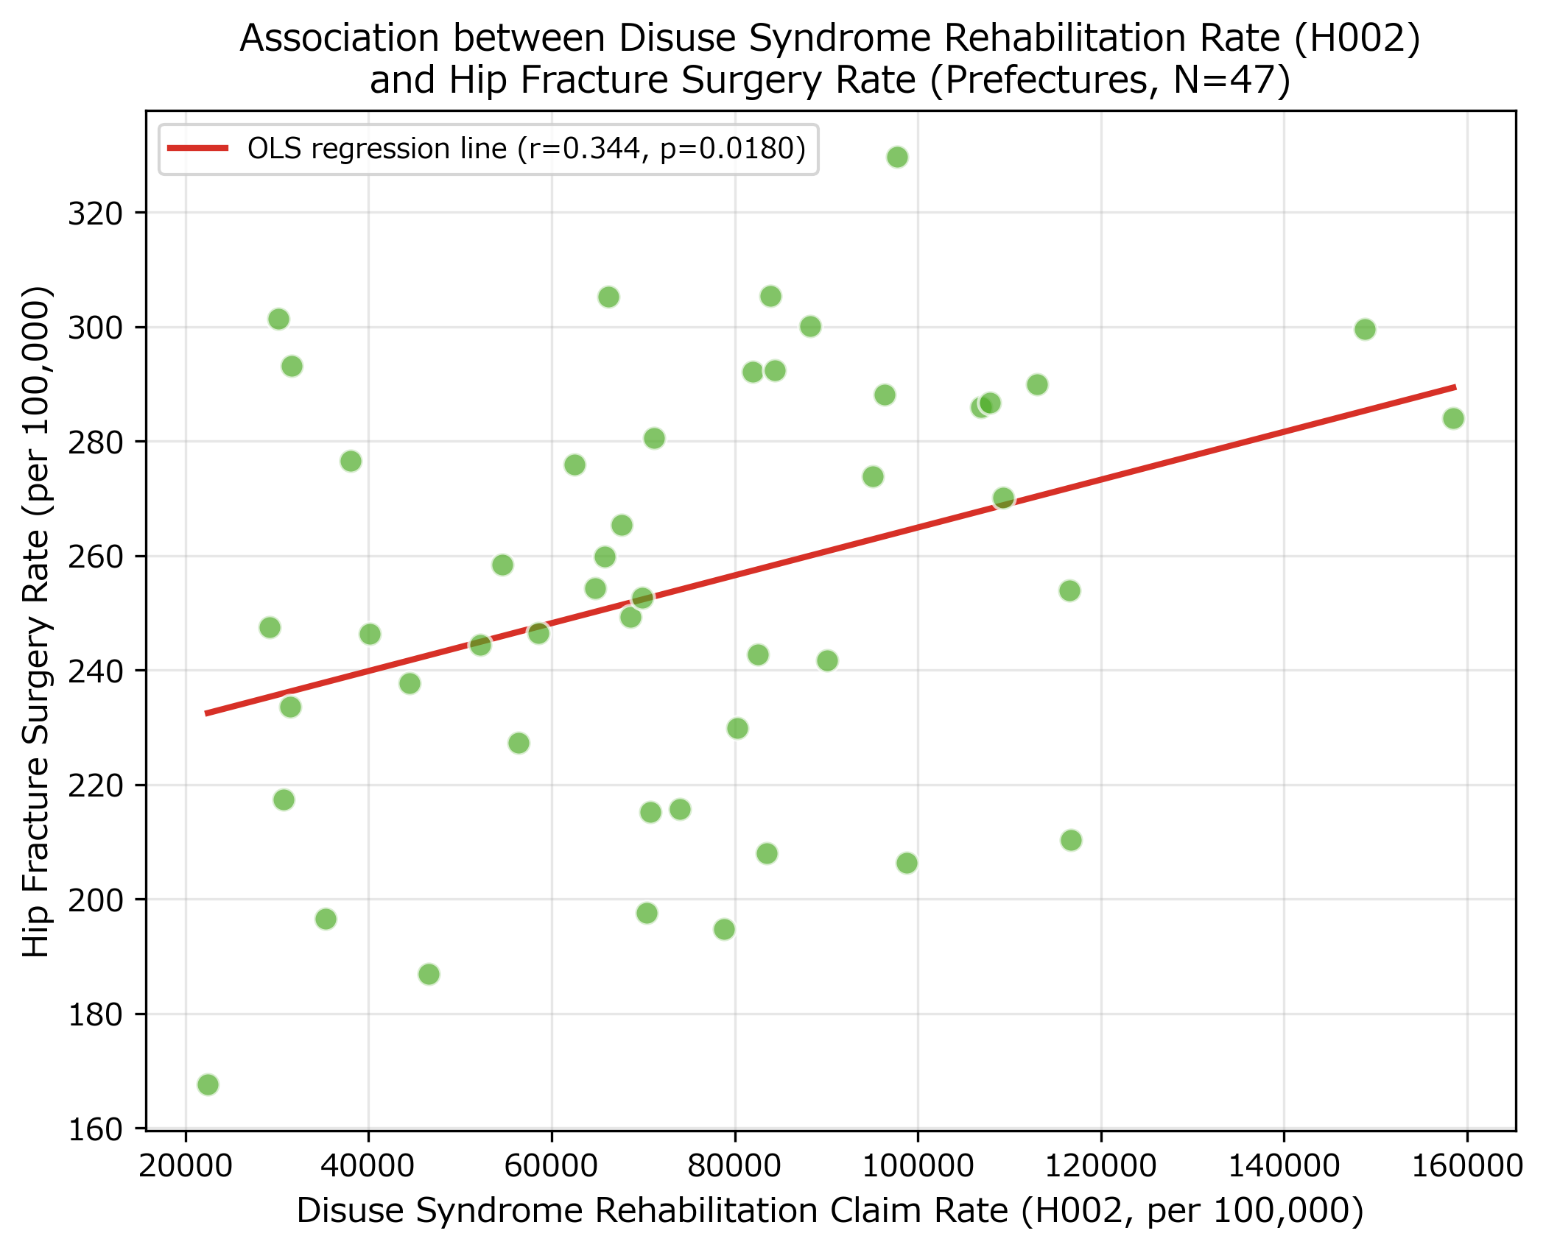
Supplementary Figure S1. Scatter plot of H002 rate versus hip fracture surgery rate.
Supplementary Figure S2. Scatter plot of musculoskeletal rehabilitation rate (H003) versus hip fracture surgery rate by prefecture (N = 47). Pearson r = 0.345, p = 0.018.
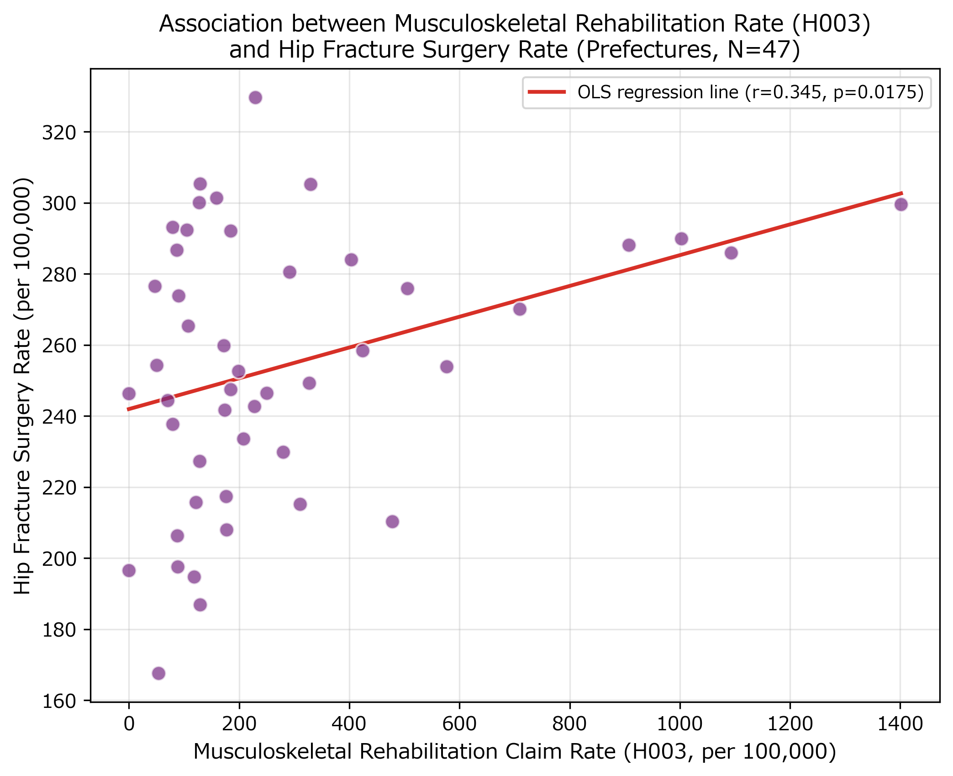
Supplementary Figure S2. Scatter plot of H003 rate versus hip fracture surgery rate.

