Exercise 6. Answer Sheet

Student's Name: Haruki Terushima Student's ID: s1290037

Problem 1. Given the graph below

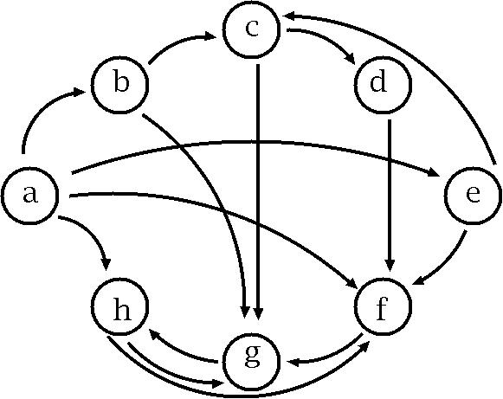

a) (10 points) Fill the following matrix by putting 1 if there is an edge between nodes. Put 0 otherwise.

 | a | b | c | d | e | f | g | h
a | 1 | 1 | 0 | 0 | 1 | 1 | 0 | 1
b | 0 | 1 | 1 | 0 | 0 | 0 | 1 | 0
c | 0 | 0 | 1 | 1 | 0 | 0 | 1 | 0
d | 0 | 0 | 0 | 1 | 0 | 1 | 0 | 0
e | 0 | 0 | 1 | 0 | 1 | 1 | 0 | 0
f | 0 | 0 | 0 | 0 | 0 | 1 | 1 | 0
g | 0 | 0 | 0 | 0 | 0 | 0 | 1 | 1
h | 0 | 0 | 0 | 0 | 0 | 1 | 1 | 1

b) (40 points) Write a program implementing Warshal's algorithm. Upload your code. Use your program to create a transitive closure G* of the graph above and show it in the space below.

Transitive closure defined by adjacency table
 | a | b | c | d | e | f | g | h
a | 1 | 1 | 1 | 1 | 1 | 1 | 1 | 1
b | 0 | 1 | 1 | 1 | 0 | 1 | 1 | 1
c | 0 | 0 | 1 | 1 | 0 | 1 | 1 | 1
d | 0 | 0 | 0 | 1 | 0 | 1 | 1 | 1
e | 0 | 0 | 1 | 1 | 1 | 1 | 1 | 1
f | 0 | 0 | 0 | 0 | 0 | 1 | 1 | 1
g | 0 | 0 | 0 | 0 | 0 | 1 | 1 | 1
h | 0 | 0 | 0 | 0 | 0 | 1 | 1 | 1

<compile>
javac *.java
java Floyd < input

<input>

8
23
0 0
0 1
0 4
0 5
0 7
1 1
1 2
1 6
2 2
2 3
2 6
3 3
3 5
4 2
4 4
4 5
5 5
5 6
6 6
6 7
7 5
7 6
7 7

<output>
This is the first weight

1 1 0 0 1 1 0 1
0 1 1 0 0 0 1 0
0 0 1 1 0 0 1 0
0 0 0 1 0 1 0 0
0 0 1 0 1 1 0 0
0 0 0 0 0 1 1 0
0 0 0 0 0 0 1 1
0 0 0 0 0 1 1 1

This is the final distances using Floyd's Algorithm

1 1 1 1 1 1 1 1
0 1 1 1 0 1 1 1
0 0 1 1 0 1 1 1
0 0 0 1 0 1 1 1
0 0 1 1 1 1 1 1
0 0 0 0 0 1 1 1
0 0 0 0 0 1 1 1
0 0 0 0 0 1 1 1

Problem 2. (50 points) Consider the following weight adjacency matrix.

 | a | b | c | d | e | f | g | h
a | 0 | 48 | ∞ | 8 | 20 | ∞ | 20 | ∞
b | ∞ | 0 | 24 | ∞ | 9 | ∞ | 76 | 29
c | 97 | ∞ | 0 | ∞ | ∞ | ∞ | 18 | 1
d | ∞ | 52 | 34 | 0 | 29 | ∞ | ∞ | ∞
e | ∞ | ∞ | ∞ | ∞ | 0 | 10 | ∞ | ∞
f | ∞ | 10 | 85 | 43 | ∞ | 0 | 41 | 29
g | ∞ | ∞ | ∞ | 76 | 38 | ∞ | 0 | ∞
h | 28 | 42 | ∞ | 77 | 21 | ∞ | 11 | 0

Write a program implementing Floyd's algorithm. Upload your code. Given the matrix above, calculate all pairs shortest paths using your program and fill the table below:

All pairs shortest path table
 | a | b | c | d | e | f | g | h
a | 0 | 40 | 42 | 8 | 20 | 30 | 20 | 43
b | 53 | 0 | 24 | 61 | 9 | 19 | 42 | 25
c | 29 | 22 | 0 | 37 | 22 | 12 | 18 | 1
d | 63 | 49 | 34 | 0 | 29 | 39 | 52 | 35
e | 67 | 20 | 44 | 53 | 0 | 10 | 51 | 39
f | 57 | 10 | 34 | 43 | 19 | 0 | 41 | 29
g | 105 | 58 | 82 | 76 | 38 | 48 | 0 | 77
h | 28 | 21 | 45 | 36 | 21 | 11 | 48 | 0

<compile>
javac *.java
java Floyd < input

<input>
8
27
0 1 48
0 3 8
0 4 20
0 6 20
1 2 24
1 4 9
1 6 76
1 7 29
2 0 97
2 6 18
2 7 1
3 1 52
3 2 34
3 4 29
4 5 10
5 1 10
5 2 85
5 3 43
5 6 41
5 7 29
6 3 76
6 4 38
7 0 28
7 1 42
7 3 77
7 4 21
7 5 11

<output>
This is the first weight

0 48 inf 8 20 inf 20 inf
inf 0 24 inf 9 inf 76 29
97 inf 0 inf inf inf 18 1
inf 52 34 0 29 inf inf inf
inf inf inf inf 0 10 inf inf
inf 10 85 43 inf 0 41 29
inf inf inf 76 38 inf 0 inf
28 42 inf 77 21 11 inf 0

This is the final distances using Floyd's Algorithm

0 40 42 8 20 30 20 43
53 0 24 61 9 19 42 25
29 22 0 37 22 12 18 1
63 49 34 0 29 39 52 35
67 20 44 53 0 10 51 39
57 10 34 43 19 0 41 29
105 58 82 76 38 48 0 77
28 21 45 36 21 11 48 0

