Exercise 2. Answer Sheet

Student's Name: Haruki Terushima Student's ID: s1290037

Problem 1. (10 points) Consider a priority queue S implemented as a heap. Write a pseudo-code for the Maximum(S) operation on this priority queue.

def Maximum(S)
if S[1] > S[2]:
maximum = S[1]
else:
maximum=-∞
for 𝑖 =A.length/2 to A. length
if maximum<S[i]:
maximum= S[i]
end
end
end
return maximum
end

Problem 2. (20 points) Consider top-down heap construction approach.

a). Write a pseudo-code for a HeapTopDown(A) algorithm using Max-Heap-Insert (A, key) operation

def HeapBottomUp (𝑨)
//Input: An array A[1..n] of orderable items
//Output: A heap A[1..n]

𝐴. heapsize = 𝐴. length
for 𝑖 =1 to A. length
Max-Heap-Insert (A, A[i])
end
end

b) What is the time complexity of HeapTopDown(A) algorithm? Why?

Log(n*logn)

Problem 3. (20 points) Illustrate the operation Heap-Extract-Max on a heap A=[15,13,9,5,12,8,7,4,0,6]

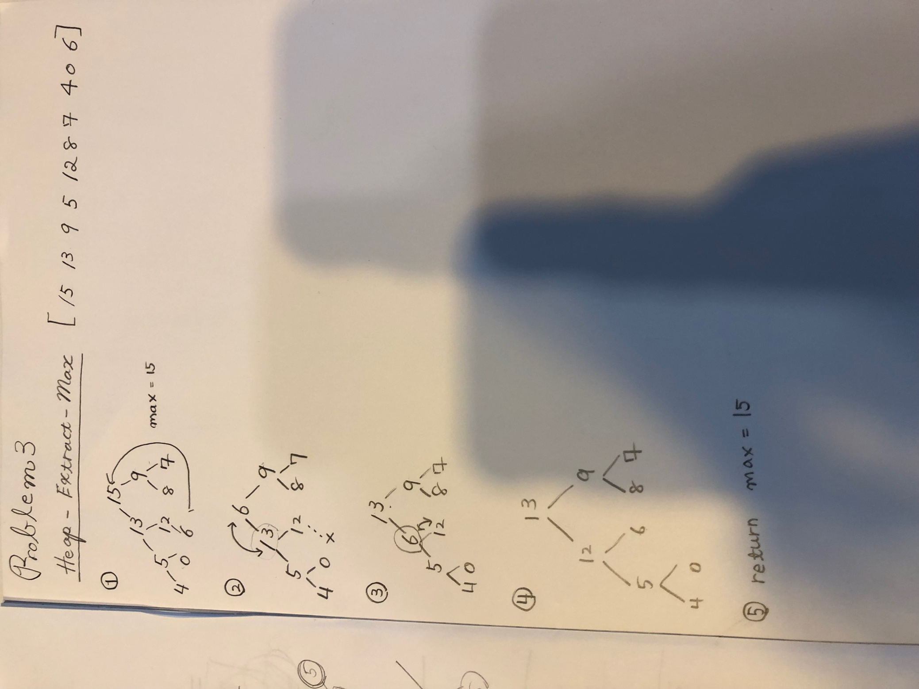

Problem 4. (50 points) Write a program implementing HeapBottomUp (A) algorithm. Upload your source code. Show your input array and the output heap in the space below.

python3 HeapBottomUp.py

input
10
4
1
3
2
16
9
10
14
8
7

output
[16, 14, 10, 9, 8, 7, 4, 3, 2, 1]

