Kurita_Haruma_Project2
Haruma Kurita
2025-11-15

Github Repository
Link to GitHub: https://github.com/haruma-kurita/Sickle_Cell_Disease_Project

Background
Sickle cell disease (SCD) is a group of genetic disorders in which red blood cells contort into a sickle shape. This analysis examines the associations between various air pollutants (CO, PM2.5, and O3) and potential impacts on SCD patients in Durham County, North Carolina. Air pollution data were obtained from the EPA monitoring station at RDU airport for the years 2018-2020.

Data Processing

Results

Summary Statistics
Summary Statistics for Air Pollutants (2018-2020)
Mean CO (ppm) | Mean PM2.5 (μg/m³) | Mean O3 (ppm) | Max CO (ppm) | Max PM2.5 (μg/m³) | Max O3 (ppm)
0.34 | 7.74 | 0.039 | 1.3 | 31.2 | 0.068

Plot 1: Monthly Average CO and O3 Concentrations
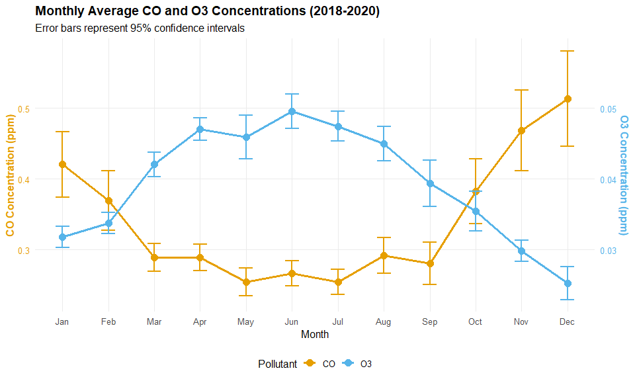
The CO and O3 concentrations show distinct seasonal patterns. CO concentrations are relatively stable throughout the year with slightly higher values in winter months. O3 concentrations peak during summer months (June-August), consistent with increased photochemical activity in warmer weather. The dual y-axis allows for clear visualization of the 95% confidence intervals for both pollutants despite their different scales.

Plot 2: Monthly PM2.5 Concentrations by Year
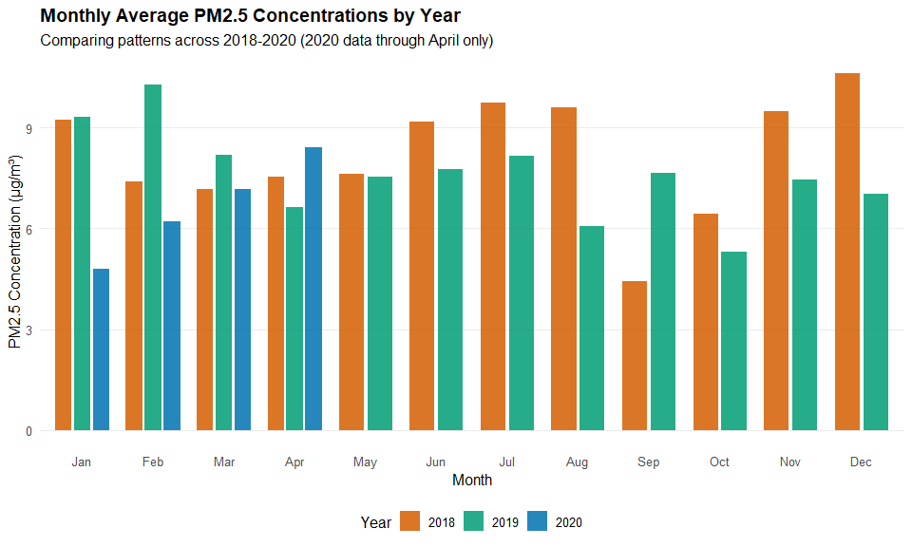
PM2.5 concentrations show variability across months and years. Generally, concentrations tend to be higher in winter and spring months. The 2020 data (available only through April) shows relatively lower PM2.5 levels compared to the same months in 2018 and 2019, which may reflect reduced human activity during the early COVID-19 pandemic period.

Conclusions
This analysis processed air quality data from 2018-2020 and revealed seasonal patterns in pollutant concentrations. O3 shows clear summer peaks, while CO remains relatively stable year-round. PM2.5 exhibits more variable patterns with generally higher concentrations in cooler months. These findings provide a foundation for understanding potential air quality impacts on sickle cell disease patients in Durham County. Further analysis would be needed to directly correlate these pollutant levels with health outcomes in SCD patients.

