Prognostic Value of Peritumoral CXCL17 Expression in HCC Haruma Kurita

Analysis Report

Executive Summary
Purpose
Hepatocellular carcinoma (HCC) is a leading cause of cancer related mortality characterized by high post-surgical recurrence rates influenced by the tumor microenvironment. While previous studies evaluated the chemokine CXCL17 by artificially dichotomizing patients into high and low risk groups based on sample medians, this assumes homogenous risk within those groups. The objective of this study was to precisely quantify the independent effect and continuous dose-response relationship of peritumoral CXCL17 expression on overall survival (OS) in HCC patients who underwent curative surgical resection, adjusting for complex clinical and pathological confounders.

Methods
Data from the hepatoCellular dataset was evaluated utilizing a complete case analysis approach to handle missing data. A multivariable Cox proportional hazards regression model was fit to assess overall survival with model assumptions explicitly tested. To address violations of the proportional hazards assumption by categorical covariates, the final model was stratified by tumor multiplicity, tumor size, vascular invasion, TNM stage, and Barcelona Clinical Liver Cancer (BCLC) stage. To correct for a failure in the linearity assumption for the continuous predictor a restricted cubic spline was applied to the peritumoral CXCL17 expression (CXCL17P) variable. The adjusted model evaluated a final cohort of 227 patients which captured 97 death events.

Main Findings
- CXCL17 Expression is Not a Significant Predictor: Adjusting for pre-specified clinical covariates, there is no statistically significant association between continuous peritumoral CXCL17 expression and overall survival. Both the linear main effect (p = 0.4818) and the restricted cubic spline adjustment (p = 0.9795) were insignificant.
- Negligible Effect on Hazard: The linear component of CXCL17P yielded an adjusted Hazard Ratio of 1.003 (95% CI: 0.995, 1.010). This indicates virtually no change in mortality risk as the continuous biomarker density increases.
- Clinical Confounders Drive Mortality: Alpha-fetoprotein (AFP) serum levels >25 ng/ml remained a highly significant independent predictor of mortality, increasing the hazard of death by 2.63 times compared to baseline levels ≤25 ng/ml (p < 0.001). Aspartate aminotransferase (AST) >42 U/liter was not statistically significant (HR = 1.209, p = 0.4215).

Discussion
The findings fail to reject the null hypothesis that continuous peritumoral CXCL17 expression does not have a significant independent effect on overall survival in HCC patients when adjusting for standard clinical covariates. By evaluating the continuous dose-response relationship rather than relying on arbitrary cut-points, and by rigorously addressing model assumption violations through stratification and restricted cubic splines, this analysis suggests that previous methodologies dichotomizing patients into risk groups may have artificially inflated the biomarker's prognostic significance.

Brief Recap of Objectives / Methods
The objective of this analysis was to quantify the independent effect of continuous peritumoral CXCL17 expression on overall survival in patients with hepatocellular carcinoma using a complete-case multivariable Cox proportional hazards model. To correct for structural assumption violations identified during initial diagnostics, the final adjusted model incorporated a 3-knot restricted cubic spline to capture the non-linear relationship of CXCL17P and was stratified over five clinical covariates (tumor multiplicity, tumor size, vascular invasion, TNM stage, and BCLC stage) that violated the proportional hazards assumption.

Results

Table 1: Descriptive Statistics of the Sample
Baseline Characteristic | N | N = 227¹
Peritumoral CXCL17 Expression | 227 | 46 (15, 143)
Tumor Multiplicity | 227
1 |  | 170 (75%)
2 |  | 57 (25%)
AFP | 227
1 |  | 78 (34%)
2 |  | 149 (66%)
AST | 227
1 |  | 131 (58%)
2 |  | 96 (42%)
Tumor Size | 227
1 |  | 96 (42%)
2 |  | 131 (58%)
Vascular Invasion | 227
0 |  | 186 (82%)
1 |  | 41 (18%)
TNM Stage | 227
1 |  | 122 (54%)
2 |  | 105 (46%)
BCLC Stage | 227
1 |  | 136 (60%)
2 |  | 91 (40%)
¹ Median (Q1, Q3); n (%)

Looking at the 227 patients there is a spread in CXCL17 expression with an IQR from 15 to 143. Most of the cohort presented with earlier stage pathology as 75% had just a single tumour and 82% showed no signs of vascular invasion. However, their clinical lab results were a bit more mixed with about two-thirds of the group showing elevated AFP levels.

Figure 1: Adjusted Survival Curves Comparing the 25th and 75th Percentiles of Peritumoral CXCL17 Expression
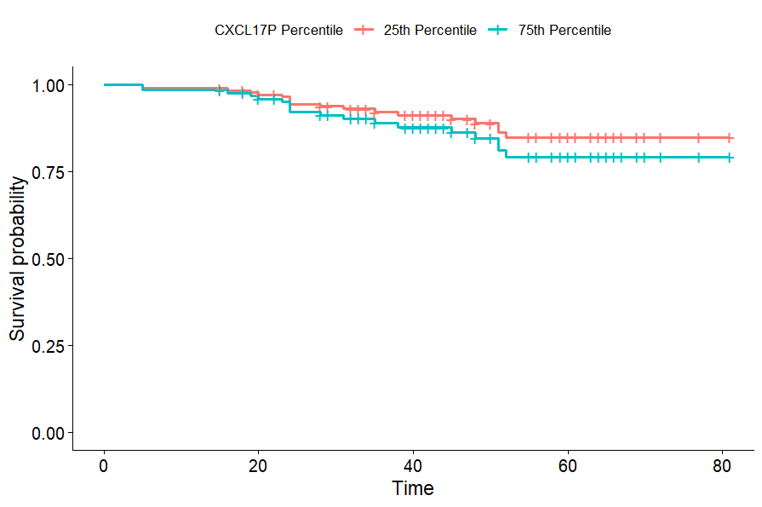

Figure 1 illustrates the covariate-adjusted survival probabilities over time for patients at the 75th versus the 25th percentile of peritumoral CXCL17 expression. The survival trajectories between the two groups remain closely intertwined throughout the follow-up period, suggesting no pronounced difference in overall survival based on this biomarker contrast.

Results from Multivariable Cox Proportional Hazards Regression

A multivariable Cox proportional hazards model was fitted to evaluate the association between peritumoral CXCL17 expression and overall survival among 227 complete cases, which included 97 observed mortality events. To properly satisfy model assumptions, restricted cubic splines were applied to the continuous CXCL17 variable to account for non-linearity, and the model was stratified by tumor multiplicity, tumor size, vascular invasion, TNM stage, and BCLC stage to correct for proportional hazards violations.
When comparing patients at the 75th percentile of CXCL17 expression to those at the 25th percentile, the model yielded an adjusted hazard ratio of 1.42 (95% CI: 0.85, 2.38; p = 0.186). Because this confidence interval crosses 1.0 and the p-value is greater than 0.05, the observed 42% relative increase in mortality risk is not statistically significant. While the primary biomarker contrast did not demonstrate independent prognostic value, the model did identify elevated alpha-fetoprotein (AFP Level 2) as a highly significant independent predictor of mortality, demonstrating a hazard ratio of 2.63 (p = 0.00045) when compared to baseline AFP levels.

Discussion

Main Takeaways
The primary analysis evaluated the association between peritumoral CXCL17 expression and overall survival in patients with hepatocellular carcinoma. Utilizing a rigorously adjusted multivariable Cox proportional hazards model, the results indicated that an increase in CXCL17 expression from the 25th to the 75th percentile was not significantly associated with mortality risk (HR = 1.42, 95% CI: 0.85 - 2.38). While unadjusted or simplified models may show a signal, this analysis demonstrates that peritumoral CXCL17 expression does not remain a significant independent prognostic factor once standard clinical covariates and non-linear dynamics are accounted for. Instead, elevated alpha-fetoprotein (AFP) emerged as the primary statistically significant predictor of poorer overall survival.

Comparison to Published Analysis
The published analysis categorized peritumoral CXCL17 expression into a binary variable (high vs. low) and additionally adjusted for intratumoral CXCL17. While dichotomizing simplifies clinical interpretation, it is methodologically disadvantageous as it discards quantitative information, reduces statistical power, and risks masking true non-linear relationships or creating spurious associations based on arbitrary cutpoints. Our approach—utilizing restricted cubic splines—provides a more robust, statistically sound evaluation of the continuous dose-response dynamic. Furthermore, including both intra- and peritumoral CXCL17 in a single model risks collinearity and variance inflation if the two expressions are highly correlated. Consequently, while the published paper reported findings based on their binary categorization, our continuous spline-based analysis suggests that peritumoral CXCL17 alone does not carry significant independent prognostic value when rigorously adjusted for standard clinical covariates.

Limitations
A primary limitation of this analysis is that the outcome is overall survival, which measures all-cause mortality rather than HCC-specific deaths; consequently, deaths from unrelated causes or underlying liver failure may confound the survival estimates. Analytically, the reliance on a complete-case framework (n=227) excluded subjects with missing covariate data, which diminishes statistical power and could introduce selection bias. Furthermore, while stratifying the Cox model successfully resolved proportional hazards violations for clinical covariates (tumor multiplicity, size, invasion, and staging), this mathematical correction inherently prevents the estimation of hazard ratios for those specific variables.

Future Research Directions
Future research using this dataset should implement multiple imputation techniques (such as MICE) to properly account for missing baseline data, thereby maximizing statistical power and mitigating complete-case bias. Additionally, prospective multi-center studies are needed to validate these findings on a larger scale. Incorporating longitudinal, repeated measurements of CXCL17 expression over time—rather than relying solely on a single baseline peritumoral tissue sample—would allow for time-dependent covariate survival modeling to determine if dynamic changes in the biomarker track more closely with disease progression and mortality than a static baseline measurement.

Appendix

References and AI Disclosure Statement
Type of AI Tool Used: Google Gemini (Large Language Model)
Description of Use: Gemini was utilized to troubleshoot R programming code for survival analysis visualizations,
guide the interpretation of statistical outputs and organize the overall document layout.

