INTERNATIONAL CYBERSECURITY AND DIGITAL FORENSICS ACADEMY

Packet Capture and Protocol Analysis
Lab Report
Student Practical Laboratory Report

Course | CORE102 TCP IP Networking and Linux Network Tools
Instructor | Aminu Idris AMCPN
Maximum score | 100 marks
Gradebook category | Practical Laboratories
Estimated duration | 5 to 6 hours
Platform | Kali Linux or Ubuntu Linux in an authorised laboratory environment
Version | September 2026

Student name _MUHAMMAD HARUNA OSORI
Registration number _ C11/26/OCO/17007
Submission date __________

PART 1.
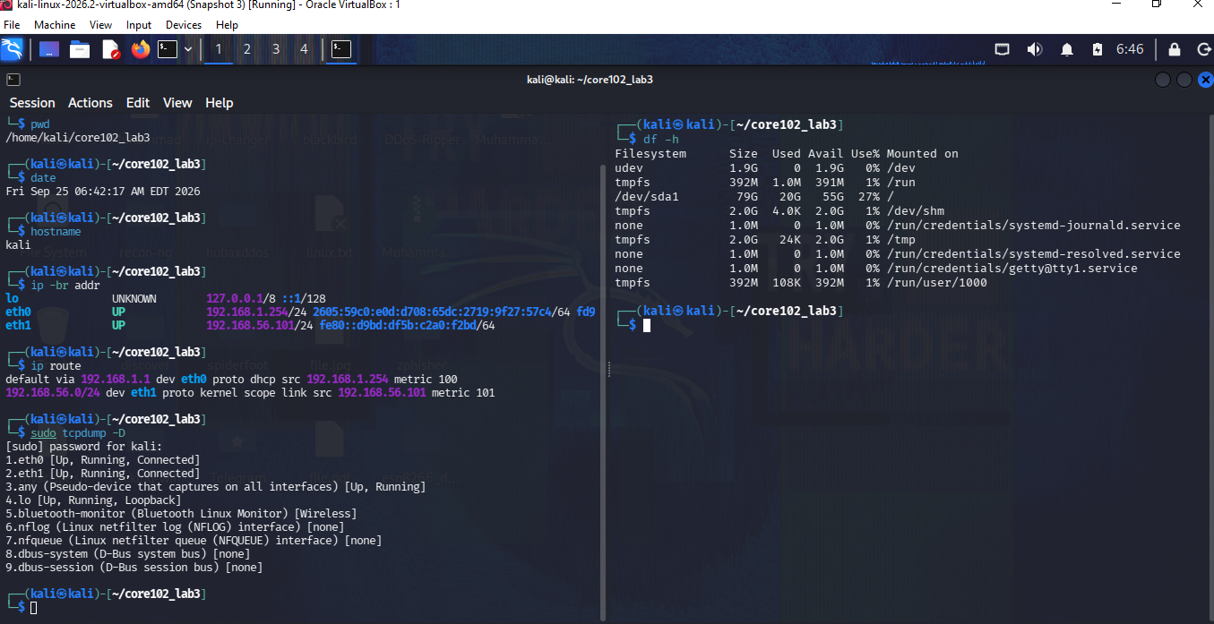

PART 2
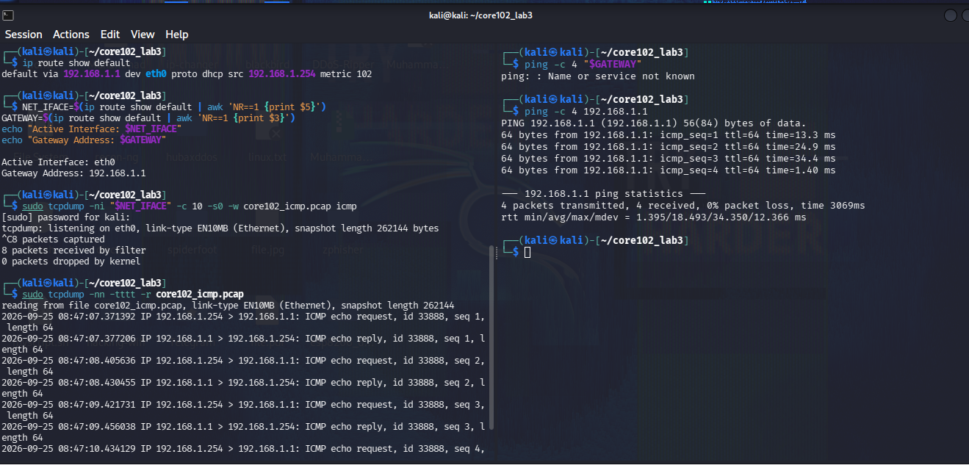

Interface: eth0
Kali IP: 192.168.1.254
Gateway: 192.168.1.1
Capture file: core102_icmp.pcap
Procedure:
The active interface and default gateway were identified using ip route. An ICMP capture was started on eth0 using tcpdump. Four ICMP echo requests were then sent to the default gateway using ping.
Observation:
The capture showed ICMP Echo Request packets travelling from 192.168.1.254 to 192.168.1.1 and corresponding Echo Reply packets travelling back to 192.168.1.254. The sequence numbers increased from 1 to 4, showing four request/reply pairs.
Result:
The ping completed successfully with 4 packets transmitted, 4 received and 0% packet loss. This confirms successful ICMP communication between the Kali host and its default gateway.
Evidence:
The saved PCAP file was core102_icmp.pcap.

Important limitation
The tcpdump output shows 8 packets captured, rather than the laboratory's required 10-packet capture. Therefore, the capture should be repeated for the final assessment evidence. The lab manual specifies a 10-packet capture.
Frame | Source | Destination | ICMP type | Identifier or sequence | Meaning
1 | 192.168.1.254 | 192.168.1.1 | Echo Request | 1 | Kali asks router for a reply
1 | 192.168.1.1 | 192.168.1.254 | Echo Reply | 1 | Router responds
2 | 192.168.1.254 | 192.168.1.1 | Echo Request | 2 | Kali asks again
2 | 192.168.1.1 | 192.168.1.254 | Echo Reply | 2 | Router responds
3 | 192.168.1.254 | 192.168.1.1 | Echo Request | 3 | Kali asks again
3 | 192.168.1.1 | 192.168.1.254 | Echo Reply | 3 | Router responds
4 | 192.168.1.254 | 192.168.1.1 | Echo Request | 4 | Kali asks again
4 | 192.168.1.1 | 192.168.1.254 | Echo Reply | 4 | Router responds
 |  |  |  |  | Kali asks again

PART 3
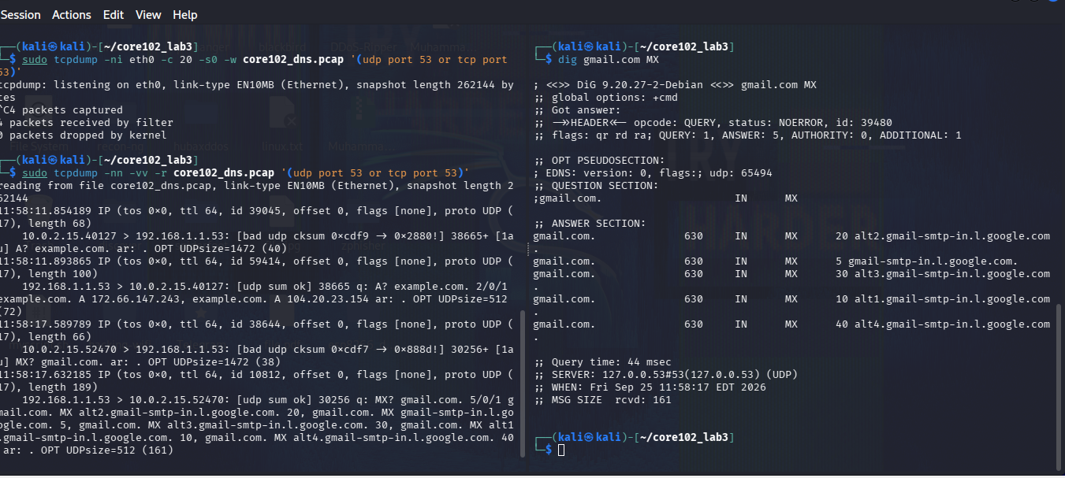

The initial DNS test showed that the system was using the local resolver 127.0.0.53 rather than sending the DNS query directly through the active eth0 interface. Therefore, the port-53 capture on eth0 recorded no packets.

DNS traffic was successfully captured on eth0. An A query for example.com and an MX query for gmail.com were generated and observed. Both queries received successful responses from DNS server 192.168.1.1 on port 53. The client source ports, transaction IDs, response status, and returned records were identified from the packet capture. 4 packets were captured successfully.
The capture recorded 4 DNS packets: a request and response for each query. The client used temporary UDP source ports 40127 and 52470, while the DNS server listened on the standard DNS port 53.
The transaction IDs matched between each request and its corresponding response, confirming that the responses belonged to the correct queries.
Although dig displayed the local resolver 127.0.0.53, the packet capture on eth0 showed the DNS traffic being forwarded to 192.168.1.1.
Query name | Type | Client port | Server | Response code | Answer summary
example.com | A | 40127 | 192.168.1.1:53 | NOERROR | 172.66.147.243, 104.20.23.154
gmail.com | MX | 52470 | 192.168.1.1:53 | NOERROR | MX records including gmail-smtp-in.l.google.com and alt1–alt4.gmail-smtp-in.l.google.com

PART 4
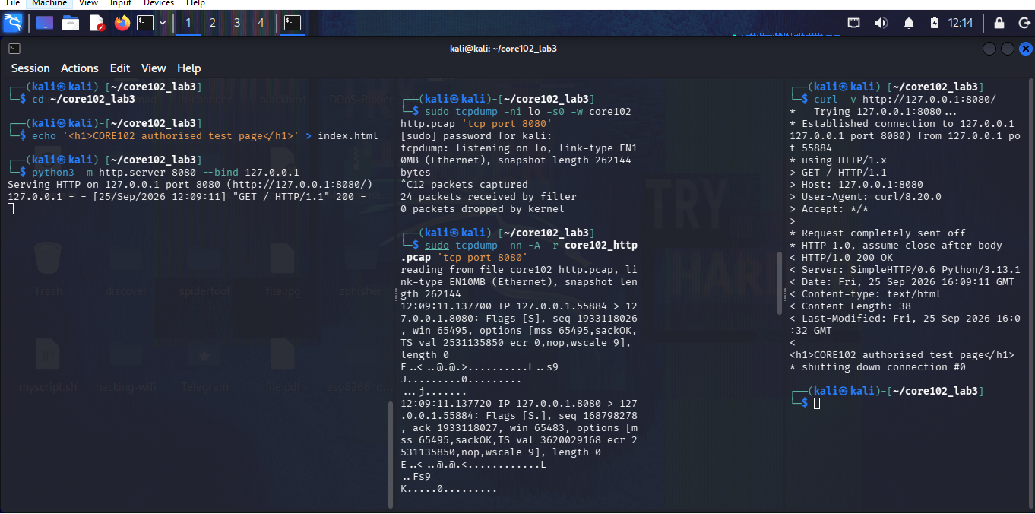

Stage | Display filter | Frame number | Evidence observed
Initial SYN | tcp.flags.syn == 1 && tcp.flags.ack == 0 | 1 | 127.0.0.1:55884 → 127.0.0.1:8080, Flags [S]
SYN ACK | tcp.flags.syn == 1 && tcp.flags.ack == 1 | 2 | 127.0.0.1:8080 → 127.0.0.1:55884, Flags [S.]
Final ACK | tcp.flags.ack == 1 | 3 | 127.0.0.1:55884 → 127.0.0.1:8080, Flags [.]
HTTP request | http.request | 4 | GET / HTTP/1.1
HTTP response | http.response | 5 | HTTP/1.0 200 OK and requested HTML content

I created three terminal , and I started python http server on the first terminal . create a listing on the second terminal and the local HTTP traffic was successfully captured on the loopback interface. A Python web server was accessed using curl, and the capture showed the TCP handshake, HTTP GET request, successful 200 OK response, and connection closure. The test page was returned correctly, confirming that the HTTP communication was captured and analysed successfully.

PART 5
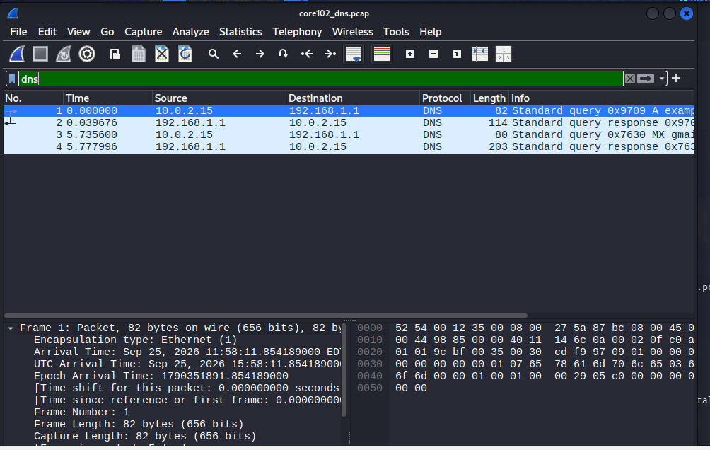

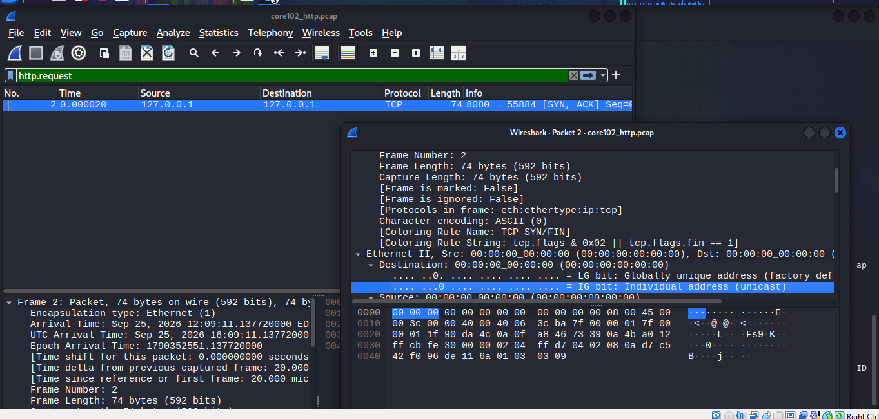

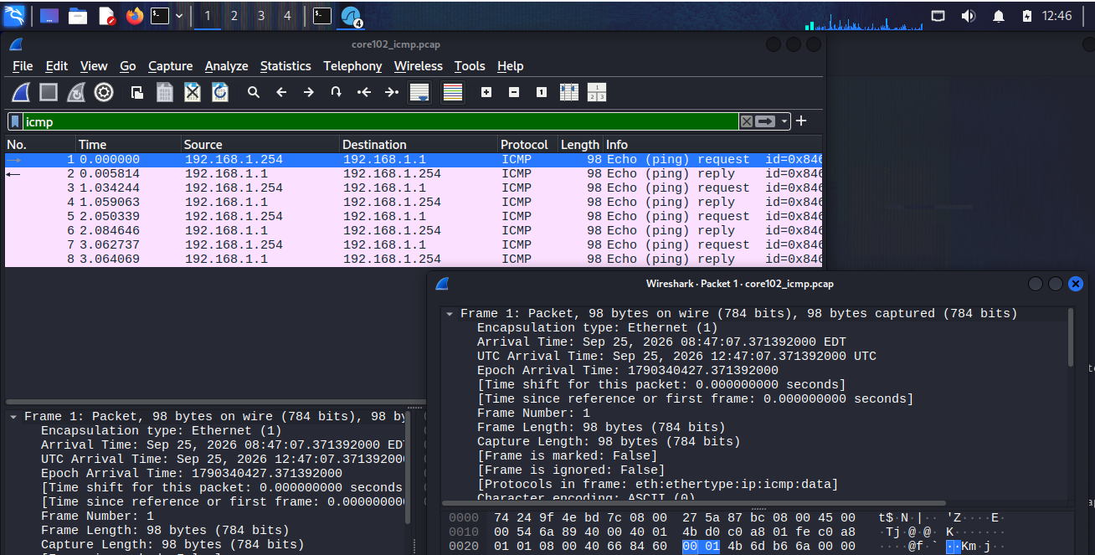

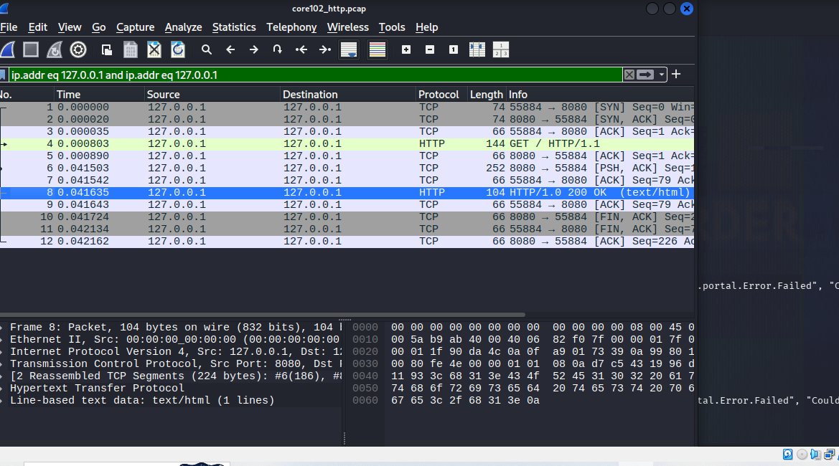

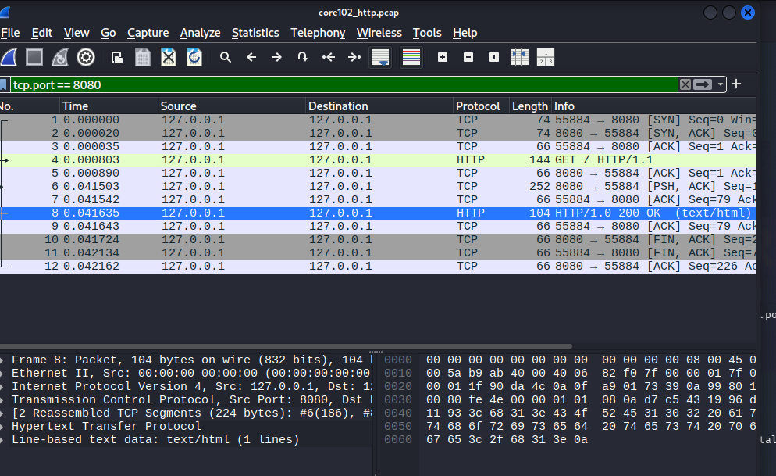

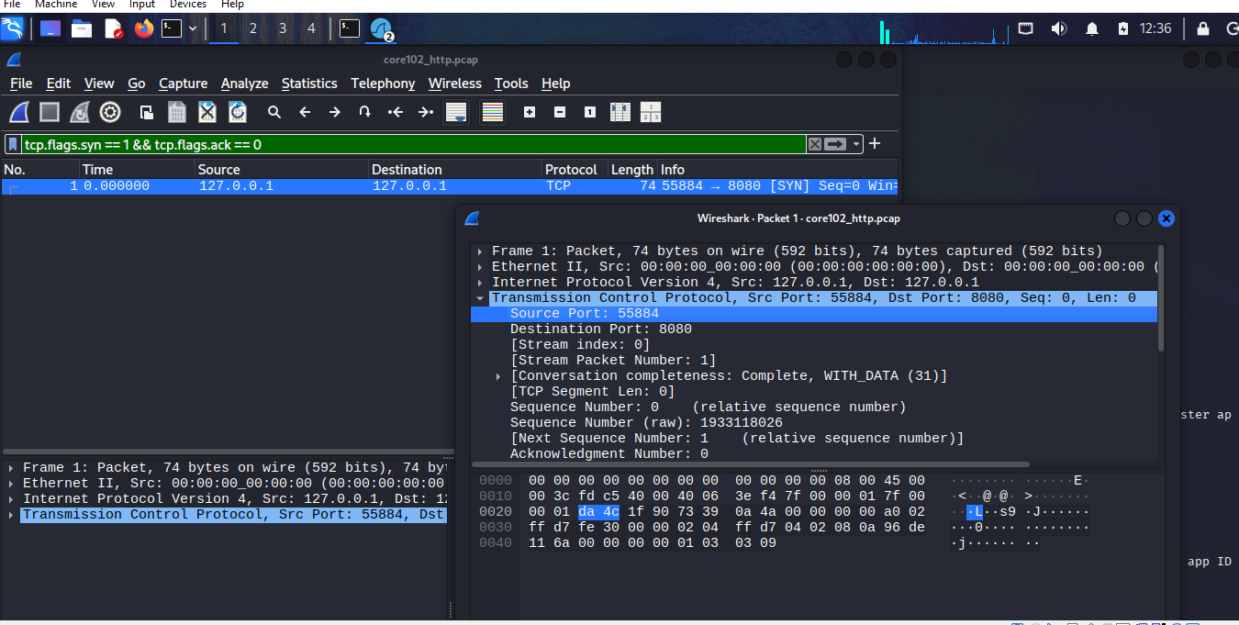

The captured PCAP files were opened and analysed in Wireshark using the required display filters. The analysis identified DNS, ICMP and local HTTP traffic, as well as the TCP handshake and HTTP request. The TCP stream and protocol statistics were also reviewed to understand the communication flow and confirm that only authorised test traffic was present
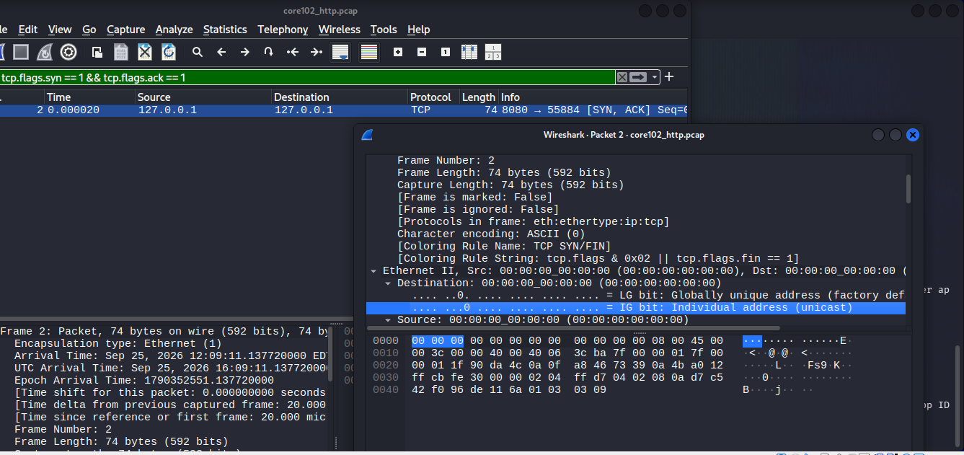

PART 6
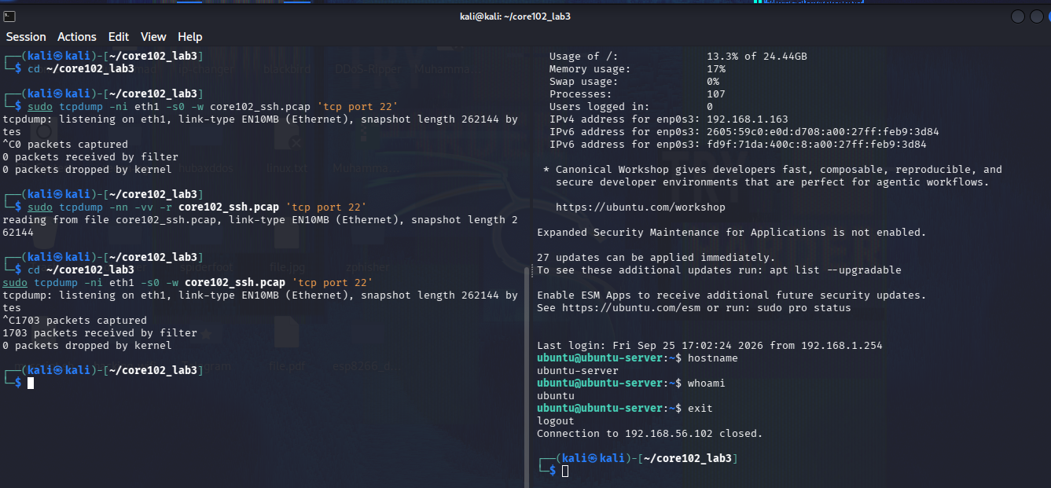

Capture reading
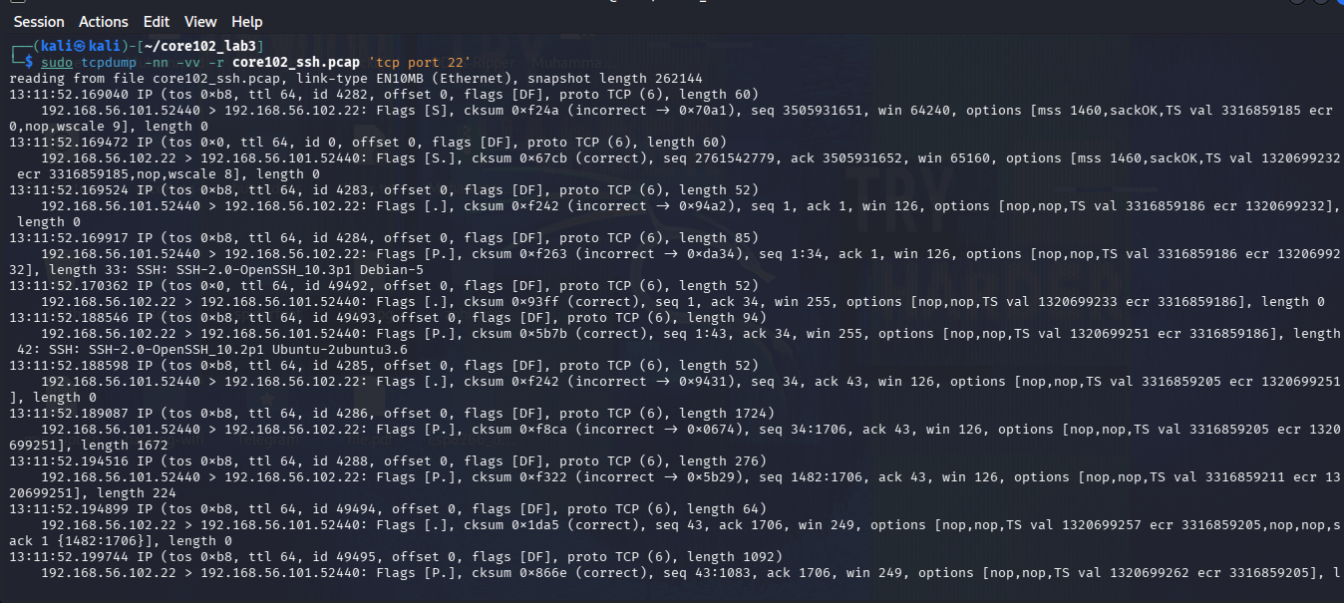

The authorised SSH session to the second virtual machine was successfully established and monitored using tcpdump on the private-lab interface. The capture showed the TCP three-way handshake, followed by encrypted SSH payload packets and the connection closure. Although commands such as hostname and whoami were executed during the session, their contents were not readable in the packet capture because SSH encrypts the session data. This confirmed that the SSH communication was successfully captured while protecting the contents of the session.
PART 7
Use at least one of your PCAP files to reconstruct a short timeline. Reference exact frame numbers and timestamps.
Time | Frame | Source | Destination | Protocol | Event and interpretation

1. Identify the first communication attempt.
2. Show the request and its matching response.
3. Identify one field that links the packets into a conversation.
4. State whether the exchange completed normally and cite the packet evidence.
5. Calculate the elapsed time between the first request and final response.

PART 6

