**Questions:**

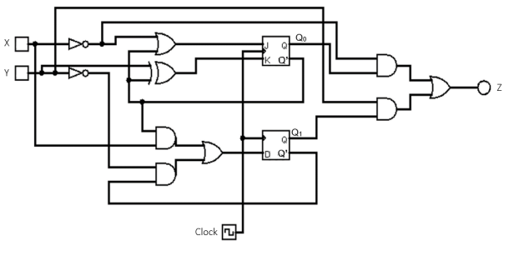A synchronous sequential circuit is given below:

1. **Determine the type of this circuit: Mealy or Moore. Provide an explanation for your choice.**
2. The inputs, and the current state determine the output of the function. This means it is a Mealy Model sequential circuit. If the output depended only on the current state, this would be a Moore model.
3. **Find the simplest possible expressions for the functions that drive the J0, K0, and D1 inputs of the flip-flops.**

**J0 =?**

**K0 =?**

**D1 =?**

**Present a detailed derivation for each expression.**

1. J0 = X′ + Q0′

K0 = Y ⊕ Q0′ = Y. Q0 + Y′. Q0′

D1 = Q0′. X + Q1′. Y′

1. **Determine the simplest possible expressions for the next states 𝑸0+ and 𝑸1+ (using Q0 for the J-K flip-flop and Q1 for the D flip-flop) and the expression for the output Z.**

**𝑸0+ =?**

**𝑸1+ =?**

**Z =?**

𝑸0+ = J0 · Q0′ + K0′ · Q0 (J-K FF characteristic function)

𝑸0+ = (X′ + Q0′) · Q0′ + (Y′+ Q0′) · (Y + Q0) · Q0

𝑸0+ = X′ · Q0′ + Q0′ + (Y′ · Y + Y′ · Q0 + Q0′ · Y + Q0′ · Q0) · Q0

𝑸0+ = Q0′ + (Y′ · Q0 · Q0 + Q0′ · Y · Q0)

𝑸0+ = Q0′ + Y′ · Q0

𝑸0+ = Q0′ + Y′ (minimization)

𝑸1+ = D1

𝑸1+ = Q0′ · X + Q1′ · Y′

Z = Q0 ·X′ + Q1 · Y

1. **Create the state/output table, detailing the relationships between states and corresponding outputs.**

Q1+ Q0+, Z

|  |  |  |  |  |
| --- | --- | --- | --- | --- |
| **X Y**  **Q1Q0** | **0 0** | **0 1** | **1 0** | **1 1** |
| **0 0** | **1 1, 0** | **0 1, 0** | **1 1, 0** | **1 1, 0** |
| **0 1** | **1 1, 1** | **0 0, 1** | **1 1, 0** | **0 0, 0** |
| **1 0** | **0 1, 0** | **0 1, 1** | **1 1, 0** | **1 1, 1** |
| **1 1** | **0 1, 1** | **0 0, 1** | **0 1, 0** | **0 0, 1** |

S+, Z

|  |  |  |  |  |
| --- | --- | --- | --- | --- |
| **X Y**  **S** | **0 0** | **0 1** | **1 0** | **1 1** |
| **A** | **D, 0** | **B, 0** | **D, 0** | **D, 0** |
| **B** | **D, 1** | **A, 1** | **D, 0** | **A, 0** |
| **C** | **B, 0** | **B, 1** | **D, 0** | **D, 1** |
| **D** | **B, 1** | **A, 1** | **B, 0** | **A, 1** |