

**EE451 PROJECT PROPOSAL**

**Students:** Harun Durmuş **Student ID’s:** 270206025 **Date:** 09.11.2023

Mustafa Eren Çelebi270206053

Necmettin Yiğit Dübek260206049

**COMPARISON OF ZERO FORCING AND MMSE EQUALIZERS IN DIFFERENT AWGN CHANNELS**

**Abstract**

This project aims to conduct a comprehensive comparison of the performance of Zero Forcing and MMSE (Minimum Mean Square Error) equalizers in Band Limited AWGN (Additive White Gaussian Noise) channels. Zero Forcing leverages the direct relationships between transmitted and received signals, whereas MMSE optimizes received signals based on the Minimum Mean Square Error principle. The project will employ simulations to investigate performance differences between both equalizer types and compare the results. The primary objective is to determine which equalizer type demonstrates superior performance in a Band Limited AWGN channel.

**Introduction**

In communication systems, equalization plays a pivotal role in suppressing channel-induced interference and ensuring reliable data transmission. This project delves into the comparison of two common equalization techniques: Zero Forcing and MMSE, and their effect in suppressing intersymbol interference (ISI) in Band Limited AWGN channels.

**Work Packages**

The project's tasks are organized into the following work packages:

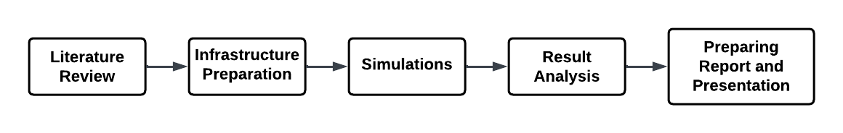

**1. Literature Review**

* **Theoretical Foundations of Zero Forcing and MMSE Equalizers:** A comprehensive study of the theoretical underpinnings of Zero Forcing and MMSE equalization techniques.
* **AWGN Channel and Bandwidth Limitations:** Research on the characteristics of the Additive White Gaussian Noise channel and the associated bandwidth limitations.

**2. Infrastructure Preparation**

* **Software and Hardware Setup:** Procurement and preparation of the necessary software and hardware for conducting simulations.
* **Data and Tools Acquisition:** Collection of datasets and simulation tools required for the project.

**3. Simulations**

* **Zero Forcing Equalizer Simulations:** Conducting simulations to evaluate the performance of Zero Forcing equalizers under various scenarios.
* **MMSE Equalizer Simulations:** Performing simulations to assess the performance of MMSE equalizers in different scenarios.

**4. Result Analysis**

* **Review and Analysis of Simulation Results:** Careful examination and analysis of the simulation outcomes for both Zero Forcing and MMSE equalizers.
* **Performance Comparison:** Comparative analysis of the performance of Zero Forcing and MMSE equalizers based on simulation results.

**5. Reporting and Presentation Preparation**

* **Project Report:** Compilation of project results into a comprehensive written report that covers the methodology, results, and insights gained from the project.
* **Presentation:** Preparation of an engaging presentation summarizing the project's outcomes for knowledge dissemination.

**Project Timeline**

The project will span a 5-week period, during which the specified work packages will be completed in a structured manner. The culmination of the project will result in the creation of a detailed report and presentation that directly compare the performance of Zero Forcing and MMSE equalizers in Band Limited AWGN channels. This project aims to provide valuable insights into equalization methods in communication systems.

metin, ekran görüntüsü, sayı, numara, tasarım içeren bir resim

Açıklama otomatik olarak oluşturuldu  
**Figure 1:** Project Gant Chart

**Notes on Zero Forcing and MMSE Equalization**

**1. Equalization Overview**

Equalization is a critical component of wireless communication systems that serves to compensate for channel-induced intersymbol interference (ISI). Every channel can be characterized as linear and time-invariant, with specific phase and magnitude responses. These responses influence the quality of signal transmission.

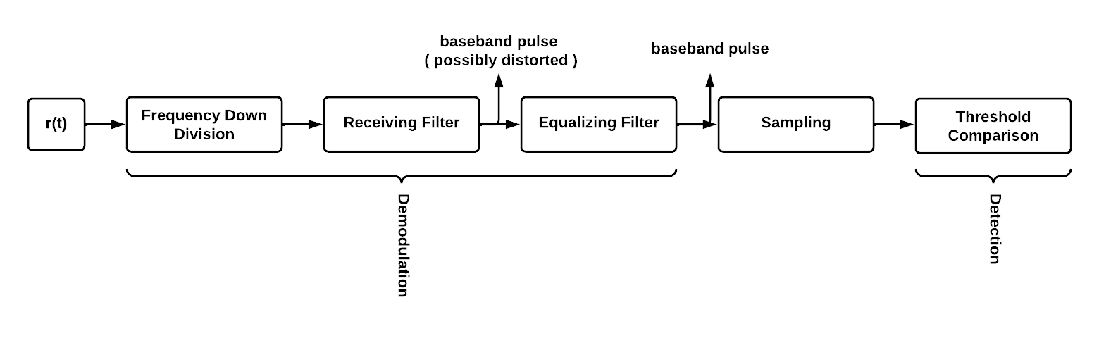

**1.2. Transversal Filtering**

Transversal filtering is a common approach to equalization, involving the use of a filter with adjustable taps. The filter operates on the incoming signal to minimize ISI and noise.

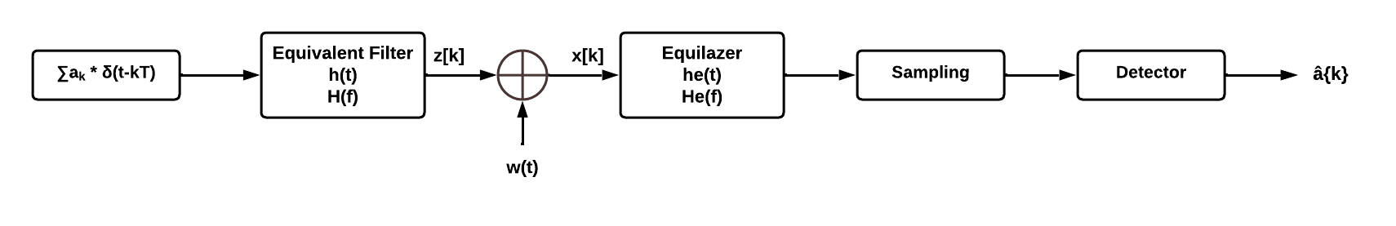

The equivalent filter is equal to below:

* H(f) = Ht(f).Hc(f).Hr(f), where Ht(f) is TX filter, Hc(f) is channel and Hr(f) is Rx filter responses.

**1.2.1 Zero Forcing Equalizer**

Zero Forcing equalization is achieved by adjusting the filter taps to ensure that the equalizer output is forced to zero at N sample points on each side of the signal. This approach aims to entirely suppress ISI but can result in an increase in noise.

* adjust {cn} (n = -N to N), so that z[k] = { 1 if k = 0

0 if k = ±1, ±2, … , ±N }

**1.2.2 MMSE Equalizer**

The MMSE Equalizer seeks to minimize the mean square error (MSE) of ISI and noise power at the equalizer output. Unlike Zero Forcing, MMSE Equalization does not entirely eliminate ISI but provides a trade-off by not enhancing noise as much.

* adjust {cn} (n = -N to N), so that min(E{⌊(z[k] – x[k])2⌋})

**Conclusion**

This project represents an opportunity to gain deeper insights into the practical aspects of Zero Forcing and MMSE equalizers in real-world communication scenarios. The results of this study will contribute to our understanding of equalization techniques in communication systems.