**EE 316 PROJECT REPORT: L-C METER**

**Date:** 22.06.2023

**Student Name:** Harun Durmuş **Student ID:** 270206025

**Student Name:** Necmettin Yiğit Dübek **Student ID:** 260206049

**Contents of Procedure:**

1. Basic oscillator circuits
   1. 555 IC Timer Integrated Circuits
   2. Astable operation of IC 555 Timer
   3. Pin Descriptions of the NE555 Timer Integrated Circuit
   4. Circuit Design
2. Phase or time delay of basic R-C and L-R circuits
   1. Buffer Operation
   2. Circuit Design
3. Phase detection and comparison
   1. Phase Comparison
   2. Phase Difference Measurement
   3. Accuracy of Measurements
   4. Circuit Design with Proteus
4. Analog to digital converters
5. Converting binary numbers into decimal
6. Feed-back extension for noisy measurement conditions
   1. Feedback Design
   2. Case: Sinusoidal Case
7. References

**Objective**

To create an electronic design that determines capacitance or inductance with %2 error by measuring voltage.

**Introduction**

The goal is to demonstrate the design and construction of an electrical circuit that can precisely ascertain the capacitance or inductance of a specific component with a maximum error rate of 2%, the L-C Meter project report. The proposed circuit works by measuring the voltage across the component being tested and deriving the corresponding parameters from the waveform that results.

Many applications, including electrical circuits, communication systems, and many more, depend on accurate capacitance or inductance estimation. Conventional gauging methods, nevertheless, require specialized equipment and are prone to errors because of things like parasitic capacitance or inductance in the measurement setup.

These drawbacks are addressed by the suggested circuit, which offers a straightforward, precise, and dependable way for measuring capacitance or inductance with little setup time. The circuit design will be thoroughly explained, together with simulation results and experimental validation, in the report to show how reliable and effective it is.

**Procedure**

1. **Basic Oscillator Circuits**
   1. **555 IC Timer Integrated Circuits**

The 555 timer is a multipurpose integrated circuit that is frequently used in electronics. It is made up of a voltage divider, a discharge transistor, a flip-flop, and two comparators. Monostable (one-shot), astable (free-running), and bistable (flip-flop) are the three types of operation for the 555 timer. A 555 timer must be configured in astable mode in order to generate a square wave. In this mode, the outside resistor and capacitor attached to it can have their values changed to alter the output waveform's oscillation frequency. The following formula can be used to figure out the frequency:

* f = 1.44 / (( Rdv1 + 2*Rdv2 ) * C),

where C is the capacitor linked between pins 2 and 6, and R1 and R2 are the two resistors attached to the trigger and threshold inputs, respectively. The frequency of the output waveform may be changed to any desired range through modifying the values of the resistor and capacitor. Additionally, by varying the resistors' values while maintaining a constant ratio, the square wave's duty cycle can be modified.

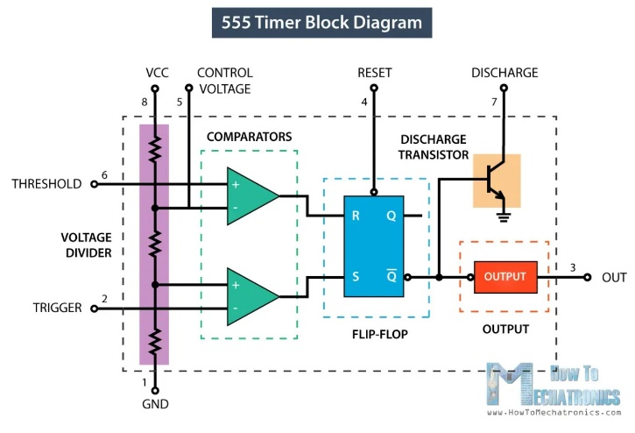

**Figure 1.1:** Internal Block Diagram of 555 Timer

* 1. **Astable operation of IC 555 Timer**

A free-running circuit that generates a square wave is known as an astable multivibrator (AMV). An AMV circuit with a variable duty cycle may be created by connecting the 555 (Figure 1.1). Figures 1.1 and 1.2 provide the schematic representation of the 555's internal phases and stages, respectively. Because the threshold and trigger pins (THRS and TRIG) are connected together and the circuit is made to self-retrigger, the circuit is an AMV.

* 1. **Pin Descriptions of the NE555 Timer Integrated Circuit**
* **Pin Number 1, GND, Ground Supply:** This pin is the [ground](https://en.wikipedia.org/wiki/Ground_(electricity)" \l "Electronics" \o "Ground (electricity)) reference voltage (zero volts).
* **Pin Number 2, TRIG, Trigger:** When VTRIGGER falls below ½ VCONTROL ( 1/3 VCC, except when control is driven by an external signal), output goes to the high state and a timing interval starts. As long as trigger continues to be kept at a low voltage, output will remain in the high state.
* **Pin Number 3, OUT, Output:** This pin is a [push-pull](https://en.wikipedia.org/wiki/Push-pull_output" \o "Push-pull output) (P.P.) output that is driven to either a low state (GND) or a high state.
* **Pin Number 4, RST, Reset:** A timing interval may be reset by driving this pin to GND, but the timing does not begin again until this pin rises above approximately 0.7 volts. This pin overrides trigger, which in turn overrides threshold.
* **Pin Number 5, CV, Control:** This pin provides access to the internal [voltage divider](https://en.wikipedia.org/wiki/Voltage_divider" \o "Voltage divider) (2⁄3 VCC by default).
* **Pin Number 6, THRS, Threshold:** When the voltage at this pin is greater than VCONTROL (2⁄3 VCC by default except when control is driven by an external signal), then the output high state timing interval ends, causing output to go to the low state.
* **Pin Number 7, DIS, Discharge:** This pin is an [open-collector](https://en.wikipedia.org/wiki/Open-collector" \o "Open-collector) (O.C.) output for bipolar timers, or an open-drain (O.D.) output for CMOS timers. This pin can be used to discharge a [capacitor](https://en.wikipedia.org/wiki/Capacitor" \o "Capacitor) between intervals, in phase with output.
* **Pin Number 8, Vcc, Positive Supply.**

diyagram, şematik içeren bir resim

Açıklama otomatik olarak oluşturuldu

**Figure 1.2:** LTSpice Simulation

**1.4 Circuit Design**

The resulting waveform is shown in figure 1.3. The time that output is high and low are nearly equal to each other. The period of the output square wave is the sum of these durations ( T = low + high ). In order to adjust duty cycle following equation is used:

* %DC = ( Rdv1 + Rdv2 ) / ( Rdv1 + 2*Rdv2 )

Therefore, design values of Rdv1=1 kΩ and Rdv2=32 kΩ provides high accuracy that gives %50,77 positive duty cycle. The capacitor C2 ( figure 1.2 ) can be adjusted for determining oscillation frequency of the square wave generator. With these values, oscillation frequency is determined as 1.477 kHz in simulation by using the formula in part 1.1.

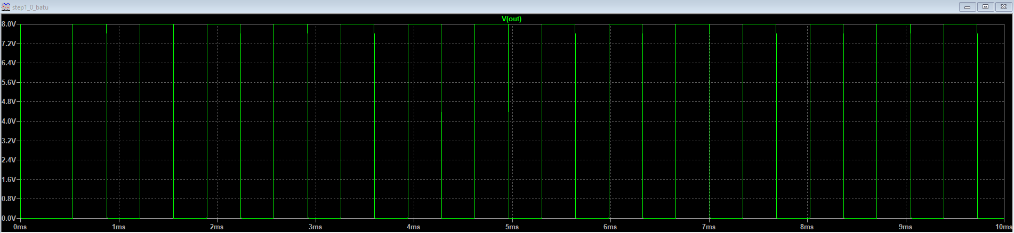

**Figure 1.3:** Square Wave Output

1. **Phase or time delay of basic R-C and L-R circuits** 
   1. **Buffer Operation**

XOR gates can be used to form inverters or buffers when a single input is tied to Vdd or Ground. 0 V low and 1 V high square waveform is obtained after buffer XOR gate. It is understood that resultant voltage value should be amplified when it is time to measure phase difference value. That’s why an amplifier circuit will be used in future steps.

diyagram içeren bir resim

Açıklama otomatik olarak oluşturuldu

**Figure 2.1:** Voltage Buffer

* 1. **Circuit Design**

The RC circuit with known-value resistor and unknown variable value capacitor must have higher cut-off frequency than oscillation frequency. With 500 Ω resistor (known_R11), frequency range of the RC circuit is changing from 3.18 kHz to 318 kHz in the range of 1 nF to 100 nF capacitance which is given in the project design tutorial.

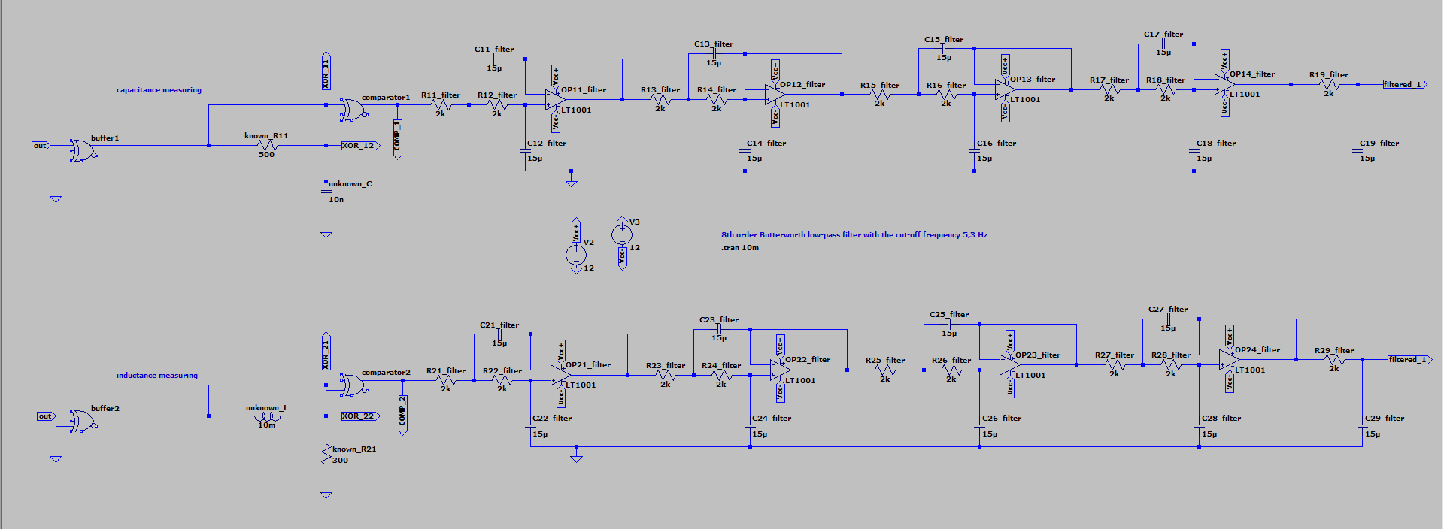

**Figure 2.2:** Design Diagram with LTSpice

1. **Phase detection and Comparison** 
   1. **Phase Comparison**

Besides the XOR gate being a buffer, it can be also used as phase comparator. At this project, the phase delay between original square wave and voltage value of the unknown capacitor is changing. But there is a problem while measuring the value. Since the comparisonresult is noisy, low-pass filter design is needed to add on output.

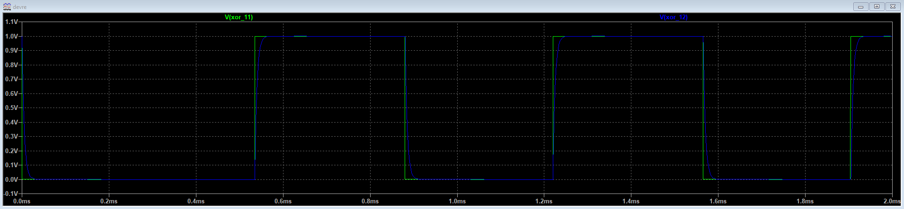

**Figure 3.1:** Phase Difference Display

metin, elektronik donanım, ekran, görüntüleme içeren bir resim

Açıklama otomatik olarak oluşturuldu

**Figure 3.2:** Square Wave Generated By Phase Delay

**3.2 Phase Difference Measurement**

Output value of the comparator is a square wave representation of the phase difference. Every impulse is charging low-pass filter capacitors time-by-time. Low-pass filter after phase comparator is used to reduce noise due to square wave oscillator. Thus, using a cut-off frequency with a very small value, will be able to obtain the linear output characteristics of L-C Meter. With 5,3 Hz cut-off frequency value, output voltage that appears only depending on phase-delay based square wave, starts to charge filter capacitors ( C19_filter and C29_filter ). It is also known that at 4τ ( time constant ) of the elapsed time, capacitor starts entering steady state with an error by %2 criterion. 4τ is enough to obtain aimed accuracy of the project, but it is more safe to measure the voltage at 5τ time which is steady state approximation of the voltage value. Time constant of the RC circuits can be obtained according to the formula below:

* τ = RC
* fcut-off = 1/(2πτ)

With reference to the formulas above, 5τ equals 0,943 seconds for the design. All measurements are made at 5τ seconds. There is an example of the measurement at C meter mode of the design in figure 3.3.

metin, iç mekan, ekran görüntüsü içeren bir resim

Açıklama otomatik olarak oluşturuldu

**Figure 3.3:** Filtered Voltage Value of the System at Steady State

By sampling capacitance ranges ,which are from 1 nF to 100 nF, with a step size 5 nF, these results are obtained:

masa içeren bir resim

Açıklama otomatik olarak oluşturuldu

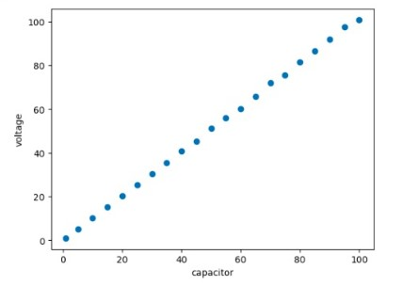

**Figure 3.4:** C-V Table **Figure 3.5:** Linearity of C-V Relationship

According to figure 3.4 and figure 3.5, it is obtained that there is a linearity between each values from 1 nF to 100 nF. That means that with lineer equation which has a form of:

* y – y0 = m * ( x – x0 )

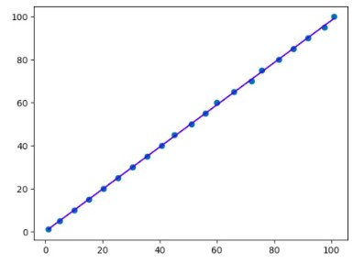The formula above is able to give a function of C(V) while y represents the capacitance (nF) and x represents the voltage (mV). The less slope m means that the lower error and higher accuracy will be obtained. In order to determine optimum lineer equation, an artificial intelligence model which is integrated in a python code is used. Code is generating a lineer equation (figure 3.6) by analyzing every sample in a way that all results with less than %2 percent error value which is defined at the beginning of the task.

**Figure 3.6:** Lineer Equation with AI Model

Similarly for inductance measuring:

masa içeren bir resim

Açıklama otomatik olarak oluşturuldu

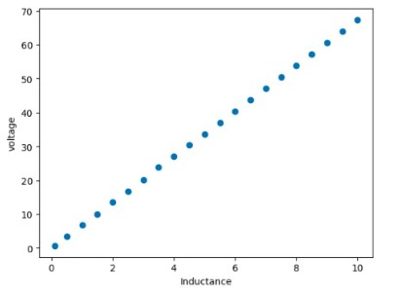

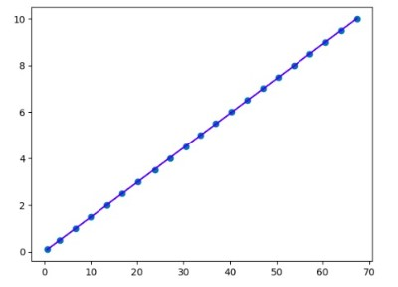

**Figure 3.7:** L-V Table **Figure 3.8 and 3.9:** Linearity of L-V Relationship

* 1. **Accuracy of Measurements**

Thanks to AI model, all of the function outputs of line equation, gives accurate results. Thus, no operation for noise reduction is needed anymore.

Obtained capacitance values and the lineer equations of each capacitance and inductance with the AI code is in figure 3.10.

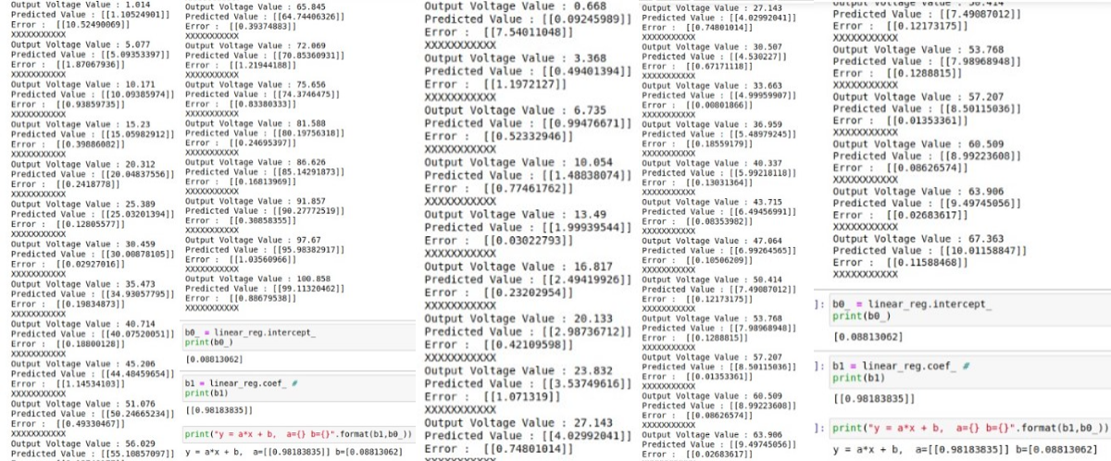

**Figure 3.10:** Code Outputs Which Shows the Accuracy and the Coefficients of the Lineer Equations

Also, using Butterworth low-pass filter with 8th order is enough to reach the linearity that the task is aiming. Frequency response of the Butterworth filter is more suitable compared to the simple passive low-pass filters.

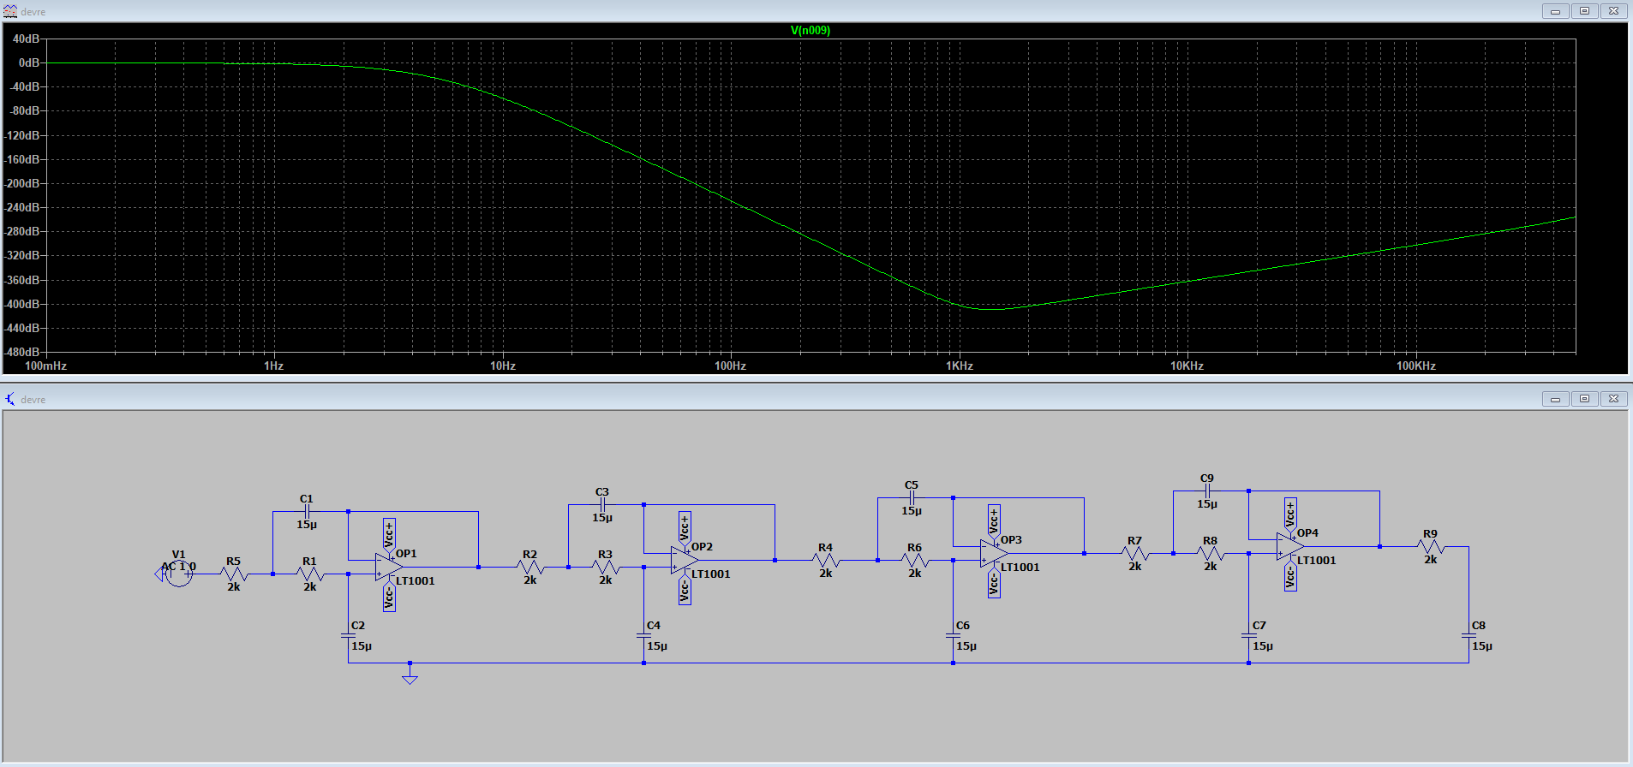

**Figure 3.11:** Frequency Response of 8th Order Butterworth Low-Pass Filter

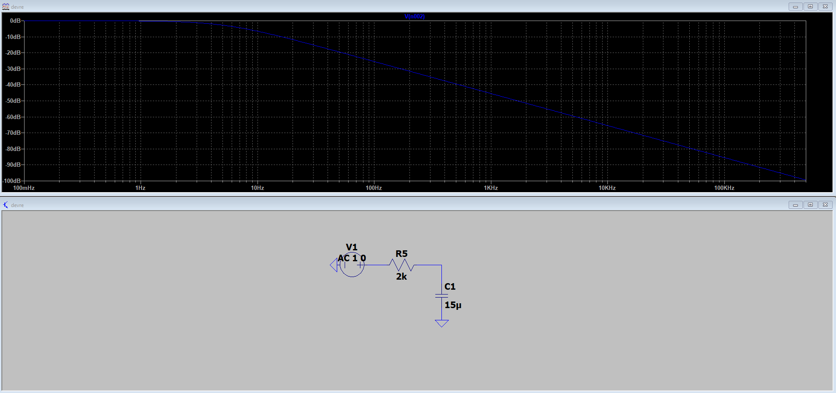

**Figure 3.12:** Frequency Response of Simple Passive Low-Pass Filter

Since the filter in figure 3.11 is more likely to ideal behaviour compared to figure 3.12, it is more benefical to use in low-pass filter operation.

**3.4 Circuit Design with Proteus**

In order to jump into next steps of the project, LTSpice was not convenient to use anymore due to absence of any analog to digital converter libraries. Proteus has an extensive library compared to LTSpice but it is observed during the simulations that Proteus requires a high CPU performance during simulations. Even the simulations are applied with a high-performanced PC, contuinously CPU load errors are obtained and that was very challenging for sample measurements that is made for creating linear behavior graphs.

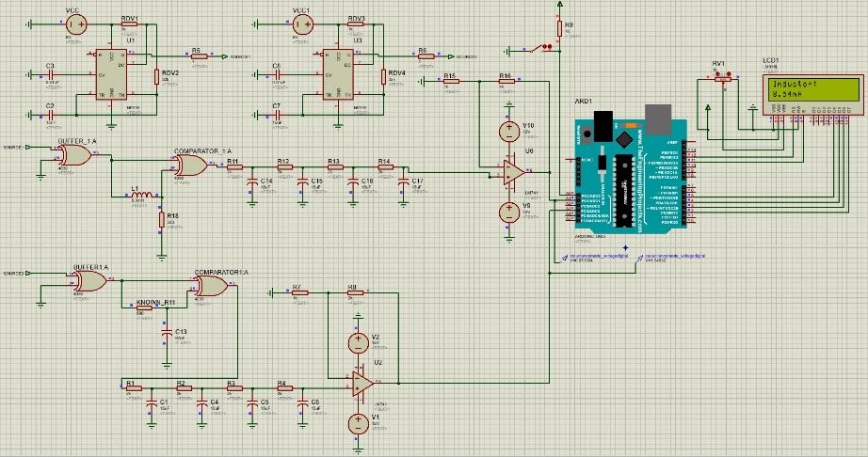Since active components of the circuit such as op-amps requires the high CPU performance that is mentioned before and cause of errors are mostly due to these parts, it was a requirement that more simple low-pass filter should have been used instead of Butterworth’s low-pass filter. Simple low-pass circuit configuration is used for the Proteus.

**Figure 3.13:** Circuit Design in Proteus

For the process of analog data which indicates the relative inductance or capacitance linear proportionally, Arduino UNO microcontroller is used. Inductance measuring mode part of the circuit is connected to A1 pin of microcontroller while capacitance measuring mode part is connected to pin A3. Also a switch operation to show both connected inductor and capacitor components simultaneously. When switch is open, no current flow occurs and pin A0 reads high voltage from the power supply. When switch is closed, A0 pin is connected ground and reads low voltage. High voltage (5 V) stands for inductance mode and low voltage (0 V) represents capacitance measuring mode.

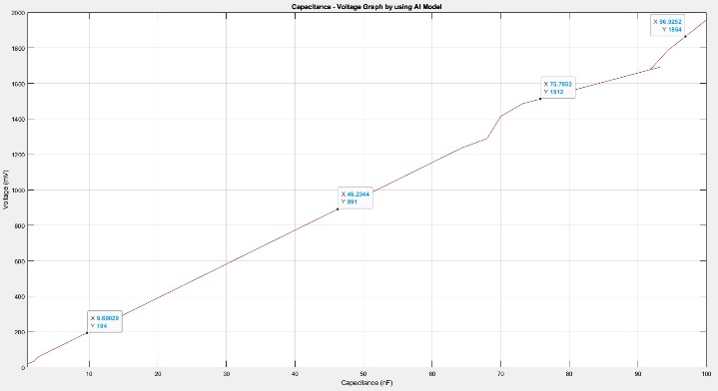Benefits of the Arduino UNO microcontroller, such as defining more than one linear graph with several if statements, increases the accuracy of the displaying process. But also there observed some disadvantages. Since the sample measurements are made and linear graph coefficients are created with AI model while microcontroller is not connected, there occurs an inevitable voltage drop on the microcontroller while it is connected. These caused more error in displaying since the graphs are not accurate enough. In order to fix this error, measurements should have been made while all components are connected, but Proteus started to give several CPU load errors again while microcontroller is connected. Here are some measurements and comparison of them with the ideal linearity graphs.

**Figure 3.14:** Capacitance-Voltage Graph by using AI Model

çizgi, metin, öykü gelişim çizgisi; kumpas; grafiğini çıkarma, diyagram içeren bir resim

Açıklama otomatik olarak oluşturuldu

**Figure 3.15:** Inductance-Voltage Graph by using AI Model

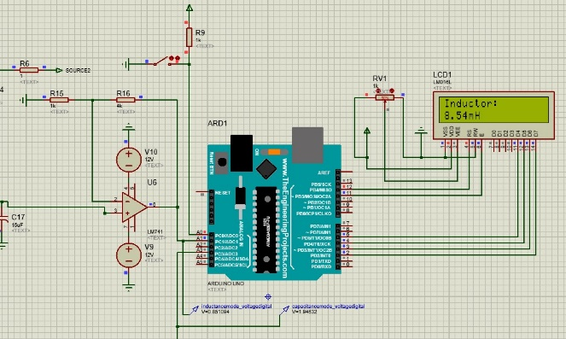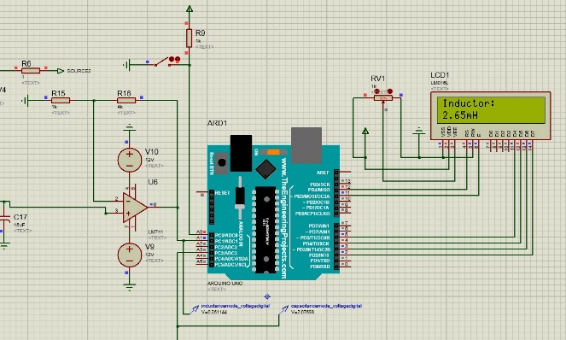**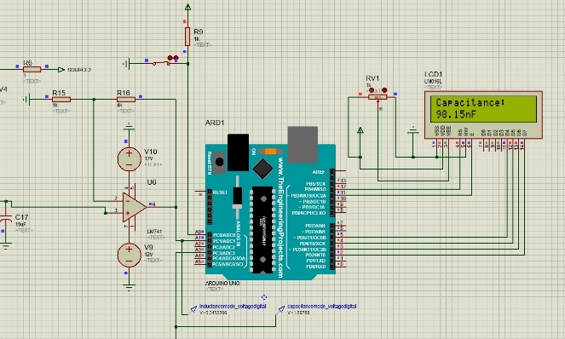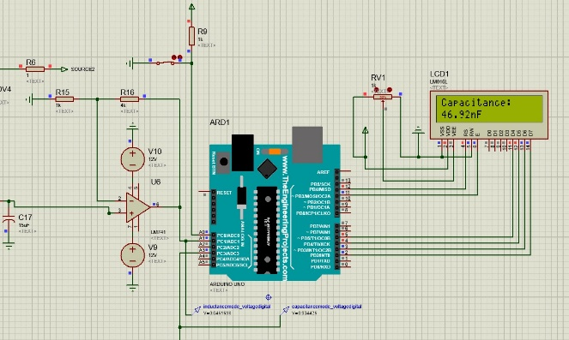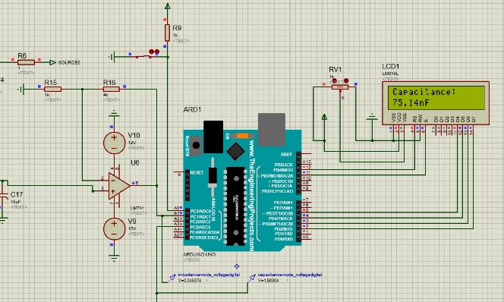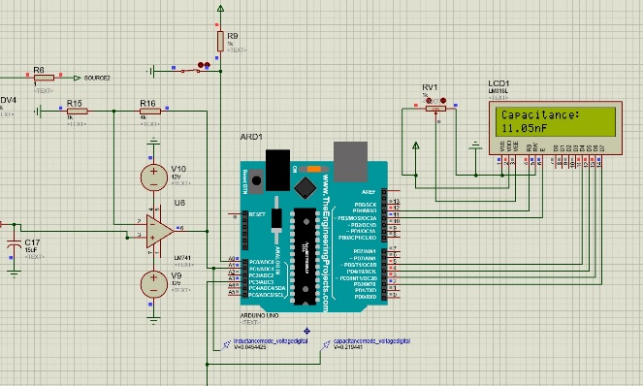Figure 3.15:** Screen outputs while 11 nF, 46 nF, 76 nF and 97 nF are connected

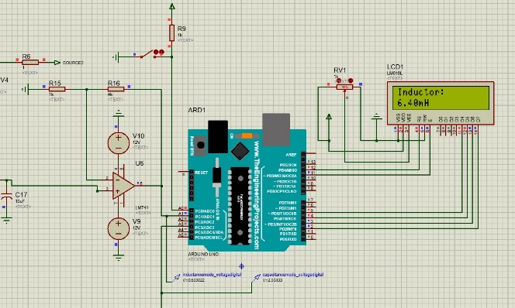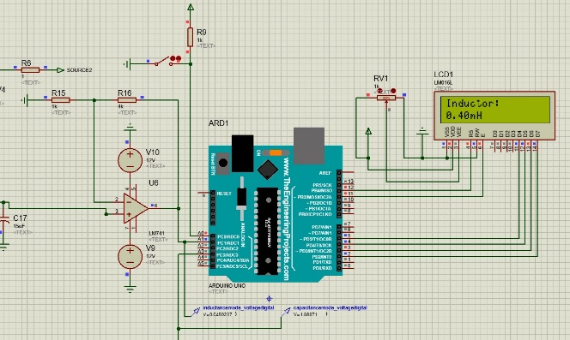**Figure 3.16:** Screen outputs while 0.4 mH, 2.9 mH, 6.6 mH and 8.9 mH are connected

1. **Analog to Digital Converters**

Arduino has a ATMEGA328 microcontroller which is used to provide convertion from analog to digital signal . The analog signal can reach its module by being connected to any pin between pins A0 and A5 on the Arduino module.The voltage range of this module is from 0 V to 5 V. Zero volt indicates that the output is 0 bit.On the other hand, 5 V (⁓5000 mV) indicates 1023 output bit. After the values of analog voltage input more than 5 V, module reads still as 1023 bit.From the figure below, it can be observed that each bit incerement represents 4.887 mV incerement.

metin, ekran görüntüsü, çizgi, diyagram içeren bir resim

Açıklama otomatik olarak oluşturuldu

**Figure 4.1:** How to Convert Analog Signal to Digital Signal

If a microcontroller with a higher bit number is used, it is possible obtain higher accuracy consequently.Nevertheless, reaching below %5 error percentage by using the Arduino integrated development enviroment in order to implement the AI based equation. In chapter 5, processing this bit information into decimal values will be handled and explained.

1. **Converting Binary Numbers into Decimal**

**metin, yazı tipi, çizgi, beyaz içeren bir resim

Açıklama otomatik olarak oluşturuldu**Arduino converts the value by reading from analog pins from bit to decimal number corresponding to the numbers between 0 and 1024. “ReadPin” and “ReadPin2” variables indicates the translated numbers in our code. In order for us to convert the reading values to normal voltage, we leave analog voltage measured alone in the formula on right-hand side.

By multiplying the resulting equation by 1000, Voltage value is converted to mV, since all measurements and equations are made according to mV values. Analog signal at the steady-state of the circuit is transmitted over the Arduino module.



**Figure 5.1:** Voltage Calculation in Arduino for Capacitance



**Figure 5.2:** Voltage Calculation in Arduino for Inductance

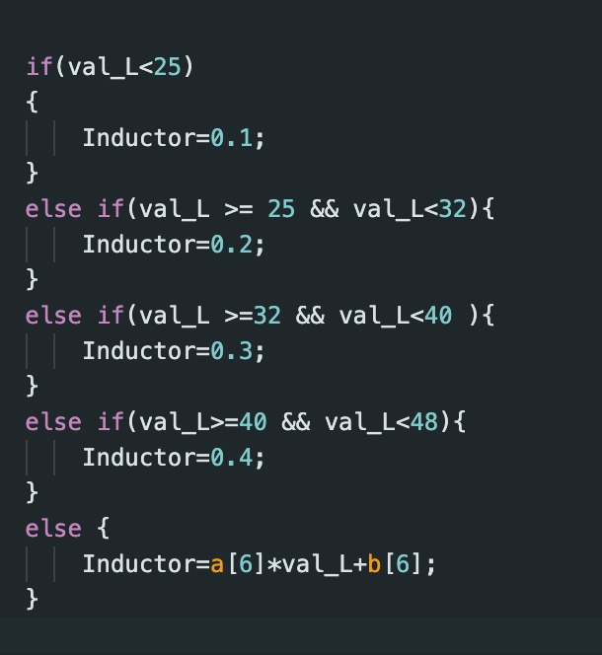We calculated the capacitor and inductor values we wanted by putting the voltages we found into the equations formed between the different voltages we created from the graphs. In order to reduce the error in the results, different equations are formed at different voltage ranges.

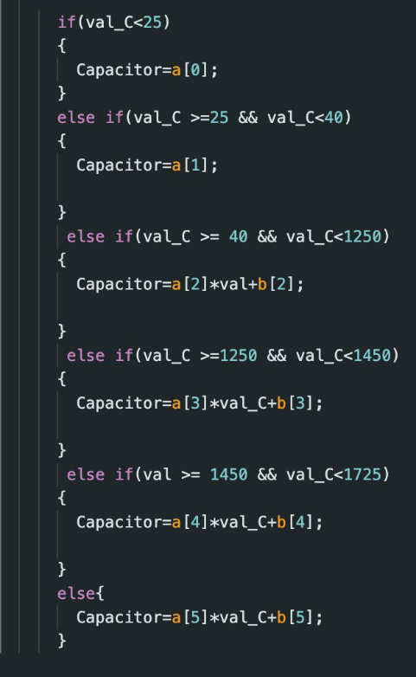**Figure 5.3 and 5.4:** If-else Conditions in order to Use Different Lineer Equation Coefficients

In order to print the calculated inductance and capacitance values to the LCD display component, the following code blocks are formed by using the “Liquid Crystal” library in Arduino. Figure 5.3 and 5.4 indicates that different lineer equations used for error reducing by incrementing number of them. Relatively initial values are challenging to measure accurately. That is why single valued conditions that are in the corresponding intervals are used. In this way, average error percentage is greatly decreased.

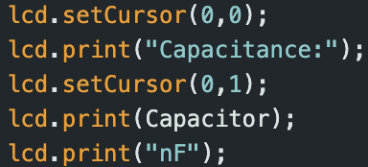 metin, yazı tipi, ekran görüntüsü, tipografi içeren bir resim

Açıklama otomatik olarak oluşturuldu

**Figure 5.5 and 5.6:** Arduino Code for Visualization on the LCD Display

Since the LCD is formed in a 16x2 matrix system, we use the setCursor(.) function to print a text on a lower line on the LCD. In addition, print(.) function provides the demanded visualization.

1. **Feed-back Extension for Noisy Measurement Conditions**
   1. **Feedback Design**

metin, diyagram, çizgi, sayı, numara içeren bir resim

Açıklama otomatik olarak oluşturuldu

**Figure 6.1:** Feedback Design

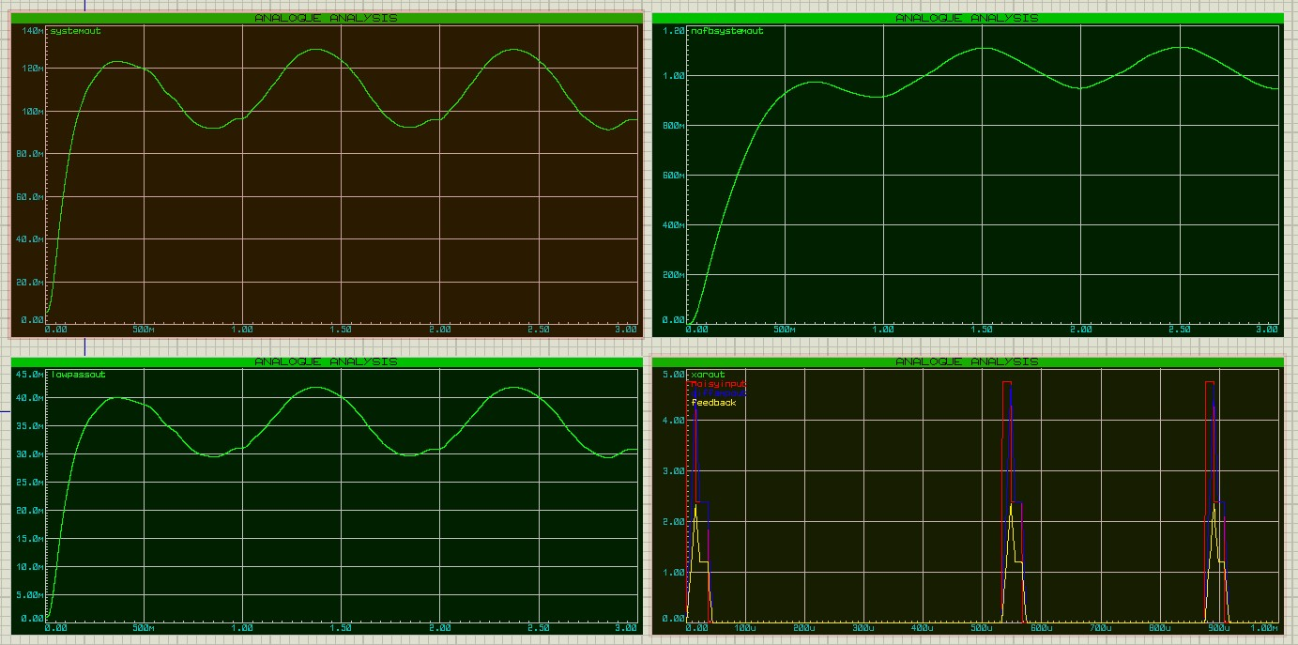

**Figure 6.2:** Feedback Design Outputs

General feedback design is considered for the design in figure 6.1. There is a difference and inverting amplifier in order to create feedback algorithm. But lately, it is understood that it is not convenient to use these kind of mechanical feedback algorithms for noise cancelling after we consulted our mentor for this project. Also it is observed that there is no major difference between no-feedback design and the circuit with the feedback branch by analyzing upper two graphs in the figure 6.2.

The purpose of this design was substracting pure noise voltage from the noisy voltage at difference amplifier. To complete substraction process noise voltage is amplified with an amplification gain -1.

* 1. **Case: Sinusoidal Noise**

In the case of random noise generator is added to output of the buffer, Proteus simulation gives CPU load error. The reason why sinusoidal voltage source is used for noise representation.

During the node control measurements, it is observed that low-pass filter causes non-negligible phase delay at the output by comparing the input and delayed filter output at figure 6.3. The best way to show this phase delay is using sinusoidal additive voltage source represented as background noise.

metin, çizgi, diyagram, öykü gelişim çizgisi; kumpas; grafiğini çıkarma içeren bir resim

Açıklama otomatik olarak oluşturuldu

**Figure 6.3:** Phase Delay in Low-Pass Filtering

The problem is, a differential amplifier would not be give accurate result while the pins of the amplifier are not at the same phase. These causes wrong differentiating results at the output.

As a solution, a high-pass filter can be considered as a re-phaser circuit. This high-pass filter can be placed at the feedback branch of the circuit. But placing high-pass filter after a low-pass filter does not make sense for cancelling unwanted noises.

As a result of the feedback attempt, these configurations are failed to obtain noise cancellation. The low-pass filter on the basis circuit has already strong noise cancelling factor with a very low cut-off frequency which is about 5 Hz.

**Conclusion**

In conclusion, the L-C Meter project aimed to design and construct an electronic circuit capable of accurately measuring the capacitance or inductance of a component with a maximum error rate of 2%. The proposed circuit offered a simple and reliable solution to overcome the limitations and errors associated with conventional measurement methods.

The project report covered various aspects of the circuit design and operation. The utilization of the 555 IC timer integrated circuit in astable mode provided a stable square wave output, which served as the basis for measuring the phase or time delay of basic R-C and L-R circuits. The phase comparison technique using XOR gates allowed for the detection and comparison of the phase delay between the original square wave and the voltage across the unknown component.

The accuracy of the measurements was enhanced by employing low-pass filters and utilizing an artificial intelligence (AI) model to determine the linear relationship between capacitance or inductance and voltage. The linearity of the measured values was demonstrated through the generated line equations and verified with experimental results.

Furthermore, the implementation of analog-to-digital converters (ADCs) using an Arduino UNO microcontroller facilitated the conversion of analog signals into digital values, enabling precise and convenient data acquisition. However, certain challenges were encountered during the transition from LTSpice to Proteus for circuit simulation, requiring some modifications in the circuit design and measurements.

Additionally, a feedback extension in the case of noisy conditions are considered. Although the designed feedback configuration is failed to decrease error percentage of the output, it is understood that noise cancellation in such electronic circuits should not be designed like mechanical systems. Also, phase delays that occur because of filters and other components should be considered for cancellation process.

Overall, the L-C Meter project successfully achieved its objective of designing and implementing an electronic circuit capable of accurately measuring capacitance or inductance with a maximum error rate of 2% except for few capacitance and inductance ranges. The circuit design, simulation results, and experimental validations presented in this report demonstrate the reliability and effectiveness of the proposed L-C Meter circuit.

**7. References**

* "Electronic Devices", Joseph J. Carr, Glencoe Tech Series (GTC), 1991.
* "NE555 Datasheet" (PDF). Texas Instruments. September 2014. Archived (PDF) from the original on June 28, 2017.
* "Linear LSI Data and Applications Manual", Signetics, 1985.
* IC Timer Cookbook (1 ed.), Jung Walt, Sams Publishing, 1977.
* Analog to Digital Conversion, pijaeducation.com.