Quiz 1 - Detailed Solutions

Question 1: Vector Orthogonality and Similarity
Given: u = [2, -3]ᵀ and v = [6, 4]ᵀ

Part A: Are these vectors orthogonal?
Definition: Two vectors are orthogonal (perpendicular) if and only if their dot product equals zero.
- Calculate the dot product u · v
u · v = u₁v₁ + u₂v₂
u · v = (2)(6) + (-3)(4)
u · v = 12 + (-12)
u · v = 0
- Interpret the result
Since u · v = 0, the vectors are orthogonal.
Answer: YES, the vectors u and v are orthogonal because their dot product equals zero.

Part B: Are these vectors similar?
Definition: In this context, "similar" vectors typically means parallel vectors (one is a scalar multiple of the other): v = k·u for some scalar k.
- Check if v = k·u for some constant k
If v = k·u, then each component must satisfy:
v₁ = k·u₁ → 6 = k·2 → k = 3
v₂ = k·u₂ → 4 = k·(-3) → k = -4/3
- Compare the k values
We get k = 3 from the first component and k = -4/3 from the second. These are not equal.
Answer: NO, the vectors are not similar (not parallel) because there is no single scalar k that satisfies v = k·u. In fact, since they are orthogonal, they point in perpendicular directions.

Part C: Write a line expression to separate these points
Interpreting the vectors as points: P₁ = (2, -3) and P₂ = (6, 4)
Three valid approaches exist, each optimizing a different objective:
Method 1: Simple Line Through Origin
- Find direction vector: d = P₂ - P₁ = (4, 7)
- Use as normal vector with c = 0: 4x + 7y = 0
- Verify: P₁ → 4(2) + 7(-3) = -13 (negative), P₂ → 4(6) + 7(4) = +52 (positive)
Answer: 4x + 7y = 0 (simplest form, passes through origin)
Method 2: Perpendicular Bisector (Maximum Margin)
- Find midpoint: M = ((2+6)/2, (-3+4)/2) = (4, 0.5)
- Normal vector: n = (4, 7), Line passes through M
- Compute c: c = 4(4) + 7(0.5) = 16 + 3.5 = 19.5
- Verify equal distance: P₁ → -13 - 19.5 = -32.5, P₂ → 52 - 19.5 = +32.5
Answer: 4x + 7y = 19.5 (equidistant from both points, like SVM)
Method 3: Pseudo-Inverse (Least Squares Optimal)
- Set up system Xw = y with targets y = [-1, +1]ᵀ
X = [[2, -3], [6, 4]] (each row is a point)
- Solve using pseudo-inverse: w = X⁺y = (XᵀX)⁻¹Xᵀy
w = [-0.0385, 0.3077]ᵀ or equivalently w = [-1, 8]ᵀ (scaled)
- Verify: w·P₁ = -1 (exact!), w·P₂ = +1 (exact!)
Answer: -x + 8y = 0 (least squares fit to targets [-1, +1])
Summary - All Valid Answers:
• 4x + 7y = 0 — Simple (through origin)
• 4x + 7y = 19.5 — Perpendicular bisector (maximum margin)
• -x + 8y = 0 — Pseudo-inverse (least squares optimal)
Note: Any line 4x + 7y = c with -13 < c < 52 separates the points. Different methods optimize different objectives.
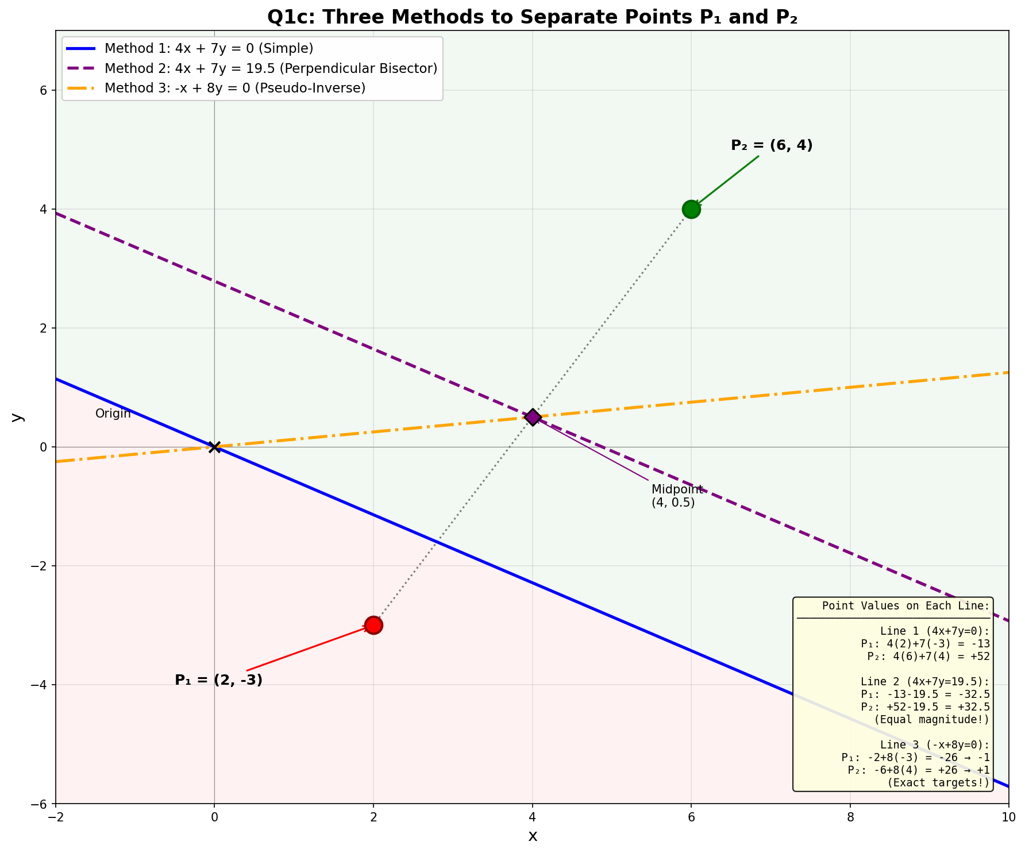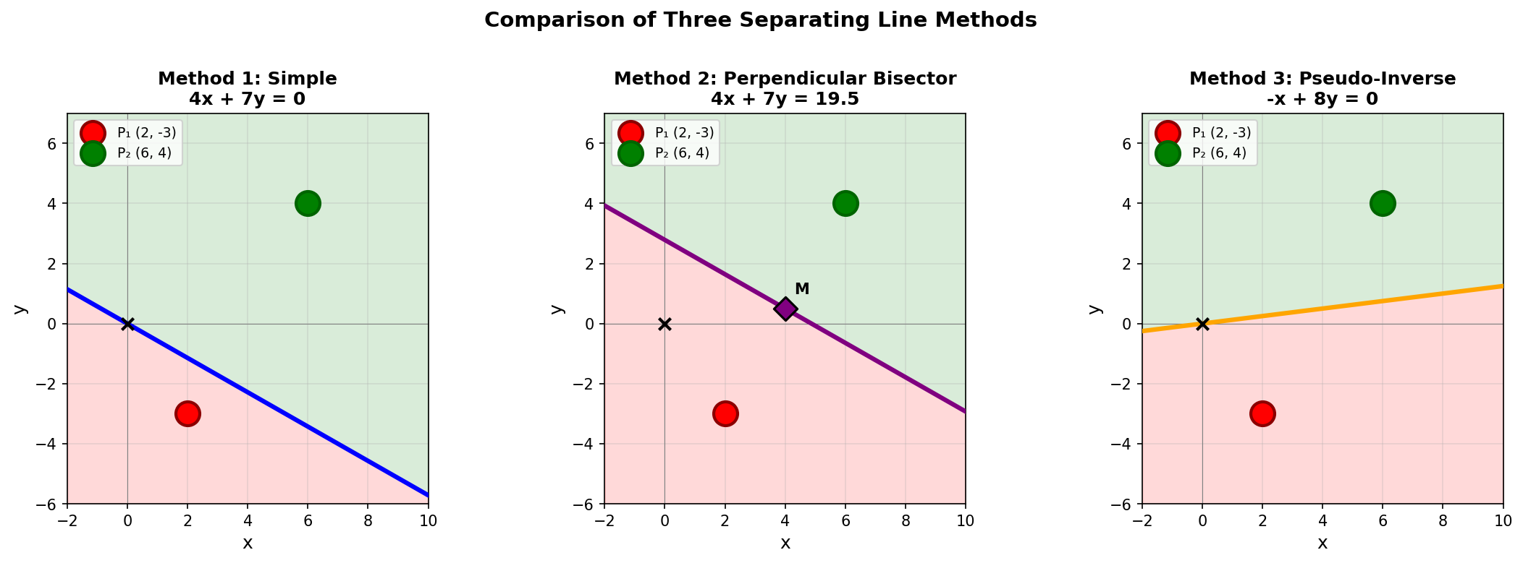

Question 2: Decision Boundary Parameter
Given: Linear model y = 2x₀ - x₁ + b. Find b such that the decision boundary passes through points (1, 4) and (3, 2).
Key Concept: The decision boundary is where y = 0, giving us: 2x₀ - x₁ + b = 0
- Apply the decision boundary equation to point (1, 4) where x₀ = 1, x₁ = 4
2(1) - 4 + b = 0
2 - 4 + b = 0
b = 2
- Apply the decision boundary equation to point (3, 2) where x₀ = 3, x₁ = 2
2(3) - 2 + b = 0
6 - 2 + b = 0
b = -4
- Analyze the results
We obtain b = 2 from the first point and b = -4 from the second point.
Important Observation: These constraints are inconsistent. The two points do not lie on any line of the form 2x₀ - x₁ + b = 0 (a line with fixed normal vector [2, -1]).
Answer: No single value of b exists that makes the decision boundary pass through both points. If the question expects a unique answer, there may be a typo. If forced to choose: b = 2 for point (1,4) or b = -4 for point (3,2).

Question 3: Supervised Learning True/False
Statement: "In supervised machine learning, we need training data with known outputs (ground truth) to estimate model parameters."
- Define supervised learning
Supervised learning is a machine learning paradigm where the model learns from labeled examples, i.e., input-output pairs (xᵢ, yᵢ).
- Explain why ground truth is essential
- The model makes predictions ŷ = f(x; θ) using parameters θ
- We compute the loss L(y, ŷ) comparing predictions to ground truth
- Parameters are updated to minimize this loss via gradient descent
- Without known outputs, we cannot compute loss or update parameters
Answer: TRUE. Supervised learning requires labeled training data because the learning algorithm needs ground truth outputs to compute prediction errors and optimize model parameters through loss minimization.

Question 4: Line Equation in Vector Form
Given: The equation 3x + 4y = 12 represents a line in 2D.

Part A: Write in vector form nᵀx = d
- Identify the components
The equation ax + by = c can be written as nᵀx = d where:
n = [a, b]ᵀ (normal vector, coefficients of x and y)
x = [x, y]ᵀ (position vector)
d = c (constant on right side)
- Apply to our equation 3x + 4y = 12
n = [3, 4]ᵀ and d = 12
Answer: [3, 4]ᵀ · [x, y]ᵀ = 12, where the normal vector n = [3, 4]ᵀ

Part B: What is the unit normal vector n̂?
Definition: The unit normal vector has magnitude 1 and points in the same direction: n̂ = n / ||n||
- Calculate the magnitude ||n||
||n|| = √(n₁² + n₂²)
||n|| = √(3² + 4²)
||n|| = √(9 + 16)
||n|| = √25 = 5
- Compute the unit normal
n̂ = n / ||n|| = [3, 4]ᵀ / 5
n̂ = [3/5, 4/5]ᵀ = [0.6, 0.8]ᵀ
Answer: n̂ = [3/5, 4/5]ᵀ or equivalently [0.6, 0.8]ᵀ. This is the famous 3-4-5 right triangle!

Question 5: Deep Neural Network Geometry
Question: Which best describes what a deep neural network does geometrically?
Options: (1) Single linear transformation, (2) Multiple nonlinear transformations, (3) Memorizes training data, (4) Creates lookup table
- Analyze each option
- Option 1: False. A single linear transformation can only create linear decision boundaries. Multiple linear transformations without nonlinearity still produce a single linear transformation (matrix multiplication is associative).
- Option 2: Correct. Each layer applies a linear transformation followed by a nonlinear activation (ReLU, sigmoid, etc.). This allows the network to learn complex, curved decision boundaries.
- Option 3: False. While overfitting can lead to memorization, the goal is generalization. A properly trained network learns patterns, not memorizes examples.
- Option 4: False. A lookup table would require storing every possible input. Neural networks generalize to unseen inputs through learned representations.
- Geometric interpretation
Each layer transforms the feature space. The nonlinear activations allow the network to "bend" and "fold" the space, making classes that were previously intertwined become linearly separable in the transformed space.
Answer: (2) Applies multiple nonlinear transformations to map input points to an output space where classification is easier. This is the fundamental geometric insight behind deep learning.

Question 6: Eigenvalue and Eigenvector Computation
Given: λ = 3 is an eigenvalue of matrix B with eigenvector e = [1, 2]ᵀ. Compute Be.
- Recall the eigenvalue-eigenvector definition
Bv = λv where λ is an eigenvalue and v is the corresponding eigenvector.
This equation states that multiplying an eigenvector by its matrix produces a scalar multiple of that eigenvector.
- Apply the definition to our problem
Be = λe
Be = 3 · [1, 2]ᵀ
Be = [3, 6]ᵀ
- Verify understanding
Notice that Be points in the same direction as e (both along the line y = 2x), just scaled by factor 3. This is the geometric meaning of eigenvectors: they are directions that remain unchanged under the transformation, only stretched or compressed.
Answer: Be = [3, 6]ᵀ

Summary of Answers
Question | Answer
Q1a | YES - vectors are orthogonal (dot product = 0)
Q1b | NO - vectors are not similar/parallel (no common scalar)
Q1c | 4x+7y=0 (simple) | 4x+7y=19.5 (bisector) | -x+8y=0 (pseudo-inv)
Q2 | No unique b exists (b=2 for (1,4), b=-4 for (3,2))
Q3 | TRUE - supervised learning requires labeled data
Q4a | n = [3, 4]ᵀ, d = 12
Q4b | n̂ = [3/5, 4/5]ᵀ = [0.6, 0.8]ᵀ
Q5 | Option (2) - multiple nonlinear transformations
Q6 | Be = [3, 6]ᵀ

