**Pizza Sales SQL Queries Presentation with Result**

**KPI**

**1.--Total Revenue**

SELECT CAST(SUM(total_price) AS DECIMAL (10,2)) AS Total_Revenue

FROM pizza_sales

**Output:**

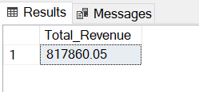

**2. - - Average Order Value**

SELECT SUM(total_price) / COUNT(DISTINCT order_id) AS Average_Order_Value

FROM pizza_sales

**Output:**

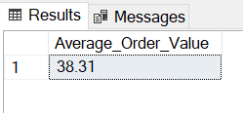

**3.-- Total Pizza Sold**

SELECT SUM(quantity) AS Total_Pizza_Sold

FROM pizza_sales

**Output:**

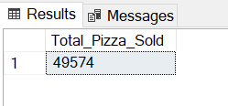

**4. --Total Orders**

SELECT count(distinct order_id) AS Total_Orders

FROM pizza_sales

**Output:**

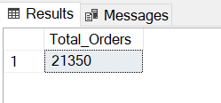

**5.--Average Pizza Per Orders**

--Note: This result shows exact number but not in fraction

--That's why we have to cast this item

--10,2 decimal meaning after comma it will shows 10 digit

--So we need to cast again to 2 decimal point

SELECT CAST( --this is for 2 decimal

CAST( --this is for total output will be decimal

SUM(quantity) AS DECIMAL (10,2)) /

CAST( --this is for total output will be decimal

COUNT (DISTINCT order_id) AS DECIMAL (10,2))

AS DECIMAL(10,2)) AS Average_Pizza_Per_Orders --this is for 2 decimal

FROM pizza_sales

**Output:**

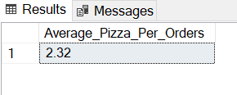

**B. Hourly Trend Total Pizza Sold**

--Datepart will extract hour data from order_time

SELECT DATEPART(HOUR, order_time) AS Order_Hour, SUM(quantity) AS TotalPizzaSold

FROM pizza_sales

GROUP BY DATEPART(HOUR, order_time)

ORDER BY DATEPART(HOUR, order_time)

**Output:**

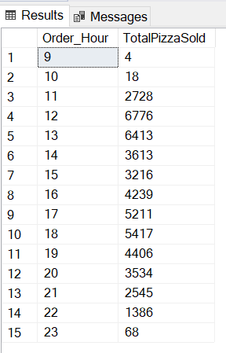

**C. Weekly Trend Total Pizza Sold**

--Datepart will extract IS_Week data from order_time

SELECT DATEPART(ISO_WEEK, order_date) AS Week_Number, --it will shows total weeks of a year

YEAR(order_date) as Order_Year, --years of 2015 showed

count(distinct order_id) AS Total_Orders

FROM pizza_sales

GROUP BY DATEPART(ISO_WEEK, order_date), YEAR(order_date) --aggregated function are used as a group by statement (requirement)

ORDER BY DATEPART(ISO_WEEK, order_date), YEAR(order_date) --aggregated function are used as a order by statement (requirement)

**Output:**

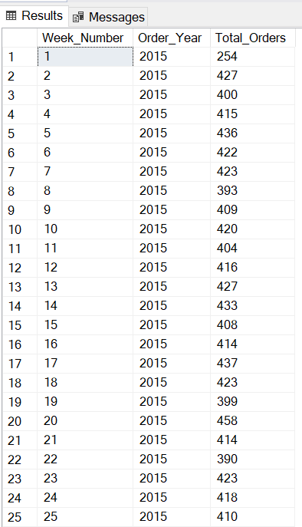 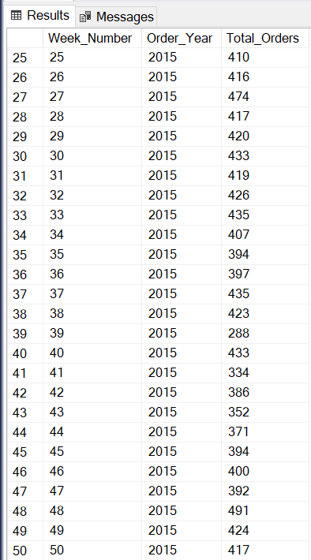

**D.1. Percentage of Total Order by Pizza Category**

SELECT pizza_category, SUM(total_price) * 100 / SUM(total_price)

FROM pizza_sales

GROUP BY pizza_category

**Output:**

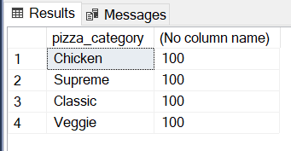

--Note: The above result shows only 100 with pizza category

--So we should be subquery to find out real values

--just divided by subquery sum_of_total_Price

SELECT pizza_category AS P_Categrory, ROUND(sum(total_price),2) as Total_Sales , ROUND( SUM(total_price) * 100 /

-- A subquery used here for correct result

(SELECT SUM(total_price) from pizza_sales WHERE MONTH(order_date) = 1 ),2) AS Percentage_OfTotalSales

FROM pizza_sales

--when we used filter in main query we should use this filter also subqueyr

WHERE MONTH(order_date) = 1

--WHERE MONTH(order_date) = 1 indicateds that will shows the month of january = 4 shows the month of April

GROUP BY pizza_category

ORDER BY Percentage_OfTotalSales DESC, Total_Sales DESC

**Output:**

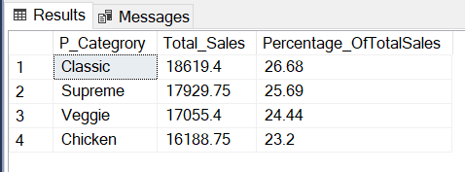

**E. Percentage of Sales by Pizza Size**

SELECT pizza_size, CAST(SUM(total_price) AS DECIMAL (10,2)) AS Total_Sales, CAST(

SUM(total_price) * 100 /

-- A subquery used here for correct result

-- Both subquery and main query should use filter (SELECT SUM(total_price) FROM pizza_sales WHERE DATEPART(QUARTER, order_date) = 1) AS decimal (10,2) ) AS Percent_SalesBYPizza_Size --rounded query end this line

FROM pizza_sales

--Where quarter is 1

WHERE DATEPART(QUARTER, order_date) = 1

GROUP BY pizza_size

ORDER BY pizza_size, Total_Sales DESC

**Output:**

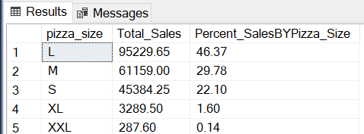

**F.1. Top 5 Best Seller Pizza By Revenue**

SELECT TOP 5 pizza_name, CAST(sum(total_price) AS DECIMAL (10,2)) AS Total_Revenue

FROM pizza_sales

GROUP BY pizza_name

ORDER BY Total_Revenue DESC

**Output:**

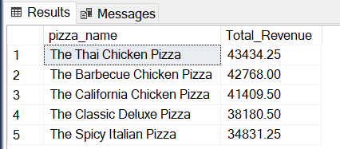

**F.2. Bottom 5 Best Seller Pizza by Revenue**

SELECT TOP 5 pizza_name, CAST(sum(total_price) AS DECIMAL (10,2)) AS Total_Revenue

FROM pizza_sales

GROUP BY pizza_name

ORDER BY Total_Revenue ASC --to figur out bottom 5 pizza

**Output:**

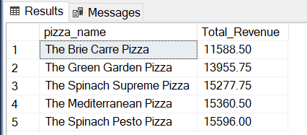

**F.3. Top 5 Best Seller Pizza By Total Quantity**

SELECT TOP 5 pizza_name, CAST(sum(quantity) AS DECIMAL (10,2)) AS Total_Quantity

FROM pizza_sales

GROUP BY pizza_name

ORDER BY Total_Quantity DESC

**Output:**

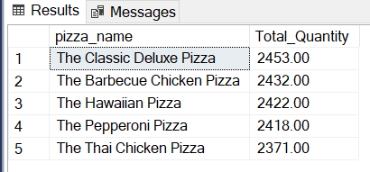

**F.5. Bottom 5 Best Seller Pizza By Total Quantity**

SELECT TOP 5 pizza_name, CAST(sum(quantity) AS DECIMAL (10,2)) AS Total_Quantity

FROM pizza_sales

GROUP BY pizza_name

ORDER BY Total_Quantity ASC --to figur out bottom 5 pizza

**Output:**

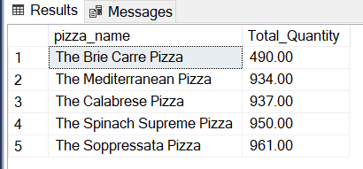

**F.6. Top 5 Best Seller Pizza By Total Quantity**

SELECT TOP 5 pizza_name, CAST(count(distinct order_id) AS DECIMAL (10,2)) AS Total_Orders

FROM pizza_sales

GROUP BY pizza_name

ORDER BY Total_Orders DESC

**Output:**

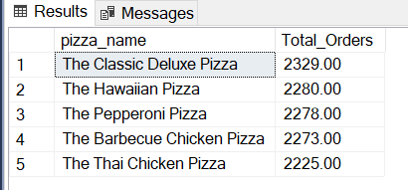

**F.7. Bottom 5 Best Seller Pizza By Total Quantity**

SELECT TOP 5 pizza_name, CAST(count(distinct order_id) AS DECIMAL (10,2)) AS Total_Orders

FROM pizza_sales

GROUP BY pizza_name

ORDER BY Total_Orders ASC --to figur out bottom 5 pizza

**Output:**

