SENIOR PROJECT

TERONE

Submitted by:
Anıl Düzgün Albayrak
Mehmet Harun Şahinol
Elif Akçay
Senan Batu Çobanoğlu

Project Supervisor: Prof. Dr. Cafer Calışkan

Faculty of Engineering
Antalya Bilim University
Spring 2018
TABLE OF CONTENTS

ABSTRACT ……………………………………………………………………... | 2
1 INTRODUCTION …………………………………………………………… | 3
2 OPERATING DYNAMICS………………………………………………...…. | 4
2.1 System Components …………………………………………………...... | 4
2.1.1 Mainboard (Raspberry Pi) ………………………………………... | 4
2.1.2 Thermal Camera (MLX90640-D55)….…………………………... | 5
2.1.3 USB Modem…………… …………………………………….….. | 6
2.1.4 Operating System………………..………………………………………. | 6
2.1.5 Software Languages ………………………………………………..  3 REQUIREMENTS and USE CASE……………….………………………. | 6
- Personas……………………………………………………………….… | 7
3.2 Features …………..…………… …………………………………….….. | 7
3.3 Use-case scenarios……………… …………………………………….….. | 8
3.4 Functional Requirements………… ………………………………….….. | 8
3.5 Non-functinol Requirements……… …………………………………….….. | 8
4 CONCLUSIONS ……………………………………………………...……… | 8
REFERENCES ………………………………………………………………… | 9

ABSTRACT

In this project, we aspire to develop a solar panel hotspot detection system. The system gets visual information from the thermal camera, processes it, and transfers it to a server for detection of hotspots using the YOLO (You Only Look Once) real-time object detection model and OpenCV.

The system comprises two critical components. The first part is the mainboard which is equipped with an internet connection and has the ability to capture thermal images. It receives data from the thermal camera, processes it into an image, and then sends it to the detection model. The second part is a server-based real-time detection system. Although this part seems to be easily done with the help of libraries at first, setting up the backend infrastructure of the system will be quite challenging. Additionally, additional features may require us to devote more time and in-depth study to the object recognition system.

1 INTRODUCTION

Renewable energy has been increasing every year exponentially. The capacity of Photovoltaic (PV) solar power plants has seen man annual increase of around %28_{[1]}. The increase in capacity is mainly due to increase in efficiency of photovoltaic panels and size of these solar power plants. The exponential growth of photovoltaic (PV) energy in the last decade underscores the increasing importance of developing advanced and robust condition monitoring systems for the burgeoning solar power plants.

A typical PV power station comprises hundreds or even thousands of interconnected PV modules arranged in a series circuit. Solar panels are made from very durable material and are designed to withstand diverse weather conditions. In general, they have a life span of up to 25 years _{[2]}. Unfortunately, PV modules are subject to various defects with the passage of time, which leads to adverse problems such as low-power efficiency. Usually, the electrical characteristics of all PV cells in the string are similar and operate at the maximum power point (MPP) current to achieve each cell’s optimal output. However, when there is a discrepancy among the cell electrical characteristics, the single string current is not able to operate at every cell’s MPP, which causes minimal performance. When there is one low current PV cell (e.g., due to weed shadow) in the string of several high short-circuit current PV cells, the forward bias across all of these cells reverses biases the shaded cell, which drastically increases the cell temperature and leads to hot spotting _{[3]}. Therefore, it is crucial to identify these faults at the earliest to avoid any further deterioration. This project aims to solve this problem.

2 OPERATING DYNAMICS

The thermal sensor MLX90640 sends the collected information as a matrix. By organizing this information on the Raspberry Pi 3 B+ device, the data obtained will be sent to another computer via USB modem and at the same time to the server. The Hotspot Detection Model (HDM) running on the server will detect hotspot points in the incoming photo. Finally, this final data will be displayed on the computer.

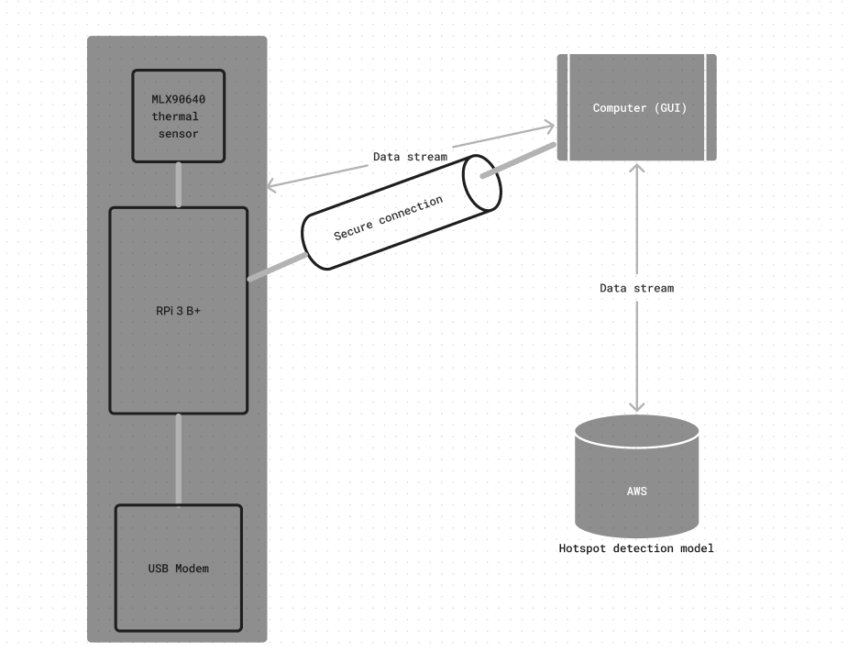
Figure 1 – Workflow of Terone

2.1 System Components

2.1.1 Mainboard (Raspberry Pi)

The Raspberry Pi is a low cost, credit-card sized computer that plugs into a computer monitor or TV. Raspberry Pi has many models. Our first intend was using Raspberry Pi Zero 2W as a computer. It had enough performance and low cost for our project. However, since we had doubts about its compatibility with the thermal camera, we decided on the Raspberry Pi 3 B+ model.
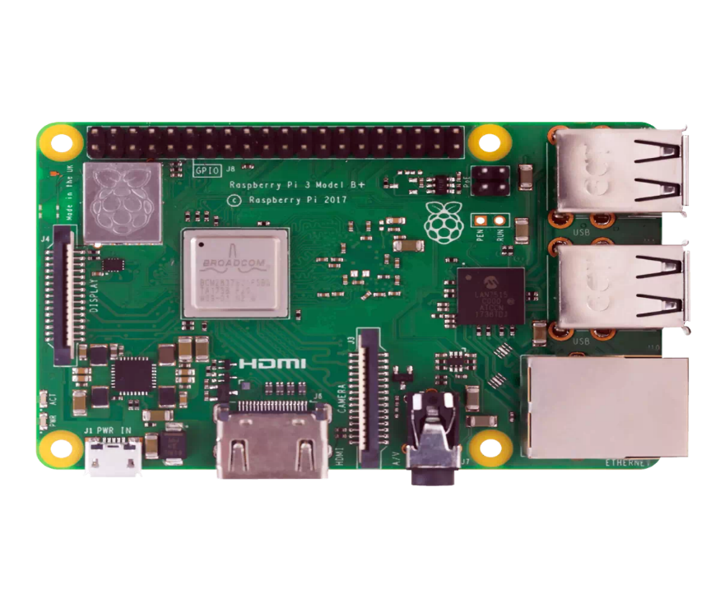

2.1.2 Thermal Camera (MLX90640-D55)

The MLX90640-D55 Thermal Camera is a small size, non-contact and low-cost IR array thermal imaging camera with 32×24 pixels. It detects the IR distribution of objects in the field of view, converts the data to the surface temperature of the objects through calculation, and then generates thermal images for easy integration into a variety of industrial or intelligent control applications.
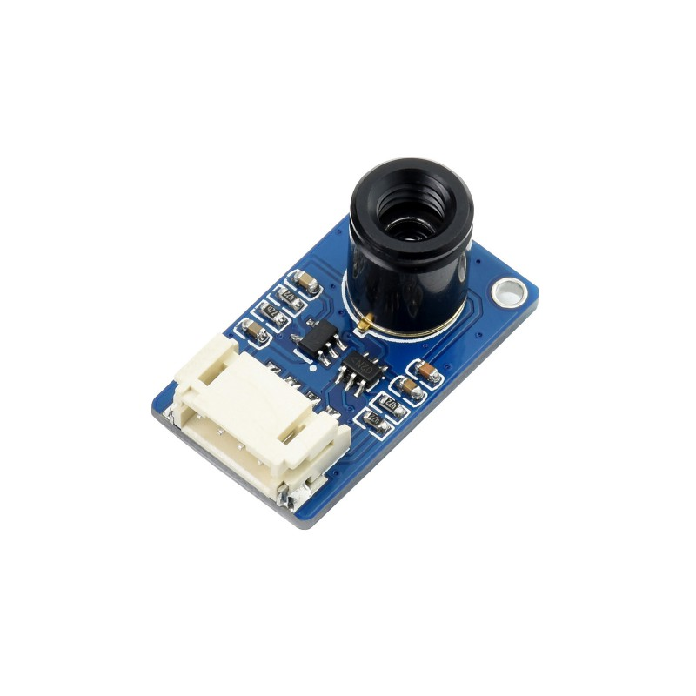
Figure 3 – MLX90640-D55 Thermal Camera

2.1.3 USB Modem

A USB modem can supply the internet access required for the device to transfer data to the server. It's dependable and portable to use a USB modem and we don’t have specific modem model for now.

When connecting the device to the internet, there are two crucial elements to consider. First, the modem must be identified and connected automatically after booting. Second, the RPi should monitor internet connectivity and automatically rejoin if the connection fails.

2.1.4 Operating system

An operating system is software that manages all of the computer hardware resources. Like other computers Raspberry Pi needs to have an operating system in order to run. We will run it on Linux. Linux is an open-source, free, secure, lightweight, and stable platform that is highly preferred by programmers. There are many distributions available for Linux, but for this project, we will be using Rasbian on Raspberry Pi because it is highly compatible with Raspberry Pi and maintained by manufacturer company.

2.1.5 Programming language

The preferred language for this project is mainly Python. Python has many useful libraries that can be used easily in this project this way, the focus is on implementation rather than dealing with the difficulties of the programming language.

3 REQUIREMENTS and USE CASES

3.1 Personas
- End User (who have solar panels and want to check their performance)
- Seller (the person or company that selling the product)
- Technic Service (the person who assists the End-User when necessary)
- Software Developer (the person who fixes the bugs and adds new features)
3.2 Features

Simultaneous analysis of the inefficient points of the solar panel using a contrast image. This processed image can be used to interpret some of the reasons for inefficient operation. The user can detect some micro-cracks in the solar panel or functional problems due to overheating.

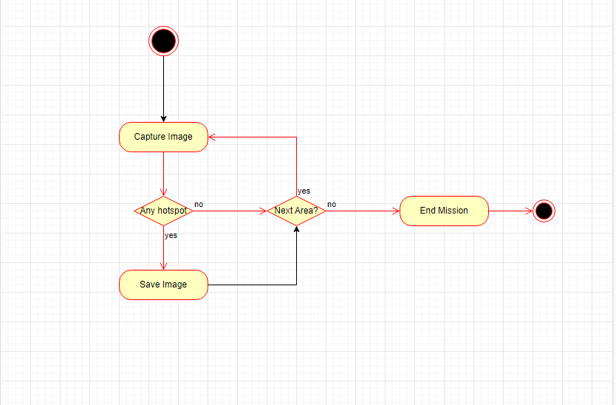

Figure 2 - An activity diagram for people utilizing the device

3.3 Use Case Scenarios
This project works in one specific scenario.
The user wants to know if there is a problem:
- The user points the thermal imaging camera at the solar panel.
- If a hotspot is detected by the software, a snapshot is saved.
- The person can identify where the problem is by looking at the contrasted image.

3.4 Functional Requirements
- It cannot search a wide area because of its limited field of view.
- The device must be connected to wifi. (according to the possibility of processing the software on the server)
- It is necessary to have the appropriate software to process the data received from thermal sensors.
- In order to process the data received from the thermal camera correctly, a computer with high processing power must be used.

3.5 Non-functional Requirements (Optional)
- After scanning the solar panel with a thermal camera, the time taken to produce the image and send it to the user's computer should be short.

4 Assumptions, Constrains and Risks

In this project, the aim is to develop a product that can detect the hotspots on a solar panel which leads that panel to stop working. Since this project has a time limit of 6 months we will be focusing on this issue. If the time enough that can also be added a feature to detect the contamination as an addition which can also has a negative effect on solar panels.
Some of the risks on this project is to not be able to find enough data to train the AI modal. Another risk is to connect the device to the internet, there are two crucial elements to consider. First, the modem must be identified and connected automatically after booting. Second, the RPi should monitor internet connectivity and automatically rejoin if the connection fails.

REFERENCES

[1] Herraiz, A.H., Marug´an, A.P., M´arquez, F.P.G. 2020. Photo- voltaic plant condition monitoring using thermal images analysis by convolutional neural network-based structure. Renewable Energy 153, 334–348 (2020)

[2] Richardson, Luke, How long will my solar panels last?, 2018, Retrieved from https://news.energysage.com/how-long-do-solar-panels-last/.

[3] Henry, Chris, Sahadev Poudel, Sang-Woong Lee, and Heon Jeong. 2020. "Automatic Detection System of Deteriorated PV Modules Using Drone with Thermal Camera" Applied Sciences 10, no. 11: 3802.

