CS 491 SDD

TERONE

Submitted by:
Anıl Düzgün Albayrak
Elif Akçay
Mehmet Harun Şahinol
Senan Batu Çobanoğlu

Table of Contents
1. INTRODUCTION 2
2. SOFTWARE DESIGN 2
2.1. SOFTWARE ARCHITECTURE 2
2.2. TOPOLOGY 2
2.3. MODULE STRUCTURE 3
2.4. INTERFACE DESIGN 4
2.6. SEQUENCE DIAGRAMS 7
2.7. USER INTERFACE (UI) MOCKUPS 7
2.8. DATA DESIGN 7
2.9. TOOLS and TECHNOLOGY 7
3. PROJECT SCHEDULE 7

1. INTRODUCTION

This project aims to detect the HotSpot problem in solar panels using a thermal camera. The goal is to transfer the image taken with the thermal camera to a mobile application and to show the user the image and the working status of the solar panel, and to notify the user if a hotspot problem has occurred or if there are situations that may cause this problem.

2. SOFTWARE DESIGN

2.1. SOFTWARE ARCHITECTURE
Explain your software architecture and the reason for you to pick it.
For example, we have chosen a 3 tier client & server architecture because ….
Another example, we have chosen an IoT architecture because …
Given that we are developing a mobile app, we will use … architecture because.

2.2. TOPOLOGY
Draw the topology diagram to show the hardware components of your system.
The software topology maps the applications and components from the solution onto the hardware topology. The idea is to get as much information as possible regarding the software components themselves, where they will be hosted, and their baseline configuration.

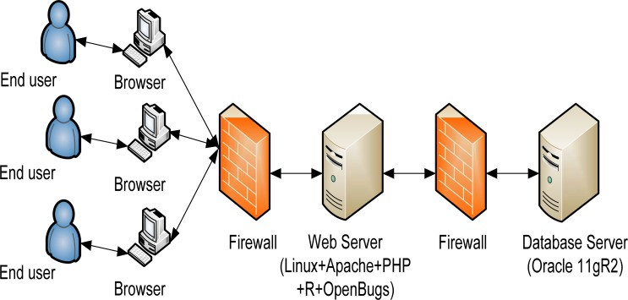

2.3. MODULE STRUCTURE
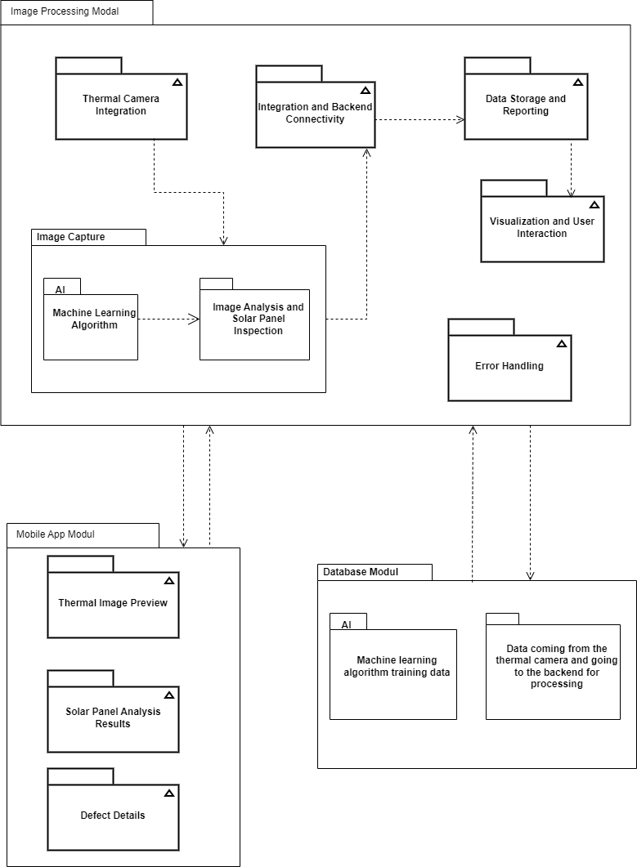

2.4. INTERFACE DESIGN

1. Thermal Image Capture Module:
Responsible for interfacing with the thermal camera, capturing images, and providing raw images to the Image Processing Module.
Methods in Thermal Image Capture Module:
- captureImage(): Method to capture thermal images.
- getRawImage(): Method to retrieve the captured raw image data.

Interface Interactions:
Thermal Image Capture → Image Processing :
Thermal Image Capture Module triggers 'captureImage()'. Captured images are passed to the Image Processing Module via 'processImage(rawImage)'.

2. Image Processing Module:
Utilizes machine learning algorithms for hotspot detection and defect analysis on the captured thermal images.
Methods in Image Processing Module:
- processImage(rawImage): Method to receive raw images and perform analysis.
- getAnalysisResults(): Method to retrieve analysis results and defect details.

Interface Interactions:
Image Processing → User Interface:
Image Processing Module provides analysis results using 'getAnalysisResults()'. User Interface Module displays the processed images and defect information with 'displayImage(processedImage)' and 'showDefectDetails(defectInfo)'.

Image Processing → Data Storage:
Image Processing Module stores processed image data and defect details using ‘saveImage(processedImage)' and 'saveDefectDetails(defectInfo)'.

3. User Interface Module (Mobile App):
Manages the user interface of the mobile app, displaying processed images and defect information to users.
Method in User Interface Module:
- displayImage(processedImage): Method to display processed images to users.
- showDefectDetails(defectInfo): Method to showcase defect information and highlight defected areas on images.

4. Data Storage Module:
Stores processed images, analysis results, and defect details for future reference.
Method in Data Storage Module:
- saveImage(processedImage): Method to save processed images.
- saveDefectDetails(defectInfo): Method to store defect information.

5. Error Handling Module:
Handles errors that occur during image capture, processing, or interface communication.
Methods in Error Handling Module:
- reportError(errorMessage): Method to report errors and exceptions.

Interface Interactions:
Error Handling Across Modules: All modules uses the Error Handling Module's 'reportError(errorMessage)' method to report errors or exceptions encountered during their operations.

2.5. CLASS DIAGRAMS
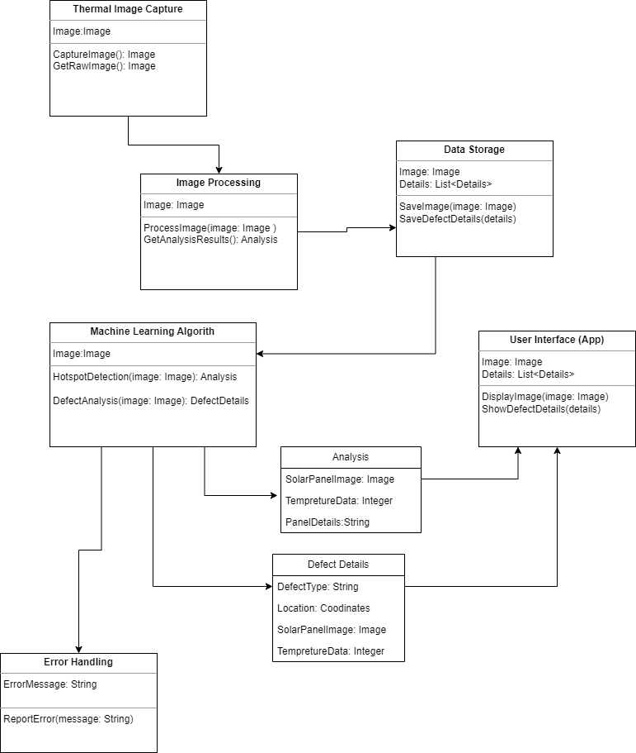

2.6. SEQUENCE DIAGRAMS

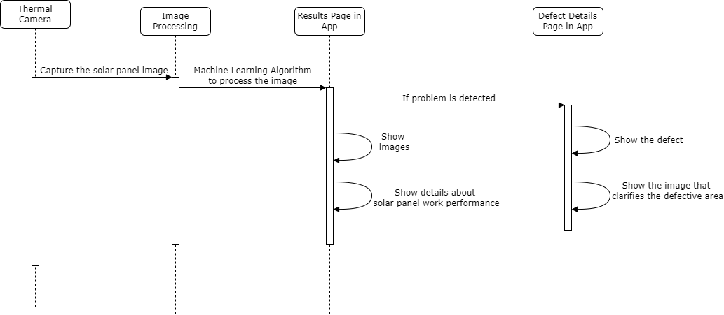

2.7. USER INTERFACE (UI) MOCKUPS
Create the user interface mockups for your project. You might use https://balsamiq.com/ for it. If not,even pictures of hand drawings are fine.

2.8. DATA DESIGN

Panel:

- panel_id: Unique identifier for the solar panel
- model: Model name of the solar panel
- installation_date: Date the panel was installed
- location: Coordinates or description of the panel's location
- other_metadata: Additional relevant information about the panel

Image:

- image_id: Unique identifier for the thermal image
- panel_id: Foreign key referencing the Panel table
- capture_time: Timestamp of when the image was captured
- raw_image_data: Raw data from the thermal camera (optional)
- processed_image_data: Processed image data after pre-processing (optional)

Analysis:

- analysis_id: Unique identifier for the analysis
- image_id: Foreign key referencing the Image table
- hotspot_count: Number of detected hotspots
- average_temperature: Average temperature of the panel
- maximum_temperature: Maximum temperature recorded on the panel
- defect_data: Array of detected defects (see Defect structure)

Defect:

- defect_id: Unique identifier for the defect
- analysis_id: Foreign key referencing the Analysis table
- type: Type of defect (e.g., hotspot, cracked cell, shading)
- location: Coordinates or description of the defect location on the image
- severity: Severity level of the defect (e.g., low, medium, high)
- temperature: Temperature measured at the defect location
- image_crop: Sub-image data focusing on the defect area (optional)

Tables:

- Panels: Stores information about individual solar panels.
- Images: Stores metadata and data about captured thermal images.
- Analyses: Stores results of processing each image, including detected hotspots and average/maximum temperatures.
- Defects: Stores details of individual defects identified in each analysis.

Relationships:

- One Panel can have many Images.
- One Image has one corresponding Analysis.
- One Analysis can have many Defects.

2.9. TOOLS and TECHNOLOGY

What tools and technology will you be using in your project? Why did you choose that? For example, if you are developing a cross platform mobile app and chose React Native, explain why you chose that compared to alternatives.

3. PROJECT SCHEDULE

Who is responsible from which module or section of the project? For example Person A will write module 1, etc.
What will you deliver and when? It is strongly advised to have multiple milestones where each of you finish your responsibilities for that milestone and integrate your code.

