Senpar app preview
Full-page browser view captured after the app finished loading:
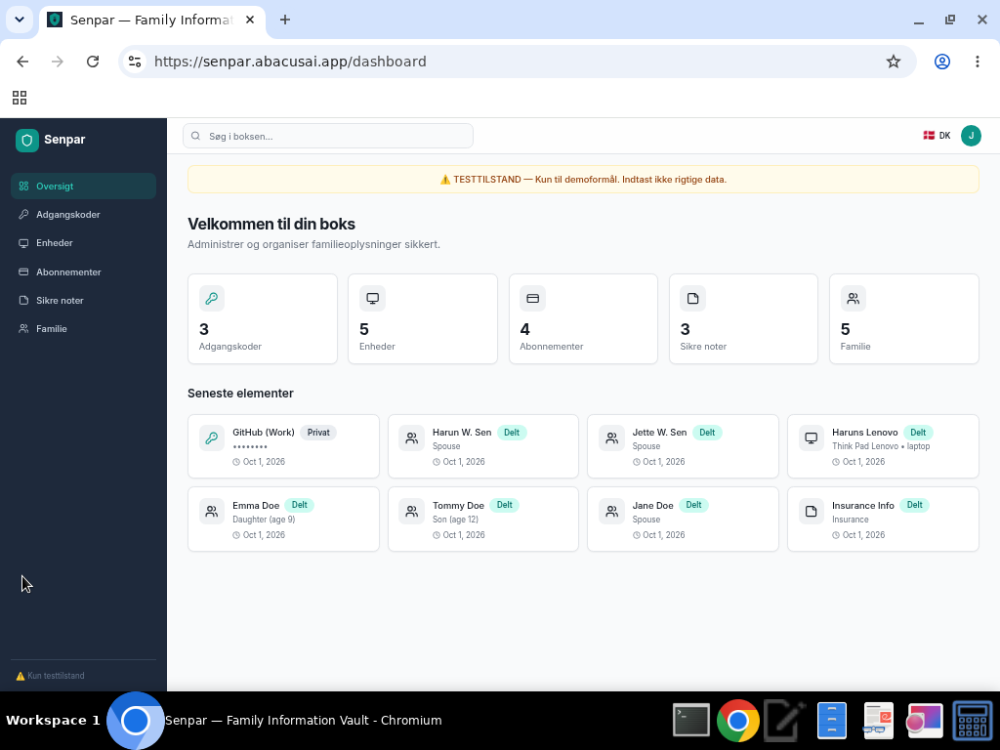
Senpar dashboard preview

