**TRIVAGO API TEST**

I also double-checked API testing with Postman tool and you can see the screenshots of my test.

* 404 endpoint which does not exist

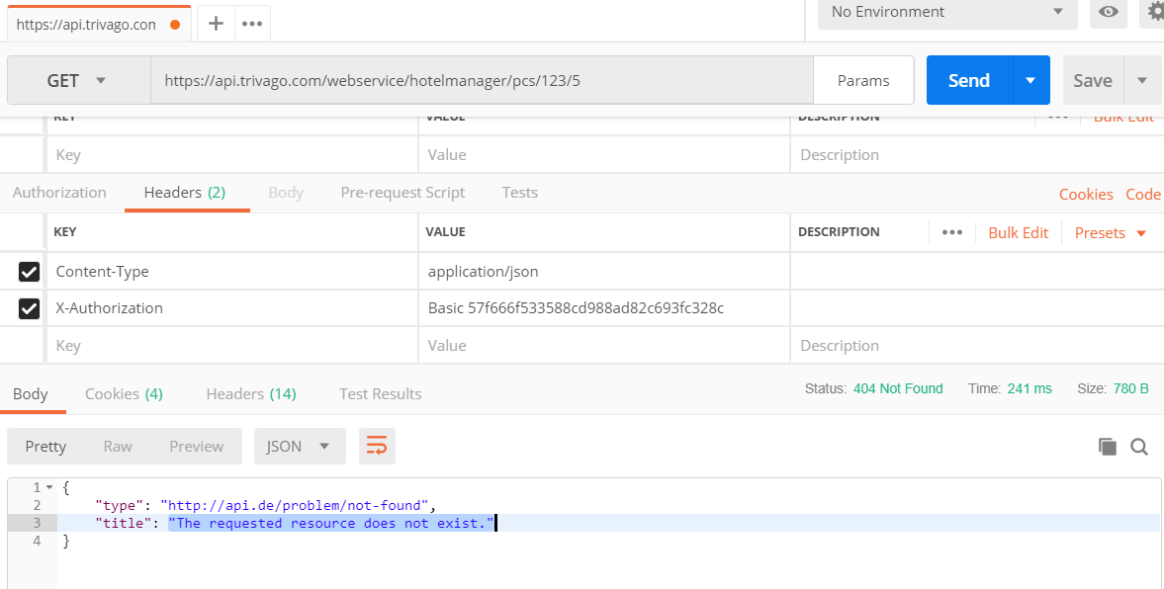

* 401 Wrong Auth

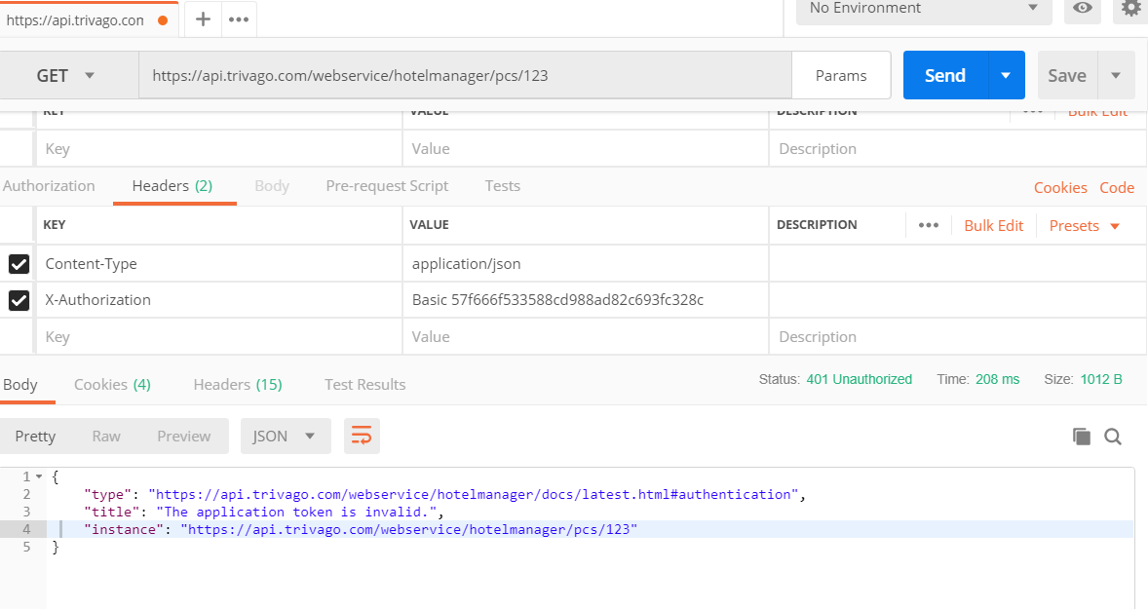

* 401Application Token Required

