Volume Profile

Indicators & Signal Blocks Reference

StrategyQuant — Volume Profile Suite
3 Core Indicators • 36 Signal Blocks • 9 Categories
Revised technical edition • Version 2.0 • 14 July 2026

Table of Contents
1. Core Concepts
2. Core Indicators
2.1 Volume Profile (VP)
2.2 Volume Profile Custom Hours (VPCH)
2.3 Volume Profile Custom Hours MultiSession (VPCHMS)
3. Signal Blocks Reference
3.1 Price vs. Structure (VP01–VP04)
3.2 Order Flow & Delta (VP08–VP11)
3.3 Profile Shape & POC Position (VP12–VP13, VPEL, VPES)
3.4 Value Area Width (VP14–VP15)
3.5 Initial Balance (VP18–VP19, VP44–VP45)
3.6 POC Dynamics — Multi-Session (VP21–VP22)
3.7 Value Area Dynamics — Multi-Session (VP23–VP24)
3.8 Reversal & Pattern Signals (VP09–VP13L/S, VP27L/S, VPODL/S)
3.9 VWAP Signals (VP27–VP28)
4. Common Parameters
5. Strategy Building Guidance

1. Core Concepts
Before using any blocks, understand these foundational Market Profile / Volume Profile concepts:
Concept | Definition
POC (Point of Control) | The price level with the highest traded volume in the session. Represents "fair value" — where the most two-sided trading occurred.
VAH (Value Area High) | Upper boundary of the Value Area — the zone containing the configurable percentage (default 70%) of total volume.
VAL (Value Area Low) | Lower boundary of the Value Area.
Value Area | The price range between VAL and VAH. Represents where the market accepted value during the session.
IBH / IBL | Initial Balance High / Low — the high and low established during the opening period of a session (default: first 60 minutes).
HVN (High Volume Node) | Local peaks in the volume profile — prices where significant volume clustered. Act as support/resistance.
LVN (Low Volume Node) | Local valleys in the volume profile — prices where volume was thin. Price tends to move quickly through LVNs.
BullPOC / BearPOC | The POC computed separately from bullish (close > open) and bearish (close < open) candles.
Delta | Total bull volume minus total bear volume. Measures net buying/selling pressure.
VWAP | Volume-Weighted Average Price — the average price weighted by volume, anchored to a session boundary.
Profile Range | Session High minus Session Low — the total price range of the session.
POCPctUp / POCPctDown | Percentage distance from POC to the top / bottom of the profile range. Reveals where the POC sits structurally.

IMPORTANT: All signal blocks are boolean conditions (return true / false). They are designed to be used in StrategyQuant's AlgoWizard as entry/exit conditions, or combined in Custom Blocks to build composite strategies.

2. Core Indicators

2.1 Volume Profile (VP)
Block Name: (VP) Volume Profile
Source: VolumeProfile.java
Return Type: Price
The primary Volume Profile indicator. Computes a volume-at-price histogram for a configurable session window and outputs key structural levels (POC, VAH, VAL, IB, HVNs, LVNs) plus order-flow metrics (Delta, BullPOC, BearPOC).

Session Types
Value | Name | Description
1 | Previous Day | Last completed daily session
2 | Previous Week | Last completed weekly session (Mon–Mon)
3 | Previous Month | Last completed monthly session
4 | Previous Year | Last completed yearly session
5 | Actual Day | Current developing daily session (recalculated every bar)
6 | Actual Week | Current developing weekly session
7 | Actual Month | Current developing monthly session
8 | Actual Year | Current developing yearly session
9 | Previous Swing | Previous completed ZigZag segment
10 | Actual Swing | Current developing ZigZag segment

Key Parameters
Parameter | Default | Range | Description
SessionType | 2 | 1–10 | Which session boundary to use
ProfileRows | 50 | 10–100 | Number of price bins (Range-Based mode)
BinSizeMode | 2 (Fixed) | 1–2 | 1 = Range-Based, 2 = Fixed Tick Size
TicksPerBin | 3 | 1–1000 | Ticks per bin (Fixed mode only)
ValueAreaPct | 70 | 65–75 | Percentage of volume defining the Value Area
IBMinutes | 0 | 0–14400 | Initial Balance period override (0 = default)
HvnCount | 5 | 1–10 | Number of HVNs to detect
HvnThresholdPct | 20 | 10–90 | Min volume % of max bin to qualify as HVN
LvnThresholdPct | 40 | 10–90 | Max volume % of max bin to qualify as LVN
EnableLVN | false | — | Enable Low Volume Node detection
EnableVCP | false | — | Enable Volume Cluster Profile (Gaussian smoothing)

Outputs (29 data series)
Output | Description
POC | Point of Control price
VAH / VAL | Value Area High / Low
IBH / IBL | Initial Balance High / Low
HVN1–HVN5 | High Volume Node prices (ranked by volume)
LVN1–LVN5 | Low Volume Node prices
VPOC / VVAH / VVAL | Volume Cluster Profile POC/VAH/VAL (when VCP enabled)
BullPOC / BearPOC | POC of bullish / bearish candles only
TotalVolume | Total session volume
TotalBullVolume / TotalBearVolume | Volume from bull / bear candles
Delta | TotalBullVolume − TotalBearVolume
DeltaPOC | Delta at the POC price level
DeltaVA | Delta within the Value Area
ProfileRange | Session High − Session Low
POCPctUp / POCPctDown | POC position as % from top / bottom of profile range

2.2 Volume Profile Custom Hours (VPCH)
Block Name: (VP) Volume Profile Custom Hours
Source: VolumeProfileCustomHours.java
Same core VP engine but with user-defined session hours instead of fixed Day/Week/Month boundaries. Define any intraday window (e.g., London session 07:00–16:00, US open 13:30–22:00, Asian session 00:00–09:00).
TIME-ZONE REQUIREMENT: Custom session hours must be interpreted in a documented time zone (for example broker/chart time, exchange time, or UTC). Daylight-saving changes can shift London and New York sessions relative to one another.

Additional Parameters
Parameter | Default | Description
SessionStartHours | 8 | Session start hour (0–23)
SessionStartMinutes | 0 | Session start minutes (0–59)
SessionEndHours | 16 | Session end hour (0–23)
SessionEndMinutes | 0 | Session end minutes (0–59)
SessionMode | 1 (Previous) | 1 = Previous (last completed), 2 = Actual (developing)

TIP: Overnight sessions are supported. If end time ≤ start time (e.g., 18:00–06:00), the session automatically wraps to the next calendar day.

2.3 Volume Profile Custom Hours MultiSession (VPCHMS)
Block Name: (VP) Volume Profile Custom Hours MultiSession
Source: VolumeProfileCustomHoursMultiSession.java
Advanced version that computes 4 independent session profiles simultaneously (London, New York, Sydney, Tokyo). Each session can be independently enabled/disabled with custom hours, and each outputs its own POC/VAH/VAL. Sessions may overlap.
SESSION-TIME NOTE: The displayed London, New York, Sydney, and Tokyo hours are examples. Confirm the time zone and daylight-saving behavior used by the chart or data feed before using them in production.

Session Configuration
Session | Default Hours | Enabled
London | 07:00–16:00 | Yes
New York | 13:00–22:00 | Yes
Sydney | 21:00–06:00 | No
Tokyo | 00:00–09:00 | Yes

Per-Session Outputs
Output | Description
LondonPOC / LondonVAH / LondonVAL | London session profile levels
NewYorkPOC / NewYorkVAH / NewYorkVAL | New York session profile levels
SydneyPOC / SydneyVAH / SydneyVAL | Sydney session profile levels
TokyoPOC / TokyoVAH / TokyoVAL | Tokyo session profile levels

3. Signal Blocks Reference

3.1 Price vs. Structure
These blocks answer the fundamental question: Where is price relative to the volume profile?
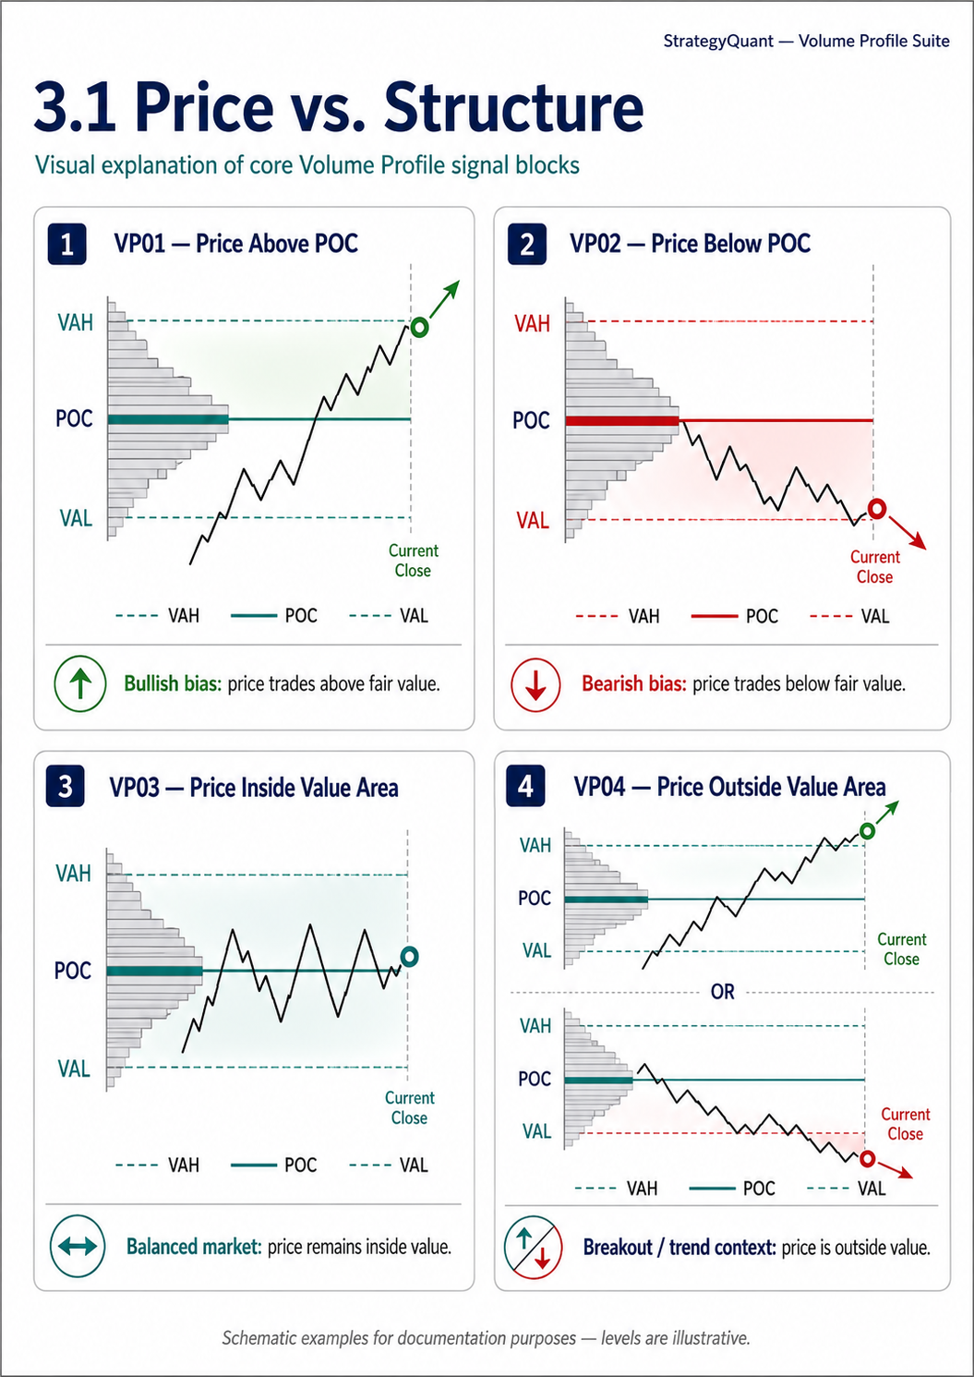

(VP01) Price Above POC — Price Above POC
Block Name: (VP01) Price Above POC
Source: VPPriceAbovePOC.java
Opposite Block: (VP02) Price Below POC

Description
Returns true when the current close is above the session's POC.

Market Profile Principle
Price trading above fair value (POC) indicates bullish directional bias — buyers are in control.

Logic
Close > POC

Usage Guidance
- Use as a regime filter — only take long trades when price is above POC
- Combine with other signals: e.g., Price Above POC + Rising POC = strong bullish confluence
- On the Previous Day session, this tells you whether today's action is above yesterday's fair value

(VP02) Price Below POC — Price Below POC
Block Name: (VP02) Price Below POC
Source: VPPriceBelowPOC.java
Opposite Block: (VP01) Price Above POC

Description
Returns true when the current close is below the session's POC.

Market Profile Principle
Price trading below fair value suggests bearish bias — sellers are in control.

Logic
Close < POC

Usage Guidance
- Mirror of VP01 — use as a short-side regime filter
- Combine with Falling POC for stronger conviction short setups

(VP03) Price Inside Value Area — Price Inside Value Area
Block Name: (VP03) Price Inside Value Area
Source: VPPriceInsideVA.java
Opposite Block: (VP04) Price Outside Value Area

Description
Returns true when the current close is between VAL and VAH (inclusive).

Market Profile Principle
Price inside the Value Area indicates a balanced, rotational market. Favor mean-reversion and range-bound strategies.

Logic
Close >= VAL AND Close <= VAH

Usage Guidance
- Filter for mean-reversion strategies — when price is inside VA, expect rotation toward POC
- Combine with POC Magnet Long/Short for pullback entries inside value
- Avoid trend-following entries when this is true

(VP04) Price Outside Value Area — Price Outside Value Area
Block Name: (VP04) Price Outside Value Area
Source: VPPriceOutsideVA.java
Opposite Block: (VP03) Price Inside Value Area

Description
Returns true when the current close is above VAH or below VAL.

Market Profile Principle
Price outside the Value Area indicates trending/breakout conditions. Favor momentum and continuation setups.

Logic
Close < VAL OR Close > VAH

Usage Guidance
- Filter for trend-following strategies — only trade breakouts/continuations when outside VA
- Key decision: will price stay outside value (trend day) or return (80% rule)?
- Combine with IB Breakout signals for high-conviction directional trades

3.2 Order Flow & Delta
These blocks analyze directional candle-volume balance within the volume profile. They do not represent true bid/ask order-book delta unless the underlying implementation uses bid and ask volume.
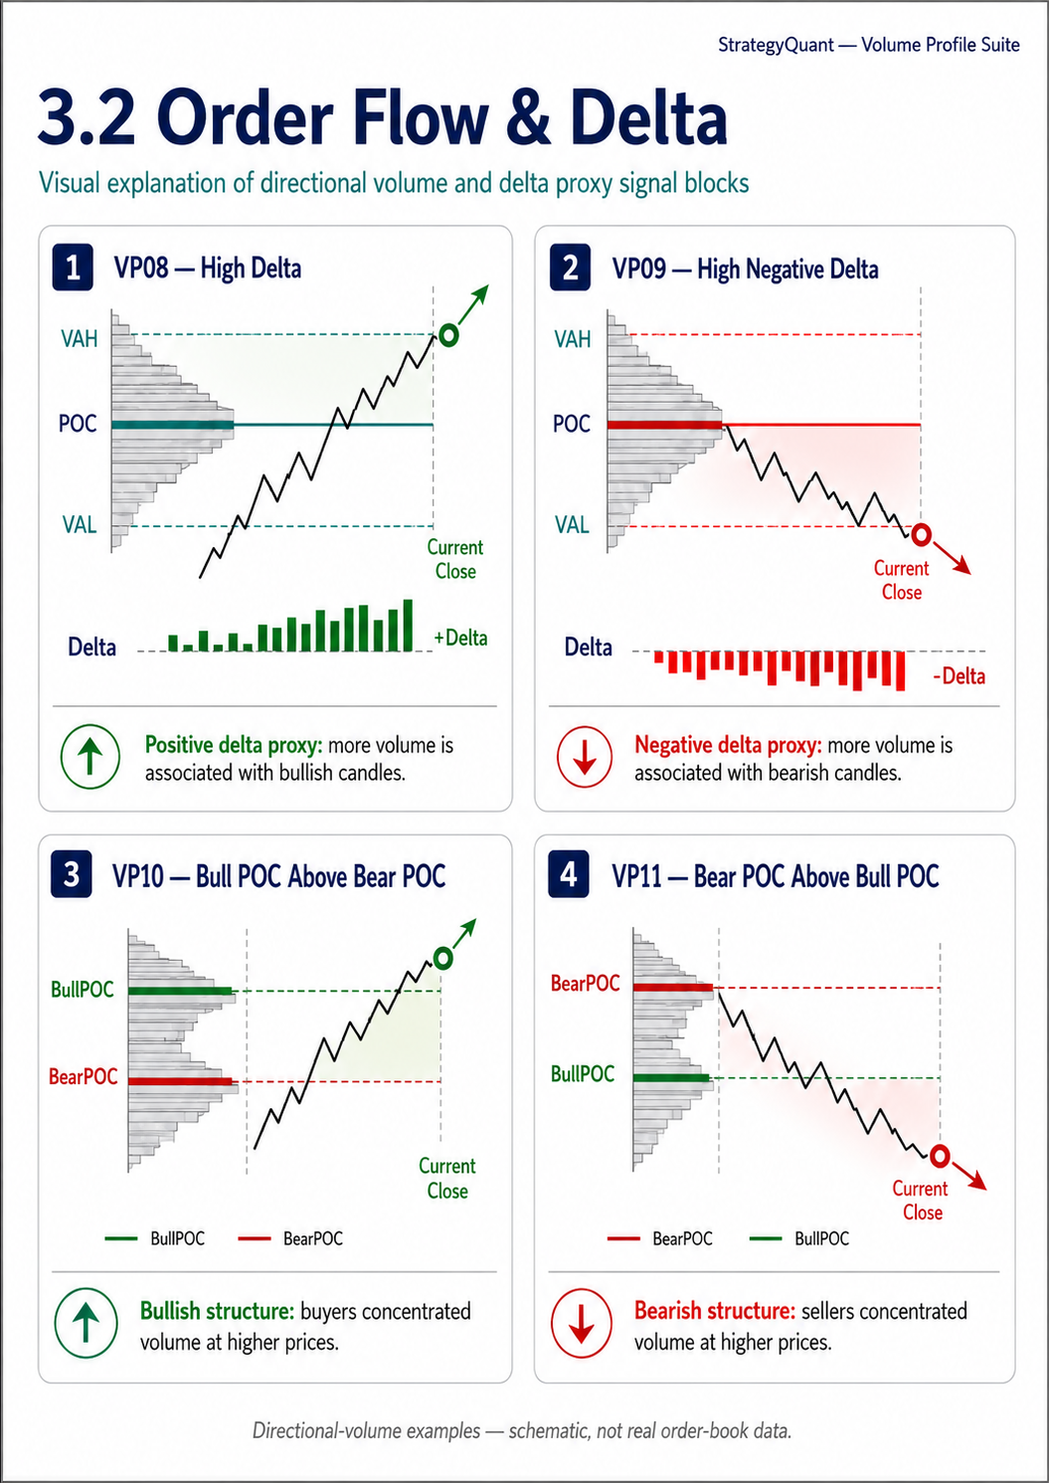
DELTA TERMINOLOGY: Here, Delta = TotalBullVolume − TotalBearVolume, where volume is classified by candle direction. This is a directional-volume proxy, not conventional ask-volume minus bid-volume delta.

(VP08) High Delta — High Delta (Bull Dominance)
Block Name: (VP08) High Delta
Source: VPHighDelta.java
Opposite Block: (VP09) High Negative Delta

Description
Returns true when session delta (bull volume − bear volume) exceeds MinDelta.

Market Profile Principle
A strong positive delta proxy indicates that more session volume was assigned to bullish candles than bearish candles. It can support bullish context, but it is not direct evidence of aggressive ask-side buying.

Logic
Delta > MinDelta

Parameters
Parameter | Default | Description
MinDelta | 100 | Minimum positive delta threshold

Usage Guidance
- Possible confirmation filter for long entries when the directional-volume proxy is positive
- Higher MinDelta = more selective (fewer but stronger signals)
- Pair with Price Above POC for double confirmation

(VP09) High Negative Delta — High Negative Delta (Bear Dominance)
Block Name: (VP09) High Negative Delta
Source: VPHighNegDelta.java
Opposite Block: (VP08) High Delta

Description
Returns true when session delta is below −MinDelta.

Market Profile Principle
A strong negative delta proxy indicates that more session volume was assigned to bearish candles than bullish candles. It can support bearish context, but it is not direct evidence of aggressive bid-side selling.

Logic
Delta < −MinDelta

Parameters
Parameter | Default | Description
MinDelta | 100 | Minimum absolute negative delta (entered as positive)

(VP10) Bull POC Above Bear POC — Bull POC Above Bear POC
Block Name: (VP10) Bull POC Above Bear POC
Source: VPBullAboveBear.java
Opposite Block: (VP11) Bear POC Above Bull POC

Description
Returns true when the BullPOC is above the BearPOC.

Market Profile Principle
Bull-candle volume is concentrated at a higher price than bear-candle volume. This can be used as bullish structural context, subject to confirmation.

Logic
BullPOC > BearPOC

Usage Guidance
- Regime filter — when bull volume concentrates above bear volume, the structural bias is long
- Works well on weekly sessions to identify multi-day regimes
- Combine with Rising POC for strong trend confirmation

(VP11) Bear POC Above Bull POC — Bear POC Above Bull POC
Block Name: (VP11) Bear POC Above Bull POC
Source: VPBearAboveBull.java
Opposite Block: (VP10) Bull POC Above Bear POC

Description
Returns true when BearPOC is above BullPOC.

Market Profile Principle
Bear-candle volume is concentrated at a higher price than bull-candle volume. This can be used as bearish structural context, subject to confirmation.

Logic
BearPOC > BullPOC

3.3 Profile Shape & POC Position
These blocks analyze where the POC sits within the profile range. They describe profile shape and possible auction imbalance; accumulation or distribution is a contextual interpretation, not a deterministic conclusion.
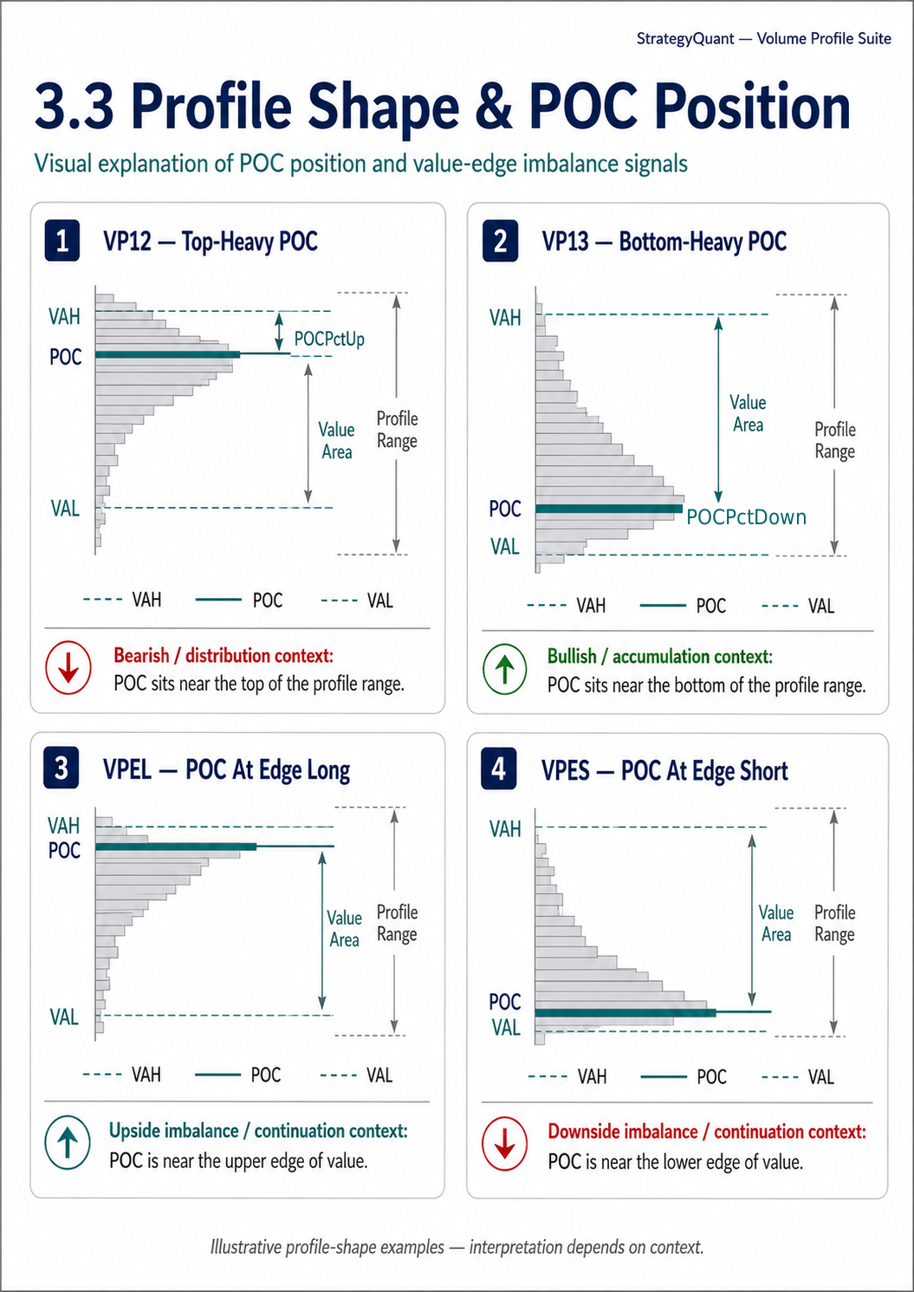

(VP12) Top-Heavy POC — Top-Heavy POC (Distribution)
Block Name: (VP12) Top-Heavy POC
Source: VPTopHeavyPOC.java
Opposite Block: (VP13) Bottom-Heavy POC

Description
Returns true when the POC is in the upper portion of the profile range.

Market Profile Principle
Most volume occurred near the upper part of the profile. This may reflect distribution, rejection, or acceptance of higher prices; use price behavior and session context to determine the bias.

Logic
POCPctUp < ThresholdPct AND POCPctUp > 0

Parameters
Parameter | Default | Description
ThresholdPct | 30 | POC must be in the top X% of the range

Usage Guidance
- Possible bearish or distribution-context filter when confirmed by rejection or weakening price behavior
- Combine with Price Below POC → distribution + price rejection = short signal
- Best on daily/weekly sessions

(VP13) Bottom-Heavy POC — Bottom-Heavy POC (Accumulation)
Block Name: (VP13) Bottom-Heavy POC
Source: VPBottomHeavyPOC.java
Opposite Block: (VP12) Top-Heavy POC

Description
Returns true when the POC is in the lower portion of the profile range.

Market Profile Principle
Most volume occurred near the lower part of the profile. This may reflect accumulation, rejection, or acceptance of lower prices; use price behavior and session context to determine the bias.

Logic
POCPctDown < ThresholdPct AND POCPctDown > 0

Parameters
Parameter | Default | Description
ThresholdPct | 30 | POC must be in the bottom X% of the range

(VPEL) POC At Edge Long — POC At Edge Long (Imbalanced Up)
Block Name: (VPEL) POC At Edge Long
Source: VPPOCAtEdgeLong.java
Opposite Block: (VPES) POC At Edge Short

Description
Returns true when the POC sits within EdgePct% of VAH (the top edge of the Value Area).

Market Profile Principle
A POC near the upper edge of value indicates that accepted volume is concentrated high in the value area. It can support an upside-continuation interpretation when confirmed by price action.

Logic
POC >= VAH − (vaRange × EdgePct / 100)

Parameters
Parameter | Default | Description
EdgePct | 20 | POC must be within this % of VAH

Usage Guidance
- Filter for impulsive/trending markets — the profile is skewed, not bell-shaped
- More aggressive than Top-Heavy POC because it uses the Value Area rather than the full range
- Great regime filter for momentum strategies

(VPES) POC At Edge Short — POC At Edge Short (Imbalanced Down)
Block Name: (VPES) POC At Edge Short
Source: VPPOCAtEdgeShort.java
Opposite Block: (VPEL) POC At Edge Long

Description
Returns true when the POC sits within EdgePct% of VAL (the bottom edge of the Value Area).

Market Profile Principle
A POC near the lower edge of value indicates that accepted volume is concentrated low in the value area. It can support a downside-continuation interpretation when confirmed by price action.

Logic
POC <= VAL + (vaRange × EdgePct / 100)

Parameters
Parameter | Default | Description
EdgePct | 20 | POC must be within this % of VAL

3.4 Value Area Width
These blocks classify the session by Value Area width. A narrow area can indicate concentrated acceptance and possible expansion; a wide area can indicate broad acceptance and rotational context. Neither outcome is guaranteed.
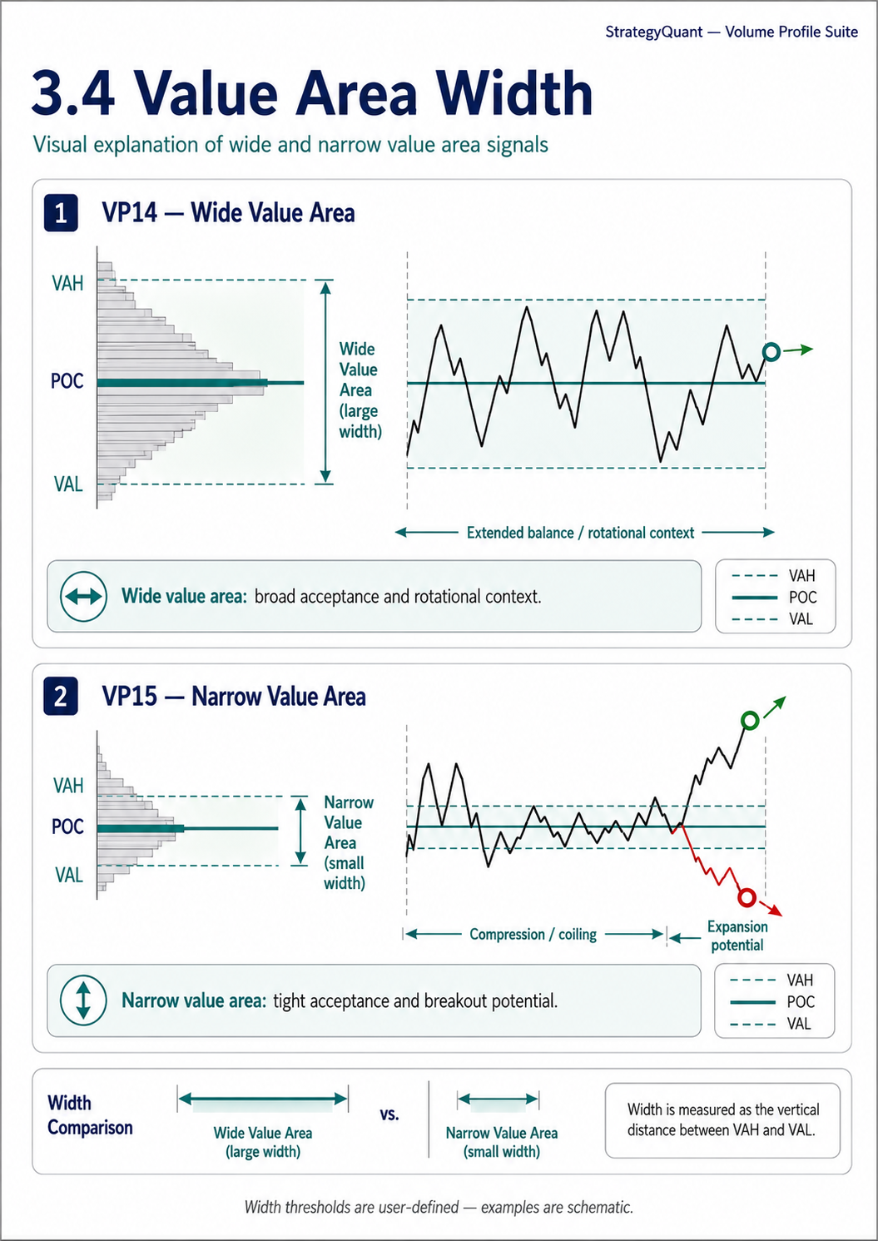
THRESHOLD WARNING: The documented defaults (Wide > 30 points and Narrow < 150 points) overlap. With those settings, both paired blocks can be true for widths between 30 and 150 points. Configure non-overlapping thresholds when mutual exclusivity is required.

(VP14) Wide Value Area — Wide Value Area
Block Name: (VP14) Wide Value Area
Source: VPWideValueArea.java
Opposite Block: (VP15) Narrow Value Area

Description
Returns true when the Value Area width (VAH − VAL) exceeds WidthPips points.

Market Profile Principle
A wide VA indicates broad price acceptance and may support a rotational or mean-reversion context. Confirm with current price behavior and volatility.

Logic
(VAH − VAL) > WidthPips (converted to price)

Parameters
Parameter | Default | Description
WidthPips | 30 | Minimum VA width in points. Configure together with VP15 to avoid overlap.

(VP15) Narrow Value Area — Narrow Value Area
Block Name: (VP15) Narrow Value Area
Source: VPNarrowValueArea.java
Opposite Block: (VP14) Wide Value Area

Description
Returns true when the Value Area width is below WidthPips points.

Market Profile Principle
A narrow VA indicates concentrated acceptance and may precede expansion. Direction and breakout quality require separate confirmation.

Logic
(VAH − VAL) > 0 AND (VAH − VAL) < WidthPips (converted to price)

Parameters
Parameter | Default | Description
WidthPips | 150 | Maximum VA width in points. Configure together with VP14 to avoid overlap.

3.5 Initial Balance (IB)
The Initial Balance is the range established during the opening period of a session (typically the first hour). IB breakouts are among the most powerful intraday signals.
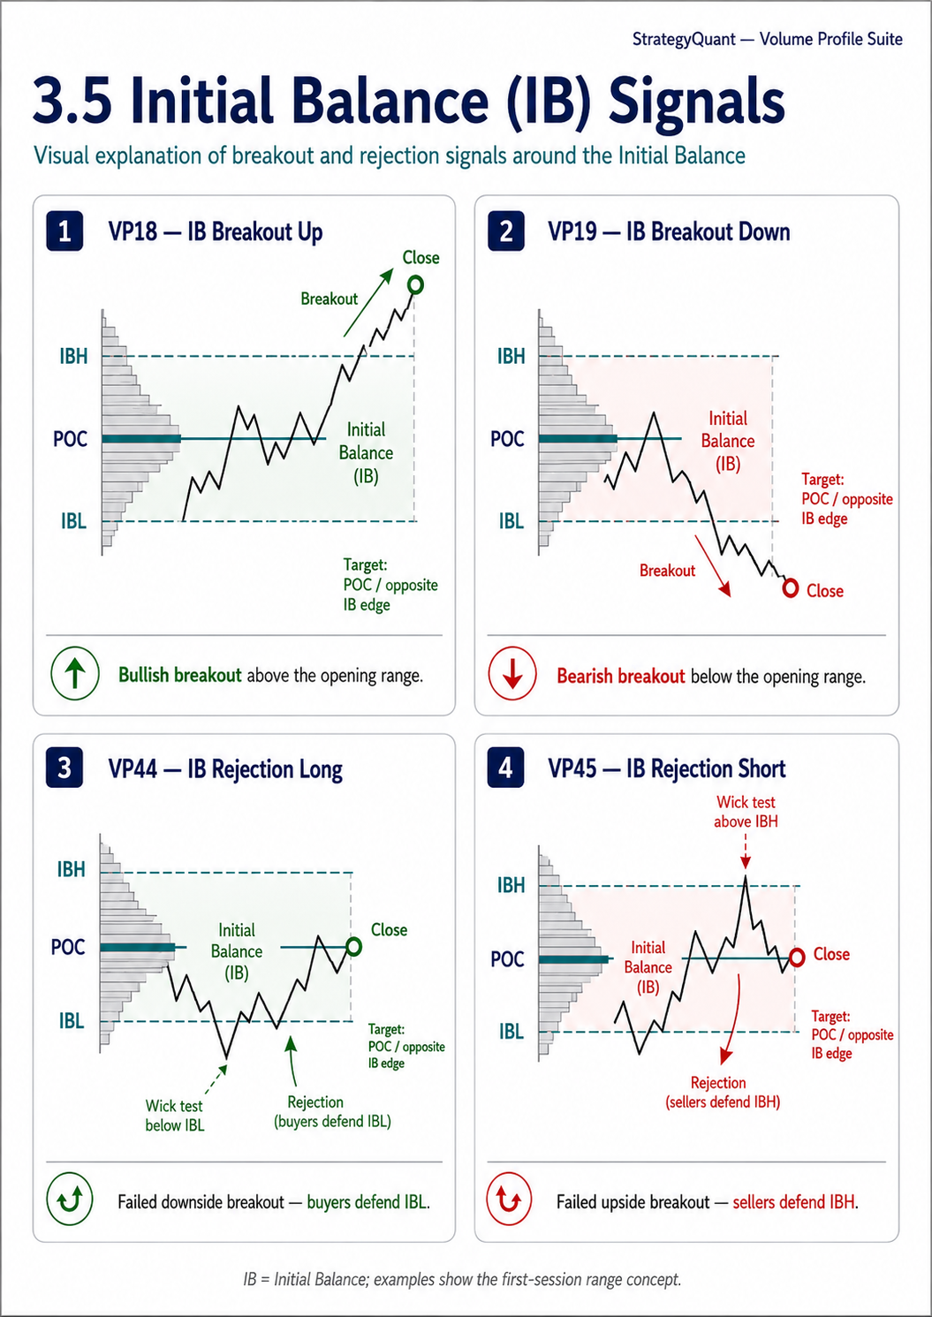

(VP18) IB Breakout Up — IB Breakout Up
Block Name: (VP18) IB Breakout Up
Source: VPIBBreakoutUp.java
Opposite Block: (VP19) IB Breakout Down

Description
Returns true when the current close is above the IBH.

Market Profile Principle
Price leaving the IB range upward signals directional conviction and often leads to a full-range extension to the upside. One of the most powerful intraday VP setups.

Logic
IBH > 0 AND Close > IBH

Parameters
Parameter | Default | Description
IBMinutes | 60 | Initial Balance period in minutes from session open

Usage Guidance
- Classic trend-day entry — go long on IB breakout up, target 1.5x–2x IB range
- Combine with High Delta to confirm buyers are driving the breakout
- Narrow IB (small range) breakouts are often more powerful than wide IB breakouts

(VP19) IB Breakout Down — IB Breakout Down
Block Name: (VP19) IB Breakout Down
Source: VPIBBreakoutDown.java
Opposite Block: (VP18) IB Breakout Up

Description
Returns true when the current close is below the IBL.

Market Profile Principle
Price leaving the IB range downward signals directional conviction and often leads to full-range extension to the downside.

Logic
IBL > 0 AND Close < IBL

Parameters
Parameter | Default | Description
IBMinutes | 60 | Initial Balance period in minutes from session open

(VP44) IB Rejection Long — IB Rejection Long
Block Name: (VP44) IB Rejection Long
Source: VPIBRejectionLong.java
Opposite Block: (VP45) IB Rejection Short

Description
Returns true when price tests the IBL (wick dips below) but closes back above it.

Market Profile Principle
Responsive buying defends the IB floor. Bullish reversal signal — the breakout attempt failed.

Logic
IBL > 0 AND Low < IBL − Tolerance AND Close > IBL + MinRejection

Parameters
Parameter | Default | Description
Tolerance | 2 | Minimum wick below IBL (points)
MinimumRejection | 2 | Min close distance above IBL (points)

Targets: POC, then IBH

(VP45) IB Rejection Short — IB Rejection Short
Block Name: (VP45) IB Rejection Short
Source: VPIBRejectionShort.java
Opposite Block: (VP44) IB Rejection Long

Description
Returns true when price tests IBH (wick pokes above) but closes back below it.

Market Profile Principle
Responsive selling defends the IB ceiling. Bearish reversal signal.

Logic
IBH > 0 AND High > IBH + Tolerance AND Close < IBH − MinRejection

Parameters
Parameter | Default | Description
Tolerance | 2 | Minimum wick above IBH (points)
MinimumRejection | 2 | Min close distance below IBH (points)

Targets: POC, then IBL

3.6 POC Dynamics (Multi-Session)
These blocks compare the current POC with the POC value LookbackBars bars ago. When LookbackBars approximates one session, the comparison can be interpreted as rising or falling fair value across sessions.
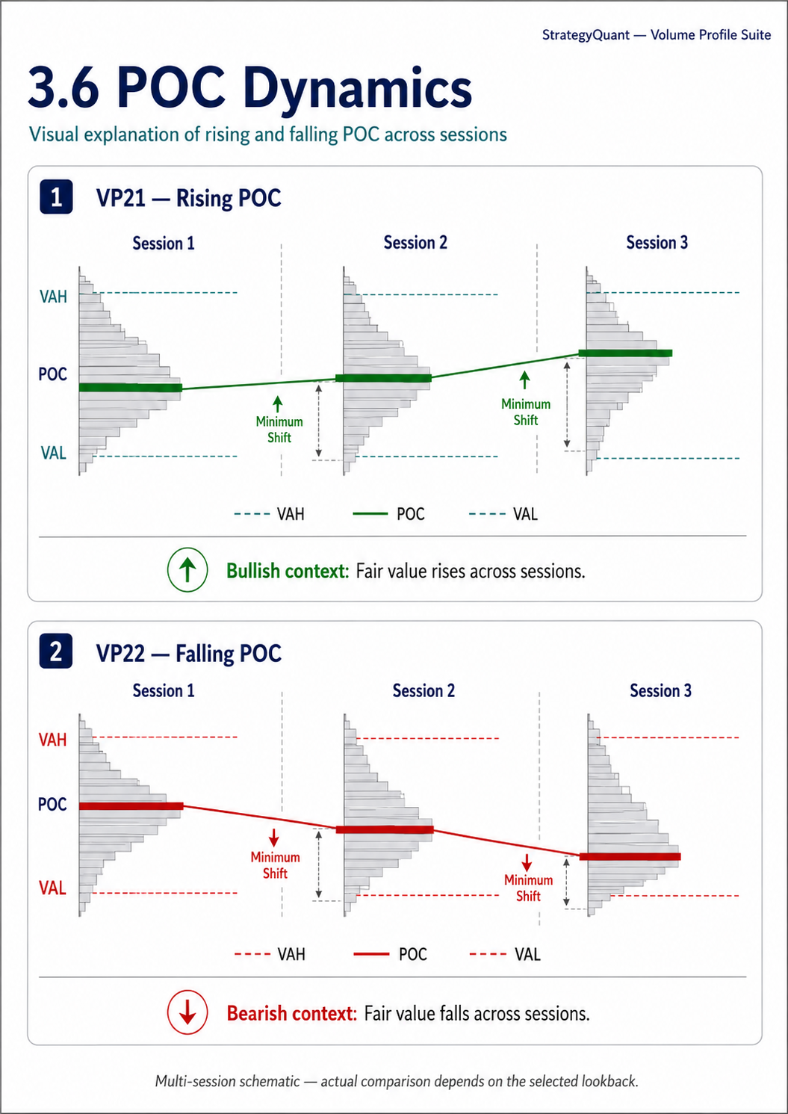
LOOKBACK ALIGNMENT: LookbackBars is a bar offset, not a guaranteed completed-session index. Holidays, weekends, missing bars, overnight sessions, and timeframe changes can prevent exact session-to-session alignment.

(VP21) Rising POC — Rising POC (Long Regime)
Block Name: (VP21) Rising POC
Source: VPRisingPOC.java
Opposite Block: (VP22) Falling POC

Description
Returns true when the current POC is higher than the POC from LookbackBars ago by at least MinimumShift pips.

Market Profile Principle
A rising POC can support a bullish regime interpretation. Prefer long setups only when additional context and testing support the hypothesis.

Logic
currentPOC > priorPOC + MinimumShift

Parameters
Parameter | Default | Description
LookbackBars | 48 | Bars to look back (≈ 1 session for M30 daily)
MinimumShift | 5 | Minimum POC increase in pips

Usage Guidance
- Set LookbackBars to ≈ one session: M30 daily = 48, M15 daily = 96, M30 weekly = 240
- Strong regime filter — Rising POC + Price Above POC = strong long bias
- Use on weekly sessions for swing trading context

(VP22) Falling POC — Falling POC (Short Regime)
Block Name: (VP22) Falling POC
Source: VPFallingPOC.java
Opposite Block: (VP21) Rising POC

Description
Returns true when the current POC is lower than the POC from LookbackBars ago by at least MinimumShift pips.

Market Profile Principle
A falling POC can support a bearish regime interpretation. Prefer short setups only when additional context and testing support the hypothesis.

Logic
currentPOC < priorPOC − MinimumShift

Parameters
Parameter | Default | Description
LookbackBars | 48 | Bars to look back
MinimumShift | 5 | Minimum POC decrease in pips

3.7 Value Area Dynamics (Multi-Session)
These blocks compare Value Area positions using values separated by LookbackBars. When the lookback aligns with session boundaries, they can identify upward or downward shifts in accepted value.
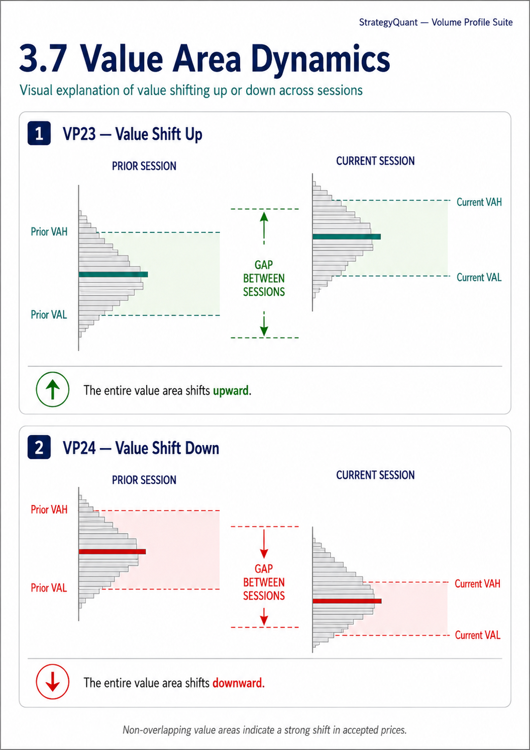
LOOKBACK ALIGNMENT: Set LookbackBars to match the intended comparison period and verify that the selected data contains a consistent number of bars per session.

(VP23) Value Shift Up — Value Shift Up (Bull Regime)
Block Name: (VP23) Value Shift Up
Source: VPValueShiftUp.java
Opposite Block: (VP24) Value Shift Down

Description
Returns true when the current session's VAL sits entirely above the prior session's VAH.

Market Profile Principle
The entire value area has shifted higher — aggressive acceptance of higher prices. Strong bullish regime.

Logic
currentVAL > priorVAH + MinimumGap

Parameters
Parameter | Default | Description
LookbackBars | 48 | Bars to look back for prior session
MinimumGap | 0 | Min gap between current VAL and prior VAH (pips). 0 = any non-overlapping shift

Usage Guidance
- Very strong signal — indicates a gap-up in value (not just price)
- Combine with Price Inside VA for pullback entries in the new value area
- Rare on daily sessions, more common on shorter custom-hour sessions

(VP24) Value Shift Down — Value Shift Down (Bear Regime)
Block Name: (VP24) Value Shift Down
Source: VPValueShiftDown.java
Opposite Block: (VP23) Value Shift Up

Description
Returns true when the current session's VAH sits entirely below the prior session's VAL.

Market Profile Principle
The entire value area has shifted lower — aggressive acceptance of lower prices. Strong bearish regime.

Logic
currentVAH < priorVAL − MinimumGap

Parameters
Parameter | Default | Description
LookbackBars | 48 | Bars to look back
MinimumGap | 0 | Min gap (pips)

3.8 Reversal & Pattern Signals
These are the actionable trade setups — they detect specific price action patterns at key volume profile levels.
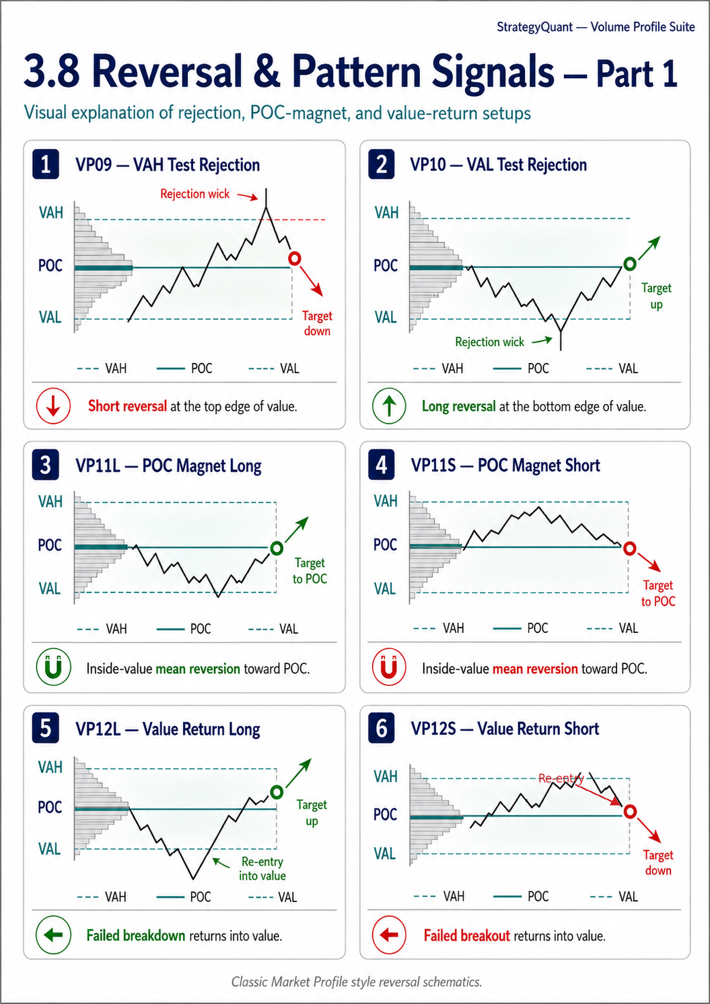
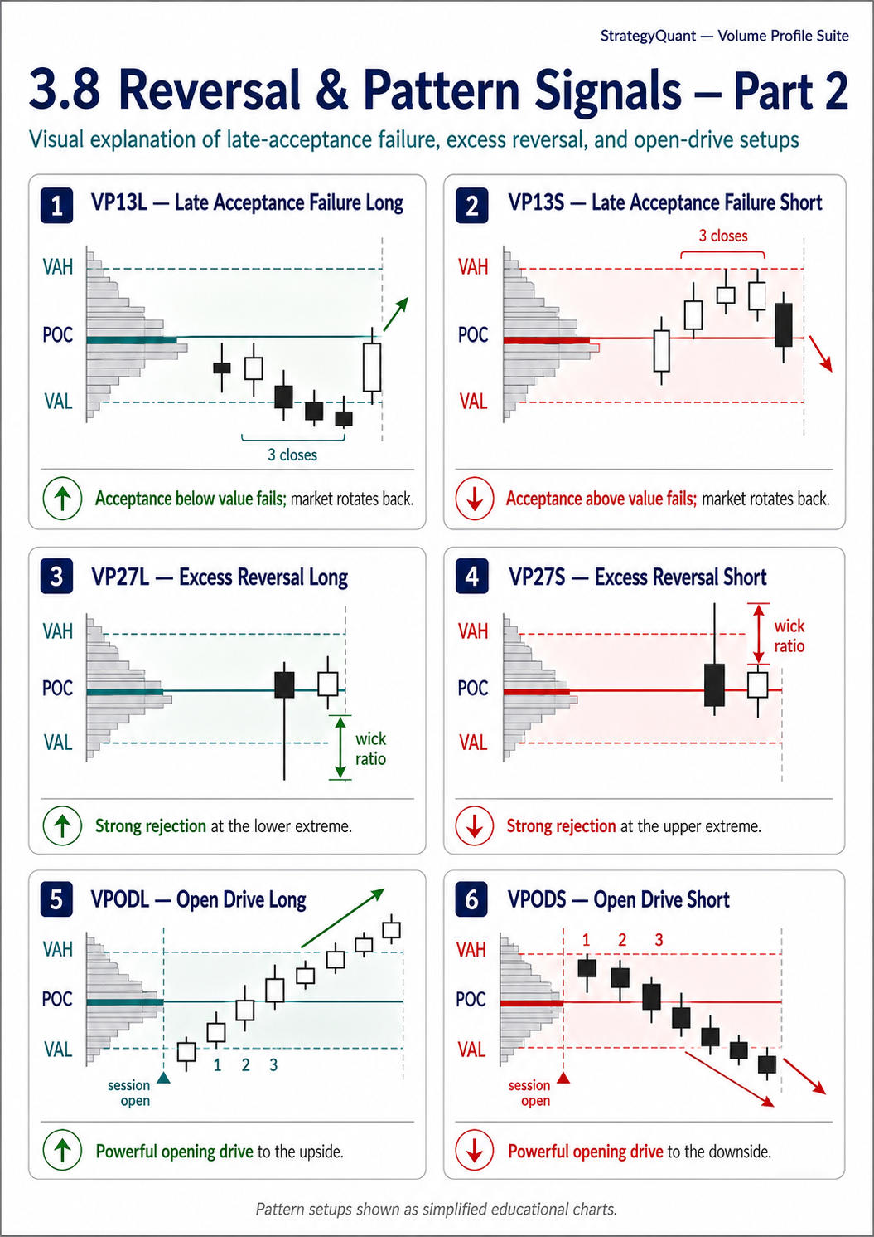
LEGACY IDENTIFIERS: VP09 and VP10 are reused by both Order Flow blocks and Value-Area Rejection blocks. Use the full block name and source filename to distinguish them. Renaming the code identifiers is recommended in a future compatibility-breaking release.

(VP09) VAH Test Rejection — VAH Test Rejection (Short)
Block Name: (VP09) VAH Test Rejection
Source: VPVAHTestRejection.java
Opposite Block: (VP10) VAL Test Rejection

Description
Price probes above prior VAH (high exceeds VAH) but closes back below VAH — responsive sellers defend the value edge.

Market Profile Principle
Classic Market Profile short setup — test and reject at the top of value.

Logic
High > VAH + MinWick AND Close < VAH − MinRejection

Parameters
Parameter | Default | Description
MinimumWick | 2 | Minimum wick above VAH (points)
MinimumRejection | 2 | Minimum close distance below VAH (points)

Usage Guidance
- Enter short near VAH after the rejection candle closes
- Works best when the prior session was a balanced/rotational day (wide VA)
- Combine with Bear POC Above Bull POC for extra confirmation
Targets: POC (first), then VAL (second)

(VP10) VAL Test Rejection — VAL Test Rejection (Long)
Block Name: (VP10) VAL Test Rejection
Source: VPVALTestRejection.java
Opposite Block: (VP09) VAH Test Rejection

Description
Price probes below prior VAL (low dips below VAL) but closes back above VAL — responsive buyers defend the value edge.

Market Profile Principle
Classic Market Profile long setup — test and reject at the bottom of value.

Logic
Low < VAL − MinWick AND Close > VAL + MinRejection

Parameters
Parameter | Default | Description
MinimumWick | 2 | Minimum wick below VAL (points)
MinimumRejection | 2 | Minimum close distance above VAL (points)

Targets: POC (first), then VAH (second)

(VP11L) POC Magnet Long — POC Magnet Mean Reversion (Long)
Block Name: (VP11L) POC Magnet Long
Source: VPPOCMagnetLong.java
Opposite Block: (VP11S) POC Magnet Short

Description
Price is inside the value area but stretched below POC by at least MinimumDeviation pips.

Market Profile Principle
The POC acts as a magnet pulling price back toward fair value. Inside-value mean reversion — long bias targeting POC.

Logic
Close >= VAL AND Close <= VAH AND Close < POC − MinDeviation

Parameters
Parameter | Default | Description
MinimumDeviation | 5 | Minimum distance below POC (points)

Usage Guidance
- Classic mean-reversion entry — buy when price is inside value but below POC
- The POC is the strongest gravitational level in a profile
- Works best in balanced/rotational markets (combine with Wide Value Area)
Targets: POC (the magnet)

(VP11S) POC Magnet Short — POC Magnet Mean Reversion (Short)
Block Name: (VP11S) POC Magnet Short
Source: VPPOCMagnetShort.java
Opposite Block: (VP11L) POC Magnet Long

Description
Price is inside the value area but stretched above POC by at least MinimumDeviation pips.

Market Profile Principle
Short bias targeting a return to POC. Mean reversion from the upper half of value.

Logic
Close >= VAL AND Close <= VAH AND Close > POC + MinDeviation

Parameters
Parameter | Default | Description
MinimumDeviation | 5 | Minimum distance above POC (points)

Targets: POC

(VP12L) Value Return Long — Value Return Long (80% Rule)
Block Name: (VP12L) Value Return Long
Source: VPValueReturnLong.java
Opposite Block: (VP12S) Value Return Short

Description
After leaving value below VAL, price re-enters the Value Area — the breakout failed.

Market Profile Principle
This setup is commonly referred to as the “80% Rule” in Market Profile literature. The actual probability of reaching the opposite value-area edge varies by market, session definition, entry rules, costs, and testing methodology.

Logic
Bar[Shift+1] Close < VAL − MinDeviation; Bar[Shift] Close between VAL and VAH

Parameters
Parameter | Default | Description
MinimumDeviation | 2 | Minimum distance below VAL to qualify as "outside" (points)

Usage Guidance
- A commonly used Market Profile mean-reversion setup; validate its probability on the selected market and session
- Long entry after a failed breakdown
- Stop loss: below the recent swing low / failed breakout candle
Illustrative targets: POC first, then VAH; the opposite edge is not guaranteed

(VP12S) Value Return Short — Value Return Short (80% Rule)
Block Name: (VP12S) Value Return Short
Source: VPValueReturnShort.java
Opposite Block: (VP12L) Value Return Long

Description
After leaving value above VAH, price re-enters the Value Area.

Market Profile Principle
Mirror of Value Return Long — short after a failed breakout above value.

Logic
Bar[Shift+1] Close > VAH + MinDeviation; Bar[Shift] Close between VAL and VAH

Parameters
Parameter | Default | Description
MinimumDeviation | 2 | Minimum distance above VAH (points)

Targets: POC, then VAL

(VP13L) Late Acceptance Failure Long — Late Acceptance Failure Long
Block Name: (VP13L) Late Acceptance Failure Long
Source: VPLateAcceptanceFailureLong.java
Opposite Block: (VP13S) Late Acceptance Failure Short

Description
Market attempted acceptance below value (3 consecutive closes below VAL) but later fails and returns into value.

Market Profile Principle
More selective than a simple Value Return because several closes first confirm attempted acceptance outside value before the market returns inside.

Logic
Bars[+1,+2,+3] all closed < VAL − MinDev; Bar[0] closes inside VA

Parameters
Parameter | Default | Description
MinimumDeviation | 1 | Min distance below VAL for "outside" bars (points)

Usage Guidance
- High-conviction long entry — the 3-bar trap below value is a strong buyer signal
- Rarer than a one-bar Value Return; any improvement in win rate must be established through testing
Targets: POC, then VAH

(VP13S) Late Acceptance Failure Short — Late Acceptance Failure Short
Block Name: (VP13S) Late Acceptance Failure Short
Source: VPLateAcceptanceFailureShort.java
Opposite Block: (VP13L) Late Acceptance Failure Long

Description
Market attempted acceptance above value (3 consecutive closes above VAH) but later fails and returns into value.

Market Profile Principle
The extended acceptance above was a trap — fade back toward POC then VAL.

Logic
Bars[+1,+2,+3] all closed > VAH + MinDev; Bar[0] closes inside VA

Parameters
Parameter | Default | Description
MinimumDeviation | 1 | Min distance above VAH (points)

Targets: POC, then VAL

(VP27L) Excess Reversal Long — Excess Reversal Long (Tail)
Block Name: (VP27L) Excess Reversal Long
Source: VPExcessReversalLong.java
Opposite Block: (VP27S) Excess Reversal Short

Description
Strong rejection at the lower extreme: price wicks below VAL but closes back inside value with a long lower wick relative to body.

Market Profile Principle
This "excess" or "tail" in Market Profile terminology indicates strong responsive buying at the value edge. The wick-to-body ratio confirms the rejection is genuine.

Logic
Low < VAL − MinWick; Close inside VA; lowerWick > WickRatio × body

Parameters
Parameter | Default | Description
MinimumWick | 2 | Min wick below VAL (points)
WickRatio | 20 | Wick-to-body ratio ×10 (20 = 2.0x)

Usage Guidance
- Long entry after excess/tail at the bottom of value
- The wick ratio filter eliminates false signals from small-body candles
- Combine with High Delta → excess + aggressive buying = high-conviction reversal
Targets: POC, then VAH

(VP27S) Excess Reversal Short — Excess Reversal Short (Tail)
Block Name: (VP27S) Excess Reversal Short
Source: VPExcessReversalShort.java
Opposite Block: (VP27L) Excess Reversal Long

Description
Strong rejection at the upper extreme: price wicks above VAH but closes back inside value with a long upper wick relative to body.

Market Profile Principle
Excess/tail at the top — strong responsive selling.

Logic
High > VAH + MinWick; Close inside VA; upperWick > WickRatio × body

Parameters
Parameter | Default | Description
MinimumWick | 2 | Min wick above VAH (points)
WickRatio | 20 | Wick-to-body ratio ×10 (20 = 2.0x)

Targets: POC, then VAL

(VPODL) Open Drive Long — Open Drive Long
Block Name: (VPODL) Open Drive Long
Source: VPOpenDriveLong.java
Opposite Block: (VPODS) Open Drive Short

Description
Market opens and drives aggressively upward — 3 consecutive bullish bars with cumulative move exceeding MinimumMove points.

Market Profile Principle
An Open Drive describes decisive directional movement immediately after the configured session open. The signal is intended as a trend-day context; its performance and suitable trade management must be validated.

Logic
First 3 bars after the configured session open: each Close > Open; Close[0] − Open[2] >= MinimumMove

Parameters
Parameter | Default | Description
MinimumMove | 10 | Min cumulative upward move (points)
SessionStartHours | 8 | Session open hour
SessionStartMinutes | 30 | Session open minutes

Usage Guidance
- Treat the signal as directional opening context rather than an automatic trade instruction
- Enter long and trail stop; expect range extension
- Combine with Narrow Value Area (prior session) → compressed day followed by Open Drive = explosive move

(VPODS) Open Drive Short — Open Drive Short
Block Name: (VPODS) Open Drive Short
Source: VPOpenDriveShort.java
Opposite Block: (VPODL) Open Drive Long

Description
Market opens and drives aggressively downward — 3 consecutive bearish bars with cumulative move exceeding MinimumMove points.

Market Profile Principle
Directional Open Drive context to the downside; validate the setup and risk controls for the selected market.

Logic
First 3 bars after the configured session open: each Close < Open; Open[2] − Close[0] >= MinimumMove

Parameters
Parameter | Default | Description
MinimumMove | 10 | Min cumulative downward move (points)
SessionStartHours | 8 | Session open hour
SessionStartMinutes | 30 | Session open minutes

3.9 VWAP Signals
These blocks use the Anchored VWAP indicator for momentum crossover signals.
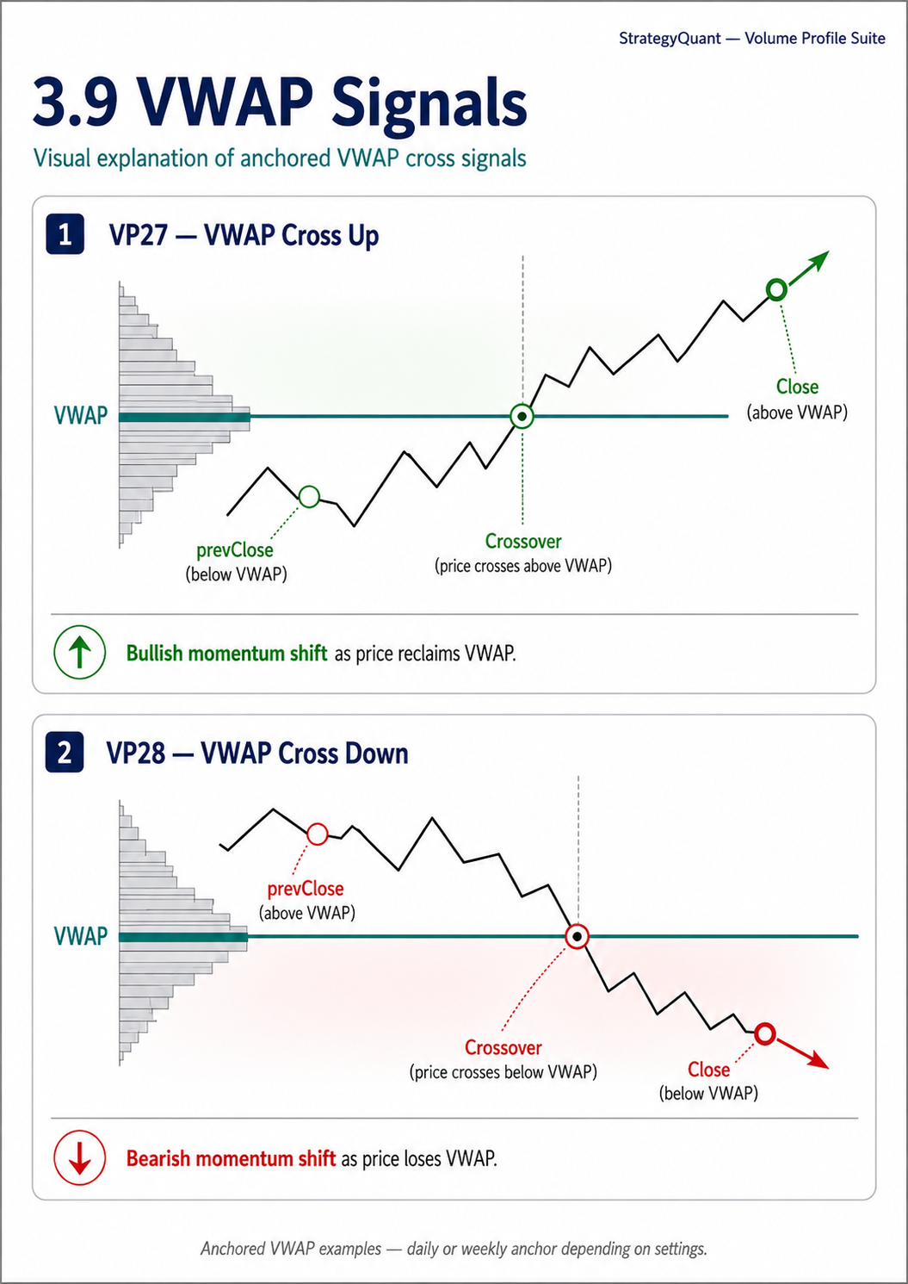

(VP27) VWAP Cross Up — VWAP Cross Up
Block Name: (VP27) VWAP Cross Up
Source: VPVWAPCrossUp.java
Opposite Block: (VP28) VWAP Cross Down

Description
Price crosses above the Anchored VWAP — current close is above VWAP while previous close was at or below.

Market Profile Principle
Momentum shift signal — price reclaiming the volume-weighted mean often signals the start of an intraday reversal or continuation move.

Logic
Close > VWAP AND prevClose <= prevVWAP

Parameters
Parameter | Default | Description
SessionType | 1 | VWAP anchor: 1 = Daily, 2 = Weekly

Usage Guidance
- Bullish entry trigger — go long on the cross-up
- More reliable when combined with Price Above POC or High Delta
- Daily VWAP is standard for intraday; Weekly VWAP is useful for swing trades

(VP28) VWAP Cross Down — VWAP Cross Down
Block Name: (VP28) VWAP Cross Down
Source: VPVWAPCrossDown.java
Opposite Block: (VP27) VWAP Cross Up

Description
Price crosses below the Anchored VWAP — current close is below VWAP while previous close was at or above.

Market Profile Principle
Momentum shift to the downside — price losing the volume-weighted mean.

Logic
Close < VWAP AND prevClose >= prevVWAP

Parameters
Parameter | Default | Description
SessionType | 1 | VWAP anchor: 1 = Daily, 2 = Weekly

DATA AND VALIDATION: Signal outputs depend on data quality, volume type (real or tick volume), session boundaries, symbol point size, and bar construction. Developing-session levels can change as new bars arrive. Validate every block against the target platform and market before relying on it.

4. Common Parameters
All signal blocks share a common set of VP parameters:
Parameter | Default | Description
Chart | Chart 0 | Which chart data to use
Symbol | Current | Which symbol to evaluate
SessionType | 1 (Prev Day) | Session boundary for VP calculation
ProfileRows | 50 | Number of price bins
ValueAreaPct | 70 | % of volume defining the Value Area
Shift | 0 | Bar lookback (0 = current bar)

NOTE: All signal blocks internally instantiate the VolumeProfile indicator with Fixed Tick Size bin mode (BinSizeMode=2, TicksPerBin=3) and default HVN/LVN settings. These internal values are preconfigured for the block logic and cannot be changed from the block UI. They should not be interpreted as universally optimized settings for every market.

5. Strategy Building Guidance

Combining Blocks Effectively
The signal blocks are designed to be layered together in StrategyQuant's AlgoWizard. The following are example combination patterns that must be validated for the selected market, timeframe, and data source:

Trend-Following Stack
- Regime Filter: Rising POC (VP21) + Price Above POC (VP01)
- Entry Signal: IB Breakout Up (VP18) OR Open Drive Long (VPODL)
- Confirmation: High Delta (VP08) + Bull POC Above Bear POC (VP10)

Mean-Reversion Stack
- Regime Filter: Wide Value Area (VP14) + Price Inside VA (VP03)
- Entry Signal: POC Magnet Long (VP11L) OR VAL Test Rejection (VP10)
- Confirmation: Bottom-Heavy POC (VP13)

Failed Breakout / Trap Strategy
- Setup: Price Outside VA (VP04) — wait for breakout
- Entry Signal: Value Return Long (VP12L) OR Late Acceptance Failure Long (VP13L)
- Confirmation: Excess Reversal Long (VP27L)
- Target: POC first, then the opposite VA edge when supported by testing

Distribution / Short Regime
- Regime Filter: Falling POC (VP22) + Top-Heavy POC (VP12) + Bear POC Above Bull (VP11)
- Entry Signal: VAH Test Rejection (VP09) OR VWAP Cross Down (VP28)
- Confirmation: High Negative Delta (VP09)

Timeframe Considerations
Timeframe | Recommended Session | Typical Use
M1–M5 | Actual Day, Custom Hours | Scalping and short-term intraday trading (use Fixed Tick bins)
M15–M30 | Previous Day, Custom Hours | Intraday swing (primary use case)
H1 | Previous Week/Month | Position trading, regime filters
H4–D1 | Previous Month/Year | Long-term bias, macro regime

Session Type Selection Guide
Goal | Recommended Session
Intraday entry signals | Previous Day — established levels to trade against today
Developing context | Actual Day — shows where value is forming right now
Swing trading | Previous Week — weekly value levels for multi-day holds
Regime identification | Previous Month — monthly POC migration for trend direction
Custom session strategies | VPCH — define exact session hours (London, US RTH, etc.)
Multi-session confluence | VPCHMS — compare London vs NY vs Tokyo levels simultaneously

Opposite Block Pairing
Every directional signal block has an @OppositeBlock annotation, meaning StrategyQuant's builder can automatically generate the mirror signal. This is useful for:
- Long/Short strategy symmetry — build one side, auto-generate the other
- Strategy flipping — quickly test the inverse hypothesis
- Genetic algorithm — the builder can explore both directions during optimization

