NIP Project — Submission Template
Pega Platform project · This document is your complete submission
Read this before you start:
1. Fill in Section 1 completely. The Pega application name must follow the format NIP-[Project]-[YourName].
2. Create a new Operator in Pega with your full name and log in as that operator before taking any screenshot.
3. When you create your test case, enter YOUR FULL NAME in the Issue Description (Vehicle) or Movie Name (Movie) field.
4. Complete only the section for your chosen project. Delete the other project section.
5. Paste one screenshot per user story (10 total). Follow the screenshot rules in your selected project section.
6. Answer every question in Sections 3 and 4 in your own words.
7. Save the file using this format: ProjectName_FirstName_LastName.docx. Use VehicleService or MovieTicket as the ProjectName. Examples: VehicleService_Ravi_Kumar.docx or MovieTicket_Ravi_Kumar.docx.

Section 1 — Your Details
Full Name | HARVEEN KAUR
Email ID (registered on NIP) | harveenkaur282@gmail.com
Phone Number | 9871181244
College Name | Amity University, Noida
Course (e.g. IT, CS) | B. tech CSE
State | Uttar Pradesh
Project Chosen (Vehicle Service OR Movie Ticket Booking) | Movie Ticket Booking
Pega Application Name (e.g. NIP-VehicleService-YourName) | NIP-MovieTicket-Harveen Kaur
Case Type Name (exact) | Movie Ticket Request
Pega Instance URL | https://1xtcmfpk.pegaacademy.net/prweb/app/nip--movie-ticket--harveen-kaur/
Operator Name (created in Pega with your full name) | Harveen Kaur
If the option is not available in App Studio:
- Switch to Dev Studio by clicking the operator icon (top right) → "Dev Studio".
- Navigate to:
Application → Structure → Rulesets
- Find the ruleset NIPMovie — version 01-01-01.
- Open it and look for the "Locked" checkbox or field.
- Uncheck/Unlock it and click Save

Section 2B — Movie Ticket Booking Management Application
Complete this section only if you selected this project. Delete the other project section before submitting.

Screenshot rules — IMPORTANT before you start:
1. Name your Pega application as: NIP-VehicleService-YourName OR NIP-MovieTicket-YourName
2. Create a new Operator in Pega with your full name (Security → Operators) and log in as that operator.
3. When you create your test case, enter YOUR FULL NAME in the Issue Description (Vehicle) or Movie Name (Movie) field.
4. The logged-in operator name must be visible in every screenshot wherever the Pega interface displays it.
5. The student's full name must be visible in all running-case screenshots.
6. Configuration screenshots must clearly show the relevant application or rule name.
Screenshots that do not show these will not be accepted.

US-001 — Submit Movie Ticket Request
What is expected:
Case created, customer submits Movie Name, Show Date, Show Time, Number of Tickets. Validation applied.
Screenshot — paste your screenshot below this line:
[ Paste screenshot here - follow the screenshot rules above ]

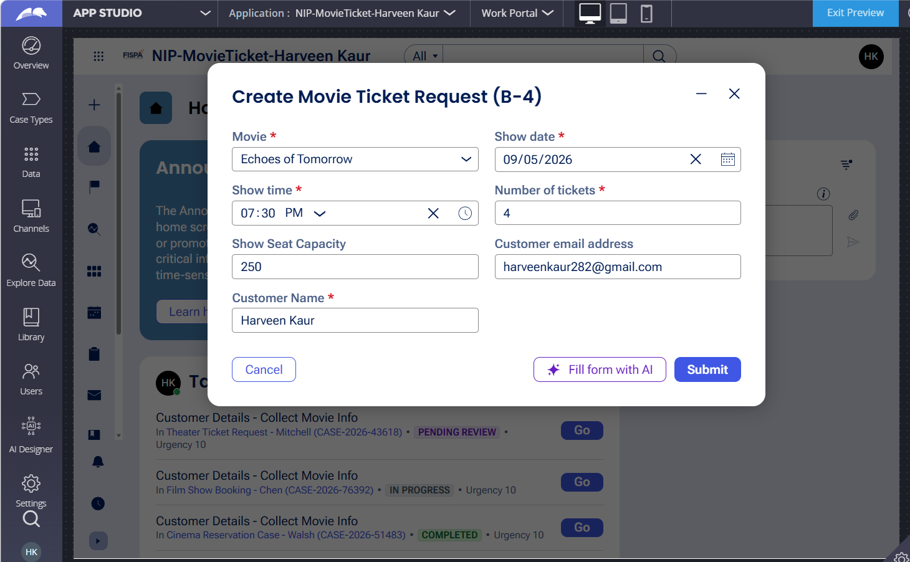
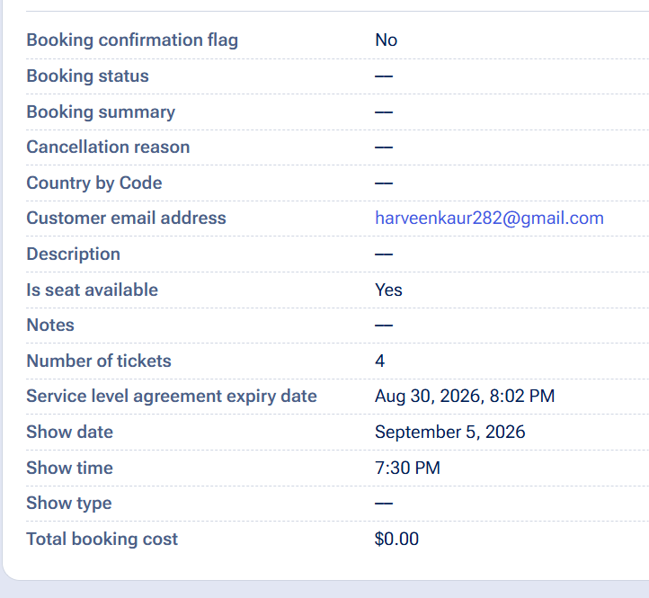

What I built for this (1–2 lines in your own words):
Configured the Initial Request stage to capture Movie Name, Show Date, Show Time, and Number of Tickets with required-field validation. The test case uses my full name as the customer name.

US-002 — Check Show Availability
What is expected:
Availability stage. Seat Availability Status and Available Seats Count captured. Booking proceeds only if available.
Screenshot — paste your screenshot below this line:
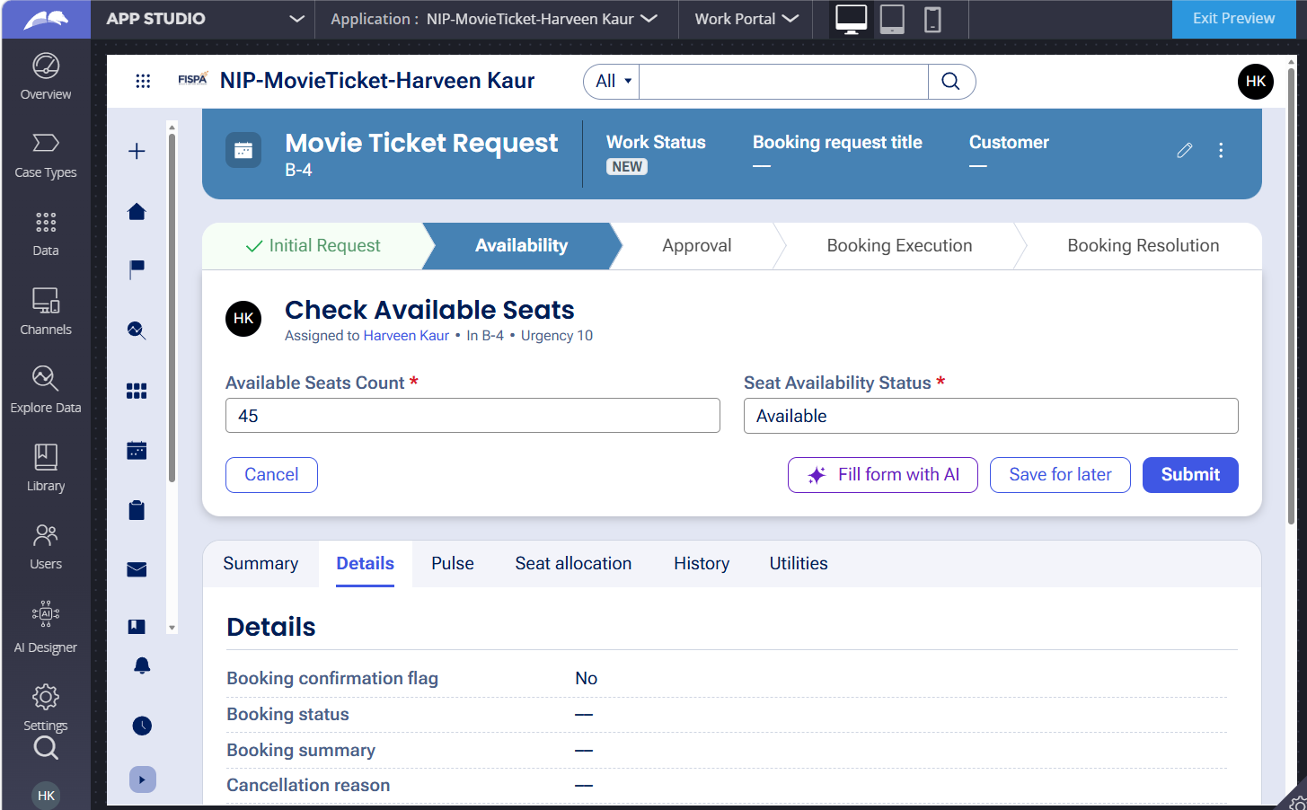

What I built for this (1–2 lines in your own words):
Configured the Availability stage to capture the available seat count and keep availability information on the case before the booking proceeds.

US-003 — Calculate Booking Cost
What is expected:
Total Cost calculated automatically from Ticket Price and Number of Tickets using a business rule.
Screenshot — paste your screenshot below this line:
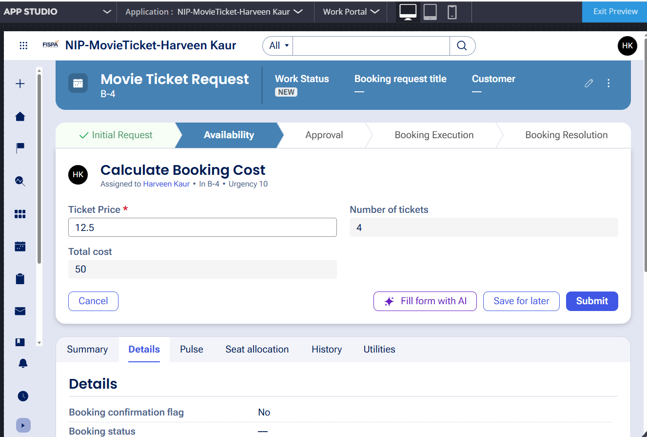

What I built for this (1–2 lines in your own words):
Here, the total cost was calculated using formula ticket price * no.of tickets, when total cost was configured as data field then had put it up as calculation field then use as expression this

US-004 — Confirm Booking Request
What is expected:
Approval stage assigned to Customer. Booking Status captured. Flow branches on confirm/cancel.
Screenshot — paste your screenshot below this line:
[ Paste screenshot here - follow the screenshot rules above ]

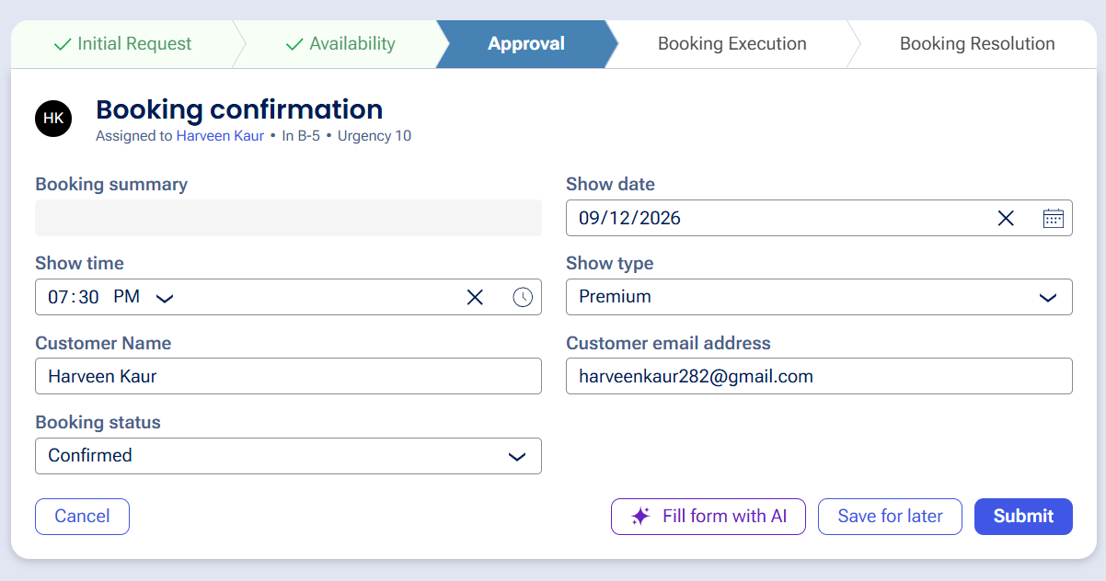

What I built for this (1–2 lines in your own words):
[ Type here ]
Configured the Approval stage to let the customer confirm the booking through the Booking Status and if it is confirmed then move forward otherwise go to cancelling stage.

US-005 — Maintain Movie and Show Data
What is expected:
Reusable Movie and Show data objects created with Movie Name, Genre, Show Date, Show Time, Seat Capacity — linked to case.
Screenshot — paste your screenshot below this line:
SHOW DATA OBJECT: (2 SCREENSHOTS)
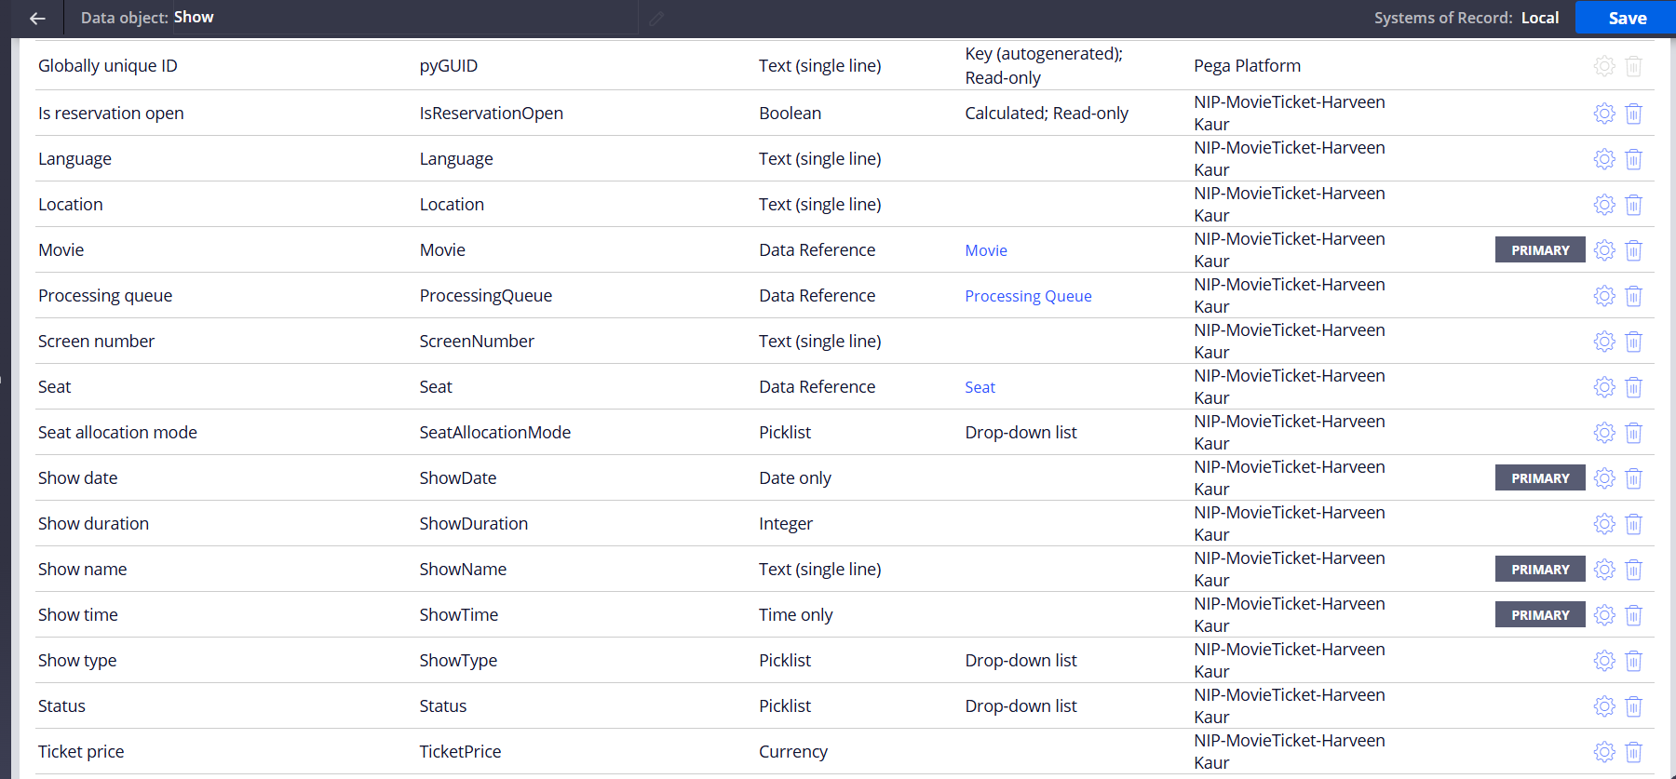
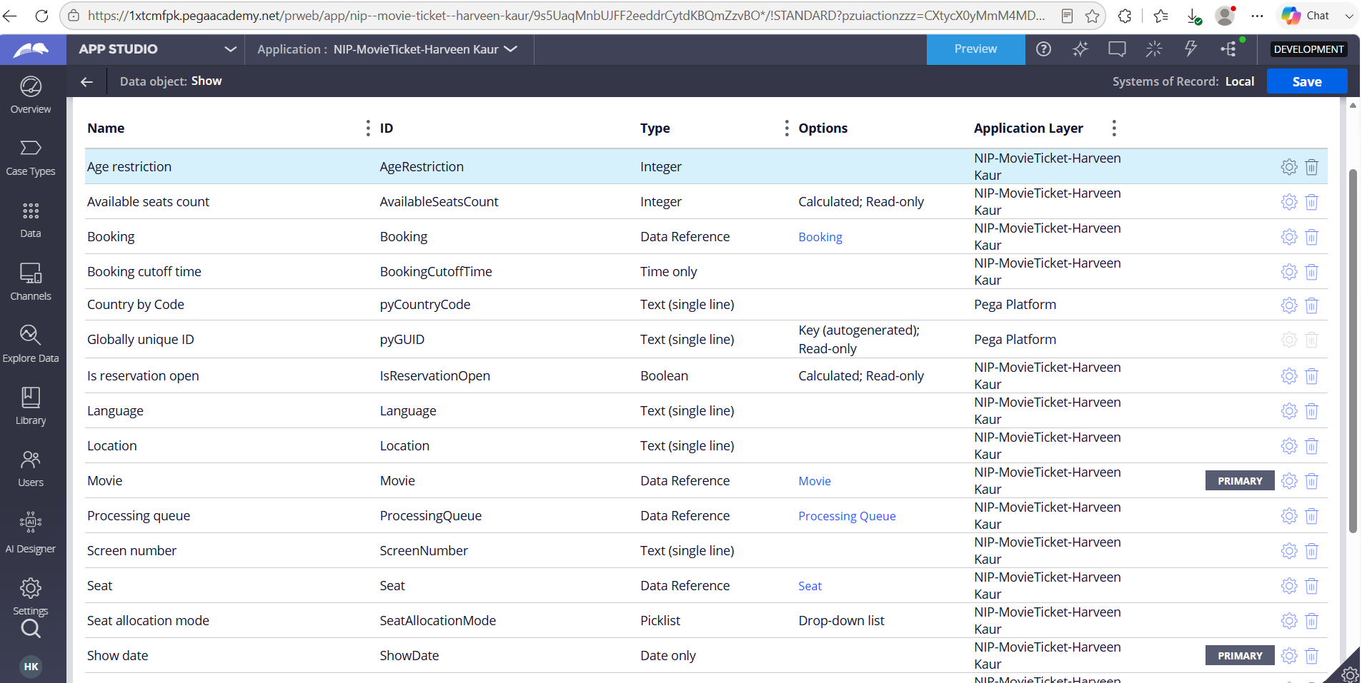

MOVIE DATA OBJECT:

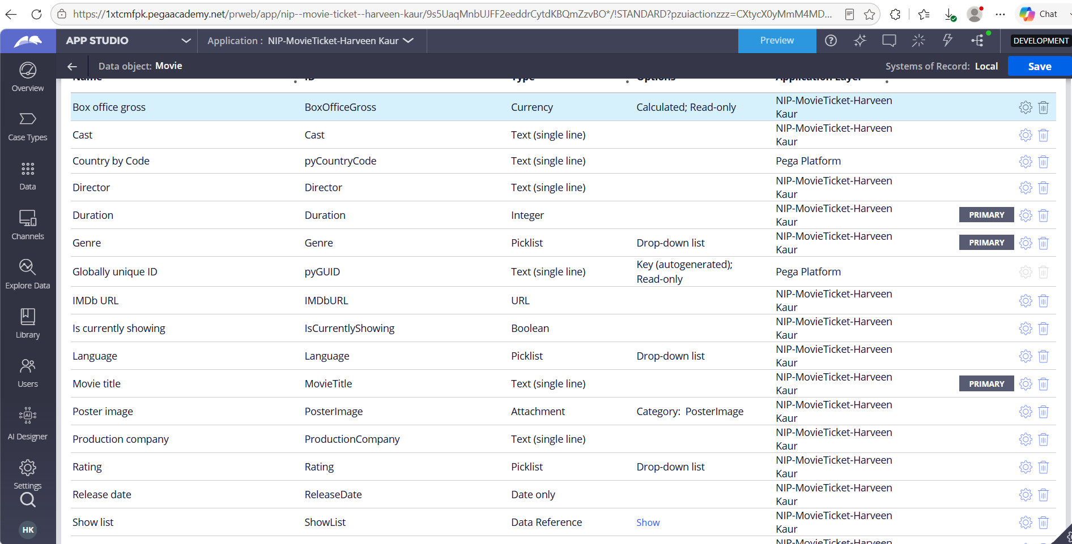

What I built for this (1–2 lines in your own words):
[ Type here ]
Created reusable Movie and Show data objects and associated the movie/show details with the Movie Ticket Request case. Also accessed them using data model tab and then clicked on view data model and from there selected the data objects- Movie and Show and showcased here. Most of the material has been from the blueprint itself.

US-006 — Review Booking Details
What is expected:
Confirmation screen shows Movie Name, Show Timing, Number of Tickets and Total Cost clearly.
Screenshot — paste your screenshot below this line:
[ Paste screenshot here - follow the screenshot rules above ]

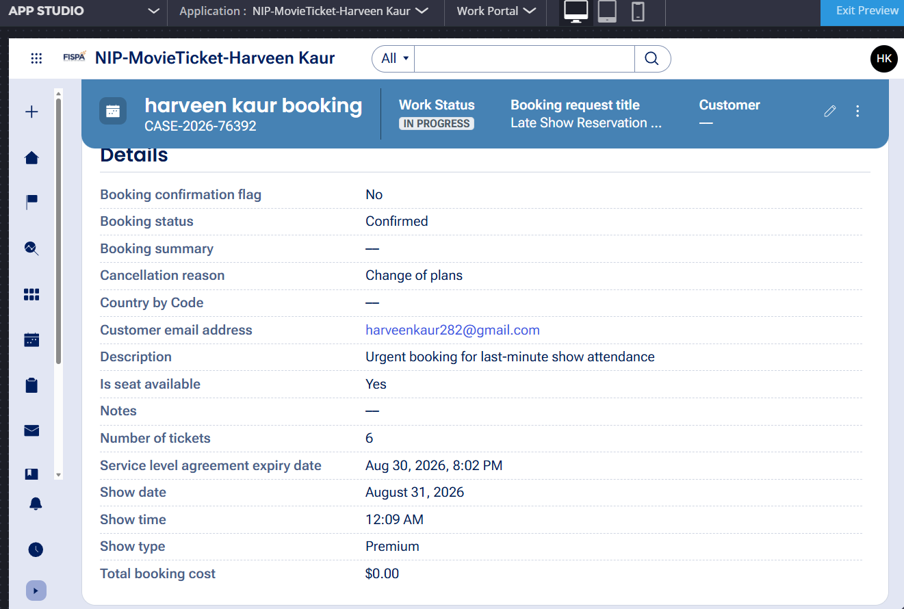

What I built for this (1–2 lines in your own words):
Configured the confirmation/finalization view so the customer-facing case details show the movie, show timing, ticket quantity, and total cost before completion.

US-007 — Process Ticket Booking
What is expected:
Booking Execution stage. Seat Numbers, Ticket ID and Booking Confirmation Status maintained.
Screenshot — paste your screenshot below this line:
[ Paste screenshot here - follow the screenshot rules above ] see below
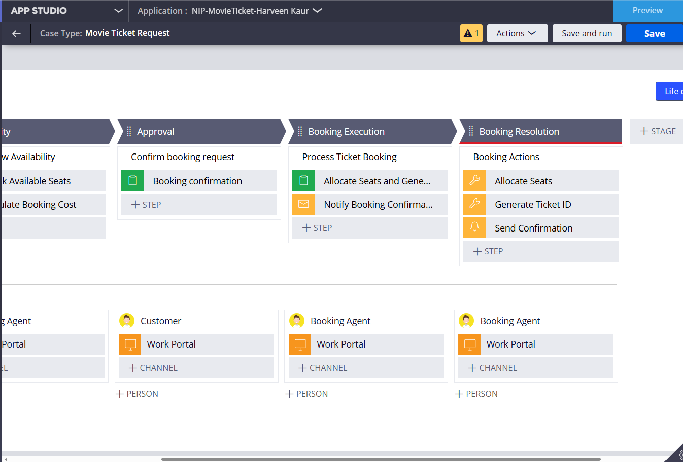

What I built for this (1–2 lines in your own words):
Some error is occuring, even though I followed all the instructions listed, pls kindly see the case type where the stage was configured.

US-008 — Notify Booking Confirmation
What is expected:
Correspondence rule triggered on case resolution. Email includes movie, show, seat and cost details.
Screenshot — paste your screenshot below this line:
[ Paste screenshot here - follow the screenshot rules above ]
See below
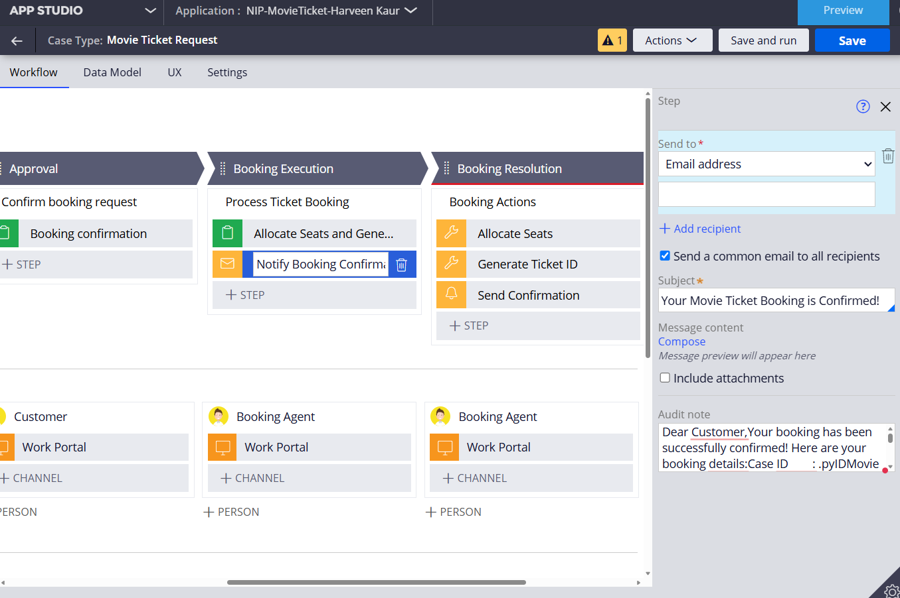

What I built for this (1–2 lines in your own words):
Configured a confirmation correspondence step intended to send booking details when the case reaches the Resolved stage.

US-009 — Define Booking SLA
What is expected:
SLA configured on the case type. Goal: 1 day. Deadline: 2 days. Priority increases on breach.
Screenshot — paste your screenshot below this line: see below
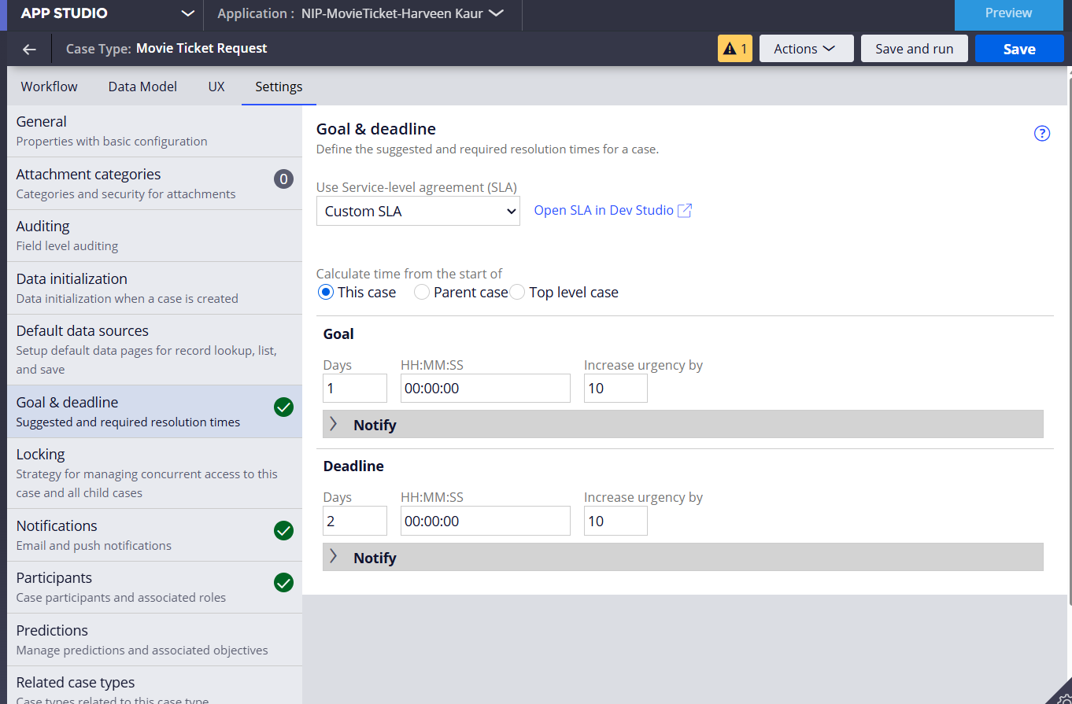

What I built for this (1–2 lines in your own words):
Configured a Custom SLA on the case type with a 1-day goal and a 2-day deadline, with urgency increases on breach.

US-010 — Route by Show Type
What is expected:
Routing rule or Decision Table routes to PremiumShowQueue or StandardShowQueue based on Show Type property.
Screenshot — paste your screenshot below this line:
[ Paste screenshot here - follow the screenshot rules above ]
Showcasing some kind of error.

What I built for this (1–2 lines in your own words):
[ Type here ]
Wasn’t able to Configure the Business Logic routing so IMAX requests go to PremiumShowQueue and all other show types go to StandardShowQueue.

Section 3 — About Your Application
These answers are checked against your screenshots. Write exactly what is in your application.

Q1. List your stages in the order they appear in your case lifecycle.
Stage names in order, separated by commas.
Initial request, availability, approval, booking execution, booking resolution and alternate stage as cancellation
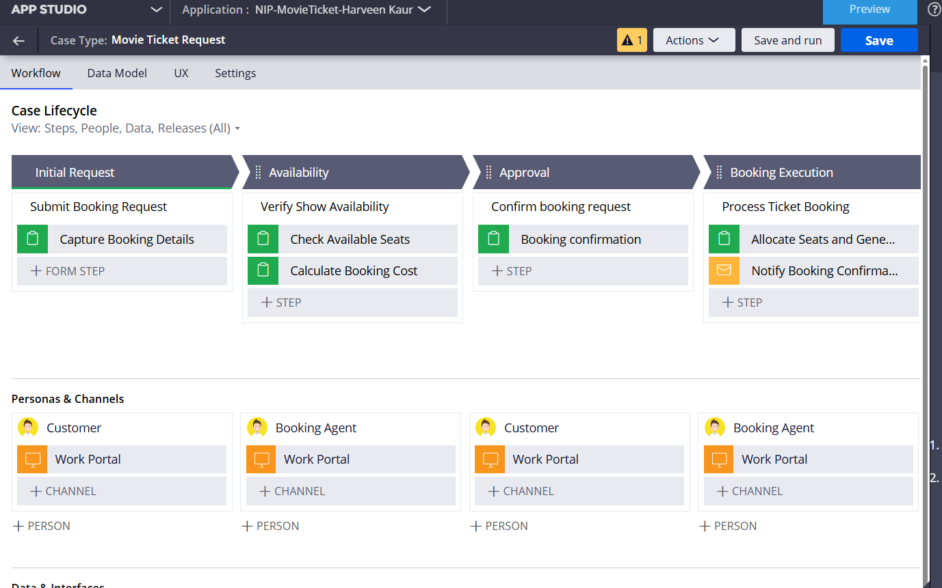

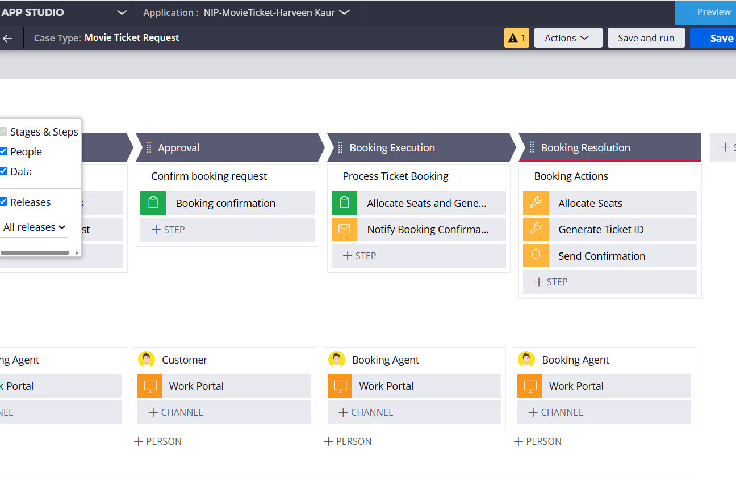
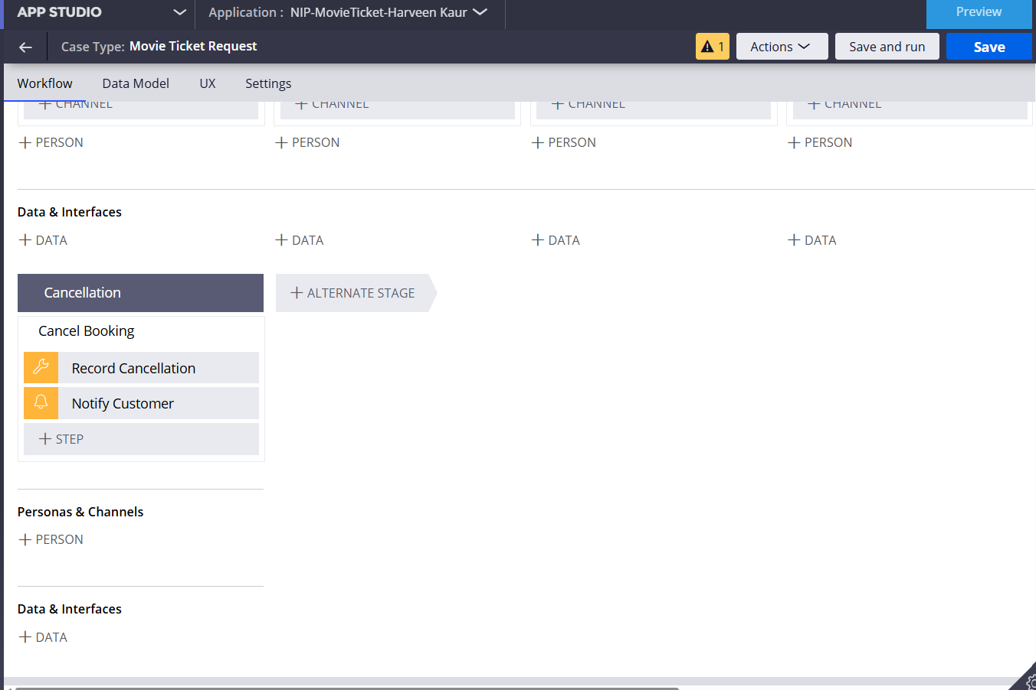

Q2. Name the data object(s) you created and the properties inside them.
Data object name and its properties.
Created three data objects show, movie and seat, where show- show date, show time, etc and movie- movie name, movie genre, and for seat various- seat capacity, row number, label, allocation, price, etc

Q3. What is the exact name and type of the rule you used to calculate Total Cost?
Provide:
• Rule Name
• Rule Type
• Properties used in the calculation
• Formula used
Total cost was calucalted, configured as data field- calculated itself and read only field
Formula used was: .TicketPrice * .NumberOfTickets

Section 4 — Your Understanding
Short, honest and specific answers score well.

Q4. What did Blueprint generate for you, and what did you add or change yourself afterwards?
Be specific about what was already there and what you built or modified on top.
It generated by mistake all the stages as the different case types, and some data fields were extra and various things like sla, routing and all were not at all configured, so had to do that manually also with the help of pega autopilot
It also added various other personas that were not even needed for now- like theatre manager, or it support etc.

Q5. Was there anything Blueprint created that you had to correct or configure further? Describe one example.
A real example from your own work.
Yes I had to delete the rest of the case types only keep movie ticket request and then had to modify the stages with their processes/steps according to the instruction given. I myself had to add data fields to all, cuz mostly they were not added to the steps.

Q6. Explain your case flow from creation to resolution, in order.
What happens first, who does what, when the case closes.
The customer creates a Movie Ticket Request and enters movie, show date, show time, and ticket quantity. Availability is checked and booking cost is calculated. The request then reaches Approval, where the booking status is confirmed. Confirmed requests move to Booking Execution, where ticket ID and seat numbers are maintained. Finally, the case is finalized and reaches Resolved, with the confirmation correspondence step configured for completion.

Q7. Pick two design choices you made in your application and explain why you made them.
For each design choice, provide:
• What you implemented
• Why you chose that approach
• What benefit it provides to the application
[ Type here ]

I used a dedicated Availability stage because seat availability is a separate business decision and should be checked before final booking. This keeps the flow easy to follow.
I had some erros/problems in configuring the routing logic though.

Q8. What was the hardest part, and how exactly did you fix it?
Specific and honest. A real challenge scores much better than a generic answer.
The hardest part was getting the generated workflow and fields into a state that worked correctly with my custom operator. I resolved it by creating the operator, and still faced routing logic errors, access group assigning when configuring operator, adding datat fields again and again to the steps.

Q9. If the approval step was only needed when Total Cost is above a certain amount, what would you change in your application?
Explain what you would change and where. You do not need to build this.
I would have told the customer upfront that only approved if so and so the case.

Q10. List three exact rule names from your application that you personally created or modified.
Include the rule name and rule type for each one (for example: CalculateTotalCost - Declare Expression).
Expression rule yes: to calculate the total cost
Others I was not able to configure- challenges faced.
Q11. List all personas used in your application.
List the persona names exactly as they appear in your application.
All these down below mentioned in the screenshot.
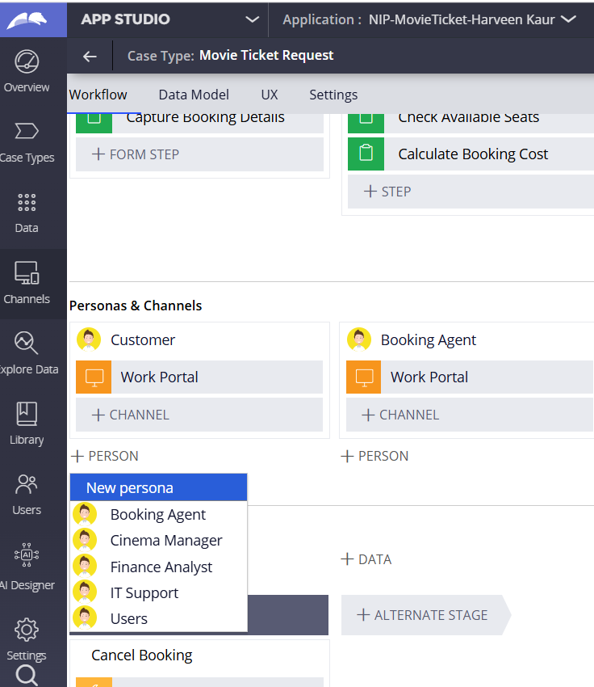

Q12. List all work queues used in your application and explain when each one is used.
For each work queue, provide its exact name and the condition or type of work routed to it.
PremiumShowQueue: used for IMAX/premium or special screenings. StandardShowQueue — used for all other show types. BookingAgentQueue: used for the booking approval/work assignment shown in the case flow.

Before You Submit — Check These
Read through once before uploading.
1. Section 1 filled in. Application named as NIP-[Project]-[YourName]. Names match the actual application.
2. New Operator created in Pega with my full name. I logged in as that operator for all screenshots.
3. Only my chosen project section remains — the other project section is deleted.
4. All 10 user story screenshots are pasted and follow the operator, running-case, application, and rule-name evidence requirements.
5. Every question in Sections 3 and 4, including Q10, Q11, and Q12, is answered in my own words.
6. This file is named using the required format: ProjectName_FirstName_LastName.docx (for example, VehicleService_Ravi_Kumar.docx or MovieTicket_Ravi_Kumar.docx) and uploaded as required.

