Pitch for Internder
Daan Nijs (r0123456789) & Dries Decuyper (r987654321)

Description
We would like to pitch an app like Tinder, but for internships. Our current best name is Internder. The profile pictures are replaced with logos of technologies, a picture of the city it is in, the manager, the office, etc... There is no "match", but students can export a list of the internships they're interested in. The idea is a fun way to narrow down the list of potential places to apply for. Currently it’s an Excel file in Toledo that’s inaccessible on mobile. We would like to make this process fun and incremental: swipe on a couple of places while waiting on a bus, maybe a couple of more while waiting in line. Being used in these short moments makes our app intrinsically mobile. At any point the user can export a list of internships they’re interested in so they can make their final choice.
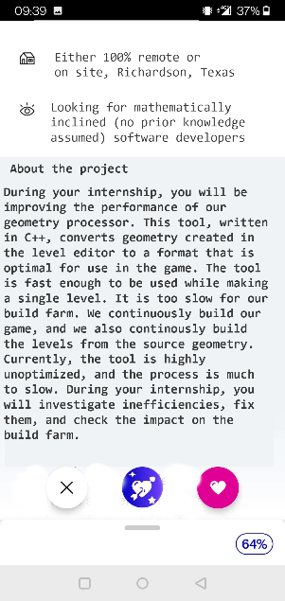

Motivation
When we first investigated internships, we were demotivated by how we were supposed to sift through possible places to apply to through a dry excel with unappealing descriptions. It seems logical to make this process fun, so that people are motivated to start internships on day 1.

Inspiration
We looked at tinder a lot for our basic interactions. In tinder, someone swipes left to reject someone, and right to express interest. We do the same: if someone swipes left on an internship, it means they're not interested, and the spot will never be seen again. If someone swipes right, it's added to a list of potentially interesting spots. We chose to do this, as it's proven to be fun, works as a 10-second interaction, and solves the problem of the old excel list being boring.

Statement of Work

Need to have
- A local file with all the information (location, id, photo’s, description) of an internship.
- A script to transform the existing intranet excel into this local file.
- A way to swipe left and right on an internship.
- A way to read a description of an internship.
- A way to export a list of internships that were swiped right upon.

Nice to have
- Automatically update the list of internships from intranet.
- Allow photos to be uploaded and viewed.
- “Compatibility score” based on a personal profile and tags on internships.
- Account for distance in compatibility score.
- Allow for chatting with the people offering the internships.
- Allow people running the internship to swipe on students. A match is communicated to both parties.

Tech stack
We’re going to use React Native to build the app. Transforming the excel will be done using a python script, and we’re going to transform it into a json file.
If we manage to implement “automatically update the list of internships”, we’re going to query intranet on app startup. If it fails, we’ll use the old file.

Risks
- We have never used React Native before
- We’re counting a lot on good descriptions and, optionally, pictures. Right now the database does not have pictures, and we’re not sure if they’re actually useful.
- We optionally will calculate distance but have no idea how we would implement calculating a distance between an intern’s domicile, and an internship’s location. For example, it has to account for public transport versus own transportation (bike, car)
- Allowing chat between people running internships and interns is a huge risk. Implementation seems heavy, and it might also be open to abuse. Should we have pictures of interns? Maybe it’s best if, on a match, the intern’s email address is only shared with the internship.

